Document ID | Document Name | Version | Date
ATL_ENG_UML15 | Functional Specifications | V 1.1 | 28-Dec-06
Client | Project Name and Description | Proj ID | Proj Mgr
Vakrangee Software | Enterprise Document Management System | VKDMS1 | Hari P Thapliyal

Template Revision History
Srl. No. | Version No. | Author | Date of Release | Description/  Purpose of Change | Reviewed/  Approved By
1. | 1.0 | Hari Prasad Thapliyal | 15-Dec-06 | Initial release
2. | 1.1 | Devakumar Sanyasi | 28-Dec-06 | Modified Approval Table
3.
4.

Document Creation/Revision History
Srl. No. | Version No. | Author/  Reviewer | Author/ Reviewer Name | Date | Purpose of Change
1. | 1.0 | Author | Veni Manchala | 19-Dec-06 | Initial Release
2. | 1.0 | Reviewer | Hari Prasad Thapliyal | 26-Dec-06
3. | 1.1 | Reviewer | Devakumar Sanyasi | 28-Dec-06
4. | 1.2 | Author | Veni Manchala | 25-Jan-07 | Detailed use cases
5. | 1.3 | Author | Veni Manchala | 13-Feb-07 | Client meeting
6. | 1.4 | Author | Veni Manchala | 28-Feb-07 | New client requirements
7. | 1.5 | Reviewer | Devakumar Sanyasi | 01-Mar-07

Document Approval Details
Aurovision |  | Client
Name | Devakumar Sanyasi | Name | Dr. NK Hayatnagarkar/  Mr. Santosh Dash
Title | EVP | Title | Client
Version | V1.5 | Version | V1.5
Date | 01-Mar-07 | Date

This is a controlled document. Unauthorized access, copying, and replication are prohibited. This document must not be copied in whole or in parts by any means without the written authorization of the Software Delivery Head, Aurovision P. Ltd, Mumbai, India.
© 2006, Aurovision P .Ltd. All rights reserved.
Table of Contents

1.1 Document Overview 8
1.1.1 Purpose 8
1.1.2 Reference Documents 8
1.1.3 Definitions & Acronyms 8
1.2 Functional Specifications 9
1.2.1 Project Management 11
1.2.1.1 Project Setup 11
1.2.1.1.1 Creating a Project template 11
1.2.1.1.2 Creating a Project from a template 12
1.2.1.2 User Management 12
1.2.1.2.1 Creating a user template for the project 13
1.2.1.2.2 Adding a user 13
1.2.1.2.3 Editing a user 14
1.2.1.2.4 Deleting a user 14
1.2.1.2.5 Searching for a user 15
1.2.1.2.6 Importing Users 15
1.2.1.3 Role Management 15
1.2.1.3.1 Creating a role template for the project 16
1.2.1.3.2 Adding a role 16
1.2.1.3.3 Updating a role 17
1.2.1.3.4 Deleting a role 17
1.2.1.3.5 Searching for a role 17
1.2.1.3.6 Assigning/un-assigning roles to users 18
1.2.1.4 Folder Management 18
1.2.1.4.1 Adding a folder 18
1.2.1.4.2 Updating a folder 19
1.2.1.4.3 Deleting a folder 19
1.2.1.4.4 Functions for assigning/de-assigning folders to users 19
1.2.1.5 Workflow Management (uses Workflow Module) 20
1.2.1.5.1 Selecting workflow templates 20
1.2.2 Security (Permissions) 21
1.2.2.1.1 Associate permissions to processes (implicitly done for processes) 21
1.2.2.1.2 Setting permissions types for each role 22
1.2.3 Configuration 22
1.2.3.1 Report Management (uses Report Module) 22
1.2.3.1.1 Creating a project report using a template (from report module) 23
1.2.3.1.2 Viewing a project report (from report module) 24
1.2.3.1.3 Deleting a project report: (from report module) 24
1.2.3.1.4 Searching for a Report (uses report module) 24
1.2.3.2 Document Hierarchy 25
1.2.3.2.1 Defining document hierarchy 26
1.2.3.2.2 Providing Access to Users based on document type 26
1.2.3.3 Configuring Search Panel (uses Search Module) 27
1.2.3.3.1 Creating a search panel field list within a project 27
1.2.3.4 Configuring Repositories 28
1.2.3.5 Configuring Form Fields (uses Document Indexing) 28
1.2.3.6 Configuring Annotations (uses Doc Modification) 28
1.2.3.6.1 Defining Annotation types 28
1.2.3.7 Encrypting fields (uses Encryption module) 30
1.2.3.7.1 Marking fields for encryption 31
1.2.3.8 Configuring document types (uses Doc Modification) 31
1.2.3.8.1 Defining project document types 31
1.2.3.9 Configuring document formats (uses Doc Modification) 32
1.2.3.9.1 Defining document formats for the project 32
1.2.3.10 Configuring Devices 32
1.2.3.10.1 Configuring Scanners (uses Scanning Module) 32
1.2.3.10.2 Adding Scanners 32
1.2.3.10.3 Editing Scanners 34
1.2.3.10.4 Deleting Scanners 35
1.2.3.10.5 Configuring fax machines (uses Faxing module) 35
1.2.3.10.6 Adding fax machines 35
1.2.3.10.7 Editing fax info 36
1.2.3.10.8 Deleting fax 36
1.2.3.10.9 Configuring Printer machines (uses Printing module) 37
1.2.3.10.10 Adding printers 37
1.2.3.10.11 Editing printer info 37
1.2.3.10.12 Deleting printer 38
1.2.3.10.13 Configuring mail server (uses Messaging module) 38
1.2.3.10.14 Adding mail servers 38
1.2.3.10.15 Editing mail server info 38
1.2.3.10.16 Deleting mail server 39
1.2.3.11 Configuring Document Archival (uses Doc Storage module) 39
1.2.3.11.1 Configure Archival entry 39
1.2.3.12 Selecting Languages (uses Localization module) 40
1.2.3.12.1 Selecting languages for the project 40
1.2.3.13 Configuring Approvals 40
1.2.3.14 Groups Management – (Phase 2) 41
1.2.3.14.1 Adding a group 41
1.2.3.14.2 Updating a group 41
1.2.3.14.3 Deleting a group 41
1.2.3.15 Group hierarchy – (phase2) 42
1.2.3.15.1 Creating a group hierarchy 42
1.2.3.15.2 Assigning users to groups 42
1.2.4 Project Management & Configuration Flow 43
1.2.5 Document Management System Services 43
1.2.5.1 Document Addition 44
1.2.5.1.1 Import documents 44
1.2.5.1.2 Importing from a local folder: 45
1.2.5.1.3 Importing from a remote folder: 45
1.2.5.1.4 Scripts to do an auto import of documents into DMS 46
1.2.5.1.5 Retrieve/view docs onscreen using our in-house COBOL applications 46
1.2.5.1.6 Create new documents – (phase 2) 46
1.2.5.1.7 Creating Telephone Forms 47
1.2.5.2 Document Deletion 47
1.2.5.2.1 Deleting a document in a folder 47
1.2.5.2.2 Deleting an entire folder 47
1.2.5.2.3 Deleting a Job in a folder 47
1.2.5.2.4 Auto Deletion 48
1.2.5.3 Document modification 48
1.2.5.3.1 Image Modification 48
1.2.5.3.2 Modifying an image document 49
1.2.5.3.3 Annotations 50
1.2.5.3.4 Add Annotation 50
1.2.5.3.5 Edit Annotation 51
1.2.5.3.6 Delete Annotation 51
1.2.5.3.7 Electronic objects 51
1.2.5.3.8 Add Electronic Object 51
1.2.5.3.9 Edit Electronic Object 52
1.2.5.3.10 Delete Electronic Object 52
1.2.5.3.11 Digital signatures 52
1.2.5.3.12 Add Digital Signature 52
1.2.5.3.13 Delete Digital Signature 53
1.2.5.3.14 Rearrange pages 53
1.2.5.3.15 Rearranging pages 53
1.2.5.3.16 Creating a new file from existing file 53
1.2.5.3.17 Linking documents 54
1.2.5.3.18 Providing reference to a document 54
1.2.5.3.19 Document types 54
1.2.5.3.20 Assigning document types 55
1.2.5.3.21 Document format conversion 55
1.2.5.3.22 Converting from one format to another 55
1.2.5.3.23 Text Modification – phase 2 56
1.2.5.3.24 Functions to update text within a document 56
1.2.5.4 Document Viewing 56
1.2.5.5 Image/Document Viewer 57
1.2.5.5.1 Using viewer for document modification 59
1.2.5.5.2 Using viewer for document deletion 59
1.2.5.5.3 Using viewer for document printing 60
1.2.5.5.4 Using viewer for document faxing 60
1.2.5.5.5 Using the viewer for document mailing 60
1.2.5.5.6 Using the viewer for Book marking a page 60
1.2.5.5.7 Using viewer for Defining form fields 60
1.2.5.5.8 Using viewer for Entering form field values 60
1.2.5.5.9 Using viewer for workflow actions 61
1.2.5.5.10 Using viewer for cross-referencing docs 61
1.2.5.6 Document Indexing 62
1.2.5.6.1 Creating a form 63
1.2.5.6.2 Associating a form with documents 63
1.2.5.6.3 Entering Form Data (Meta-Data Entry) 64
1.2.5.6.4 Automatic form application 65
1.2.5.6.5 Automatic classification of documents 65
1.2.5.7 Document Collaboration 65
1.2.5.7.1 Universal inbox for viewing documents 65
1.2.5.7.2 Using document check-in check-out 66
1.2.5.8 Document Archival 67
1.2.5.8.1 Storing document audit information 67
1.2.5.8.2 Archiving data 68
1.2.5.8.3 Archive data 68
1.2.5.8.4 Auto Archival 69
1.2.5.9 DMS Flow 70
1.2.6 Image Capture Services 71
1.2.6.1.1 Job Configuration 71
1.2.6.1.2 Job Creation 72
1.2.6.1.3 Job Assignment 73
1.2.6.1.4 Scanning 73
1.2.6.1.5 Image QC 74
1.2.6.1.6 Meta Data Entry 75
1.2.6.1.7 Meta Data QC 76
1.2.6.1.8 PDF Validation 77
1.2.6.1.9 Export to DMS 77
1.2.6.1.10 Job Search 77
1.2.6.1.11 Image Capture flow 78
1.2.6.1.12 Online Image Capture (DMS) 79
1.2.7 Document Capture Services 79
1.2.8 Workflow 81
1.2.8.1 Workflow structure 82
1.2.8.2 Example DMS Workflow Definition 83
1.2.8.3 Example Image Capture Workflow Definition 85
1.2.8.4 Example Physical Record Workflow 88
1.2.8.5 Service Approvals 88
1.2.9 Searching 89
1.2.9.1.1 Creating a search panel field list within a project 89
1.2.9.1.2 Meta-data Search in a project 89
1.2.9.1.3 Full Text search 90
1.2.9.1.4 Saving a query 90
1.2.9.1.5 Viewing saved queries 91
1.2.9.1.6 Search Requisition 92
1.2.10 Reporting 92
1.2.10.1 EDMS Report Templates 93
1.2.10.1.1 Job Status by Activity 93
1.2.10.1.2 Job Duration by Activity 93
1.2.10.1.3 Number of Jobs per User per Activity 93
1.2.10.1.4 Job Duration per User per Activity 93
1.2.10.1.5 Number of Users per Activity 94
1.2.10.1.6 Number of Jobs per Activity 94
1.2.10.1.7 Number of Documents per Activity 94
1.2.10.1.8 Number of Documents per activity per user 95
1.2.10.1.9 Job Audit 95
1.2.10.1.10 Document Audit 95
1.2.10.1.11 Folder Audit 96
1.2.10.1.12 Report Audit 96
1.2.10.1.13 DMS Application Metrics 96
1.2.10.1.14 Image Capture Application Metrics 97
1.2.10.1.15 Machine Utilization 97
1.2.10.1.16 Viewing Report Results 97
1.2.11 Device Management 98
1.2.11.1 Scanning 98
1.2.11.1.1 Scanner Management 99
1.2.11.1.2 Adding/Editing/Modifying a scanner entry 99
1.2.11.1.3 Configuring a scanner 99
1.2.11.1.4 Classification rules for scanned documents 99
1.2.11.1.5 Auto Scanning 100
1.2.11.1.6 Image Modification 101
1.2.11.2 Printing 101
1.2.11.2.1 Printer connection 101
1.2.11.2.2 Printer configuration 101
1.2.11.2.3 User configures printer 102
1.2.11.3 Faxing 102
1.2.11.3.1 Fax connection 102
1.2.11.3.2 Fax configuration 102
1.2.11.3.3 Sending Fax 102
1.2.11.4 Messaging 103
1.2.11.4.1 Mail Server Connection 103
1.2.11.4.2 Mail Server Configuration 103
1.2.11.4.3 Sending a mail 103
1.2.12 Physical Records management (WIP) 104
1.2.12.1 Record Capture 104
1.2.12.1.1 Adding Record Info 104
1.2.12.2 Record Destruction 105
1.2.12.2.1 Configuring record destruction 105
1.2.12.3 Record Storage 105
1.2.13 Alerts and Notifications 105
1.2.13.1.1 Set event based alerts 106
1.2.13.1.2 Rule based Alerts 106
1.2.13.1.3 Subscribing to Alert mailing lists 106
1.2.14 Service Approvals 107
1.2.14.1.1 Configuring approvals 107
1.2.15 Data Synchronization 107
1.2.15.1.1 Manual Synchronization 107
1.2.15.1.2 Auto Synchronization 108
1.2.15.1.3 Forced Synchronization 108
1.2.16 Internationalization/Localization 110
1.2.16.1.1 Changing a language 110
1.2.17 Data Encryption 110
1.2.18 Menu Functions 111
1.2.18.1 Common Menu Functions 111
1.2.18.1.1 File Menu 111
1.2.18.1.2 Edit Menu 111
1.2.18.1.3 Help Menu 112
1.2.18.2 Admin Menu 112
1.2.18.3 Image Capture Menu 114
1.2.18.4 DMS Menu 114
1.2.18.5 Search Menu 115
1.2.19 OCR – Phase 2 115
1.2.20 Non Functional Requirements 116
1.2.20.1 Integration – phase 2 116
1.2.20.2 System 116
1.2.20.3 Web Publishing 117
1.2.20.4 Architecture 117
1.3 User Interface Specifications 119
1.4 Analysis 120
1.4.1 Mapping with Client UI 120
1.4.1.1 Project Manager 120
1.4.1.1.1 Menu Files 120
1.4.1.1.2 Project Structure 121
1.4.1.1.3 Activities 122
1.4.1.1.4 Machines 122
1.4.1.1.5 Users 122
1.4.1.1.6 Timeline 122
1.4.1.1.7 Report Preferences 122
1.4.1.1.8 Reports 122
1.4.1.1.9 Status 122
1.4.1.2 Job Creation 122
1.4.1.2.1 Menu Files 123
1.4.1.2.2 Adding New Jobs 123
1.4.1.2.3 Adding Rows 123
1.4.1.2.4 Editing Job Details 123
1.4.1.2.5 Deleting Rows 123
1.4.1.2.6 Removing Exceptions 123
1.4.1.3 Scanning 123
1.4.1.4 Image QC 123
1.4.1.5 Meta Data Entry and QC 123
1.4.1.6 PDF Validation 123
1.4.1.7 Report Generation 124
1.4.1.8 Search and Retrieval 124

Document Overview
This document provides the detailed functional specifications for the EDMS. It covers all the system modules required to complete an EDMS, in detail. It provides the description of the functions implemented by each of the modules along with the important use case scenarios. The product implementation would be designed to happen in two phases, Phase 1 and Phase 2. All the functionalities falling under Phase 2 have been indicated.

Purpose
This document would be used to provide a complete understanding of the requirements. It will act as an input to technical and UI design teams for coming up with the detailed System design and UI design.

Reference Documents
S. No. | Reference Material | Location
1 | Vision Scope Document | Visual Source Safe
2 | EDMS Scope.xls | Visual Source Safe
3 | Client UI | Visual Source Safe

Definitions & Acronyms
S. No. | Definition/Acronym | Description
1 | EDMS | Enterprise Document Management System
2 | UI | User Interface
3 | User | System user
4 | Role | An activity based grouping of users
5 | Folder | System folder where the documents reside
6 | Permission | Access Rights for an entity
7 | Document | The system entity representing any form of document
8 | Group | A group of users
9 | Admin | The super user of the system who configures and customizes the system for a project
10 | Document type | A category of documents based on its content
11 | Form | A set of fields used to index a document for its faster retrieval
12 | Universal Inbox | A term to represent a view where the user can see all the documents within the project
13 | Process | A workflow process representing a group of activities
14 | Activity | A workflow term to represent an atomic unit of work
15 | MOOP | Manual of Office Procedures – Government of India

Functional Specifications
This section describes detail functionalities of EDMS. The entire EDMS Product comprises of the following main applications:
- Image Capture Application (ICA)
- Document Management System (DMS)
- Search Application (SA)
- Document Viewer (DV)
The following System modules are required to provide the functionalities for the above mentioned applications:
- Project Management
- Configuration
- Security
- Document Addition
- Document Deletion
- Document Modification
- Document Viewing
- Document Indexing
- Document Collaboration
- Document Storage
- Workflow
- Searching
- Reporting
- Scanning
- Printing
- Faxing
- Messaging
- Encryption
- Internationalization/Localization
- Menus
- Integration with electronic devices

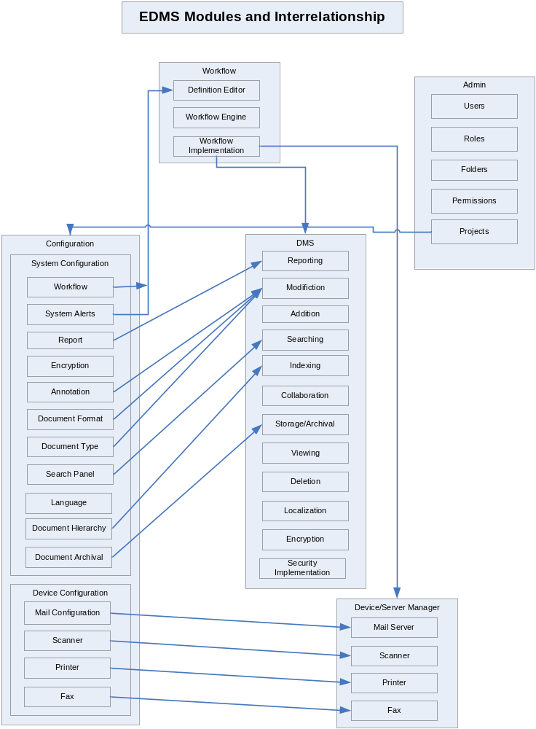

Project Management
This module explains the admin functionality related to the system. The admin should be able to do the following:
- Create a project
- Define the project structure by providing:
  - Users – template & users
  - Roles – template & roles
  - Folders
  - Permissions
  - Workflow processes
  - Search Panel configuration
  - Reports – template & reports
  - Configuring Machines – Scanners, Printers, Fax & Mail servers
  - Configuring document types
  - Configuring annotations
  - Configuring languages
  - Configuring archives
  - Encryption fields
The actor for all the use cases defined in this module is the “Admin”.

Project Setup
This module should provide functions to create/edit/delete projects and to assign various project specific parameters or entities to the project.

Creating a Project template
Pre-condition: None
Basic Flow:
- Admin selects Project – create template menu item
- Admin views a template form with a table showing:
  - Field name – text input
  - Field type – selectable text containing data types
  - Input type – selectable text containing html input control names
  - Add field - button
  - Delete field - button
  - Edit field - button
  - Save - button
- Admin clicks on add field button
- A row gets inserted with two editable text boxes for field name and field type
- Admin enters field name and data type of the field
- Admin repeats the process to define the fields for the project eg: name, district, etc.
- Admin saves project template
- System validates data and saves if successful or displays error screen
- All fields get added and a check box is displayed against each of them
- User can select the check boxes and perform delete or edit operations on the fields
Post-condition: Project template is created and the admin can now use this to create project definition.

Creating a Project from a template
Pre-condition: project template exists
Basic Flow:
- Admin selects project – new menu item (or File – new menu item)
- System displays the existing templates for projects
- Admin selects a template
- The admin views the form created by the template
- Admin enters values for all the project specific fields values required by the project
- Admin saves the project info by clicking “save” button
- Using “Edit” or “delete”, the admin can perform the required operation.
- System validates data and saves if successful or displays error screen
After project creation, the project structure should be defined by adding all project specific entities as described in the following sections.
Post-condition: A new project is created and ready to be initialized.

User Management
This module should provide functions for:
- Creating, editing, deleting user template for the project
- Creating, editing, deleting users
- Importing users from existing databases
- View all users
- View user details
- Search for users

Creating a user template for the project
Precondition: Project exists
Basic Flow:
- Admin selects user –template menu item
- Admin views a template form with a table showing:
  - Field name – text input
  - Field type – selectable text containing data types
  - Input type – selectable text containing html input control names
  - Add field - button
  - Delete field - button
  - Edit field - button
  - Save - button
- Admin clicks on add field button
- A row gets inserted with two editable text boxes for field name and field type
- Admin enters field name and data type of the field
- Admin repeats the process to define the fields for the user e.g.: age, date of birth, gender, designation, etc.
- Admin saves user template
- System validates data and saves if successful or displays error screen
- All fields get added and a check box is displayed against each of them
- User can select the check boxes and perform delete or edit operations on the fields
Post-condition: A template to enter user information is created

Adding a user
Pre-condition: User template exists
Basic Flow:
- Admin selects user – new
- If there is no predefined template for the user, the screen displays an error message directing the admin to create a template. If there is a template, then the admin views the form created by the template
- Admin enters values for all the user specific fields values required by the project eg: name, login, password, age, date of birth, gender, designation, etc.
- Admin saves the user info by clicking “save” button
- Using “edit” or “delete”, the admin can perform the required operation.
- System validates data and saves if successful or displays error screen
Post-condition: User gets added to the system

Editing a user
Pre-condition: User exists
Basic Flow:
- Admin selects a user – view
- System displays all the users
- Admin selects the required user
- Admin updates the required fields
- Admin saves
- System validates data and saves if successful or displays error screen
Post-condition: User information is updated

Deleting a user
Pre-condition: User exists
Basic Flow:
- Admin selects a user – view
- System displays all the users
- Admin selects the check boxes of the required users
- Admin presses “delete” button
- System checks for confirmation of deletion
- System deletes if confirmed else cancels operation
Post condition: User gets deleted from the system

Searching for a user
Pre-condition: User exists
Basic Flow:
- Admin selects user-search
- System displays search screen with user form fields and a search button
- Admin can enter any field value that he knows e.g.: user name and press search
- The search result screen displays all the matched users (similar to user-view screen)
- Admin can select one to view the user details
Post-condition: User is found or not found

Importing Users
Pre-condition: The target database exists
Basic Flow:
- Admin selects user-import
- System displays “User Import screen” the following fields:
  - Data-source type – drop down (database or csv)
  - Csv input – file browser to select filename in case the data-source is csv
  - Database URL – text input (the url of the target database)
  - Database Name – text input (the name of the target database)
  - Table Name – text input (the table name of the target database)
  - Get Fields – button (press to obtain fields from target table)
  - Save - button (saves the user information in the system)
- System generates a list of fields with checkboxes
- Admin selects the required fields
- Admin saves the information
Post-condition: System validates data and connection with the external database and saves the user information.

Role Management
Roles represent a group of users for performing an activity. This module should provide functions for defining project role template, adding roles, searching for and adding users to roles.
Functions for adding/deleting/updating role templates and roles

Creating a role template for the project
Pre-condition: Project exists
Basic Flow:
- Admin selects role –template menu item
- Admin views a template form with a table showing:
  - Field name – text input
  - Field type – selectable text containing data types
  - Input type – selectable text containing html input control names
  - Add field - button
  - Delete field - button
  - Edit field - button
  - Save - button
- Admin clicks on add field button
- A row gets inserted with two editable text boxes for field name and field type
- Admin enters field name and data type of the field
- Admin repeats the process to define the fields for the role eg: name, function, etc.
- Admin saves role template
- System validates data and saves if successful or displays error screen
- All fields get added and a check box is displayed against each of them
- User can select the check boxes and perform delete or edit operations on the fields
Post-condition: A role template for the project is created. Only one role template can exist per project.

Adding a role
Pre-condition: Role template exists
Basic Flow:
- Admin selects role – new menu item
- If there is no predefined template for the role, the screen displays an error message directing the admin to create a template. If there is a template, then the admin views the form created by the template
- Admin enters values for all the role specific fields values required by the project
- Admin saves the user info by clicking “save” button
- Using “edit” or “delete”, the admin can perform the required operation.
- System validates data and saves if successful or displays error screen
Post-condition: Role gets created

Updating a role
Pre-condition: Role exists
Basic Flow:
- Admin selects a role – view menu item
- System displays all roles for the project with “delete” and “edit” buttons
- Admin selects a check box for the role and presses edit button
- Admin views the role details in edit mode
- Admin updates the required fields
- Admin saves
- System validates data and saves if successful or displays error screen
Post-condition: Role information gets updated

Deleting a role
Pre-condition: Role exists
Basic Flow:
- Admin selects a role – view menu item
- System displays all roles for the project with “delete” and “edit” buttons
- Admin selects a check box for the role and presses delete button
- System checks for confirmation of deletion
- System gives an error message if there are users assigned to this role
- System deletes if confirmed else cancels operation
Post-condition: Role gets deleted

Searching for a role
Pre-condition: Role exists
Basic Flow:
- Admin selects role-search
- System displays search screen with role form fields and a search button
- Admin can enter any field value that he knows e.g.: role name and press search
- The search result screen displays all the matched roles (similar to role-view screen)
- Admin can select one to view the user details
Post-condition: The role is found or not found. In case the role is found it should lead the admin to the detail page. In case the role is no found it should show an error message.

Assigning/un-assigning roles to users
Pre-condition: Role exists and the project has at least one or more users
Basic Flow:
- Admin selects a role
- Admin views all system users on the left list box and all users assigned to the role in the right list box
- Admin selects system users and moves them to the right box by clicking right arrow button between the lists.
- System gives error if there is no user selected when pressing the right arrow button else it moves the user to the right list box.
- After moving all selected users admin either saves changes or deselects users by moving them back to left list by clicking the left arrow button.
- If changes are saved, system commits the changes
- If the reset button is pressed all users get de-assigned
Post-condition: Users get assigned to a particular role

Folder Management
This module provides functions to create and manage and define folder structure for the project. Any kind of project related document should be able to be placed within the folder. The system folders would be used to contain any kind of document formats. This module has:
- Functions for Adding/Deleting/Updating folders
- Functions for defining Folder rules
- Functions for defining Folder Security (access)

Adding a folder
Pre-condition: Project exists and the default root folder exists
Basic Flow:
- Admin selects the root folder
- Admin selects file- new folder menu item
- Admin enters the folder name
- System validates data and saves if successful or displays error screen
Post-condition: Folder gets created under the selected root folder

Updating a folder
Pre-condition: Folder exists
Basic Flow:
- Admin selects a folder
- Admin updates the folder name
- Admin saves
- System validates data and saves if successful or displays error screen
Post-condition: Folder information is modified

Deleting a folder
Pre-condition: Folder exists
Basic Flow:
- Admin selects a folder
- Admin deletes the folder
- System checks for confirmation of deletion – it informs if there are any files in the folder
- System deletes folder and all files within if confirmed else cancels operation
Post-condition: Folder gets deleted from the system along with its contents if any

Functions for assigning/de-assigning folders to users
Pre-condition: Folder exists and there should be at least one or more users in the project Basic Flow:
- Admin selects a folder
- Admin views all system users classified by Roles on the left list box and all users assigned to the folder in the right list box
- Admin selects system users or roles and moves them to the right box by clicking right arrow button between the lists.
- System gives error if there is no user selected when pressing the right arrow button else it moves the user to the right list box.
- After moving all selected users admin either saves changes or deselects users by moving them back to left list by clicking the left arrow button.
- Admin now views a drop down with all the folder permission parameters (rename, delete, all rights)
- Admin selects the folder permissions for the role/users
- Admin gets an option to apply these rules to subfolders.
- Admin views the document permissions for the folder contents (add, delete, edit, print, etc)
- Admin selects the appropriate document permissions
- Admin saves all the settings
- If changes are saved, system commits the changes
- If the reset button is pressed all users get de-assigned
Post-condition: Folder and Folder permissions get assigned to users/roles. In case no users are assigned to a folder, it is available to all users.

Workflow Management (uses Workflow Module)
EDMS requires workflow configuration for the following applications:
- Image Capture or Scanning Application
- Document Management System or DMS Application
- Search Application
The workflow module describes the use cases of all the workflow processes involved in each of the above applications.
In this section the admin should configure all the workflow related parameters for Scanning, DMS and Search Applications. The use cases include:
- Selecting processes for each of the above mentioned applications
- Sequencing the processes (defining both sequence and parallel execution paths)
- Assigning/de-assigning roles to processes
- Setting event or activity based alarms

Selecting workflow templates
Pre-condition: sample workflow templates and the project roles should be available.
Basic Flow:
- Admin selects workflow – configure menu item
- The system displays the workflow definition editor
- The editor displays all the available templates for the application.
- The admin can select one or more templates to be available for the project.
- Admin saves the selection
Post-condition: workflow is defined for the application. Only one workflow can be defined for one project.
The above steps can be performed for Image Capture and DMS Applications. The only difference would be the workflow templates used by the workflow editor. DMS and Search applications would have their respective workflow processes and corresponding templates for the workflow. The actual workflow processes are detailed in various parts of this document.

Security (Permissions)
Permissions are the access rights given to users and roles in order to perform a particular workflow process. This can be also be referred as Security module. The current system has the following permission categories along with the permission types within each category:
- Document - view/edit/delete/print/email/fax/download
- Job - create/delete/update/view
- Scanner - create/delete/configure/execute
- Folder - add/delete/view/update/lock
- Meta Data - add/delete/enter/view
- Annotations - add/delete/update/view/print
- Role - create/delete/update/view/access
- Search - configure/create /execute
- Report – create/update/delete/view/generate/print/fax/mail/download
- Electronic Object – add/delete/view
- Digital signature – add/delete/update/view
- Import – local/remote/Auto
- Export – local/remote/auto
EDMS should provide facility to add more permission categories if required for a project.
This module should provide the following functions:
- Functions for associating processes with the permission categories
- Functions for setting permissions & permission types for each role.

Associate permissions to processes (implicitly done for processes)
Pre-condition: Processes and permissions should exist
Basic Flow:
- Admin selects permissions – set process permission menu item
- Admin views the permission association screen
- It displays all the workflow processes in the form of the following table:
  - Workflow processes : Displays the name of the workflow process
  - Add permission category: Button
  - Save: Button
- Admin presses “permission category” button
- A window displaying all the permission categories available in the system is displayed
- There are checkboxes against each permission category name
- Admin selects all the required permissions for a particular process and closes the window
- Admin repeats the process for every workflow process
- Admin presses the “save” button
- System validates data and saves if successful or displays error screen
Post-condition: The Permission categories get associated with the processes

Setting permissions types for each role
Pre-condition: Roles and permissions should have been assigned to processes
Basic Flow:
- Admin selects a Process
- System displays all the roles associated with a process along with a “set permissions” button against each role.
- Admin presses the “set permissions” button against a particular role
- System displays the permissions window displaying the permissions matrix
- The permission categories are displayed in the y-axis and the permission types as displayed in the x-axis, based on the permissions assigned for this process. The matrix is filled with check boxes
- Admin selects appropriate permissions check box
- Admin saves the setting
- System validates and saves changes
Post-condition: The permission types get set against each role

Configuration

Report Management (uses Report Module)
EDMS has a set of report templates. Please refer to the Report Module for all the list of templates along with their contents.
- Job Status By Activity
- Job Duration By Activity
- Number of Jobs Per User Per Activity
- Job Duration per User per Activity
- Number Of Users Per Activity
- Number Of Jobs per Activity
- Job Audit
- Document Audit
- Number Of Documents Per Activity
Here the admin uses the reporting module functions for:
- Adding/deleting/updating reports based on report templates
- Searching for reports

Creating a project report using a template (from report module)
Pre-condition: project exists with assigned users, roles and activities
Basic Flow:
- Admin selects reports - “new” menu item
- Admin gets a screen with the following fields:
  - Report Name: Text input
  - Application: drop down (DMS or Image Capture)
  - Select Template: drop down (displaying all the predefined templates)
Based on the selected template one of the following input fields would be displayed:
  - By Role: drop down
  - By User : drop down
  - By Activity: drop down
  - By Job Numbers: from: text input to: input (Only displayed for Scanning Application)
  - By Date: from: date to: date
  - By Status:
  - Save: Button
  - Edit: Button
  - Delete: Button
- Admin enters the field values
- Admin saves the report
- System validates data and saves the report by the given name
Post-condition: Reports are created by admin and can be viewed by the system users

Viewing a project report (from report module)
Pre-condition: project exists with assigned users, roles and activities and at least one report to be displayed
Basic Flow:
- Any user can view the report by going to reports- “view” menu item
- System displays all the reports created by the admin with check boxes and “generate” buttons beside them and “delete” and “edit” buttons below
- User can view a particular report by clicking on it
- User views the report details page
- User can view the report results by pressing the “generate report” button.
- Based on the report template the report results are displayed
- User has an option to print or save the report as a file on his local file system.
Post-condition: report can be viewed or edited or deleted or generated.

Deleting a project report: (from report module)
Pre-condition: project exists with assigned users, roles and activities and at least one report to be displayed
Basic Flow:
- User selects report - View menu item
- System displays all the reports with check boxes beside them and “delete” and “edit” buttons below
- User selects the check boxes
- User presses delete
- System deletes the reports after confirming
- In case the user presses “edit”, he can select only one report and gets to see report details page in edit mode.
Post-condition: Selected Report is deleted.

Searching for a Report (uses report module)
Pre-condition: project exists with assigned users, roles and activities and at least one report exists
Basic Flow:
- Admin selects report-search
- System displays search screen with report form fields and a search button
- Admin can enter any field value that he knows eg: report name and press search
- The search result screen displays all the matched reports (similar to report-view screen)
- Admin can select one to view the report details
Post-condition: Search is successful and the report is viewed or search fails and a message is displayed.

Document Hierarchy
Document is the main entity of EDMS. The attributes of a document should be decided during design time based on common properties of different types of documents. When the system imports any document, they should be saved as this entity in the EDMS apart from being saved as a physical file.
The following is an example list of document attributes:
- Name
- Height
- Width
- Format (image, text, xml, etc)
- NoOfPages
- Document category
- Document Type
- Document Class
- Barcode Number
- Physical Location
- Rack Number
This module should provide functions to create a document hierarchy. The implementation could be a part of Document Inexing or Document Storage module. This information can be used to generate a folder structure and applied to all the documents entering the system either by manual import or dby auto scanning.
- Department – equivalent to a file cabinet
- Document Category – equivalent to a file folder
- Document Type – equivalent to a document set within a file. All documents in this set are of same type. Barcode number is associated to this.
- Document Class – class of a particular document based on its validity
- This hierarchy should be defined by the admin during project creation. So when a document with the same name is either imported or scanned into the system it can automatically move to the assigned file folder unless specifically assigned to a different location based on project folders.
- This module should provide document security to users/roles for a category or type of documents.

Defining document hierarchy
Pre-condition: project exists
Basic Flow:
- Admin selects a department icon and drags it to the work area
- Admin drags a connector icon and attaches it to the department
- Admin adds document category icon to the other end of the connector
- Admin can repeat the above steps to add more than one category for a department
- Similarly admin can add more than one document for each document category
- When admin adds a document, he supplies the document properties like:
  - Name
  - Class
  - Height
  - Width, etc. based on the document attribute requirements
- Admin saves the document hierarchy structure.
- System validates all entries and saves the structure
- System creates a similar folder structure under the project root folder directory.
- So when this particular document comes into the system either by scanning or import, based on the document properties mapping, it gets placed in the correct location.
Post-condition: Document hierarchy gets defined.

Providing Access to Users based on document type
Pre-condition: Document Hierarchy exists
- Admin selects the project and views the Document hierarchy
- Admin selects either a department or category or document type icon
- Admin selects assign users menu item
- Admin gets a window displaying all the system users categorized by their role
- Admin selects a role or users
- Admin views all the document permissions available for the role/users (view, edit, delete, etc)
- Admin selects the required permissions
- Admin saves the selection
- The selected users or roles get associated with the selected department/category/type with appropriate document permissions.
- Admin can repeat the process for all types.
- The default access is to all users.
- Post-condition:

Configuring Search Panel (uses Search Module)
This module uses the functionality of search module in order to let the admin define the fields in the search panel for the project. The panel defined here would be visible as the search panel for the entire project. The users can perform search operations by using this panel.

Creating a search panel field list within a project
Pre-condition: Project exists
Basic Flow:
- Admin selects search – configure panel
- Admin views a template form with a table showing:
  - Project Name – text input (enters the project name from which to search for documents)
  - Field name – text input
  - Field type – selectable text containing data types
  - Disable Field for Office – drop down (containing office locations)
  - Input type – selectable text containing html input control names
  - Add field - button
  - Delete field - button
  - Edit field - button
  - Save - button
- Admin clicks on add field button
- A row gets inserted with two editable text boxes for field name and field type
- Admin enters field name and data type of the field
- The field content is disabled when a user belonging to a specific office location logs in.
- Admin repeats the process to define the fields for the search panel e.g.: document name, document class, document format, etc.
- Admin saves search panel template
- System validates data and saves if successful or displays error screen
- All fields get added and a check box is displayed against each of them
- User can select the check boxes and perform delete or edit operations on the fields
- Based on the Project name, the system identifies the project root folder as the source folder for search operation.
Post-condition: The search template is defined. All the users of this project can use this panel to perform search operation.

Configuring Repositories
- Admin selects configure repository menu item
- Admin views a template screen with a table showing:
  - Project Name – text input (enters the project name from which to search for documents)
  - Repository name – text input (Branch Office)
  - Repository location – text input (eg: UP)
  - Add field - button
  - Delete field - button
  - Edit field - button
  - Save - button
- Admin clicks on add field button
- A row gets inserted with two editable text boxes for Repository name and Repository location
- Admin enters Repository name and Repository location data
- Admin repeats the process to define the more repositories.
- Admin saves the information.
- System validates data and saves if successful or displays error screen
- All Repositories get added and a check box is displayed against each of them
- User can select the check boxes and perform delete or edit operations on the fields

Configuring Form Fields (uses Document Indexing)

Configuring Annotations (uses Doc Modification)
In this section the admin gets to configure the project specific categories for annotations. The implementation happens in document modification module (in the annotations section).

Defining Annotation types
Annotations can be used either in the form of “notes” or “exceptions” or “comments” or any other specific type. Here the admin gets to define the types used by the project.
Annotations should be of the following types:
- Notes
- Tags
- Flags
- Sticky notes
- Exceptions
Annotation categories could be project specific categories based on the activity eg: Job Creation, Scanning, etc.
Pre-condition: Project exists.
Basic Flow:
- Admin selects document –annotations - add types
- Annotations type details page is displayed containing:
  - Type name – text input
  - Type description – text input
  - Add Categories – Button
  - Save – Button
  - Edit – Button
  - Delete - Button
- Admin enters the values for type name and description
- Admin presses the “Add Categories Button”
- The system displays annotations categories details page with the following fields:
  - category name– text input
  - category description – text input
  - Delete- button
  - Edit - button
  - Save - button
- Admin enters the values for all the category fields
- Admin saves the entries
- The category is displayed in the Annotations type page
- More categories can be added for the type by clicking on the “Add Categories Button”
- Admin saves the type
- System performs validations and saves the types along with their categories
- Screens should be provided for viewing, editing and deleting types by selecting Document - Annotations – view types menu item.
Post-condition: Annotation types are defined for the project

Encrypting fields (uses Encryption module)
The system should provide functions to encrypt and decrypt any kind of data. This is implemented by the encryption module. In this section the admin gets to select the entities and their fields required to be encrypted.
EDMS needs to identify entities requiring encryption

Marking fields for encryption
Pre-condition: Project exists and the list of entities requiring encryption must be predefined.
Basic Flow:
- Admin selects encrypt – view All entities menu item
- System displays entities page which shows all the predefined project entities in a list e.g.: users, roles, documents, jobs, etc.
- Admin selects an entity
- System displays details page
- The details page displays all the fields of that entity along with a check box against it e.g.: user name, user password, etc.
  - Attribute name - text
  - Check box – check box
  - Save – button
- The admin gets to select the fields for encryption and press save button
- System should validate if the field is encrypt-able
- System should then save the information
- The admin can repeat the above steps for various entities in order to select the fields for encryption
- The admin can use the same screen to edit the encryption selection.
Post-condition: The fields requiring encryption for all the selected entities are defined. So whenever the selected entity is created in the system, the encrypted field will be stored with encryption.

Configuring document types (uses Doc Modification)
Document type is used to categorize a document. The functions to associate document types are provided by document modification modules. In this section the admin uses the document type module to define the allowable document types for the project.

Defining project document types
- Admin selects document –document types- add menu item
- System displays document type details screen with the following fields:
  - Document type – text input
  - Description – text input
  - Save - button
- Admin enters the values and saves the entries
Screens and functions should be provided to edit and delete document types by selecting document –document types - view

Configuring document formats (uses Doc Modification)
Documents can be of many formats like: text, jpg, gif, etc. The system should provide functions to convert from one document format to another in the document modification module. In this section the admin gets to define the allowable document formats for the project. Functions to implement this must also be part of document modification module.

Defining document formats for the project
Pre-condition: Project must exist and there should be a predefined list of allowable document formats.
Basic Flow:
- Admin selects document – select formats
- System displays all the allowable document formats with a check box against each e.g.::
  - Gif
  - Jpeg
  - Bmp
  - PDF
  - Save - button
- Admin selects the check boxes of the required formats and saves the entries
Post-condition: The system saves the information and provides functions accordingly for document conversion within the document modification module.

Configuring Devices

Configuring Scanners (uses Scanning Module)
This module uses the functionality of Scanning module to:
- Add scanners for the project
- Configure the scanners

Adding Scanners
Pre-condition: Physical machines must be connected to the system with appropriate drivers. This section just configures the scanner settings.
Basic Flow:
- Admin selects scanners –add menu item
- The Add Scanners page is displayed
- It contains the following fields:
  - Scanner name – text input
  - Scanner location – selectable input
  - Scanner speed – selectable input
  - Scanner type (simplex/duplex) – selectable input
  - Output folder – text input with file browser button
  - Scanner Quantity (number of scanners) – text input
  - Image configuration – button
  - Document Classification - button
  - Save - button
- Admin enters scanner name and location
- Admin clicks the image configuration button
- Image configuration window is displayed with the following fields:
  - Output image format – selectable input
  - Output image size – selectable input
  - Output image resolution – selectable input
  - Output image color (color/black and white)– selectable input
  - Apply - button
- Admin sets the values for the image configuration and saves by pressing apply button
- Admin then clicks the classification button
- Document Classification page is displayed with the following fields:
  - Blank page – check box
  - Bar code number – check box
  - Fixed page – check box with file browser button (should provide the path of the page)
  - Forms – check box with file browser button (should provide the path of the document form)
  - Save - button
- Admin selects the document classification fields based on which document would be classified
- Admin saves the data by pressing “save”
- These settings will help segregating the documents at the time of scanning
- The system validates data and then adds the scanner
- The system checks the scanner entry by making a connection to the scanner. The scanner entry gets saved to EDMS only if the connection is successful. The system also validates that the scanner supports both TWAIN and ISIS protocols.
- Only Admin is allowed to add scanners
Post-condition: Scanner is added to the project and configured for use.

Editing Scanners
Pre-condition: scanner entry exists.
Basic Flow:
- Admin selects scanners –view menu item
- System displays scanners list window
- This window displays all the scanners as a list with the following fields:
  - Scanner name
  - Scanner location
- Admin selects a scanner
- The Scanner Details page is displayed in editable mode (same fields as Add scanner window)
- It contains the following fields:
  - Scanner name – text input
  - Scanner location – selectable input
  - Scanner speed – selectable input
  - Scanner type (simplex/duplex) – selectable input
  - Output folder – text input with file browser button
  - Image configuration – button
  - Save - button
- Admin edits scanner fields
- Admin clicks the image configuration button
- Image configuration window is displayed with the following fields:
- Output image format – selectable input
- Output image size – selectable input
- Output image resolution – selectable input
- Output image color (color/black and white)– selectable input
- Apply - button
- Admin edits the values for the image configuration and saves by pressing apply button
- The system validates data and then saves the scanner data
- The system checks the scanner entry by making a connection to the scanner. The scanner entry gets saved to EDMS only if the connection is successful.
Post-condition: scanner configuration is modified.

Deleting Scanners
Pre-condition: scanner entry exists.
Basic Flow:
- Admin selects scanners –view menu item
- System displays scanners list window
- This window displays all the scanners as a list with the following fields:
  - Scanner name
  - Scanner location
  - Check box – against each scanner entry
  - Delete - button
- Admin selects the required check boxes
- Admin presses delete button
- System confirms deletion
- System gives an error if the scanner is under use in the project
- System deletes if there is no error
- Only admin is allowed to delete entries
Post-condition: scanner entry is deleted

Configuring fax machines (uses Faxing module)
In this section the admin gets to add and configure fax machines to be used by the project. Appropriate UI should be provided here. The implementation is provided in the fax module.

Adding fax machines
Pre-condition: Project exists and the fax machines being added to the project must be connected to the system with their appropriate drivers.
Basic Flow:
- User selects fax menu
- User selects add menu item
- A fax adding form is displayed
- User enters the required fields:
  - Fax machine name
  - fax location
  - fax specific details (eg: make, configuration parameters etc)
- User saves the fax info
- System validates and saves after it is able to establish a connection with the fax machine
Post-condition: Fax machines get added in the project

Editing fax info
- User selects fax menu
- User selects view menu item
- System displays all the fax machines
- User selects a particular fax machine
- A fax details form is displayed
- User edits the required fields:
  - Fax name
  - Fax machine location
  - Fax specific details (eg: make, number, other configuration parameters etc)
- User saves the fax info
- System validates and saves after it is able to establish a connection

Deleting fax
- User selects fax menu
- User selects view menu item
- System displays all the fax machines with a check box
- User selects the required check boxes
- User presses delete button
- System confirms and deletes the fax info.

Configuring Printer machines (uses Printing module)
In this section the admin gets to add and configure printer machines to be used by the project. Appropriate UI should be provided here. The implementation is provided in the printing module.

Adding printers
Pre-condition: Project exists and the printers being added to the project must be connected to the system with their appropriate drivers.
Basic Flow:
- User selects printers menu
- User selects add menu item
- A printer adding form is displayed
- User enters the required fields:
- Printer name
- Printer location
- Printer specific details (e.g.: make, configuration parameters etc)
- User saves the printer info
- System validates and saves after it is able to establish a connection
Post-condition: Printer gets added to the project for use.

Editing printer info
Pre-condition: A printer entry exists.
Basic Flow:
- User selects printers menu
- User selects view menu item
- System displays al the printers
- User selects a particular printer
- A printer details form is displayed
- User edits the required fields:
- Printer name
- Printer location
- Printer specific details (e.g.: make, configuration parameters etc)
- User saves the printer info
- System validates and saves after it is able to establish a connection
Post-condition: Printer info gets updated

Deleting printer
Pre-condition: Printer entry exists.
Basic Flow:
- User selects printers menu
- User selects view menu item
- System displays all the printers with a check box
- User selects the required check boxes
- User presses delete button
- System confirms and deletes the printer info.
Post-condition: Printer entry is deleted.

Configuring mail server (uses Messaging module)
In this section the admin gets to add and configure mail servers to be used by the project. The implementation is provided in the messaging module and the UI for accessing the functionality should be provided accordingly.

Adding mail servers
Pre-condition: Project exists and the mail servers being added to the project must be connected to the system with their appropriate drivers.
Basic Flow:
- User selects mail menu
- User selects add menu item
- A mail-server adding form is displayed
- User enters the required fields:
  - Mail server name
  - server location
  - mail server specific details (e.g.: configuration parameters such as IP, etc etc)
- User saves the mail server info
- System validates and saves after it is able to establish a connection with the mail server

Editing mail server info
- User selects mail menu
- User selects view menu item
- System displays all the mails servers
- User selects a particular mail server
- A mail server details form is displayed
- User edits the required fields:
- User saves the mail server info
- System validates and saves after it is able to establish a connection

Deleting mail server
- User selects mail menu
- User selects view menu item
- System displays all the mail servers with a check box
- User selects the required check boxes
- User presses delete button
- System confirms and deletes the mail server.

Configuring Document Archival (uses Doc Storage module)
In this section the admin should have a facility to select documents for archival and provide other archival related information for the system to generate scripts. The UI should be provided accordingly.

Configure Archival entry
Pre-condition: Project and project folders with documents must exist for archiving
Basic Flow:
- User selects – document – archival – add entry
- System displays archival details page with the following fields:
  - Archival name – text input (name given by the user)
  - Archival data – txt input with file browser button. The user should select the folder whose documents should be archived. The entire document in the sub folders also get included.
  - Archival destination – select the folder or server (local or remote) to which the data should be archived
  - Archival Date – date field (specify the date on which archival should start)
  - Archival frequency – select input (daily/weekly/monthly) (in case of repeating an archival activity specify the frequency of archival)
  - Save - button
- User enters the field information and saves
- System validates data and saves
- Screens should be provided to view, edit and delete all the archival entries
Post-condition: Based on this archival information, the system should provide scripts to archive data as per the configuration. While performing archival, the system should also save the following audit information in the database:
- Archive created on - date/ time
- Archive created by – username
- Archived on – date/time
- Archived to – machine and folder name

Selecting Languages (uses Localization module)
In this section the admin can select all the languages to be used by the project. The functions to implement this are provided by localization/internationalization module.

Selecting languages for the project
Pre-condition: Project exists and there are predefined list of available languages supported by the system.
Basic Flow:
- Admin selects system-language-add
- Admin gets a form displaying all the available languages supported by the system
- Admin selects all the languages for the project by selecting the check box against each display
- Admin saves the form
- System validates and adds the selected languages
Post-condition: The selected languages would be available to the user for viewing screens
In future phases of this product a new language should be added using a UI

Configuring Approvals
In this section, the User needs to select the services which require approval before completion. It uses the Service Approval module.
- User enters the approval configuration screen
- System displays the following:
  - Services – drop-down (list of services eligible for approval e.g.: deletion, record destruction, etc.)
  - Approvers – drop-down (list of System Roles who can approve)
- User selects the data and saves
System validates and enforces approvals for all the selected services. So if a service has to undergo approval, eg: if the user with proper access rights performs document deletion, then the document is sent to the approver for the final action. If the approver approves, then the deletion activity completes else the deletion is rolled back.

Groups Management – (Phase 2)
A group of users form a “Group”. This term might vary based on the project. This module provides functions for Adding/Deleting/Updating Groups:
- Create a group
- Update a group
- Delete a group
- Assign users to a group
- View all groups
- View group details

Adding a group
- Admin enters group name
- Admin enters group id
- Admin enters any group specific fields required by the project
- Admin can press “Assign Users” button in order to assign users to groups
- Admin saves group
- System validates data and saves if successful or displays error screen

Updating a group
- Admin selects a group
- Admin updates the required fields
- Admin saves
- System validates data and saves if successful or displays error screen

Deleting a group
- Admin selects a group
- Admin deletes the group
- System checks for confirmation of deletion
- System gives an error message if there are users assigned to this group
- System deletes if confirmed else cancels operation

Group hierarchy – (phase2)
Sometimes the project needs to depict its group hierarchy for processing business logic based on hierarchy. This module provides functions to define group hierarchy. The functions should:
Add parent objects to groups

Creating a group hierarchy
- Admin views all groups
- Admin selects a group
- Admin drags the group to the work area
- Admin drags a connector(s)
- Admin selects group(s) at the connector end locations to depict the sub-groups
- Admin can add one or more connectors for creating sub-groups
- Admin repeats the process for defining the entire organizational structure
- Admin can then select each group icon and press “Assign users” button to assign users to a group.
- Admin can view the users associated with a group by clicking the “View Users” button after selecting a group icon.
- Double clicking a group icon would display a pop-up showing the group details.

Assigning users to groups
- Admin selects a group
- Admin views all system users on the left list box and all users assigned to the group in the right list box
- Admin selects system users and moves them to the right box by clicking right arrow button between the lists.
- System gives error if there is no user selected when pressing the right arrow button else it moves the user to the right list box.
- After moving all selected users admin either saves changes or deselects users by moving them back to left list by clicking the left arrow button.
- If changes are saved, system commits the changes
- If the reset button is pressed all users get de-assigned

Project Management & Configuration Flow

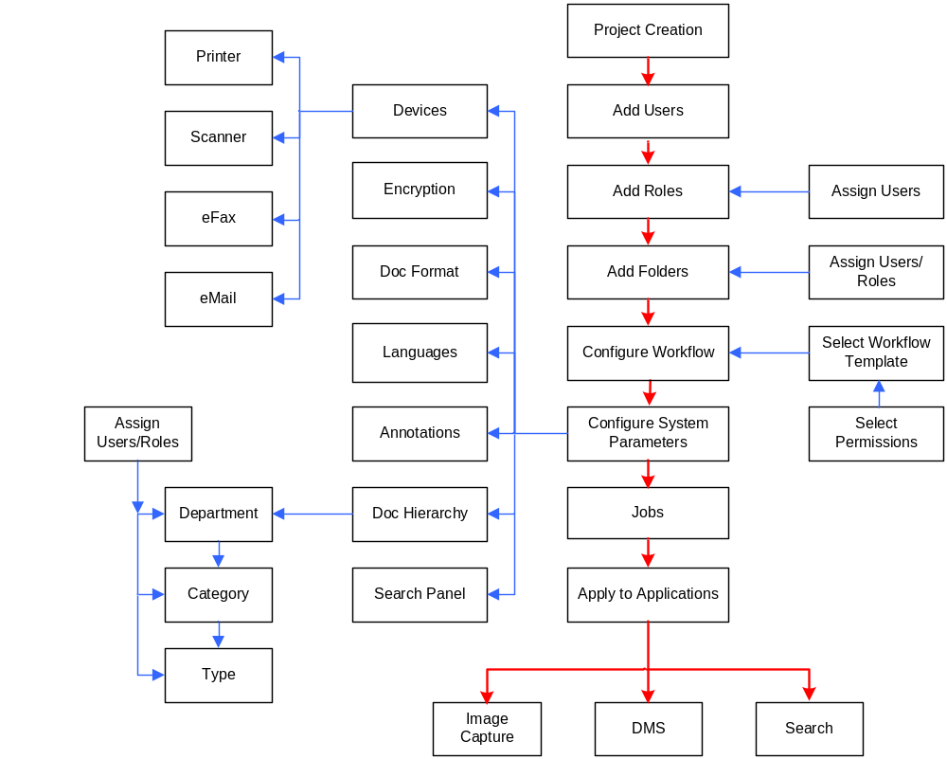

Document Management System Services
All the modules under this section provide various Document Lifecycle Management functions. A Document goes through the following lifecycle:
Creation – Document Addition module
Deletion – Document Deletion module
Viewing – Document viewing module
Modification – Document Modification module
Workflow – Workflow Module
Printing – Printing Module
Faxing – Faxing Module
Mailing – Mailing Module
Collaboration – Document Collaboration module
Indexing – Document indexing module
Archiving - Document archiving module

Document Addition
This section describes the functions with respect to document addition in the EDMS. Documents can be brought into the system by either importing them through a scanner or from an external file system. This module forms a part of DMS application.
Document is the main entity of EDMS. The attributes of a document should be decided during design time based on common properties of different types of documents. When the system imports any document, they should be saved as this entity in the EDMS apart from being saved as a physical file.
The following is an example list of document attributes:
- Name
- Height
- Width
- Format (image, text, xml, etc)
- NoOfPages
- Document category
- Document Type
- Document Class
- Barcode Number
- Physical Location
- Rack Number

Import documents
This module should provide functions to import documents.
- Import a specific file – functions to import a file into DMS (any file format – XML, Word, Image, facsimile, email)
- Import from an entire folder – functions to import all files from a folder into DMS
- Log/audit/register all the import related activities.
- Make database entries with respect to the document fields & audit fields
- Add physical files to the system target file folder
- It is desirable for the EDMS solution to store documents up to 1,000 pages in length.

Importing from a local folder:
Pre-condition: source folder should be accessible and should contain documents for importing
Basic Flow:
- User selects import – local from file menu
- A local machine folder menu is displayed (typically use to import scanned documents into the system)
- Select the folder/file from which to import the files
- Press open button
- Select a target folder in which to put the imported files
- Select the target file type that the incoming files should be converted to
- The folder with all the files should get placed in the target folder in the specified format
- In case no target format is selected, the files should be imported in their original format.
- Database entries should be made with document and audit information
Post-condition: documents gets imported into the target folder of DMS

Importing from a remote folder:
Pre-condition: source folder should be accessible and should contain documents for importing
Basic Flow:
- User selects import – remote option from file menu
- User enter the remote machine name which should be mapped through lan/wan
- The remote machine folder menu is displayed
- Select the folder from which to import the files
- Press open button
- Select a target folder in which to put the imported files
- The folder with all the files should get placed in the target folder in the specified format
- In case no target format is selected, the files should be imported in their original format.
- Database entries should be made with document and audit information
Post-condition: documents gets imported into the target folder of DMS

Scripts to do an auto import of documents into DMS
Scripts should be written to do bulk imports from any file systems to predefined system folders in the required format.
This activity should be performed by the Admin.
Pre-condition: source folder should be accessible and should contain documents for importing
Basic Flow:
- Admin selects import – auto menu item
- Auto import screen options get displayed
- This should contain the following fields:
  - Source folder: (admin selects the folder from which to import documents)
  - Target folder: (admin selects target folder of DMS)
  - Import date: date time field (date to perform import)
  - Save: button
- Admin enters all the information and presses save button

Retrieve/view docs onscreen using our in-house COBOL applications
The integration module should provide access to the COBOL application through which our EDMS can import documents into the system and process them or view them directly from their folder. (Release 1.1)

Create new documents – (phase 2)
Functions should be provided to create new documents in the DMS. This is not a requirement in the scope document, but is a nice to have feature for a DMS.
- Should be able to create a new document of any format
- Should be able to configure any document specific parameters, like size, type, resolution, etc.
- Should be able to save it into a selected folder in the DMS
- Should be able to save the specifications like a template and create more documents from this setting
- Should be able to create html form based documents based on system templates.
Creation of documents might require integration with standard document creation tools like MS office, PDF conversion etc. These links to the system should be provided by the integration module.
This feature will be provided as a part of phase2.

Creating Telephone Forms
There must be a provision to provide forms to capture telephone conversations and the document could be made available to the DMS for use and management.
This feature will be provided as a part of phase2

Document Deletion
The system should be able to select and delete any document by the user with appropriate access rights. The following deletion functions are required to be implemented:
- Delete a single document
- Delete a collection of documents
- Delete a folder with all its documents

Deleting a document in a folder
- User views the system folders
- User either parses the folder to view a document or user searches for a document from search panel
- User selects a document
- Press delete icon inside the document viewer
- System confirms deletion
- System verifies if user has deletion rights
- System deletes the selected document

Deleting an entire folder
- User views the system folders
- User parses the folder structure to reach the desired folder
- User selects the folder
- Press delete icon in the folder view
- System confirms deletion decision
- System verifies if user has deletion rights
- System deletes the selected document

Deleting a Job in a folder
- User views the system folders
- User either parses the folder to view a Job or user searches for a Job from search panel
- User selects a Job
- Press delete icon inside the document viewer
- System confirms deletion
- System verifies if user has deletion rights
- System deletes the selected Job

Auto Deletion
- User enters the Auto-Deletion Screen
- User views the list of all the Auto deletion rules
- User can either select a rule and edit it or delete it
- User clicks on “Add Rule” button
- User enters the Auto-Deletion Add Rule Screen
- User views the following fields:
  - Rule Name – Text input (User enter name of rule)
  - Entity – Drop Down (User selects a Job or Document)
  - Meta-Data Field table – Field name, Fields condition, field value. The User must select the field name from a drop down of valid meta-data fields for the entity eg: document type. Example rows of this table would be as follows:
    - Document Type = Ekatrikaran
    - Document Class = A
  - Deletion date – date/time field (User enters the date when the deletion check should happen based on the above conditions)
  - Deletion frequency – daily/weekly/monthly (User selects the frequency with which the deletion rules must be checked starting from the Deletion Date)
  - Send Alert to – drop-down (User selects the Role to which an alert is sent)
  - Required Approval – checkbox
  - Approving Authority - drop-down (User selects the Role to which approval is sent)
- Use Saves the Rule
- System validates and performs the action on the set date

Document modification
This module should include all document modifications related functionalities

Image Modification
Image modification module should provide standard imaging functions as a tool box in any image document view. The functions would be accessible from the scanning module which typically would provide scanning, indexing and imaging features for documents.
It must provide the following image modification functions in a toolbox: (uses document viewing module)
- Functions for image enhancements and clean-up techniques such as de-skew, de-speckle and Darkening / lightening.
- Cleaning black patches
- Adjusting brightness and contrast
- Rotating image
- Zooming functions
- Highlighting image areas

Modifying an image document
This use case would be used as a part of the document viewer
Pre-condition: user has access rights to modify document
Basic Flow:
- User views a document in the viewer
- A toolbox is visible with various icons for image modification with the following functions:
  - Cleaning Black patches – As a part of this activity, the user selects an area on the image and applies the function to the area. The selected area changes its color to the background color.
  - Adjusting Brightness and contrast – As a part of this activity the user adjusts the brightness and contrast of the entire image
  - Rotating image – As a part of this activity the user can rotate the entire image by the selected angle
  - Manipulating work area of image - As a part of this activity the user changes the work area of the image by changing its size
  - Adding Exceptions – (see annotations)
  - Splitting Groups – As a part of this activity the user drags the page from one document type and places it in another document type
  - Rearranging pages – As a part of this activity the user drags the page from one place to another within a document.
  - Rescanning pages - As a part of this activity the user selects a position in the viewer and runs a scan command. The scanned document gets placed in the mouse position.
  - Splitting an image and saving it as two separate images – As a part of this activity the user marks an area on the image and saves it as a separate image.
  - Merging two or more images and saving it as one image – As a part of this activity the user selects 2 or more images and selects the merge icon from the toolbar. (Desirable but not mandatory)
  - Highlighting image areas
- User selects a particular icon e.g.: for removing black patches
- With the icon, user selects the region on image for whitening
- The marked area removes all black patches
- User saves document
Post-condition: the user should be able to modify the image and save it

Annotations
This module should provide:
- Functions to add/modify/delete annotations to documents – used by all system users
- Functions to define annotation types and categories – used by admin module
Once applied for a document annotations should be viewable throughout the lifecycle of the document, unless specifically deleted by the authorized user. Even while printing the document there should be a provision to print with the annotations.
It is desirable for the EDMS solution NOT to store annotations in image headers.
Annotations should be of the following types:
- Notes
- Tags
- Flags
- Sticky notes
- Exceptions
Each type should be associated with a choice of pre-defined templates. This should be done by the Admin. When the user adds an annotation, he should be given a choice to select the type of annotation. User should have a choice of fonts to enter text in the annotation.

Add Annotation
This use case would be used as a part of the document viewer
Pre-condition: user has access rights to add annotation
Basic Flow:
- Select a document
- View in the doc viewer
- Press edit icon
- Click on add an annotation from the menu item or toolbox
- A window should be displayed in which you can enter
  - The type of annotation (from a select list with predefined annotation types)
  - The category of annotation (from a select list with predefined annotation categories)
  - The content of annotation (text editor icons must be provided to select font, size, style and color)
- User saves the annotation and the system displays the content in a corresponding template based on the annotation type.
- The annotation should be drag-able to any part of the document
- Save changes – the document should get saved along with the annotations
Post-condition: the user should be able to add/edit/save or print annotation

Edit Annotation
- Select an annotation
- Double click inside the annotation window – it should become editable
- Change/edit the fields
- The changes get saved

Delete Annotation
- Select an annotation in a document
- Press delete
- Annotation should be deleted after confirmation

Electronic objects
Functions to add/modify/delete electronic objects to documents
Electronic objects are like media files (audio, photographs and video). Functions should be provided to attach such files into the document. When the document is viewed, it should be viewed with the electronic objects. This would form a part of the Document viewer.

Add Electronic Object
Pre-condition: user has access rights to the electronic object
Basic Flow:
- Select a document
- View in the doc viewer
- Press edit icon
- Click on add an electronic object from the menu item or toolbox
- A window with the list of electronic object types is displayed
- Select the type (e.g.: image/media file/audio file etc)
- Select the location of the electronic object
- Click on add
- It should get added to the selected mouse position on the document.
- Save changes to the document

Edit Electronic Object
- Select the electronic object
- Double click the object
- It should display a properties window showing its properties like name, format, size, etc.
- Edit the object properties, like name, location, etc
- Save changes

Delete Electronic Object
- Select an electronic object
- Press delete
- Should confirm deletion and then delete

Digital signatures
Functions to add/modify/delete digital signatures to documents
Our application should be able to integrate Digital Signatures issued by any of the licensed CAs in India. This would form part of Integration module. The signatures imported from that module would be placed in a specified system folder and would be accessed by this module. This function should also be part of the document viewer.

Add Digital Signature
Pre-condition: user has access rights to modify document
Basic Flow:
- Select a document
- View in the doc viewer
- Press edit icon
- Click on add digital signature menu item or toolbar
- It should display a folder containing the digital signatures for the logged in user
- Select the digital signature and add
- The signature should get appended to the document
Post-condition: the user should be able to add digital signature to the document.

Delete Digital Signature
- Select the digital signature
- Delete it
- System should verify and delete it from the document

Rearrange pages
Functions to modify page numbers
All documents contain one or more pages which are arranged by their page numbers. This module should provide functions to rearrange pages by altering the page numbers. This function should be a part of the document viewer.

Rearranging pages
Pre-condition: user has access rights to modify document
Basic Flow:
- Select a document
- View the doc in the viewer
- Its pages are displayed by default as thumbnails
- Select a page thumbnail
- Drag and drop the page in a different location (between pages, etc)
- Save document by pressing save icon
- System should renumber the pages
Post-condition: user can rearrange and save pages within a document

Creating a new file from existing file
Pre-condition: user has access rights to modify document
Basic Flow:
- Select a document
- View the doc in the viewer
- Its pages are displayed by default as thumbnails categorized by document types
- Select file-new-folder
- System asks for the folder name
- System creates the folder and displays in the viewer as the new document type
- Select a page thumbnail or multiple pages
- Drag and drop the page(s) in the new folder
- Save document by pressing save icon
- System should renumber the pages
Post-condition: user can rearrange and save pages within a document

Linking documents
This module should provide functions to add document references to other documents.
There can be a scenario when a document needs to provide a reference to another document for further processing. This module should provide functions to provide a link to other documents. This feature should be a part of the document viewer. (Release 1.2)

Providing reference to a document
This is a desirable, but not a mandatory feature.
Pre-condition: user has access rights to add the link
Basic Flow:
- Select a document
- View in the doc viewer
- Click edit icon
- Click “link a document” from the menu item or toolbox
- The base project folder is displayed
- Parse the folder/sub folders and select the document to be referenced
- A highlighted link with the document name gets added to the current document
- Save changes to the document.
- Clicking the link should display the contents of the linked document in the current window.
- One or more documents can be provided as links.
Post-condition: The user can add a link to the document and view it.

Document types
Documents are classified by “Document Type”. After scanning/importing a document there should be a provision to select one/multiple document(s) and assign a document type to them. Document type can be assigned at the time of document creation too (uses document hierarchy). There must also be functions to allow document type definitions (used by the admin module).

Assigning document types
- Select the project folder
- Select one or more documents in the folder structure
- From folder view select “assign type” icon
- A window opens with the list of available types (to be assigned at the time of project creation by the admin)
- Select a “document type” and press assign.
- System should do validations
- All documents should get associated with the assigned type.
- In case a Form is associated with the selected document type, then the form automatically gets associated with the selected documents on performing this operation.

Document format conversion
There should be functions to change a document from one format to another. This should be done for both a single document as well as multiple documents. It should be possible to convert any selected format to another system recognizable format. This function is provided as a part of the Document Viewer. The system recognizable formats are as follows (more can be added as required):
- Text
- Image (TIFF multi-page files G3 and G4 compression, JPEG, GIF, XML and PDF )
- Word (The EDMS solution must have the capability to rendition documents from MS Word to PDF format)
- Fax
- XML
- Email
- Html
In Phase 1, we are only going to provide functions for:
- Conversion from any format to html and pdf for viewing documents
- Conversion from any text based document to a standard image document in order to use image modification functions
- Conversion from MS Word to PDF format.

Converting from one format to another
Pre-condition: user has access rights to convert format of the document
Basic Flow:
- From a folder view select a document or multiple documents
- From the menu or folder view icon choose “convert format”
- A window with allowed formats is displayed (configures by admin for every project)
- Choose a format and select apply
- The document(s) gets saved in the appropriate format after displaying certain warnings (as in the appearance might change etc)
Alternate Flow:
- The document is opened in the viewer
- The user selects convert format icon
- A window with allowed formats is displayed (configures by admin for every project)
- Choose a format and select apply
- The document gets saved in the appropriate format after displaying certain warnings (as in the appearance might change etc)

Text Modification – phase 2

Functions to update text within a document
- This module should provide standard editing functions applicable to any text based document e.g.: cut, paste, insert, etc.
- Select an editable document
- View the document
- Edit its content – standard edit menu should be provided for all edit functions (cut/copy/paste/redo/undo)
- Save the document

Document Viewing
This module should be able to load any image or non image documents from within the system as well as from external systems into the document viewer. It should provide standard page/image viewing features like pagination, view as thumbnails, add as bookmark, etc. The following is the detail list of functionalities to be provided as specified in scope:
- Image viewing functions: functions to rotate and zoom images
- Functions for viewing non image documents like MS Word, Excel, power point etc, without native applications in PDF or HTML format. Supports viewing of common file formats without launching application that created them (viewers), including images i.e. able to view file formats without requiring the native application
- Functions to retrieve and view docs onscreen through our in-house COBOL applications or other 3rd party applications
- Functions to display pages one a time, multiple pages on screen at once, select desired page easily go to first/last page. Facility to traverse to next page/previous page or specific page for viewing multi page documents
- Functions to bookmark pages for viewing
- Support for Thumbnails and direct page level access within a document should be possible.
- Viewer must allow strip-by-strip display of the image in case of low band width availability
- Facility of viewing annotations
- The proposed EDMS must support split screen viewing (a document in one window and another application screen in a second window).
- Multiple document windows open at once by single user

Image/Document Viewer
A Document Viewer needs to be built incorporating all the above mentioned features:
- Should be able to open any format of document – viewing any document from any folder or search results page should open the document in this viewer.
- A menu item should be provided to open a document in a new viewer window, so that multiple documents can be viewed in multiple viewers.
- There should be a provision to view third party application in a frame of this viewer (Relase1.2)
- The viewer must convert the document to a standard image format for viewing.
- The document view by default is the thumbnails view where all the pages are listed as thumbnails on one section of the screen with the other section displaying the first page of the document.
- An image toolbox is displayed on the screen with icons for rotating, zooming, and image modifications functions. There should be a facility to hide this toolbox. (the use cases are described in document modification)
- An append toolbox is displayed with icons for appending to the document e.g.: electronic object, digital signature, annotations, etc. There should be a facility to hide this toolbox. (the use cases are described in document modification)
- A form toolbox should be displayed with icons to add and view form fields. There should be a facility to hide this toolbox. This toolbox should be displayed only for documents of type Form OR for documents associated with a form. (the use cases are described in document indexing)
- Previous and next buttons are provided to traverse from one page to another along with links with all page numbers to allow direct access to desired page.
- A menu should be provided to change the page view to a list instead of thumbnails.
- A menu should be provided to delete selected pages (use case provided in document deletion)
- A menu should be provided to bookmark the currently selected page for fast viewing. While book-marking the system should ask for:
  - Bookmark category
  - Bookmark name
- The bookmarked documents should be viewable from the menu categorized by their categories.
- In case the document has annotations, they must all be visible by default. The menu should have a feature to hide the annotations.
- A menu should be provided with features to take a printout or send the document as a fax or as a mail object depending on his access rights.
- Print command should print the document on the default printer (uses print module)
- Fax command should fax the document using the fax machine configured for the project(uses fax module)
- Mail command should ask for: (uses messaging module)
  - To address
  - Message body
  - Using the default mail server configured for the user/role, a mail should be sent with the document as attachment
- Workflow actions menu or toolbar must be provided by the viewer. The workflow actions include:
  - Share
  - Forward & Forward condition (complete, on-hold, partly-complete, conditional complete)
  - Return
  - Check-in
  - Check-out
- Document related references section must be provided in the viewer. This section should have the following tabs:
  - Document info: displays document properties
    - Document name
    - Document format
    - Document size
    - Document classification
    - Physical document reference
  - Project info: displays the project details of the document
    - Project name
    - Project details
  - Route info: displays the route info of the document
    - Route name
    - Route description
    - Initiated by
    - Initiated on
  - Meta-Data info: displays all the form fields with their values
    - Field name
    - Field value
  - Tracking info: displays the lifecycle of the document
    - Date
    - Time
    - Action
    - By
    - Description
  - Messages: displays all the messages related to this document with the most recent one on the top
    - By
    - On
    - Activity
    - Message

Using viewer for document modification
Refer to the use cases of document modification module. The viewer must include toolbars for performing all the document modification functions.

Using viewer for document deletion
- User opens the document in the viewer
- User selects the delete icon from the toolbar or menu
- The system validates user permissions for deleting document
- System performs appropriate action.

Using viewer for document printing
- User opens the document in the viewer
- User selects the print icon from the toolbar or menu
- The system validates user permissions for printing document
- System displays the print window for configuring printer before printing
- System performs appropriate action.

Using viewer for document faxing
- User opens the document in the viewer
- User selects the fax icon from the toolbar or menu
- The system validates user permissions for faxing document
- System performs appropriate action.

Using the viewer for document mailing
- User opens the document in the viewer
- User selects the mail icon from the toolbar
- The system validates user permissions for mailing document
- System displays the mailing window to configure the mailing inputs
- User enters the inputs
- System performs appropriate action.

Using the viewer for Book marking a page
- User views a document in the viewer
- From the menu user chooses bookmark – add
- A bookmark window asking for: category & bookmark name is displayed
- User enters the values and saves
- User views the bookmark name under bookmark-view-category name
- User opens another document
- From the menu user selects the bookmark-view-category name-bookmark name
- User gets to view the document which he had bookmarked showing the page that was bookmarked in the details window.

Using viewer for Defining form fields
(See document indexing)

Using viewer for Entering form field values
(See document indexing)

Using viewer for workflow actions
Pre-condition: Document is opened in the viewer and has an assigned workflow route.
- Share
  - User presses the share button
  - User views a list of system users pop up
  - User selects a user name and presses “OK”
  - System sends an alert to the shared user.
  - The shared user can now have viewing rights for the document
- Forward
  - System displays a selectable input: “Forward condition” with the following entries:
    - Complete
    - Partial
    - Conditional
    - On-hold
  - User selects a forward condition
  - User enters the message in the message box
  - User presses “fwd” button
  - System sends the document to the next activity based on the workflow route
- Return
  - User can add annotations & modify image if required
  - User presses “return” button
  - System sends the document to the previous activity based on the workflow route
- Check-in & Check-out
  - User presses check-out button before modifying a document
  - The modification menus & toolbars become visible
  - User can perform any document modification functions
  - User saves the document
  - User presses check-in to commit the changes
  - The document modification menus and toolbars get hidden again

Using viewer for cross-referencing docs
Pre-condition: Document is opened in the viewer and has an assigned workflow route.
- User presses “cross reference” button
- System opens a full text document search window
  - Folder name: browse folder
  - Search text: text input
  - Search: button
  - Save: button
  - Cancel: button
- User enters the search text
- User performs search operation
- The pop-up displays the search results in the form of a document list
- User can select a document to view it in a separate viewer
- User can save the search query. In this case when the user clicks the cross reference button next time, he would get to view the previous search query.

Document Indexing
This module should provide functions to allow manual and auto indexing of documents. This includes classification of documents into folders as well as creating data classes and applying them to documents for quick search and retrieval.
The system should provide the following features as per the scope document:
- Catalogue documents which are stored off-line
- Support for auto indexing using CSV import from other applications
- Creation of User-defined data classes with multiple user-defined indexes on various data types and provide the functionality for defining user-defined indexes or fields that could be associated to any document across the cabinet.
- Support for indexing the documents or folders on user defined and system defined parameters.
- Association of data classes with documents and folders for easy search and retrieval
- Filing and indexing of documents for quick retrieval
- The proposed EDMS product must support a hierarchical organization of documents in cabinets, folders and subfolders or any other comparable structure for Classification of information and hierarchical storage management for large volume of documents.
- The proposed system must have the capability to extract data from any form, structured or unstructured. Perform the data extraction using techniques such as OMR, ICR, OCR, MICR and Barcodes. Export the data to the document management system for image retrieval.
- Facility for assigning document types

Creating a form
Pre-condition: User should have appropriate rights to perform this activity
Basic Flow:
- The user scans a sample document to be used as a form
- The user saves the document as a form template
- User opens the form document in the viewer
- User selects a page of the document
- Using the forms tool box the user marks an area in the document
- A form field window is displayed containing:
  - Name of field
  - Type of field
  - Image location
  - Save button
- User enters the name of the field
- User enters its data type
- If its an image he enters the file path of the image
- User saves the field data
- A field list window is displayed showing all the fields defined for this form
- User must enter the “Data Type” and “Barcode Number” associated with this form by using the forms tool box
- User can mark more areas and repeat the field definition process for all
- User saves the form document.
- When new documents enter the system through scanning, all the documents having the same barcode number (or Data Type) get associated with this form automatically (Auto-Scanning). The form can also be associated explicitly with a document at the time of scanning by specifying in the scanner configuration setting. So during meta-data entry, when the user views the document, he sees all the form fields and gets to enter the values.

Associating a form with documents
This use case is to define an explicit association of documents to a form
Please check the use case in “Scanning Module” called “Classification rules for scanned documents”.
A bunch of documents can be selected post scanning operation and can be assigned new Forms in the following way:
- User logs in DMS
- User selects a bunch of documents
- User selects Folder – Apply Form
- System displays a window displaying all the forms.
- User selects a particular form to be associated with the selected documents
- System displays a window confirming form application to the selected documents.
- User confirms
- The form gets applied to all the selected documents
- If the folder structure is dependant on the form (document type) then the system relocates the documents to appropriate folders.

Entering Form Data (Meta-Data Entry)
This use case will be for the DMS Application. Please check the “Meta Data Entry” use case described in the “Workflow Module” for Image Capture Application.
Pre-condition: User has appropriate access rights
Basic Flow:
- User views a document in the document viewer
- User views the form toolbox
- User selects the show fields icon
- User sees a window with all the fields in the following way:
  - Field name
  - Field value
  - Image location
- User enters the field values against the field names E.g.:
  - Document name – lic20003456inspol
  - Signature – c:\signatures\users\ramkumar.gif
- User saves the meta data
- System validates and saves the meta data
- User saves the document using the save document icon of the viewer.
Post-condition: The document gets saved with the meta-data fields as indexes in the database.

Automatic form application
The system should provide scripts to apply form definitions to a bunch of documents so that a bulk of documents can be associated with a form or a data class. Please check the use case in “Scanning Module” called “Classification rules for scanned documents”.

Automatic classification of documents
The system should provide scripts to apply folder structure to a bunch of documents so that they can be classified to land into appropriate folders. Document Hierarchy must be used to provide the information for this activity.
The following fields will be used by the system to identify a particular document:
- Bar code
- Doc type
- Doc class
- Form fields associated with the document
- Project specific fields e.g.: job id

Document Collaboration
All documents in the EDMS should be accessible to users through a common universal inbox. The users with the appropriate right can view or modify documents assigned to them. This should happen in a secure collaborative way. EDMS should provide the following functionalities as per the scope document:
- The workflow system must support a “universal inbox” which is accessible concurrently by multiple users and secure inboxes (access restricted to specific users).
- Proposed EDMS must provide Inbox and Outbox for individual users for posting documents.
- System must provide version control for tracking document revisions. Check-in and Check-out support for collaborative working on documents.
- Lock documents and folders for modifications
- The proposed EDMS solution must support concurrent read/print access to documents by multiple users
- Universal view must provide functions to perform on bulk documents eg: approval, deletion and assignment and callback.

Universal inbox for viewing documents
The system should provide user friendly interfaces to view documents. This can be decided during UI Design. As an example we can assume that the documents are viewed in a Folder view where the documents are present in the project folder structure.
E.g.: the root project folder is “LIC” and the document hierarchy is defined as follows:
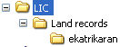
The logged in user should be able to enter the folder to view all documents assigned to him by default. He should have a provision to change the view to a “universal inbox” where he can view all project documents and not just the ones assigned to him. The documents displayed in the folder should display the following information:
- Document name
- Document format
- Document type
- Document Route
- Document activity
- Document status
The documents which are being modified or checked-out should be displayed in red color. This view must support concurrent read/print access to documents by multiple users with appropriate access rights.
There should be an additional view called “Outbox” in the menu, which should display all the documents assigned to the user whose activity has been completed by the user.

Using document check-in check-out
- User logs into the DMS
- User can view all the documents assigned to him here categorized in folders/cabinets
- User can view the documents in the check-out status if any (check out is the status of a document which is being modified by a user). This can be indicated either as a status field or in a particular color e.g.: red color.
- User can change the view to universal inbox where he can view all the documents in the project.
- User can view documents if he is authorized to do so. When the user clicks on a document, the document opens in the document viewer.
- User checks-out the document for working (for document modification). The document gets locked. He has the provision to lock an entire folder if authorized to do so.
- User performs the necessary action on the assigned documents and checks in (saves the document).
Every document action and revision should be logged/ saved by the system. Check the reporting module for the audit related fields.

Document Archival
This module should provide functions to store and archive documents in the DMS. It should provide the following functions:
- To archive data based on the archival configuration
- To transfer data from one location to another across LAN/WAN/MAN
- To store audit details for archival– used by reports
- To store document audit and version information – used by reports
- To store import and export related audit information – used by reports
- To store workflow related audit information– used by reports
- To store folder audit information– used by reports
- To export data to external file systems
- To download data
- To provide automatic migration of documents between storage platforms as part of the archiving and document lifecycle management process based on triggering events initiated from another system.

Storing document audit information
- User imports data into DMS
- The documents get physically stored in DMS file system and also get a database entry
- Along with document attributes, the following document creation audit fields get stored in the database:
  - Created on – Date/time
  - Created by – User name
- If the user views a document, the following document audit fields get stored in the database:
  - Viewed on – date/time
  - Viewed by – user
- If the user checks out a document and modifies it, the following document modification audit fields get stored in the database:
  - Modified on – Date/time
  - Modified by – User name
  - Previous version – text (alphanumeric)
  - Current version – text (alphanumeric)
- If the user modifies a document which causes a workflow activity change, then the workflow activity related audit information gets saved in the database e.g.:
  - Activity:
    - Started on – date
    - Started by – username
    - Completed on – date
    - Completed by – username
- If the user deletes a document, the following document audit information gets saved in the database:
  - Deleted on – date
  - Deleted by – username

Archiving data
Scripts should be written to move a copy of the data into a backup server on daily/weekly/monthly basis depending on the script configuration. The audit information like the data moved the version of the documents, move by user name, etc. should be logged or stored. The fields in the script should be configurable.
The use case for creating an archival entry is provided in the Admin section as the Admin is responsible for configuring archival information. Its implementation is however provided here.

Archive data
Here the user or admin selects the data that should be archived.
- User selects – document – archival – add
- System displays archival details page with the following fields:
  - Archival name – text input (name given by the user)
  - Archival data – txt input with file browser button. The user should select the folder whose documents should be archived. The entire document in the sub folders also get included.
  - Archival destination – select the folder or server (local or remote) to which the data should be archived
  - Archival frequency – select input (daily/weekly/monthly)
  - Save - button
- User enters the field information and saves
- System validates data and saves
- Screens should be provided to view, edit and delete the archival entry
- Based on this archival information, the system should provide scripts to archive data as per the configuration. While performing archival, the system should also save the following audit information in the database:
  - Archive created on - date/ time
  - Archive created by – username
  - Archived on – date/time
  - Archived to – machine and folder name

Auto Archival
- User enters the Auto-Archival Screen
- User views the list of all the Auto Archival rules
- User can either select a rule and edit it or delete it
- User clicks on “Add Rule” button
- User enters the Auto-Archival Add Rule Screen
- User views the following fields:
  - Rule Name – Text input (User enter name of rule)
  - Entity – Drop Down (User selects a Job or Document)
  - Meta-Data Field table – Field name, Fields condition, field value. The User must select the field name from a drop down of valid meta-data fields for the entity e.g.: document type. Example rows of this table would be as follows:
  - Document Type = Ekatrikaran
  - Document Class = A
  - Archival date – date/time field (User enters the date when the deletion should happen based on the above conditions)
  - Archival Destination – Text input (User enters the complete path of the destination folder)
- Use Saves the Rule
- System validates and performs the action on the set date
- Based on this archival information, the system should provide scripts to archive data as per the configuration. While performing archival, the system should also save the following audit information in the database:
  - Archive created on - date/ time
  - Archive created by – username
  - Archived on – date/time
  - Archived to – machine and folder name

DMS Flow
The following image summarizes the DMS services available.

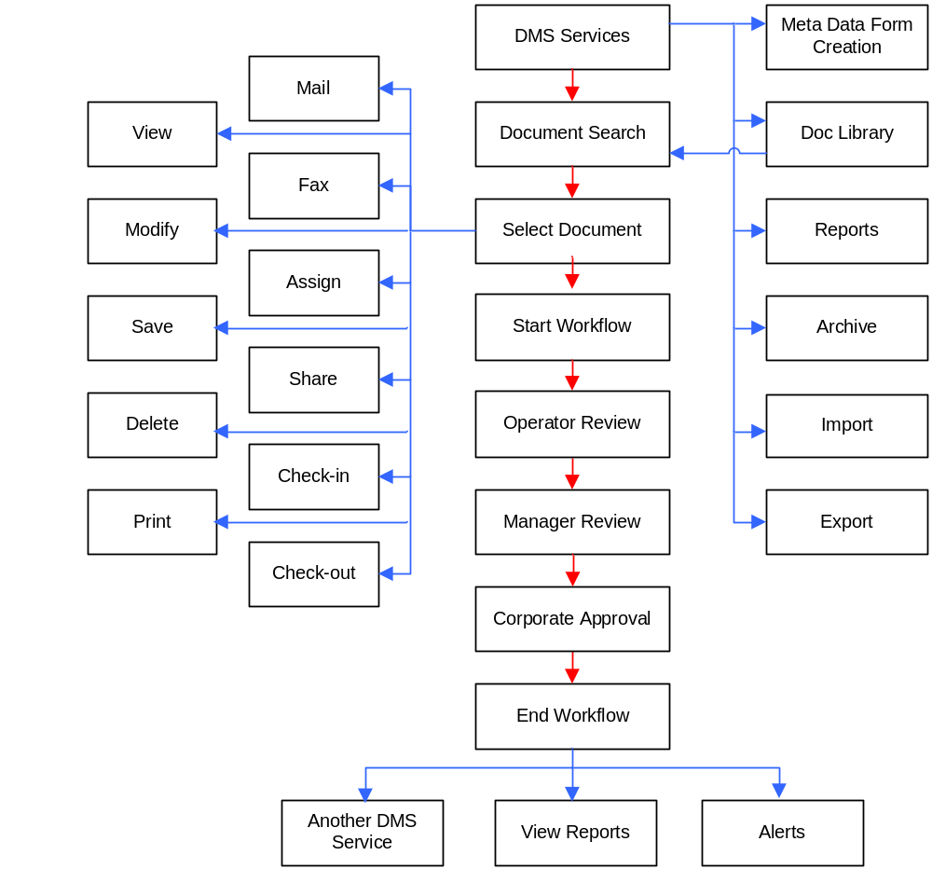

Image Capture Services
This module deals with converting a physical file into an electronic document format, mainly images. The physical files are bundled together in the form of dockets. We use the term “Job” to represent a docket. In Image Capture, “Job” is the work item going through the system workflow. Job is a bunch or file of related documents of different document types. Since “Job” is the work-item, all services listed here apply to a job instead of a particular document. A Job goes through a lifecycle from creation, verification to being ready to be exported to DMS.
- Job Configuration – Performed as a part of Configuration module
- Job Creation – Described in this section
- Job Assignment– Described in this section
- Job Deletion - Same as Document Deletion with Job as the entity instead of Documents.
- Job Viewing - Same as Document Viewer with Job as the viewing entity
- Job Collaboration - Same as Document Collaboration with Job as the collaborating entity
- Job Verification - Refer to Image QC, Meta Data QC and PDF Validation use cases described below.
- Job Workflow – Described in the Workflow module
- Auto Scanning – Described in Scanning Module
- Auto Classification - Described in Scanning Module
- Export to DMS – Described in this section
- Reports - Described in the Reporting module
- Job Search – Same as document Search in Search module with jobs as the search results. It is described in the use cases below.
- Online Image Capture
The following use cases describe the Image Capture related services.

Job Configuration
Pre-condition: The user belongs to the appropriate role and has the permissions to perform the activities in the process
- User enters the Job Configuration Screen
- System displays the following fields:
  - Job Category – Text input (user enters the name of the job category)
  - Job Code Range (User enters for a particular category)
    - From
    - To
  - Job Content – drop-down (User selects either Doc Type or Docket). In case of a Doc Type, the Job is a group of document types whereas in case of a Docket, the Job is a group of Dockets, where each Docket contains one or more Doc Types
- User enters all the values and saves the Job Configuration settings
- System validates and applies the setting to the project.

Job Creation
Pre-condition: The user belongs to the appropriate role and has the permissions to perform the activities in the process
Basic Flow:
- The valid role to perform this process is the “Job Creator”.
- Job Creator logs into the scanning application
- Job Creator enters the Job Creation Screen
- Job Creator views the following fields related to a Job:
  - Job Name – text Input
  - Job Category – drop down
  - Job Code – Text Input (based on category)
  - Document List – Table
  - Save – button
  - Delete – button
  - Edit - button
  - Document List table contains the following fields:
    - Document Class
    - Document Type
    - Barcode Number
    - Number Of Pages
  - In case the Job Content is a Docket, then the Document List table displays the fields categorized by Docket. E.g.:
    - Docket Name
      - Document Class
      - Document Type
      - Barcode Number
      - Number Of Pages
- Job Creator enters all the fields
- Job Creator saves or edits or deletes the job data (based on the role permissions)
- System validates data and performs the appropriate actions
Post-condition: In case of no errors during save operation, the Job is saved to the system and is ready to be scanned. In case of delete the job is deleted after validation.

Job Assignment
- User Select Job Assignment Menu item
- User selects a group of jobs or an entire category of jobs to be assigned
- User selects the workflow template for the jobs. This template specifies the list and sequence of activities e.g.: Image QC, Scanning, etc.
- User sets the Security permissions related to the activities for the users e.g.: Job – Read, Delete, etc.
- User selects the groups of users or an entire role for assignment
- User can select an option to assign users specifically to individual jobs by pressing “User-Job Mapping” button.
  - This takes the user to the “User-Job Mapping” screen, where the user sees the following table having the columns:
    - Job Numbers – Displays the Job Range here
    - Users – Displays the user names here separated by commas
    - Priority – selectable input (high, medium. Low) – to be set for each job.
    - Add – button
    - The user can press “Add” button to map more jobs to users
- User enters the allocated time for each activity
- User selects the “Alerts” button to configure alerts related to the activity
- System displays the Rules available for the “Activity” based alerts
- User selects a rule e.g.: For “Image QC” activity user selects rule “if Activity not started for 2 days”, then all the users associated with this workflow will get a notification.
- User saves the Assignment
- The system will now follow the workflow definition for the selected jobs.

Scanning
Pre-condition: The user belongs to the appropriate role and has the permissions to perform the activities in the process, there is at least one job for scanning and there is at least one scanner available for use.
Basic Flow:
- The Role responsible for this process is “Scanner”.
- Scanner logs into the scanning application
- Scanner views the Scanning screen.
- Scanner views all the jobs assigned to him by clicking “View All Jobs” button.
- Scanner selects a particular Job for Scanning.
- Scanner has views all the project scanners by clicking “Select Scanner” button.
- Scanner views all the project scanners and selects a particular scanner.
- Scanner has the option to modify scanner configuration parameters of the selected scanner.
- After choosing a Job and a scanner, the Scanner performs the scanning activity.
- The system validates the scanner configuration data and performs scan operation on the Job.
- The scanned images of all the documents get displayed in the document viewer categorized by document types.
- The scanner views all the documents and the pages within the documents to ensure all the pages got scanned.
- In case of any discrepancy the scanner has the option to delete the scanned images and perform a rescan on the Job.
- The scanner should be able to rescan a particular document within a job.
- After confirming the scanned images the Scanner saves the document into the Scanning Application System.
- The Job is now scanned and ready for Image QC.
Post condition: Based on his role, a scanner should be able to launch a scanner, configure it, view scanned documents, delete and re scan the documents.

Image QC
Pre-condition: The user belongs to the appropriate role and has the permissions to perform the activities in the process and there is at least one scanned job available.
Basic Flow:
- The Role responsible for this process is the “Image QC Operator”.
- The Image QC Operator logs into the scanning application
- Image QC Operator enters the Image QC Screen
- He views all jobs assigned to him by clicking “View All Jobs” button.
- He selects a particular job to perform the image qc process
- All the documents within the job open in the document viewer categorized by the Document type.
- Image QC Operator selects every page of each document to perform Image QC
- Using the tool bar and features of the document viewer he should be able to perform the following functions on the documents and their pages:
  - Cleaning Black patches – As a part of this activity, the user selects an area on the image and applies the function to the area. The selected area changes its color to the background color.
  - Adjusting Brightness and contrast – As a part of this activity the user adjusts the brightness and contrast of the entire image
  - Rotating image – As a part of this activity the user can rotate the entire image by the selected angle
  - Manipulating work area of image - As a part of this activity the user changes the work area of the image by changing its size
  - Adding Exceptions – (see document modification module - annotations)
  - Splitting Groups – As a part of this activity the user drags the page from one document type and places it in another document type
  - Rearranging pages – As a part of this activity the user drags the page from one place to another within a document.
  - Rescanning pages - As a part of this activity the user selects a position in the viewer and runs a scan command. The scanned document gets placed in the mouse position.
- After performing the functions he should be able to save the document.
- This role should have the permission to view jobs, view documents, modify document, delete and rescan documents within a job and add/edit/delete annotations to documents.
- In case of adding an exception (annotation) the job should be visible in the appropriate workflow process based on the category of exception. Eg: in case the category of exception is “Job Creation” it will be visible in the job creator’s view.
Post-condition: If Image QC passes, then the job is ready for Meta Data Entry else based on the exception it goes to a different process.

Meta Data Entry
Pre-condition: The user belongs to the appropriate role and has the permissions to perform the activities in the process and there is at least one scanned job available
Basic Flow:
- The Role responsible for this process is the “Meta Data Entry Operator”.
- Meta Data Entry Operator logs into the scanning Application
- He views the Meta Data Entry Screen
- He views all the Jobs from the “View All Jobs” screen.
- He selects a Job
- The Job with all its documents opens in the document viewer categorized by the document type.
- Meta Data Entry Operator selects the document and its pages for meta data entry
- On selecting a page, he gets to see all the meta-data fields displayed in that page.
- He selects a particular field and views the corresponding highlighted area on the image.
- He enters the field values against each field based on the content of the highlighted area.
- He saves the document with the meta-data info.
- The system validates and saves the document and the job.
- The job is now ready for Meta Data QC process.
- This role should have permissions to view/edit jobs, view/print/fax/mail documents and edit form fields.
Post-condition: Based on the document action, the job is either saved with meta-data info or faxed, mailed or printed.

Meta Data QC
Pre-condition: User belongs to the appropriate role and the job should have completed meta-data entry process. This process always follows Meta-Data Entry.
Basic Flow:
- The Role responsible for this process is the “Meta Data QC Operator”.
- Meta Data QC Operator logs into the scanning Application
- He views the Meta Data QC Screen
- He views all the Jobs from the “View All Jobs” screen.
- He selects a Job
- The Job with all its documents opens in the document viewer categorized by the document type.
- Meta Data QC Operator selects the document and its pages for meta data entry
- On selecting a page, he gets to see all the meta-data fields displayed in that page.
- He selects a particular field and views the corresponding highlighted area on the image.
- He verifies the field values against each field based on the content of the highlighted area.
- He corrects and saves the document with the meta-data info or adds an exception using annotations.
- The system validates and saves the document and the job.
- The job is now ready for the next process.
- This role should have permissions to view/edit jobs, view/print/fax/mail documents and edit form fields.
Post-condition: The job both completes the Meta Data QC process, and gets ready for PDF-validation OR in case of an exception, the job goes back into a process based on the exception/annotation category.

PDF Validation
Pre-condition: User belongs to the appropriate role and the job in this process should have completed all the other processes and should be without exceptions.
- The “PDF Validator” logs into the scanning application
- He gets to view the PDF validation screen.
- He views all the Jobs from the “View All Jobs” screen.
- He selects a Job
- He either approves the job by pressing the approve button or adds an exception by entering the exception details in the exception window:
  - Activity – drop down (process in which exception happens eg: job creation)
  - Details – drop down (type of error eg: spelling)
  - Comments – text area (description of error)
- The job is committed to DMS after PDF Validation. So it moves from scanned folder to DMS folder.
Post-condition: In case of exceptions the job moves back to the process indicated by the exception. In case of approval the job can either move to DMS or wait for an explicit call for “Export to DMS”. This depends on the workflow definition.

Export to DMS
Pre-condition: The Job has completed the workflow successfully
- The user views all the Jobs which have passed validation from the “View All Jobs” screen.
- The user chooses “Export to DMS” menu item.
- System verifies if the user wants to perform the action
- After confirmation, the system exports all the documents in the Jobs to DMS.
- The Jobs now land in a different view of “Jobs exported”.

Job Search
- User enters the Job Search Screen
- System displays Job related search fields
  - Job Category : Drop down (list of job categories)
  - Job Range: Fixed Text (Based on the job category selected)
  - Job Name: Text input (Name of the job)
  - Job ID: Text Input (Valid number in the range)
  - By User: Text Input (Select user)
  - By Activity: Drop-down (Select Activity)
  - By Status: drop down (Select Status of Activity)
  - Search – button
- User enters the search criteria and performs search
- User is displayed all the jobs conforming to the search criteria.

Image Capture flow
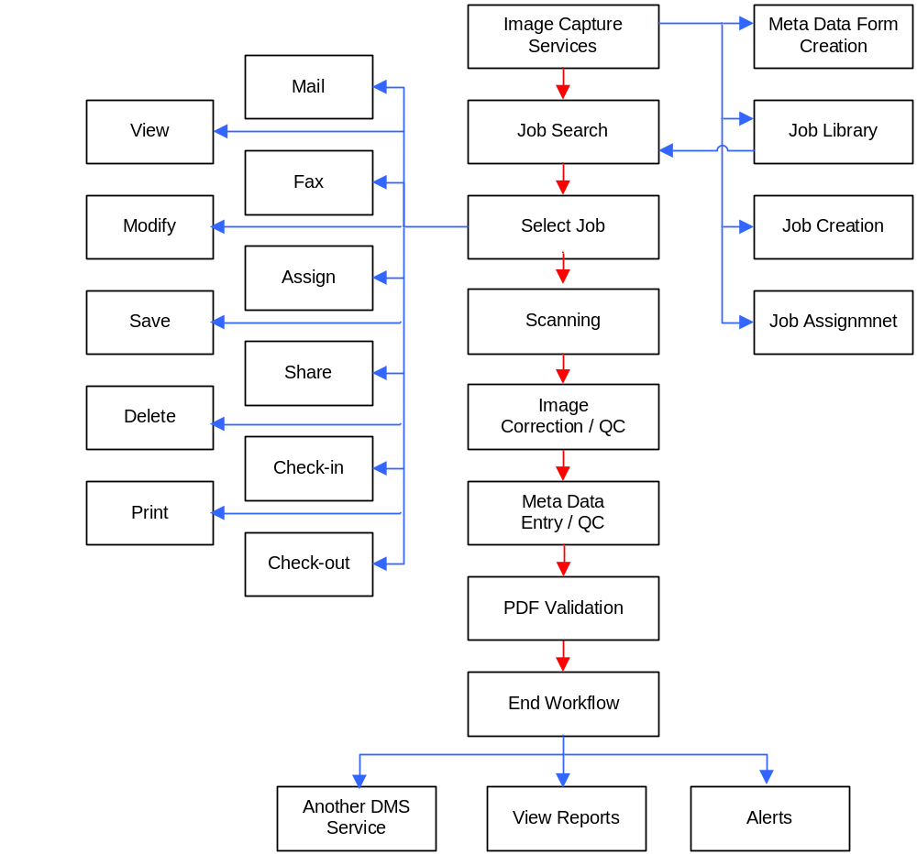

Online Image Capture (DMS)
All the above services in Image Capture should be available as an online service within DMS. With this service the users can directly scan few documents into images and make them directly a part of the DMS repository. Here, the documents instead of being grouped into jobs and then going through Image Capture flow, would directly be scanned, modified, indexed, validated and saved into DMS.
The following diagram depicts the flow of a document in an online image capture scenario:
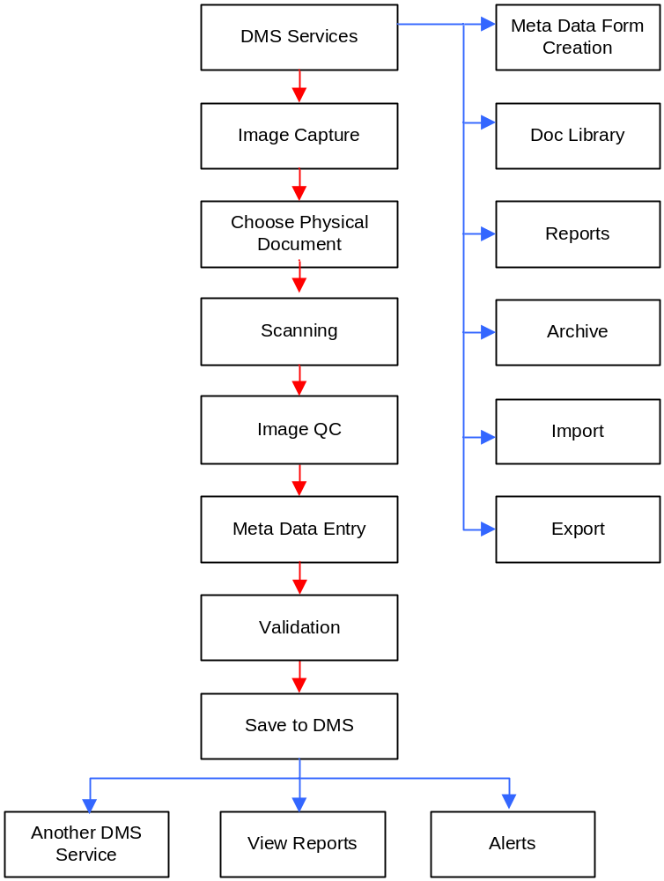

Document Capture Services
This module deals with converting an electronic document into a DMS acceptable electronic document format, mainly for non-image documents like MS Word, Text, XML, Fax, E-Mail, etc.. Like in Image Capture, “Job” is the work item going through the system workflow and all services listed here apply to a job instead of a particular document e.g.: Document deletion would be Job deletion. A Job goes through a lifecycle from creation, verification to being ready to be exported to DMS. These services would be utilized whenever documents need to enter into DMS in a bulk as an offline process.
The main services offered by this module are:
- Project management & Configuration – The common modules need to define and configure system
- Document Addition (Importing & Creation ) – Same as Document Addition of DMS Services
- Document Modification – Same as Document Addition of DMS Services
- Document Deletion – Same as Document Deletion of DMS Services
- Job Creation – Same as Job Creation of Image Capture. Jobs are created by selecting a group of related documents.
- Job Deletion – Same as Document Deletion of DMS Services with Job as an entity
- Job Collaboration - Same as Document Collaboration of DMS Services with Job as an entity
- Job Workflow
- Job Viewing - Same as Document Viewer of DMS Services with Job as an entity
- Job Verification – Same as Image QC service of Image Capture, but instead of images, the documents get verified. In case of an error exceptions get added and in case of success the Jobs are ready to be exported to DMS.
- Export to DMS – Same as Export to DMS of Image Capture.

The following diagram shows Document Capture flow:

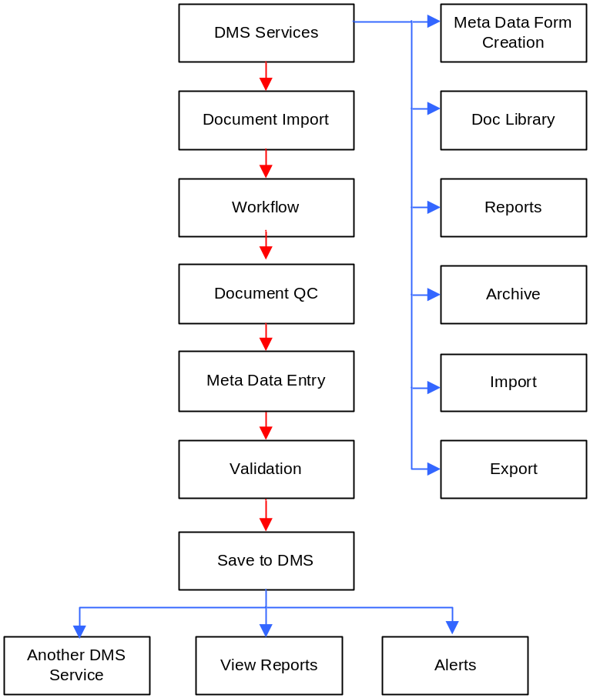

Workflow
This module should provide workflow related functionalities. The system requirements are as follows as per the scope document:
- The proposed EDMS must support adaptive workflow for routing and tracking of documents, messages and forms within or across workgroup. Collaborative working on documents in a secure environment through work-items.
- The proposed EDMS must support split screen viewing (a document in one window and another application screen in a second window) – Forms part of Document Viewing module
- The proposed EDMS should provide the capability of routing documents based on user decisions.
- It is required for the proposed EDMS to maintain a log of actions that have been taken on a document (e.g. the routing sequence, notes about problems in processing a document, people who need to review the document and other annotations) – Forms part of Reporting Module
- The workflow system must support a “universal inbox” which is accessible concurrently by multiple users and secure inboxes (access restricted to specific users) – Forms part of Document Collaboration
- The workflow system must support the generation of workflow statistics and status of work items reports – Forms part of Reporting module
- Create Ad-hoc or predefined routes for automatic document routing on sequential or parallel routes – Workflow templates define the route
- Facilities to act upon, forward, return or complete work-items
- Workflow processes must be able to be accessed and executed over the intranet, via dial-up access and over the Internet by browser-based clients using Internet or LAN.
- Refer work items to other users for reference
- Divert work items to other users for delegating or substituting.
- The workflow solution is compatible with SMTP gateways and supports transmission of document through email – Forms part of Mailing Module
- Support to define workflow rules
- Support to log Pre-scanning activities: identification of files, dismantling & unbinding of files, cleaning of leaves for clear image, repairing and taping damaged leaves.
- Support to log Post scanning activities: post capture activities including stapling, rearranging, re-filing of the scanned docs and handing over of physical docs to the owners. These docs should have cross references to the scanned image for easy reference.
- Adequate functionalities to define escalations, in case of inactivity
- The Workflow Module should be WFMC compliant

Workflow structure
In order to provide functionalities for the above system requirements, the system should provide:
Workflow Definition Module
The system should provide user interfaces to perform workflow definitions for Image Capture & DMS Applications in the following way:
- select workflow items (e.g.: documents or jobs) to go through the workflow
- Select a workflow template (showing the entire routing of work item through the activities) – These templates would be predefined system templates.
- select each activity and assign users or roles to perform the activity
- enter timeline for each activity
- set alerts for activity and rule based events
- if required select individual users per work item
- save workflow setting

Workflow Implementation Module
- Implements the functionality based on the workflow definition of the workflow definition module
- Should provide implementation and business logic to process all activities.
- Should sequence activities based on user decisions as per the workflow definition
- Should provide scripts to automate workflow on predefined sequential or parallel routes specified in the template
- Should keep track of inactivity and raise system alarms (rule based alert)
- Should audit every process and activity from start to completion – used by reports
All the use cases defined in this document represent a workflow process. The actions allowed within the use cases form the activities within a process. Each activity should be associated with a user role for access tights to perform the activity. The admin is responsible for selecting processes and assigning roles to processes and activities. The use cases for doing this are provided in the Admin module.

Example DMS Workflow Definition
- The work-item of a DMS is a “Document”. The user can select a document or a group (Document type, Category) of documents as work-items of a DMS workflow.
- Sample workflow template:
Operator Review
Review
Manager Review
Review
Add Exception
Fail
Pass
Complete
Fail
Pass
- On selecting the above template the system displays the following activities:
  - Operator Review
  - Manager Review
- User can add Activity parameters e.g.:
  - Operator Review:
    - Role – Operators
    - Timeline – 4 days (time allotted for an activity)
    - Threshold – 2 days (minimum)
    - Select Rules for Alerts:
      - Rule – If time left <2 days
      - Rule – If status changes to complete
      - Rule – If work item checked-out
    - Alert Frequency – drop down (5mins, 10mins, etc.)
    - Alert Number – drop down (1 alert, 2 alerts, etc.)
    - Select Rules for Escalation
      - Rule – If inactive > 2 days
      - Rule – If threshold has reached
    - Activity Description – Text Input (user can enter any instruction related to the activity)
  - Manager Review:
    - Role – Managers
    - Timeline – 3 days
    - Threshold – 2 days (minimum)
    - Select Rules for Alerts:
      - Rule – If inactive > 2 days
      - Rule – If work-tem is deleted
      - Rule – If work item checked-out
    - Alert Frequency – drop down (5mins, 10mins, etc.)
    - Alert Number – drop down (1 alert, 2 alerts, etc.)
    - Select Rules for Escalation
      - Rule – If inactive > 2 days
      - Rule – If threshold has reached
    - Activity Description – Text Input (user can enter any instruction related to the activity)
In addition to the above representative workflow government specific DMS flows should be configurable supporting activities such as Registering, Diarizing inline with suggestions made in MOOP.

Example Image Capture Workflow Definition
Same process as above but the activities will be specific to image capture eg:
Use cases are provided in the Image Capture Services section
The following diagram shows a sample workflow definition diagram:
- On selecting the below template the system displays the following activities:
  - Scanning
  - Image Correction
  - Image QC
  - Meta Data Entry
  - Meta Data QC
  - PDF Validation
- User can add Activity parameters e.g.:
  - Scanning:
    - Role – Scanners
    - Timeline – 4 days
    - Threshold – 2 days (minimum)
    - Select Rules for Alerts:
      - Rule – If time left <2 days
      - Rule – If status changes to complete
      - Rule – If work item checked-out
    - Alert Frequency – drop down (5mins, 10mins, etc.)
    - Alert Number – drop down (1 alert, 2 alerts, etc.)
    - Select Rules for Escalation
      - Rule – If inactive > 2 days
      - Rule – If threshold has reached
    - Activity Description – Text Input (user can enter any instruction related to the activity)
  - Image QC:
    - Role – Testers
    - Timeline – 3 days
    - Threshold – 2 days (minimum)
    - Select Rules for Alerts:
      - Rule – If inactive > 2 days
      - Rule – If work-tem is deleted
      - Rule – If work item checked-out
    - Select Rules for Escalation
      - Rule – If inactive > 2 days
    - Activity Description – Text Input (user can enter any instruction related to the activity)

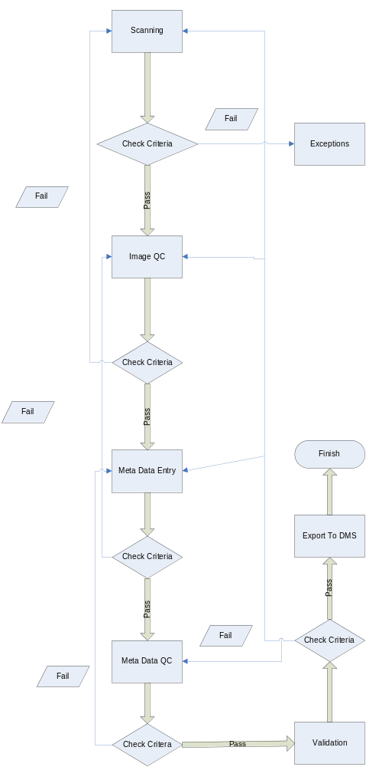

Example Physical Record Workflow
- The template could have the following activities:
  - Viewed By Agent
  - Moved Location
  - Sent for Reference
- User can add Activity parameters e.g.:
  - Viewed By Agent:
    - Role – Agents
    - Timeline – None
    - Select Rules for Alerts:
      - Rule – If not returned in 2 days
    - Select Rules for Escalation
      - Rule – If not returned in 2 days
    - Activity Description – Text Input (user can enter any instruction related to the activity)
  - Moved Location:
    - Role – Agents
    - Timeline – 3 days
    - Select Rules for Alerts:
      - Rule – If item not reached location
    - Select Rules for Escalation
      - Rule – If item not reached location
Activity Description – Text Input (user can enter any instruction related to the activity)

Service Approvals
There could be a requirement for certain services to go through an approval process. The workflow module should provide necessary workflow templates to incorporate approvals for all the standard system services. E.g.: there could be a template defining workflow for “Document Deletion” service. It could go through the following flow:
Work Item – Document or Job
Workflow Activities – Approve-> Delete
Here when the user selects “Delete” service on a document, the workflow process initiates the flow and sends the document to the Approver and then deletes it.

Searching
This module should provide advanced search features to search for a document within the DMS or across multiple repositories based on both user-defined and system defined parameters.
The following is the list of search requirements as per the scope document:
- Provide search based on system specific parameters
- Provide search based on user defined indexes
- Search single document or document repository based on user-defined criteria (index attribute or full-text)
- Transparent search across multiple repositories and servers
- Provides a list of matching documents (repository search) listed by relevancy
- Save document search queries for re-use
- Software optimized for rapid search and retrieval on multiple very large document repositories (billion pages and above)
- Full text documents may be searched by phrases, word proximity search, wild cards and Boolean searches.
- Support fuzzy searching
- Capture the print streams that produce various types of financial and forwarding documents and reports and other types of documents produced. Automatically index and store in the repository for convenient access to historical information. – phase 2
The module should provide functions to:
- Configure search options
  - E.g.: search by phrases, word proximity, wild cards, Boolean and fuzzy searching
- Select search source or domain- This entry should display all the office locations or repositories on which search is performed.
- Save search queries for reuse
- Add/edit/delete search panel fields for a project
- Provide efficient searching based on the search options

Creating a search panel field list within a project
This use case is described in the Admin module

Meta-data Search in a project
- User selects search-meta-data menu item
- User sees the search panel with the fields added by admin
- User can configure his search panel by adding/removing some fields related to desired document if authorized to do so (the field list for the project is defined by the admin). He presses the “customize panel” button.
- User selects the search repository. (entered by Admin)
- User has an option of configuring search options like including fuzzy search, etc. He can do this by pressing “Advanced” button.
- User enters the search values
- A successful search lists the search results in the order of relevancy
- An unsuccessful search displays a message along with an option to save the query (or requisition list).
- The search result link will take the user to the document viewer where he views his document and based on his authorization can carry on a document action.
- User can save the search query by pressing “save query” button.

Full Text search
- User selects search-full text menu item
- User sees the search panel with the following fields:
  - Select folder: text input with file browse button
  - Enter search text: text input
  - Search – button
- User selects the search repository. (entered by Admin)
- User has an option of configuring search options like including fuzzy search, etc. He can do this by pressing “Advanced” button.
- User enters the search text and presses search button
- A successful search lists the search results in the order of relevancy
- An unsuccessful search displays a message along with an option to save the query (or requisition list).
- The search result link will take the user to the document viewer where he views his document and based on his authorization can carry on a document action.
- User can save the search query by pressing “save query” button.

Saving a query
- User presses “save query” button from the search panel screen
- A query screen appears asking the user to enter a name for the query
- User presses save button to save the query
- The system should save the query info which is basically all the panel fields with their values

Viewing saved queries
- User selects search – view queries
- User gets a search screen with :
- Query name
- Query elements
- User enters the values if he knows or presses search button
- User gets a list of matching or all saved search queries
- User selects a query
- User enters the detail page, which is nothing but a search panel page with the query inputs already filled.
- From here user can perform normal document search
- The search panel parameters/fields list should be defined by the project super-user at the time of project setup. These will then be displayed in the search panel configuration window.

Search Requisition
Pre-condition: search request for a document fails
Basic flow:
- User performs the search operation as indicated in the use case above
- The search fails
- User is shown a message asking him if he would like to add the search to a requisition list.
- If the user selects “OK”, he is displayed a screen to enter the requisition name
- User enters the name and saves the requisition
- To view the requisition list the user selects search – requisition list menu item
- The user is shown a screen displaying all the names of the requisitions along with their search parameters.
Post-condition: search field values get added in the requisition list.

Reporting
The following are the system requirements based on the scope document:
- The proposed EDMS solution must be able to produce an audit trail for various document activities such as add, delete, view, print, etc.
- The proposed EDMS solution must be able to produce an audit trail at Image, folder and cabinet levels
- The workflow system must support the generation of workflow statistics and status of work item reports
- It is required for the proposed EDMS to maintain a log of actions that have been taken on a document (e.g. the routing sequence, notes about problems in processing a document, people who need to review the document and other annotations)
- EDMS System performance, utilization, load etc related reports and statistics to be provided by EDMS.
- Extensive Reports & Audit trail like Report on total records scanned along with associated indexes, Records exported or not exported to DMS etc.
- Ability to generate MIS on prescribed format and the same should be customizable for the users
This module should provide functions for:
- Adding/deleting/updating reports based on report templates above (performed by the Admin – see the Admin section for use cases)
- Generating report results for every report
- Providing printing, faxing, mailing and saving facilities for report results

EDMS Report Templates

Job Status by Activity
Displays the status of every activity for every job
Input fields: Activity, Status, Role, User, Date (from, to), Job Number(from, to)

 | Job Creation | Scanning | Image QC | MetaData Entry | Meta Data QC | PDF-Validation
Job1 | started | not started | not started | not started | not started | not started
Job2 | completed | completed | not started | not started | not started | not started

Job Duration by Activity
Displays the time taken in days to complete each activity for each job
Input fields: Activity, Role, User, Date (from, to), Job Number (from, to)

 | Job Creation | Scanning | Image QC | Meta Data Entry | Meta Data QC | PDF-Validation
Job1 | 5 days | 3 days | 3 days | 4 days | 2 days | 2 days
Job2 | 6 days | 4 days | 4 days | 5 days | 3 days | 3 days

Number of Jobs per User per Activity
Displays the number of Jobs worked on by users per activity
Input fields: Activity, Status, Role, User, Date (from, to), Job Number (from, to)

 | Job Creation | Scanning | Image QC | Meta Data Entry | Meta Data QC | PDF-Validation
User1 | 10 Jobs | 20 Jobs | 10 Jobs | 15 Jobs | 15 Jobs | 5 Jobs
User2 | 11 Jobs | 21 Jobs | 11 Jobs | 16 Jobs | 16 Jobs | 6 Jobs

Job Duration per User per Activity
Displays the time taken per user to complete an activity per job
Input fields: Activity, Role, User, Date (from, to), Job Number(from, to)

 | Job Creation | Scanning | Image QC | Meta Data Entry | Meta Data QC | PDF-Validation
User1 | 5 days | 3 days | 3 days | 4 days | 2 days | 2 days
User2 | 6 days | 4 days | 4 days | 5 days | 3 days | 3 days

Number of Users per Activity
Displays the number of users working on each activity
Input fields: Activity, Status, Date (from, to), Job Number (from, to)

Job Creation | Scanning | Image QC | Meta Data Entry | Meta Data QC | PDF-Validation
20 users | 21 users | 22 users | 23 users | 24 users | 25 users

Number of Jobs per Activity
Displays the number of Jobs under each activity
Input fields: Activity, Status, Role, User, Date (from, to), Job Number (from, to)

Job Creation | Scanning | Image QC | Meta Data Entry | Meta Data QC | PDF-Validation
20 jobs | 21 jobs | 22 jobs | 23 jobs | 24 jobs | 25 jobs

Number of Documents per Activity
Displays the number of documents per activity per date
Input fields: Activity, Role, User, Date (from, to)

 | date 1 | date 2
Imported | 10 docs | 23 docs
Exported | 11 docs | 24 docs
Archived | 12 docs | 25 docs
Deleted | 13 docs | 26 docs
Modified | 14 docs | 27 docs
Indexed | 15 docs | 28 docs
Searched | 15 docs | 15 docs
Printed | 15 docs | 15 docs
Faxed | 15 docs | 15 docs
Mailed | 15 docs | 15 docs

Number of Documents per activity per user
Displays the number of documents worked on per activity per user
Input fields: Activity, Role, User, Date (from, to)

 | date 1 | date 2
Imported | 10 docs | 23 docs
Exported | 11 docs | 24 docs
Archived | 12 docs | 25 docs
Deleted | 13 docs | 26 docs
Modified | 14 docs | 27 docs
Indexed | 15 docs | 28 docs
Searched | 15 docs | 15 docs
Printed | 15 docs | 15 docs
Faxed | 15 docs | 15 docs
Mailed | 15 docs | 15 docs

Job Audit
Displays the Job trail from creation to completion
Input fields: Role, User, Date (from, to), Job Number (from, to)

 | Started On | Started By | Completed On | Completed By | Time Taken
Job Creation | date 1 | user 1 | date 2 | user 2 | 5 days
Scanning | date 2 | user 2 | date 3 | user 3 | 6 days
Image QC | date 3 | user 3 | date 4 | user 4 | 7 days
Meta Data Entry | date 4 | user 4 | date 5 | user 5 | 8 days
Meta Data QC | date 5 | user 5 | date 6 | user 6 | 9 days
PDF Validation | date 6 | user 6 | date 7 | user 7 | 10 days
Job Modification | date 7 | user 7 | date 8 | user 8 | 11 days
Job Deletion | date 8 | user 8 | date 9 | user 9 | 12 days

Document Audit
Displays a document trail from creation to all the stages of workflow
Input fields: Role, User, Date (from, to), Document Name

 | Started On | Started By | Completed On | Completed By | Time Taken
Doc Creation | date 1 | user 1 | date 2 | user 2 | 5 days
Doc Modification | date 2 | user 2 | date 3 | user 3 | 6 days
Doc Deletion | date 3 | user 3 | date 4 | user 4 | 7 days
Doc Import | date 4 | user 4 | date 5 | user 5 | 8 days
Doc Export | date 5 | user 5 | date 6 | user 6 | 9 days
Doc Indexing | date 6 | user 6 | date 7 | user 7 | 10 days
Doc Archived | date 7 | user 7 | date 8 | user 8 | 11 days
Doc Searched | date 8 | user 8 | date 9 | user 9 | 12 days
 | date 9 | user 9 | date 10 | user 10 | 12 days
Doc Viewed | date 9 | user 9 | date 10 | user 10 | 13 days
 | date 10 | user 10 | date 11 | user 11 | 14 days

Folder Audit
Displays a Folder trail from creation to all stages of workflow
Input fields: Folder name, User, Date (from, to)

 | Started On | Started By | Completed On | Completed By | Time Taken
Folder Creation | date 1 | user 1 | date 2 | user 2 | 5 days
Folder Modification | date 2 | user 2 | date 3 | user 3 | 6 days
Folder Deletion | date 3 | user 3 | date 4 | user 4 | 7 days

Report Audit
Displays a Report trail from creation to all stages of report workflow
Input fields: Role, User, Date, Report Name

 | Performed By | Performed On
Creation | user1 | date1
Modification | user2 | date2
Deletion | user3 | date3
Viewing | user4 | date4
Generation | user5 | date5
Printing | user6 | date6
Mailing | user7 | date7
Faxing | user8 | date8
Download | user9 | date9

DMS Application Metrics

No Of Documents
No Of Users
No Of Printers
No of Fax Machines
No Of Activities

Image Capture Application Metrics

No of Jobs
No Of Users
No Of Scanners
No Of Printers
No of Fax Machines
No Of Activities

Machine Utilization

 | Machine Name | Quantity | Location | Usage
Scanner | scanner1 | 5 | Regional Office | 100 Jobs
 | scanner 2 | 10 | Zonal Office | 200 Jobs
Printer | printer 1 | 3 | Regional Office | 50 docs
 | printer 2 | 6 | Zonal Office | 200 docs
Fax | fax1 | 4 | Zonal Office | 20 docs
Mail server | ms1 | 1 | Regional Office | 200 mails

Viewing Report Results
Pre-condition: reports are created by the admin and there is data existing in the system to display report results. The user viewing the report has appropriate access rights
Basic Flow:
- User selects report – view all reports
- User enters a screen displaying all the reports generated by the admin
- User selects a particular report
- User enters the report details screen
- User enters the field values for the various fields displayed (eg: username, activity name, etc.)
- User presses the “generate report” button on the screen
- System validates data and in case of no error takes the user to the report results screen.
- User enters the report results screen displaying the desired report in its respective template. Based on the template the table is generated displaying appropriate results. Each report results page has the following functions:
  - Print
  - Mail
  - Fax
  - download
- User can select one of the above report functions
Post-condition: Based on the report action, the report is generated and printed or mailed or faxed or downloaded.

Device Management

Scanning
This module explains the scanning related functionalities. It is a part of integration module as we would be using external interfaces to provide the scanning functionality. It must provide functions to:
- Add/edit/delete scanners into the project – used by admin
- Configure scanner and image parameters – used by any user with appropriate access rights
- Configure classification parameters – set by the admin and later modified by the user
- Scripts to perform auto scanning
- Store all scanning activity related information eg: number of pages scanned, number of actual pages, number of documents scanned, number of document imported into DMS, etc.
It should provide functions as per the scope document:
- Configure image format – functions to change/select format to TFF G3 and G4, JPEG, GIF, XML and PDF
- Configure image Size - The proposed EDMS must support imaging of 8-1/2” x 11” and legal size, single-sided or double-sided pages (duplex on demand).
- Configure image output – functions to set image output size
- Configure scan speed – functions to select scan speed for scanning documents
- Configure output image resolution – functions to select output image resolution (150,200,300,400 and 600dpi)
- Configuring color – functions to allow bi-tonal and gray scale image scanning
- Configuring indexing parameters – functions to set indexing parameters like barcode, blank pages, fixed page and auto form for documents for auto indexing.
- Assigning document types to scanned documents – functions to assign document types to specific set of documents
- Configuring type – functions to use simplex/duplex scanner setting
- Configuring batches – functions to assign batches to documents
- Configuring output folder – functions to select output folder for scanned batches
- The selected scanner should support both TWAIN and ISIS protocols
- All kinds of physical documents should be scannable including hard documents such as Daks and faxes.

Scanner Management

Adding/Editing/Modifying a scanner entry
This is the same as configuring scanner section of Admin. Though the user can edit configuration parameters, he cannot delete the scanners. Only the Admin has the right to create and delete scanners. The functions are used by the admin but the implementation takes place as a part of Scanning module.

Configuring a scanner
Please refer to the scanning configuration use case of the Admin Module.

Classification rules for scanned documents
Pre-condition: User should have appropriate rights for classification, the documents used for classification must be present and scanners must be available.
- User selects the scanning menu option
- User selects view scanners
- User selects a particular scanner
- User enters the scanner details page
- User clicks on “classification” button
- User sees the following classification options on the screen:
  - Barcode Number – check box
  - Blank Page– check box
  - Fixed Page– check box
  - Forms– check box
- User selects the desired classification criteria
- In case the user selects the Barcode Number, the documents get classified by Barcode number within the target folders.
- In case the user selects the Blank Page, the documents get classified by Blank Page within the target folders.
- In case the user selects the Fixed Page, the system displays folder browser window form which the user should select the page image file to be used as a separator. Documents will be segregated based on this file.
- In case the user selects the Form, the system displays folder browser window form which the user should select the form document to be applied on all incoming documents. Documents will be associated with the form fields mentioned in this document and during meta-data entry the users will view these form fields and enter the values.
- User saves the classification settings.
- When the scan command is issued with the above settings, the scanner should be launched using the settings and should classify documents based on the classification settings.
Post – condition: When the scan command is issued with the above settings, the scanner should be launched using the settings and should classify documents based on the classification settings

Auto Scanning
Pre-condition: Scanners must exist in the system, documents must exist for scanning on the specified date and the user with the appropriate rights should be able to schedule auto scanning operation.
Basic Flow:
- Admin selects machines - scanners –schedule menu item
- The system displays all the schedules for scanning in a table showing:
  - Scanner name: (Displays the scanner name)
  - Scanning Date: (Displays the scanning date)
  - Scanning Jobs: (Displays the job numbers being scanned)
  - Add: Button (opens the add schedule page)
  - Delete: Button (deletes the selected schedule)
  - View: Button (opens the schedule page for the selected schedule)
- There are check boxes against each entry.
- User clicks “Add” button.
- The Schedule Scanners page is displayed
- It contains the following fields:
  - Scanner name – selectable input (list of existing scanners)
  - Configure Scanner – button (opens up the scanner configuration window for the selected scanner)
  - Schedule date – Date field
  - Schedule Time – Time field
  - Select Jobs – (user enters the job range here)
  - Save - Button
- Admin presses the “Configure Scanner” button and is taken to the scanner configuration screen.
- Admin sets the scanner settings for the auto scanning operation
- Admin can change either the image configuration or document classification settings
- Admin enters the date and time of scanning
- Admin selects the jobs to be scanned
- Admin saves the auto scanning settings
- The system validates data and then saves the scanner and scheduler settings
- The scanning operation should take place automatically on the specified date based on the settings.
Post-condition: Auto scanning should happen on the set date and documents must be ready for Image QC.

Image Modification
Provide the following image modification functions which would be used in the document viewer and would be provided as icons in a toolbox:
- Functions for image enhancements and clean-up techniques such as de-skew, de-speckle and Darkening / lightening.
- Cleaning black patches
- Adjusting brightness and contrast
- Rotating image
- Zooming functions
- Deleting pages
- Rescanning pages
These functions form a part of scanning module as typically every scanner comes with an imaging tool which provides these functions.
Please refer to the Image modification section of the Document modification/ Document viewer modules.

Printing

Printer connection
This module provides functions to add/ delete/ edit printers to the system and configure them.
The selected printer must have high volume, high speed print capabilities to generate 1,000+ pages per day
The use cases for adding/deleting/editing printers are in the Admin module, as they would be used as a part of Admin Module. The implementation however should be provided under this module.

Printer configuration
This module provides functions to print documents in the application. It should cater to the following requirements:
- User should be able to print a page with or without annotations
- User should be able to print a document (with all its pages) with or without annotations
- Print file (a collection of documents) with or without annotations
- Print folder (collection of files) with or without annotations
- It must be able to send print jobs to network printers and to print from individual printers attached to workstations, subject to proper authentications.

User configures printer
- User views a document
- User selects the print icon from the tool bar
- The system brings up printer configuration page
- The default system printer is selected
- User can change the printer along with any configuration parameters eg: choose current page or all pages, choose to include or exclude annotations, etc.
- User selects print button
- Depending on his access rights the system prints the document

Faxing

Fax connection
Connecting/disconnecting to a Fax machine
This module provides functions to add/ delete/ edit fax machines to the system and configure them.
Use cases for adding/editing/deleting fax machines to the project are defined in the Admin module as they get used by the Admin. The implementation however should be provided under this module.

Fax configuration
The system should provide functions to allow the users to send and receive faxes. The following is the system requirement:
Functions to set standard fax attributes
Functions to transmit Group 3 and Group 4 facsimiles from the repository

Sending Fax
- User views a document in the document viewer
- User selects the fax icon from the tool bar
- The system brings up fax configuration page
- The default system fax machine is selected (set by the admin)
- User can change the fax machine along with any configuration parameters eg: choose current page or all pages.
- User selects fax button
- Depending on his access rights the system faxes the document

Messaging

Mail Server Connection
Connecting/disconnecting to a mail server
This module provides functions to add/ delete/ edit mail servers to the system and configure them.
User should be able to save e-mail documents into DMS folders
The use cases for adding/editing/deleting mail servers to the project are defined in the Admin module as they are used by the Admin. The implementation however should be provided under this module.

Mail Server Configuration
This module should provide the following system functions:
- Functions to set standard mail server attributes
- Functions to send mails

Sending a mail
- User views a document
- User selects the mail icon from the tool bar
- The system brings up mail configuration page
- The default system mail server is selected (set by the admin)
- User can change the mail server along with any configuration parameters eg: choose current page or all pages.
- User selects mail button
- Depending on his access rights the system opens the compose window of the mailing application with the document as attachment.
- User can then compose a message and send the mail by filling in the mailing address.
- The mail should be saved in the sent mail folder of the mail application used by the user.

Physical Records management
This module deals with creating, managing and tracking physical documents or records whose electronic versions participate in Image Capture and DMS. It is a requirement to manage the lifecycle of a physical record along with the lifecycle of its electronic counterpart. When an electronic document is saved in the system it must be saved with a reference to its physical document. Hence at any point in time it must be possible to obtain the details of a record for an electronic document. The following services form a part of Record Management:
- Record Capture
- Record Destruction
- Record Workflow
- Record Storage

Record Capture
This module provides functions to add/delete/modify/save record information into the system.

Adding Record Info
- User Enters View Records Screen
- System displays a list of records entered in the system
- User can edit/view an existing record or Add a new one
- User clicks on “Add” button
- User enters “Add Record” screen
- The system displays the following fields:
  - Record Name – Text Input
  - Record Category – drop down (Same as document categories)
  - Record Type – drop down (Same as document type)
  - Record Location – drop down (list of locations)
  - Rack Name – Text Input
  - Record retention period – drop down (list of document class)
  - Save – Button
  - Edit – Button
  - Delete – Button
- User enters the required details and saves
- System validates and saves the record entry

Record Destruction
This module must provide functions to initiate physical destruction of records. When an electronic document undergoes deletion from DMS, the user can select an option to destroy its corresponding physical document. Destruction can also be performed based on some system rules. Screens should be provided to configure record destruction rules.

Configuring record destruction
- User enters the Record-Destruction Screen
- User views the list of all the deletion rules
- User can either select a rule and edit it or delete it
- User clicks on “Add Rule” button
- User enters the Add Rule Screen
- User views the following fields:
  - Rule Name – Text input (User enter name of rule)
  - Meta-Data Field table – Field name, Fields condition, field value. The User must select the field name from a drop down of valid meta-data fields for the entity e.g.: document type. Example rows of this table would be as follows:
    - Document Type = Ekatrikaran
    - Document Class = A
  - Deletion date – date/time field (User enters the date when the deletion check should happen based on the above conditions)
  - Deletion frequency – daily/weekly/monthly (User selects the frequency with which the deletion rules must be checked starting from the Deletion Date)
  - Send Alert to – drop-down (User selects the Role to which an alert is sent)
- Use Saves the Rule
- System validates and moves the Records to permanent Deletion list. An operator with appropriate rights can view the list and perform the actual destruction procedure.

Record Storage
The storage layout of the records must conform to the layout of each respective domain e.g.: in a government domain/ record room location, it should follow the layout inline with the suggestions made in the manual of office procedure.
A standard template must be available to represent the storage layout of a domain.

Alerts and Notifications
This module should provide functions to send system alerts and notifications based on rules and events.

Set event based alerts
(Implementation depends on workflow module since processes are defined there)
Pre-condition: workflow processes must be present
Basic Flow:
- Admin selects a workflow – set alert menu item
- System displays all the workflow processes with their details
- System displays activities within a process with its status
- Admin selects a particular status of the activity which should trigger the alert
- Admin should select the Roles to whom this alert should be sent
- Save the setting
- System validates fields and saves – displays error if the date and time are less than the current time.
Post-Condition: The system must send alert messages at the specified time for the specified event. E.g.: If the alert is set on “Image QC” and “completed” event, the roles associated with this alert are notified of the event by e-mail.

Rule based Alerts
- User enters the “Set Alerts” screen
- User views the list of all the alerts set in the system
- User clicks on “Add Alert” button
- User enters the “Add alert” Screen
- User views the following fields:
  - Work Item – drop down ( user selects the work item eg: Document, Job, Activity or any other system entity)
  - Rule – drop down (system defined rules for the selected entity eg: Document is checked-out or if an Activity is not started for more than 2 days, etc.)
  - Users – List (System users categorized by Role. User can select a Role or a set of users)
- User saves the Alert settings
- System validates data and sends the alerts based on the rules.

Subscribing to Alert mailing lists
- User selects the documents for alerts
- User selects subscribe to mailing list menu item
- User is displayed various alert lists available in the system with check boxes beside each
- User selects the check boxes and presses “Subscribe” button
- User gets notification based on his subscription. E.g.: if the user subscribes to “document events” mailing list, he gets notified for all document events of his selected work-items like: “read, print, delete, view, change, etc.”

Service Approvals
This module must provide functions to:
- select services requiring prior approval
- select the approving authority(Role) for performing approvals
Instead of functioning as a separate module, approvals can also form a part of document workflow. Refer to the Workflow module.

Configuring approvals
- User enters the approval configuration screen
- System displays the following:
  - Services – drop-down (list of services eligible for approval e.g.: deletion, record destruction, etc.)
  - Approvers – drop-down (list of System Roles who can approve)
- User selects the data and saves
- System validates and enforces approvals for all the selected services. So if a service has to undergo approval, e.g.: if the user with proper access rights performs document deletion, then the document is sent to the approver for the final action. If the approver approves, then the deletion activity completes else the deletion is rolled back.

Data Synchronization
This module is responsible for synchronizing data between various office locations configured by the system. The office locations or Repositories should have been configured by the Admin in the configuration module. This module must provide functions to:
- Push data from one repository to another
- Pull data from one repository into another

Manual Synchronization
- User enters synchronize data screen
- System displays the following fields:
  - Source Repository : drop down (displays all the configured repositories)
  - Target Repository : drop down (displays all the configured repositories)
  - All Repositories: select box (user selects this in case he wants all repositories to be synchronized)
  - Synchronize : button (user clicks this to perform synchronization operation between the 2 repositories)
  - Send Alerts – Check Box
  - Select Role for Alerts – drop down (system roles)
- User enters the data and presses the button
- System saves data and performs the synchronization action

Auto Synchronization
- User enters auto synchronize data screen
- System displays the following fields:
  - Source Repository : drop down (displays all the configured repositories)
  - Target Repository : drop down (displays all the configured repositories)
  - All Repositories: select box (user selects this in case he wants all repositories to be synchronized)
  - Synchronize start date : date field
  - Synchronize start time: time field
  - Frequency : daily/weekly/monthly
  - Send Alerts – Check Box
  - Select Role for Alerts – drop down (system roles)
- User enters the data and presses the button
- System saves data and performs the synchronization action

Forced Synchronization
- User enters force synchronize data screen
- System displays the following fields:
  - Source Repository : drop down (displays all the configured repositories)
  - Target Repository : drop down (displays all the configured repositories)
  - All Repositories: select box (user selects this in case he wants all repositories to be synchronized)
  - Force End Of Day Synchronization – checkbox
  - Send Alerts – Check Box
  - Select Role for Alerts – drop down (system roles)
- User enters the data and presses the button
- System saves data and performs forced synchronization action everyday as the end of day event.

Internationalization/Localization
This module should provide functions to change language settings for all labels at:
- Application level – change the language on all screens throughout the application
- Project level – change the language on all screens throughout the project
- Screen level – change the language on selected screen
The above fields are termed as the scope of the language.
This module should also provide functions to select the languages available in the system. Currently the use cases for this are provided in the Admin module as the Admin selects the languages to be used by a project. The implementation however should be provided under this module.

Changing a language
- User logs into the application
- User opens a project
- The language menu item displays all the languages available for the project.
- User selects a particular language from the menu item eg: Hindi
- A window asking for scope of change is displayed e.g.: screen, project or application
- User selects the scope and presses ok
- The language change happens as per the scope

Data Encryption
This module should provide functions to encrypt and decrypt data. The admin marks the fields for encryption and this module should have scripts to perform bulk encryptions for all the marked fields. When the field values are viewed in the entity’s detail page, they should be decrypted and displayed.
The following is the scope document requirement:
- Secure access to EDMS application where user authentication should be based on X.509 certificate under the PKI and as per the provision of the IT Act.
- Support for the password encryption

Menu Functions
This module should provide functions for all the common menu features in an application such as:

Common Menu Functions

File Menu
- New – Should open a new Project for the application (uses project management module)
- Open – Should Open an existing project (uses project management module)
  - User selects open
  - System should display a file browser window
  - User browses to the project
  - User selects a project and presses open
  - The project opens with all its components
- Save – Should save all the project settings as draft
- Finalize – Should save all project settings as final
- Print – Should print the selected document
- Fax – should fax the selected document
- Mail – should e-mail the selected document
- Exit – should exit the application

Edit Menu
- Undo – should undo the last command
- Redo – should redo the last command
- Cut – should cut the selection
- Copy – should copy the selection
- Paste – should paste the selection in the specified location
- Paste Special
- Clear – should clear the work area if any (during document hierarchy)
- Select All – select all selectable fields on the screen
- Find – should find a text
- Replace – should replace a text with the given text

Help Menu
- Help documentation – should open the help documentation for EDMS in a separate window
- About Product – Should display information related to the product e.g.: version, copyright information, licensing information etc.

Admin Menu
Based on this FS, the following menu and menu items were identified by the document writer (mostly available to Admin):
- Project
  - Template – add, view (to create/edit/view/delete project template)
  - New/Edit (to enter project details) – could be same as File menu
- User
  - Template – create, view (to create/edit/view/delete user templates)
  - Add (to create project users)
  - View (to view/edit/delete users)
  - Search (to search for project users)
- Role
  - Template – create, view (to create/edit/view/delete role templates)
  - Add (to create roles)
  - View (to view/edit/delete role info)
  - Search (to search for roles)
  - Assign Users (to assign users to roles)
- Permissions
  - View Permissions (view permissions)
  - Assign processes (to assign permission categories to processes)
- Folder
  - New (to create a new folder)
  - Edit (to edit selected folder)
  - Delete (to delete the selected folder)
- Workflow
  - Scanning (select processes, assign roles, set permissions)
  - DMS (select processes, assign roles, set permissions)
  - Search (select processes, assign roles, set permissions)
  - Report (select processes, assign roles, set permissions)
- Configuration
  - Annotations
    - Types (to create/edit/view/delete annotation types)
    - Categories (to create/edit/view/delete annotation categories)
  - Document type (to create/edit/view/delete document types)
  - Search panel (to create/edit/view search panel fields)
  - Document Hierarchy (to assign a document hierarchy)
  - Alarm (to set activity based alarm)
  - Encrypt
    - View all entities (displays all system entities)
    - View encrypted entities (displays only the entities with encryption requirement)
  - Language (to select languages)
  - Archive (set archival settings)
- Report
  - Create
  - View (view, edit, generate)
  - Search (displays report search screen)
- Machine Configuration
  - Scanner – new, view (to create/edit/view/delete scanners)
  - Printer – new, view (to create/edit/view/delete printers)
  - Fax – new, view (to create/edit/view/delete fax machines)
  - Mail server – new, view (to create/edit/view/delete mail server)
- File
- Edit
- Help

Image Capture Menu
- Job Creation
- Scanning
- Image QC
- Meta Data Entry
- Meta Data QC
- PDF Validation
- Report
- Search
- Language
- File
- Edit
- Help

DMS Menu
- Explorer – Universal, Personal
- Import
  - Local
  - Remote
- Export
- Index
- Folder
  - Delete
  - update
- Report
  - view
- Search
  - view
  - Configure
  - Add to requisition list
  - Save query
- Language
- File
- Edit
- Help

Search Menu
- File
- Edit
- Help
- Report
The usage of all the above menu and menu items are described as use cases in various modules. The menu structure and names might change after UI design.

OCR – Phase 2
The following is the requirements from the scope document:
- The proposed EDMS product must have a separate OCR capability.
- It is desirable that the OCR software be able to convert electronic image files to electronic text.
- The proposed OCR software is suitable for use on long documents (up to 1000 pages).
- The proposed OCR software provides convenient basic search features such as Boolean, wild card and keyword etc.
- The proposed OCR software provides advanced, convenient search features such as concept-based searches (synonym concept, thesaurus-based, relevancy ranking) and proximity (“X” within 5 words of “Y”), highlighting the search phrase in the text, saving search queries for re-use, jump to search phrase in text, etc.
- The proposed system must have the capability to extract data from any form, structured or unstructured. Perform the data extraction using techniques such as OMR, ICR, OCR, MICR and Barcodes. Export the data to the document management system for image retrieval.
The detail functional specifications for this module would be documented as a part of Phase 2.

Non Functional Requirements

Integration – phase 2
The following list is from the scope document which describes the interfaces related requirements. These interfaces need to be provided after product development. These APIs will be provided as a part of phase 2.
- The proposed EDMS must be based on open systems standards and an interface must be available for integration of the EDMS with in house Insurance package (FEAP) developed in MF-Cobol and on Red Hat Linux (current version being RHEL4) and other line of business applications. – Phase 2
- Interface for data import and export.
- Interface for rapid development of custom web interfaces – Phase 2
- XML or Web Based Document Management and Workflow API toolkit for system integration and application development.
- API tool kit for application development and integration both at server side and client side.
- Imaging processing libraries that support image enhancement, image recognition, image compression, image manipulation, data extraction, form processing, image view.

System
The following list is from the scope document which describes the system related requirements. These need to be kept in mind during system design and applies to the entire system.
- The EDMS solution must be Year 2000 compliant and free from any date-related malfunctions. This should apply to all the date related fields in the system and database.
- The EDMS solution must support mirrored drives.
- The EDMS capabilities must include backup capabilities for the document repository and database(s).
- Support for incremental and full Backups
- Support for replicating data onto remote sites.
- Disaster recovery for all levels for all activity functions.
- Caching – Provide screen caching facilities. The page searched should be displayed without waiting for the entire document to be loaded.
- A Backup strategy should be documented during system design to cater to all the above mentioned backup requirements. The functions required to perform backups can form a part of the “Document Archival” module.

Web Publishing
The following list is from the scope document which describes the web publishing related requirements. Since this product will be developed using web interfaces, the following must be adhered:
- The EDMS solution must be able to publish documents to a Web server.
- The EDMS solution must allow browser based users to enter information over the Internet into forms, and for forms-based information to propagate through the system using the product’s workflow or other capabilities.
- The EDMS solution must facilitate browser based users to search for and retrieve, download and print documents in the repository. The feature will be used in future Phases, but must be present to be used later.
- Remote systems administration over an intranet must be a feature of the proposed EDMS. (Web based administration).

Architecture
The following list is from the scope document which describes the architecture related requirements. These are meant to be considered for the system architecture and detailed design. The features not feasible during phase 1 should be implemented as a part of phase 2 and marked accordingly after system design.
- All software modules of the proposed EDMS solution must have a general release date prior to the date of the Bidder’s proposal. None of the proposed EDMS software shall be in alpha or beta version or unreleased as of the date of release of the bid proposal.
- The architecture of the product must support a multi-tiered architecture the logical and physical separation of metadata storage from document repository storage, and the separation of client processes, server processes and interfacing processes. Multi-tier architecture built on J2EE Standards.
- The proposed EDMS solution must be a 32-bit as well as capable of deployment on 64-bit platform product.
- The architecture of the product must support creation of multiple, distributed repositories and transparent access to multiple, distributed document repositories from any client.
- Support for Billions of documents in the image repository.
- Highly integrated product architecture with tightly integrated back-end application server
- The proposed EDMS product must support TCP/IP or be network protocol independent. The product must work in network environment (web based) with multiple users.
- The proposed EDMS product must be scalable to the number of users, retrieval volume and document storage as estimated in the scope of work.
- The proposed EDMS product must run on Linux at the server. Since we do not intend to invest in OS, the DMS software should not have any requirement for any commercial OS.
- The proposed EDMS product must run on LINUX at the server.
- The proposed EDMS product must support access to repositories and workflow functionality over the LAN, Internet and the Corporation intranet (WAN).
- The proposed EDMS solution must support the estimated volume of transactions and documents through such features as server replication and clustering or equivalent
- The proposed EDMS product must support fail-over back-up and recovery capabilities.
- The proposed EDMS product must support various data storage platforms appropriate to the size and requirements of the corporation application
- Support for separate image server(s) for storing actual images
- Support for web services or other messaging standards and also standard EAI products (Corporation is currently using TIBCO)
- Since we do not intend to invest in RDBMS at the Branch office level, the DMS software should not have any requirement for any commercial RDBMS AT BRANCH LEVEL.
- The proposed EDMS should also support Oracle, PostgreSQL, Microsoft SQL and other DBMS for Divisional / Central level deployment.
- The proposed EDMS product must support access to the document repositories and workflow functionality through Internet Explorer, Netscape Navigator, open source and other industry-standard browsers.
- Document scanning support from browser and client should be available. – Client Support in Phase 2
- The proposed EDMS product must support all versions of Windows and Linux clients & VXL thin clients. – Phase 2
- The EDMS Server must support J2EE and XML based Application Server or Web Services.
- Conformance to industry standard for Meta Data, Retrieval, Indexing and Security (VK)
- WFMC and AIIM compliance for DMS (VK)
- File numbering should be based on centralized numbering sequence for a given unit or department (VK)
- Ability to configure domain/client specific UI labels at implementation time.
- user interface should be provided for government components such as noting and correspondence

User Interface Specifications
In order to design GUI, basic flow and functional specifications are needed to be reviewed and approved first. GUI developed by client's designer may be helpful in making the final GUI of the system but that is not the ultimate GUI of this product. Therefore, GUI will be developed along with use cases and SRS as evolutionary prototype.

Analysis

Mapping with Client UI
The client has provided certain user interface screens for development of Scanning application. This section will provide the functionality mapping of the UI with the system functions.
The following are the major UI components:
- Project Manager
- Job Creation
- Scanning
- Image QC
- Meta Data Entry and QC
- PDF Validation
- Report Generation
- Search and Retrieval

Project Manager
This section provides the screens for the functions performed by the project manager. Project manager is like the system Admin.
It has the following sections:
- Menu Files
- Project Structure
- Activities
- Machines
- Users
- Reports
- Status

Menu Files
As a part of file menu the client UI has the following menus:
- File
  - New
  - Open
  - Save
  - Save As
  - Finalize
  - Print Preview
  - Print
  - Exit
The implementation for this section is provided by common menu functions module “File” menu section.
- Edit
  - Undo – should undo the last command
  - Redo – should redo the last command
  - Cut – should cut the selection
  - Copy – should copy the selection
  - Paste – should paste the selection in the specified location
  - Paste Special
  - Clear – should clear the work area if any (during document hierarchy)
  - Select All – select all selectable fields on the screen
  - Find – should find a text
  - Replace – should replace a text with the given text
The implementation for this section is provided by common menu functions module “Edit” menu section
- Setup
  - User Bank – implementation provided by user management module of Admin
  - Project Setup
  - Language – implementation provided by internationalization/Localization module
- Help
  - Help File
  - About Client
The implementation for this section is provided by common menu functions module “Help” menu section

Project Structure
The client has the following UI sections under this:
Project details – Implementation provided by the “Project Management” module of Admin.
Project Structure – Implementation provided by the “Document Hierarchy” section of Admin

Activities
This has the following sections:
- Pre-scanning – Defined & Implemented by workflow management module
- Job Creation– Defined & Implemented by workflow management module
- Scanning – Defined & Implemented by workflow management module
- Meta-data– Defined & Implemented by workflow management module. Also Implemented by Document Indexing module for creating and associating forms.

Machines
This is implemented by Scanning module (adding scanners)

Users
This is implemented by User Management and Role Management modules of Admin (creating users, roles and assigning users to roles)

Timeline
This will be provided as a part of workflow definition and implementation (parameters for each activity can be defined here)

Report Preferences
This will be implemented by Reporting Module (creating report templates and reports based on the templates)

Reports
This section shows a list of reports created for the project by the project manager. This function is provided by the reporting module (view reports).

Status
This section displays the status of various activities. This function can be available either from reporting module (if we create a report to obtain these values) or from workflow module which provides all the activity related information.

Job Creation
This section provides screens for job creation process. It has the following sections:
- Menu Files
- Adding New Jobs
- Adding Rows
- Editing Job Details
- Deleting Rows
- Removing Exceptions

Menu Files
- File Menu – implementation provided by Common Menu functions “File Menu” module
- Edit Menu – Implementation provided by Common Menu functions “Edit Menu” module
- Reports – Implementation provided by reporting module (Project specific reports)
- Help Menu – Implementation provided by Common Menu functions “Help menu module

Adding New Jobs

Adding Rows

Editing Job Details

Deleting Rows
All the above sections will be defined and implemented by the workflow module. Job will be a workflow entity and all its attributes will be defined during the entity creation. The methods to get all jobs, edit jobs, delete jobs, would all be provided by the workflow engine. These methods will in turn be used by the UI.

Removing Exceptions
Exceptions are like annotations. Hence the document modification will provide the implementation under the “annotations” section.

Scanning
The implementation is provided by the scanning module:
- Starting a scanner
- Logging scanning related information (number of pages scanned, etc)
- Importing documents into DMS after scanning and applying document types

Image QC
The implementation is provided by document modification module (image modification section) and document viewing (document viewer section).

Meta Data Entry and QC
The implementation is provided by Document Indexing (entering and viewing form values section)

PDF Validation
This is a part of workflow and is hence implemented by the workflow module. Getting all the jobs in various status and changing jobs to “approved” or “rejected” status forms a part of workflow. Hence this is implemented by the workflow module. Adding exceptions uses “annotation” feature of document modification module.

Report Generation
Uses reporting module (creating/editing/generating reports)

Search and Retrieval
Implemented by Search module:
- Search panel configuration
- Search results by relevance
- Search details page (view document using document viewer)

