A Simple Estimation Quiz
Table 2-1, appearing on the following page, contains a quiz designed to test your estimation skills. Please read and observe the following directions carefully:
- For each question, fill in the upper and lower bounds that, in your opinion, give you a 90% chance of including the correct value. Be careful not to make your ranges either too wide or too narrow. Make them wide enough so that, in your best judgment, the ranges give you a 90% chance of including the correct answer. Please do not research any of the answers—this quiz is intended to assess your estimation skills, not your research skills. You must fill in an answer for each item; an omitted item will be scored as an incorrect item. Please limit your time on this exercise to 10 minutes.
- (Also, you might want to photocopy the quiz before taking it so that the next person who reads this book can take it, too.)
- The correct answers to this exercise (the latitude of Shanghai, for example) are listed in Appendix B in the back of the book. Give yourself one point for each of your ranges that includes the related correct answer.
Table 2-1: How Good an Estimator Are You?
[Low Estimate - High Estimate] | Description
[ _______ – _______ ] | Surface temperature of the Sun
[ _______ – _______ ] | Latitude of Shanghai
[ _______ – _______ ] | Area of the Asian continent
[ _______ – _______ ] | The year of Alexander the Great's birth
[ _______ – _______ ] | Total value of U.S. currency in circulation in 2004
[ _______ – _______ ] | Total volume of the Great Lakes
[ _______ – _______ ] | Worldwide box office receipts for the movie Titanic
[ _______ – _______ ] | Total length of the coastline of the Pacific Ocean
[ _______ – _______ ] | Number of book titles published in the U.S. since 1776
[ _______ – _______ ] | Heaviest blue whale ever recorded
Source: Inspired by a similar quiz in Programming Pearls, Second Edition (Bentley 2000).
This quiz is from Software Estimation by Steve McConnell (Microsoft Press, 2006) and is © 2006 Steve McConnell. All Rights Reserved. Permission to copy this quiz is granted provided that this copyright notice is included.
How did you do? (Don't feel bad. Most people do poorly on this quiz!) Please write your score here: _____________
[The common definition of estimate is] "the most optimistic prediction that has a non-zero probability of coming true." … Accepting this definition leads irrevocably toward a method called what's-the-earliest-date-by-which-you-can't-prove-you-won't-be-finished estimating
—Tom DeMarco

Parkinson's Law will kick in—the idea that work will expand to fill available time

"Student Syndrome" (Goldratt 1997): If developers are given too much time, they'll procrastinate until late in the project, at which point they'll rush to complete their work, and they probably won't finish the project on time
Destructive late-project dynamics make the project worse than nominal Once a project gets into "late" status, project teams engage in numerous activities that they don't need to engage in during an "on-time" project. Here are some examples:
- More status meetings with upper management to discuss how to get the project back on track.
- Frequent reestimation, late in the project, to determine just when the project will be completed.
- Apologizing to key customers for missing delivery dates (including attending meetings with those customers).
- Preparing interim releases to support customer demos, trade shows, and so on. If the software were ready on time, the software itself could be used, and no interim release would be necessary.
- More discussions about which requirements absolutely must be added because the project has been underway so long.
- Fixing problems arising from quick and dirty workarounds that were implemented earlier in response to the schedule pressure.
The important characteristic of each of these activities is that they don't need to occur at all when a project is meeting its goals. These extra activities drain time away from productive work on the project and make it take longer than it would if it were estimated and planned accurately.

Weighing the Arguments
Goldratt's Student Syndrome can be a factor on software projects, but I've found that the most effective way to address Student Syndrome is through active task tracking and buffer management (that is, project control), similar to what Goldratt suggests, not through biasing the estimates.
As Figure 3-1 shows, the best project results come from the most accurate estimates (Symons 1991). If the estimate is too low, planning inefficiencies will drive up the actual cost and schedule of the project. If the estimate is too high, Parkinson's Law kicks in.
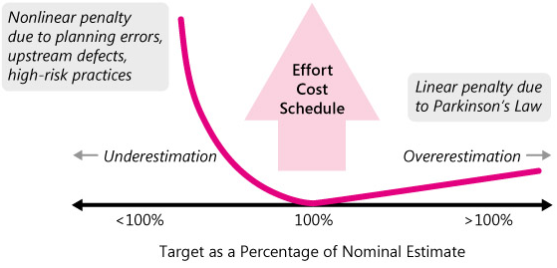
Figure 3-1: The penalties for underestimation are more severe than the penalties for overestimation, so, if you can't estimate with complete accuracy, try to err on the side of overestimation rather than underestimation

Software Industry's Estimation Track Record
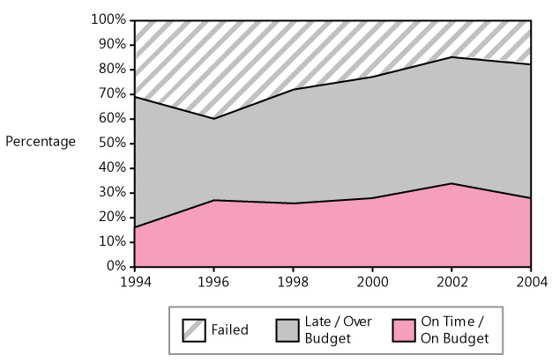
Table 3-1: Project Outcomes by Project Size
Size in Function Points (and Approximate Lines of Code) | Early | On Time | Late | Failed (Canceled)
10 FP (1,000 LOC) | 11% | 81% | 6% | 2%
100 FP (10,000 LOC) | 6% | 75% | 12% | 7%
1,000 FP (100,000 LOC) | 1% | 61% | 18% | 20%
10,000 FP (1,000,000 LOC) | <1% | 28% | 24% | 48%
100,000 FP (10,000,000 LOC) | 0% | 14% | 21% | 65%
Source: Estimating Software Costs (Jones 1998).
As you can see from Jones's data, the larger a project, the less chance the project has of completing on time and the greater chance it has of failing outright.

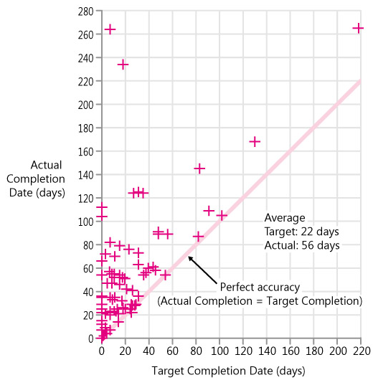

Benefits of Accurate Estimates

Improved status visibility
Higher qualityBetter coordination with nonsoftware functions
Better budgeting
Increased credibility for the development team
Early risk information

The detection of a mismatch between the project goal and the project estimate should be interpreted as incredibly useful, incredibly rare, early-in-the-project risk information. The mismatch indicates a substantial chance that the project will fail to meet its business objective.

Recognize a mismatch between a project's business target and a project's estimate for what it is: valuable risk information that the project might not be successful. Take corrective action early, when it can do some good
Numerous other researchers have found that guessing, intuition, unstructured expert judgment, use of informal analogies, and similar techniques are the dominant strategies used for about 60 to 85% of all estimates (Hihn and Habib-Agahi 1991, Heemstra and Kusters 1991, Paynter 1996, Jørgensen 2002, Kitchenham et al. 2002).
Estimation error creeps into estimates from four generic sources:
- Inaccurate information about the project being estimated
- Inaccurate information about the capabilities of the organization that will perform the project
- Too much chaos in the project to support accurate estimation (that is, trying to estimate a moving target)
- Inaccuracies arising from the estimation process itself

- The Seattle Mariners' new baseball stadium was estimated in 1995 to cost $250 million. It was finally completed in 1999 at a cost of $517 million
- The Irish Personnel, Payroll and Related Systems (PPARS) system was cancelled after it overran its €8.8 million system by €140 million
- The FBI's Virtual Case File (VCF) project was shelved in March 2005 after costing $170 million and delivering only one-tenth of its planned capability (5 different CIOs and 10 different project managers, not to mention 36 contract changes)

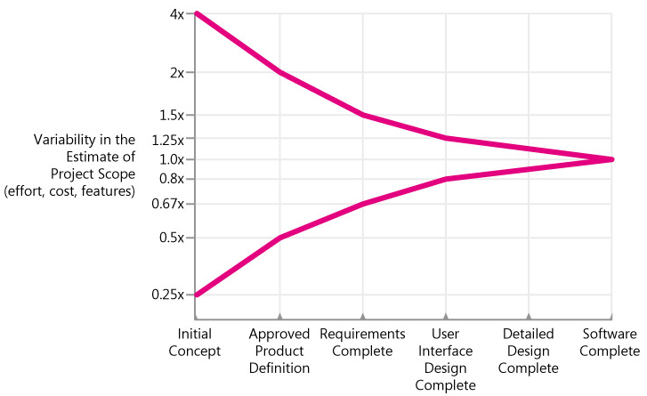
Figure 4-1: The Cone of Uncertainty based on common project milestones
As you can see from the graph, estimates created very early in the project are subject to a high degree of error. Estimates created at Initial Concept time can be inaccurate by a factor of 4x on the high side or 4x on the low side (also expressed as 0.25x, which is just 1 divided by 4). The total range from high estimate to low estimate is 4x divided by 0.25x, or 16x!
The only way to reduce the variability in the estimate is to reduce the variability in the project.

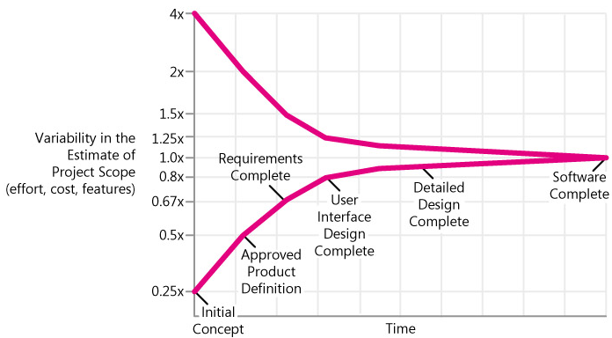
Figure 4-2: The Cone of Uncertainty based on calendar time
Common examples of project chaos include the following:
- Requirements that weren't investigated very well in the first place
- Lack of end-user involvement in requirements validation
- Poor designs that lead to numerous errors in the code
- Poor coding practices that give rise to extensive bug fixing
- Inexperienced personnel
- Incomplete or unskilled project planning
- Prima donna team members
- Abandoning planning under pressure
- Developer gold-plating
- Lack of automated source code control
These sources of chaos share two commonalities. The first is that each introduces variability that makes accurate estimation difficult. The second is that the best way to address each of these issues is not through estimation, but through better project control.
Omitted Activities

Omitted work falls into three general categories: missing requirements, missing software-development activities, and missing non-software-development activities.
Table 4-2 lists requirements that are commonly missing from estimates.
Table 4-2: Functional and Nonfunctional Requirements Commonly Missing from Software Estimates
Functional Requirements Areas | Nonfunctional Requirements
Setup/installation program | Accuracy
Data conversion utility | Interoperability
Glue code needed to use third-party or open-source software | Modifiability
Glue code needed to use third-party or open-source software | Performance
Help system | Portability
Deployment mode | Reliability
Interfaces with external systems | Responsiveness
 | Reusability
 | Scalability
 | Security
 | Survivability
 | Usability

 | Tip #17 | Include time in your estimates for stated requirements, implied requirements, and nonfunctional requirements—that is, all requirements. Nothing can be built for free, and your estimates shouldn't imply that it can.

Table 4-3: Software-Development Activities Commonly Missing from Software Estimates
Ramp-up time for new team members  Mentoring of new team members  Management coordination/manager meetings  Cutover/deployment  Data conversion  Installation  Customization  Requirements clarifications  Maintaining the revision control system  Supporting the build  Maintaining the scripts required to run the daily build  Maintaining the automated smoke test used in conjunction with the daily build  Installation of test builds at user location(s)  Creation of test data  Management of beta test program  Participation in technical reviews  Integration work  Processing change requests  Attendance at change-control/triage meetings  Coordinating with subcontractors | Technical support of existing systems during the project  Maintenance work on previous systems during the project  Defect-correction work  Performance tuning  Learning new development tools  Administrative work related to defect tracking  Coordination with test (for developers)  Coordination with developers (for test)  Answering questions from quality assurance  Input to user documentation and review of user documentation  Review of technical documentation  Demonstrating software to customers or users  Demonstrating software at trade shows  Demonstrating the software or prototypes  of the software to upper management, clients, and end users  Interacting with clients or end users; supporting beta installations at client locations  Reviewing plans, estimates, architecture, detailed designs, stage plans, code, test cases, and so on

 | Tip #18 | Include all necessary software-development activities in your estimates, not just coding and testing.

Table 4-4: Non-Software-Development Activities Commonly Missing from Software Estimates
Vacations | Company meetings
Holidays | Department meetings
Sick days | Setting up new workstations
Training | Installing new versions of tools on workstations
Weekends | Troubleshooting hardware and software problems

4.8 Off-The-Cuff Estimates
Project teams are sometimes trapped by off-the-cuff estimates. Your boss asks, for example, "How long would it take to implement print preview on the Gigacorp Web site?" You say, "I don't know. I think it might take about a week. I'll check into it." You go off to your desk, look at the design and code for the program you were asked about, notice a few things you'd forgotten when you talked to your manager, add up the changes, and decide that it would take about five weeks. You hurry over to your manager's office to update your first estimate, but the manager is in a meeting. Later that day, you catch up with your manager, and before you can open your mouth, your manager says, "Since it seemed like a small project, I went ahead and asked for approval for the print-preview function at the budget meeting this afternoon. The rest of the budget committee was excited about the new feature and can't wait to see it next week. Can you start working on it today?"
Precision & Accuracy
Accuracy refers to how close to the real value a number is. Precision refers merely to how exact a number is. In software estimation, this amounts to how many significant digits an estimate has. A measurement can be precise without being accurate, and it can be accurate without being precise. The single digit 3 is an accurate representation of pi to one significant digit, but it is not precise. 3.37882 is a more precise representation of pi than 3 is, but it is not any more accurate.

4.10 Other Sources of Error
The sources of error described in the first nine sections of this chapter are the most common and the most significant, but they are not exhaustive. Here are some of the other ways that error can creep into an estimate:
- Unfamiliar business area
- Unfamiliar technology area
- Incorrect conversion from estimated time to project time (for example, assuming the project team will focus on the project eight hours per day, five days per week)
- Misunderstanding of statistical concepts (especially adding together a set of "best case" estimates or a set of "worst case" estimates)
- Budgeting processes that undermine effective estimation (especially those that require final budget approval in the wide part of the Cone of Uncertainty)
- Having an accurate size estimate, but introducing errors when converting the size estimate to an effort estimate
- Having accurate size and effort estimates, but introducing errors when converting those to a schedule estimate
- Overstated savings from new development tools or methods
- Simplification of the estimate as it's reported up layers of management, fed into the budgeting process, and so on
Don't assume that effort scales up linearly as project size does. Effort scales up exponentially.
Every 10 multiplier for FP size, productivity drops by factor .2. Like 100 FP, 1, 1000 FP, .8, 10000 FP .6, 100000, .5
Count, Compute, Judge
Suppose you're at a reception for the world's best software estimators. The room is packed, and you're seated in the middle of the room at a table with three other estimators. All you can see as you scan the room are wall-to-wall estimators. Suddenly, the emcee steps up to the microphone and says, "We need to know exactly how many people are in this room so that we can order dessert. Who can give me the most accurate estimate for the number of people in the room?"
The estimators at your table immediately break out into a vigorous discussion about the best way to estimate the answer. Bill, the estimator to your right, says, "I make a hobby of estimating crowds. Based on my experience, it looks to me like we've got about 335 people in the room."
The estimator sitting across the table from you, Karl, says, "This room has 11 tables across and 7 tables deep. One of my friends is a banquet planner, and she told me that they plan for 5 people per table. It looks to me like most of the tables do actually have about 5 people at them. If we multiple 11 times 7 times 5, we get 385 people. I think we should use that as our estimate."
The estimator to your left, Lucy, says, "I noticed on the way into the room that there was an occupancy limit sign that says this room can hold 485 people. This room is pretty full. I'd say 70 to 80 percent full. If we multiply those percentages by the room limit, we get 340 to 388 people. How about if we use the average of 364 people, or maybe just simplify it to 365?"
Bill says, "We have estimates of 335, 365, and 385. It seems like the right answer must be in there somewhere. I'm comfortable with 365."
"Me too," Karl says.
Everyone looks at you. You say, "I need to check something. Would you excuse me for a minute?" Lucy, Karl, and Bill give you curious looks and say, "OK."
You return a few minutes later. "Remember how we had to have our tickets scanned before we entered the room? I noticed on my way into the room that the handheld ticket scanner had a counter. So I went back and talked to the ticket taker at the front door. She said that, according to her scanner, she has scanned 407 tickets. She also said no one has left the room so far. I think we should use 407 as our estimate. What do you say?"
What to Count

Software projects produce numerous things that you can count. Early in the development life cycle, you can count marketing requirements, features, use cases, and stories, among other things.
In the middle of the project, you can count at a finer level of granularity—engineering requirements, Function Points, change requests, Web pages, reports, dialog boxes, screens, and database tables, just to name a few.
Late in the project, you can count at an even finer level of detail—code already written, defects reported, classes, and tasks, as well as all the detailed items you were counting earlier in the project.
You can decide what to count based on a few goals.

