uvicorn api:app --reload --port 8080

<http://localhost:8080/docs#/default/get_all_messages_messages_get>

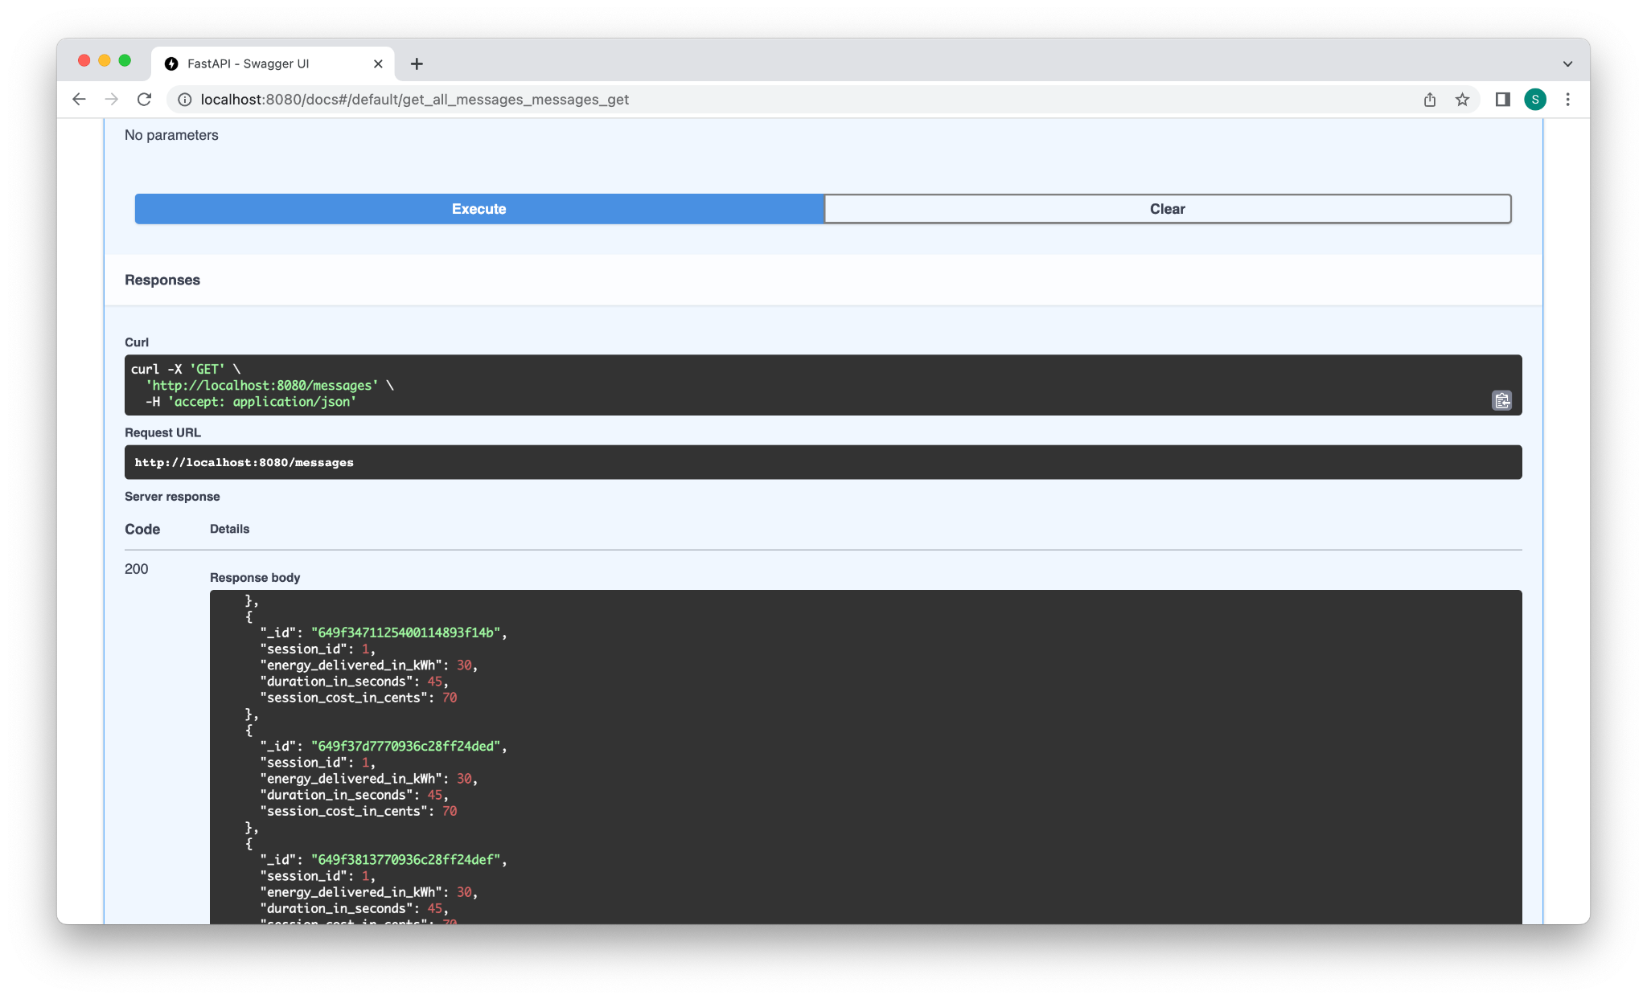

<http://localhost:8080/messages>

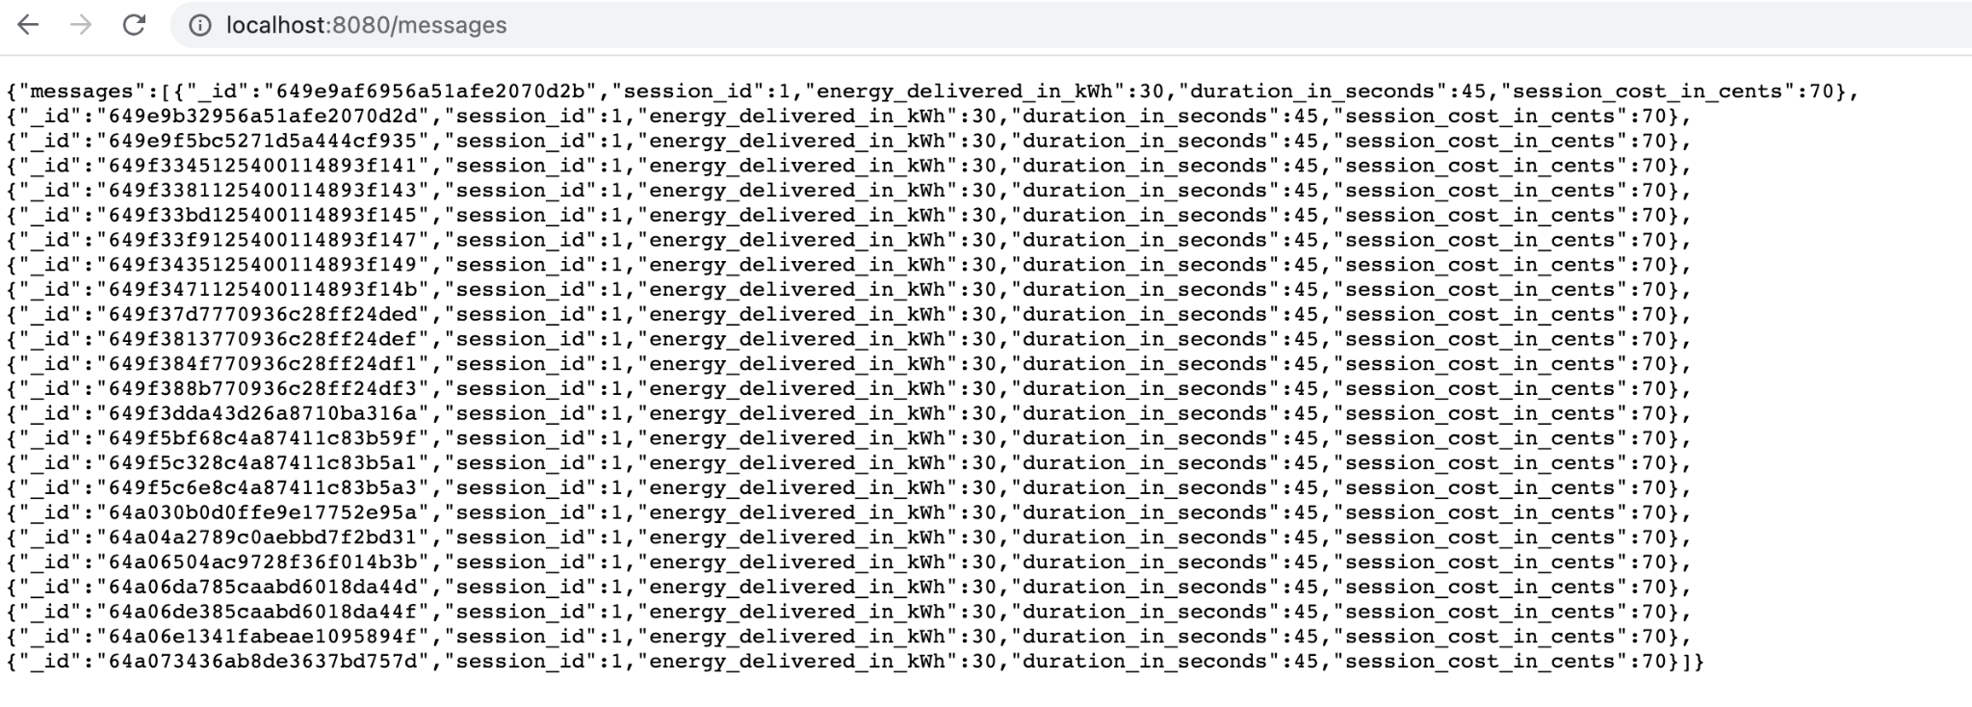

The MQTT Broker is also working as l have installed the mosquitto in local so the mqtt_broker as “localhost”

I have MQTTX client to check the responses:

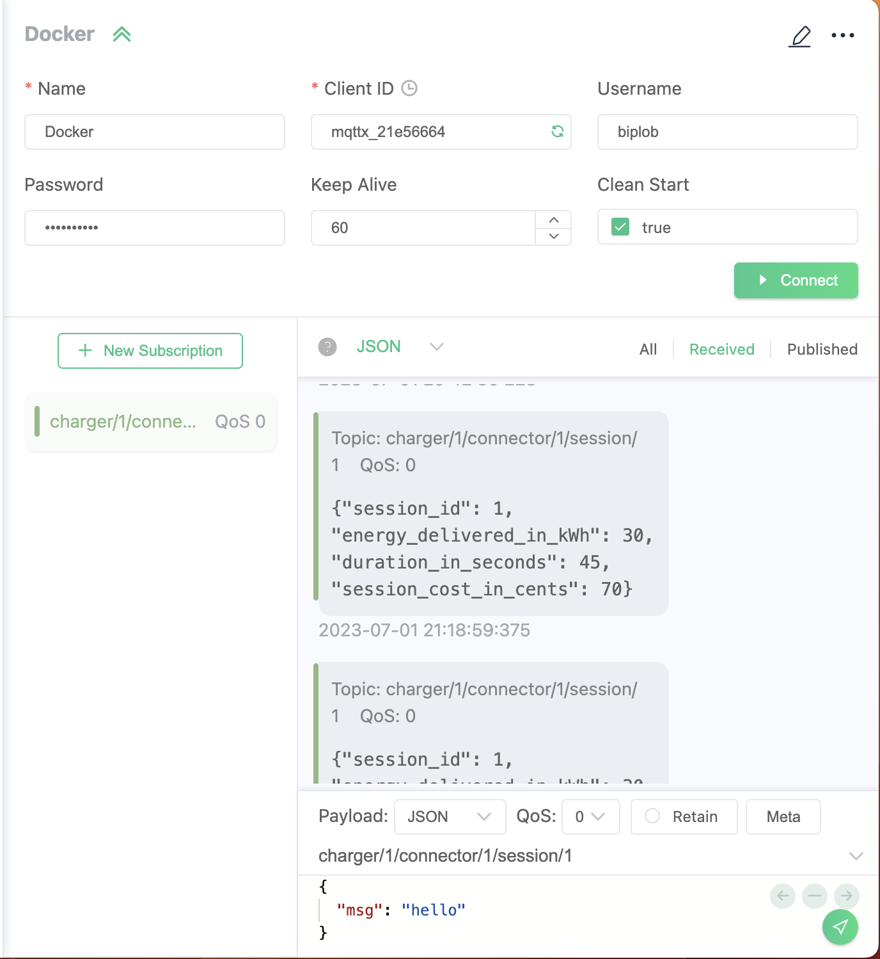

The payload is getting stored in the MongoDB collection in “mqttpy”;

