**VIRTUALISATION PROJECT ON**

**RESOURCE OPTIMISATION IN VIRTUALISATION**

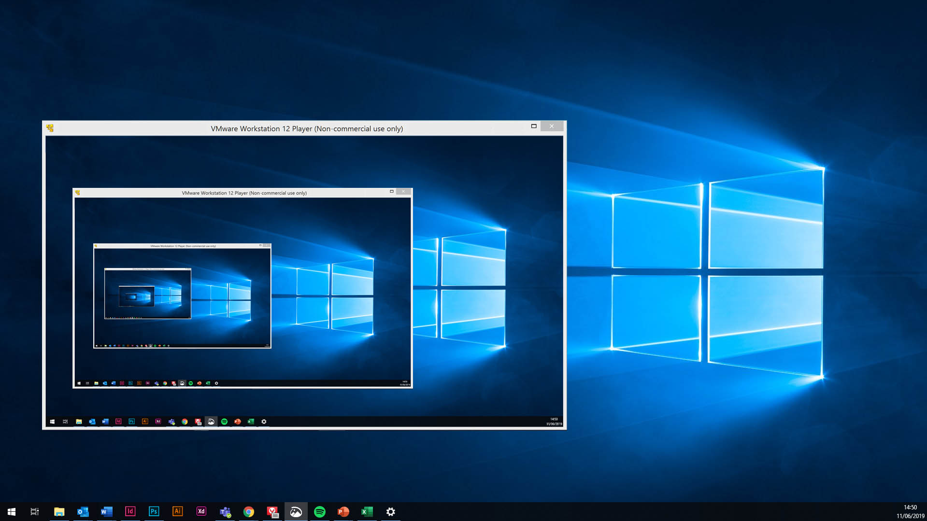

**BY BISHWA JYOTI DAS**

**REG NO: 19BCE1755**

**SCOPE**

* The scope of the project is to visualize the resource optimizations in virtual environment. We will also check how virtual resources are handled in the cloud.
* The resource allocation problem is a major issue in cloud-based services whose focus is to reduce the wastage of resources as much as possible. There are many methods through which cloud achieves this and virtualization is an integral part of it.
* Though the deployment and allocation of virtual machines in data centers can be a bit of an issue when cloud infrastructure is made of lightweight computing devices.

**OBJECTIVE**

* To check how the various resources are handled and optimized in virtual as well as the cloud environment. There are various resources in Cloud as well as Virtual environments. Virtual environments are largely used in Cloud to increase it’s functionality and efficiency.
* The allocation of resources plays a very significant role in determining the power consumption, performance as well as the good use of the allocated resources such that there is a minimum wastage. Thus resource optimization is a key technique of achieving such results efficiently.

**METHODOLOGY**

* We will basically review several research papers and articles to check all the available optimisation techniques for cloud based services as well as virtualisation environments.
* We will also see the respective ways through which the famous cloud service providers such as Google and AWS optimise their resources.

**NEED FOR OPTIMISING RESOURCES IN THE CLOUD**

* Cloud has made it possible to access our data from anywhere around the world.
* Cloud is based on the fact that you pay for the resources that you use.
* Scheduling of tasks as well as resource allocation plays a key role in the cloud.
* Services are delivered to the users on the basis of what they choose to do. For example we can go for Infrastructure as a Service(IAAS), Platform as a Service(PAAS) or Software as a Service. Each have their own merits as well as demerits.
* In IAAS we don’t have to worry about hardware resources and their servicing at all as it is maintained by the cloud service provider. In Platform as a Service even the Operating Systems are managed by the provider. In SAAS our applications as well as network are managed by the cloud provider.
* Thus this results in different prices for different scenarios. As the responsibilities decrease from us and increase in the cloud provider’s end it will obviously lead to increase in pricing overall. But it will also be very helpful as most of the processes are automated rather than manual thus leading to savings as well.

**DIFFERENT SCENARIO’S FOR CLOUD RESPONSIBILITIES IN AZURE**

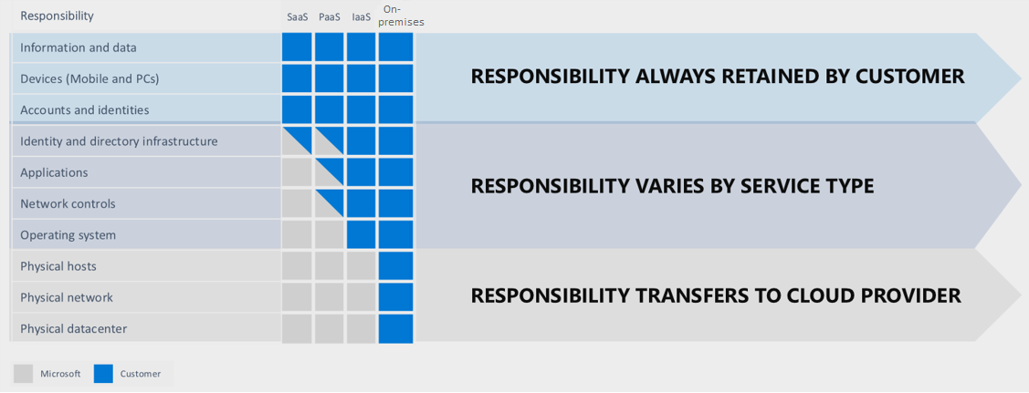

**BENEFITS OF CLOUD OPTIMISATION**

* Using cloud has many advantages like the ability to easily be able to scale up or down according to our need.
* The challenge lies in the pattern to understand our spends and what we need to do to save as much as possible. We may not use many of the resources properly and thus it leads to a wastage for us.
* There are certain situations where our cloud costs are increasing. There may be a possibility that the customer base is increasing regularly as well. But without a proper visibility we won’t be able to know why our costs have been increasing and the specific techniques we can use for it.
* A Cloud Optimisation stratergy thus comes into picture where the goal is to reduce the wastage of resources as well as increase the performance by removing the unnecessary features.
* Cloud optimisations help companies in the longer run as well. Cloud optimization is important for companies that want to have more cloud benefits such as reducing their cloud costs, boosting the productivity of employees, and moving their operations from on-premises architecture to a cloud based environment.

**PRACTICING CLOUD OPTIMISATION BOOSTS VISIBILITY**

* Most of the users of cloud think that they are are using the Pay-as-you-go model efficiently. The thing that we have to know is that even the most of the famous cloud service providers like Google Cloud, Microsoft Azure and others don’t enable these capabilities in our accounts automatically. The pay-as-you-go model sometimes works rather inefficiently where certain resources are overallocated leading to an increase in the overall costs.



**CLOUD OPTIMISATION ADVANTAGES**

* The Cloud optimisation process focusses on finding out underutilized features, or resources which are overprovisioned or mismanaged tools and services to find out the areas where improvement can be made.

**TO REDUCE UNNCESSARY COST**

* Cloud optimisation also helps to reduce any unnecessary extra costs. This is helpful for people those people who are new to cloud as well as those who have been using the cloud for some time.

**CLOUD OPTIMISATION REDUCES CLOUD COST**



**WASTAGE OF CLOUD RESOURCES**



**BOOSTING CLOUD UTILISATION**

* Cloud offers several features and new features are added after some particular time. Some famous cloud companies offers hundreds of new features after a year.
* Some of these features may be helpful depending on the need of the company but most of it may be unnecessary usage of cloud resources.
* Companies and individuals working alone need to target this bare minimum in order to optimize their cloud costs to the maximum.
* It also helps engineers and employees to increase their productivity by focusing on their job. Using cloud optimization stratergies thus frees up time and ensures that the team performance does not decrease.

**MANAGE AZURE COSTS**

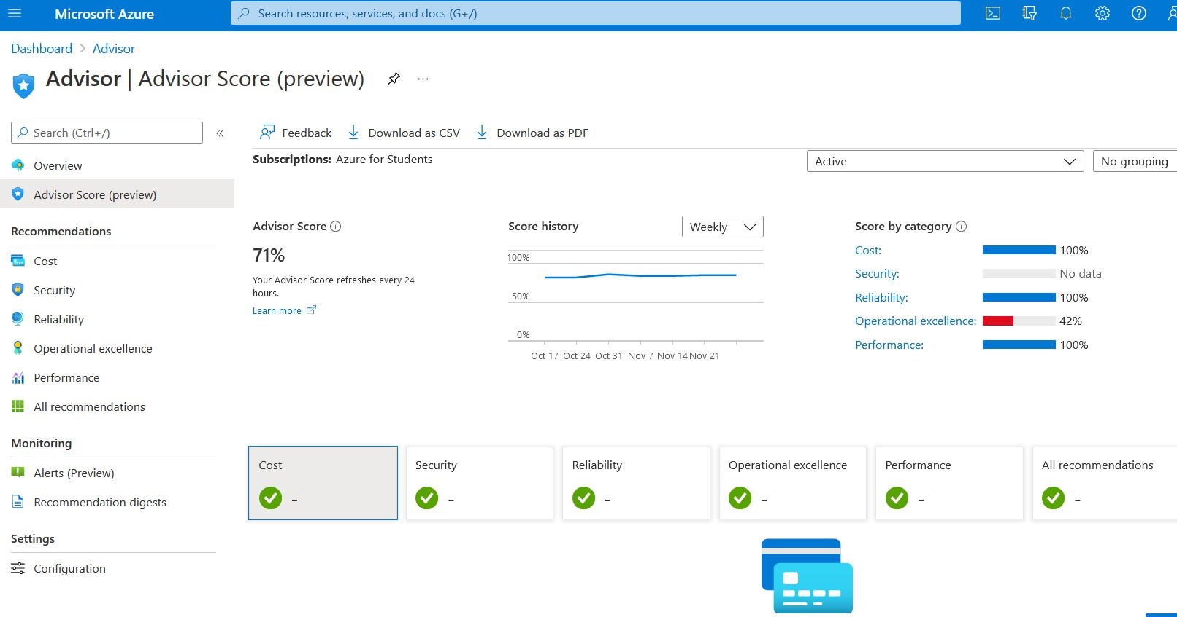

**AZURE ADVISOR**

* It helps improve the reliability of mission critical applications and the reliability score and recommendations can be checked in azure advisor itself.
* To optimise the costs of the virtual machines it is helpful if we resize or shut down the underutilised resources.
* The advanced evaluation model in Advisor considers shutting down virtual machines when all of these statements are true:

i) P95th of the maximum value of CPU utilization is less than 3%.

ii) Network utilization is less than 2% over a seven-day period.

iii) Memory pressure is lower than the threshold values

* Advisor considers resizing virtual machines when it's possible to fit the current load in a smaller SKU (within the same SKU family) or a smaller number of instances such that:

i) The current load doesn’t go above 80% utilization for workloads that aren't user facing.

ii) The load doesn't go above 40% for user-facing workloads.

**AZURE ADVISOR BENEFITS**

* Optimize the spends for MariaDB, MySQL and PostgreSQL. If these resources are being underutilized you can view it in Azure Advisor itself.
* Low resource utilization results in unwanted expenditure that you can fix without significant performance impact.
* To reduce the costs as well as effectively manage the resources it is recommended to reduce the size of virtual cores by half of original value.
* Azure Advisor identifies virtual network gateways that have been idle for more than 90 days. Because these gateways are billed hourly, they could be reconfigured or delete them if they are not useful anymore.
* Consider buying reserved Virtual machines or reserved instances. Advisor automatically predicts after reviewing your VM usage for the past 30 days to determines if reserved instances or VM are truly required or not. Discounts are automatically applied on new or existing VMs that have same size and region as the reservations.

**AZURE MONITOR METRICS**

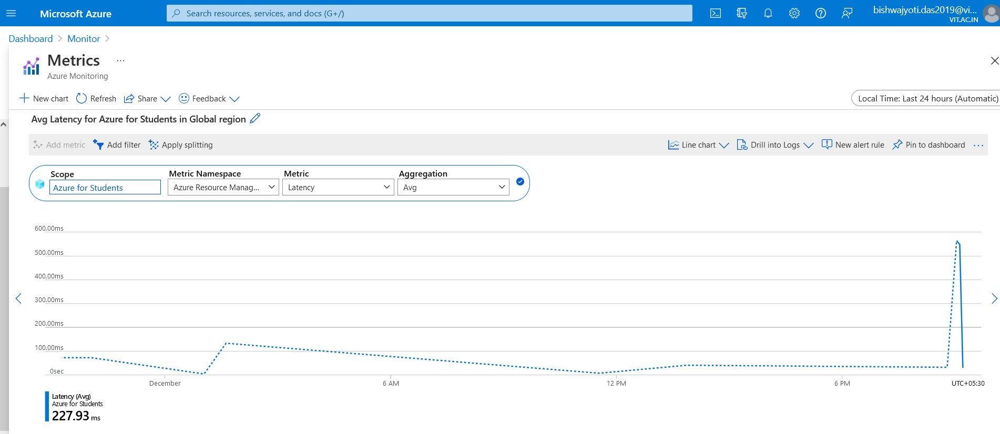

**AZURE MONITOR BENEFITS**

* Azure monitor is a tool to measure utilization of resources in azure.
* You can measure rather anything from CPU Utilization or amount of bandwidth of VM as well as latency.
* You can group them as a resource and you can also view based on individual virtual machines as well.
* With the help of Azure monitor resource monitoring can be made significantly easier.
* You can also get an overview of current health statistics of your VM which will be helpful combined with Azure Monitor as it gives both visualization graphs as well as data statistics.
* We can also make use of Azure Cost Management services which will give us detailed results of where we are spending more money so that we can restrict the use of resources to a certain degree.

**AVERAGE CPU UTILISATION BY RESORCE ID**

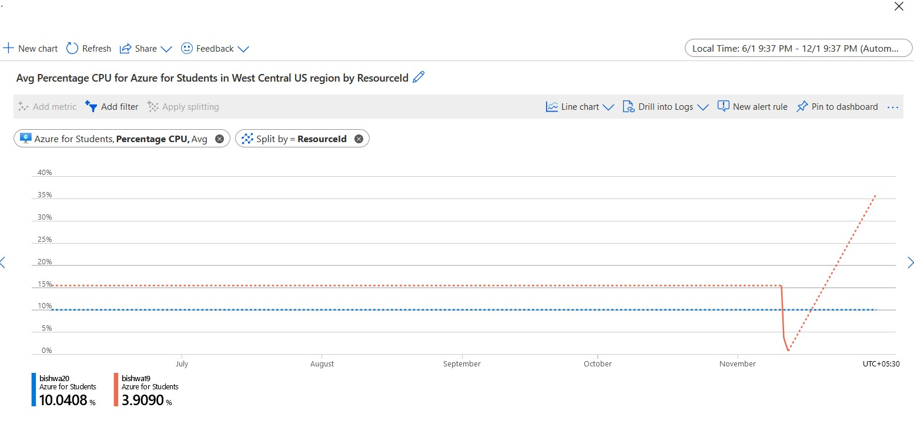

**AZURE RESOURCE MAP FOR A VM**

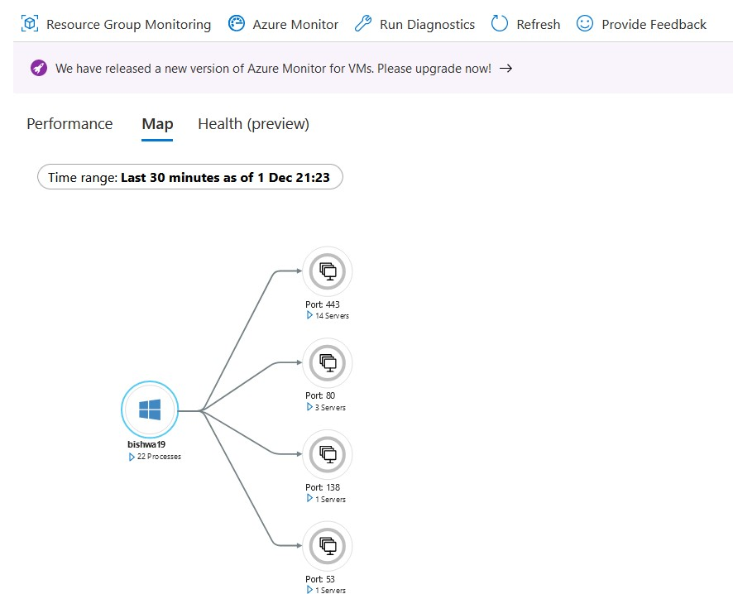

**AZURE VM HEALTH PREVIEW**

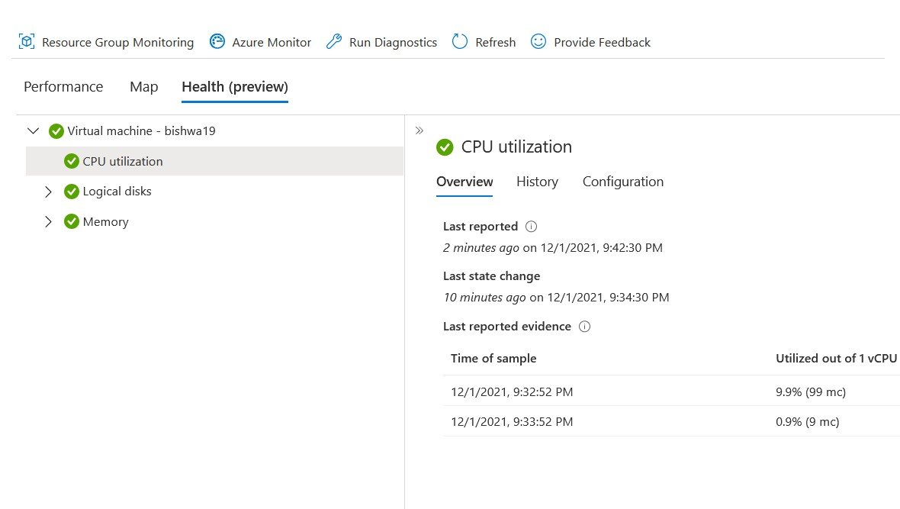

**CONNECTING TO A WEBSITE USING VM**

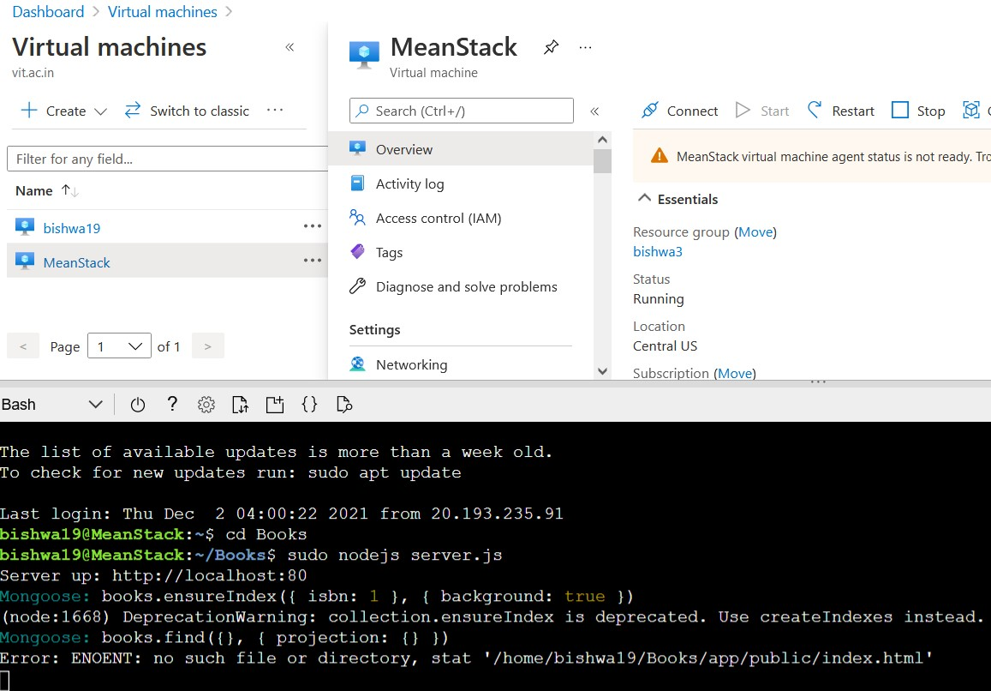

**VIEWING THE WEBSITE**

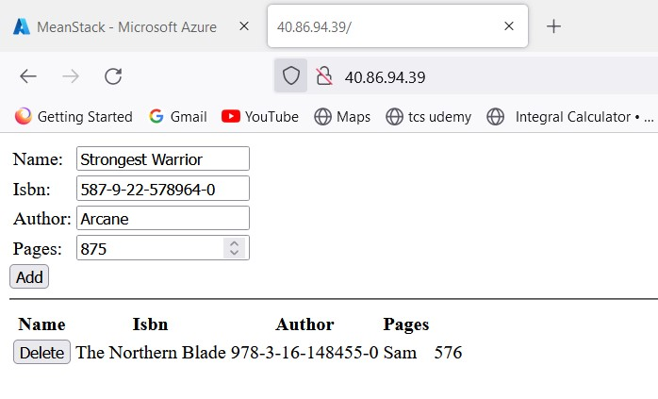

**ADDING A BOOK**

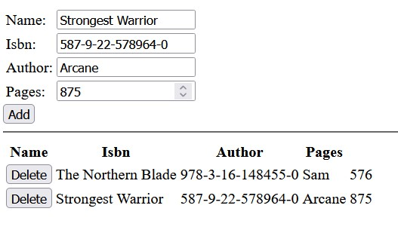

**CONNECTING TO RDP CLIENT**

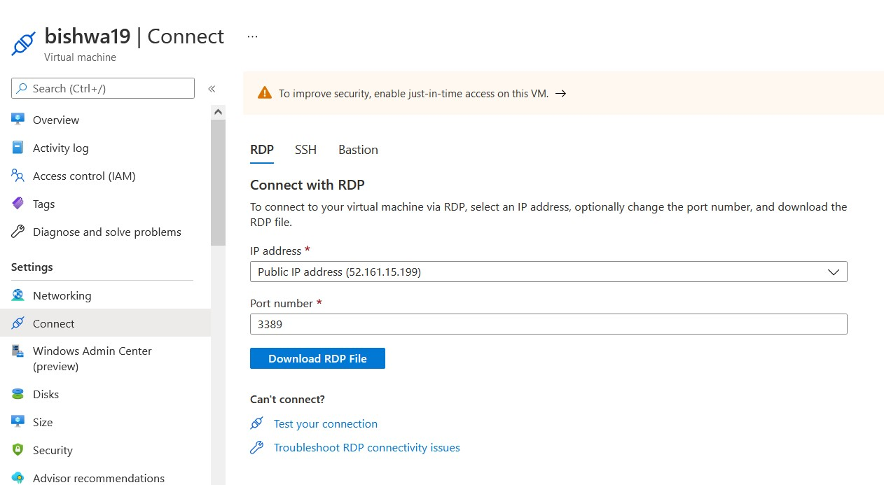

**CONNECTING TO RDP**

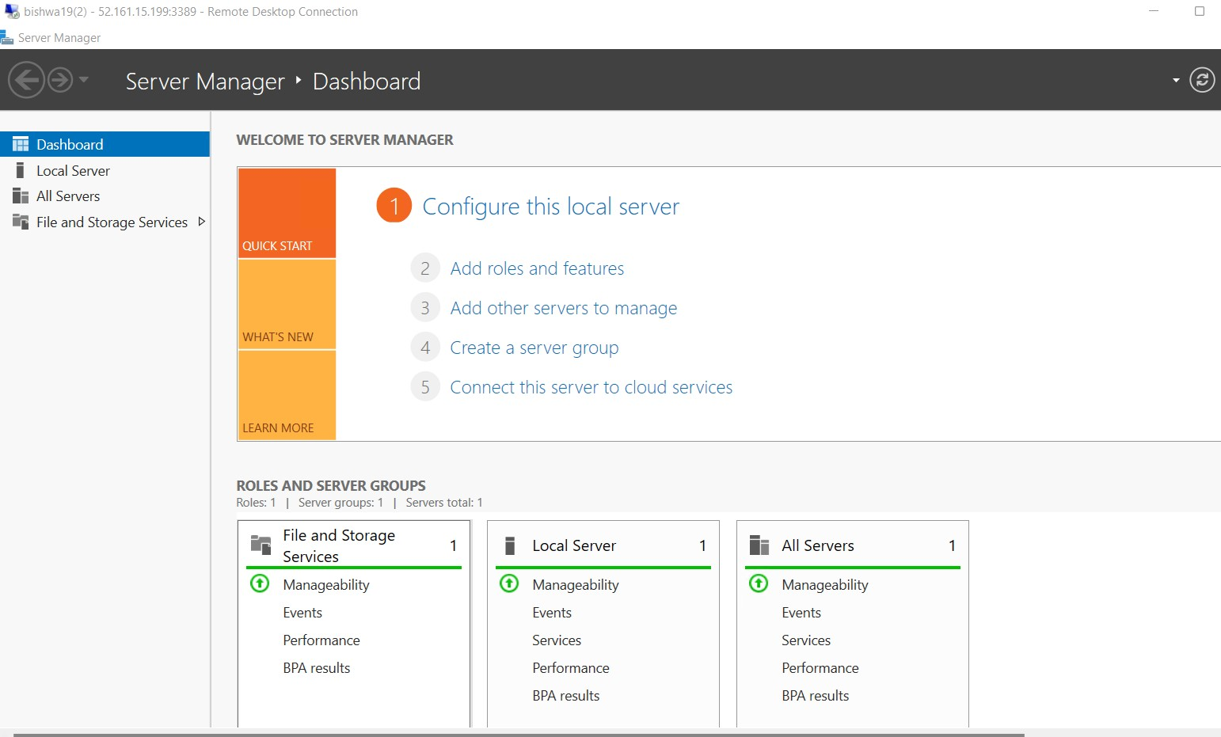

**CONCLUSION**

From this project we get to know how important Virtualisation is in the aspect of Cloud Management. We thus get to know how to handle cloud resources efficiently through the use of Azure Advisor which sets the score for how efficiently the resources are being managed by us.

We get to know the use of Azure Monitor through which we can check several factors like CPU Utilisation as well as Disk and Memory Utilisation. We can also check the Bandwidth as well as Latency of our Virtual Machines. Thus, accordingly we can allocate the resources and scale them up and down according to our needs.

**REFERENCES**

1. <https://www.cloudzero.com/blog/cloud-optimization>
2. <https://cloud.google.com/blog/products/it-ops/best-practices-for-optimizing-your-cloud-costs>
3. <https://azure.microsoft.com/en-in/overview/cost-optimization/>