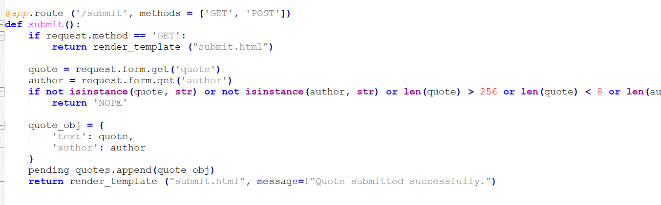

First we need to submit a quote with a webhook we use site.webhook and put it in a form <form action=''> and as author whatever

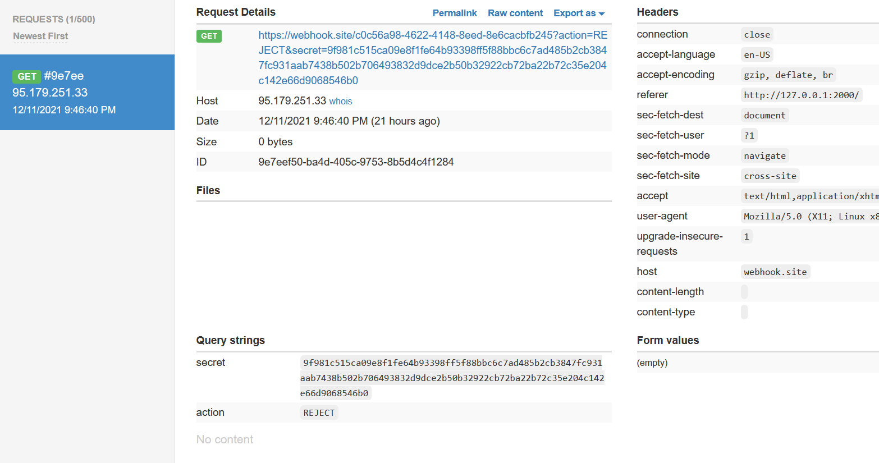

We receive the secret after which we need to put approve in postman form and send it to it’s path

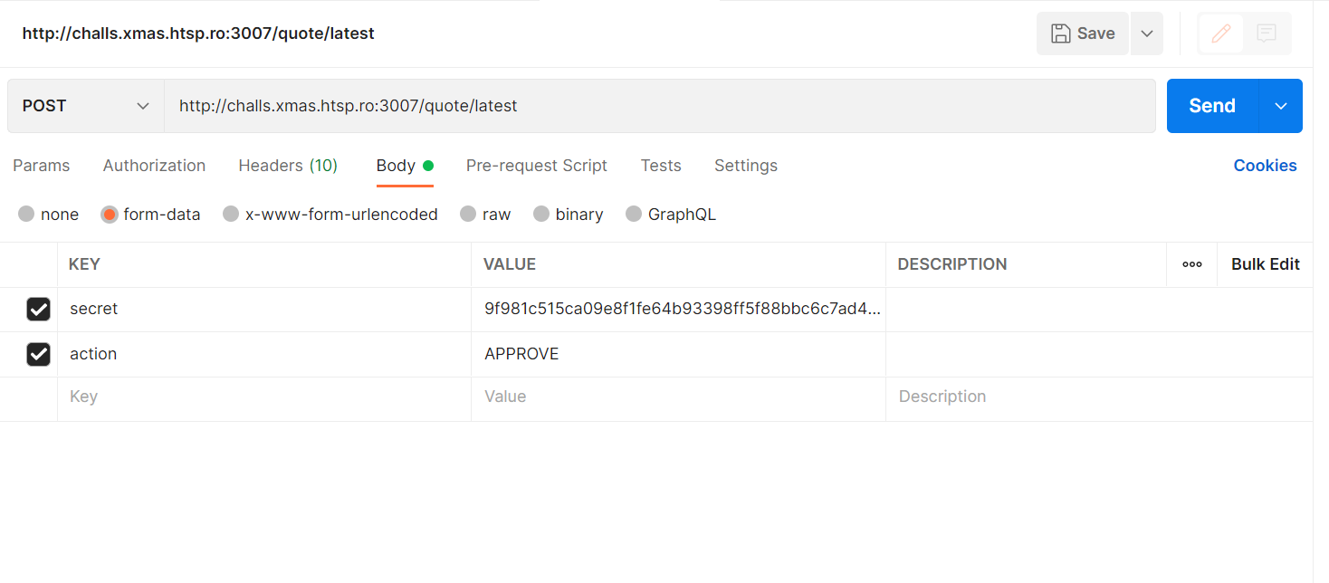

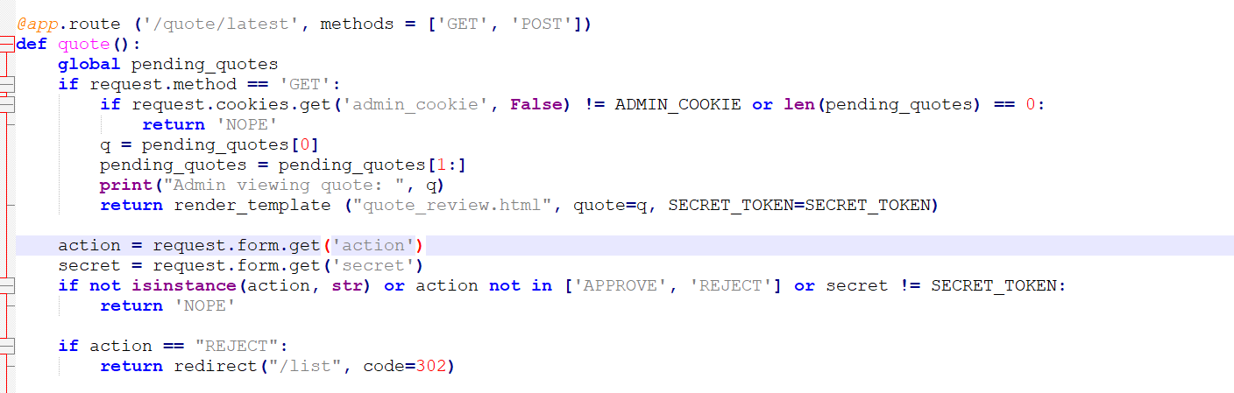

We get the flag as response