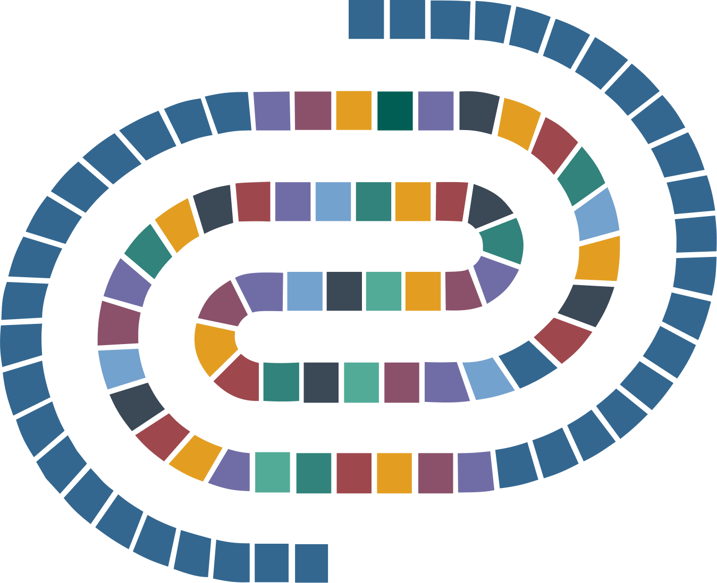

General Documentation for project

Alice in DaSCHland

Noémi Villars-Amberg

20.08.2026

Copyright: Alice in DaSCHland
License: CC BY 4.0
How to cite: Noémi Villars-Amberg, Alice in DaSCHland, 20.08.2026.

Contents
Project Presentation 3
Purposes and goals 3
Key Features 3
Nature of gathered data 4
Type of data collected 4
Sources of the data 4
Privacy and Legal considerations 4
Data Processing 5

Project Presentation

Purposes and goals
The Alice in DaSCHland project is designed to serve as a comprehensive example of the features and possibilities offered by DSP-APP and DSP-TOOLS. Its primary purpose is to provide new and prospective customers with a clear, well-documented project that demonstrates the full potential of the DaSCH Service Platform. By offering a tangible and coherent example, users can better understand how the platform’s tools and applications can be adapted to their own projects.
Additionally, the project acts as a practical resource for the DaSCH Research Data Unit Team, enabling them to illustrate specific features during customer interactions. It also provides detailed documentation and import scripts, showcasing how each feature can be created and implemented using DSP-TOOLS. Beyond its educational role, the project serves as a testing environment for updates to DSP-APP and contributes to the documentation of the DaSCH Service Platform.

Key Features
Alice in DaSCHland is built around the universally recognized story of Alice in Wonderland, which is in the public domain. This choice ensures that the project’s content is widely accessible and easily understood by a global audience. The story’s familiarity also allows for creative exploration of the platform’s multimedia capabilities, as the DaSCH Service Platform specializes in the display and publication of diverse multimedia materials.
To demonstrate the platform’s ability to manage both public and private data, the project includes two distinct narratives: the original Alice in Wonderland story, which is publicly accessible, and an alternative storyline set in the fictional world of DaSCHland, which remains private.

Nature of gathered data

Type and volume of data collected
The project collects a wide range of data types to highlight the platform’s versatility. Textual data includes the story itself, along with chapters, character descriptions, locations, and events. To showcase the platform’s multimedia capabilities, the project incorporates images (JPEG), documents (PDF), audio files (MP3), videos (MP4), text files (XML, CSV), and archives (ZIP).
Data is organized within a structured folder system, with each type of data stored in designated subfolders. Textual data and metadata for multimedia files are managed using spreadsheets (XLSX). All data collected for this project is published, as its purpose is to serve as a public showcase.
The project currently contains 164 multimedia resource instances, 168 textual resource instances, and a total data volume of 530 MB.

Sources of the data
The project integrates data from a variety of reputable sources. Original illustrations by John Tenniel were sourced from alice-in-wonderland.net, while the full text of the chapters was obtained from Project Gutenberg. Book editions and videos were downloaded from Archive.org, and book covers are hosted on external IIIF servers, with references included in the resource instances. Audio recordings were sourced from LibriVox.
The original and alternative textual data were created by Daniela Subotic and Noémi Villars-Amberg, with the assistance of AI tools (ChatGPT) for the DaSCHland storyline. AI-generated images for the DaSCHland narrative were produced using ChatGPT and MistralAI.

Privacy and Legal considerations
No data required anonymization, as all gathered data is either in the public domain or generated by AI and therefore not subject to copyright. Resources and files created by the DaSCH Research Data Unit Team are published under the Creative Commons License CC BY 4.0, ensuring compliance with FAIR principles.

Data Processing
The development of the project began with the creation of an initial data model designed to encompass all class types available on the DaSCH Service Platform. The team first identified and collected existing public domain data to determine what could be gathered and what needed to be created. Subsequent steps involved the progressive creation of additional data, with the data model evolving to reflect new features and requirements as the project advanced.

