Dana Seibert

Vistas in Advanced Computing

1 August 2017

Molecular Dynamics

In this simulation, I modeled the initial molecule at a target of 300 for 30,000 time steps. The model reached equilibrium at step 5,800 and had an average of 310.501 K for the rest of the time steps.

The graph below shows the stabilization of temperature at time step 2,300. The average temperature is 296.4956 K and the standard deviation is 5.410 for temperature. 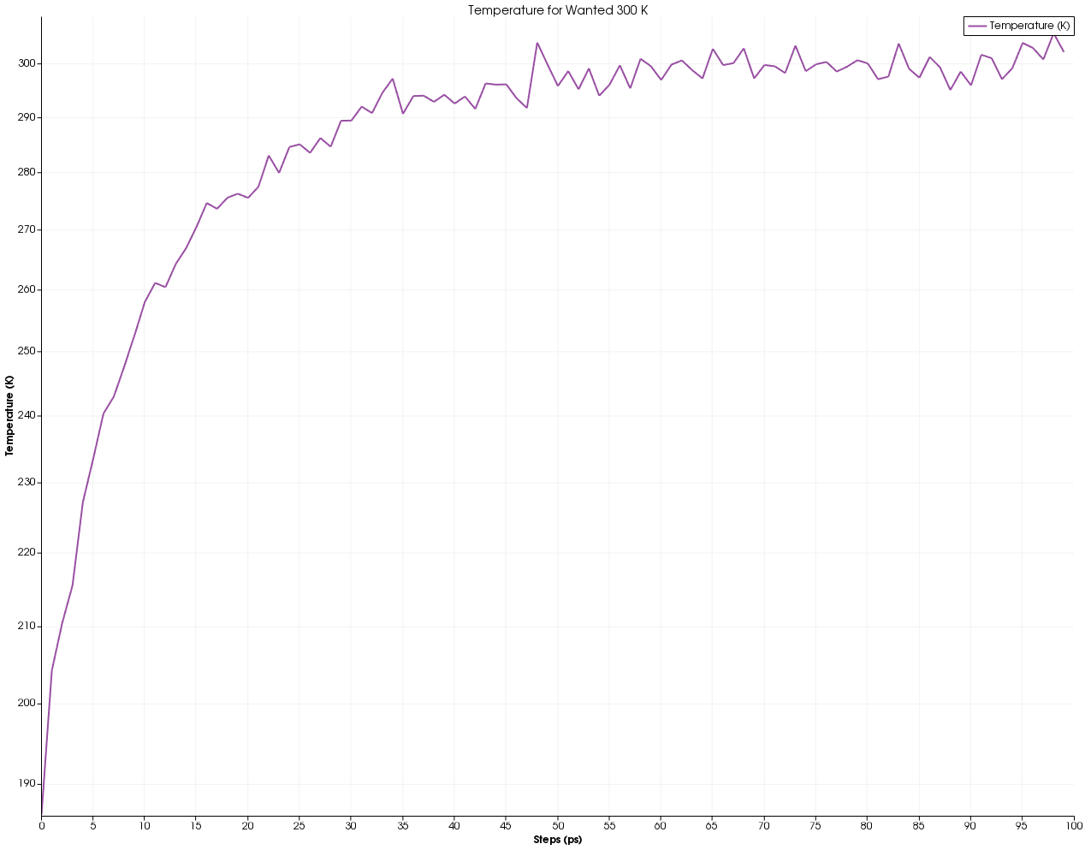

The graph below shows the temperature and the kinetic energy stabilizing at 2,000 steps

and verifies that temperature is correctly reflecting its relationship with kinetic energy.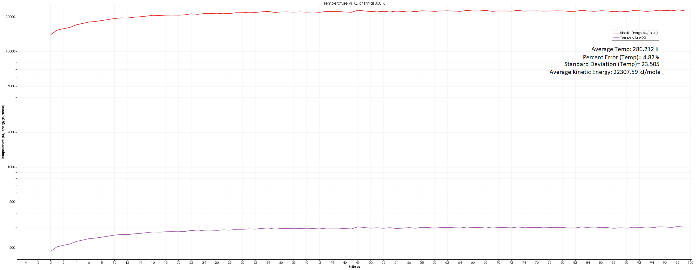

As the time goes on the energy of the system balances out and remains stable with the energy remaining stable after 1,000 steps.

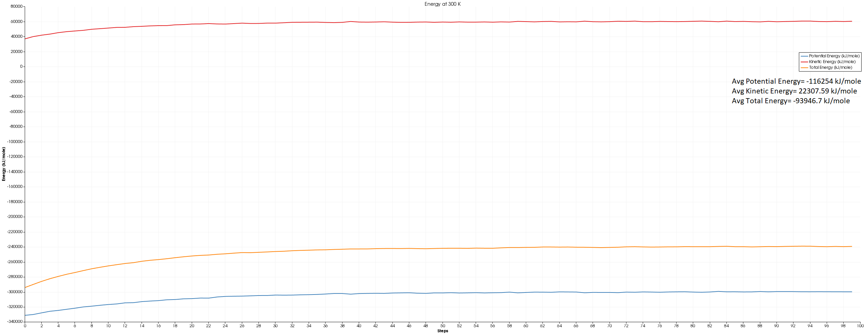

Below is the image of the original model.

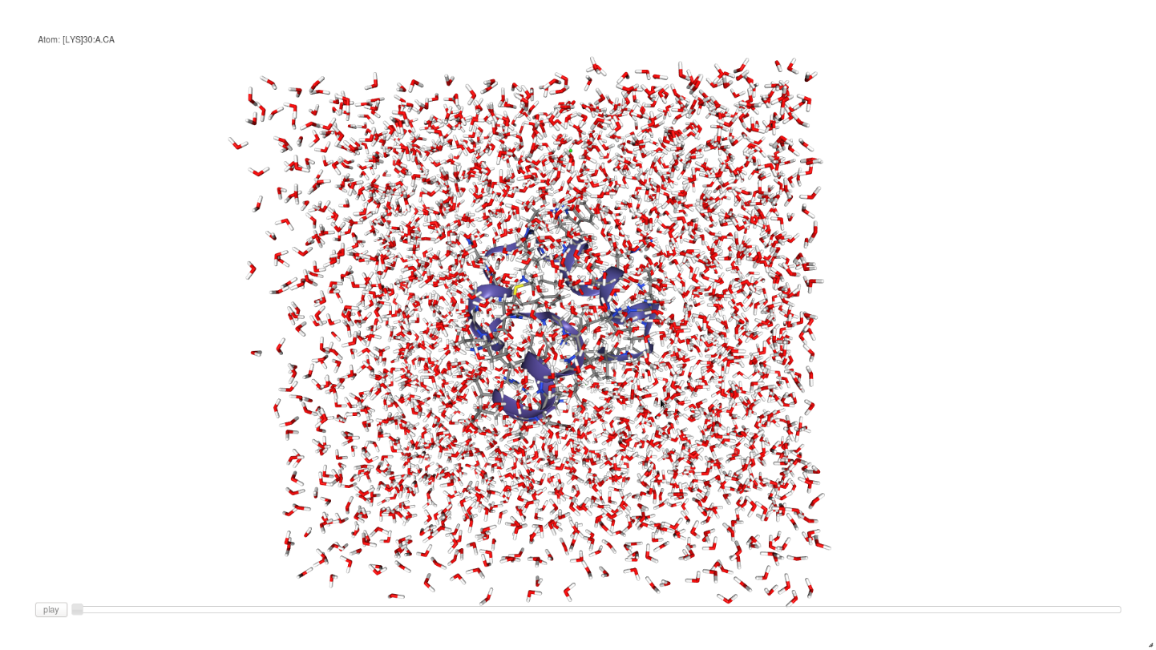

In this simulation, I modeled (5fdr_solv-cube_equil.pdb) at a target of 300 for 30,000 time steps. The model reached equilibrium at step 5,800 and had an average of 310.501 K for the rest of the time steps.

The graph below shows the stabilization of temperature at time step 2,200. The average temperature is 295.5975 K and the standard deviation is 4.961 for temperature. 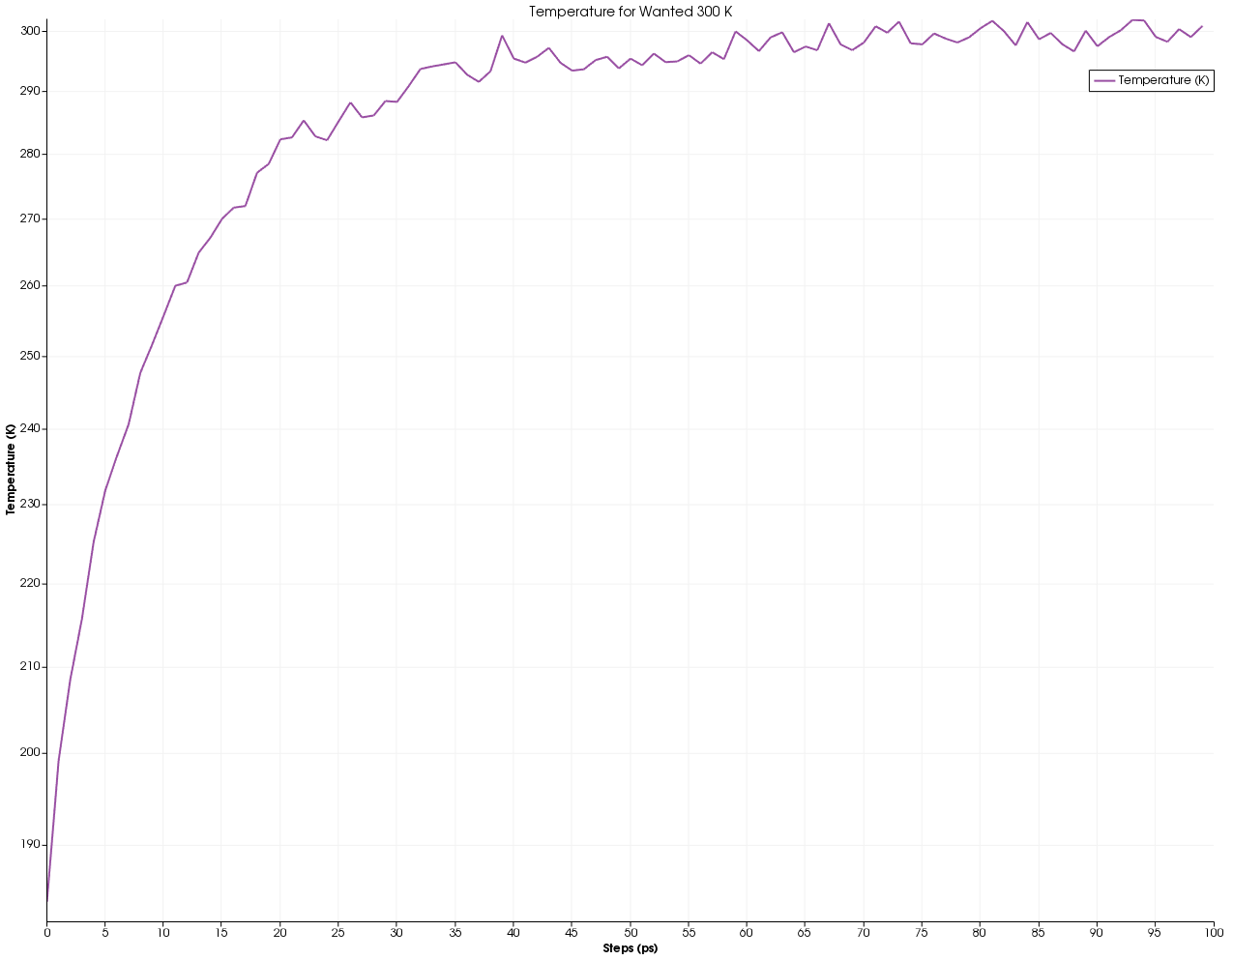

The graph below shows the temperature and the kinetic energy stabilizing at 1,200 steps

and verifies that temperature is correctly reflecting its relationship with kinetic energy.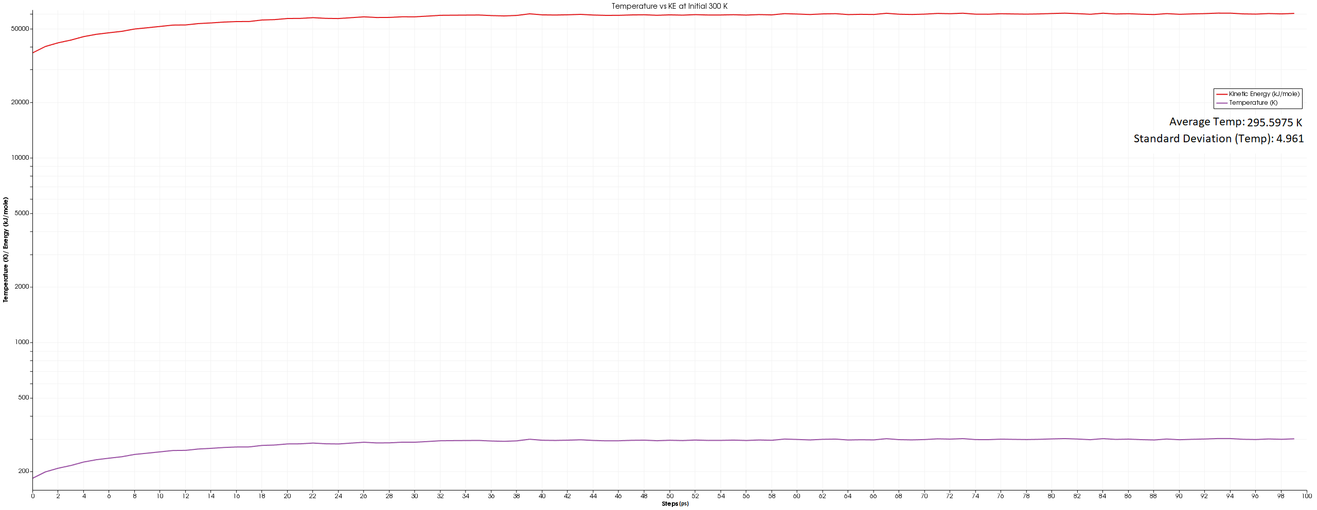

As the time goes on the energy of the system balances out and remains stable with the energy remaining stable after 1,000 steps.



Below is the image of the (5fdr_solv-cube_equil.pdb) model.

