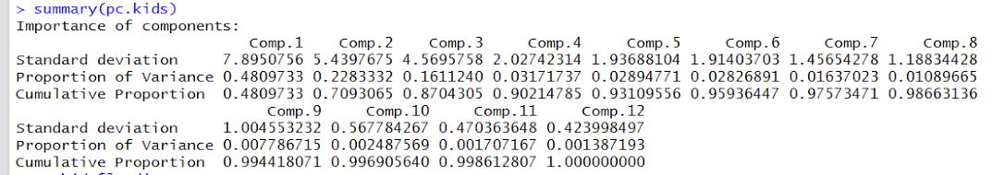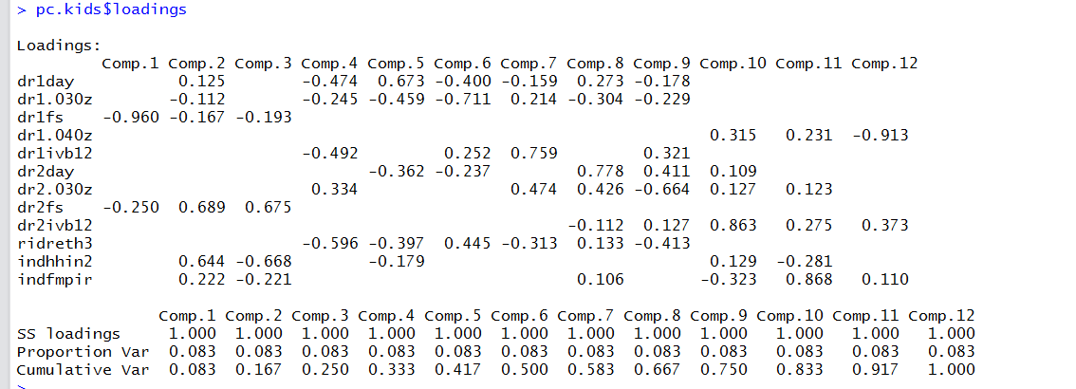

Amount of Variation Contributed by Components

PCA Analysis Showing Components' Contribution to Variance