Dasha Pokutnaya and Savanah Russ

HPM 573

Final Project Report

2 May 2018

Human papillomavirus (HPV) is a sexually transmitted virus that is primarily transmitted through vaginal or oral sex with an infected individual. The lifetime risk of HPV infection is 80% (Chesson et al., 2014). While most HPV genotypes cause asymptomatic infections that resolve on their own, some genotypes lead to persistent infections, resulting in differing levels of dysplasia due to cervical intraepithelial neoplasia (CIN). About 90% HPV infections with mild CIN I clear; however 5% of cases progress to CIN II wherein two-thirds of the cervical cells are abnormal. Of those who develop CIN II, 50% of the infections spontaneously clear.

Women are recommended to schedule a pap smear test every three years which on average costs $50. If the pap smear detects abnormal cell growth, a second pap smear test with a simultaneous HPV DNA test to detect high-risk HPV infections is performed. The combined costs of both tests if approximately $250 per year until the infection either clears or progresses. If the infection progresses to CIN II, a colposcopic biopsy and an additional three annual pap smears with a total average estimated cost is $2500 dollar per year (Chura 2014). Within our model, we assumed that all individuals would receive the recommended test corresponding to their state. Additionally, we assumed that all individuals would be paying the same amount for each of the tests.

In the United States, about 79 million Americans are infected with genital HPV and about 14 million new cases occur annually, mostly in teens and young adults (“Manual for the Surveillance”). In 2006, a 90-98% efficacious three-dose HPV vaccine, changed to a two-dose vaccine in 2016, was released that covers a variety of HPV genotypes including 16 and 18, the causative agents of 70% of all HPV-associated cervical cancers and 80% of invasive anal cancer cases (Villa et al., 2005; Steinau et al., 2011). The $190, 2-dose vaccine (the mean cost per dose is $95) is recommended for both males and females between the ages of 12-26 years of age (“Morbidity and Mortality Weekly Report (MMWR))”. However, with the high vaccine cost, stigma around sexually transmitted diseases, and the small proportion of individuals whose HPV infections develop into cancer, some question the cost-effectiveness of the HPV vaccine.

To approach the questions, “Is the Human Papillomavirus vaccine cost effective and does it improve human capital with the increased cost?” we used a discrete-time Markov model. In order to simply our model, we assume a 100% vaccine efficacy and a homogenous, USA-born female population. We also assume that all individuals vaccinated completed the 2-dose regimen. While there are no current estimates on the number of women who receive both doses of the two-dose vaccine series, in 2012, only 33.4% had received all 3 doses of the previously recommended vaccine (“Human Papillomavirus Vaccination Coverage”). Furthermore, we also assumed a closed population and a post-vaccine absorbing state.

The data sources used to inform the input parameters of the model were largely pulled from the Centers for Disease Control & Prevention (CDC). The probabilities for moving through the transition matrix were determined from incidence and prevalence rates provided by the CDC, as well as from current literature that reported results on the natural history of disease of HPV infection and CIN II lesions. The health utilities and costs of therapeutic and preventative medical interventions used to inform the cost effectiveness and cost benefit analysis were also found in current medical and health policy literature. Further details on the specific probabilities, utilities and costs used to inform the model can be found in the table descriptions for Table 1, Table 2 & Table 3.

In order to answer our study question, we utilized a discrete time Markov model. We found that this approach was more appropriate over a continuous time Markov model, because both the preventative vaccine intervention and the therapeutic medical interventions being evaluated would only be relevant at half year checks. Women who have no history of HPV infection or CIN II typically only schedule pap smears annually, women who have a positive HPV diagnosis are checked annually, and women who receive a CIN II+ diagnosis are seen by physicians bi-annually. While we made the change in time of the model one year, we were able to account for the bi-annual checkups for women with CIN II by using a half-life adjustment. We also set the simulation time of the model to 50 years, assuming that all the women within this model were of age of sexual debut (~18 years of age) and if they were to become infected with HPV, we would see it between sexual debut and 70 years of age. We then used the information gathered from the literature to inform the input parameters of the model.

We created three different models to be run: 1. No vaccination implementation 2. 60% HPV vaccination coverage 3. 80% HPV vaccination coverage. Each model corresponds with probability transition matrix: no vaccination (Table 1), 60% vaccination coverage (Table 2), and 80% vaccination coverage (Table 3). We referenced primary literature articles as well as the Centers for Disease Control and Prevention (CDC) when determining the transmission matrices parameters and cost parameters. After running all of the models, we compared the output of the no vaccination implementation against the 60% and 80% HPV vaccination coverage models.

**Table 1. No Vaccination Coverage**

|  |  |  |  |
| --- | --- | --- | --- |
|  | Susceptible | HPV Infection | CIN II |
| Susceptible | 0.2 | 0.8 | 0.0 |
| HPV Infection | 0.9 | 0.05 | 0.05 |
| CIN II | 0.5 | 0.0 | 0.5 |

The CDC estimates that about 80% of sexually active women will be infected with at least one type of HPV sometime in their life (Chesson et al., 2014). However, in order for a susceptible individual to acquire CIN II, the individual must first be infected with a high-risk HPV genotype to progress to CIN I and CIN II, thus moving from a susceptible state straight to CIN II state has a probability of 0. Of those that become infected, 90% clear the infection and revert back to being susceptible, 5% remain at the HPV prevention stage since infection can take up to two years to clear, and 5% develop CIN II (“Manual for the Surveillance”). Once the disease progresses to CIN II, 50% of individuals clear the infection while 50% have a persistent infection that remains at CIN II (Moscicki et al., 2010). To simplify our model, we did not include progression to CIN III and invasive cervical carcinoma.

**Table 2. 60% Vaccination Coverage**

|  |  |  |  |  |  |
| --- | --- | --- | --- | --- | --- |
|  | Susceptible | Vaccinated | Post Vaccinated | HPV Infection | CIN II |
| Susceptible | 0.2 | 0.6 | 0.0 | 0.2 | 0.0 |
| Vaccinated | 0.0 | 0.0 | 1.0 | 0.0 | 0.0 |
| Post Vaccinated | 0.0 | 0.0 | 1.0 | 0.0 | 0.0 |
| HPV Infection | 0.9 | 0.0 | 0.0 | 0.05 | 0.05 |
| CIN II | 0.5 | 0.0 | 0.0 | 0.0 | 0.5 |

In the United States, about 60% of females have received at least one dose of the HPV vaccine in 2016. Within our model, we are assuming 100% vaccine efficacy although the current vaccine’s efficacy is between 90-98% (Villa et al., 2005). Once vaccinated, individuals move from the transient vaccinated stage to the post vaccinated stage in which they remain for the rest of the simulation. A post vaccination stage was necessary because vaccination is a one-time expense. The last two row remain unchanged from table 1.

**Table 3. 80% Vaccination Coverage**

|  |  |  |  |  |  |
| --- | --- | --- | --- | --- | --- |
|  | Susceptible | Vaccinated | Post Vaccinated | HPV Infection | CIN II |
| Susceptible | 0.1 | 0.8 | 0.0 | 0.1 | 0.0 |
| Vaccinated | 0.0 | 0.0 | 1.0 | 0.0 | 0.0 |
| Post Vaccinated | 0.0 | 0.0 | 1.0 | 0.0 | 0.0 |
| HPV Infection | 0.9 | 0.0 | 0.0 | 0.05 | 0.05 |
| CIN II | 0.5 | 0.0 | 0.0 | 0.0 | 0.5 |

Finally, we evaluated the cost effectiveness and cost-benefits of vaccinating 80% of a population. The only changes made to this table compared to table 2 were the proportion of vaccinated individuals. The increased proportion of vaccinated individuals, lowered the number of susceptible individuals that remained susceptible as well as the number who moved to the HPV infection state.

**Figure 1. Survival curve and histogram for 60% vaccination coverage.**

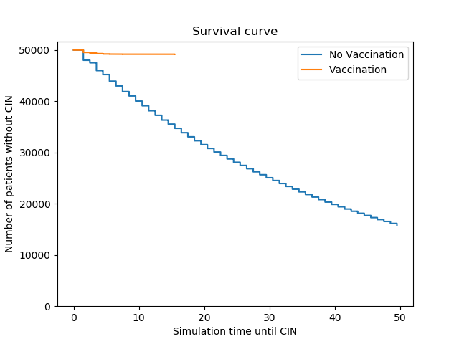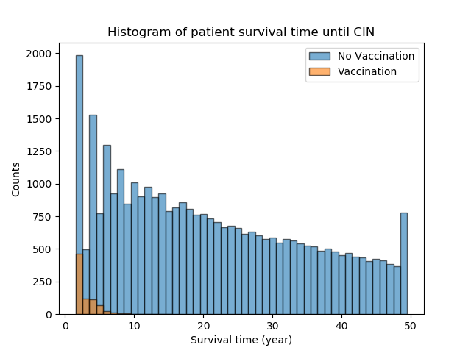

**Figure 2. Cost-effectiveness and cost-benefit analysis for 60% vaccination coverage.**

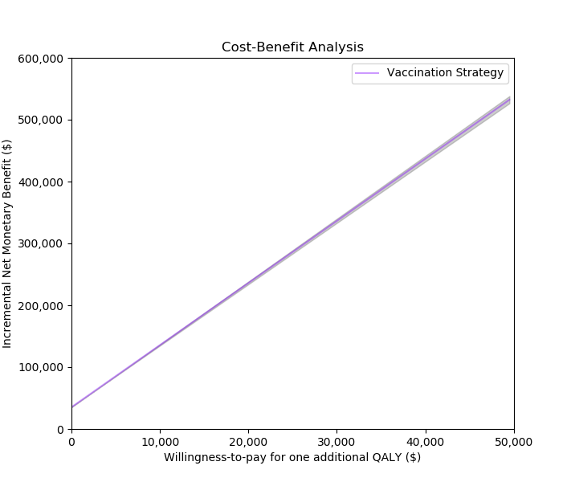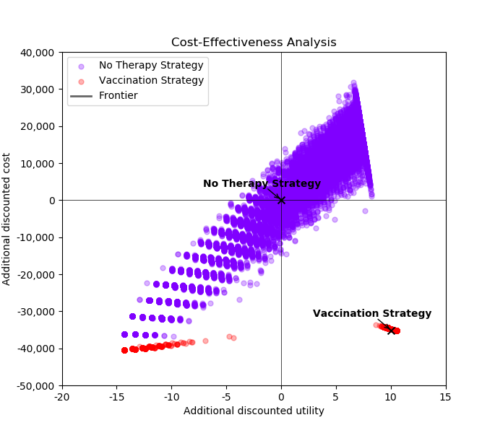

**Figure 3. Survival curve and histogram for 80% vaccination coverage.**

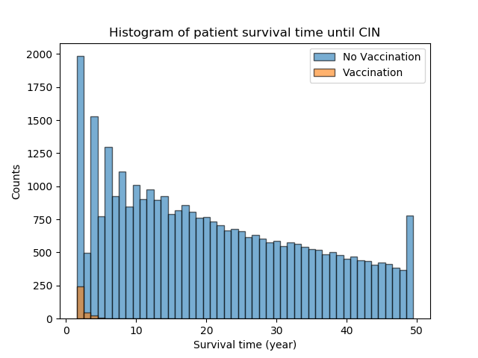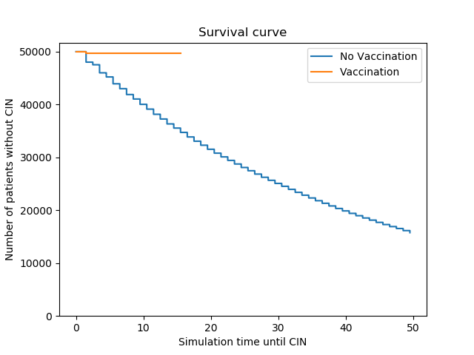

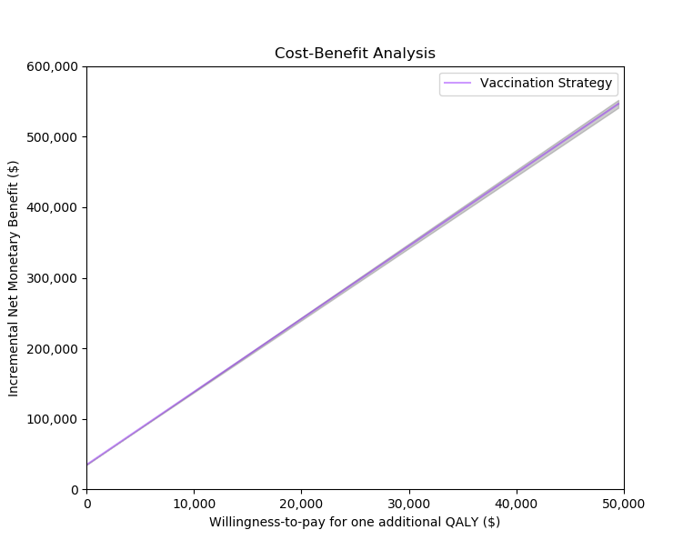**Figure 4. Cost-effectiveness and cost-benefit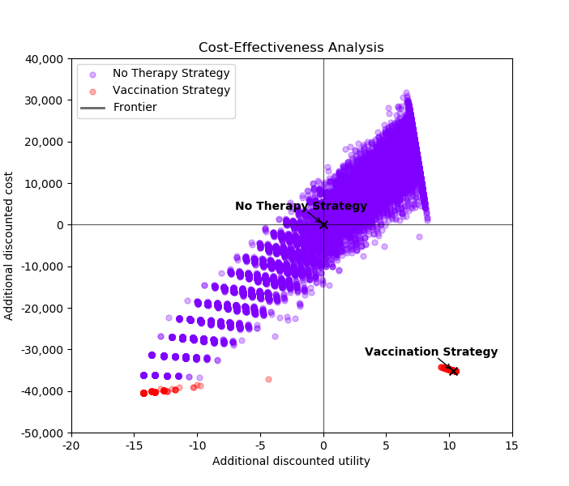 analysis for 80% vaccination coverage.**

The model was calibrated on the basis that the random variables generated follow an empirical distribution. This is under the assumption that we had chosen to implement a discrete-time Markov model and due to the fact that we had a finite number of samples for the model to move through the probability transition matrix. Because we know that an empirical distribution requires the use of confidence interval, rather than a projection interval, we reported the 95% Confidence Intervals.

After running our discrete-time Markov model, we can conclude that introducing the Human Papillomavirus vaccine into a population of susceptible women would be cost effective. The effectiveness of this intervention is measured by the number of prevented CIN II cases. Without any intervention, the number of individuals without CIN II lesions decreases steadily over time going down from 50,000 susceptibles to 20,000 (Fig. 1 and 3). The medical interventions in place for diagnosing and treating CIN II lesions and positive HPV tests, while effective, are costly and do not have the ability to further prevent the development of subsequent HPV infections and CIN II lesions. When viewing the cost-effectiveness plot for HPV infection with no vaccination intervention, there is higher variation along the threshold. There are multiple points on the graph that suggest the medical interventions for treating CIN II and HPV infection in the absence of a vaccination may provide less health for less of a cost, provide more health for more of a cost, and less health for more of a cost (Fig. 2 and 4). Because of the latter most observation, we can determine that HPV infection and CIN II treatment medical interventions are not cost effective and require a preventative rather than therapeutic option for lowering prevalence of HPV infection and CIN II lesions.

When evaluating the cost effectiveness of the implementation of the HPV vaccine for 60% of the susceptible females in a closed population, we see the points on the graph in the lower right quadrant of the graph which indicates that for a lower amount of cost, we can achieve better health (Fig. 1). This is a much preferred alternative than the cost effectiveness of the therapeutic interventions used to treat HPV infection and CIN II lesions. When evaluating the cost benefit analysis performed on implementing the HPV vaccine for 60% of susceptible females, we can see that as willingness to pay for one additional QALY increases, we reach a positive discounted net social benefit, showing that the payback is worth the investment on this prevention vaccination measure in a fully susceptible female population (Fig. 2).

When evaluating the cost effectiveness of the implementation of the HPV vaccine for 80% of the susceptible females in a closed population, we can see that the points on the cost effectiveness plane are in the lower right quadrant, as they were for 60% vaccination coverage, indicating that we can achieve greater health with a low cost by implementing this vaccine into this population at 80% vaccine coverage (Fig. 3). Once again this is a preferred alternative to spending more money to reach the same level of health achieved by the less costly vaccination intervention. When evaluating the cost benefit analysis performed on implementing the HPV vaccine for 80% of susceptible females, we can see that as willingness to pay for one additional QALY increases, we reach a positive discounted net social benefit, showing that the payback is worth the investment on this prevention vaccination measure in a fully susceptible female population (Fig. 4).

After completing the evaluation of the discrete-time Markov model run, we can conclude that the implementation of the HPV vaccine at 60% coverage in a fully susceptible female population is cost effective and should be implemented under these circumstances. The survival curves produced by the model shows that vaccination at and above 60% coverage greatly lowers the number of females who develop CIN II. Within both histograms, the number of individuals without CIN II lesions is high at the beginning of the model but decreases over time as more individuals move through the transition matrix and develop HPV infection and subsequently, a CIN II lesion. After running the Markov model that includes the vaccine intervention, the model begins with a low number of individuals without CIN II and remains relatively constant throughout time. This trend is a product of immediate vaccine implementation at the beginning of the model that prevents vaccinated individuals from ever acquiring HPV and developing a CIN II lesion. Based upon our economic evaluations described above, we can determine that the effectiveness of the vaccine at preventing HPV infection, in combination with its cost effective nature, make it an intervention that should be strongly recommended for implementation.

In order to evaluate the sensitivity of the conclusions from this model, we lowered the vaccination coverage percent to 20% within the probability transition matrix and with that raised the probability of HPV infection and staying in the susceptible class. If the model was sensitive to changes in the input parameters, we would expect to see the model have more individuals with infection and CIN II for a more sustained period of time because the susceptible individuals would not move as quickly into the vaccinated class. After performing this one way sensitivity analysis, we visualize that lowering the vaccination probability increased the number of CIN II cases as shown in Fig. 5. This informs us that the model assumptions hold and further validates our reported results.

**Figure 5. Survival curve and histogram for 20% vaccination coverage one-way sensitivity analysis.**

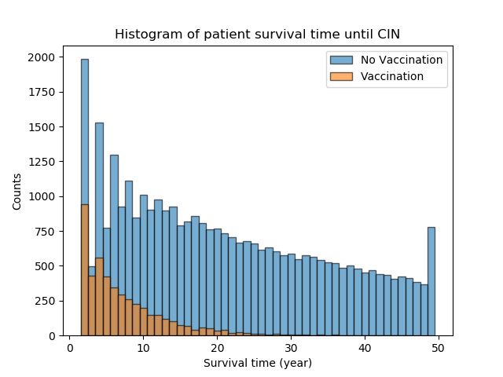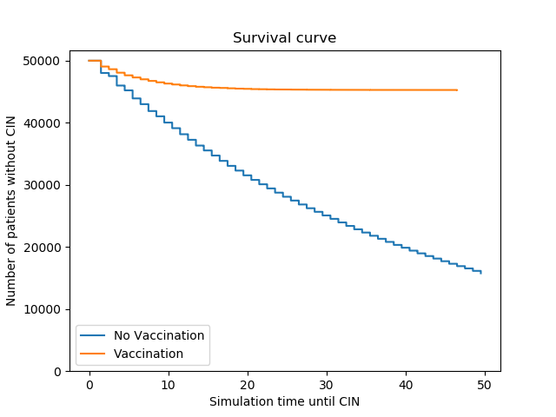

Works Cited

Chesson, Harrell W., et al. "The estimated lifetime probability of acquiring human

papillomavirus in the United States." *Sexually transmitted diseases* 41.11 (2014):

660-664.

“Human Papillomavirus Vaccination Coverage Among Adolescent Girls,

2007–2012, and Postlicensure Vaccine Safety Monitoring, 2006–2013 - United

States.” *Centers for Disease Control and Prevention*, Centers for Disease

Control and Prevention, 26 July 2013,

www.cdc.gov/mmwr/preview/mmwrhtml/mm6229a4.htm.

Chura, Justin. “FDA Approves HPV DNA Test for Cervical Cancer Screening | CTCA.”

*CancerCenter.com*, 1 May, 2014,

www.cancercenter.com/discussions/blog/FDA-approves-HPV-DNA-test-for-cervical-cancer-s

creening/.

“Manual for the Surveillance of Vaccine-Preventable Diseases.” *Centers for Disease*

*Control and Prevention*, Centers for Disease Control and Prevention, 10 Nov.

2017, [www.cdc.gov/vaccines/pubs/surv-manual/chpt05-hpv.html](http://www.cdc.gov/vaccines/pubs/surv-manual/chpt05-hpv.html).

“Morbidity and Mortality Weekly Report (MMWR).” *Centers for Disease Control and*

*Prevention*, Centers for Disease Control and Prevention, 14 Aug. 2017,

www.cdc.gov/mmwr/volumes/65/wr/mm6549a5.htm.

Moscicki, Anna-Barbara et al. “Rate of and Risks for Regression of CIN-2 in

Adolescents and Young Women.” *Obstetrics and gynecology* 116.6 (2010):

1373–1380. *PMC*. Web. 1 May 2018.

Steinau, Martin, et al. "Human papillomavirus prevalence in invasive anal cancers in the

United States prior to vaccine introduction." *Journal of lower genital tract disease*

17.4 (2013): 397.

Villa, Luisa L., et al. "Prophylactic quadrivalent human papillomavirus (types 6, 11, 16,

and 18) L1 virus-like particle vaccine in young women: a randomised

double-blind placebo-controlled multicentre phase II efficacy trial." *The lancet*

*oncology* 6.5 (2005): 271-278.