Mission Demolition

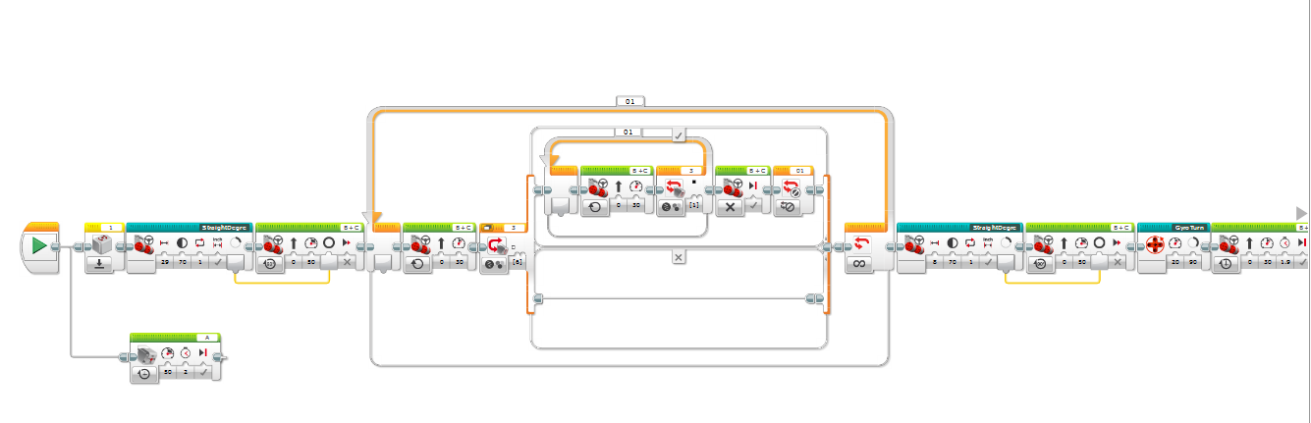

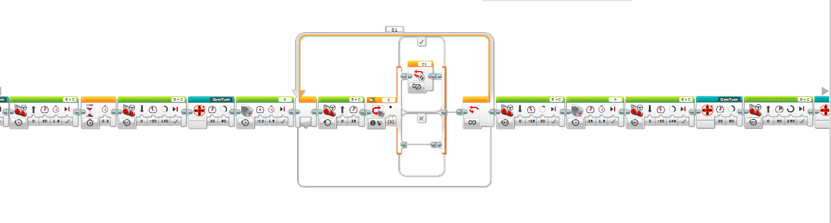

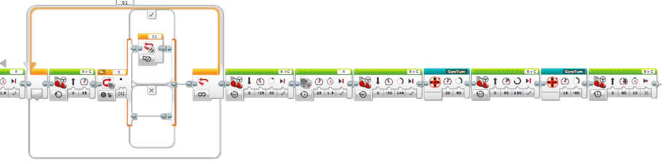

Mission: People

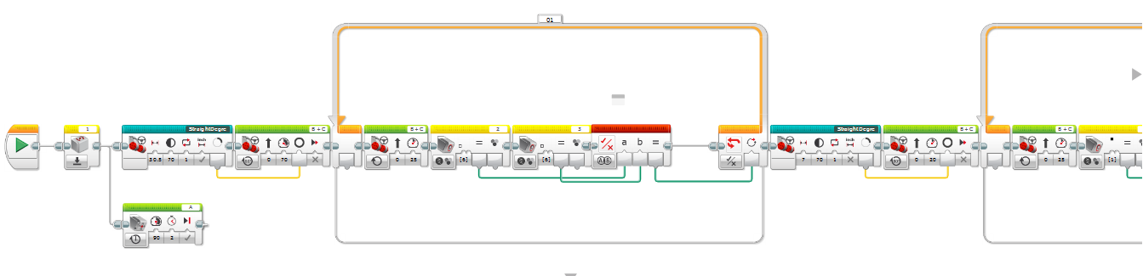

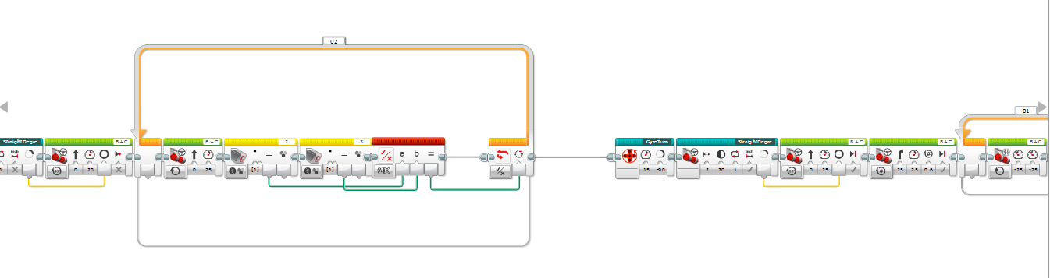

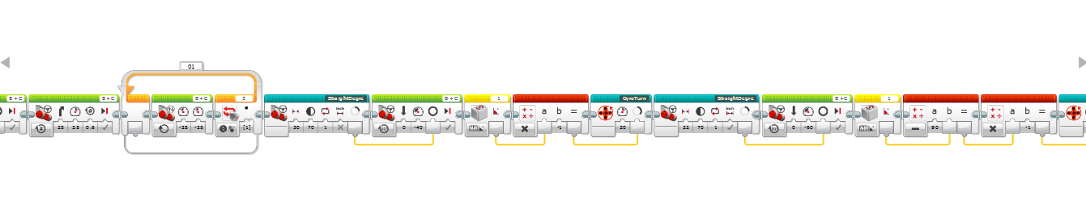

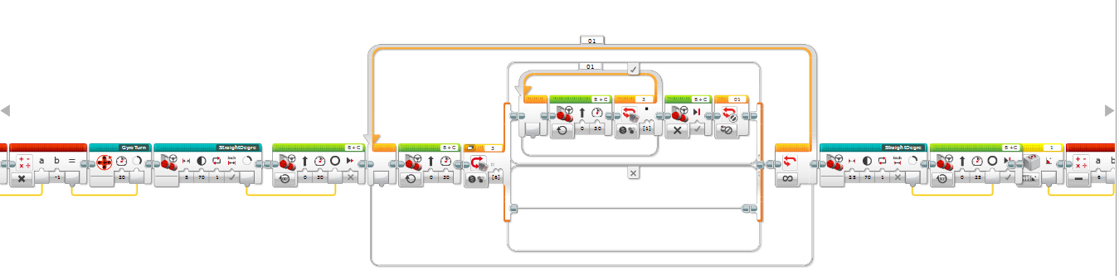

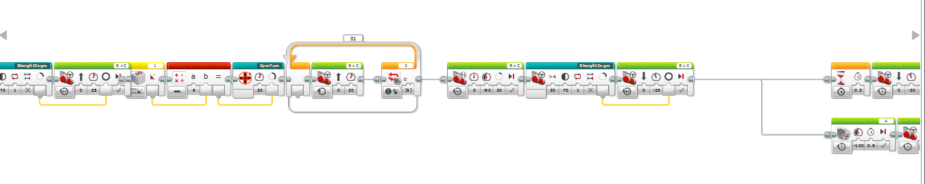

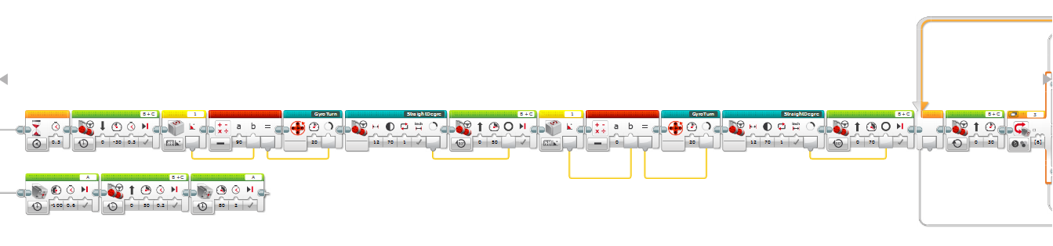

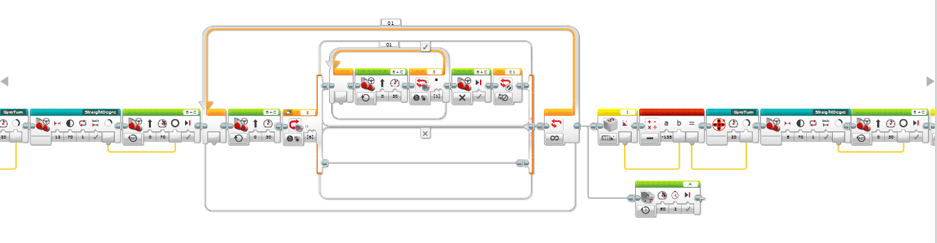

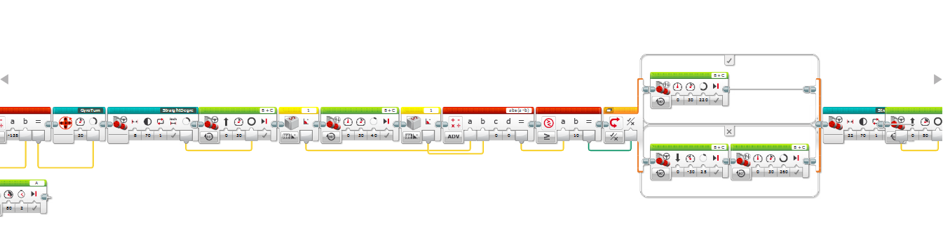

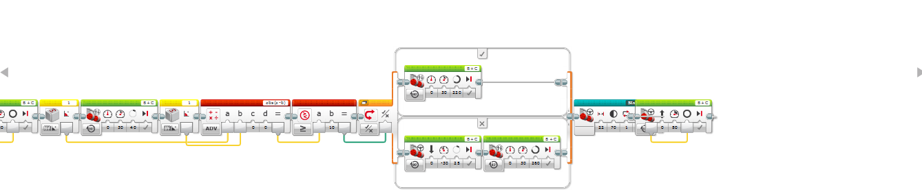

Mission: Truck Push

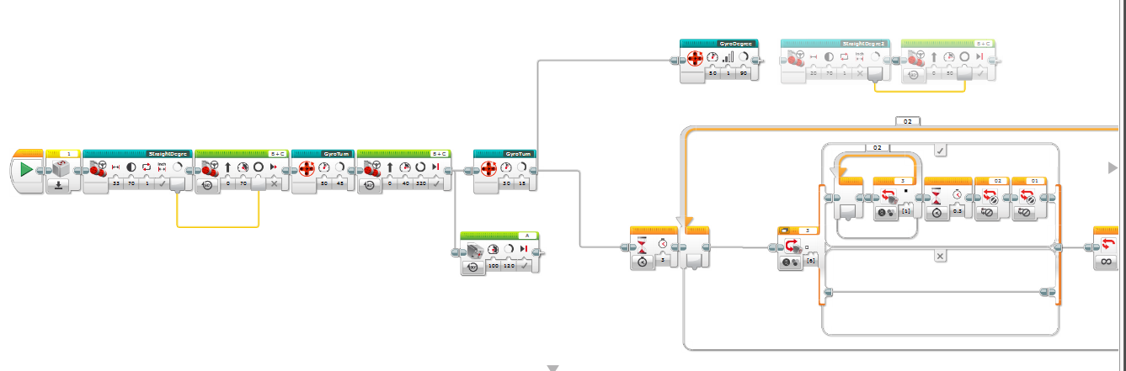

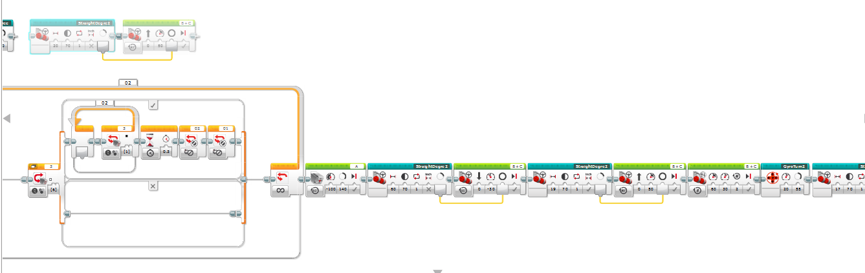

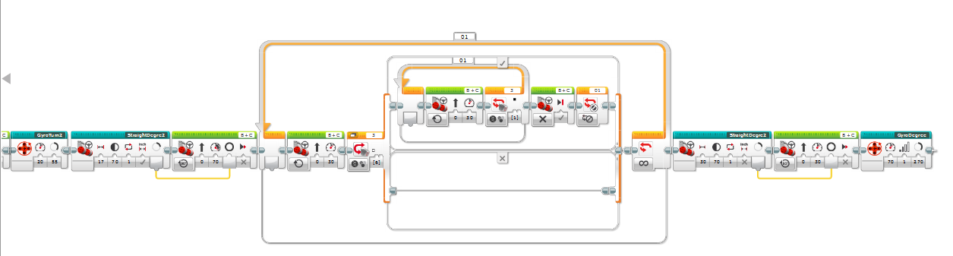

Mission: Animal compost

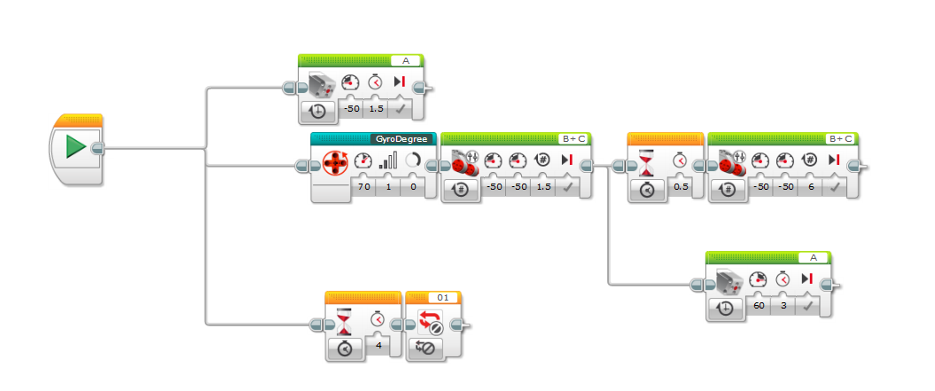

My Block: Straight Degree

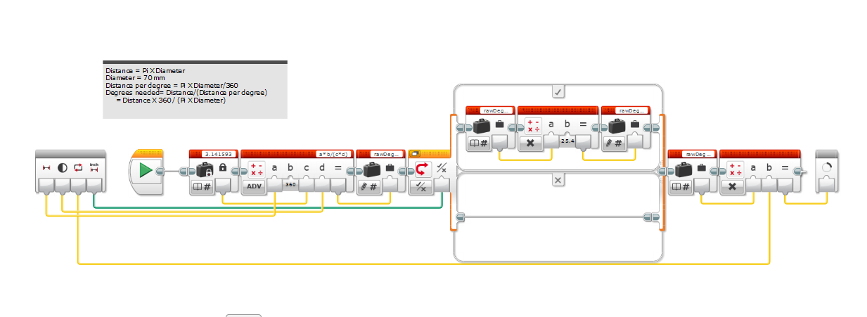

My Block: Gyro Degree

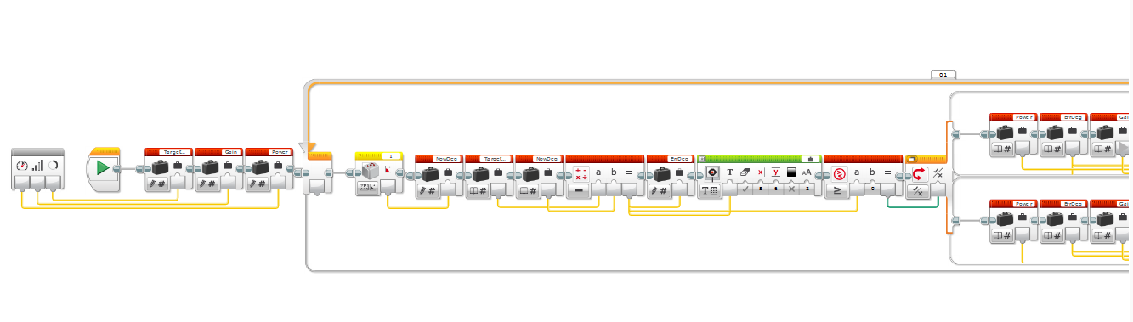

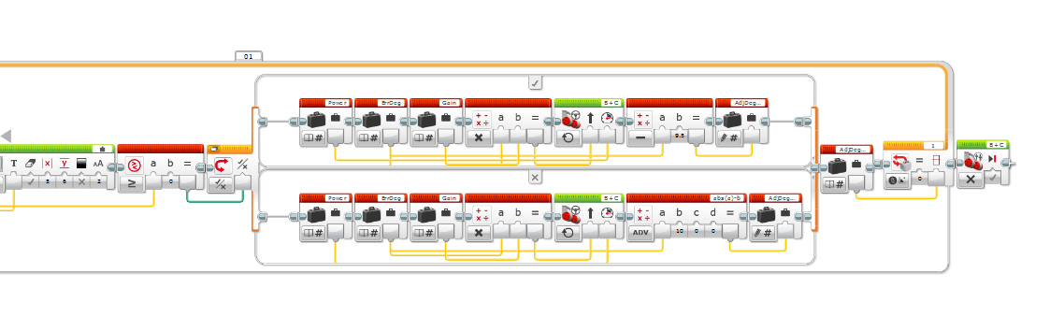

My Block: Gyro Turn

