

**Business Data Management**

Project Report on

**Attendance Management System**

Darshan Dalvi

Rutgers Business School

Table of Contents

Brief Description of the System 2

Abstract 2

Business value and Scope 2

ER Diagram 3

Assumption 4

Database Table Description 4

Tables Details 4

View Details 7

Stored procedure Details 8

Queries/Reports and screenshots 9

Subject wise attendance 9

Daily Attendance 9

Extra Classes 9

Leave Report 10

Defaulter Below 75% 10

Defaulter Below 50% 11

Project Scripts/Dumps 11

# Brief Description of the System

## Abstract

This system we are proposing is mainly considering with the automate the task of attendance of various school and educational institute. The scope of this assignment limited to designing database layout so for middleware and frontend we have made some assumption.

We are using MySQL database server to design backend layout. To compute various things like defaulter etc. we have created a stored procedure which help to segregate the defaulter student. This system will be receiving the input from various sources like card reader at entry point, Manual entry by Professor or any biometric input. (Assumption the institute already capture the biometric in separate system we can fetch it in this system for verification via database link). For larger report we have created the report using view which are more efficient and provide encapsulation of data for logical level.

Here we have constructed 5 basic table for core functionality which record the attendance, student details, course details, professor details. And one another table which get populated by store procedure name as defaulter which maintain list of students who are defaulter for 75% and 50%. From the layout currently, we are generating 5-6 report on various parameter. All the tables has been normalized to 3rd Normal Form. We use view to display the complex report. It’s good idea to calculate all the report at end of day as EOD so are proposing the defaulter table will be update at every night at 0015 hr which will be executed by MySql EVENT.

This system will help to facilitate the record of the student base on Student Unique identification number with respective course. We have place the mechanism which help to evaluate the attendance criteria for student as per professor conditions. This system will help to generate report and tracking day to day operations which lead to reduce human error and load to great extent.

## Business value and Scope

* Considering over the manual approach. The automated attendance will enhance the productivity of the educational institute.
* Easier for the student to maintain the attendance threshold.
* Can be further enhance to mobile application and web base application.
* Notification system also be added for various parameter like important classes and reminder, attendance value below threshold.

# EER Diagram

The EER Diagram

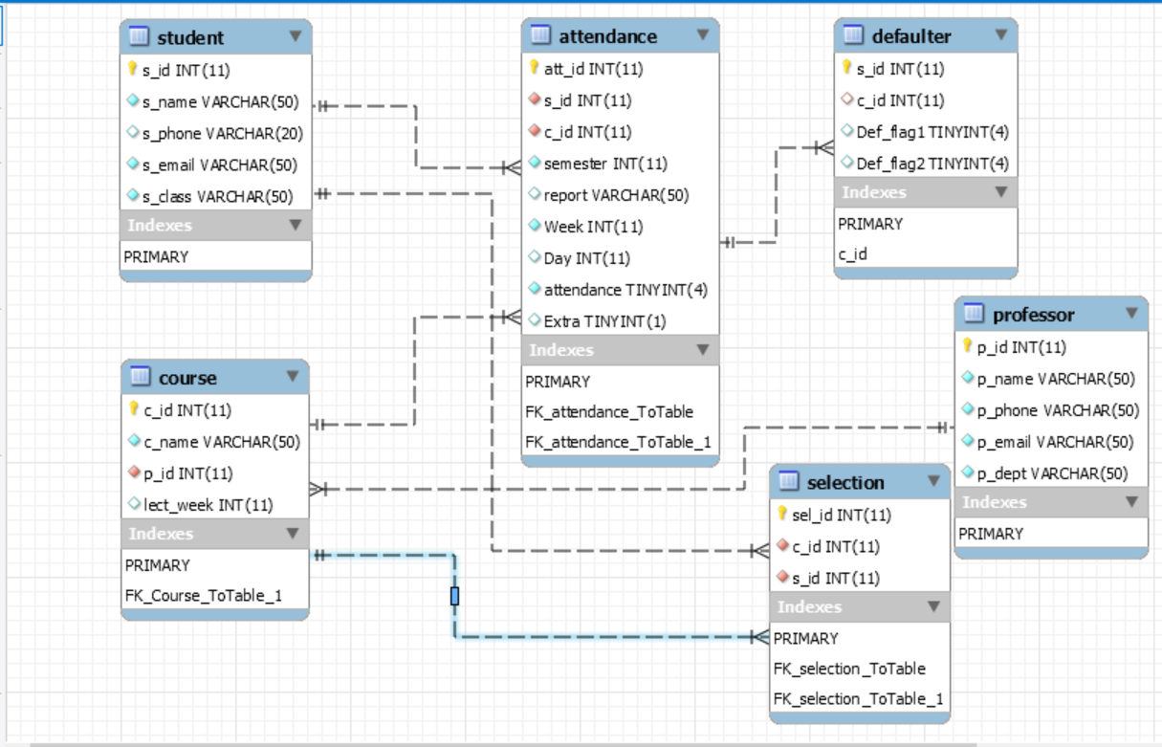

Initial ER Diagram

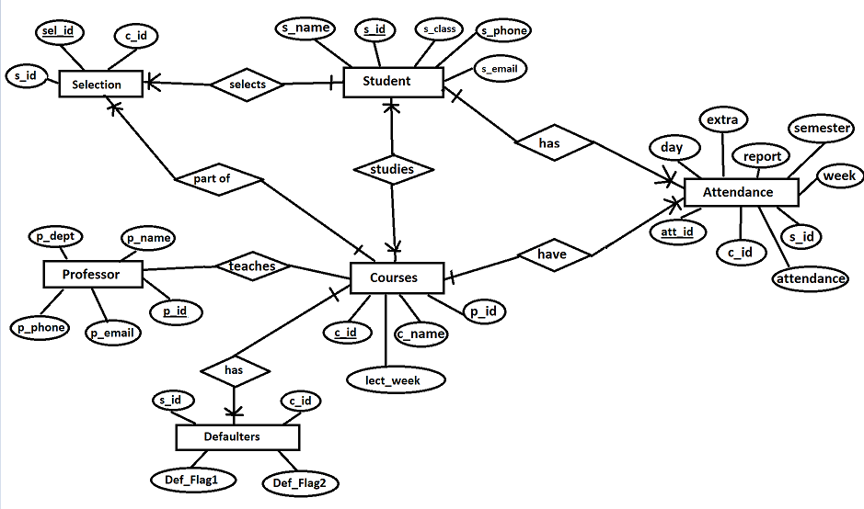

# Assumption

* We shall assume that the number of lecture per week is fixed and the extra lectures is as per demand populated.

# Database Table Description

For core functionality we are using 5 table as student, attendance, selection, course, professor and one for defaulter report we are using defaulter table we will discuss those table in details below

## Tables Details

1. Student

The student table is the master data table for student entry the column are as s_id, s_name, s_phone, s_email, s_class respectively for Student Number, Student Name, Student Phone, Student Email, Student Class. The s_id is the primary key for student table.

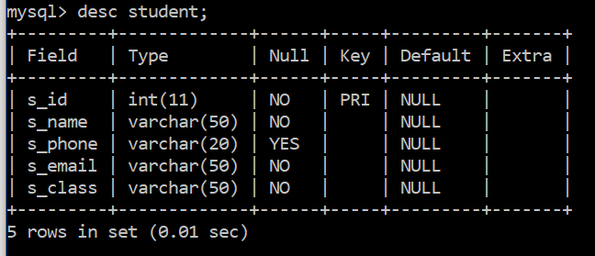

1. Attendance

Attendance table record the record of attendance it has column as follow. Att_id, s_id, c_id, semester, report, week, day, attendance and Extra these column resemblances for unique number for attendance record. Which is primary key for this table and s_id ,c_id are the foreign keys for student and course table respectively. Semester column hold the record for the student enrolled for which sem. The report column keep record for the leave report like Medical, Casual or some any other as recorded by professor or operator. The week and day column represent a week of semester and day of week. Where as attendance is mark as 0 or 1 (0- Absent and 1-Presnet) and extra column record for extra lectures perform in respective week

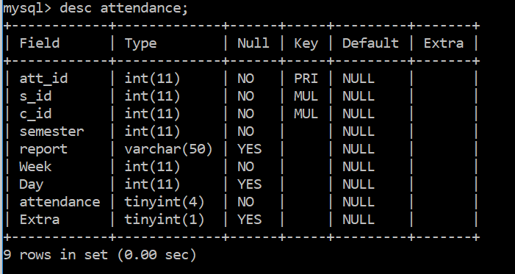

1. Selection

The selection table keep the record for subject selected by student it hold data for 3 column sel_id, c_id, s_id where sel_id is primary key for selection table and other two entries are foreign key reference from course and student table. We have created this table to achieve **normalization.**

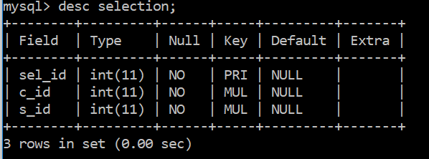

1. Course

Course table hold the record for course and its schedule per week it has four column namely c_id which is primary key for this table, c_name describe the name of course, p_id is a foreign key with reference to professor table which indicate professor related to that course. And lect_week identifies lectures per week.

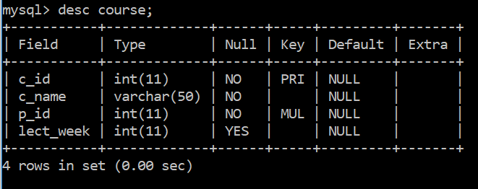

1. Professor

Professor table responsible for store information about professor like unique id for professor stored in p_id column, p_name column responsible for professor name, p_phone store phone number of professor , p_email for email of professor and p_dept represent department of professor

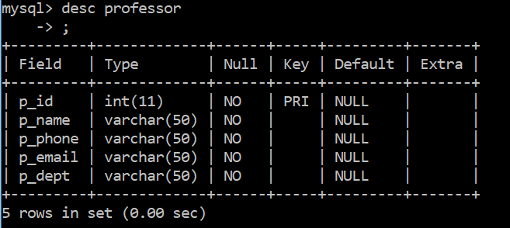

1. Defaulter

Defaulter table maintain for the list of defaulter who are below 75% and 50% it contain 4 column namely s_id, c_is, def_flag1, def_flag2 the s_id is primary key for table and c_id is the foreign key reference to course table.

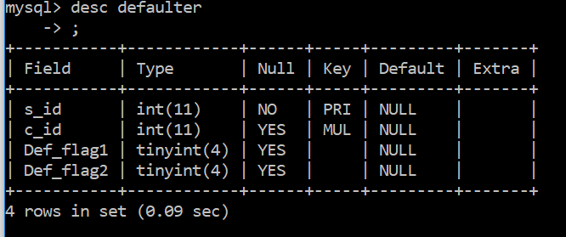

## View Details

We have created a view name to produce leave report from the student which will show the report of leave

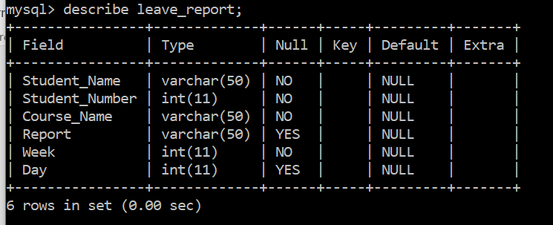

## Stored procedure Details

The store procedure sp_defaulterlist is trigger from the front end whenever an operator or professor passes the argument for respected course. The procedure populates the defaulter table on request and then the specific query run against the same table to display report

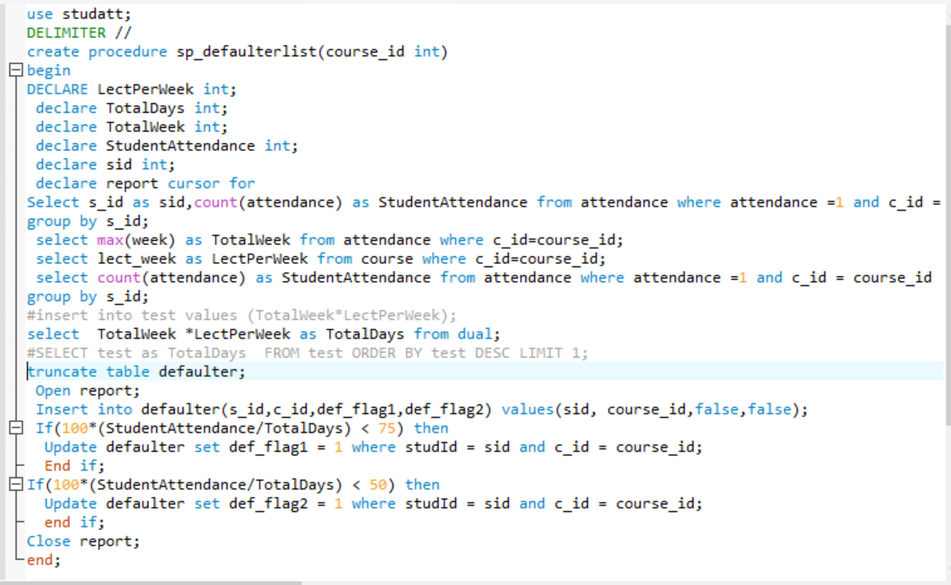

# Queries/Reports and screenshots

### Subject wise attendance

Example of generating Attendance for course “C”

mysql>select s.s_name,c.c_name,a.week,a.day,a.attendance from attendance a,student s , course c where s.s_id=a.s_id and a.c_id=c.c_id and c.c_id=1 group by s.s_name,c_name,week,day order by week;

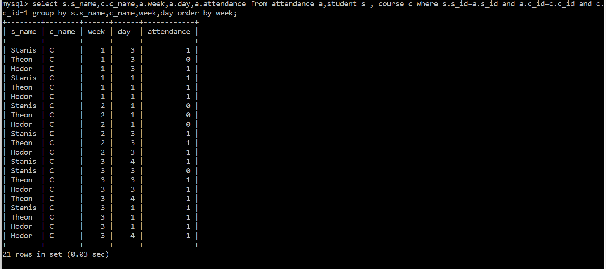

### Daily Attendance

Example of generating daily attendance for week 2, day 3 and course Python

mysql>select s.s_name Student_Name ,a.s_id Student_Number ,a.attendance from student s , attendance a where a.s_id=s.s_id and a.week=2 and a.day=3 and a.c_id=5;

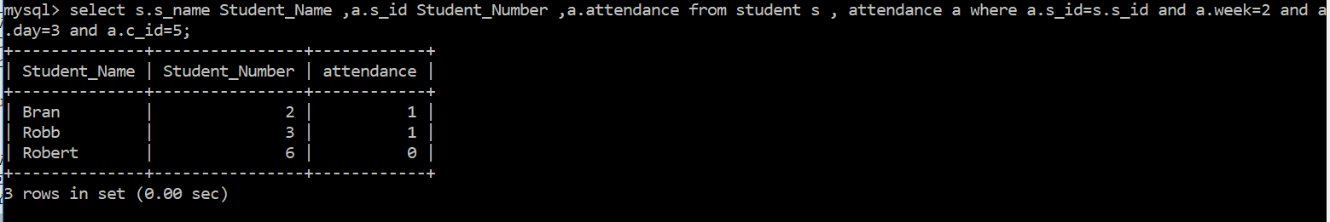

### Extra Classes

Example of report of students who are present for extra classes.

mysql> select a.s_id Student_Number,s.s_name Student_Name, c.c_name, a.week Week ,a.day Day ,a.attendance Attendance from attendance a ,student s ,course c where a.s_id=s.s_id and a.c_id=c.c_id and Extra=1;

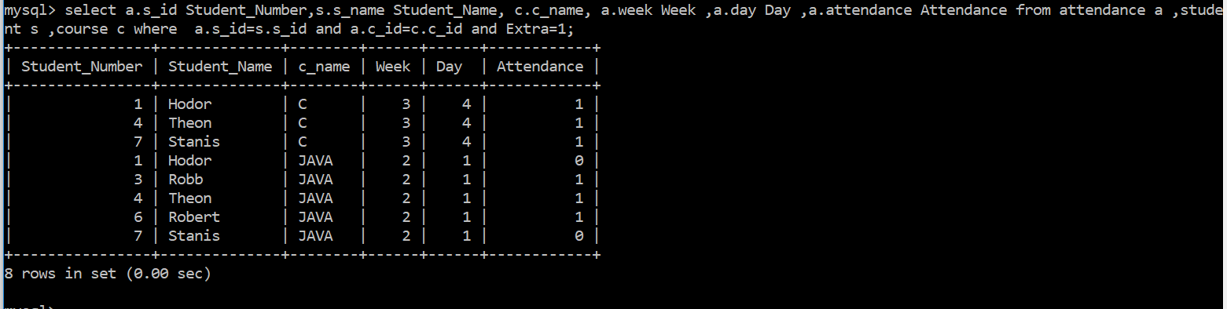

### Leave Report

Example of leave report for the student who are on leave with valid leave reason like Medical, Casual etc.

mysql> select s.s_name Student_Name ,a.s_id Student_Number,c.c_name Course_Name, a.report Report ,a.week Week,a.day Day from student s ,attendance a ,course c where a.s_id=s.s_id and c.c_id=a.c_id and a.report is not null;

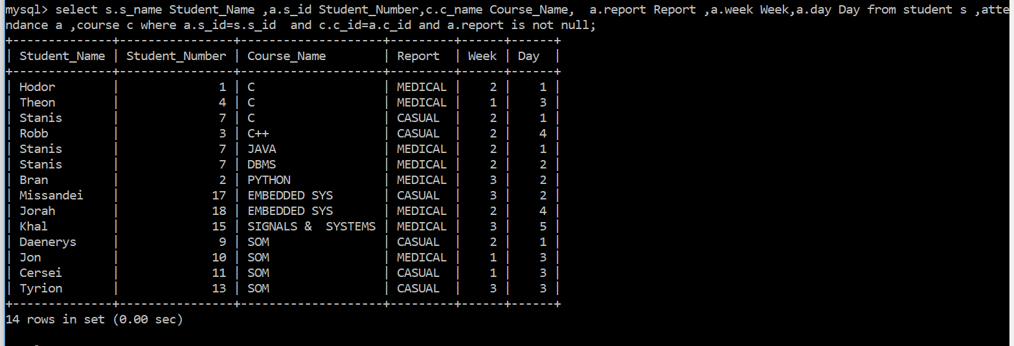

### Defaulter Below 75%

The table defaulter will popup with the procedure call and we can fetch the required information

mysql> select s_id,c_id from defaulter where def_flag1=1

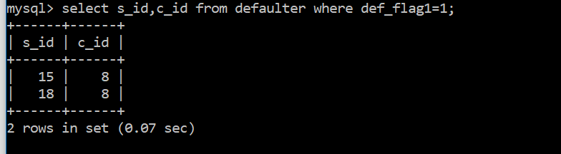

### Defaulter Below 50%

The table defaulter will popup with the procedure call and we can fetch the required information

mysql> select s_id,c_id from defaulter where def_flag2=1;

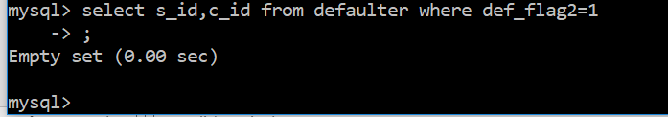

# Project Scripts/Dumps

Below are the dumps from project.

   

   

 