**CAREER SUMMARY**

* **Passionate about leveraging technology** to solve business challenges and drive innovation.
* **Dedicated** and **Self-Motivated** Senior Software Engineer with experience in Fortune 50 Corporate as well as Consulting, beginning my career in Conversational AI, moving through Full Stack Development, and now adding AI Engineering qualities to the mix.
* Primary implementor of conversational AI application, significantly improving customer engagement and support for a Fortune 40 retailer’s call center.
* **Self-Taught** JavaScript for 2.5+ years before breaking into the industry.
* Previously worked in a technical environment in the Entertainment business with clients from Akon to Thomas Friedman to Maroon 5. While in show business I led a crew of up to 10 direct reports in complex tasks as Director of Lighting for the Campus of Davidson College.

**TECHNICAL SKILLS**

* **Generative AI** **Text**: OpenAI, Azure AI, Learning LangChain to aid efficiency and speed, LM Studio (for fast access Open Source LLMs)
* **Generative AI** **Image**: Stable Diffusion via InvokeAI
* **Languages**: JavaScript, TypeScript, C#, Python
* **Frameworks/Libraries**: ReactJS, Next.js, Node.js, some .NET
* **Cloud Platforms**: AWS, Azure
* **Databases**: MySQL, NoSQL

**CREDENTIALS**

* **AWS -** Certified AWS Solution Architect – Associate
* **Microsoft** – Certified Azure AI Fundamentals
* **Microsoft** – Certified AI Engineer – Associate (**In Progress**)

**EDUCATION**

* + - **Davidson College**, Davidson, North Carolina

Bachelor of Art in Spanish Literature

* **University of North Carolina at Charlotte**, Charlotte, North Carolina

Full-Stack Web Development Certificate

**Professional Experience**

**Slalom Build, Charlotte, NC January 2023 – Present**

**Senior Software Engineer**

**Accomplishments:**

* **AI & Marketing Platform**: Key early implementor in developing an AI-powered platform for rapid marketing microsite generation, employing Azure Open AI, Python, and ReactJS.
* **Energy Sector UX Improvement**: Overhauled the user experience for reporting streetlight issues, leveraging TypeScript and ReactJS for enhanced usability and integration.
* **Financial Services**: Created a financial dashboard offering insights into tax harvesting and account management, drawing from rich client data for increased product clarity using C# and Razor.

**Responsibilities:**

* Full Stack Development, Provide Leadership, Support, and Development Help for newer engineers

**Environment: React.js, TypeScript, Microsoft Azure, .NET Core, GPT-3/4, Python, Stable Diffusion**

**Slalom Build, Charlotte, NC July 2021 – January 2023**

**Software Engineer**

**Accomplishments:**

* **Aided** in the **selection of foundational technologies** and the delivery of **full-stack** features for relocation management solutions on a long term 18-month project, developing deeper expertise.
* **Built out the Password Reset functionality** for the application using **AWS Cognito**.

**Responsibilities:**

* Full Stack Development for vertically sliced stories, emphasis on Front End

**Environment: React.js, TypeScript, Amazon Web Services (AWS), Next.js, Full-Stack Development, Microsoft Azure**

**Lowe’s Companies, Inc., Charlotte, NC February 2021 – Present**

**Software Engineer**

**Accomplishments:**

* **Received** **“Exceeds Expectations”** year-end review resulting in early (sub 2-year) promotion from Associate Software Engineer to Software Engineer
* **Lowe’s Subject Matter Expert** on Nuance Mix’s Platform for the Messaging Channel
* **Spearhead** a systematic pushback on work happening in the Nuance Platform to ensure:
  + **Halt a ‘waterfall’ workstyle ‘Lift and Shift’ of functionality** from having further disastrous results
  + **UX Designers** understand the power of the platform and redesign product flows so they are both worthy and possible in the framework.
  + **Engineering** has realistic requirements, improved development experience, faster turnaround
  + **Collaboration lead** across disciplines to improve vendor’s platform for Lowe’s sake
* **Engineer** around a product limitation within LivePerson’s Conversational AI: which means Lowe’s can freely update FAQ/KB articles without suffering production breaks due to low character limits on text

**Responsibilities:**

* **Discovery** and **Planning** for Integrations across platforms to solution for Lowe’s evolving needs
* **Lead Engineer** for SMS/ABC channel enabled virtual assistants
* **On-Demand Application Development and Support** for Contact Center
* **Leverage** 3rd party vendors to connect the dots between internal products and pertinent business needs

**Environment: Nuance Mix (Dialog + NLP Services + NDEP), LivePerson Conversational AI, JavaScript, Twilio**

**Lowe’s Companies, Inc., Charlotte, NC June 2019 – January 2021**

**Associate Software Engineer**

**Accomplishments:**

* **Lowe’s Subject Matter Expert** on Twilio, LivePerson, SMS
* **Learned** C# at rapid pace
* **LivePerson Conversational AI: Produce** **Successful Production Grade NLP (Natural Language Processing) based Chatbot largely upon my sole effort** **in response to COVID-19 Crisis**
  + **Increase** virtual assistant containment rate 20% higher than project scope and requirement
  + **Cost Savings** of at least $70,000/mo. due to lower external escalations from virtual assistant
  + **So Robust** other departments sought to copy and employ in other domains
    - This is not a simple bot, and relies very little on LivePerson’s ‘visual interface’
    - The meat is in the custom JavaScript code I wrote behind the scenes to produce functionality for Lowe’s that the platform’s out of the box solution will not handle
  + **Agile** weekly releases
  + **MVP** turn around in 2 months for RAPID COVID-19 Response
  + **Released Feature Updates:**
    - **Installation Services Flow**
      * Routing to almost 200 unique districts down to the Zip Code level, so our agents could service our customer’s Installation Service needs in a hyper localized way
    - **Order Status API Integration**
      * **Money Maker** by saving on operational costs:
        + **Increase containment rates to higher than 30%+** consistently
        + **Decrease call center phone call volume AND SMS/ABC escalations** to expensive Lowe’s 4th party agents, who stand in for Lowe’s Contact Center during the Pandemic
      * **Delighting customers** with self-serve options heretofore unrealized in the SMS and ABC channels
    - **Holiday Automation**
      * **Engineer** a ‘Holiday path’ in such a way that only Holiday name and date need be changed to produce effective messaging for our Contact Center’s holiday schedule
      * **Removed** **and Freed Up** **both UX as well as Engineering** from having to design, produce, and QA a Holiday flow specific to each holiday – saving Lowe’s Time, Effort, Money, and possible customer dissatisfaction with errors or inaccurate information
* **Produce API** **for Team** so that Twilio numbers could more easily be moved between staging and production environments, as needed. This API is built on Azure’s serverless functions in .NET Core in C#.
* **Build an HR Bot** based on Twilio, Azure Serverless functions, and Azure Cosmos Database which serves new potential hires for Lowe’s. Customers text a keyword to a short code which returns information about Lowe’s careers.
  + **Integrate** a functionality extension to this service for the Talent Acquisition Team so that upwards of 200,000 candidates in an interview pool will receive SMS notifications to their phone while in the waiting area for when they can enter the interview room.

**Responsibilities:**

* **Lead Engineer** for SMS/ABC channel enabled virtual assistants
* **On-Demand Application Development and Support** for Contact Center
* **Engineer chat bots (one-way and two-way** **communications)** for Contact Center, HR, and Store Operations
* **Leverage** 3rd party vendors to connect the dots between internal products and pertinent business needs
* **Subject Matter Expert** on Twilio, LivePerson, SMS, Nuance Platform

**Environment: Azure (Serverless Functions, CosmosDB, some Azure DevOps), C#, NLP, JavaScript, NodeJS, Nuance, PowerBI, LivePerson Conversational AI, Twilio**

**University of North Carolina at Charlotte, Charlotte, NC December 2018 – March 2019**

**Full-Stack Web Developer**

**Accomplishments:**

* **Lead and Spearheaded** two group projects through idea generation, discussion moderator, and by setting, defining, and delegating project tasks
* **Complete 3 Professional Grade Products from Scratch**
* **Mentored** a number of students in coding syntax, problem solving, helping them build a mental model of what we were learning
* **Solidified** ability to think and write code, and to have **grounded roots** in relying upon documentation: whether JavaScript, Library, Framework, or other languages.
* **Built** projects with a plethora of technologies including MERN
* **Graduated** with the coveted grade of “A”

**Responsibilities:**

* **Learn** Full-Stack development
* **High** **Emphasis** on JavaScript
* **Semantic HTML & CSS**
* **Servers & Databases**
* **Fast Learning: Drink Everything from a Fire-Hydrant**

**School of Hardknocks, Charlotte, NC January 2016 – November 2018**

**Self-Taught JavaScript and NodeJS**

**Accomplishments:**

* **Created** Notes-Node as first full application: This program is a command line application and all its features are accessed via the command line
* **High Pluralsight Scores** due to personal effort put in to learning.
  + **Scores are all from BEFORE taking** the bootcamp:

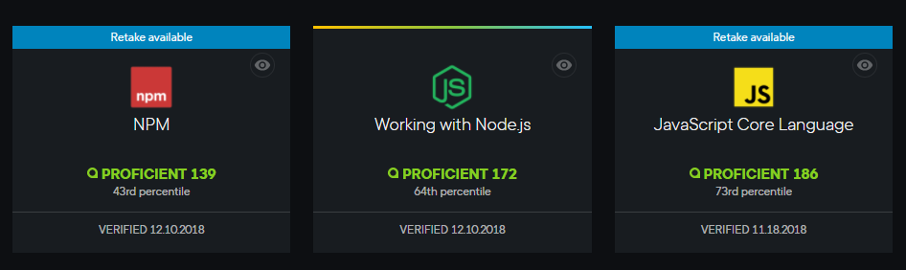

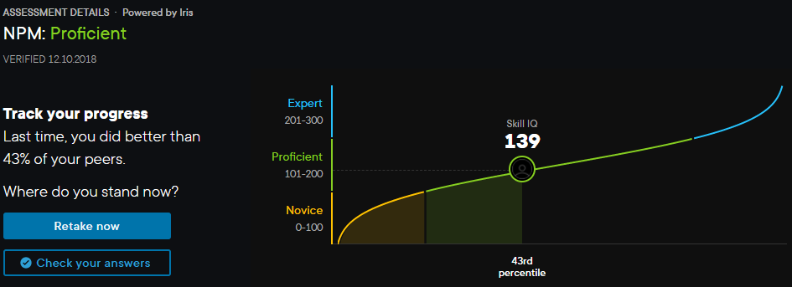

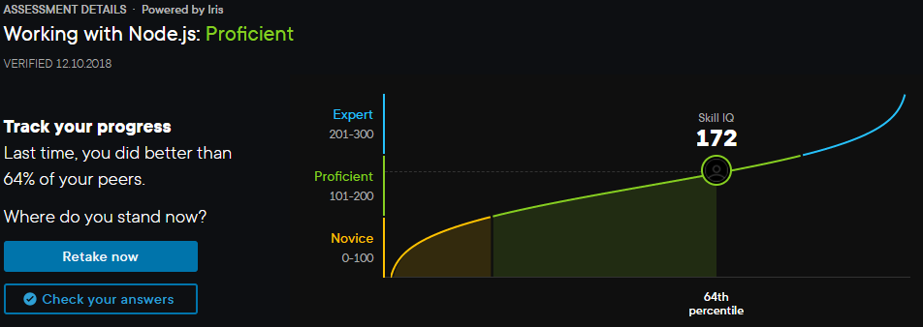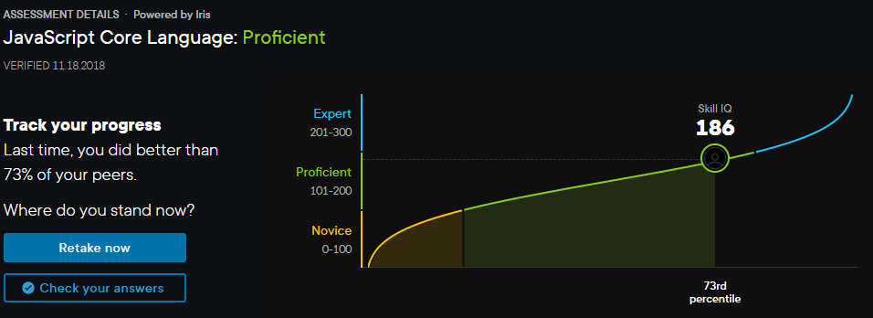

**Davidson College, Davidson, NC October 2013 – December 2018**

**Master Electrician (Lighting)**

**Accomplishments:**

* **Anticipating** Career Change: Specifically **Mentored, Guided, Developed and Trained** my own successor to be better than myself of my own volition while in the role of Master Electrician
* **Considered Technical Debt and Industry Change:** Targeted critical systems campus wide and upgraded legacy technologies as well as planned the multi-year systemic upgrade for multiple venues across the campus
* **Designed and Implemented** lighting viewed by 1 million+ people for the [North Carolina Republican Senate Debate in 2014](https://www.washingtonpost.com/news/the-fix/wp/2014/05/06/everything-you-need-to-know-about-todays-primary-in-north-carolina/?utm_term=.2ef0a2bb4bcd)
* **Designed, Coordinated, and Executed** lighting for the First Annual Holiday Gala, which is among the most popular events in Davidson and the surrounding area
* **Provide** **Spanish Language Translation** between clients of the Hispanic International Community and the College’s Internal staff: saving the College a lot of money

**Responsibilities:**

* **Director** of the Lighting Department of the Duke Family Performance Hall
* **Project Manager** for Internal and External Events of The Duke Family Performance Hall
* **Chief EOS Hardware Programmer**
* **Respond** to ever changing production requirements
* **Architect and Manager** for Interdepartmental Business Dropbox

**Environment:** ETC EOS Systems, MS-Office Suite, DMX-512A, FlareCon, Di-Fi, AirTable, Dropbox Business, Unison, Crestron, some FileMakerPro