**CAREER SUMMARY**

* Dedicated and Self-Motivated Software Engineer meeting the needs of a Fortune 50 Company (Lowe’s Companies, Inc)
* Self-taught JavaScript for 2.5+ years.
* Graduated from UNCC Charlotte Coding Bootcamp after three months of intensive training.
* Lead two projects in the bootcamp to success with praise of the instructor.
* Working in a technical environment in the Entertainment business with clients from Akon to Thomas Friedman to Maroon 5.
* Led a crew of up to 10 direct reports in complex tasks as Director of Lighting (Theatrical Master Electrician) for the Campus of Davidson College.

**TECHNICAL SKILLS**

|  |  |
| --- | --- |
| Software | vsCode, VS, Postman, MS Suite, Audio, Video, Photo Editing Suites, & more |
| Developer Tools | Azure, C#, JavaScript, MERN, jQuery, View Engines, HTML5, CSS, & more |
| Database | MySQL & No-SQLs DB, Firebase, some GraphQL, GraphQL Yoga, & Prisma |
| OS and Hardware | Windows (any), MacOS, Linux (Learning) |

**EDUCATION and CREDENTIALS**

* + - **Davidson College**, Davidson, North Carolina

Bachelor of Art in Spanish Literature

* **University of North Carolina at Charlotte**, Charlotte, North Carolina

Full-Stack Web Development Certificate

**Professional Experience**

**Lowe’s Companies, Inc., Charlotte, NC February 2021 – Present**

**Software Engineer**

**Accomplishments:**

* **Received** **“Exceeds Expectations”** year-end review resulting in early (sub 2-year) promotion from Associate Software Engineer to Software Engineer
* **Lowe’s Subject Matter Expert** on Nuance Mix’s Platform for the Messaging Channel
* **Spearhead** a systematic pushback on work happening in the Nuance Platform to ensure:
  + **Halt a ‘waterfall’ workstyle ‘Lift and Shift’ of functionality** from having further disastrous results
  + **UX Designers** understand the power of the platform and redesign product flows so they are both worthy and possible in the framework.
  + **Engineering** has realistic requirements, improved development experience, faster turnaround
  + **Collaboration lead** across disciplines to improve vendor’s platform for Lowe’s sake
* **Engineer** around a product limitation within LivePerson’s Conversational AI: which means Lowe’s can freely update FAQ/KB articles without suffering production breaks due to low character limits on text

**Responsibilities:**

* **Discovery** and **Planning** for Integrations across platforms to solution for Lowe’s evolving needs
* **Lead Engineer** for SMS/ABC channel enabled virtual assistants
* **On-Demand Application Development and Support** for Contact Center
* **Leverage** 3rd party vendors to connect the dots between internal products and pertinent business needs

**Environment: Nuance Mix (Dialog + NLP Services + NDEP), LivePerson Conversational AI, JavaScript, Twilio**

**Lowe’s Companies, Inc., Charlotte, NC June 2019 – January 2021**

**Associate Software Engineer**

**Accomplishments:**

* **Lowe’s Subject Matter Expert** on Twilio, LivePerson, SMS
* **Learned** C# at rapid pace
* **LivePerson Conversational AI: Produce** **Successful Production Grade NLP (Natural Language Processing) based Chatbot largely upon my sole effort** **in response to COVID-19 Crisis**
  + **Text** **the number 84109**
  + **Increase** virtual assistant containment rate 20% higher than project scope and requirement
  + **Cost Savings** of at least $70,000/mo. due to lower external escalations from virtual assistant
  + **So Robust** other departments sought to copy and employ in other domains
    - This is not a simple bot, and relies very little on LivePerson’s ‘visual interface’
    - The meat is in the custom JavaScript code I wrote behind the scenes to produce functionality for Lowe’s that the platform’s out of the box solution will not handle
  + **Agile** weekly releases
  + **MVP** turn around in 2 months for RAPID COVID-19 Response
  + **Released Feature Updates:**
    - **Installation Services Flow**
      * Routing to almost 200 unique districts down to the Zip Code level, so our agents could service our customer’s Installation Service needs in a hyper localized way
    - **Order Status API Integration**
      * **Money Maker** by saving on operational costs:
        + **Increase containment rates to higher than 30%+** consistently
        + **Decrease call center phone call volume AND SMS/ABC escalations** to expensive Lowe’s 4th party agents, who stand in for Lowe’s Contact Center during the Pandemic
      * **Delighting customers** with self-serve options heretofore unrealized in the SMS and ABC channels
    - **Holiday Automation**
      * **Engineer** a ‘Holiday path’ in such a way that only Holiday name and date need be changed to produce effective messaging for our Contact Center’s holiday schedule
      * **Removed** **and Freed Up** **both UX as well as Engineering** from having to design, produce, and QA a Holiday flow specific to each holiday – saving Lowe’s Time, Effort, Money, and possible customer dissatisfaction with errors or inaccurate information
* **Produce API** **for Team** so that Twilio numbers could more easily be moved between staging and production environments, as needed. This API is built on Azure’s serverless functions in .NET Core in C#.
* **Build an HR Bot** based on Twilio, Azure Serverless functions, and Azure Cosmos Database which serves new potential hires for Lowe’s. Customers text a keyword to a short code which returns information about Lowe’s careers.
  + **Integrate** a functionality extension to this service for the Talent Acquisition Team so that upwards of 200,000 candidates in an interview pool will receive SMS notifications to their phone while in the waiting area for when they can enter the interview room.

**Responsibilities:**

* **Lead Engineer** for SMS/ABC channel enabled virtual assistants
* **On-Demand Application Development and Support** for Contact Center
* **Engineer chat bots (one-way and two-way** **communications)** for Contact Center, HR, and Store Operations
* **Leverage** 3rd party vendors to connect the dots between internal products and pertinent business needs
* **Subject Matter Expert** on Twilio, LivePerson, SMS, Nuance Platform

**Environment: Azure (Serverless Functions, Azure DevOps, CosmosDB), C#, NLP, JavaScript, NodeJS, Nuance, PowerBI, LivePerson Conversational AI, Twilio**

**University of North Carolina at Charlotte, Charlotte, NC December 2018 – March 2019**

**Full-Stack Web Developer**

**Accomplishments:**

* **Lead and Spearheaded** two group projects through idea generation, discussion moderator, and by setting, defining, and delegating project tasks
* **Complete 3 Professional Grade Products from Scratch**
* **Mentored** a number of students in coding syntax, problem solving, helping them build a mental model of what we were learning
* **Solidified** ability to think and write code, and to have **grounded roots** in relying upon documentation: whether JavaScript, Library, Framework, or other languages.
* **Built** projects with a plethora of technologies including MERN
* **Graduated** with the coveted grade of “A”

**Responsibilities:**

* **Learn** Full-Stack development
* **High** **Emphasis** on JavaScript
* **Semantic HTML & CSS**
* **Servers & Databases**
* **Fast Learning: Drink Everything from a Fire-Hydrant**

**School of Hardknocks, Charlotte, NC January 2016 – November 2018**

**Self-Taught JavaScript and NodeJS**

**Accomplishments:**

* **Created** Notes-Node as first full application: This program is a command line application and all its features are accessed via the command line
* **High Pluralsight Scores** due to personal effort put in to learning.
  + **Scores are all from BEFORE taking** the bootcamp:

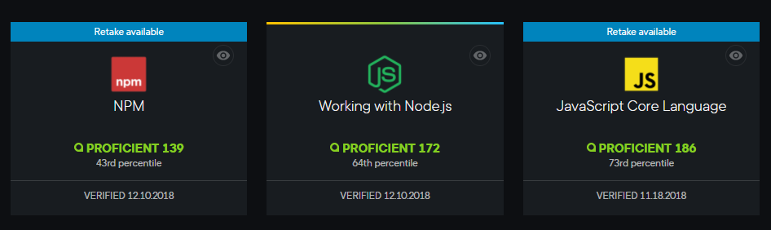

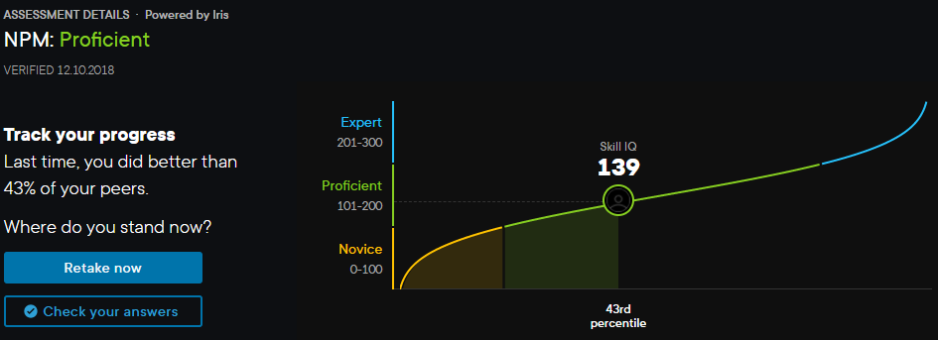

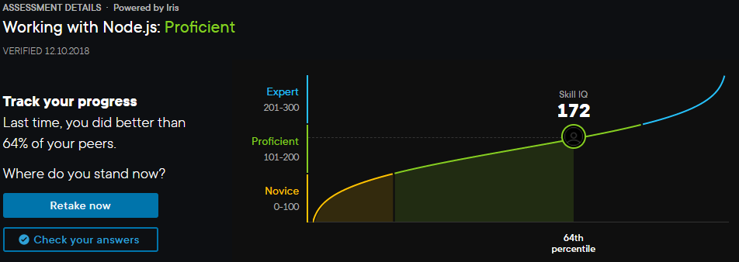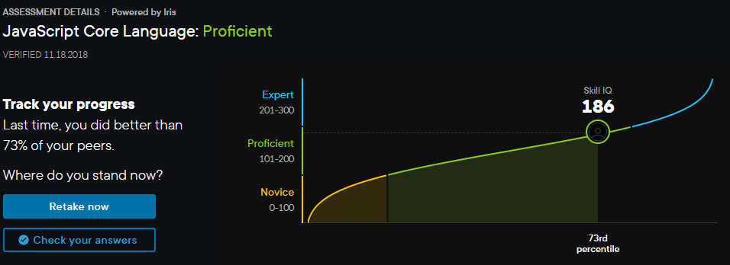

**Davidson College, Davidson, NC October 2013 – December 2018**

**Master Electrician (Lighting)**

**Accomplishments:**

* **Anticipating** Career Change: Specifically **Mentored, Guided, Developed and Trained** my own successor to be better than myself of my own volition while in the role of Master Electrician
* **Considered Technical Debt and Industry Change:** Targeted critical systems campus wide and upgraded legacy technologies as well as planned the multi-year systemic upgrade for multiple venues across the campus
* **Designed and Implemented** lighting viewed by 1 million+ people for the [North Carolina Republican Senate Debate in 2014](https://www.washingtonpost.com/news/the-fix/wp/2014/05/06/everything-you-need-to-know-about-todays-primary-in-north-carolina/?utm_term=.2ef0a2bb4bcd)
* **Designed, Coordinated, and Executed** lighting for the First Annual [Holiday Gala](http://www.davidsonian.com/2018-holiday-gala/), which is among the most popular events in Davidson and the surrounding area
* **Provide** **Spanish Language Translation** between clients of the Hispanic International Community and the College’s Internal staff: saving the College a lot of money

**Responsibilities:**

* **Director** of the Lighting Department of the Duke Family Performance Hall
* **Project Manager** for Internal and External Events of The Duke Family Performance Hall
* **Chief EOS Hardware Programmer**
* **Respond** to ever changing production requirements
* **Architect and Manager** for Interdepartmental Business Dropbox

**Environment:** ETC EOS Systems, MS-Office Suite, DMX-512A, FlareCon, Di-Fi, AirTable, Dropbox Business, Unison, Crestron, some FileMakerPro

**Davidson College, Davidson, NC August 2009 – October 2013**

**Assistant Master Electrician (Lighting)**

**Accomplishments:**

* **Increased productivity** of the lighting department by 100%
* **Produced** a decade of at least 20 successful [Dance Davidson Shows](https://www.google.com/maps/uv?hl=en&pb=!1s0x8856aa342ddd6671%3A0xe12cec70059c472a!2m22!2m2!1i80!2i80!3m1!2i20!16m16!1b1!2m2!1m1!1e1!2m2!1m1!1e3!2m2!1m1!1e5!2m2!1m1!1e4!2m2!1m1!1e6!3m1!7e115!4shttps%3A%2F%2Flh5.googleusercontent.com%2Fp%2FAF1QipMb-rdPUxGlDjDDXFaALK5ofdN8XPIKVn445ZBk%3Dw280-h160-k-no!5sdance%20davidson%20-%20Google%20Search&imagekey=!1e10!2sAF1QipMb-rdPUxGlDjDDXFaALK5ofdN8XPIKVn445ZBk&sa=X&ved=2ahUKEwiGtraRk5HhAhWCmOAKHfjJACkQoiowCnoECAsQBg)

**Responsibilities:**

* **Coordinated and Expanded** the number of light shows provided by the Entertainment Department
* **Troubleshot** computer technology software and equipment for many college departments
* **Managed** up to 10 employees for placement, order and quality of lighting
* **Program** Ion Light board for large-scale events
* **Designed** atmospheric lighting for approximately 20 events annually
* **Trained** newer employees on lighting equipment and procedures
* **Maintained** and **exercised repair** over a **$17M, 600** seat [Duke Family Performance Hall](https://www.google.com/maps/uv?hl=en&pb=!1s0x8856aa3819fef7ad%3A0xf05bb9d0423fc4af!2m22!2m2!1i80!2i80!3m1!2i20!16m16!1b1!2m2!1m1!1e1!2m2!1m1!1e3!2m2!1m1!1e5!2m2!1m1!1e4!2m2!1m1!1e6!3m1!7e115!4shttps%3A%2F%2Fwww.davidson.edu%2Facademics%2Ftheatre%2Ffacilities!5sDuke%20Family%20Performance%20Hall%20-%20Google%20Search&imagekey=!1e10!2sAF1QipMdYWl-JgW7aAbv7qlG_0F1xHvt_yehOPnOSjkN&sa=X&ved=2ahUKEwjK7NrKmJHhAhVoU98KHXlUBJMQoiowD3oECA4QBg)

**Environment:** ETC EOS Systems, MS-Office Suite, DMX-512A, FlareCon, Di-Fi, AirTable, Dropbox Business, Unison, Crestron, some FileMakerPro

**Davidson College, Davidson, NC August 2009 – December 2018**

**Sr. Stage Hand Technician**

* **Stage Manager** responsible for running shows – setup, directing backstage, communications   
  coordinator
* **Build** and **Operate** audio systems of many sizes:   
  • Fender 150 - Fender 250 - Yamaha - Allen & Heath – and more
* **Operate** projectors, televisions, and video cameras for live media streaming and ESPN 3
* **Maintain** mobile computer systems to deploy in various venues – Dell PC and Mac
* **House management** duties including: Quality, Safety, Equipment Protection and Oversight
* **Resolve** issues between client, faculty, staff and stage personnel
* **Preferred manager** for important college events for President, Trustees and high-profile guests

**Environment:** ETC EOS Systems, MS-Office Suite, DMX-512A, FlareCon, Di-Fi, AirTable, Dropbox Business, Unison, Crestron, some FileMakerPro

**Davidson College, Davidson, NC August 2006 –May 2009**

**Information Technology Student Consultant**

* **Identified** and **Resolved** time sensitive computer issues as tech support specialists
* **Upgraded** and **Installed** computer hardware and software
* **On-Site Troubleshooted** and **Supported** computer-based systems in 36 classrooms and a private computer lab
* **Tracked, Received, Distributed** and **Monitored** audio/video equipment for 1600 students and faculty maintaining accurate documentation
* **Managed** and **Completed** an accurate inventory documentation of computer related systems in main academic building
* **Set Up,** **Built** and **Installed** PCs, Printers, Hardware, and Software
* **Trained & Taught** students to use audio/video equipment for school related projects or research
* **Converted** (Digitize) analog formats of audio and/or video to modern digital media
* **Brainstormed** with professional staff to increase usability, access, and efficient arrangement of instructional facilities

**Environment:** Windows, MacOS, VCR to DVD, Dell and Apple Hardware

**PORTFOLIO HIGHLIGHTS (2019):**

**The Maid-Bot -** [View Project Here](https://maid-bots.herokuapp.com/)

*Solo Project*

* Uses React, Express, Node, MySQL, Material-UI
* Robot making AI with a mean streak!
* ~~Make sure to turn on your speakers!~~ (Maid-Bot **Retired**: Speaking now costs money!)
* Don’t despair – you can read something of [Her Biography Here](https://github.com/dashinja/maid-bot/blob/master/README.md).

**L.I.S.A.**

* Full-Stack application using ReactJS, GraphQL Yoga, Apollo, Ant-Design, Prisma ORM, NextJS, and JWT
* Social Media Intelligence: A Business Tool
* Offers estimated price range based on key performance indicators
* Normalizing Brand Sponsorship Costs for Influencers across the Industry
* Currently supports YouTube (and will soon support Twitch, Twitter, and Instagram accounts)

**COL-lege** - [View Project Here](https://puffroi.herokuapp.com/)

*Project Lead*

* Full-Stack application using MySQL, NodeJS/Express, Socket IO, Handlebars, and more
* Helping college students actual, and aspiring, get an Edge on Cost of Living
* Application that streamlines firm decision making for uncertain futures
* Includes CMS Admin control for main page data moderation

**Recipeciprocity** - [View Project Here](https://dashinja.github.io/recipeciprocity)

*Project Lead*

* Uses Firebase, jQuery, Bootstrap, APIs and more
* A community recipe sharing platform for Food Lovers, Aspiring Cooks, and Veterans Sharing their Craft
* ~~Listen to instructions while you cook: This platform will also read the recipes to you in a pleasant voice~~ (**Retired**: Speaking now costs money!)

**Notes-Node** -[View Project Here](https://dashinja.github.io/notes-node/)

* Uses NodeJS, Lodash, Yargs, FileReaders, FileWriters, Vanilla JavaScript (ES6+), JSON
* This program is a command line application and all its features are accessed via the command line