ASSIGNMENT 2 (Land Cover Mapping and Accuracy Assessment)
Dashlin Naidoo

27048942

MODULE: GIT 342

DATE OF SUBMISSION:

DEPARTMENT OF GEOGRAPHY AND ENVIRONMENTAL STUDIES

INTRODUCTION
Accurate and up-to-date land cover information is a critical geospatial dataset for sustainable environmental management, agricultural planning, and policy development in South Africa. The Spatial Data Infrastructure Act (No. 54 of 2003) and initiatives led by the Chief Directorate: National Geospatial Information (CD:NGI) emphasise the creation of standardised land cover products to support national and provincial planning ((CSIR), 2010). Reliable land cover data enable decision-makers to monitor ecosystem changes, assess anthropogenic impacts, and implement evidence-based conservation strategies.
Historically, per-pixel classification methods, such as Maximum Likelihood and Support Vector Machines, have been widely used in land cover mapping. However, these approaches often suffer from spectral confusion, “salt-and-pepper” noise, and limited representation of spatial context, (Benz, 2004) issues that are exacerbated with higher-resolution imagery (Blaschke, 2014)
In contrast, Geographic Object-Based Image Analysis (GEOBIA) represents a paradigm shift from pixel-level to object-level analysis. By grouping spectrally similar pixels into image objects through segmentation, GEOBIA incorporates spectral, textural, geometric, and contextual attributes, allowing more meaningful and interpretable classifications (Benz, 2004) (Hay, 2005) (Bock, 2005). These image objects correspond to real-world entities and enable integration of ancillary datasets, resulting in more thematically accurate and cartographically coherent outputs (Blaschke, 2014).
This research employs a rule-based Geographic Object-Based Image Analysis (GEOBIA) methodology to classify a South African landscape into nationally standardized land cover categories, thereby mitigating the limitations inherent to per-pixel classifiers. The subsequent section delineates and maps the study area, which was derived from a pre-processed Sentinel-2 satellite image.

RESEARCH AIM AND OBJECTIVES
The aim of this study is to develop and evaluate a rule-based GEOBIA methodology for land cover classification in South Africa.
To achieve this aim, the following objectives have been set:
- Develop a rule-set classifier in eCognition using pre-processed Sentinel-2 imagery, a DEM, slope, and vector data.
- Produce a detailed land cover map of the study area.
- Conduct an accuracy assessment using high-resolution reference data.

STUDY AREA
The study area for this assignment is an extract from a pre-processed Sentinel-2 scene, the specific location of which will be detailed with a map and description in the subsequent section, focusing on the diversity of its land cover features.
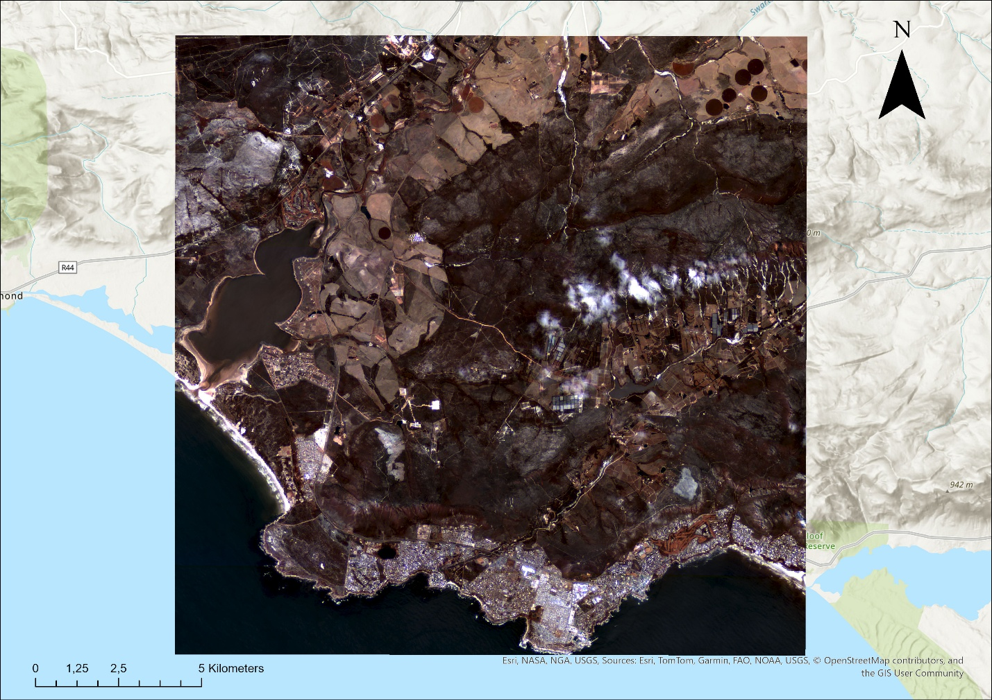
Figure 1:Sentinel-2 Image of Study area. Made by Dashlin Naidoo

THEORY

GEOBIA vs Per-Pixel Classification
Traditional pixel-based classification assigns each pixel to a class using only spectral values, which often results in a "salt-and-pepper" effect in high-resolution images (Benz, 2004) .Geographic object-based image analysis (GEOBIA) addresses this problem by grouping similar adjacent pixels into meaningful objects, integrating spectral, spatial, and contextual information (Bock, 2005). This object-oriented approach better represents real-world structures and improves thematic accuracy, especially in heterogeneous landscapes such as savannas.

Segmentation and Object Features
Segmentation is the foundation of GEOBIA, dividing imagery into homogeneous objects based on spectral and spatial similarity (Hay, 2005).The quality of segmentation, determined by scale, colour, and shape parameters, directly affects classification outcomes (Blaschke, 2004).Object attributes such as spectral means, shape metrics, and contextual relationships form the basis for class differentiation and enable hierarchical, multiscale analysis (Benz, 2004).

Supervised vs Rule-Based Classification
While supervised classification relies on statistical training data, rule-based classification applies expert-defined logic using spectral, spatial, and contextual thresholds (Blaschke, 2014).This knowledge-driven approach enhances transparency and repeatability and has been adopted in South Africa’s Computer Automated Land-Cover (CALC) and SANLC programmes, in line with the Spatial Data Infrastructure Act (Act 54 of 2003) and the hierarchical SALCC legend ((DRDLR), 2018). Stakeholder surveys confirm that consistent, repeatable products are critical for national reporting.

METHODS

Data Preparation
Sentinel-2 Level-2A imagery was used as the primary dataset. Relevant spectral bands were selected, including Blue, Green, Red, NIR, Red Edge, and SWIR (1 & 2) bands.

Image Segmentation
First a chessboard segmentation was done on the Roads and Crops thematic layers as they are used later in Rule-based Classification. Then a multiresolution segmentation algorithm was applied to create homogeneous image objects for classification. The segmentation parameters were:
- Scale: 10
- Shape: 0.1
- Compactness: 0.1
All Sentinel-2 bands and the slope layer were included with equal weighting (1.0). This process generated spatially coherent objects representing distinct land-cover features such as vegetation patches, water bodies, and built-up areas. The segmentation was executed at the pixel level, forming the base layer for subsequent object-based analysis.

Rule based classification
Within the GEOBIA framework, we developed a rule-based classification system in eCognition. This method combined expert knowledge with quantitative thresholds from spectral indices (like NDVI, NDWI) and contextual features (like slope and distance to roads) to categorize land cover according to the South African National Land-Cover (SANLC) hierarchy.

Grasslands
Objects were classified as Grasslands when vegetation was moderately healthy but with relatively low canopy closure.
Rules applied:
- NDVI between 0.0 and 0.4, indicating sparse to moderate greenness.
- ENV less than or equal to 0.4, reducing confusion with dense vegetation or forests.
This combination distinguishes grassland areas from shrubland (slightly higher NDVI) and bare soil (low NDVI, low ENV).
The ENV constraint effectively removed confusion with cultivated vegetation, which tends to exhibit higher red reflectance.

Shrublands
Shrublands were defined as transitional zones between grasslands and forests, characterized by discontinuous woody vegetation.
Rules applied:
- NDVI between 0.075 and 0.6, capturing intermediate vegetation density.
- ENV between 0 and 0.4, ensuring limited canopy saturation.
This range effectively separated shrubs from both low-biomass grasses and denser tree canopies, consistent with field spectral behavior observed in semi-arid biomes.

Forests
Objects with dense canopy and high photosynthetic activity were assigned to the Forest class.
Rules applied:
- NDVI ≥ 0.6 and < 1.0, representing continuous, high-chlorophyll vegetation.
This high NDVI threshold minimized confusion with agricultural vegetation while isolating closed-canopy woodland and riparian forest systems.

Cultivated Land
Cultivated Land objects were identified based on spatial overlap with mapped agricultural boundaries, supported by geometric regularity and contextual indicators.
Rules applied:
- Overlap with the given crops shapefile ≥ 1 pixel.
This rule ensured alignment with existing land-parcel datasets and reduced misclassification of natural vegetation with similar spectral signatures during growing seasons.

Built-up Area
Built-up surfaces were characterized by high reflectance in SWIR bands and proximity to anthropogenic features.
Rules applied:
- NDBI between –0.2 and 0.5, typical of impervious surfaces.
- NDVI between 0 and 0.5, filtering vegetated objects.
- BAEI between 0.9 and 1.4, highlighting soil and concrete mixtures.
- Distance to roads less than or equal to 36 pixels, adding contextual validation.
- Mean NIR between 0.25 and 0.5, indicating moderate reflectance typical of urban materials.
This composite rule minimized confusion between bare land and built-up features by incorporating both spectral and spatial context.

Barren Land
Barren Land objects exhibited low vegetation indices and high reflectance in visible and SWIR bands.
Rules applied:
- BSI between 0.0 and 0.06, confirming soil or rock exposure.
- NDVI less than or equal to 0.2, NDWI less than 0, identifying non-vegetated, dry surfaces.
This combination distinguished exposed soil and eroded surfaces from built-up and semi-vegetated areas.

Waterbodies
Water Bodies were detected through strong water absorption and low reflectance in SWIR bands.
Rules applied:
- NDWI between –0.5 and 0.7, typical for water and wet pixels.
- Mean SWIR1 between –0.1 and 0.2, representing low reflectance.
- Slope < 2, ensuring flat terrain.
The multi-criteria approach improved separation of open water from wetlands and shaded vegetation.

Wetlands
Wetlands displayed mixed spectral signatures due to the coexistence of shallow water, vegetation, and soil.
Rules applied:
- NDWI between –0.3 and 0.77, capturing variable moisture conditions.
- Mean Coastal less than or equal to 0.1, suppressing bright, dry surfaces.
- Mean Slope less than or equal to 0, identifying low-lying depressions.
These thresholds targeted inundated or seasonally saturated zones, complementing NDWI-derived water extent.

Mines
Was using manual classification and the SA landcover map provided by the Department of Forestry

RESULTS

Classification Accuracy
The accuracy assessment was performed using a confusion matrix comparing classified results with reference samples.
The classification achieved an overall accuracy of 57.8% and a Kappa coefficient (κ) of 0.538.
The Kappa value indicates a moderate level of agreement between the classification output and reference data, implying that the classification performed substantially better than random assignment but still experienced some confusion between spectrally similar classes.

Classified map

The final land-cover classification map (Figure 1) illustrates the spatial distribution of nine classes across the study area: Barren Land, Built-up Area, Cultivated Land, Forests, Grasslands, Mines, Shrublands, Waterbodies, and Wetlands.
Each class was derived using manual rule-based classification and verified against the South African National Land-Cover (SANLC) dataset for thematic consistency.

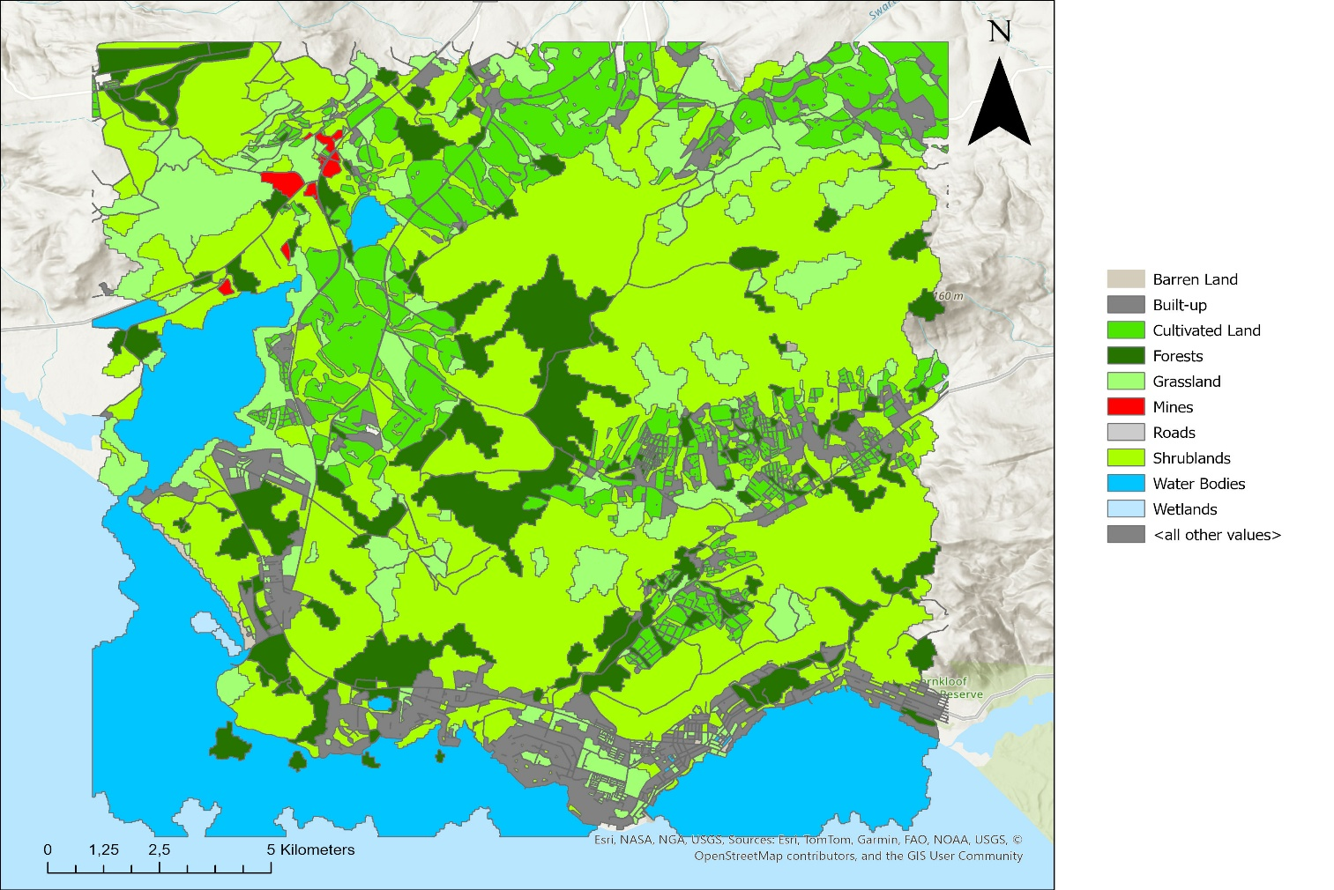
Figure 2: Classified Landcover Map

The map demonstrates clear spatial patterns, forests and shrublands dominating higher elevation regions, cultivated lands concentrated near valleys, and built-up areas along accessible transport corridors. Wetlands and waterbodies are distinctly visible in low-lying floodplains.

Error Matrix

The error matrix (Table 1) summarizes the classification performance across all classes.
Misclassifications were most frequent between grasslands, shrublands, and cultivated lands, where seasonal and spectral overlap is common.
Waterbodies and wetlands showed the highest user’s accuracies, while Mines and Built-up areas exhibited higher commission errors due to spectral confusion with bright soil and rock surfaces.
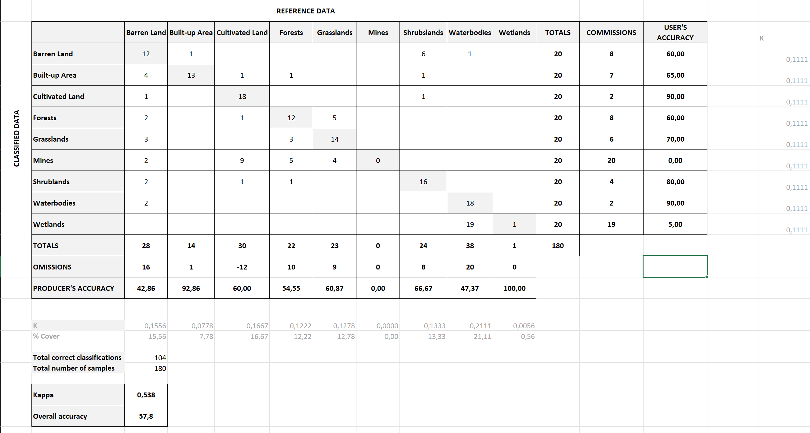
Table 1: Confusion Matrix for landcover classification
Although certain classes such as Built-up and Wetlands exhibited extremes in accuracy values, overall patterns indicate that vegetation-related categories were well represented, confirming that manual classification effectively distinguished natural land-cover units.

Class Specific Observations

Grasslands

Grasslands were widely distributed, particularly in open lowland areas. Moderate vegetation density and partial canopy cover led to some misclassification with shrubland. However, overall mapping reliability remained satisfactory.

Shrublands

Shrublands occurred mainly in transitional zones and were spectrally mixed with grasslands and cultivated fields. Despite this, an 80% user’s accuracy suggests effective discrimination using manual refinement and SANLC comparison.

Forests

Shrublands occurred mainly in transitional zones and were spectrally mixed with grasslands and cultivated fields. Despite this, an 80% user’s accuracy suggests effective discrimination using manual refinement and SANLC comparison.

Cultivated Land

Cultivated lands were clearly delineated due to geometric regularity and field boundaries visible in high-resolution imagery. Occasional confusion occurred with fallow or dry grasslands during off-season imagery.

Built-up Area

Built-up areas achieved high producer accuracy (92.9%) but moderate user accuracy (65%), primarily due to overestimation where barren soil and rocky surfaces shared similar reflectance.

Barren Land

This class showed the lowest producer accuracy (42.9%), reflecting difficulty distinguishing exposed soils from lightly vegetated grasslands in semi-arid conditions.

Mines

The mine class exhibited 0% accuracy due to the small number of samples and high spectral similarity to barren areas and built-up surfaces. Refinement with contextual or texture features could improve future detection.

Waterbodies

Waterbodies achieved strong accuracies (Producer 47.4%, User 90%) with clear spectral separability from surrounding classes. Misclassifications were mainly along edges or shallow water zones.

Wetlands

Wetlands displayed contrasting accuracies (Producer 100%, User 5%), indicating that while reference wetland samples were well captured, commission errors were high due to spectral confusion with moist soils and waterlogged vegetation

DISCUSSION

Interpretation of Accuracy and Performance

The classification achieved an overall accuracy of 57.8% and a Kappa coefficient of 0.538, indicating a moderate level of agreement between the classified output and reference data. This outcome demonstrates that while the rule-based GEOBIA approach effectively identified general land-cover patterns, it struggled with finer class distinctions.

The reduced accuracy is largely the result of spectral confusion among vegetation classes, particularly grasslands, shrublands, and cultivated land. These classes share overlapping spectral characteristics, especially during dry or transitional seasons when vegetation reflectance converges. Consequently, some image objects were incorrectly assigned due to insufficient spectral separation within the chosen index thresholds.

Influence of creating my own ruleset

The manual rule-set design introduced both strengths and weaknesses.
By allowing the interpreter to apply expert knowledge and visual judgment, the method provided thematic control and alignment with the South African National Land-Cover (SANLC) classification system. However, it also introduced subjectivity, thresholds for indices such as NDVI, NDWI, and BSI were chosen through visual inspection rather than data-driven optimization. As a result, certain thresholds may not have been universally representative of their respective classes, causing inconsistent classification performance across the study area.

Moreover, the binary logic of the rule-set (using fixed numerical boundaries) limited flexibility. Many objects fell near threshold edges, leading to ambiguous classification, particularly in ecotones where two land-cover types coexist. This rigidity partly explains the low producer accuracies for Barren Land (42.86%) and the misclassification of Mines (0%), where spectral variability is high.

Possible Improvements

To enhance classification accuracy and reduce subjectivity, several methodological improvements are recommended:

Automated Rule Optimization:
Implementing decision-tree or machine-learning classifiers such as Random Forest or Support Vector Machines could automatically derive optimal thresholds, minimizing user bias.

Multi-temporal and Seasonal Analysis:
Using imagery from different seasons would help capture phenological variation, improving class separability between agricultural and natural vegetation.

Expanded and Balanced Validation Dataset:
Increasing the number of ground-truth samples, particularly for minority classes like Mines, would improve both the representativeness and reliability of accuracy metrics.

CONCLUSION

This study applied a manual, rule-based GEOBIA classification of Sentinel-2 imagery to produce a detailed land-cover map consistent with the South African National Land-Cover (SANLC) framework. The workflow combined multiresolution segmentation, spectral index derivation (NDVI, NDWI, BSI, NDBI, SAVI, BAEI, ENV), and knowledge-based classification rules for nine major land-cover classes.

The classification achieved an overall accuracy of 57.8% and a Kappa coefficient of 0.538, reflecting moderate agreement with reference data. These results demonstrate that the method effectively captured general land-cover patterns but also revealed limitations in distinguishing spectrally similar classes such as grasslands, shrublands, and cultivated land. The moderate accuracy primarily resulted from fixed threshold rules, subjective manual interpretation, and spectral overlap in vegetation-dominated regions.

Despite these challenges, the approach successfully demonstrated the interpretability and spatial coherence of object-based image analysis (GEOBIA) when supported by expert knowledge and national reference datasets. The study highlights the practical value of combining manual classification with segmentation-based object delineation for regional land-cover mapping.

Future improvements should focus on automating threshold selection using machine-learning classifiers, integrating multi-temporal imagery to account for seasonal variability, and enhancing feature selection with texture and contextual metrics. Increasing the number of validation samples—especially for underrepresented classes such as Mines—would also strengthen accuracy assessments.

Overall, this project illustrates both the potential and the current limitations of rule-based GEOBIA for land-cover mapping in heterogeneous landscapes, providing a solid foundation for more automated and scalable approaches in future remote-sensing analyses.

References
(CSIR), C. f. S. a. I. R., 2010. South African National Land Cover Field Guide, Pretoria: s.n.
(DRDLR), D. o. R. D. a. L. R., 2018. South African National Land Cover 2017/2018 Final Report., Pietermaritzburg: s.n.
Benz, U. H. P. W. G. L. I. a. H. M., 2004. Multi-resolution, object-oriented fuzzy analysis of remote sensing data for GIS-ready information. In: ISPRS Journal of Photogrammetry and Remote Sensing. s.l.:s.n., p. 239–258.
Blaschke, T. B. C. a. P. A., 2004. Image segmentation methods for object-based analysis and classification. In: Remote Sensing Image Analysis: Including the Spatial Domain. s.l.:Dordrecht: Kluwer Academic Publishers, p. 211–236.
Blaschke, T. H. G. K. M. L. S. H. P. A. E. Q. F. R. v. d. M. F. v. d. W. H. v. C. F. a. T. D., 2014. Geographic Object-Based Image Analysis – Towards a new paradigm. In: ISPRS Journal of Photogrammetry and Remote Sensing. s.l.:s.n., p. 180–191.
Bock, M. X. P. M. J. R. G. a. W. M., 2005. Object-oriented methods for habitat mapping at multiple scales – Case studies from Northern Germany and Wye Downs, UK. In: Journal for Nature Conservation. s.l.:s.n., p. 75–89.
Department of Environmental Knowledge and Information, S. S. A. (. S., 2024. The 2022 South African National Land Cover Data and its Operational Use, Pretoria: s.n.
Hay, G. C. G. W. M. a. R. J., 2005. An automated object-based approach for the multiscale image segmentation of forest scenes. In: International Journal of Applied Earth Observation and Geoinformation. s.l.:s.n., p. 339–359.
Pax-Lenney, M. W. C. M. S. G. S. S. C. a. C. W., 2001. Forest mapping with a generalized classifier and Landsat TM data. In: Remote Sensing of Environment. s.l.:s.n., p. 241–250.

