Batch: A1 Roll No.: 1611015

Experiment / assignment / tutorial No.__2___

Grade: AA / AB / BB / BC / CC / CD /DD

Signature of the Staff In-charge with date

Title: Simulation of Hidden terminal problem using NS-2.
____________________________________________________________________

Aim: To Simulate Hidden terminal problem using NS-2.
_____________________________________________________________________
Expected Outcome of Experiment:
CO2: Differentiate infrastructure based and Ad hoc networks elaborating characteristics and features of Ad hoc Networks
_____________________________________________________________________

Books/ Journals/ Websites referred:

- Jochen Schiller, "Mobile communications", Addison wisely, Pearson Education.
- http://citeseerx.ist.psu.edu/viewdoc/download?doi=10.1.1.76.7774&rep=rep1&type=pdf
- http://www.mathcs.emory.edu/~cheung/Courses/558/Syllabus/18-WirelessSim/intro.html

Pre Lab/ Prior Concepts:

Due to the lack of a centralised control entity in ad hoc networks, sharing of wireless bandwidth among ad hoc nodes (medium access control) must be organised in a decentralised manner. Therefore distributed Medium Access Control (MAC) mechanisms such as Carrier Sense Multiple Access with Collision Avoidance and its’ variants such as MACA, MACA for Wireless (MACAW) and 802.11 Distributed Coordination Function (DCF) have gained widespread popularity in ad hoc networks. However, all these CSMA/CA based MAC protocols suffer from the well known “hidden terminal” problem. In wireless networks, it is a commonly accepted practice to use a pre-data control information exchange (virtual medium sensing) to avoid the hidden terminal problem. One such virtual sensing mechanism is the 802.11 Request To Send/Clear To Send (RTS/CTS) exchange resulting in nodes getting exclusive access to the channel for a well-defined time period. However, the use of RTS/CTS-like schemes introduces the “exposed terminal problem”, where some nodes that heard the RTS/CTS exchange refrain from transmission even though they would not have interfered with any ongoing transmission.

New Concepts to be learned:

The hidden terminal problem is due to the fact that a node (say A) transmitting to another node (say B) cannot hear transmissions from another node C, which might also be transmitting to B, and might interfere with the A-to-B transmissions. e.g. Say transmissions are limited to a distance d, this arrangement causes the problem described:
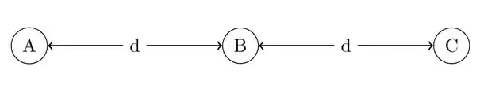
To get around this, we use the RTS/CTS mechanism. A now broadcasts a Request To Send message that asks "Can I send this message?" to all nodes within distance d. If B is free, it replies with a Clear to Send (CTS) which makes other nodes at a distance d from B enter a backoff period where they do not transmit.
However, this can also cause nodes that are within a distance d of B to enter backoff periods (e.g. B′ – even if they don't directly interfere with the transmissions between B and A.

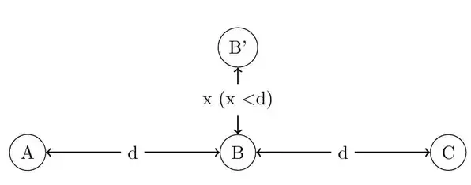
Implementation Details:

Wireless/Mobile Network simulation example:
Scenario:
All the tcl files are attached along with this writeup.
Outputs:

Withput rts-cts:

CASE1:

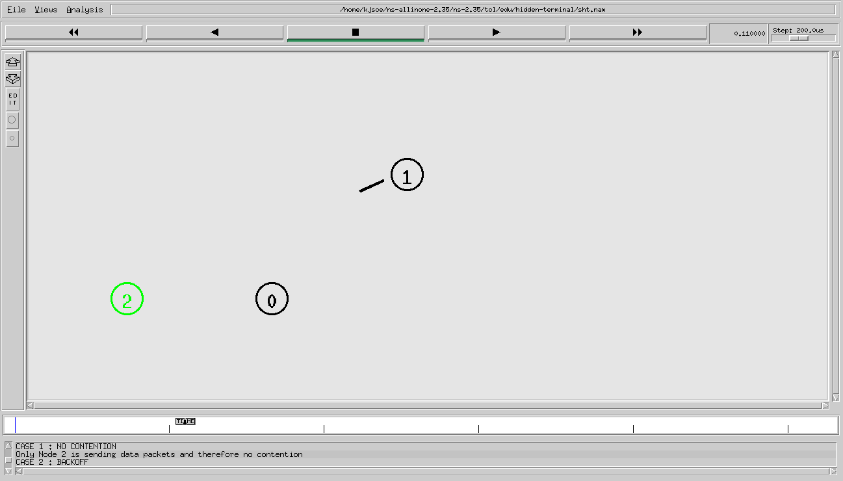

Case2: 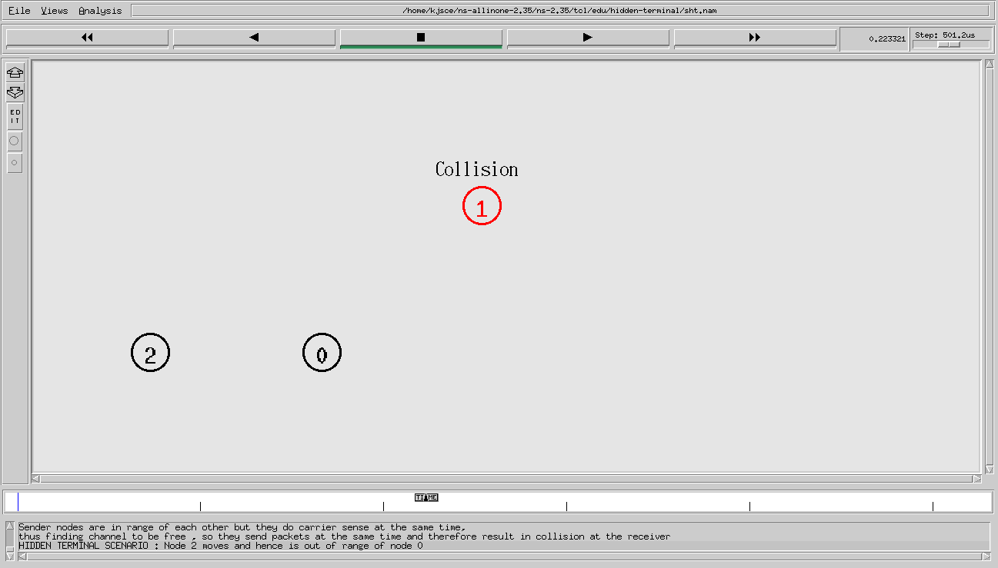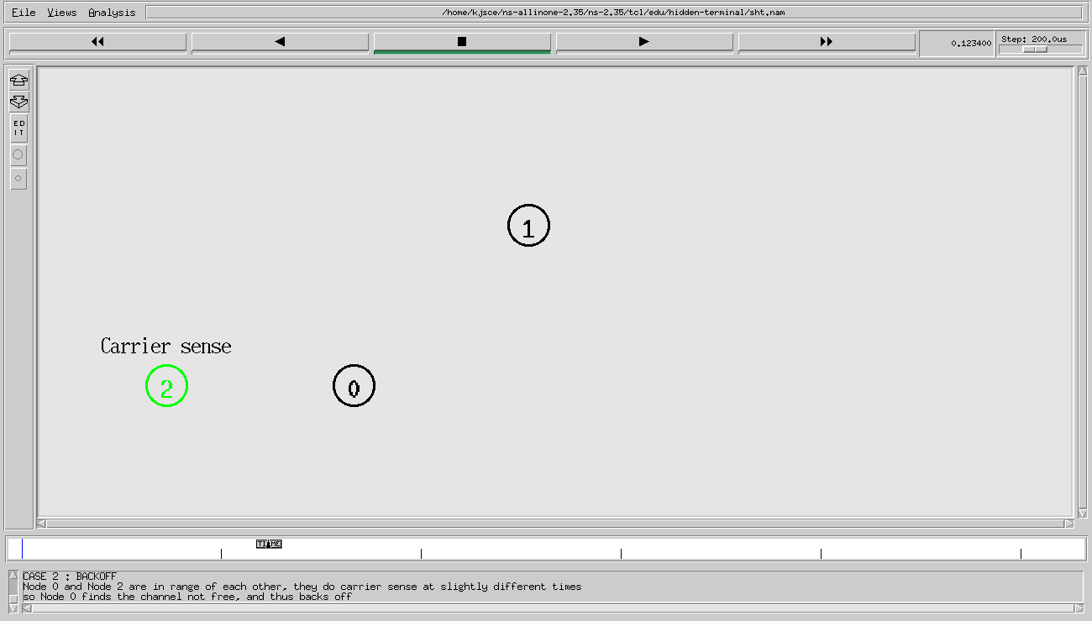 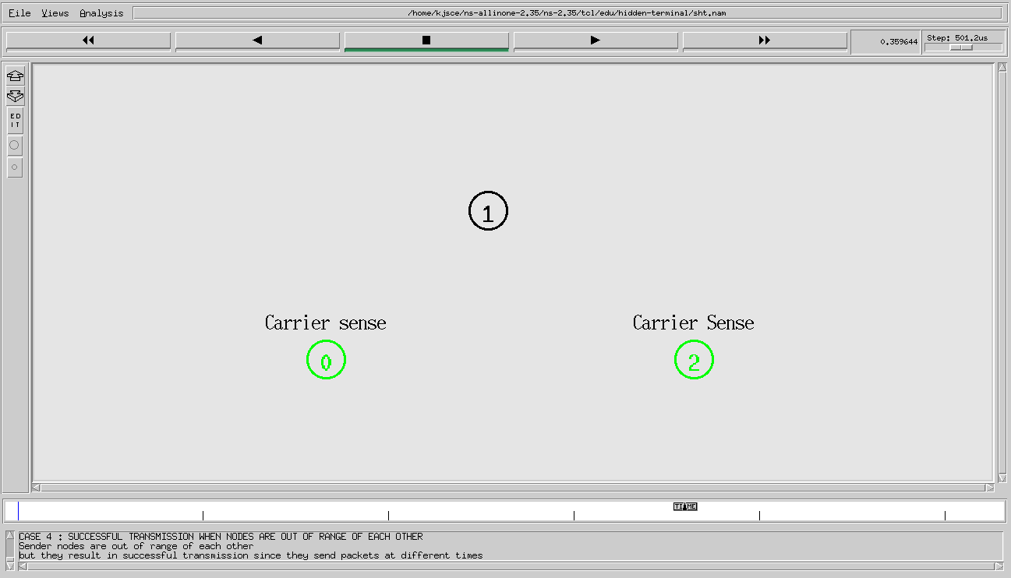

With RTS-CTS:
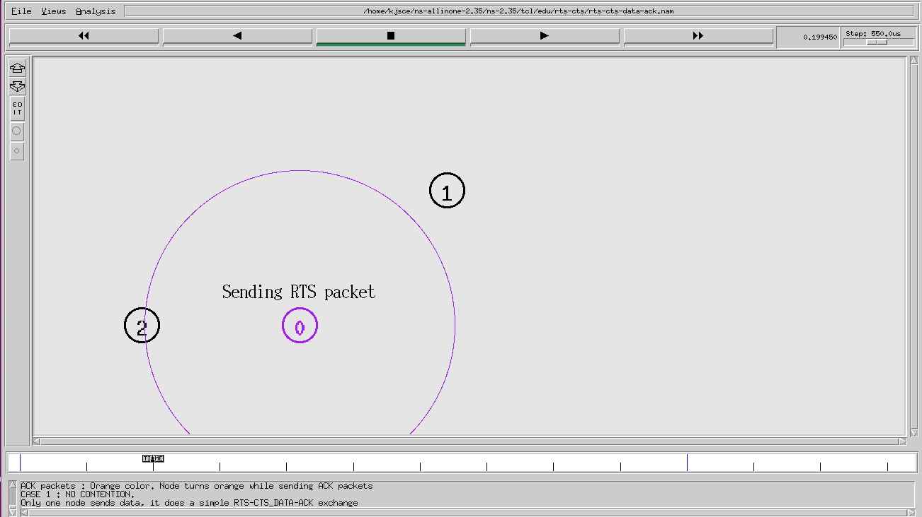
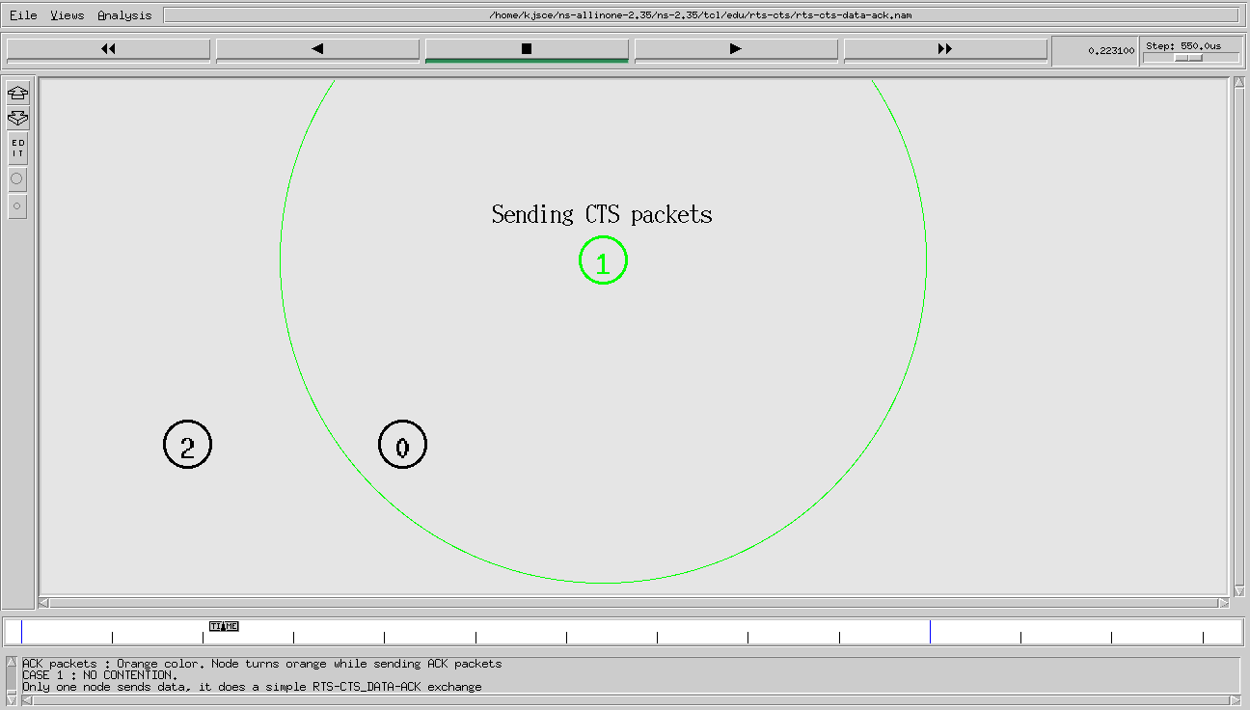
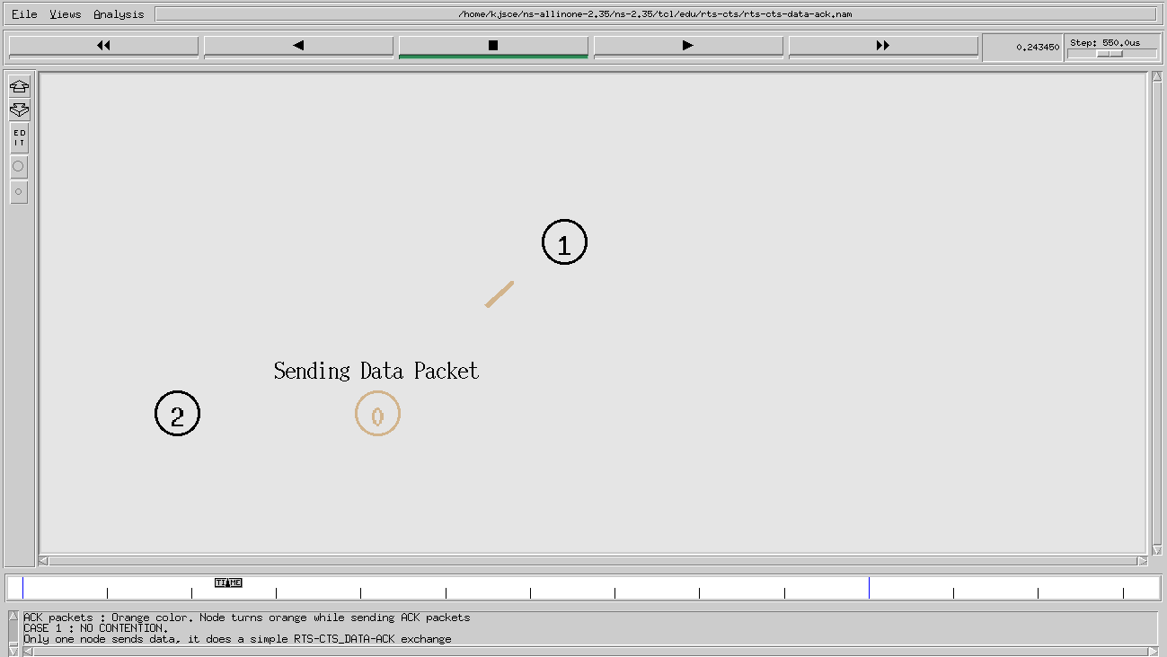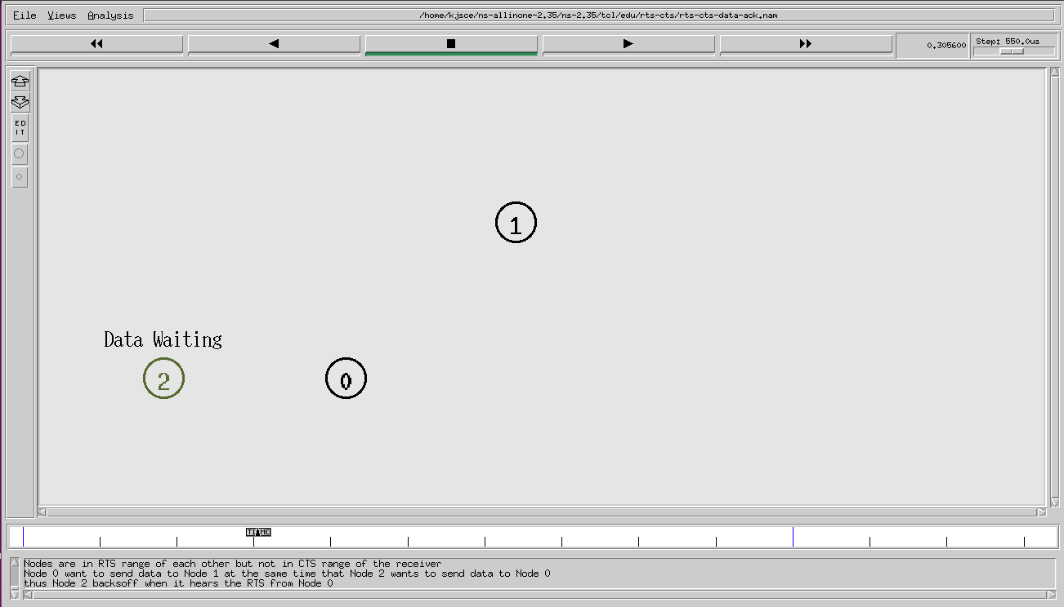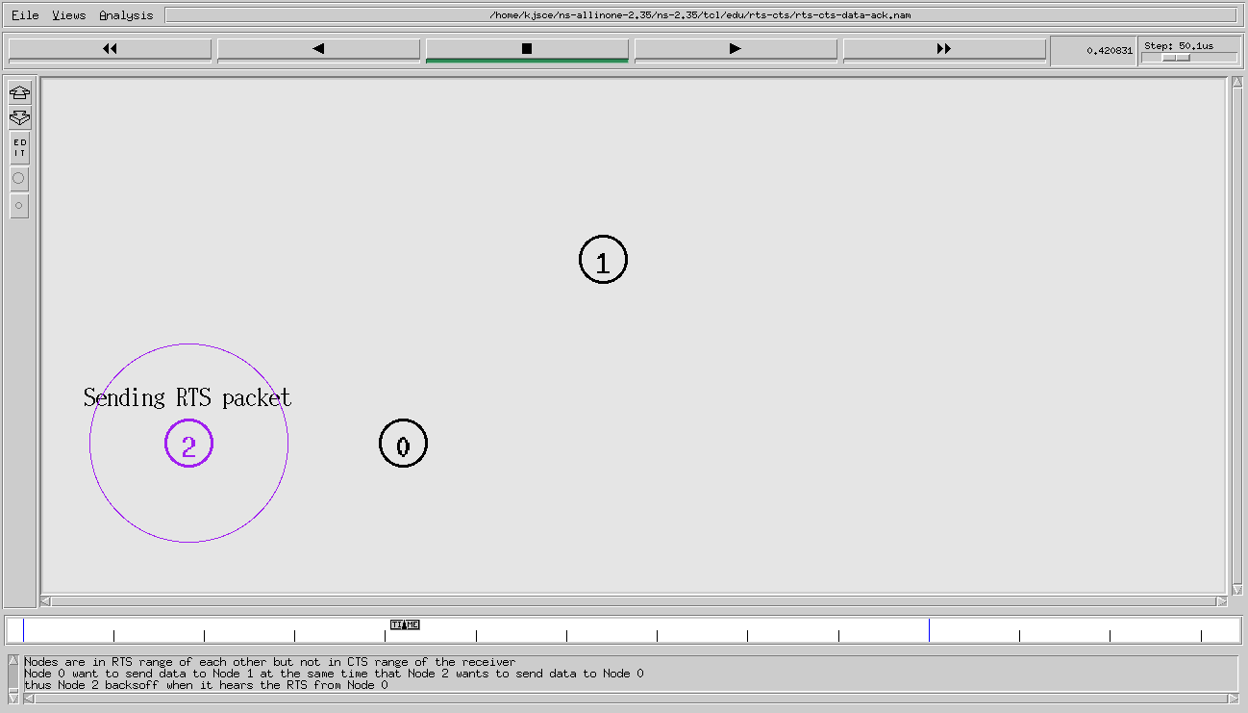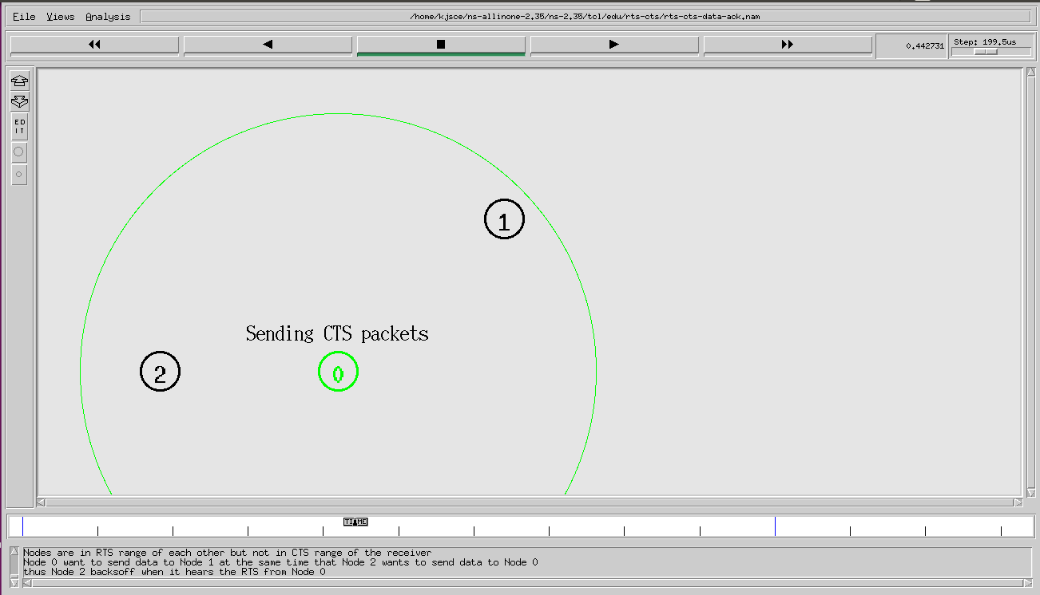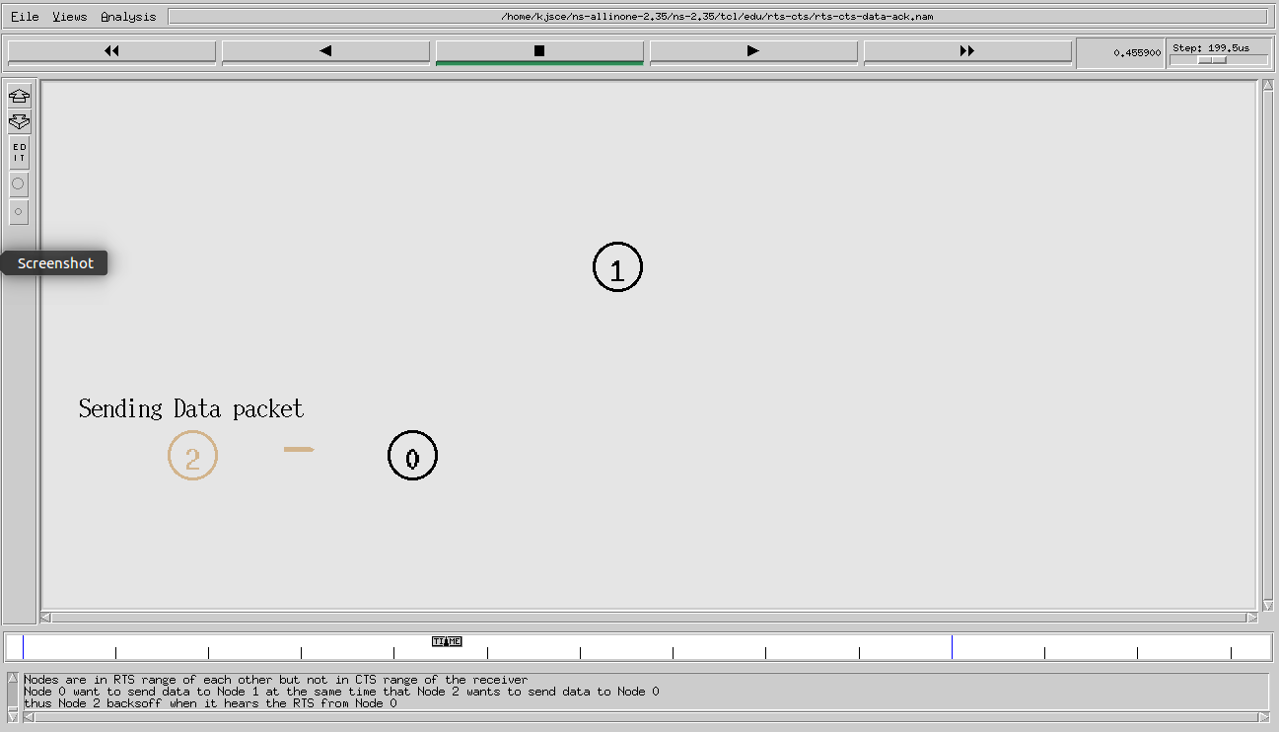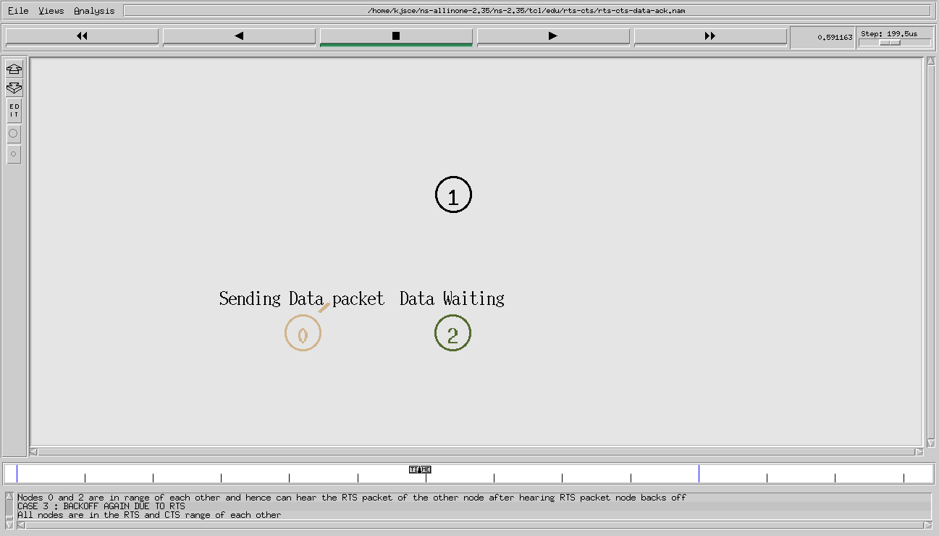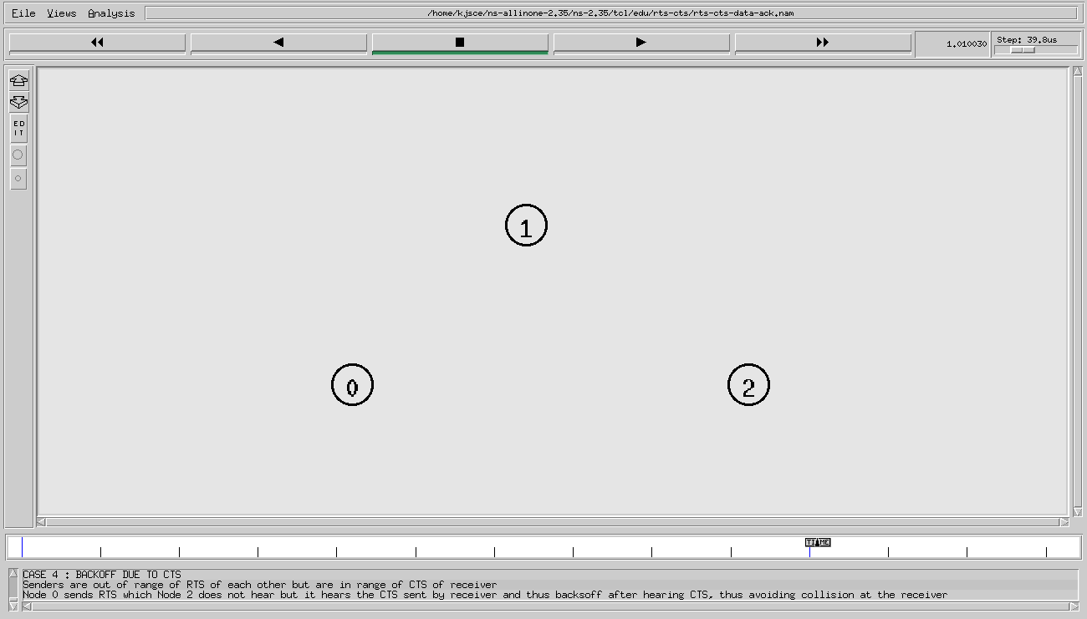

Using Four Nodes
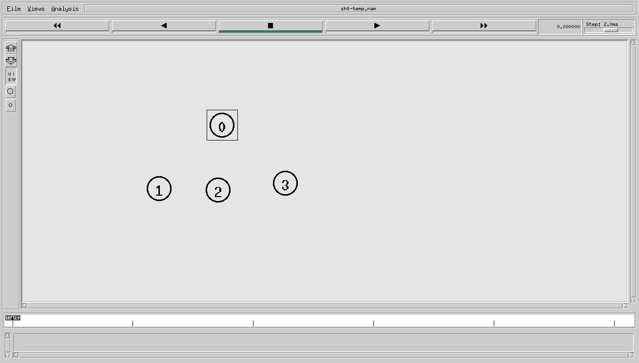

Conclusion:

Hidden Terminal problem was implemented in NS-2.

Postlab Questions:

- Explain Exposed terminal problem

In wireless networks, when a node is prevented from sending packets to other nodes because of a neighboring transmitter is known as the exposed node problem
Consider the wireless network having four nodes labeled A,B,C and D, where the two receivers are out of range of each other, yet the two transmitters (B,C) in the middle are in range of each other.
Here, if a transmission between A and B is taking place, node C is prevented from transmitting to D as it concludes after carrier sense that it will interfere with the transmission by its neighbor node B.However note that node D could still receive the transmission of C without interference because it is out of range from B. Therefore, implementing directional antenna at a physical layer in each node could reduce the probability of signal interference, because the signal is propagated in a narrow band.
The exposed terminal analogy is described as follows:
- B sends to A , C wants to send to another terminal D not A or B
- C senses the carrier and detects that the carrier is busy
- C postpones its transmission until it detects the medium as being idle again
- But A is outside radio range of C, waiting is not necessary
- C is "exposed" to B

Date: _____________ Signature of faculty in-charge

