Batch: A1 Roll No.: 1611015

Experiment / assignment / tutorial No.__3___

Grade: AA / AB / BB / BC / CC / CD /DD

Signature of the Staff In-charge with date

Title: Simulating IEEE 802.11 wireless LAN using NS-2 (Infrastructure mode)
_____________________________________________________________________

Aim: To get familiarized with the most widely used network simulator NS-2 and use it for simulating wired cum wireless networks _____________________________________________________________________
Expected Outcome of Experiment:
CO2: Differentiate infrastructure based and Ad hoc networks elaborating characteristics and features of Ad hoc Networks
_____________________________________________________________________
Books/ Journals/ Websites referred:

- Jochen Schiller, "Mobile communications", Addison wisely, Pearson Education
- http://www.isi.edu/nsnam/ns/tutorial/
- http://www.mathcs.emory.edu/~cheung/Courses/558/Syllabus/18-WirelessSim/intro.html

Pre Lab/ Prior Concepts:

A wireless local-area network (LAN) uses radio waves to connect devices such as laptops to the Internet and to your business network and its applications. When you connect a laptop to a WiFi hotspot at a cafe, hotel, airport lounge, or other public place, you're connecting to that business's wireless network.

Ad hoc mode: An Ad-hoc network allows each device to communicate directly with each other. There is no central Access Point controlling device communication. Ad-hoc networks are only able to communicate with other Ad-hoc devices, they are not able to communicate with any Infrastructure devices or any other devices connected to a wired network. In addition, Ad-hoc mode security is less sophisticated compared to an Infrastructure mode network.
Infrastructure mode: An Infrastructure mode network requires the use of an Access Point. The Access Point controls Wireless communication and offers several important advantages over an Ad-hoc network. For example, a Infrastructure based network supports increased levels of security, potentially faster data transmission speeds and integration with a wired network.

Historical Profile:

Heinrich Herz discovered and first produced radio waves in 1888 and by 1894 the modern way to send a message over telegraph wires was first conducted. Marconi sent and received signals up to two miles using radio waves. Marconi became known as the “father of radio”. By 1899, Marconi sent a signal nine miles across the Bristol Channel and 31 miles across the English Channel to France. In 1901 he was able to transmit across the Atlantic Ocean.
During World War II, the United States Army first used radio signals for data transmission. This inspired a group of researchers in 1971 at the University of Hawaii to create the first packet based radio communications network called ALOHNET. ALOHNET was the very first wireless local area network (WLAN). This first WLAN consisted of 7 computers that communicated in a bi-directional star topology.
The first generation of WLAN technology used an unlicensed band (902-928 MHz ISM), which later became crowded with interference from small appliances and industrial machinery. A spread spectrum was used to minimize this interference, which operated at 500 kilobits per second. The second generation of WLAN technology was four times faster and operating at 2Mbps per second. Third generation WLAN technology operates on the same band as the second generation and we currently use it today.
In 1990, the IEEE 802 Executive Committee established the 802.11 Working Group to create a wireless local area network (WLAN) standard. The standard specified an operating frequency in the 2.4GHz ISM band. In 1997 the group approved IEEE 802.11 as the world's first WLAN standard with data rates of 1 and 2 Mbps.

New Concepts to be learned:

NS-2 is an event driven network simulator developed at UC Berkeley that simulates variety of IP networks. It is an object oriented, event driven network simulator written in C++ with OTcl as front-end. Since two different tasks – simulation of protocols & network research- are to be performed NS-2 supports two languages C++ & OTcl.
It can be used to implement network protocols such as TCP and UDP, traffic source behavior such as FTP, Telnet, Web, CBR and VBR, router queue management mechanism such as Drop Tail, RED and CBQ, routing algorithms such as Dijkstra, and more. NS provides substantial support for simulation of TCP, routing, and multicast protocols over wired and wireless (local and satellite) Networks. NS also implements multicasting and some of the MAC layer protocols (802 based) for LAN simulations.
NS supports simulation of mobile network based on wireless MAC. Following is the scenario in the ns wireless model:
- Mobile-node at core of mobility model
- Mobile nodes can move in a given topology, receive/transmit signals from/to wireless channels
- Wireless network stack consists of LL, ARP, MAC, IFQ etc.
- Allows simulations of multi-hop ad hoc networks, wireless LANs, sensor networks etc.

Implementation Details:

Related files are attached with this file.

Scenario:

In this scenario,
Node 2 is Base station connecting wired node 0,1 to mobile nodes 4..8.
If node 0 wants to send to any mobile node it has to travel to Base station(node 2).

There is tcp conncetion between node 0 and node2, Node 2 to node 0,which passes through node 1:
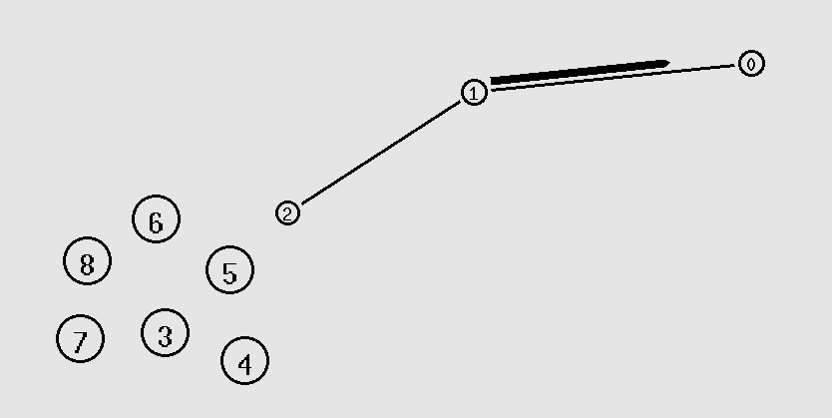

Ack:



There is another tcp conncetion from node 1 to mobile node 5, node 2 acts as Base station for this connection.


Ack:

Conclusion:
Wired and wireless networks were implemented in NS-2.

Post Lab Descriptive Questions

- What is the difference between adhoc and infraastrucuture based network.

Ad hoc mode:

An Ad-hoc network allows each device to communicate directly with each other. There is no central Access Point controlling device communication. Ad-hoc networks are only able to communicate with other Ad-hoc devices, they are not able to communicate with any Infrastructure devices or any other devices connected to a wired network. In addition, Ad-hoc mode security is less sophisticated compared to an Infrastructure mode network.

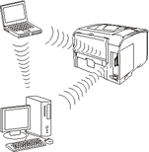

Infrastructure mode:

An Infrastructure mode network requires the use of an Access Point. The Access Point controls Wireless communication and offers several important advantages over an Ad-hoc network. For example, a Infrastructure based network supports increased levels of security, potentially faster data transmission speeds and integration with a wired network.

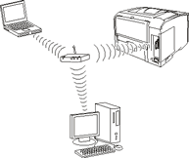

Date: 13/3/19 Signature of faculty in-charge

