Batch: A1 Roll No.: 1611015

Experiment / assignment / tutorial No._9_

Grade: AA / AB / BB / BC / CC / CD /DD

Signature of the Staff In-charge with date

TITLE : Find first and follow set for the given LL(1) grammar.
OR
Remove direct and recursive left recursion from the grammar.

AIM : To understand the LL(1) parsing technique and algorithm for removing left recursion.
______________________________________________________________________
Expected OUTCOME of Experiment:

CO 3: Design various phases of Compiler and demonstrate the programs on various phases of Compiler
__________________________________________________________________
Books/ Journals/ Websites referred:
- Aho, Ulman : Compiler Design, Tata McGraw Hill
- http://web.cs.wpi.edu/~kal/PLT/PLT4.1.2.html
_____________________________________________________________________

Pre Lab/ Prior Concepts:

Algorithm to find first and follow set:
The construction of a predictive parser is aided by two functions associated with a grammar called FIRST and FOLLOWS. These functions allow us to fill the entries of the predictive parsing table. FIRST: We associate each grammar symbol A with the set FIRST(A). The implication of this set is that the grammar symbol A can in some steps of transition produce the elements of the set FIRST(A).
If 'α' is any string of grammar symbols, let FIRST(α) be the set of terminals that begin the string derived from α. If α =*=> є then add є to FIRST(є).

RULES TO COMPUTE FIRST SET
1)If X is a terminal , then FIRST(X) is {X}
2) If X>є then add є to FIRST(X)
3) If X is a non-terminal and X-->Y1Y2Y3...Yn , then put 'a' in FIRST(X) if for some i, a is in FIRST(Yi) and є is in all of FIRST(Y1),...FIRST(Yi-1);In other words, Y1...Yi-1=*=>є .
If є is in all of FIRST(Yj) for all j=1,2....n, then add є to FIRST(X).This is so because all Yi's produce Є , so X definitely produces є

FOLLOW :FOLLOW is defined only for non terminals of the grammar G. It can be defined as the set of terminals of grammar G , which can immediately follow the non terminal in a production rule from start symbol. In other words, if A is a non-terminal, then FOLLOW(A) is the set of terminals 'a' that can appear immediately to the right of A in some sentential form, i.e. The set of terminals 'a' such that there exists derivation of the form S=*=> αAaβ for some α and β (which can be strings ,or empty).

RULES TO COMPUTE FOLLOW SET
1)If S is the start symbol, then add $ to the FOLLOW(S).
2)If there is a production rule A-->αBβ then everything in FIRST(β) except for є is placed in FOLLOW(B).
3)If there is a production A-->αB , or a production A-->αBβ where FIRST(β) contains є then everything in FOLLOW(A) is in FOLLOW(B).

Elimination of Left Recursion
Left-Recursion
The grammar for assignment statements is left-recursive; that is, in the process of expanding the first nonterminal, that nonterminal is generated again:
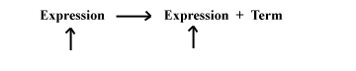
There is a formal technique for eliminating left-recursion from productions
- Direct Recursion
For each rule which contains a left-recursive option,
A --> A |
introduce a new nonterminal A' and rewrite the rule as
A --> A'
A' --> | A'
Thus the production:
E --> E + T | T
is left-recursive with "E" playing the role of "A","+ T" playing the role of , and "T" playing the role of A'. Introducing the new nonterminal E', the production can be replaced by:
E --> T E'
E' --> | + T E'
Of course, there may be more than one left-recursive part on the right-hand side. The general rule is to replace:
A --> A | | ... | | | ... |
by
A --> A' | A'| ...| A'
A' --> | A' | A' | ...| A'
Note that this may change the "structure". For the expression above, the original grammar is left-associative, while the non-left recursive one is now right-associative.
- Indirect Recursion
Step one describes a rule to eliminate direct left recursion from a production. To eliminate left-recursion from an entire grammar may be more difficult because of indirect left-recursion. For example,
A --> B x y | x
B --> C D
C --> A | c
D --> d
is indirectly recursive because A ==> B x y ==> C D x y ==> A D x y.
That is, A ==> ... ==> A where is D x y.

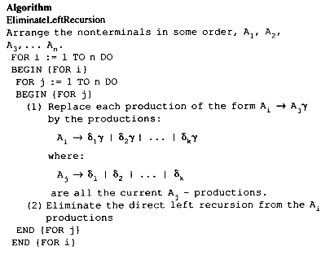
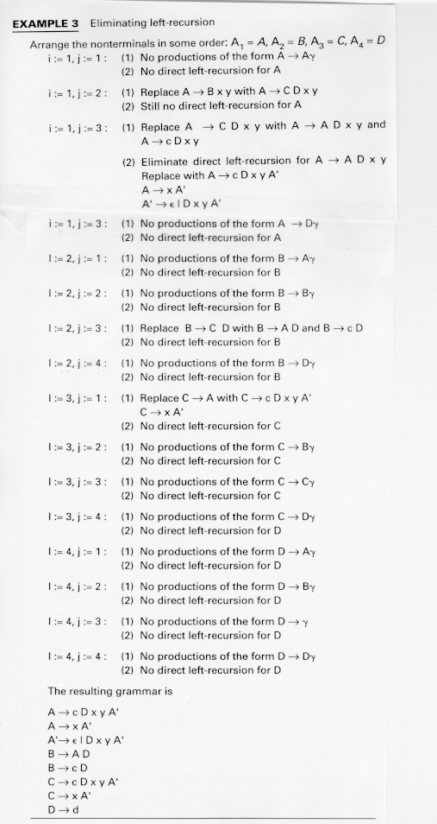
Implementation details: LEFT RECURSION REMOVAL
Code :
import java.util.*;
import java.lang.*;
class Main {
static ArrayList<String> V=new ArrayList<String>();
static ArrayList<String> T=new ArrayList<String>();
static String S;
static int ecount=0;
static ArrayList<String> grammer=new ArrayList<String>();
public static void main(String[] args) {
Scanner sc=new Scanner(System.in);
String thisline;

System.out.println("Enter start symbol");
S=sc.next();

System.out.println("Enter variables");
while(true)
{
thisline=sc.next();
if(thisline.equals("."))
{
break;
}

V.add(thisline);

}
System.out.println("Enter terminals");
while(true)
{
thisline=sc.next();
if(thisline.equals("."))
{
break;
}

T.add(thisline);

}
getp();
System.out.println("S:"+S);
System.out.print("\nV:{");
for(int k=0;k<V.size();k++)
{
System.out.print(V.get(k)+",");
}
System.out.print("}\n");

System.out.print("\nT:{");
for(int k=0;k<T.size();k++)
{
System.out.print(T.get(k)+",");
}
System.out.print("}\n");

System.out.println("\n P after removing left recursion");
for(int i=0;i<grammer.size();i++)
System.out.println(grammer.get(i));
/*}
static void getp()
{
String thisline;
Scanner sc=new Scanner(System.in);
System.out.println("Enter productions");

while(true)
{
thisline=sc.nextLine();
if(thisline.equals(""))
{break;}
directr(thisline);
}
}

static void directr(String thisline)
{
String words[]=thisline.split("-->");
String vars[]=words[1].split("\\|");
int alphacount=0;
int betacount=0;
String[] alpha=new String[20];
String[] beta=new String[20];

for(int k=0;k<vars.length&&vars[k]!=null;k++)
{
if(words[0].equals(Character.toString(vars[k].charAt(0))))
{
alpha[alphacount]=vars[k].substring(1,vars[k].length());
// System.out.print("added alpha "+alpha[alphacount]);

alphacount++;
}
else
{
//System.out.print("added beta "+vars[k]);
beta[betacount]=vars[k];
betacount++;
}
}
if(alphacount==0)//no recursibve grammer
{
//System.out.println("no recursion");
grammer.add(thisline);
}

else{ // there is left recursion
// System.out.println("recursion alphacount="+alphacount+" betacount="+betacount+"vars count="+vars.length);
String newv=words[0]+"'";
V.add(newv);
String Aline=words[0]+"-->";
for(int j=0;j<beta.length&&beta[j]!=null;j++)
{
if(j!=0)
{
Aline=Aline+"|";
}
Aline=Aline+beta[j]+newv;
}
grammer.add(Aline);

String Adashline=newv+"-->";
for(int j=0;j<alpha.length&&alpha[j]!=null;j++)
{
if(j!=0)
{
Adashline=Adashline+"|";
}
Adashline=Adashline+alpha[j]+newv;
}
Adashline=Adashline+"|epsilon";
grammer.add(Adashline);

}

}
}

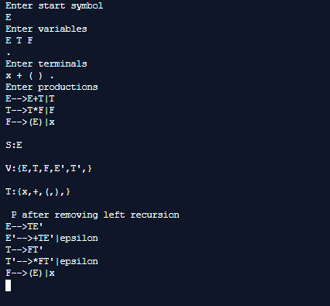

Conclusion

Program was implemented to remove left recursion from given grammer.

Date: 2/4/19 Signature of faculty in-charge

