Batch: A1 Roll No.: 1611015

Experiment No. 3

Grade: AA / AB / BB / BC / CC / CD /DD

Signature of the Staff In-charge with date

TITLE : Design and implement 2 pass Macro Processor

AIM : To learn working of two pass macro preprocessor and databases required for implementation of Macro Processor.

______________________________________________________________________
Expected OUTCOME of Experiment:

CO 2: design and implement the system programs like Assembler and Macro Pre-Processor etc.
_____________________________________________________________________
Books/ Journals/ Websites referred:
- Jhon J. Donovan : Systems programming, Tata McGraw Hill
_____________________________________________________________________
Pre Lab/ Prior Concepts:

How macros are used in assembly language Program.

Algorithm for PASS – I
- Set MDTC(macro definition table counter) to 1
- Set MNTC(macro name table counter) to 1
- Read next statement from source program
- If this source statement is pseudo-opcode MACRO (start of macro definition) then goto step 5 else goto step 16
- Read next statement from source program(macro name line)
- Enter macro name found in step 5 in name field of MNT(macro name table) and Also enter current value of MDTC in MDT index field of MNT
- Increment MNTC by 1
- Prepare argument list array
- Enter macro name into MDT at index MDTC
- Increment MDTC by one
- Read next statement from source program.
- Create and substitute index notation for arguments in the source statement if any
- Enter this line into the MDT
- Increment MDTC by one
- Check if currently red source statement is pseudo-opcode MEND. If yes then goto step 3 else goto step 11
- Write source program statement as it is in file(output of pass 1 s.p.)
- Check if pseudo opcoce END(end of source program) is encountered . If yes goto step 18 else goto step 19
- goto PASS – II
- Go to step 3
- end of PASS –I

Algorithm for PASS – II
- Read next statement from source program(from output s.p. file of pass I)
- Search in MNT for match with operation code(mnemonic)
- If macro name found the goto step 4 else goto step 11
- Retrieve MDT index from MNT and store it in MDTP(macro definition table pointer).
- Set up argument list array (store actual parameter in ala)
- Increment MDTP by 1
- Retrieve line pointer by MDTP from MDT
- Substitute index notation by actual parameter from argument list array if any
- Check if currently retrieved line is pseudo opcode MEND, if yes go to step 1 else goto step 10
- Write the statement formed in step 8 to expanded source file and go to step 6
- Write source statement directly into expanded source file
- Check if pseudo opcode END(end of s.p. output of pass I) encountered, if yes goto step 13 else goto step 1
- End of PASS-II

Stepwise-Procedure:
- Read a Source Program as input.
- Recognise the Macro Definition and
- Create Macro Name Table (MNT), and Macro Definition Table (MDT), and Prepare ALA.
- Recognise the Macro Call statement
- Update the Macro Definition Table Pointer(MDTP), and Prepare ALA.
- Expand the macro call by reading instructions from the MDT.

Sample input and output:
Input file:

MACRO
INCR1 &FIRST,&SECOND=DATA9
A 1,&FIRST
L 2,&SECOND
MEND
MACRO
INCR2 &ARG1,&ARG2
L 3,&ARG1
ST 4,&ARG2
MEND
PRG2 START
USING *,BASE
INCR1 DATA1,DATA12
INCR2 DATA3,DATA4
FOUR DC F'4'
FIVE DC F'5'
BASE EQU 8
TEMP DS '1'F
DROP 8
END

Sample Output:

Intermediate source file generated by Pass-I
PRG2 START
USING *,BASE
INCR1 DATA1,DATA12
INCR2 DATA3,DATA4
FOUR DC F'4'
FIVE DC F'5'
BASE EQU 8
TEMP DS '1'F
DROP 8
END
Macro Name Table (MNT) created by Pass-1
INDEX MACRO NAME MDT INDEX
-------------------------------------------------------------
1 INCR1 1
2 INCR2 5

Argument List Array (ALA) created by Pass-1 for INCR1 Macro
INDEX ARGUMENT
---------------------------------------
1 &FIRST
2 &SECOND

Argument List Array (ALA) created by Pass-1 for INCR2 Macro
INDEX ARGUMENT
---------------------------------------
1 &ARG1
2 &ARG2

Macro Definition table (MDT) created by Pass-1

INDEX DEFINITION
------------------------------------------------------
1 INCR1 &FIRST,&SECOND
2 A 1,#1
3 L 2,#2
4 MEND
5 INCR2 &ARG1,&ARG2
6 L 3,#1
7 ST 4,#2
8 MEND

Argument List Array (ALA) created by Pass-1 for INCR1 Macro
INDEX ARGUMENT
---------------------------------------
1 &FIRST
2 &SECOND

Output generated by Pass-II

Argument List Array (ALA) created for INCR2 Macro call
INDEX ARGUMENT
---------------------------------------
1 DATA1
2 DATA12

Argument List Array (ALA) created for INCR2 Macro call
INDEX ARGUMENT
---------------------------------------

1 DATA3
2 DATA4
Expanded Source code generated by Pass-2

PRG2 START
USING *,BASE
A 1,DATA1
L 2,DATA12
L 3,DATA3
ST 4,DATA4
FOUR DC F'4'
FIVE DC F'5'
BASE EQU 8
TEMP DS '1'F
DROP 8
END

Implementation details: (printout of code)
import java.io.*;

import java.util.*;
import java.lang.*;
class MDT{
int index;
String card;
public MDT(int i,String c)
{
index=i;
card=c;
}
}

class MNT{
int index;
String name;
int MDTindex;
public MNT(int i,String n,int m)
{
index=i;
name=n;
MDTindex=m;
}
}

class ALA1{
int index;
String argument;
public ALA1(int i,String a)
{
index=i;
argument=a;
}
}

class ALA2{
int index;
String argument;
public ALA2(int i,String a)
{
index=i;
argument=a;
}
}

public class Main
{
public static void main(String args[]) throws Exception
{
StringBuffer op=new StringBuffer();
BufferedReader in = new BufferedReader(new FileReader("Program.txt"));
String str=null;
ArrayList<String> lines = new ArrayList<String>();
while((str = in.readLine()) != null){
lines.add(str);
}
List<MNT> mnt = new ArrayList<MNT>();
List<MDT> mdt = new ArrayList<MDT>();
List<ALA1> a1 = new ArrayList<ALA1>();
List<ALA2> a2 = new ArrayList<ALA2>();

String[] linesArray = lines.toArray(new String[lines.size()]);
int macro=0;
int MDTC=1;
int MNTC=1;
int temp=0;
int argl=1;
op.append("intermediate code:\n");
for(int i=0;i<linesArray.length;i++)
{
String fullline=linesArray[i];
//System.out.println(fullline);
String[] thisline= fullline.split(" ");

for(int j=0;j<thisline.length;j++)
System.out.println(thisline[j]);
if(thisline[0].equals("END"))
{
break;
}
else{
if(thisline[1].equals("MACRO"))
{macro=1;
temp=i+1;
}
if(macro==1)
{
if(!(thisline[1].equals("MACRO")))
{
if(temp==i)
{
if(thisline.length>2){
MNT abc=new MNT(MNTC,thisline[1],MDTC);
mnt.add(abc);
MNTC++;
String[] operands=thisline[2].split(",");
for(int k=0;k<operands.length;k++)
{
ALA1 ala=new ALA1(argl,operands[k]);
argl++;
a1.add(ala);
}}
MDT ab=new MDT(MDTC,fullline);
mdt.add(ab);
MDTC++;
}//name of macro storing
else{
if(thisline[1].equals("MEND"))
{
MDT ab=new MDT(MDTC,fullline);
mdt.add(ab);
MDTC++;
macro=0;
temp=0;
}
else if(thisline.length>2){
String[] operands=thisline[2].split(",");
for(int k=0;k<operands.length;k++)
{
if(!isnumeric(operands[k]))
{

for(int t=0;t<a1.size();t++)
{
if(operands[k].equals(a1.get(t).argument))
operands[k]="#"+Integer.toString(a1.get(t).index);
}
}
}

String arguments=Arrays.toString(operands);
System.out.println(arguments);
MDT ab=new MDT(MDTC,thisline[0]+" "+thisline[1]+" "+arguments);
mdt.add(ab);
MDTC=MDTC+1;
}//
}
}
}
else
{
op.append(fullline+"\n");
}
}
}//main loop
op.append("\n\n");
op.append("MDT\n");
op.append("index\tcard\n");
for(int j=0;j<mdt.size();j++)
{
op.append(mdt.get(j).index);
op.append("\t");
op.append(mdt.get(j).card);
op.append("\n");
}

op.append("\n\n");
op.append("MNT\n");
op.append("index\tname\tMDTindex\n");

for(int j=0;j<mnt.size();j++)
{
op.append(mnt.get(j).index);
op.append("\t");
op.append(mnt.get(j).name);
op.append("\t");
op.append(mnt.get(j).MDTindex);
op.append("\n");
}
op.append("\n\n");
op.append("ALA1\n");
op.append("index\targument\n");

for(int j=0;j<a1.size();j++)
{
op.append(a1.get(j).index);
op.append("\t");
op.append(a1.get(j).argument);
op.append("\n");
}
FileWriter writer = new FileWriter("output.txt");
BufferedWriter buffer = new BufferedWriter(writer);
buffer.write(op.toString());
buffer.close();
in.close();
}
static boolean isnumeric(String str)
{
try
{
double d=Double.parseDouble(str);
}
catch(NumberFormatException e)
{
return false;
}
return true;
}
}

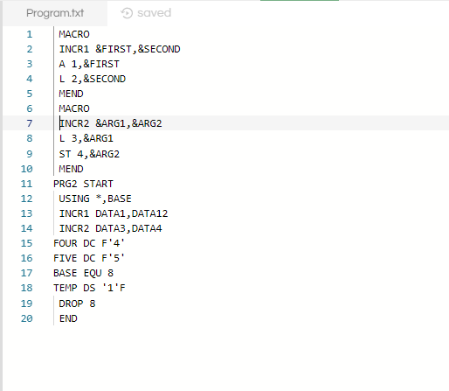
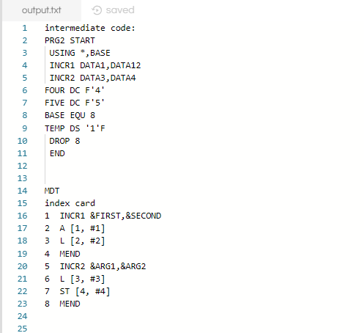
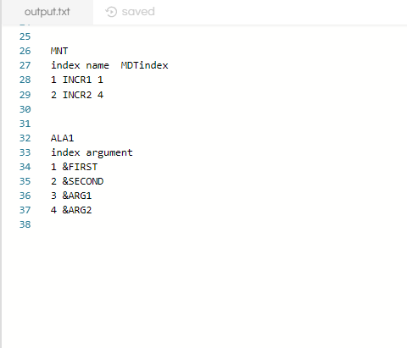

Conclusion:

Macro 2 pass assembler was studied and implemented.

Date: 26/2/19 Signature of faculty in-charge

Post Lab Subjective Questions

- What are the tasks performed by macro processor?
- Identifying micro definition
- Creating MDT, MNT and ALA for saving that macro
- Recognize macro call
- Expand macro for that call.

- What is the purpose of pass1 macro processor?
In pass1, The macro definitions are searched and stored in the macro definition table & the entry is made in macro name table.

- What is the purpose of pass2 macro processor?
In pass2, The macro calls are identified and the arguments are placed in the
Appropriate place and the macro calls are replaced by macro definitions.

- What is the purpose of MDT table?
MDT is used to store the body of macro definition. It contains fields’ index and card. MDT is a table of text lines. Every line of each macro definition except the MACRO line, is stored in the MDT (MACRO line is useless during macro-expansion) . MEND is kept to indicate the end of the definition. The macro-name line is retained to facilitate keyword argument replacement.

- What is the purpose of MNT table?
It serves a function similar to that of assembler’s MOT & POT . Each MNT entry consists of A character string (the macro name) . A pointer (index) to the entry in MDT that corresponds to the beginning of the macro- definition (MDT index).

- What is the use of MDI & MDLC?
The MDI and MDLC are the switches used to keep track of macro calls and macro definition. The MDI has status “ON” during the expansion of macro call and the value “OFF” all the other times. When its value is “ON” the cards are read from the MDT and when it is “OFF” the cards are read from the input source card. The use of MDLC is used keep track of the level of macros while defining the macros. Initially it is zero and it is incremented each time a MACRO code is found within a macro. The reverse process happens in case of MEND i.e. the valued of MDLC is decremented by one each time it encounters a MEND and the process continues till the MDLC is zero i.e. the completion of macro definition.

Post Lab objective Questions

- In which way a macro processor for assembly language can be implemented?
- Independent two pass processor
- Independent One pass Processor
- Processor incorporated into pass I of 2-pass Assembler
- All of these above
ANS:
d.All of these above

- Advantage of incorporating the Macro Processor in Pass I of assembler is that
  - Many functions have to be implemented twice
  - Functions are combined and it is not necessary to create intermediate file as output from the macro processor and input to the assembler.
  - More Flexibility is provided to the programmer in that he may use all the features of the assembler in conjunction with macros.
  - All of these above.
ANS:
d.all of these above

