

**IIIT-Bh MUMS Mailer**

Project for

Scientific Computing Using Python

**Roshan Dash**

**CSE Branch**

**B121046**

**Introduction**

About M-UMS

M-UMS is the Mandaar University Management System which is used by IIIT Bhubaneswar. It is the official platform used by the college administration for communication of notices, fees, grades, student and faculty details, and other similar information to the students. It can be accessed at the following link: [**https://hib.iiit-bh.ac.in**](https://hib.iiit-bh.ac.in)

Problem with M-UMS

M-UMS does not contain any kind of notification system like Email, SMS, or push notifications. This requires us students to actively check it regularly for new notices. We often miss important notices or see them too late.

**The solution:**

**IIIT-Bh MUMS Mailer**

About this project

This project runs continuously on a cloud virtual machine and monitors M-UMS for new notices. Whenever a new notice is sent on M-UMS, it fetches all its details like date, who posted the notice, for whom is the notice posted for, any attachments if present, title, and content. It then sends this notice through E-Mail to the college E-Mail groups like cse2021@iiit-bh.ac.in

Source code

<https://github.com/roshan1337d/mums-mailer>

**Screenshots**

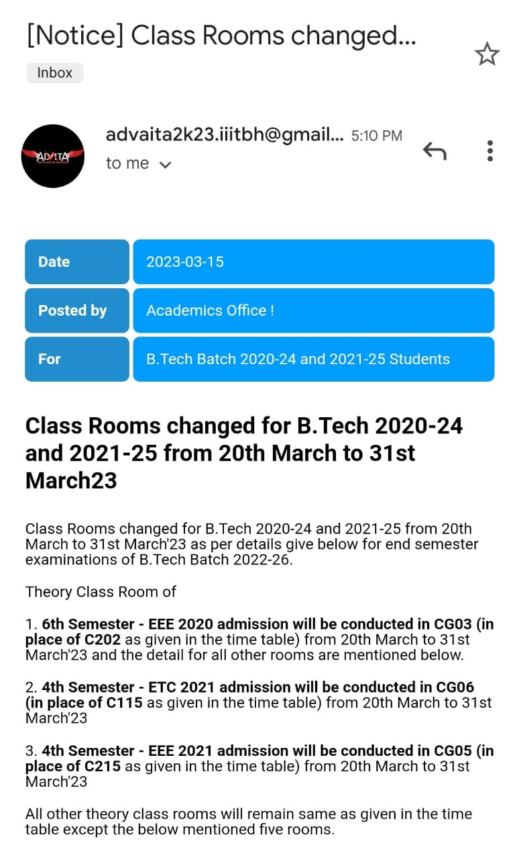

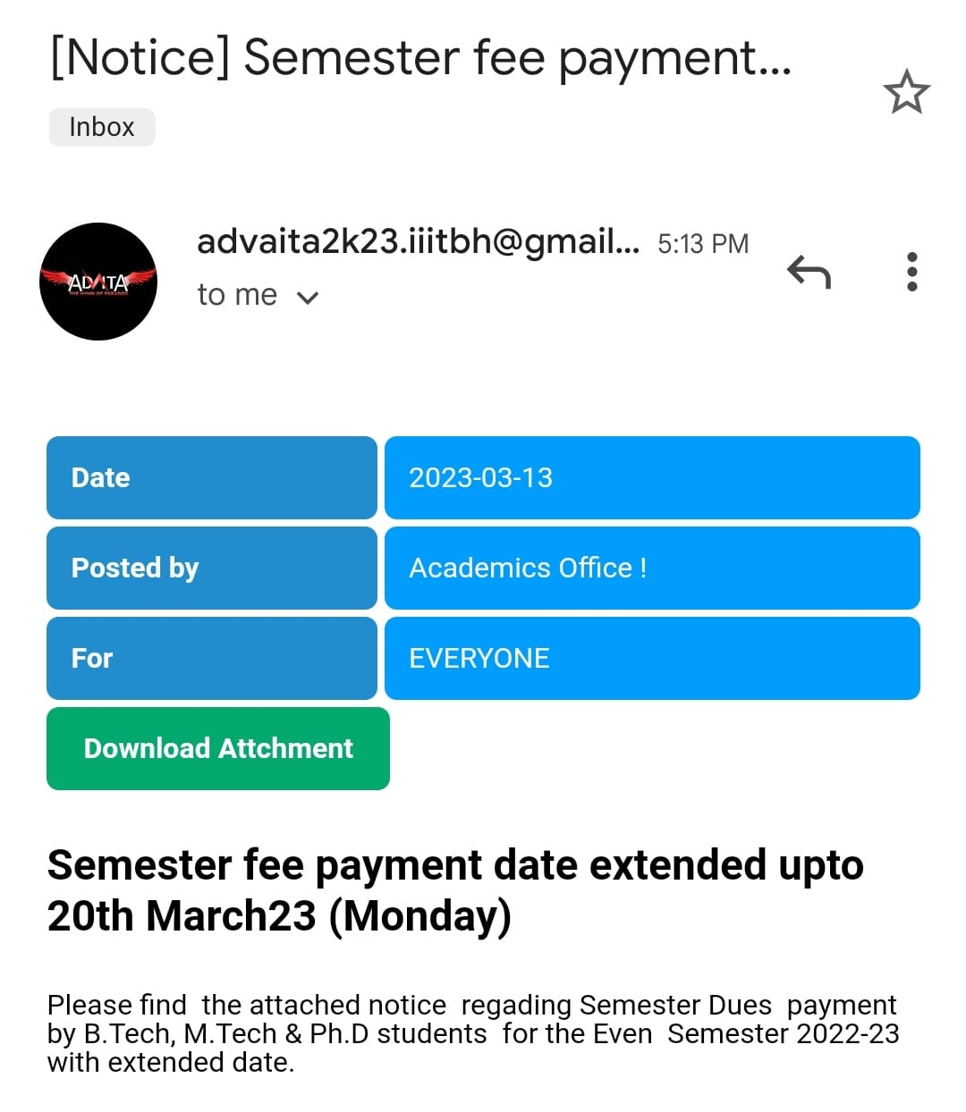**Tools Used**

Programming language:

Code editor:



VSCode

Python libraries:



**LIB**







lxml

**How does this work?**

The various API endpoints used by M-UMS were found using the Network monitoring feature of the Google Chrome developer tools. This project uses session of the Python’s request library to call upon these endpoints to simulate a real user’s actions: logging in, then opening the notice list page, heading to the detailed information page of a notice, opening the attachments etc. Beautiful soup library is used to scrape data from these various pages.

If it detects a new notice is sent on M-UMS, the scraped data of this new notice is put together in a HTML E-Mail template and mailed to the configured E-Mail addresses using the smtplib library.

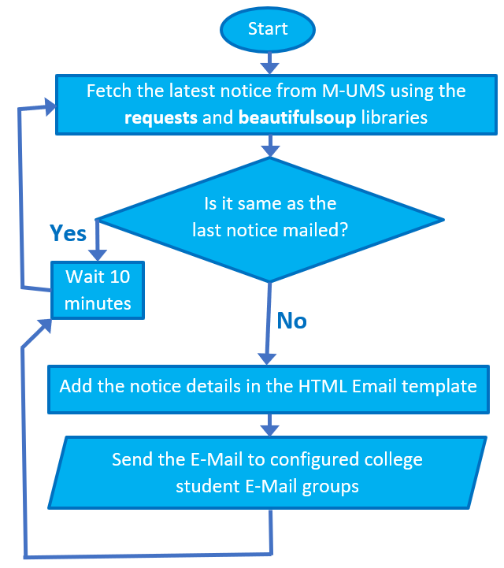**Process flowchart**

**M-UMS API Endpoints**

Login

https://hib.iiit-bh.ac.in/m-ums-2.0/start/login/auth.php?client=iiit

**Method:** POST

**Data:** **uid** (MUMS login id as string), **pwd** (MUMS login password as string), **txtInput** (Any random integer number for captcha as it is not verified on the backend server)

Notice list

https://hib.iiit-bh.ac.in/m-ums-2.0/app.misc/nb/docList.php

**Method:** GET

**Returns:** HTML document containing minimal details of 50 latest notices. We get the detailed notice page URL and notice title from here.

Notice details

https://hib.iiit-bh.ac.in/m-ums-2.0/app.misc/nb/{notice id from the notice list}

**Method:** GET

**Returns:** HTML document containing the detailed information of a particular notice.

Attachment direct link

https://hib.iiit-bh.ac.in/m-ums-2.0/app.misc/nb/{attachment id from the notice details}

**Method:** GET

**Returns:** HTML document containing an iframe with the attachment. We get the direct attachment link from here which can be accessed publicly.

**Setup process**

Creating config.json

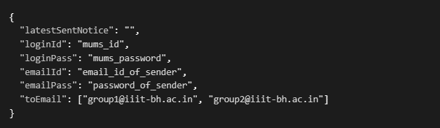A **config.json** file needs to be created in the same place as the **main.py** file. As this file contains login credentials, it is added in the **.gitignore** file to exclude it from being pushed to GitHub. The file content is as follows:

Installing venv and required libraries

* python -m venv venv
* pip install -r requirements.txt

Both these commands are run at the root directory of the project. The first command creates a virtual environment to avoid dependencies intermixing with other projects. The second command installs all the required libraries.

Running

* python main.py

This command is run at the root directory of the project to start the main python script.

Keeping it running

To make it work as desired i.e. to send E-Mails whenever a new notice comes out on M-UMS, this project needs to be left running continuously 24x7. To do this we can use a cloud virtual machine like that from Microsoft Azure, Google Cloud, AWS, or some PAAS provider like Heroku.

**What’s next?**

If the college administration permits and provides a custom iiit-bh.ac.in domain email account for this project, it can be hosted on the cloud to improve the experience for both the students and administration. Students will receive all notices directly to their college email account and be notified by Gmail about the same. Administration would not need to send the same notice both on M-UMS and college email manually as is done for some important notices currently.



**Thank**

**you**