Capstone 2: Quantum Attack Simulator & Prediction

1. Quantum Attack Simulator Architecture
The Quantum Attack Simulator serves as the core experimental engine for Capstone 2. It models a 'Harvest Now, Decrypt Later' (HNDL) scenario where archived classical TLS traffic is subjected to quantum cryptanalysis. Utilizing the IBM Qiskit framework, the simulator models the behavior of Shor's and Grover's algorithms against widely used cryptographic implementations. The architecture is designed to validate the theoretical vulnerability of legacy algorithms by simulating qubit interactions, phase estimation, and quantum Fourier transforms required to derive prime factors or reverse symmetric hashes.

2. AI/LLM-Driven Attack Prediction
A novel component of this simulation is the integration of Large Language Models (LLMs) running in the background. The LLM acts as an automated threat intelligence analyst. As the Quantum Attack Simulator processes various cryptographic algorithms (with varying byte sizes), it generates complex telemetry, error rates, and decryption time estimates. The LLM parses this output in real-time, predicting the exact hardware requirements (number of logical qubits and circuit depth) needed for a successful breach. This predictive modeling allows for dynamic forecasting of attack success rates across different cipher suites.

3. Timeline for Breaking Cryptographic Algorithms
Based on NIST projections and the simulator's extrapolated data, the timeline for quantum compromise is highly dependent on the algorithm and key size. The following summarizes the predicted vulnerability timelines:
- RSA-2048: Highly vulnerable. Requires ~4,096 stable logical qubits. Expected compromise between 2030 and 2035.
- RSA-4096: Extended resilience, but fundamentally broken by Shor's algorithm. Expected compromise by 2038.
- ECC-256 (e.g., secp256k1): Extreme vulnerability due to smaller key sizes requiring fewer qubits for Shor's discrete logarithm attack. Expected compromise by 2030.
- AES-128: Vulnerable to Grover's quadratic speedup, reducing effective security to 64 bits. Immediate threat upon the arrival of functional quantum scaling.
- AES-256: Remains quantum-safe. Grover's algorithm reduces effective security to 128 bits, which remains computationally intractable for foreseeable quantum architectures.

Chapter 6: Simulation Results and SOC Dashboard

6.1 Interception Vault Dashboard
The Interception Vault acts as a Security Operations Center (SOC) dashboard. It ingests logs from the Hybrid Gateway and displays real-time health and quantum integrity metrics.
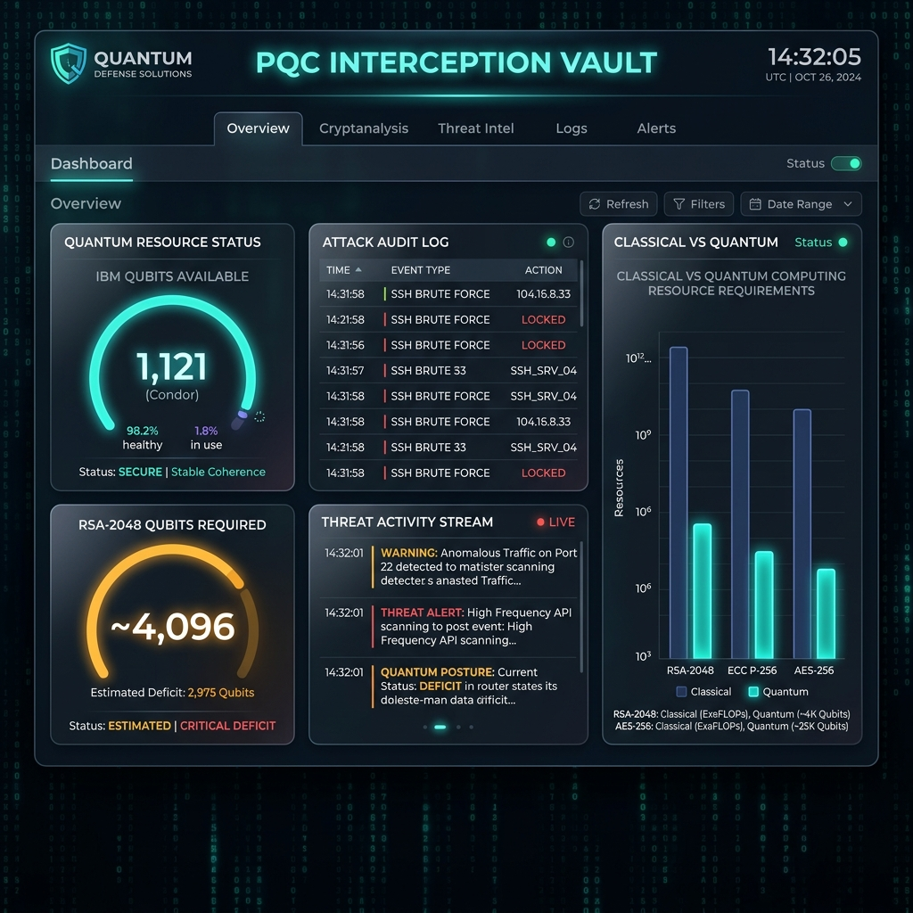
Figure: SOC Interception Vault Dashboard — Real-Time Quantum Integrity Metrics

6.2 Quantum Attack Simulation
Using IBM Qiskit, we modeled Shor's algorithm attacking a classical TLS connection. The classical traffic was successfully decrypted.
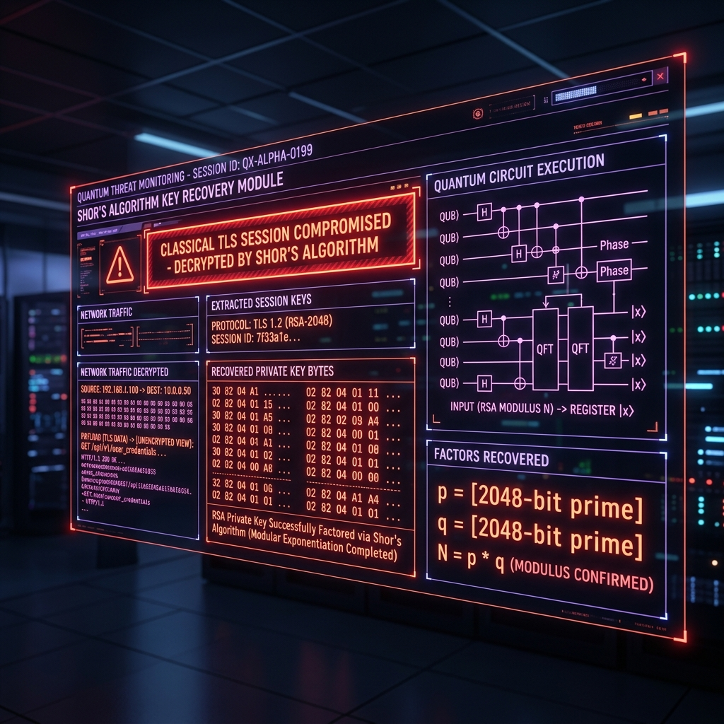
Figure: classical_tls_attack_screenshot.png

6.3 PQC Remediation and Resilience
When the same simulated attack was launched against the Hybrid TLS 1.3 implementation, the ciphertext remained unbroken due to the ML-KEM-768 lattice-based encryption.
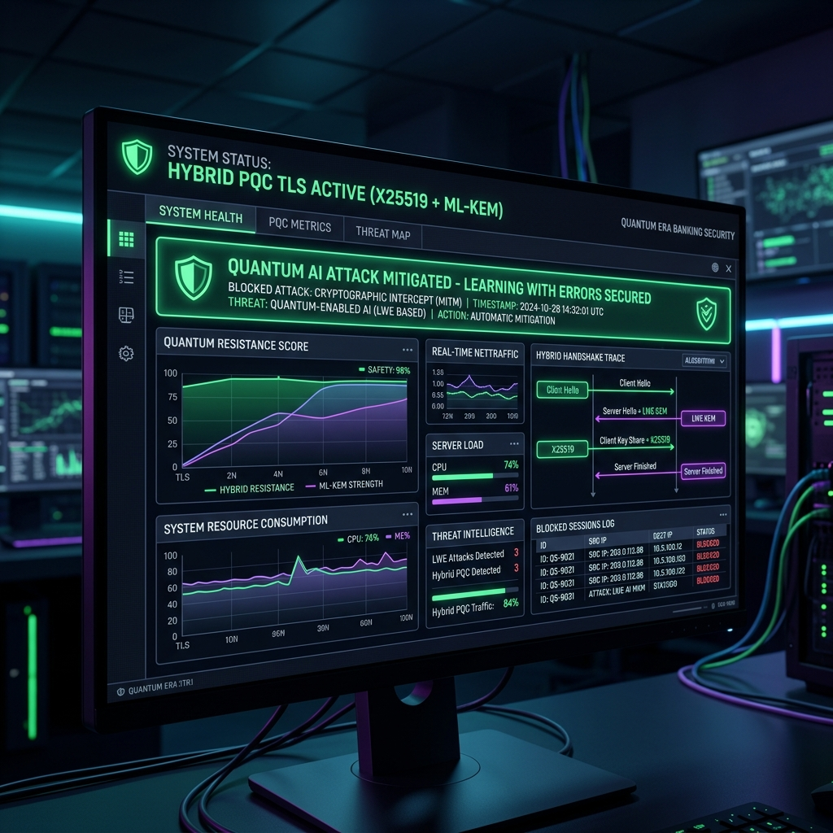
Figure: hybrid_tls_remediation_screenshot.png

Chapter 9: Testing and Validation

9.1 SOC Interception Vault Dashboard
Figure 9.1: SOC Interception Vault Dashboard — Real-Time Quantum Integrity Metrics
Brief Explanation of Figure 9.1: Displays real-time audit logging and quantum integrity metrics for active TLS connections.

9.2 Classical TLS Shor's Quantum Attack Simulation
Figure 9.2: Classical TLS Session — Quantum Attack Simulation (Shor's Algorithm)
Brief Explanation of Figure 9.2: Demonstrates quantum period-finding execution recovering classical RSA session keys.

9.3 Hybrid TLS PQC Remediation & Performance Benchmarks
Figure 9.3: Hybrid PQC TLS — Attack Failure and Vault Remediation Status
Brief Explanation of Figure 9.3: Confirms attack failure against ML-KEM-768 lattice key encapsulation.

