CEBU INSTITUTE OF TECHNOLOGY UNIVERSITY

COLLEGE OF COMPUTER STUDIES

Software Design Description
for
DASIGConnect
Change History Signature
Version | Date | Author | Changes | Reason (MVP Validation Findings)
1.0 | 05/16/2026 | Chris Daniel Cabatana, Jaylord Bayonas, Lerah Caones, Mark Anton Camoro, Richemmae V. Bigno | Initial document | — (pre-validation)
2.0 | 08/22/2026 | Chris Daniel Cabatana, Jaylord Bayonas, Lerah Caones, Mark Anton Camoro, Richemmae V. Bigno |  | — (pre-validation)
3.0 | 10/04/2026 | Chris Daniel Cabatana, Jaylord Bayonas, Lerah Caones, Mark Anton Camoro, Richemmae V. Bigno | Re-aligned to SRS v6.0 use-case numbering (UC-1.1–UC-1.10, UC-2.1–UC-2.5, UC-3.1–UC-3.6) and verified against the implemented codebase: three-role model (Contributor, Moderator, Administrator, plus the Admin Owner flag); Cloudflare R2 object storage with presigned uploads and a backend media proxy; Railway backend hosting; Java HttpClient integrations; DB-backed session revocation; network-wide guard-rail switch and DB-level slot-conflict constraint; 15-minute review lock; review-edit diffs and severity; atomic publish claim and Fast-Track async publishing; Gemini/Voyage media enrichment pipeline; System Health, Audit Log, and Watermarking designs; updated API endpoints, components, and data schema (Flyway V1–V122; unified promotion flow, configurable posting window, removal of submission category, Moderator and Administrator review notifications) | — (pre-validation; implementation verification)
4.0 | 10/17/2026 | Chris Daniel Cabatana, Jaylord Bayonas, Lerah Caones, Mark Anton Camoro, Richemmae V. Bigno | Re-verified against release v3.0.2 code and SRS v7.0, correcting statements the code contradicts: Google Gemini performs image classification (Claude does not); Admin Owner transfer only to an active Administrator; institution uniqueness rules and pending-invitation deactivation block; no lockout email; single-attempt email delivery; 30 notification event types; Review Queue ordering (GR-T1 badge vs sort); media-processing dead letters; token key derived from FACEBOOK_APP_SECRET; System Health probes and formula-safe snapshot export (PR #409). Added Section 4, Planned Design for Validation-Driven Refactoring (RP-01–RP-05), and Appendix — REST API Endpoint Table. | VF-01–VF-05 from the MVP Validation Findings (12 Oct 2026) drive the planned design in Section 4: readiness gate (RP-01), next action and task-event log (RP-02), caption on upload and media-first picker (RP-03), mobile primary-action bar (RP-04), bulk invitations (RP-05).

Preface
This Software Design Document (SDD) describes the architectural and detailed design of DASIGConnect, a multi-tenant social media content management system developed for the Department of Science and Technology — Accelerated Science and Technology Human Resource Development Program (DOST DASIG). The system is designed to replace ad hoc coordination between member institutions and a centralized Administrator by introducing a structured, self-service content submission and publication workflow integrated with the DASIG Facebook Page.
This document translates the functional and non-functional requirements defined in the Software Requirements Specification (SRS) into concrete design decisions: system architecture, component structure, data models, API contracts, security mechanisms, and AI integration design. Where the SRS defines what the system must do, this document defines how the system does it.

Intended Audience
This document is intended for the development team responsible for implementing and maintaining DASIGConnect. It assumes familiarity with the SRS and working knowledge of the technologies involved, including Spring Boot, PostgreSQL with pgvector, React, the Facebook Graph API, and the Anthropic, Google Gemini, and Voyage AI APIs. It may also be referenced by technical reviewers and DASIG stakeholders evaluating design decisions during the pilot period.

Relationship to Other Documents
This SDD should be read in conjunction with the SRS, which remains the authoritative reference for system requirements, business rules, guard rails, and non-functional constraints. Where this document references a requirement by its identifier (e.g., GR-H1, BR-ACC-03, UC-1.3), the SRS is the source of record for that requirement's full specification. Any conflict between this document and the SRS shall be resolved in favor of the SRS unless a formal change request has been approved.

Design Conventions
Throughout this document, the term shall denotes a design decision that directly implements a mandatory requirement from the SRS. The term is or uses describes an implementation choice made within the latitude allowed by the requirements. Sequence diagrams follow UML 2.x notation. All API endpoint paths are relative to the application base URL and are prefixed with /api/v1 unless otherwise noted.

Table of Contents
Preface 4
Intended Audience 4
Relationship to Other Documents 4
Design Conventions 4
Table of Contents 5
1. Introduction 7
1.1. Purpose 7
1.2. Scope 7
1.3. Definitions and Acronyms 8
1.4. References 9
2. Architectural Design 10
Architectural Overview 10
Presentation Tier 10
Application Tier 10
Data Tier 11
External Service Integrations 12
Background Processing 12
Architectural Block Diagram 14
Security Architecture Overview 15
3. Detailed Design 16
1. Module 1 16
1.1. Administrator Account Management 16
1.2. Institution Management 24
1.3. Contributor Account Management 31
1.4. Login & Session Management 38
1.5. Post Drafting & Templates 47
1.6. AI & Text Tools Integration 55
1.7. Media Attachment Rules 61
1.8. Engagement Helpers 68
1.9. Draft Submission 74
1.10. Moderator Account Management 81
2. Module 2 87
2.1. Library Uploads & Albums 87
2.2. Semantic Search & Filtering 96
2.3. Media History Tracking 104
2.4. Admin Approval Workflow 111
2.5. Automated Watermarking 120
3. Module 3 125
3.1. Master Calendar Visibility 125
3.2. Automated Facebook Post Publishing 131
3.3. Automated Reminders & Alerts 138
3.4. Social Engagement Analytics 144
3.5. System Health Analytics 151
3.6. Audit Log Review 157
4. Planned Design for Validation-Driven Refactoring (RP-01–RP-05) 163
4.1. RP-01 — Submission gate separated from quality tips (VF-01; REQ-124) 163
4.2. RP-02 — Next action, plain-language status, task-event log (VF-02; REQ-125, REQ-126) 163
4.3. RP-03 — Caption on upload, media-first picker, log-based GO3 (VF-03; REQ-320, REQ-321) 163
4.4. RP-04 — Mobile operability (VF-04; REQ-218) 164
4.5. RP-05 — Bulk invitations with preview and batch audit (VF-05; REQ-127) 164
Appendix 165
Overview 165
Table Inventory 165
Master Entity Relationship Diagram 166
Complete SQL DDL 170
Appendix — REST API Endpoint Table 179

1. Introduction

1.1. Purpose
This Software Design Description (SDD) defines the architectural and detailed design of DASIGConnect — a web-based Social Media Content Workflow and Scheduling Management System developed for the DOST Acadême–Science and Innovation Group (DASIG) under DOST Region 7. DASIGConnect centralizes and automates the social media content coordination operations of the DASIG multi-institutional network, specifically targeting its official Facebook page.
This document translates the functional and non-functional requirements specified in the DASIGConnect Software Requirements Specification (SRS) into concrete design decisions. It covers the system architecture, user interface design, front-end component structure, back-end component design, object-oriented models, and data design for all twenty-one use cases across three development modules. It serves as the authoritative technical reference for the development team throughout the entire project lifecycle.

1.2. Scope
This SDD covers the complete design of DASIGConnect across three modules:
Module 1 — User Access & Content Creation
- 1.1 Administrator Account Management (UC-1.1)
- 1.2 Institution Management (UC-1.2)
- 1.3 Contributor Account Management (UC-1.3)
- 1.4 Login & Session Management (UC-1.4)
- 1.5 Post Drafting & Templates (UC-1.5)
- 1.6 AI & Text Tools Integration (UC-1.6)
- 1.7 Media Attachment Rules (UC-1.7)
- 1.8 Engagement Helpers (UC-1.8)
- 1.9 Draft Submission (UC-1.9)
- 1.10 Moderator Account Management (UC-1.10)

Module 2 — Media Library & Approval Pipeline
- 2.1 Library Uploads & Albums (UC-2.1)
- 2.2 Semantic Search & Filtering (UC-2.2)
- 2.3 Media History Tracking (UC-2.3)
- 2.4 Admin Approval Workflow (UC-2.4)
- 2.5 Automated Watermarking (UC-2.5)

Module 3 — Scheduling, Publishing, & Analytics
- 3.1 Master Calendar Visibility (UC-3.1)
- 3.2 Automated Facebook Post Publishing (UC-3.2)
- 3.3 Automated Reminders & Alerts (UC-3.3)
- 3.4 Social Engagement Analytics (UC-3.4)
- 3.5 System Health Analytics (UC-3.5)
- 3.6 Audit Log Review (UC-3.6)

The system is built on a React single-page application front end, a Spring Boot REST API back end, and a PostgreSQL relational database with the pgvector extension hosted on Supabase (database only). Media files and generated derivatives are stored in Cloudflare R2 through an S3-compatible integration: the browser uploads directly to R2 using backend-issued presigned URLs, and media is read through the backend's own media proxy. Five external services are integrated: the Facebook Graph API v25.0 for automated post publishing, Page engagement retrieval, and Messenger notification delivery; the Anthropic Claude API (Claude Haiku 4.5, vision-capable) for AI caption generation, proofreading, template drafting, and image classification; the Google Gemini API for optional structured media metadata enrichment; the Voyage AI API (voyage-4-lite text and voyage-multimodal-3.5 image embeddings, 1024 dimensions) for semantic media search and recommendation; and the Resend email API for notification and account-activation email delivery.

1.3. Definitions and Acronyms
- Admin Owner — A governance flag (users.is_admin) held by exactly one active Administrator. It is not a separate role. It is required for actions targeting existing Administrator accounts, account erasure, Admin Owner transfer, and connecting a different Facebook Page.
- ERD — Entity-Relationship Diagram — a visual representation of the database schema and table relationships.
- Fast-Track (Live Event) — A submission mode that skips scheduled-slot selection and publishes asynchronously immediately after approval.
- Guard Rails — Network-wide scheduling rules (conflict buffer, minimum lead time, posting window, maximum horizon, per-institution quota, daily cap — defaults ±30 min, 2 h, 8:00 AM–8:00 PM, 30 days, 3, 6), all Administrator-configurable and enforced when the runtime switch page_settings.guardrails_enforced is on.
- JPA — Java Persistence API — the Java standard specification for object-relational mapping; implemented by Hibernate in Spring Data JPA.
- JWT — JSON Web Token — a compact, URL-safe token format used for stateless authentication; implemented using the jjwt library in Spring Boot.
- ORM — Object-Relational Mapper — an abstraction layer between application code and the database; DASIGConnect uses Spring Data JPA with Hibernate.
- pgvector — A PostgreSQL extension enabling VECTOR(1024) column storage and cosine similarity nearest-neighbor search for Voyage AI embeddings.
- Presigned URL — A short-lived, signed R2 URL issued by the backend that lets the browser PUT file bytes directly to object storage without the backend receiving the file.
- R2 — Cloudflare R2, the S3-compatible object storage service used for media files and generated watermark derivatives.
- RBAC — Role-Based Access Control — a security model in which access is granted based on the user's assigned role (Contributor, Moderator, or Administrator, with a single Administrator additionally holding the Admin Owner flag).
- REST — Representational State Transfer — the architectural style used for the Spring Boot back-end API.
- RLS — Row-Level Security — a PostgreSQL feature enforcing per-institution data isolation at the database level.
- SDD — Software Design Description: this document.
- Spring Boot — An open-source Java-based framework used to build the DASIGConnect REST API back end, providing auto-configuration, embedded server, and production-ready features.
- Spring Data JPA — A Spring Boot module providing repository abstractions (JpaRepository) over JPA/Hibernate, used as the primary data access layer throughout DASIGConnect.
- Spring Security — A Spring Boot module providing authentication, JWT verification, and role-based access control through @PreAuthorize method security.
- SRS — Software Requirements Specification — the companion requirements document for DASIGConnect.
- SSE — Server-Sent Events — an HTTP-based protocol used by DASIGConnect for real-time server-to-client push notifications.
- UUID — Universally Unique Identifier — used as primary keys throughout the data model.

1.4. References
- DASIGConnect Software Requirements Specification (SRS), v7.0 — same project, companion document
- DASIGConnect System Flow Document — teammate flow specification document
- DASIGConnect MVP Validation Findings & Refactoring Priorities (12 Oct 2026) — VF-01–VF-05, RP-01–RP-05
- Spring Boot Documentation — https://docs.spring.io/spring-boot/docs/current/reference/html
- Spring Data JPA Documentation — https://docs.spring.io/spring-data/jpa/docs/current/reference/html
- Spring Security Documentation — https://docs.spring.io/spring-security/reference
- Flyway Documentation — https://documentation.red-gate.com/flyway
- Voyage AI Embedding API Documentation — https://docs.voyageai.com
- Anthropic Claude API Documentation — https://docs.anthropic.com
- Google Gemini API Documentation — https://ai.google.dev/gemini-api/docs
- Meta Graph API Reference v25.0 — https://developers.facebook.com/docs/graph-api
- Meta Messenger Platform Documentation — https://developers.facebook.com/docs/messenger-platform
- Cloudflare R2 Documentation — https://developers.cloudflare.com/r2
- Resend API Documentation — https://resend.com/docs
- pgvector GitHub Repository — https://github.com/pgvector/pgvector
- React Documentation — https://react.dev
- TanStack Query Documentation — https://tanstack.com/query
- FullCalendar Documentation — https://fullcalendar.io/docs
- Brooke, J. (1996). SUS: A quick and dirty usability scale. Taylor & Francis.

2. Architectural Design
DASIGConnect follows a three-tier client-server architecture designed around a single guiding principle: routine, high-volume work is handled by Contributors within system-enforced rules and centralized Moderator/Administrator review, while the Administrator's exception-handling role is reserved for situations where human judgment provides genuine value beyond routine review. The architecture enforces this principle through a layered design where each tier has a clearly bounded responsibility.

Architectural Overview

Presentation Tier
The front end is a React 19 + TypeScript single-page application built with Vite and served via Vercel's global CDN. Users access DASIGConnect through a standard web browser with no additional installations required. The SPA handles all routing, component rendering, and state management client-side, communicating with the back end exclusively through RESTful API calls over HTTPS and persistent SSE connections for real-time notifications. Media bytes are uploaded directly to Cloudflare R2 through backend-issued presigned URLs.
Technology | Role
React 19 + TypeScript (Vite) | SPA framework — functional components, hooks, Context API
React Router v7 | Client-side routing; access grouped by layout-route gates (RequireSignedIn, RequireReviewer, RequireAdmin)
Tailwind CSS v4 + shadcn/ui + Radix UI | Utility-first styling and accessible UI primitives
Axios | HTTP client; Authorization header managed by setAuthToken; response interceptor normalizes the {error: {code, message}} envelope and triggers the session-expired modal on 401
TanStack Query (React Query) | Server-state caching, background refetch, and request de-duplication
FullCalendar.js | Master Calendar — week/month views, drag-and-drop rescheduling, color-coded state cards
React Context + custom hooks | Authentication/session state (useAuthSession, useSessionCountdown, useLoginLockout) and toast notifications
EventSource (SSE) | Real-time in-app notifications and read-state sync

Application Tier
The back end is a Spring Boot 4 (Java 21) REST API server deployed on Railway. It handles all business logic, state machine enforcement, guard rail validation, external API orchestration, tenant isolation, and background job scheduling. The API is stateless — session state is carried in the JWT issued at login, while revocation is persisted in the database.
Technology | Role
Spring Boot 4 (Spring Web MVC) | REST API framework — auto-configuration, embedded Tomcat server
Spring Security | JWT authentication filter (JwtAuthenticationFilter), RBAC via @PreAuthorize, tenant scope resolution (TenantScopeService)
Spring Data JPA + Hibernate | ORM layer — JpaRepository interfaces, JPQL queries, native SQL for pgvector and atomic conditional updates
Flyway | Versioned schema migrations (db/migration, V1–V122); Hibernate DDL generation is not used
HikariCP | JDBC connection pool, capped at 5 connections for the Supabase Session Pooler
jjwt | JWT generation, signing (HS256), and verification
Java HttpClient (java.net.http) | Synchronous HTTP client for the Facebook Graph API, Anthropic Claude, Google Gemini, Voyage AI, and Resend
AWS SDK for Java v2 (S3) | S3-compatible client for Cloudflare R2 (presigned PUT, download, delete, bucket scan)
Spring @Scheduled | Background cron and fixed-delay jobs (publishing, stale detection, token health, embedding reconciliation, retention, and others — see Background Processing)
Spring @Cacheable | In-memory caching for the analytics summary (60-second TTL)
Spring Application Events | Decoupled notification dispatch, Fast-Track publishing (@TransactionalEventListener(AFTER_COMMIT)), and watermark failure alerts
In-memory rate limiters | Per-user hourly limits for AI caption (30/h), proofreading (30/h), and top-post template generation (10/h); account lockout for login

Data Tier
The database is PostgreSQL hosted on Supabase, with Row-Level Security (RLS) policies enforcing per-institution data isolation at the database level. The pgvector extension enables VECTOR(1024) storage and cosine similarity nearest-neighbor search for the Voyage AI embeddings powering semantic search, media recommendation, and album matching. Media files are stored in Cloudflare R2 and served through the backend media proxy.
Technology | Role
PostgreSQL (Supabase) | Primary relational database — users, institutions, submissions, media metadata, notifications, analytics caches, and audit data
pgvector | VECTOR(1024) columns in media_asset_embeddings (and legacy media_assets.embedding) and the <=> cosine distance operator
Row-Level Security (RLS) | Database-level tenant isolation and append-only enforcement for audit_log
GiST exclusion constraint | Network-wide ±30-minute slot conflict protection on slot_reservations (GR-H1), exempting only explicit Administrator overrides
Cloudflare R2 | Object storage for uploaded media, institution logos, and transient watermarked derivatives (generated/watermarked/)
Backend media proxy | GET /api/v1/media-files/{objectPath} (MediaProxyController) — stable, unauthenticated read URL stored in media_assets.storage_url

External Service Integrations
Service | Provider | Purpose
Facebook Graph API v25.0 | Meta | Automated post publishing (two-step photo method + single-call video method), Page token validation and OAuth re-authorization, post/Page engagement retrieval, Messenger notification delivery and link-code webhook
Anthropic Claude API (Claude Haiku 4.5, vision) | Anthropic | AI caption generation (UC-1.6), writing check/proofreading (UC-1.6, UC-2.4), image classification and description (UC-2.1), top-post template drafting (UC-1.5 A11), content idea suggestions (UC-3.3)
Google Gemini API (gemini-3.8-flash, configurable) | Google | Image classification (UC-2.1) into one of 14 categories plus an asset type, factual description, and up to 30 tags, with structured enrichment (scenes, objects, activities, OCR text, event hypotheses) used to improve search and recommendation
Voyage AI API (voyage-4-lite, voyage-multimodal-3.5) | Voyage AI | 1024-dimension semantic (text) and image embeddings for semantic search (UC-2.2), AI-Suggested Media and Album Auto-Match (UC-1.7)
Resend API | Resend | Transactional email — invitations, password reset, notification emails (single attempt per email; no automatic retry)
Cloudflare R2 | Cloudflare | S3-compatible media object storage

Background Processing
Job | Schedule | Purpose
PublishingSchedulerJob | Every minute | Claims and publishes due scheduled / direct_post_scheduled submissions within a 5-minute lookback (UC-3.2)
StaleSubmissionDetectorJob | Every 5 minutes | Missed scheduled post → publish_failed; never-reviewed post past its slot → missed_review (slot released); recovers stuck publishing rows including Fast-Track (GR-T9)
TokenPublishingEscalationJob | Every 5 minutes | Retries token-blocked submissions once a usable token exists; escalates at 24h and fails at 48h (UC-3.2 A3)
ReviewLockCleanupJob | Every minute | Expires 15-minute review locks and reverts in_review → pending (UC-2.4 A4)
ValidationDeadlineNotificationJob | Every 5 minutes | Reviewer deadline alerts for submissions nearing their slot; the GR-T1 priority flag itself is computed when the queue is read
AbandonmentDetectorJob | Every 5 minutes | Clears manual-publish sessions open longer than 2 hours (UC-2.4 A8)
TokenHealthCheckJob | Daily | Validates the active Facebook Page token; expiry and invalid-token alerts (GR-T3, GR-T4)
EmbeddingReconciliationJob | Every 30 seconds (app.media-processing.reconcile-delay-ms) | Re-queues image assets missing current embeddings in bounded batches; jobs that exhaust 5 attempts are dead-lettered and the asset is marked FAILED (GR-T7)
MediaProcessingWorker | Polls every second | Leases and runs media_processing_jobs (classification, enrichment, embeddings, submission media context) with retry and dead-letter handling
SocialEngagementSyncJob | Every 15 minutes | Refreshes cached Facebook post engagement (submission_engagement_metrics) (UC-3.4)
InvitationExpiryJob | Hourly | Transitions expired pending/pending_email_undelivered accounts to expired (GR-T8)
StaleDraftSlotReleaseJob | Daily 02:00 UTC | Releases slots held by drafts inactive for 7 days (GR-T2)
MediaAssetRetentionPurgeJob | Daily 02:30 UTC | Purges soft-deleted media after the 30-day retention window
GeneratedWatermarkPurgeJob | Daily 02:45 UTC | Deletes watermarked derivatives older than 3 days (UC-2.5)
EmptyScheduleWarningJob | Weekly (Mon) | Empty-schedule warning with AI content-idea suggestions (T-07)
EmbeddingFailureDigestJob | Weekly (Mon) | Embedding failure digest to Administrators (T-12)
AuditLogRetentionJob | Daily 03:45 UTC | Retention purge of aged audit entries
ScheduledJobRunRetentionJob | Daily 03:15 UTC | Prunes old scheduled_job_runs history
RevokedTokenCleanupJob | Hourly | Deletes expired revoked_tokens rows

Every tracked job records its runs in scheduled_job_runs, which feeds System Health (UC-3.5). Administrators may re-run any tracked job on demand through ManualJobRunner. Sixteen jobs are tracked; AuditLogRetentionJob, RevokedTokenCleanupJob, and the MediaProcessingWorker are scheduled but not tracked on System Health.

Architectural Block Diagram
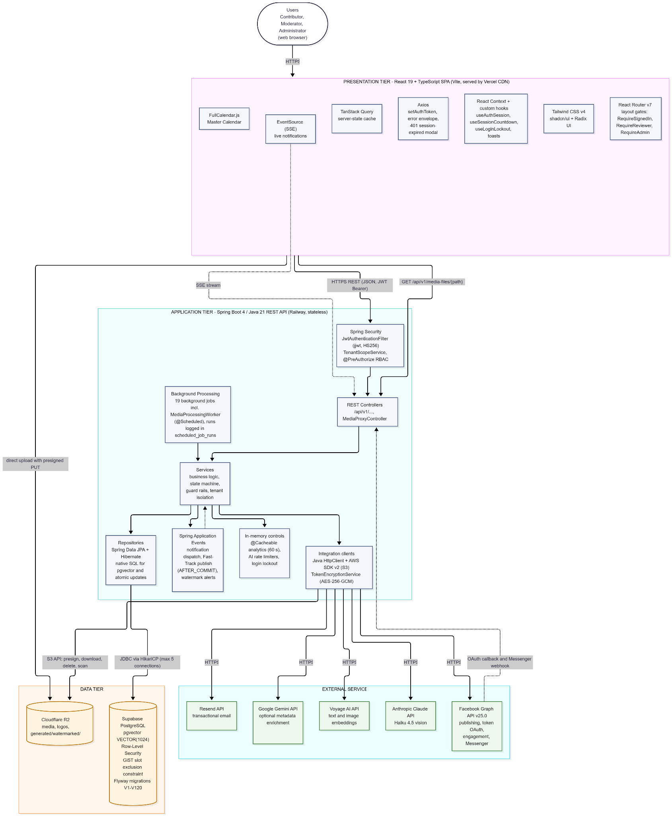
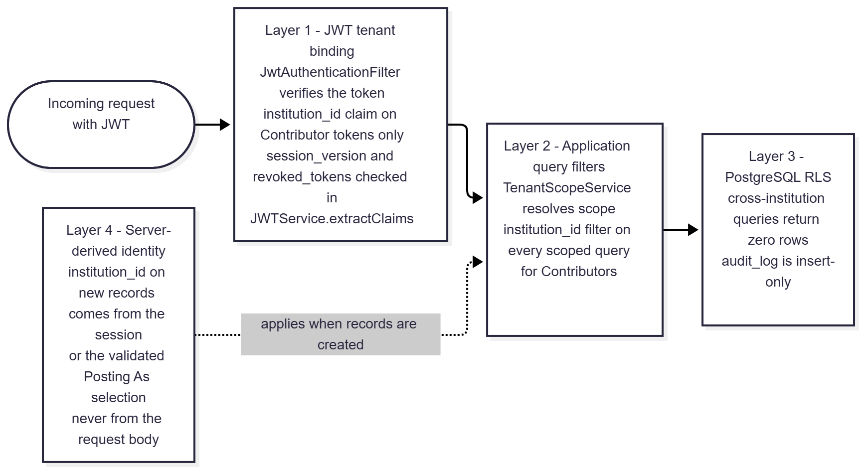

Security Architecture Overview
Tenant isolation is enforced through four complementary layers ensuring no cross-institution data leakage:
- JWT-Based Tenant Binding — institution_id is embedded as a verified claim in every Contributor token; Moderator and Administrator tokens carry no institution_id (network-wide). The claim is verified and attached to the request context by JwtAuthenticationFilter before any controller logic executes. Every token also carries session_version; revoked or outdated tokens are rejected inside JWTService.extractClaims (backed by revoked_tokens and users.session_version).
- Application Query Filters — TenantScopeService resolves the caller's scope; every institution-scoped query applies the institution_id filter for Contributors.
- PostgreSQL RLS — Database-level policies return zero rows for cross-institution queries and make audit_log insert-only.
- Server-Derived Identity — institution_id on new records is always set from the authenticated session (or, for Moderators/Administrators, from the validated "Posting As" selection), never trusted from the request body.

Additional controls: BCrypt password hashing, a 12-character password policy, 5-attempt/15-minute account lockout, AES-256-GCM encryption of Facebook Page tokens (TokenEncryptionService), HMAC-signed stateless OAuth state, formula-injection-safe CSV exports, and secrets supplied only through Railway environment variables.

3. Detailed Design

1. Module 1
Module 1 establishes the system foundation: secure user authentication with role-based routing, institution workspace provisioning, invitation-based onboarding for all three roles, and the three-step post composer with integrated AI caption, writing-check, template, media, and scheduling tools.

1.1. Administrator Account Management

1.1.1. User Interface Design
Admin Management Screen (/admin/admin-management)
A table listing all Administrator accounts with name, email, status badge (PENDING, PENDING_EMAIL_UNDELIVERED, ACTIVE, INACTIVE, EXPIRED, CANCELLED), and an "Admin Owner" tag on the single owner account. An "Invite Administrator" action is available to any Administrator while the combined Admin cap (active Admins + outstanding Admin invitations + pending promotions ≤ 3) is not reached. Deactivate, Reactivate, Delete, Erase, Demote, and Transfer Admin Owner actions are rendered only for the Admin Owner; peer Administrators see them disabled. Pending Administrator invitations appear in a separate card with Resend and Cancel actions.
Invite Administrator Dialog
An email chip input with a Send Invitation button. On success the dialog closes with a toast and the account appears with PENDING status. A cap violation returns an inline error directing the actor to remove or transfer an existing Administrator first.
Change Role / Promote Dialog
Opened from User Management on an ACTIVE Moderator or Contributor. Proposing a promotion to Administrator creates a pending request; the target's role does not change until they confirm. Demotion of an Administrator (Admin Owner only) is immediate; demotion to Contributor requires selecting an active institution.
Promotion and Owner-Transfer Confirmation Prompts
Shown to the target user on their next session when a pending promotion (72-hour expiry) or Admin Owner transfer (24-hour expiry) exists, with Confirm and Decline actions.
Invitation Accept Page (/invite?token=…)
A public route shared by all invitation flows. Validates the token, then displays a password setup form (New Password, Confirm Password) with live per-rule validation of the 12-character password policy. Submit stays disabled until all rules pass.

1.1.2. Front-end Component(s)
AdministratorManagementScreen
- Lists Administrators via GET /users/admins and pending Admin invitations via GET /invitations/pending/admins. Renders owner-only actions from User.adminOwner in the authenticated profile (GET /me).
- React functional component / Admin route (RequireAdmin)

InvitationComposer / EmailChipsInput
- Controlled form submitting POST /invitations with role = admin and no institution. Shows inline cap and conflict errors.
- React functional component

ChangeRoleModal / ConfirmDialog
- Submits PATCH /users/{id}/role (propose promotion or demote), PATCH /users/{id}/status (deactivate/reactivate), DELETE /users/{id} (delete), POST /users/{id}/erase, POST /users/{id}/admin-transfer, and DELETE /users/{id}/promotion (cancel proposal).
- React functional components

Promotion / Transfer Confirmation
- Calls POST /users/promotion/confirm, POST /users/promotion/decline, and POST /users/admin-transfer/confirm.
- React functional component rendered in the authenticated shell

InviteScreen
- Public route validating via GET /invitations/validate?token=… and activating via POST /invitations/accept. Shared across all three roles.
- React functional component

1.1.3. Back-end Component(s)
InvitationController
- POST /invitations (Admin/Moderator; role-gated per caller), GET /invitations/validate, POST /invitations/accept, POST /invitations/{id}/resend, DELETE /invitations/{id} (cancel), GET /invitations/pending/admins (Admin).
- Spring @RestController

UserController
- GET /users/admins, PATCH /users/{id}/status, PATCH /users/{id}/role, DELETE /users/{id}, POST /users/{id}/erase, POST /users/{id}/admin-transfer, POST /users/admin-transfer/confirm, POST /users/promotion/confirm|decline, DELETE /users/{id}/promotion.
- Spring @RestController

InvitationService
- Generates a 32-byte CSPRNG token (72-hour validity), stores only its SHA-256 hash, reuses PENDING / PENDING_EMAIL_UNDELIVERED / CANCELLED / EXPIRED account rows, rejects ACTIVE and INACTIVE targets (INACTIVE must be reactivated), supersedes older open tokens, and re-checks the Admin cap (app.admins.max, default 3) at both invite and accept.
- Spring @Service

UserService
- Implements deactivate/reactivate (cap-checked, no exclusions), footprint-aware delete (USER_REMOVED anonymized row vs. hard delete), erase (USER_ANONYMIZED), propose/confirm/decline/cancel promotion through one unified pending-promotion record (pending_promotion_role = admin or moderator; Admin cap re-checked at confirm via AdminCapPolicy; sessions revoked), demotion, and Admin Owner transfer (to another ACTIVE Administrator only — a non-Administrator target is rejected with 400; on confirmation the flag moves and both accounts remain Administrators). Self-targeting is rejected for every action. Owner-only checks use JwtUserDetails.adminOwner().
- Spring @Service

JWTService
- Account-wide session revocation by incrementing users.session_version on deactivate, role change, and promotion confirmation.
- Spring @Service

AuditLogService / EmailService / NotificationService
- Records INVITATION_ACCEPTED, USER_STATUS_UPDATED, USER_ROLE_CHANGED, USER_REMOVED, USER_ANONYMIZED, ADMIN_TRANSFER_REQUESTED, ADMIN_TRANSFER_CONFIRMED, and ADMIN_PROMOTION_* events; dispatches activation email via Resend; notifies promotion targets and proposers.
- Spring @Service

UserRepository / InvitationTokenRepository
- Spring @Repository extending JpaRepository<User, UUID> / JpaRepository<InvitationToken, UUID>

1.1.4. Object-Oriented Component(s)
- Class Diagram
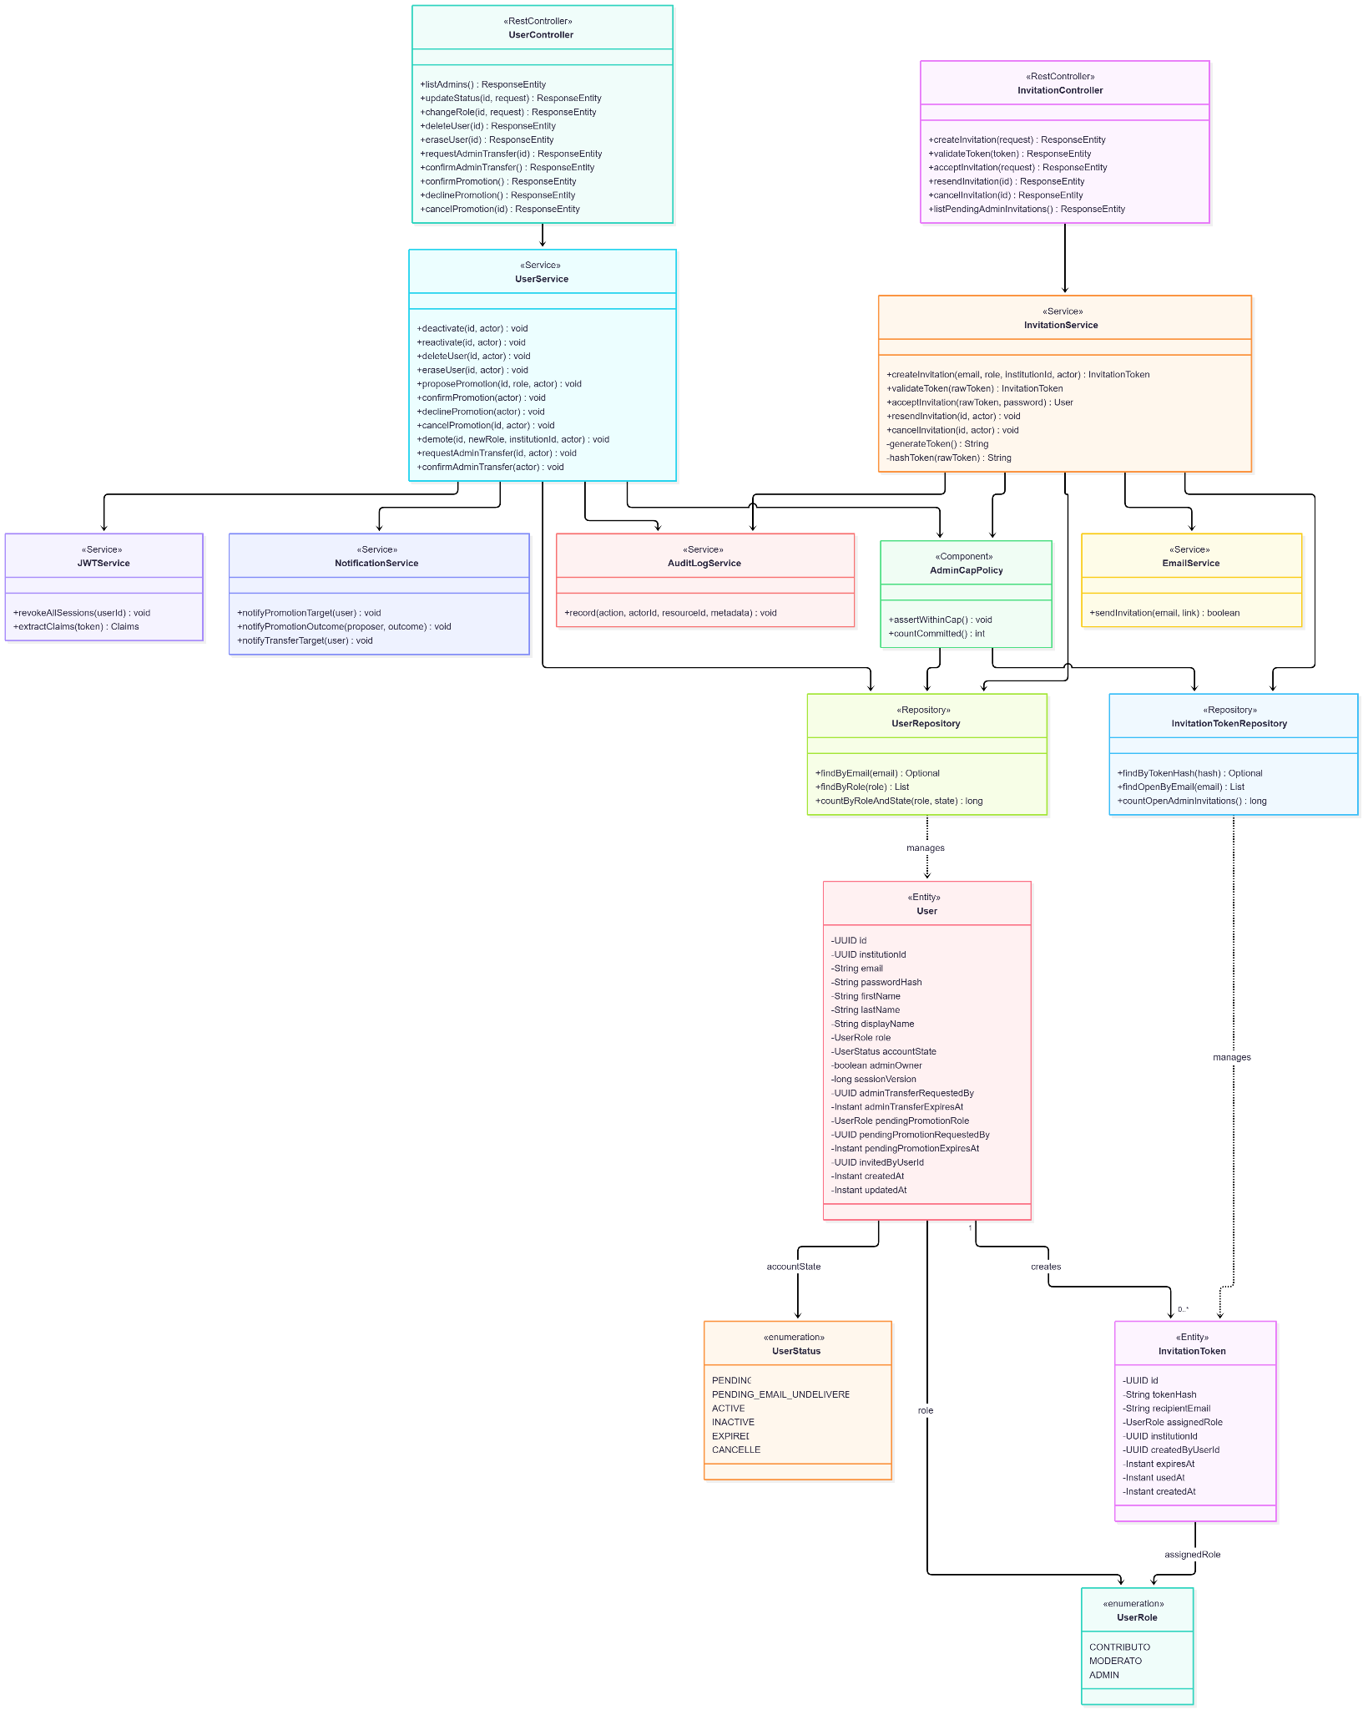
- Sequence Diagram
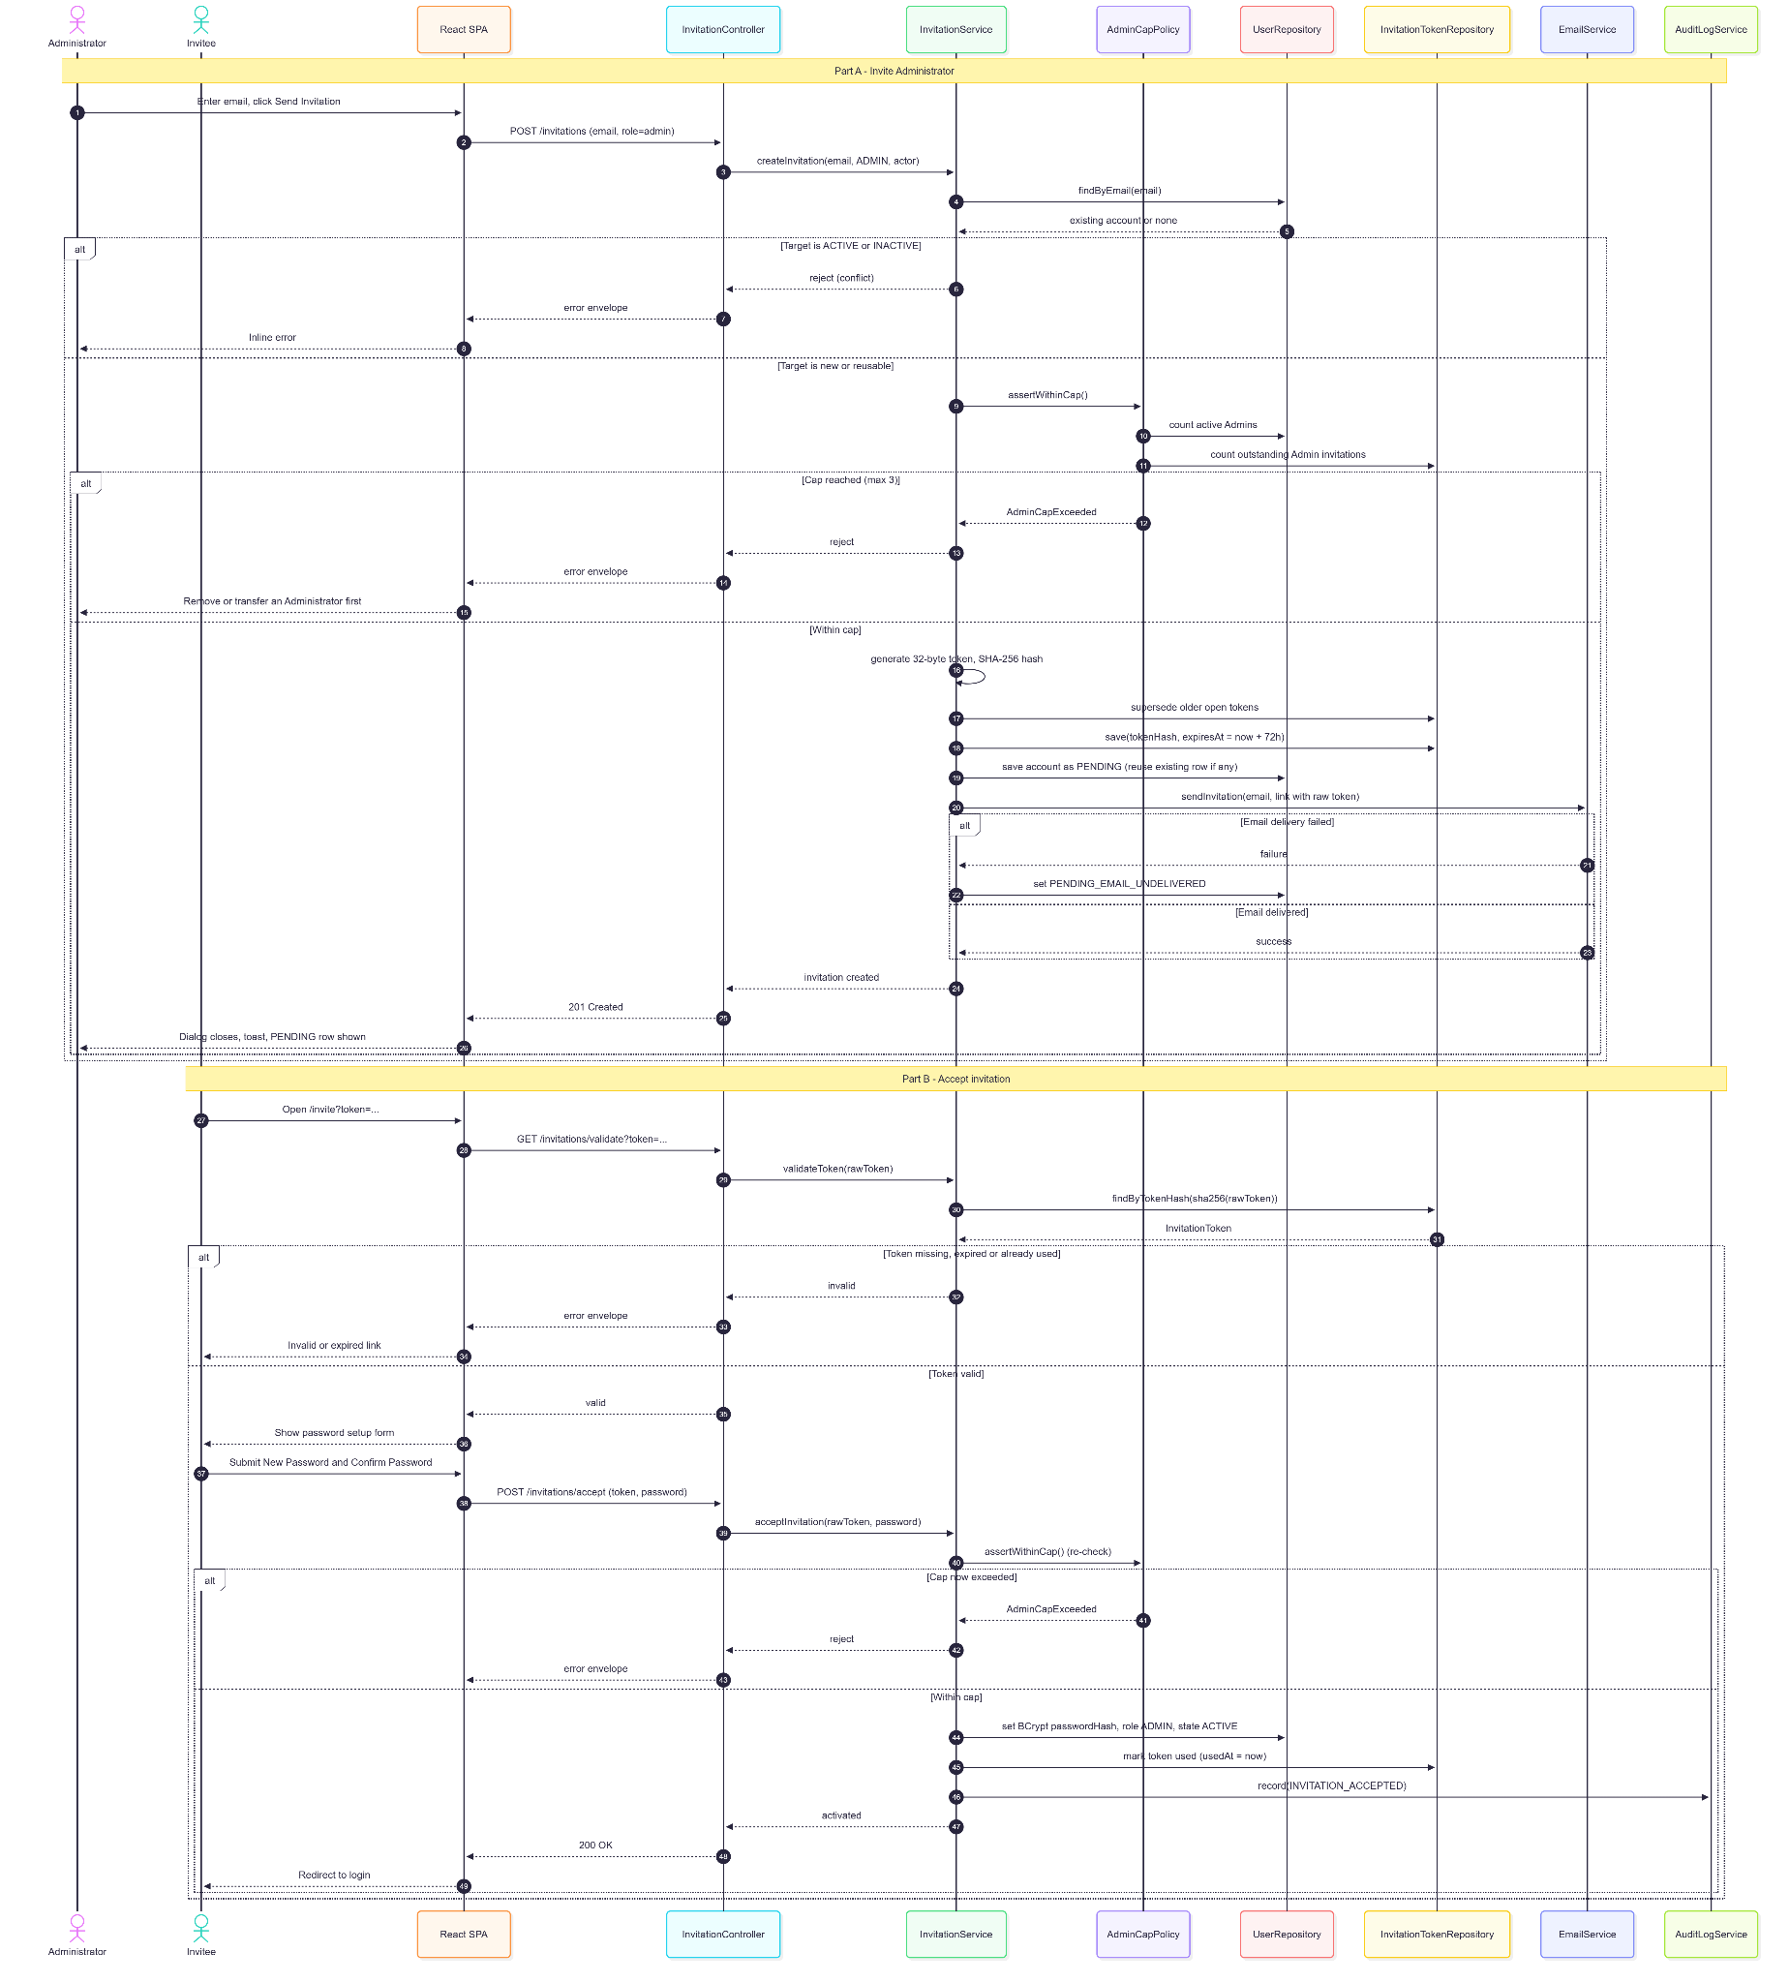

1.1.5. Data Design
- Entity Relationship Diagram
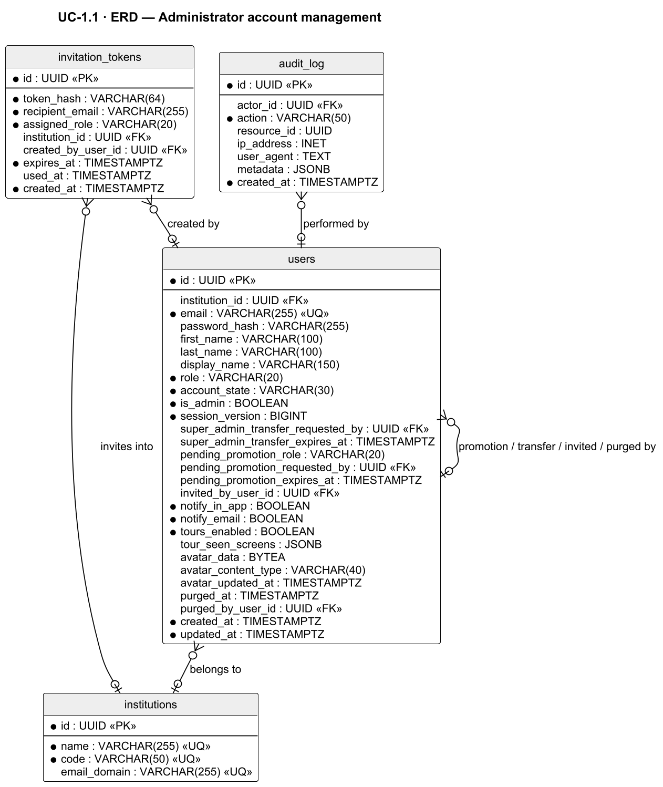

- Schema

-- users table (all roles)
CREATE TABLE users (
id UUID PRIMARY KEY DEFAULT gen_random_uuid(),
institution_id UUID REFERENCES institutions(id), -- NULL for moderator/admin
email VARCHAR(255) UNIQUE NOT NULL,
password_hash VARCHAR(255), -- NULL until activated
first_name VARCHAR(100),
last_name VARCHAR(100),
display_name VARCHAR(150),
role VARCHAR(20) NOT NULL
CHECK (role IN ('contributor', 'moderator', 'admin')),
account_state VARCHAR(30) NOT NULL DEFAULT 'pending'
CHECK (account_state IN ('pending', 'pending_email_undelivered',
'active', 'expired', 'inactive', 'cancelled')),
is_admin BOOLEAN NOT NULL DEFAULT FALSE, -- Admin Owner flag
session_version BIGINT NOT NULL DEFAULT 0, -- account-wide revocation
super_admin_transfer_requested_by UUID REFERENCES users(id), -- pending Admin Owner transfer
super_admin_transfer_expires_at TIMESTAMPTZ,
pending_promotion_role VARCHAR(20) -- 'admin' | 'moderator' (V118/V119)
CHECK (pending_promotion_role IN ('admin', 'moderator')),
pending_promotion_requested_by UUID REFERENCES users(id), -- proposing Administrator
pending_promotion_expires_at TIMESTAMPTZ, -- 72-hour confirmation window
invited_by_user_id UUID REFERENCES users(id),
notify_in_app BOOLEAN NOT NULL DEFAULT TRUE,
notify_email BOOLEAN NOT NULL DEFAULT TRUE,
tours_enabled BOOLEAN NOT NULL DEFAULT TRUE,
tour_seen_screens JSONB,
avatar_data BYTEA,
avatar_content_type VARCHAR(40),
avatar_updated_at TIMESTAMPTZ,
purged_at TIMESTAMPTZ, -- anonymization marker
purged_by_user_id UUID REFERENCES users(id),
created_at TIMESTAMPTZ NOT NULL DEFAULT NOW(),
updated_at TIMESTAMPTZ NOT NULL DEFAULT NOW()
);

-- Exactly one active Admin Owner at a time (V79)
CREATE UNIQUE INDEX idx_users_single_active_admin_owner ON users ((role))
WHERE role = 'admin' AND account_state = 'active' AND is_admin = TRUE; -- exactly one active Admin Owner

-- Invitation tokens (one-time activation links, all roles)
CREATE TABLE invitation_tokens (
id UUID PRIMARY KEY DEFAULT gen_random_uuid(),
token_hash VARCHAR(64) NOT NULL, -- SHA-256 of raw CSPRNG token
recipient_email VARCHAR(255) NOT NULL,
assigned_role VARCHAR(20) NOT NULL
CHECK (assigned_role IN ('contributor', 'moderator', 'admin')),
institution_id UUID REFERENCES institutions(id), -- required only for contributor
created_by_user_id UUID REFERENCES users(id), -- scopes Moderator invitation management
expires_at TIMESTAMPTZ NOT NULL, -- 72 hours from generation
used_at TIMESTAMPTZ,
created_at TIMESTAMPTZ NOT NULL DEFAULT NOW()
);
Related tables used by this use case:
-- audit_log (defined in UC-3.6)
CREATE TABLE audit_log (
id UUID PRIMARY KEY DEFAULT gen_random_uuid(),
actor_id UUID REFERENCES users(id),
action VARCHAR(50) NOT NULL,
resource_id UUID,
ip_address INET,
user_agent TEXT,
metadata JSONB,
created_at TIMESTAMPTZ NOT NULL DEFAULT NOW()
);

1.2. Institution Management

1.2.1. User Interface Design
Institution Management Screen (/institution-management)
A table of registered institutions with Name, Code, Status badge (Active / Inactive), logo, and Contributor count, plus summary counts by status. Administrators see a "Register Institution" button and per-row actions (Edit, Upload Logo, Deactivate/Reactivate, Delete, Reassign Users). Moderators see the same list in read-only form with no action controls. The protected default institution "DASIG Central Visayas" shows Deactivate and Delete disabled with an explanatory tooltip.
Register / Edit Institution Modal
Fields: Institution Name, Institution Code (unique), and Email Domain. Inline errors are shown for a duplicate code or email domain when registering, and for a name or email domain already used by another institution when editing.
Deactivate Confirmation
Blocked while Contributors remain assigned or invitations to the institution are still pending; the dialog directs the Administrator to reassign the Contributors (or resolve the invitations) first.
Permanent Delete Confirmation
Requires typing the institution's code. Blocked for the protected institution, any institution with PENDING/PENDING_EMAIL_UNDELIVERED/ACTIVE Contributors, any submission history, or any non-deleted media.
Reassign User
From User Management, an Administrator moves a Contributor to another ACTIVE institution; historical submissions stay attributed to the original institution.

1.2.2. Front-end Component(s)
InstitutionManagementScreen
- Fetches GET /institutions and GET /institutions/summary-counts; hosts create/edit/deactivate/reactivate/delete dialogs. Role-aware rendering (Admin vs. Moderator read-only).
- React functional component / Reviewer route (RequireReviewer)

Institution Logo Upload
- PUT /institutions/{id}/logo (multipart); logos are served by GET /institutions/{id}/logo.
- React functional component

Reassign Action (User Management)
- PATCH /users/{id}/institution.
- React functional component

1.2.3. Back-end Component(s)
InstitutionController
- POST /institutions (Admin), GET /institutions, GET /institutions/{id}, GET /institutions/summary-counts, GET /institutions/public (unauthenticated list used by public pages), PUT /institutions/{id} (Admin), PATCH /institutions/{id}/deactivate|reactivate (Admin), DELETE /institutions/{id} (Admin, code confirmation), PUT/GET /institutions/{id}/logo, PATCH /institutions/{id}/ai-media-hybrid-ranking (Admin). Class-level @PreAuthorize("hasAnyRole('ADMIN','MODERATOR')"); write endpoints are Admin-only.
- Spring @RestController

InstitutionService
- Validates uniqueness of code and email domain on create, and of name and email domain on edit; enforces protected-institution rules; blocks deactivation while Contributors are assigned or invitations to the institution are pending; performs eligibility-checked permanent deletion (cleans tokens, reservations, page settings, watermark configurations, soft-deleted media and albums, then best-effort R2 purge after commit) and writes INSTITUTION_DELETED.
- Spring @Service

WorkspaceProvisionerService
- Provisions the institution workspace (default page settings and media library scoping) on creation; RLS policies are defined once in Flyway migrations and key off institution_id.
- Spring @Service

UserService
- Reassigns a Contributor's institution_id to an ACTIVE target institution.
- Spring @Service

InstitutionRepository / AuditLogService
- Spring @Repository extending JpaRepository<Institution, UUID>; audit entries for create, edit, deactivate, reactivate, delete, and reassignment.

1.2.4. Object-Oriented Component(s)
- Class Diagram

- Sequence Diagram
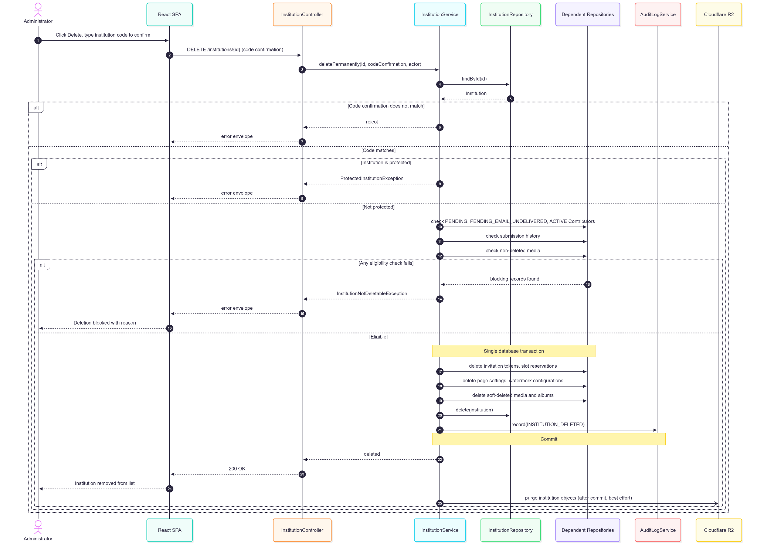
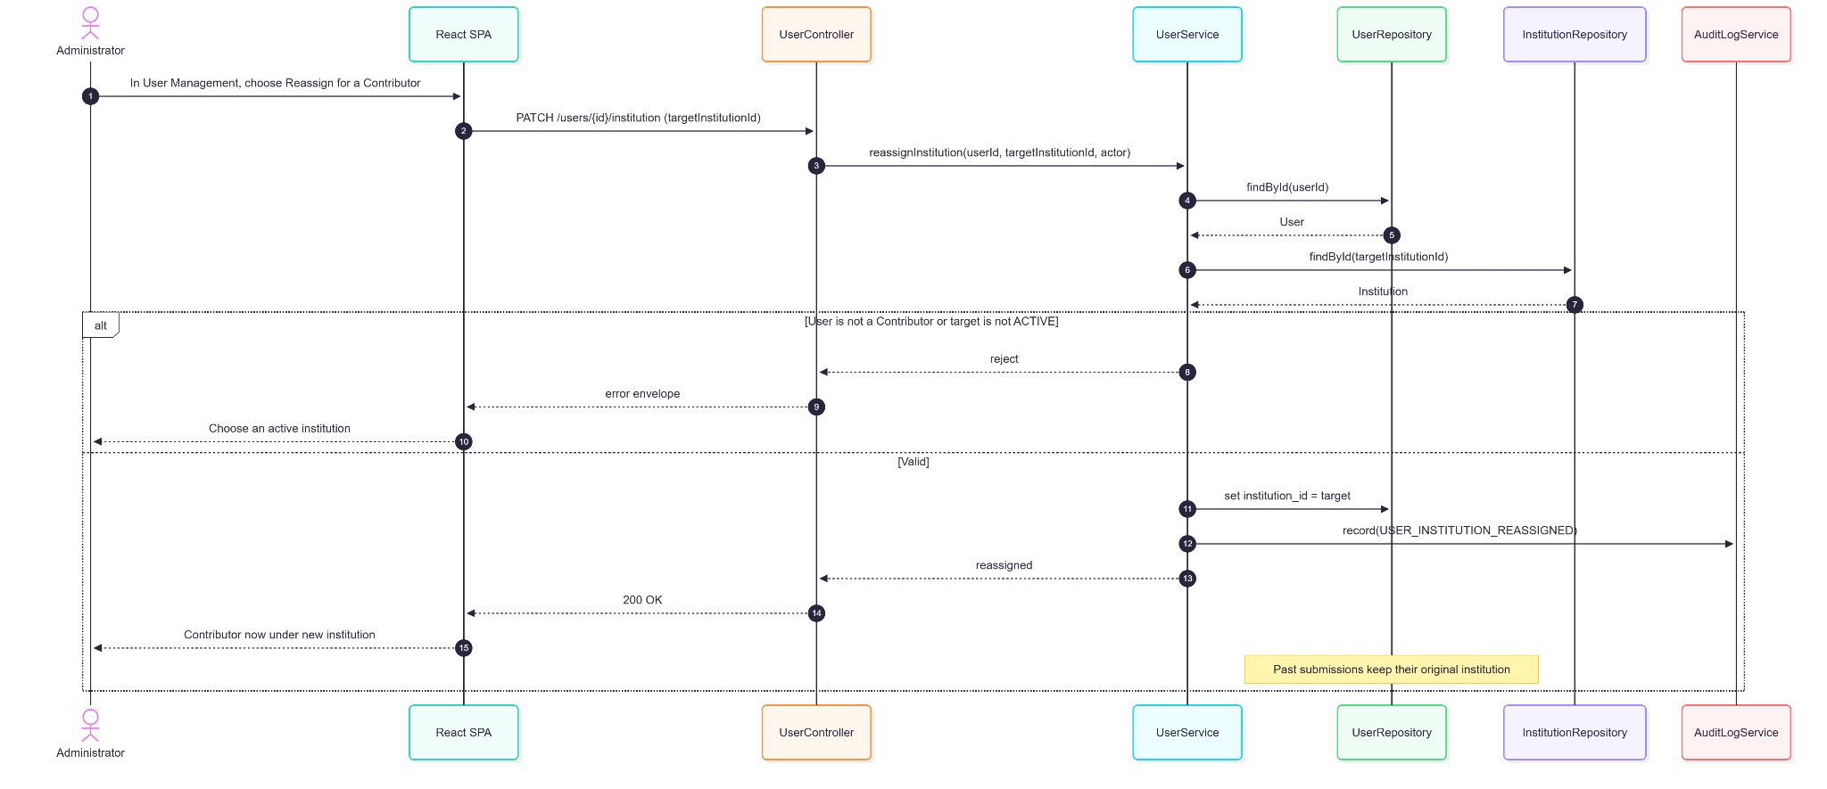

1.2.5. Data Design
- Entity Relationship Diagram
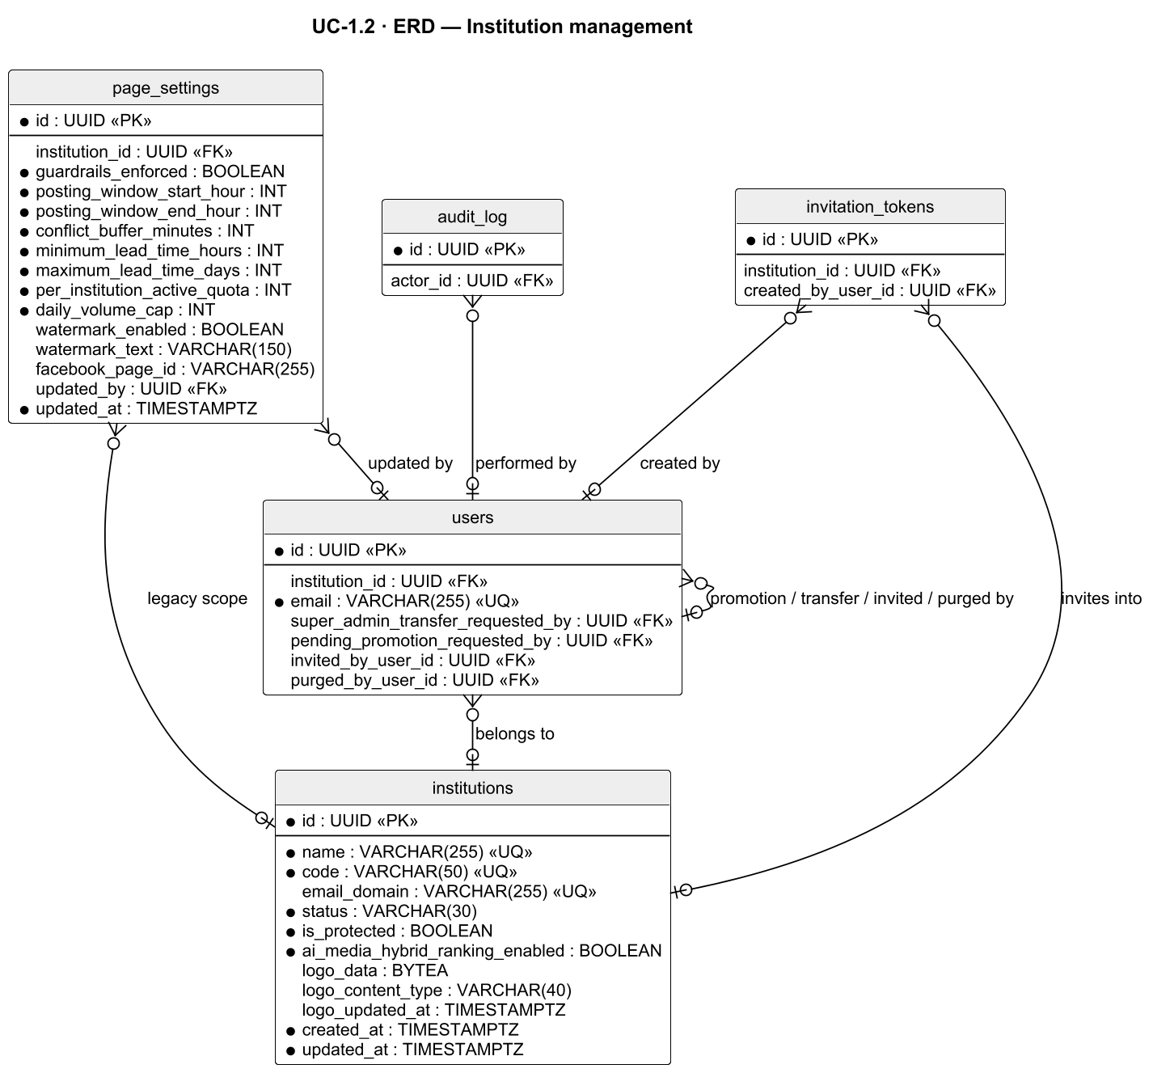
- Schema

CREATE TABLE institutions (
id UUID PRIMARY KEY DEFAULT gen_random_uuid(),
name VARCHAR(255) UNIQUE NOT NULL,
code VARCHAR(50) UNIQUE NOT NULL, -- e.g. CITU
email_domain VARCHAR(255) UNIQUE,
status VARCHAR(30) NOT NULL DEFAULT 'active'
CHECK (status IN ('pending', 'active', 'inactive')),
is_protected BOOLEAN NOT NULL DEFAULT FALSE,
ai_media_hybrid_ranking_enabled BOOLEAN NOT NULL DEFAULT FALSE,
logo_data BYTEA,
logo_content_type VARCHAR(40),
logo_updated_at TIMESTAMPTZ,
created_at TIMESTAMPTZ NOT NULL DEFAULT NOW(),
updated_at TIMESTAMPTZ NOT NULL DEFAULT NOW()
);

-- Seed (initial deployment)
INSERT INTO institutions (name, code, status, is_protected)
VALUES ('DASIG Central Visayas', 'DASIG-CENTRAL', 'active', TRUE);

-- RLS pattern (applied in Flyway to each institution-scoped table)
ALTER TABLE submissions ENABLE ROW LEVEL SECURITY;
CREATE POLICY institution_isolation ON submissions
USING (institution_id = current_setting('app.current_institution_id', true)::UUID
OR current_setting('app.current_role', true) IN ('moderator', 'admin'));
Related tables used by this use case:
-- page_settings (defined in UC-1.4)
CREATE TABLE page_settings (
id UUID PRIMARY KEY DEFAULT gen_random_uuid(),
institution_id UUID REFERENCES institutions(id),
guardrails_enforced BOOLEAN NOT NULL DEFAULT TRUE,
posting_window_start_hour INT NOT NULL DEFAULT 8, -- GR-H4 window start (Asia/Manila, V116)
posting_window_end_hour INT NOT NULL DEFAULT 20, -- GR-H4 window end (exclusive)
conflict_buffer_minutes INT NOT NULL DEFAULT 30, -- GR-H1 (V121)
minimum_lead_time_hours INT NOT NULL DEFAULT 2, -- GR-H2 (V121)
maximum_lead_time_days INT NOT NULL DEFAULT 30, -- GR-H3 (V121)
per_institution_active_quota INT NOT NULL DEFAULT 3, -- GR-S1 (V122)
daily_volume_cap INT NOT NULL DEFAULT 6, -- GR-S2 (V122)
watermark_enabled BOOLEAN,
watermark_text VARCHAR(150),
facebook_page_id VARCHAR(255),
updated_by UUID REFERENCES users(id),
updated_at TIMESTAMPTZ NOT NULL DEFAULT NOW()
);

1.3. Contributor Account Management

1.3.1. User Interface Design
User Invitations Screen and User Management Screen (/admin/user-management)
Institution-grouped cards listing Contributor accounts (name, email, status badge, last activity) with a pending-invitations card and a delivery-issues alert for PENDING_EMAIL_UNDELIVERED accounts. "Invite Contributor" opens the invitation composer, where the actor selects an ACTIVE target institution and enters one or more emails. Administrators see Deactivate/Reactivate/Delete/Erase/Change Role actions; Moderators see only Resend, Cancel, and Delete on invitations they personally sent.
Reissue Invitation Confirmation
A confirmation dialog for EXPIRED, CANCELLED, PENDING, or PENDING_EMAIL_UNDELIVERED accounts that issues a fresh 72-hour token and invalidates the previous one.
Invitation Accept Page (/invite?token=…) — shared with UC-1.1.

1.3.2. Front-end Component(s)
UserInvitationsScreen / UserManagementScreen
- Fetches GET /users, GET /users/counts, GET /invitations/pending, GET /invitations/pending/count. Hosts InstitutionUsersCard, PendingInvitationsCard, DeliveryIssuesAlert, ActionMenu.
- React functional component / Reviewer route

InvitationComposer
- Submits POST /invitations with role = contributor and institutionId. A Moderator may only choose the Contributor role.
- React functional component

PendingInvitationsCard
- POST /invitations/{id}/resend, DELETE /invitations/{id} (cancel), DELETE /invitations/by-user/{userId} (Admin).
- React functional component

1.3.3. Back-end Component(s)
InvitationController — shared with UC-1.1; Moderator access to resend/cancel/delete is restricted in InvitationService to tokens whose created_by_user_id is the caller.
UserController
- PATCH /users/{id}/status (Admin), DELETE /users/{id} (Admin any; Moderator only for a CANCELLED/EXPIRED Contributor they invited), POST /users/{id}/erase (Admin Owner), PATCH /users/{id}/role (proposal to Moderator/Administrator).
- Spring @RestController

InvitationService
- Rejects invitations to INACTIVE institutions (BR-ACC-01), rejects re-invitation of ACTIVE or INACTIVE accounts, binds the token to the institution (a mismatched token returns a generic invalid-token error).
- Spring @Service

UserService
- Footprint-aware delete: any submission, media upload, validation log, created album, or audit entry keeps the row as an anonymized inactive record (USER_REMOVED); only footprint-free accounts are hard-deleted.
- Spring @Service

AuditLogService / EmailService — as in UC-1.1.

1.3.4. Object-Oriented Component(s)
- Class Diagram
- Sequence Diagram
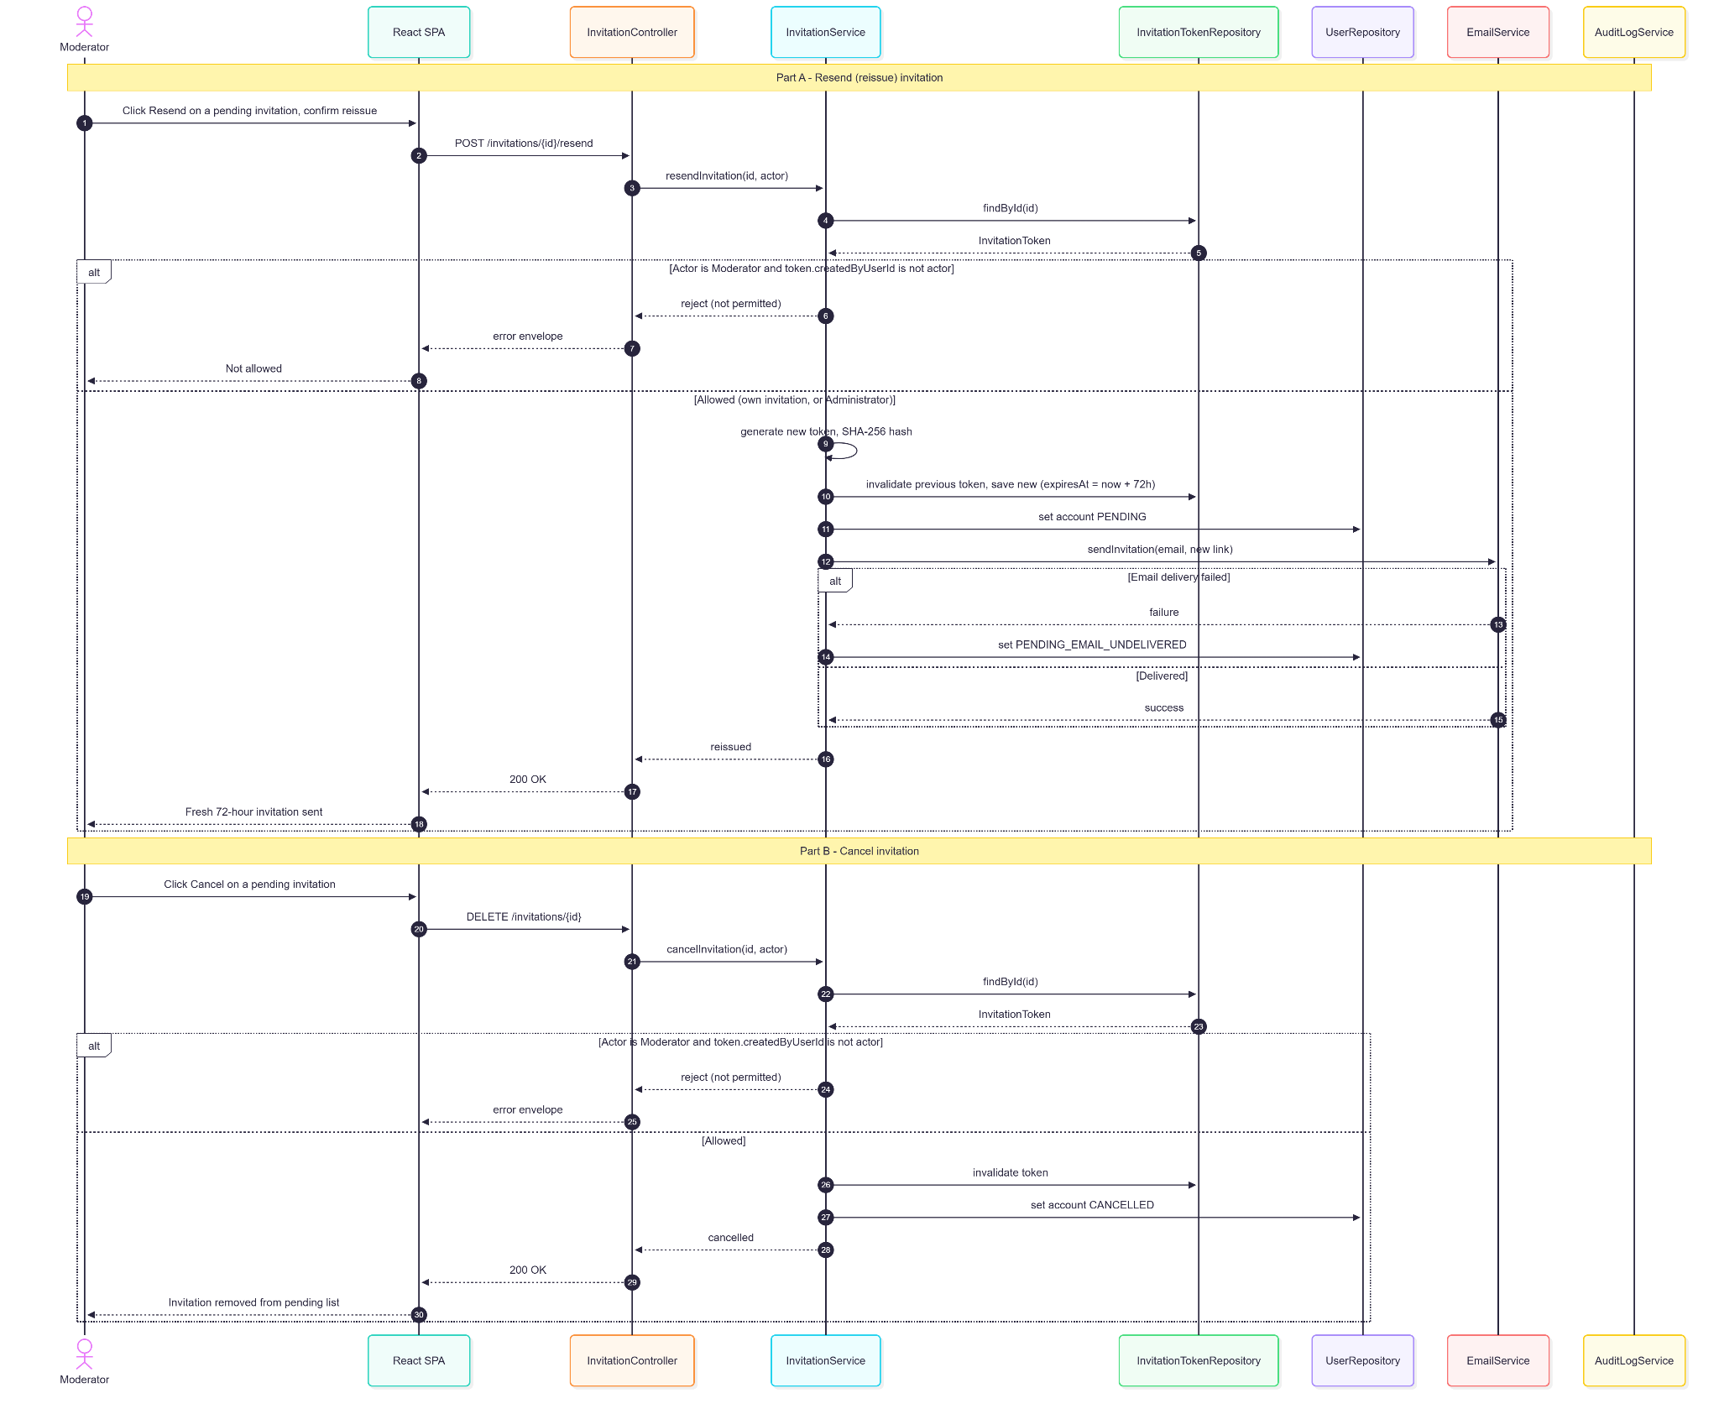
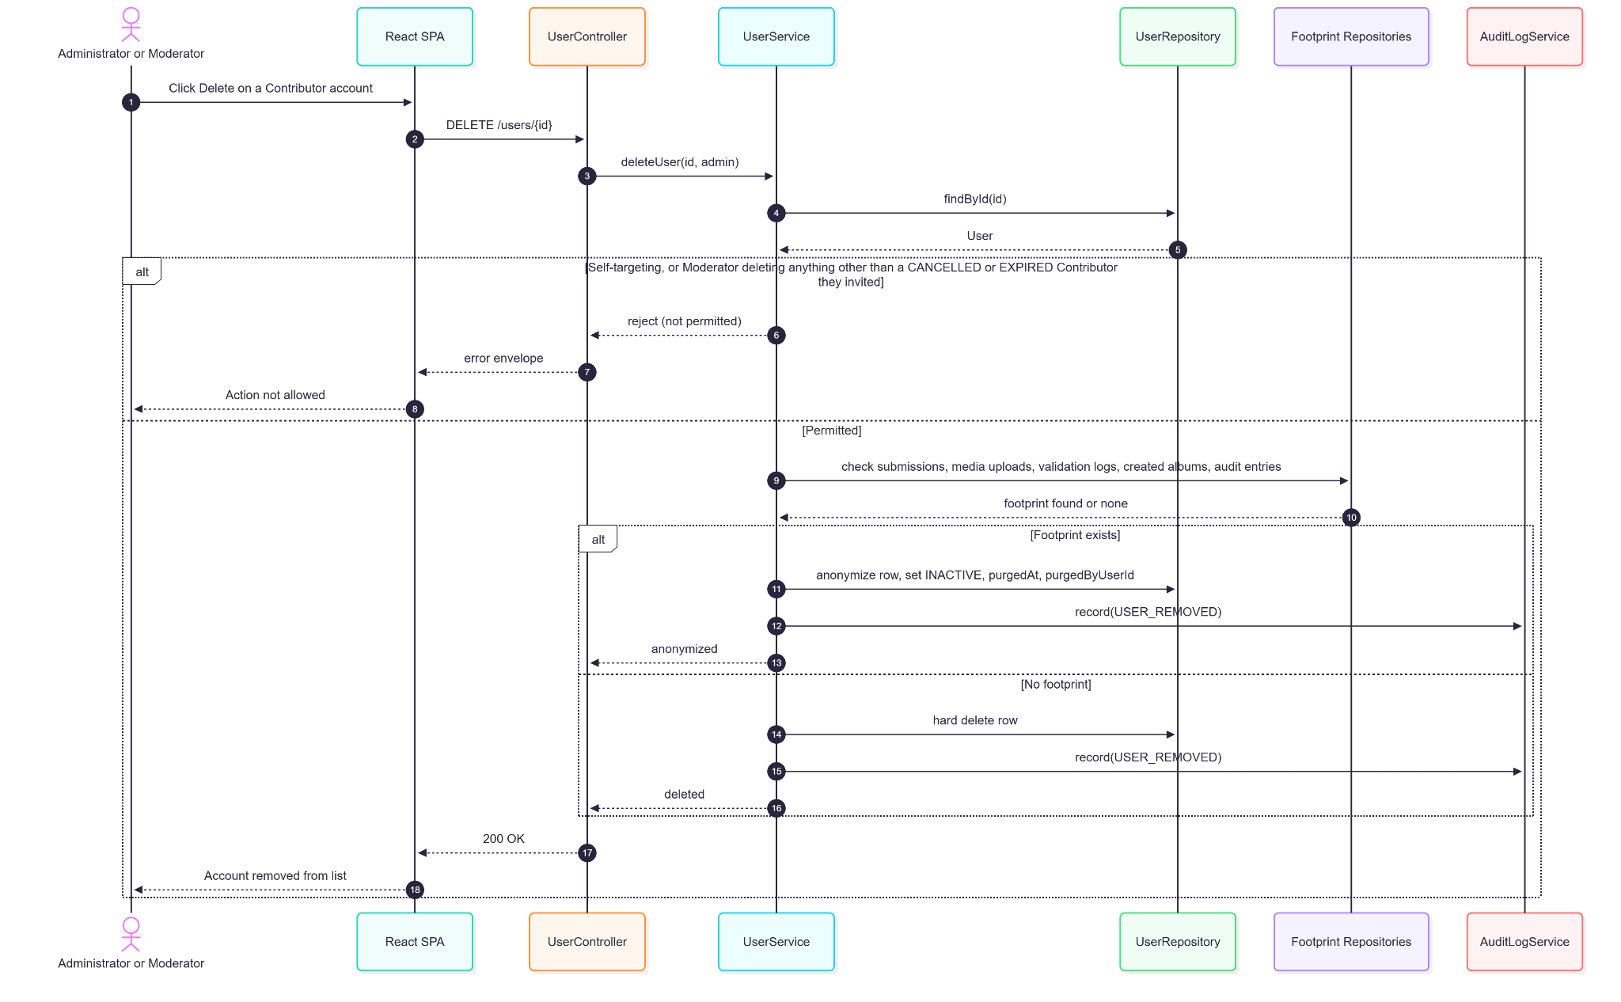

1.3.5. Data Design
- Entity Relationship Diagram
- Schema
-- users (columns used by Contributor account management)
CREATE TABLE users (
id UUID PRIMARY KEY DEFAULT gen_random_uuid(),
institution_id UUID REFERENCES institutions(id), -- required for contributors
email VARCHAR(255) UNIQUE NOT NULL,
password_hash VARCHAR(255), -- NULL until activated
first_name VARCHAR(100),
last_name VARCHAR(100),
display_name VARCHAR(150),
role VARCHAR(20) NOT NULL
CHECK (role IN ('contributor', 'moderator', 'admin')),
account_state VARCHAR(30) NOT NULL DEFAULT 'pending',
session_version BIGINT NOT NULL DEFAULT 0, -- incremented on deactivation / role change
pending_promotion_role VARCHAR(20) -- proposed Moderator or Administrator promotion
CHECK (pending_promotion_role IN ('admin', 'moderator')),
pending_promotion_requested_by UUID REFERENCES users(id),
pending_promotion_expires_at TIMESTAMPTZ, -- 72-hour confirmation window
invited_by_user_id UUID REFERENCES users(id),
purged_at TIMESTAMPTZ, -- set when anonymized (delete/erase)
purged_by_user_id UUID REFERENCES users(id),
created_at TIMESTAMPTZ NOT NULL DEFAULT NOW(),
updated_at TIMESTAMPTZ NOT NULL DEFAULT NOW()
);

CREATE TABLE invitation_tokens (
id UUID PRIMARY KEY DEFAULT gen_random_uuid(),
token_hash VARCHAR(64) NOT NULL, -- SHA-256 of raw token
recipient_email VARCHAR(255) NOT NULL,
assigned_role VARCHAR(20) NOT NULL
CHECK (assigned_role IN ('contributor', 'moderator', 'admin')),
institution_id UUID REFERENCES institutions(id), -- required for contributor invitations
created_by_user_id UUID REFERENCES users(id), -- scopes Moderator resend/cancel/delete
expires_at TIMESTAMPTZ NOT NULL, -- 72 hours from generation
used_at TIMESTAMPTZ,
created_at TIMESTAMPTZ NOT NULL DEFAULT NOW()
);

CREATE INDEX idx_users_email ON users(email);
CREATE INDEX idx_users_institution ON users(institution_id);
CREATE INDEX idx_invitation_tokens_hash ON invitation_tokens(token_hash);
CREATE INDEX idx_invitation_tokens_institution ON invitation_tokens(institution_id);
CREATE INDEX idx_invitation_tokens_created_by ON invitation_tokens(created_by_user_id);

1.4. Login & Session Management

1.4.1. User Interface Design
Login Page (/login)
A centered card with email, password (show/hide toggle), and a Log In button. Invalid credentials show a generic error. After 5 failed attempts the form is replaced by a lockout banner with the remaining duration (15 minutes). A "Forgot password?" link sits below the form. PENDING, EXPIRED, and INACTIVE accounts receive state-specific messages.
Forgot / Reset Password Pages (/forgot-password, /forgot-password-sent, /reset-password)
An email input with a neutral confirmation regardless of account existence; the reset page enforces the password policy with live per-rule feedback.
Account Settings Screen (/settings)
Tabs for Personal Settings (all roles: display name, avatar, password change, notification channel preferences, onboarding-guide toggle and reset, and — for Moderators and Administrators only — Facebook Messenger linking) and Page Settings (Administrators only: guard-rail enforcement switch and the guard-rail thresholds — conflict buffer, minimum and maximum lead time, posting-window hours, per-institution quota, daily cap — Facebook Page token management, Watermark Configuration, UC-2.5).
Link Messenger (Personal Settings)
Generates a 10-minute link code that the user sends to the DASIG Facebook Page in Messenger; the panel then shows the linked state with an Unlink action.
Session Warning Banner
Shown during the final five minutes of the JWT lifetime with "Stay Logged In" (opens the re-login modal) and "Dismiss" (hides the banner only).
Session Expired Modal
Opened at countdown zero or on a session-related 401. The user re-enters email and password; a successful re-login issues a new JWT, reloads /me, clears authenticated query caches, and restarts the countdown.

1.4.2. Front-end Component(s)
LoginScreen / ForgotScreen / ForgotSentScreen / ResetPasswordScreen / NoAccountScreen
- Submit POST /auth/login, POST /auth/forgot-password, POST /auth/reset-password.
- React functional components / public routes

useAuthSession / useLoginLockout / useSessionCountdown / usePasswordResetFlow
- Session restore from stored token and GET /me, login with lockout feedback, JWT exp countdown, session-expired modal, invite activation, and sign-out (POST /auth/logout).
- React custom hooks

RouteGates (RequireSignedIn, RequireReviewer, RequireAdmin) / ProtectedRoute
- Layout-route gates in App.tsx; unauthorized roles see ForbiddenPage.
- React functional components

DashboardShell (navigation)
- Shows Admin Management, User Management, System Health, Audit Log, and Page Settings only to Administrators; Institution Management and Review Queue to Moderators and Administrators; Dashboard, Submissions, Calendar, Media Repository, Notifications, Analytics, and Settings to all roles.
- React layout component

AccountSettingsScreen
- PATCH /me/settings, PATCH /me/tour-preferences, POST /auth/change-password, PUT /users/{id}/avatar, Messenger panel (GET/POST/DELETE /integrations/messenger/connection[/link-code]), and Page Settings (GET/PUT /settings/page).
- React functional component

1.4.3. Back-end Component(s)
AuthController
- POST /auth/login (validate credentials and account state, issue an 8-hour JWT), POST /auth/logout (revoke this token only), POST /auth/refresh (authenticated; not currently called by the frontend).
- Spring @RestController

PasswordController / PasswordService / PasswordPolicy
- POST /auth/forgot-password (neutral response; 1-hour single-use reset token), POST /auth/reset-password (increments session_version, invalidating all sessions), POST /auth/change-password (requires current password; other sessions unaffected). Policy: ≥12 characters, upper and lower case, digit, special character, no whitespace, no common fragments, no email/name.
- Spring @RestController / @Service

JWTService
- HS256 tokens embedding user ID, role, institution_id (Contributors only), Admin Owner flag, and session_version. extractClaims rejects tokens present in revoked_tokens or older than the user's current session_version, so revocation survives restarts and spans instances.
- Spring @Service

JwtAuthenticationFilter / TenantScopeService
- Authenticates each request and resolves the tenant scope used by services.
- Spring Security filter / @Service

AccountLockoutService
- Tracks failed attempts in account_lockouts; locks for 15 minutes after 5 failures (login returns 401 "Account temporarily locked" with the remaining time; no lockout email is sent).
- Spring @Service

MessengerConnectionController / MessengerWebhookController / MessengerConnectionService / MessengerWebhookService
- Issues hashed 10-minute link codes; the Meta webhook (GET/POST /integrations/messenger/webhook) verifies a code sent to the Page and binds the sender's Page-scoped ID (page_scoped_user_id) to the user. Restricted to Moderators and Administrators.
- Spring @RestController / @Service

UserController
- GET /me, PATCH /me/settings, PATCH /me/tour-preferences.
- Spring @RestController

PageSettingsController / GuardRailSettingsService
- GET/PUT /settings/page (Admin) toggles the network-wide guardrails_enforced switch and sets every guard-rail threshold: conflict buffer (default 30 min), minimum lead time (2 h), maximum lead time (30 days), posting window (8–20), per-institution active quota (3), and daily volume cap (6), all read through GuardRailSettingsService. Page Settings changes are not written to the audit log.
- Spring @RestController / @Service

RevokedTokenCleanupJob
- Hourly removal of expired revoked-token rows.
- Spring @Scheduled

1.4.4. Object-Oriented Component(s)
- Class Diagram
- Sequence Diagram
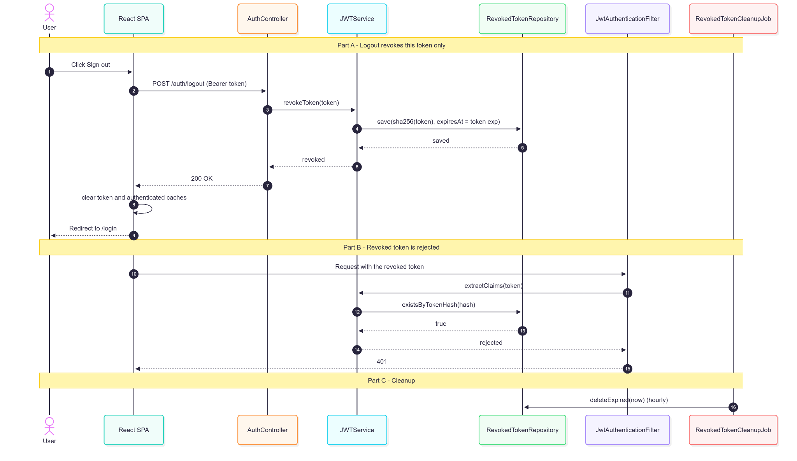

1.4.5. Data Design
- Entity Relationship Diagram
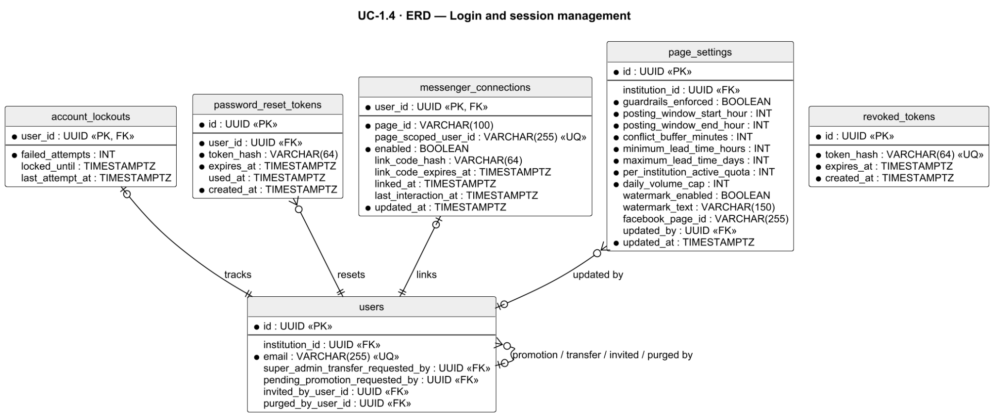
- Schema

CREATE TABLE account_lockouts (
user_id UUID PRIMARY KEY REFERENCES users(id),
failed_attempts INT NOT NULL DEFAULT 0,
locked_until TIMESTAMPTZ,
last_attempt_at TIMESTAMPTZ
);

CREATE TABLE password_reset_tokens (
id UUID PRIMARY KEY DEFAULT gen_random_uuid(),
user_id UUID NOT NULL REFERENCES users(id),
token_hash VARCHAR(64) NOT NULL,
expires_at TIMESTAMPTZ NOT NULL, -- 1 hour
used_at TIMESTAMPTZ,
created_at TIMESTAMPTZ NOT NULL DEFAULT NOW()
);

-- Single-token logout revocation (DB-backed, survives restarts)
CREATE TABLE revoked_tokens (
id UUID PRIMARY KEY DEFAULT gen_random_uuid(),
token_hash VARCHAR(64) UNIQUE NOT NULL,
expires_at TIMESTAMPTZ NOT NULL,
created_at TIMESTAMPTZ NOT NULL DEFAULT NOW()
);

-- Facebook Messenger notification linking (Moderator/Admin)
CREATE TABLE messenger_connections (
user_id UUID PRIMARY KEY REFERENCES users(id) ON DELETE CASCADE,
page_id VARCHAR(100) NOT NULL,
page_scoped_user_id VARCHAR(255) UNIQUE, -- Messenger PSID once linked
enabled BOOLEAN NOT NULL DEFAULT FALSE,
link_code_hash VARCHAR(64),
link_code_expires_at TIMESTAMPTZ, -- 10 minutes
linked_at TIMESTAMPTZ,
last_interaction_at TIMESTAMPTZ,
updated_at TIMESTAMPTZ NOT NULL DEFAULT NOW()
);

-- Network-wide page settings (guard-rail switch and thresholds)
CREATE TABLE page_settings (
id UUID PRIMARY KEY DEFAULT gen_random_uuid(),
institution_id UUID REFERENCES institutions(id), -- legacy, unused
guardrails_enforced BOOLEAN NOT NULL DEFAULT TRUE,
posting_window_start_hour INT NOT NULL DEFAULT 8, -- GR-H4 window start (Asia/Manila, V116)
posting_window_end_hour INT NOT NULL DEFAULT 20, -- GR-H4 window end (exclusive)
conflict_buffer_minutes INT NOT NULL DEFAULT 30, -- GR-H1 (V121)
minimum_lead_time_hours INT NOT NULL DEFAULT 2, -- GR-H2 (V121)
maximum_lead_time_days INT NOT NULL DEFAULT 30, -- GR-H3 (V121)
per_institution_active_quota INT NOT NULL DEFAULT 3, -- GR-S1 (V122)
daily_volume_cap INT NOT NULL DEFAULT 6, -- GR-S2 (V122)
watermark_enabled BOOLEAN, -- legacy, superseded by UC-2.5
watermark_text VARCHAR(150), -- legacy
facebook_page_id VARCHAR(255), -- legacy, unused
updated_by UUID REFERENCES users(id),
updated_at TIMESTAMPTZ NOT NULL DEFAULT NOW()
);

1.5. Post Drafting & Templates

1.5.1. User Interface Design
Submissions List (/submissions)
A server-paginated list of the actor's submissions with filter tabs: Drafts, Action Needed, Submitted, Published, Rejected, Failed, All. Each card shows the media thumbnail, event title, status badge, and last-updated time. A "New Post" button opens the composer; an optional onboarding guide explains the list.
Composer Wizard (/submissions/new, /submissions/:submissionId)
A three-step wizard — Media → Post Details → Organize & Schedule — with a step indicator, Next/Back navigation (forward gated by the step's Required items; Back always enabled), and a persistent Save as Draft button. Once a draft exists, changes autosave after a short delay. The desktop layout is two columns (form + Readiness panel); at ≤900 px the Readiness panel opens as a bottom sheet from a score chip and the Submit/Save Draft bar is sticky.
Step 2 — Post Details
"Posting As" institution selector (Moderators and Administrators; defaults to DASIG Central Visayas), Event Title, Event Date, and Caption (3,000-character limit, live counter). The caption action row contains Suggest Caption, Templates, Fancy text, and Check writing; an empty caption shows a "Need a head start?" starter. Hashtag pills insert into the caption.
Post Templates Panel
Opened from the Templates button (a right-hand drawer on desktop, a bottom sheet on small screens). Pinned header actions: Generate from Top Posts and Save current caption. Filters: All / Built-in / My templates. Applying a template requires at least one attached media item, replaces the caption, records the template, and clears current tags.
Readiness Checklist Panel
A live score out of 100 (Required 75%, Recommended 25%) with grade and dial; each row jumps to the relevant step/field. Required: title, date, caption, ≥1 media, file requirements, album, valid schedule (Standard). Recommended: caption length, ≥1 hashtag, ≥1 media tag, ≥1 per-media caption, template used or skipped.
Facebook Preview
A persistent toggle showing an in-page Facebook-style preview of caption, media carousel, and hashtags.
Revision Feedback
A needs_revision submission reopens with reviewer remarks parsed into per-field comments (pulsing fields, "mark addressed"); a rejected submission shows the reason with "Edit & Resubmit".

1.5.2. Front-end Component(s)
SubmissionListScreen
- GET /submissions/page (server pagination, bucket counts), DELETE /submissions/{id} (draft/rejected), POST /submissions/{id}/withdraw.
- React functional component / Signed-in route

SubmissionScreen
- Wizard state, readiness computation, autosave, dirty-state navigation guard; GET /submissions/lookups (institutions, guard-rail switch), POST /submissions, PATCH /submissions/{id}, GET /submissions/{id}.
- React functional component

StepProgress / SharedPrimitives / CalendarDateField / TimePickerField
- Step indicator and form primitives.

Templates Panel (renderTemplatesPanel) / TopPostTemplateModal
- GET /post-templates, POST /post-templates, DELETE /post-templates/{id}, POST /ai/templates/from-top-posts. Built-in templates are frontend constants.

InPageFacebookPreview / SubmissionReadOnlyView / SubmissionCardMedia
- Preview and read-only rendering.

RevisionFeedbackBanner / RevisionFeedbackModal
- Per-field reviewer remarks.

SpotlightTour
- Contextual, view-only onboarding guides (submission list, composer, Save Draft); preferences persisted via PATCH /me/tour-preferences.

(AI caption, Fancy Text, and Check writing components are detailed in UC-1.6; media components in UC-1.7; scheduling components in UC-1.8.)

1.5.3. Back-end Component(s)
SubmissionController
- GET /submissions/lookups, GET /submissions, GET /submissions/page, POST /submissions (create draft), GET /submissions/{id}, PATCH /submissions/{id} (update draft), DELETE /submissions/{id} (draft or rejected only).
- Spring @RestController

SubmissionService
- Draft lifecycle; server-derived institution_id (Contributor) or validated Posting-As institution (Moderator/Admin); caption limit MAX_CAPTION_CHARS = 3000 (code points; 400 on create/update); submissions and templates no longer carry a category (V120); deletion removes slot reservations, purges orphaned draft uploads, and writes SUBMISSION_DELETED.
- Spring @Service

PostTemplateController / PostTemplateService
- Personal, owner-scoped templates (GET, POST, DELETE /post-templates).
- Spring @RestController / @Service

AiTemplateController / TopPostTemplateService
- POST /ai/templates/from-top-posts: ranks the Page's last 100 posts by reactions + 2×comments + 3×shares, sends the top 6 (with bottom 3 as contrast) to Claude, returns a draft-only placeholder template; refuses below 8 engaged posts; 10 requests/hour/user.
- Spring @RestController / @Service

UserController
- PATCH /me/tour-preferences for onboarding-guide state.

SubmissionRepository / AuditLogService
- Spring @Repository extending JpaRepository<Submission, UUID>; audit entries for creation, deletion, and withdrawal.

1.5.4. Object-Oriented Component(s)
- Class Diagram
- Sequence Diagram

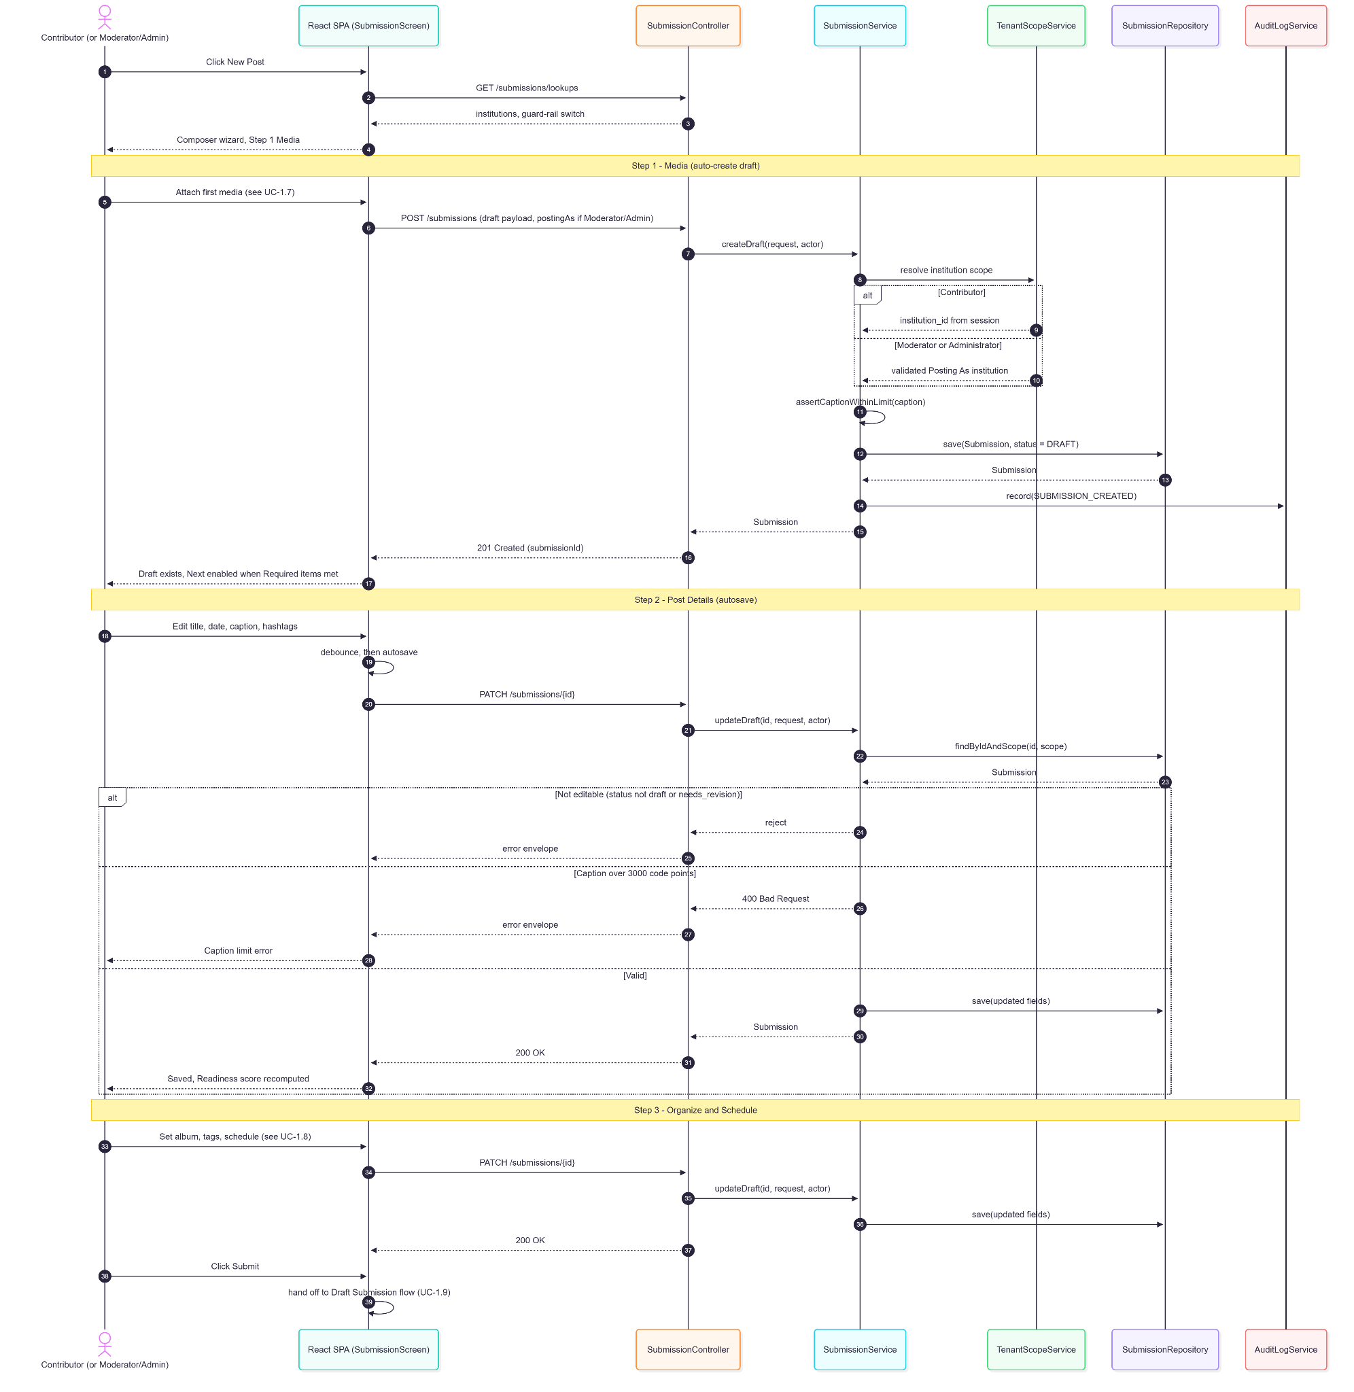
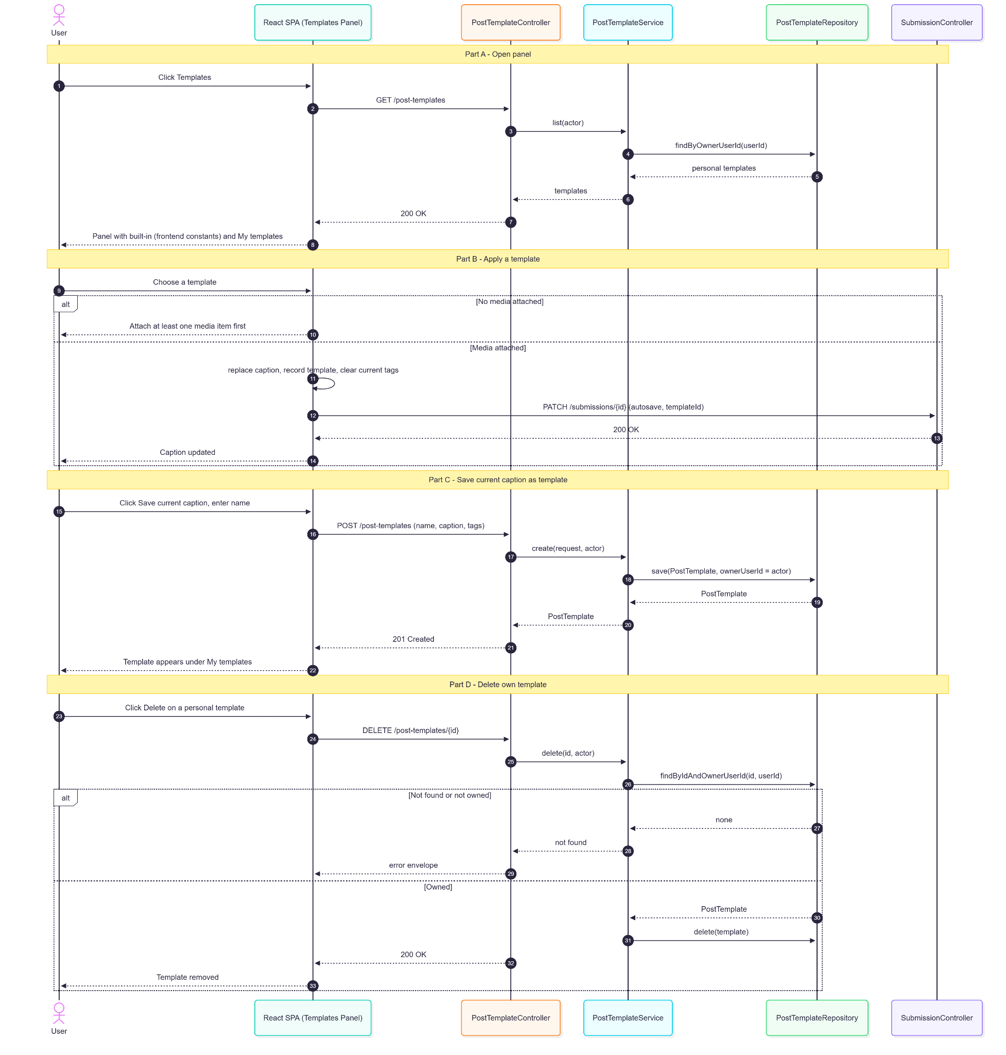

1.5.5. Data Design
- Entity Relationship Diagram
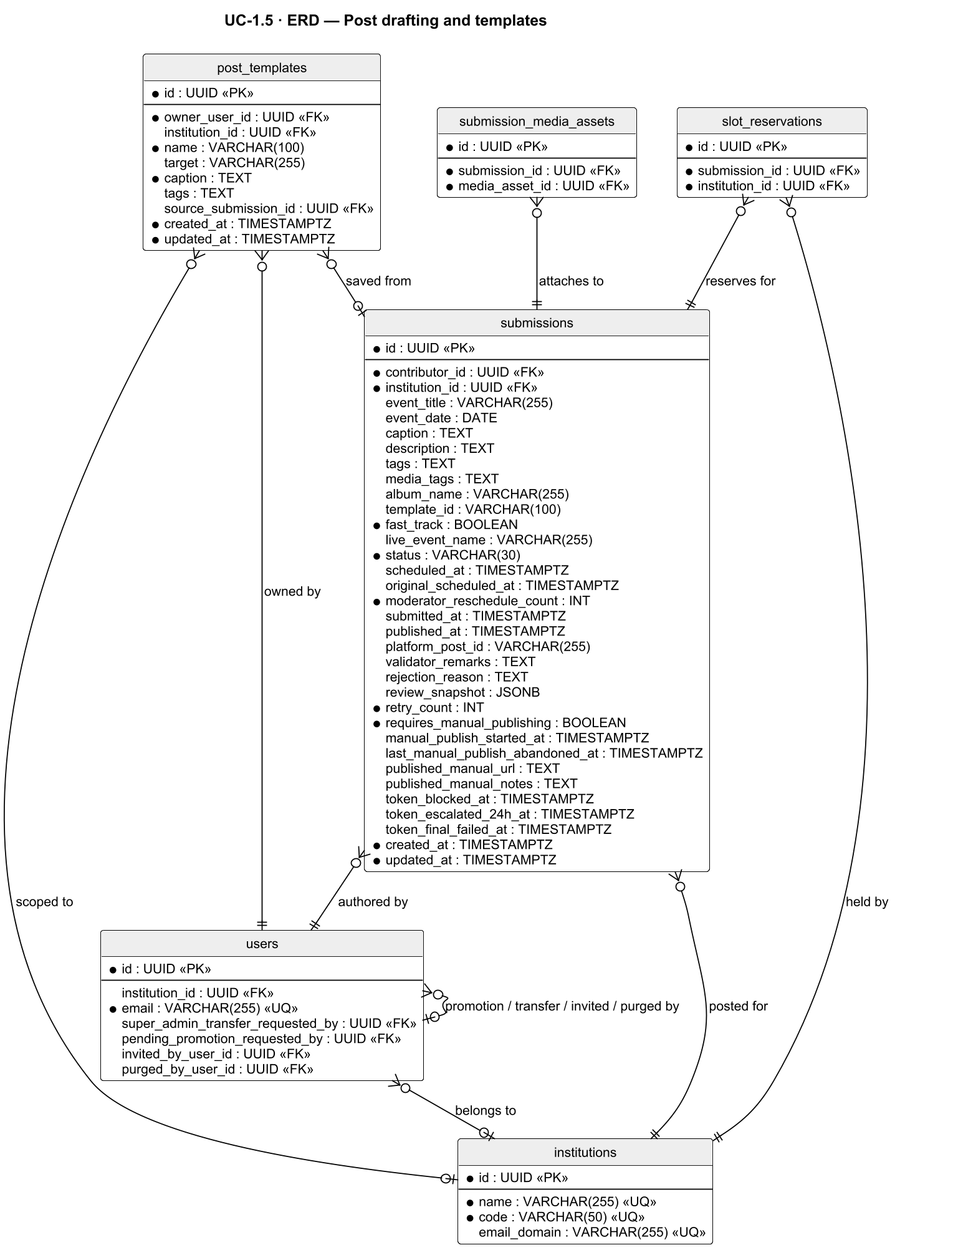
- Schema

CREATE TABLE submissions (
id UUID PRIMARY KEY DEFAULT gen_random_uuid(),
contributor_id UUID NOT NULL REFERENCES users(id),
institution_id UUID NOT NULL REFERENCES institutions(id),
event_title VARCHAR(255),
event_date DATE,
caption TEXT, -- ≤ 3000 code points
description TEXT,
tags TEXT, -- hashtags
media_tags TEXT,
album_name VARCHAR(255),
template_id VARCHAR(100),
fast_track BOOLEAN NOT NULL DEFAULT FALSE,
live_event_name VARCHAR(255),
status VARCHAR(30) NOT NULL DEFAULT 'draft'
CHECK (status IN ('draft', 'pending', 'in_review', 'needs_revision',
'missed_review', 'scheduled', 'publishing', 'publish_failed',
'published', 'published_manual', 'admin_direct_post',
'direct_post_scheduled', 'direct_post_publishing',
'direct_post_failed', 'rejected')),
scheduled_at TIMESTAMPTZ,
original_scheduled_at TIMESTAMPTZ, -- snapshot at approval (UC-3.1 A1)
moderator_reschedule_count INT NOT NULL DEFAULT 0,
submitted_at TIMESTAMPTZ,
published_at TIMESTAMPTZ,
platform_post_id VARCHAR(255),
validator_remarks TEXT, -- revision remarks
rejection_reason TEXT,
review_snapshot JSONB, -- original values for Restore original (UC-2.4)
retry_count INT NOT NULL DEFAULT 0,
requires_manual_publishing BOOLEAN NOT NULL DEFAULT FALSE,
manual_publish_started_at TIMESTAMPTZ,
last_manual_publish_abandoned_at TIMESTAMPTZ,
published_manual_url TEXT,
published_manual_notes TEXT,
token_blocked_at TIMESTAMPTZ,
token_escalated_24h_at TIMESTAMPTZ,
token_final_failed_at TIMESTAMPTZ,
created_at TIMESTAMPTZ NOT NULL DEFAULT NOW(),
updated_at TIMESTAMPTZ NOT NULL DEFAULT NOW()
);

-- Personal post templates (built-in templates are frontend constants)
CREATE TABLE post_templates (
id UUID PRIMARY KEY DEFAULT gen_random_uuid(),
owner_user_id UUID NOT NULL REFERENCES users(id),
institution_id UUID REFERENCES institutions(id),
name VARCHAR(100) NOT NULL,
target VARCHAR(255),
caption TEXT NOT NULL,
tags TEXT,
source_submission_id UUID REFERENCES submissions(id),
created_at TIMESTAMPTZ NOT NULL DEFAULT NOW(),
updated_at TIMESTAMPTZ NOT NULL DEFAULT NOW()
);

1.6. AI & Text Tools Integration

1.6.1. User Interface Design
Suggest Caption (caption action row)
Opens a prompt dialog with an optional instruction field (280-character limit; Generate disabled past it) and a tone selector — Professional (default), Community, Energetic. Generation proceeds when there is an attached image, an existing caption, or a typed prompt. A loading state is shown during the request.
Caption Suggestion
Displays one caption in the selected tone with Insert, Regenerate, Edit, and Dismiss actions. Error states: timeout (30 s, retry available), AI unavailable (auto-recovers after ~5 s), and rate-limited (shows reset time, 30 requests/hour).
Fancy Text Panel
A button-opened panel (not triggered by text selection) previewing the selected caption text in Bold Serif, Italic Serif, Bold Sans-Serif, Italic Sans-Serif, and Script, plus Plain (revert). Characters without a Unicode equivalent pass through unchanged.
Check Writing
Disabled when the caption is empty. Returns advisory spelling, grammar, clarity, and meaning-change suggestions, each with Apply and Dismiss. Never blocks editing, saving, or submission. Also available in the reviewer edit form (UC-2.4), where it runs automatically after a caption edit and reports only problems the edit introduced.

1.6.2. Front-end Component(s)
AiCaptionButton / AiCaptionPromptDialog / AiCaptionSuggestion / useAiCaptionAssist
- Submits POST /ai/caption (auto-saving the draft first if needed); logs outcomes best-effort to POST /ai/caption/log (use, use_then_edited, dismiss, re_generate, tone).
- React functional components / hook

FancyTextTool
- Pure client-side Unicode mapping; respects CAPTION_CHAR_LIMIT = 3000.
- React functional component

Check Writing panel
- POST /ai/proofread; applied suggestions reported to POST /ai/proofread/applied for adoption analytics.
- React functional component

1.6.3. Back-end Component(s)
CaptionController
- POST /ai/caption, POST /ai/caption/log. 30 requests per rolling hour per user (in-memory limiter → 429 with reset headers); 280-character prompt cap (400).
- Spring @RestController

CaptionGenerationService
- Builds the prompt from up to 4 images, media metadata, event title/date/institution, existing caption, instruction, and tone; detects instruction-vs-draft-refine intent; parses a requested word count (largest number, MAX_REQUESTED_CAPTION_WORDS = 2000) and retries up to 3 times to satisfy a requested range. Submission category is not part of the prompt.
- Spring @Service

ClaudeVisionClient
- Java HttpClient wrapper for the Anthropic Messages API (claude-haiku-4-5); base64-encodes images, downscales images > 5 MB in memory (70% → 50% → 35% → 25% → 15%), 30-second timeout (504), service errors (503). Legacy read fallback for old images on the private Supabase bucket via DASIG_SUPABASE_SERVICE_ROLE_KEY.
- Spring @Component

ProofreadController / ProofreadService
- POST /ai/proofread (30/hour/user, suggestions only), POST /ai/proofread/applied.
- Spring @RestController / @Service

AiAdoptionTrackingService / AiInteractionLogRepository
- Persists caption and proofreading interaction events to ai_interaction_log for AI Feature Adoption analytics (UC-3.4).
- Spring @Service / @Repository

(Fancy Text is a client-side transformation — no back-end component.)

1.6.4. Object-Oriented Component(s)
- Class Diagram
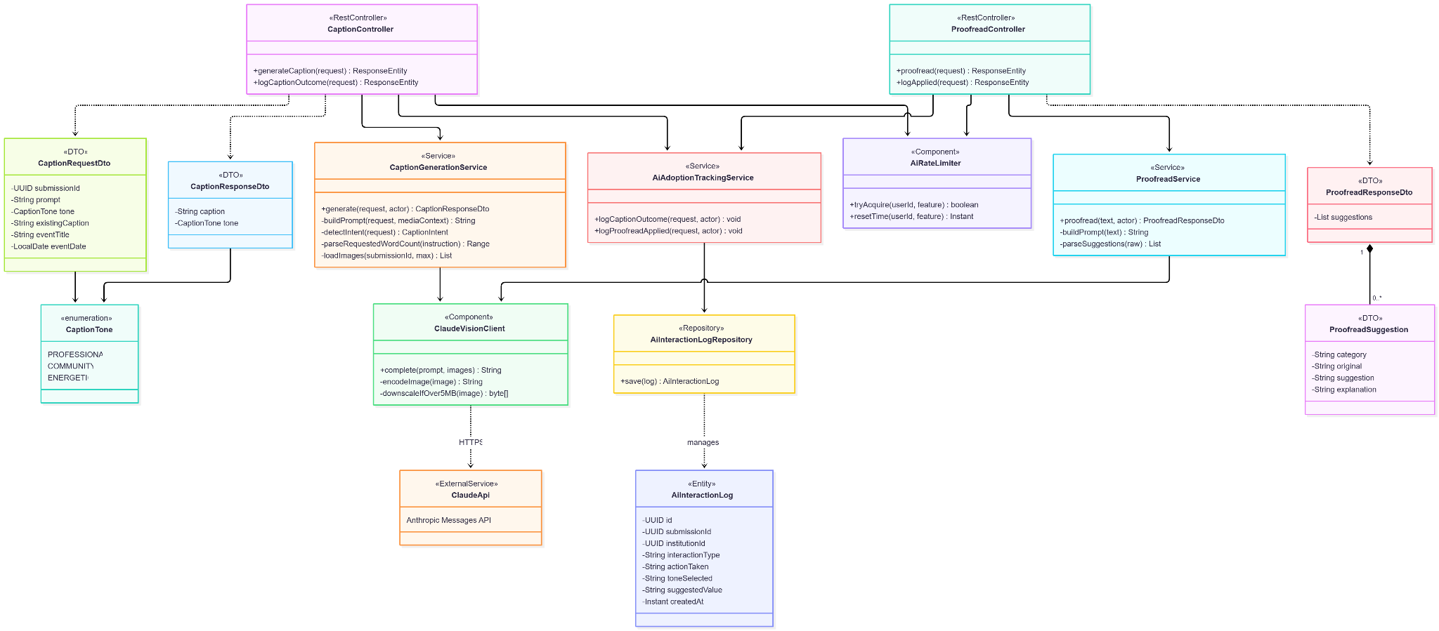
- Sequence Diagram
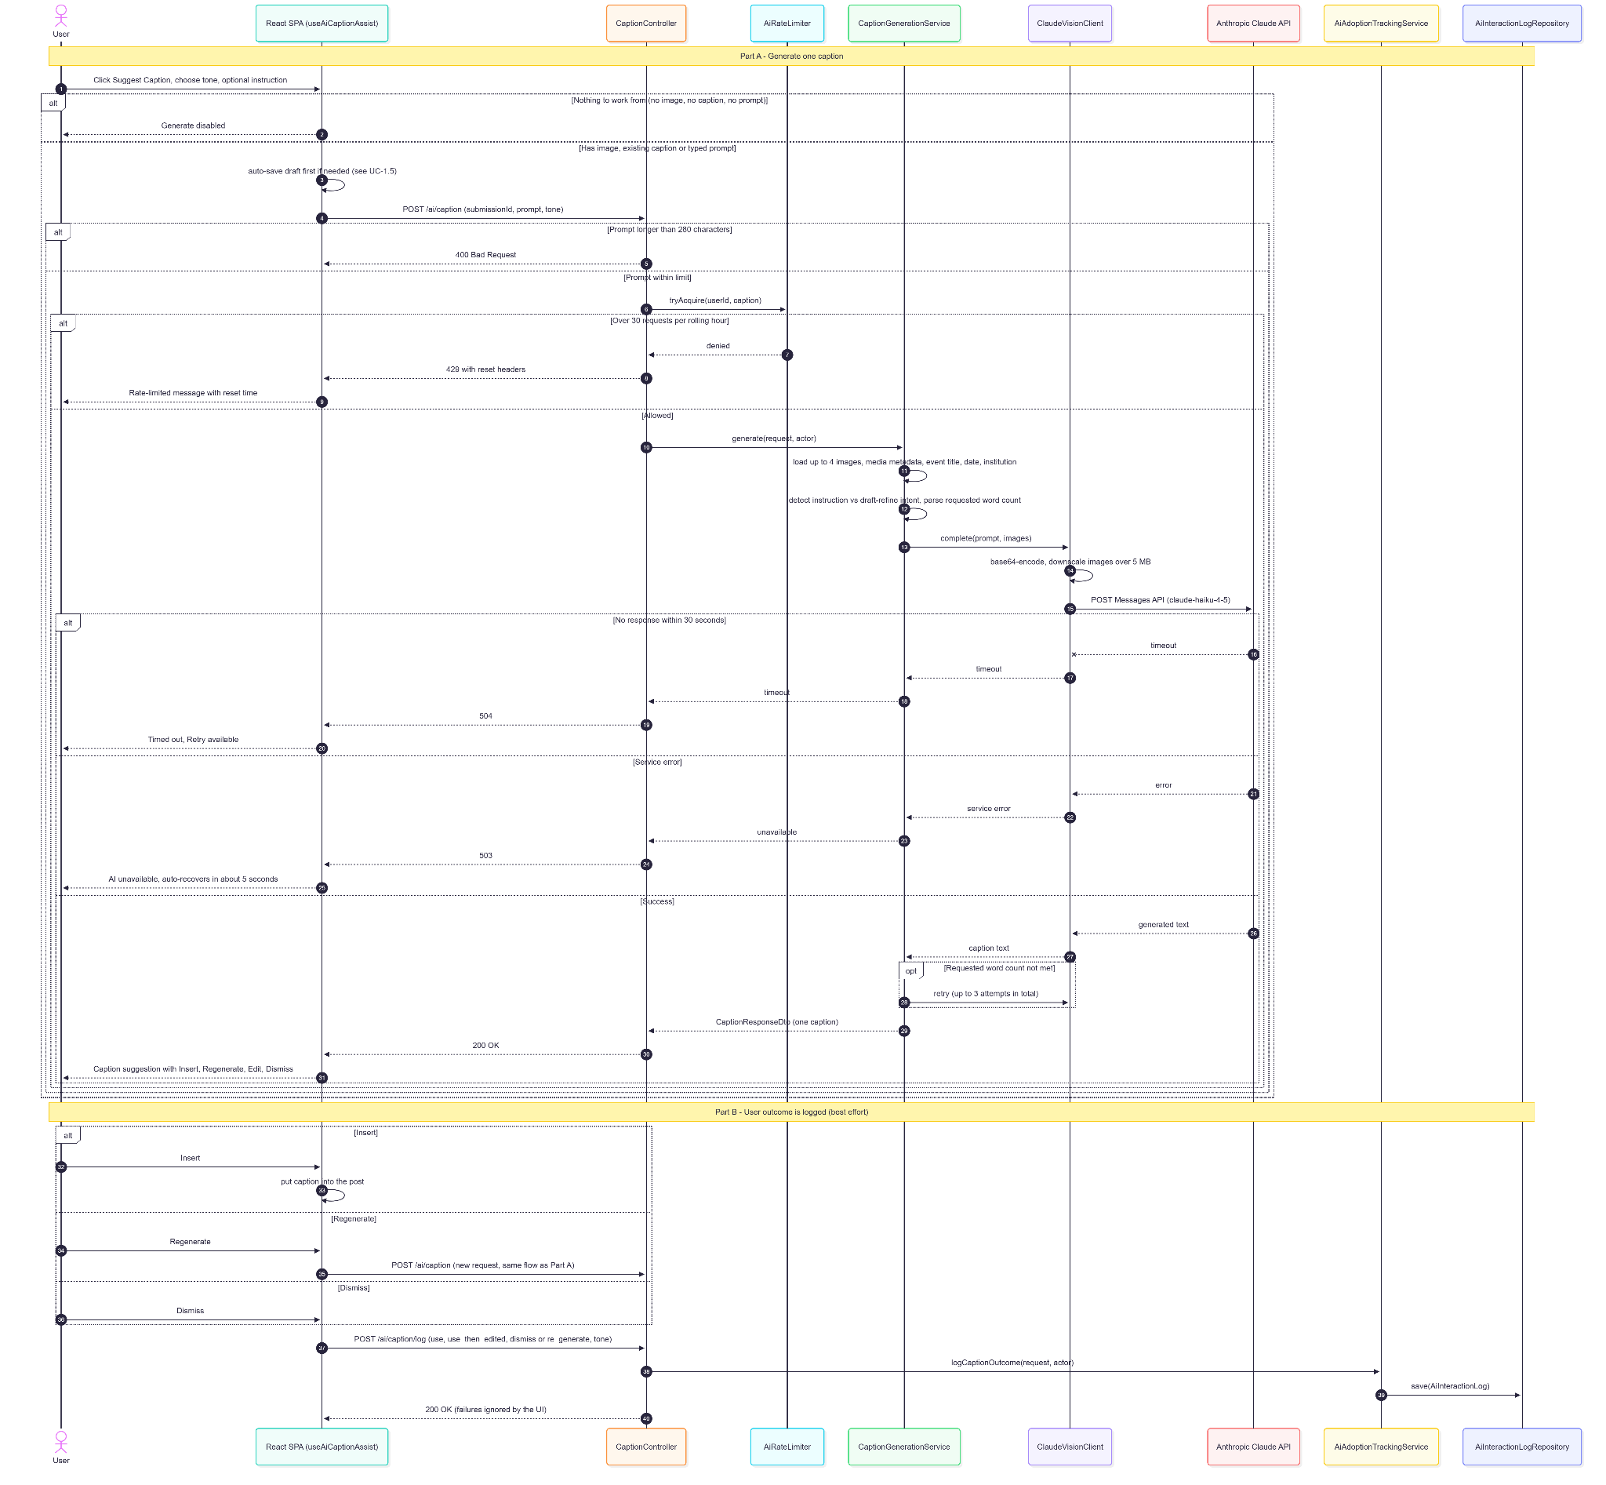

1.6.5. Data Design
- Entity Relationship Diagram
- Schema

CREATE TABLE ai_interaction_log (
id UUID PRIMARY KEY DEFAULT gen_random_uuid(),
submission_id UUID REFERENCES submissions(id),
institution_id UUID REFERENCES institutions(id),
interaction_type VARCHAR(30) NOT NULL, -- caption_suggestion | proofread | media_recommendation | ...
action_taken VARCHAR(30) NOT NULL, -- shown | use | use_then_edited | dismiss | re_generate | applied | ...
tone_selected VARCHAR(30),
suggested_value TEXT,
created_at TIMESTAMPTZ NOT NULL DEFAULT NOW()
);

1.7. Media Attachment Rules

1.7.1. User Interface Design
Step 1 — Media
Device upload (drag-and-drop or picker) and a Media Library tab. Upload cards show thumbnail, progress, and status, with Retry on network failure and a remove action. Media order can be rearranged by drag.
Media Library Tab (composer picker)
Reuses the library browser (UC-2.2) with search and, for Moderators/Administrators, an institution filter defaulting to the submission's institution. Each result has an Attach action.
AI Suggestions Tab
Enabled once event title + caption + media tags reach ≥10 characters. Shows up to 8 ranked suggestions (score ≥ 0.40) with match reasons and blue AI accents; hidden when nothing clears the floor.
Media Caption Modal
Per-asset caption (≤500 characters, live counter) and, for photos, a "Skip watermark for this image" checkbox. A caption indicator appears on the card.
Album Field (Organize & Schedule step)
Select an existing album, type a new name, or click Auto-Match: a confident match (≥0.55) auto-fills with a reason badge; an ambiguous result (0.32–0.55) lists up to 3 ranked candidates; otherwise a "no confident match" notice is shown. Media tags are entered alongside.
Mixed-Media Notice
An inline notice when images and video are mixed, explaining that automated publishing will route the post to the Failed tab for manual recovery.

1.7.2. Front-end Component(s)
SubmissionScreen media step
- Requests POST /submissions/{id}/media/upload-url (presigned R2 PUT), uploads bytes directly to R2, then registers metadata with POST /submissions/{id}/media. Library picks use POST /submissions/{id}/assets; removal DELETE /submissions/{id}/assets/{assetId}; reorder PATCH /submissions/{id}/media/order. Client-side validation of 7 formats and 50 MB.
- React functional component

SimilarMediaPanel (AI Suggestions)
- POST /ai/submissions/{id}/suggest-media, POST /ai/submissions/{id}/suggest-media-status, GET /ai/submissions/{id}/similar-media; logs via POST /ai/submissions/{id}/log-interaction.
- React functional component

AlbumCombobox
- Album select/create with POST /ai/submissions/{id}/suggest-album and ranked suggestions. Shared with UC-2.1.
- React functional component

Media Caption Modal
- Saves per-asset caption and skipWatermark with the draft.
- React modal component

1.7.3. Back-end Component(s)
SubmissionController (media endpoints)
- POST /submissions/{id}/media/upload-url, POST /submissions/{id}/media, PATCH /submissions/{id}/media/order, POST /submissions/{id}/assets, DELETE /submissions/{id}/assets/{assetId}. Enforces the 10-asset limit (BR-SUB-02).
- Spring @RestController

MediaStorageService
- AWS S3 SDK against R2: presigned PUT URLs, server-side validation of the declared MIME type, extension, and size (file content is not inspected for magic bytes), object download, delete, and public URL resolution via the backend proxy ({BACKEND_PUBLIC_BASE_URL}/api/v1/media-files/), or a custom R2 domain when R2_CUSTOM_DOMAIN_URL is set.
- Spring @Service

AIRecommendationController / AIRecommendationService
- suggestMedia: Voyage query embedding over event context → pgvector search in the submission institution's library → re-rank by semantic, visual, recency, category, and tag signals → keep score ≥ 0.40, top 8; metadata/tag fallback when embedding retrieval fails. suggestAlbum: blends tag overlap with closest-asset visual similarity per root album (max score, not centroid); thresholds 0.55 / 0.32.
- Spring @RestController / @Service

MediaRetrievalEmbeddingService / SubmissionMediaContextService / MediaProcessingQueueService
- Builds retrieval embeddings and the aggregated submission_media_contexts used for suggestions; queues processing jobs for new uploads.
- Spring @Service

SubmissionMediaAssetRepository
- Junction persistence with display_order, caption, skip_watermark.
- Spring @Repository

1.7.4. Object-Oriented Component(s)
- Class Diagram
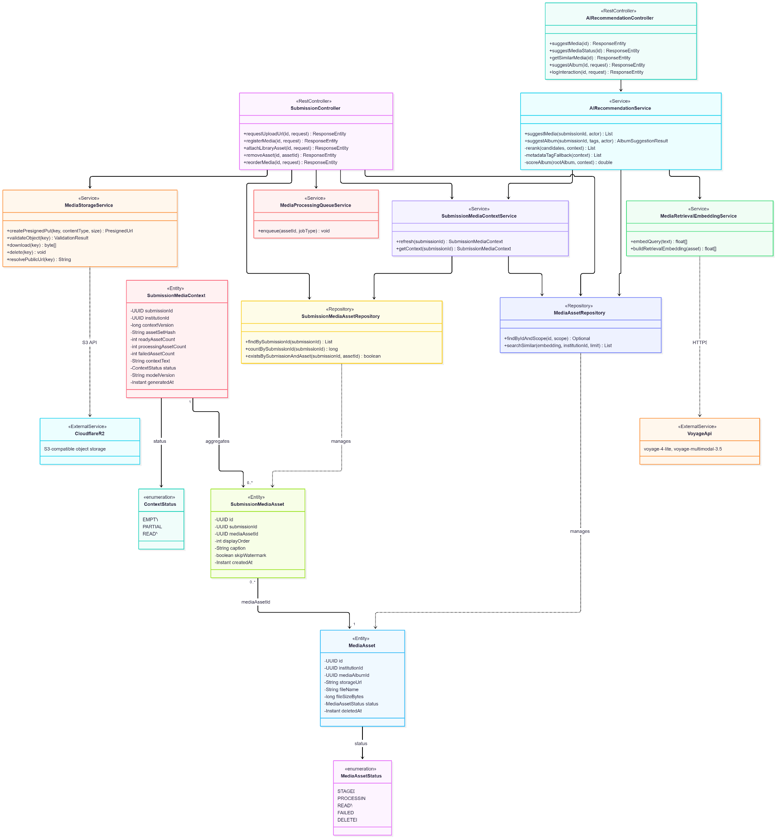.
- Sequence Diagram

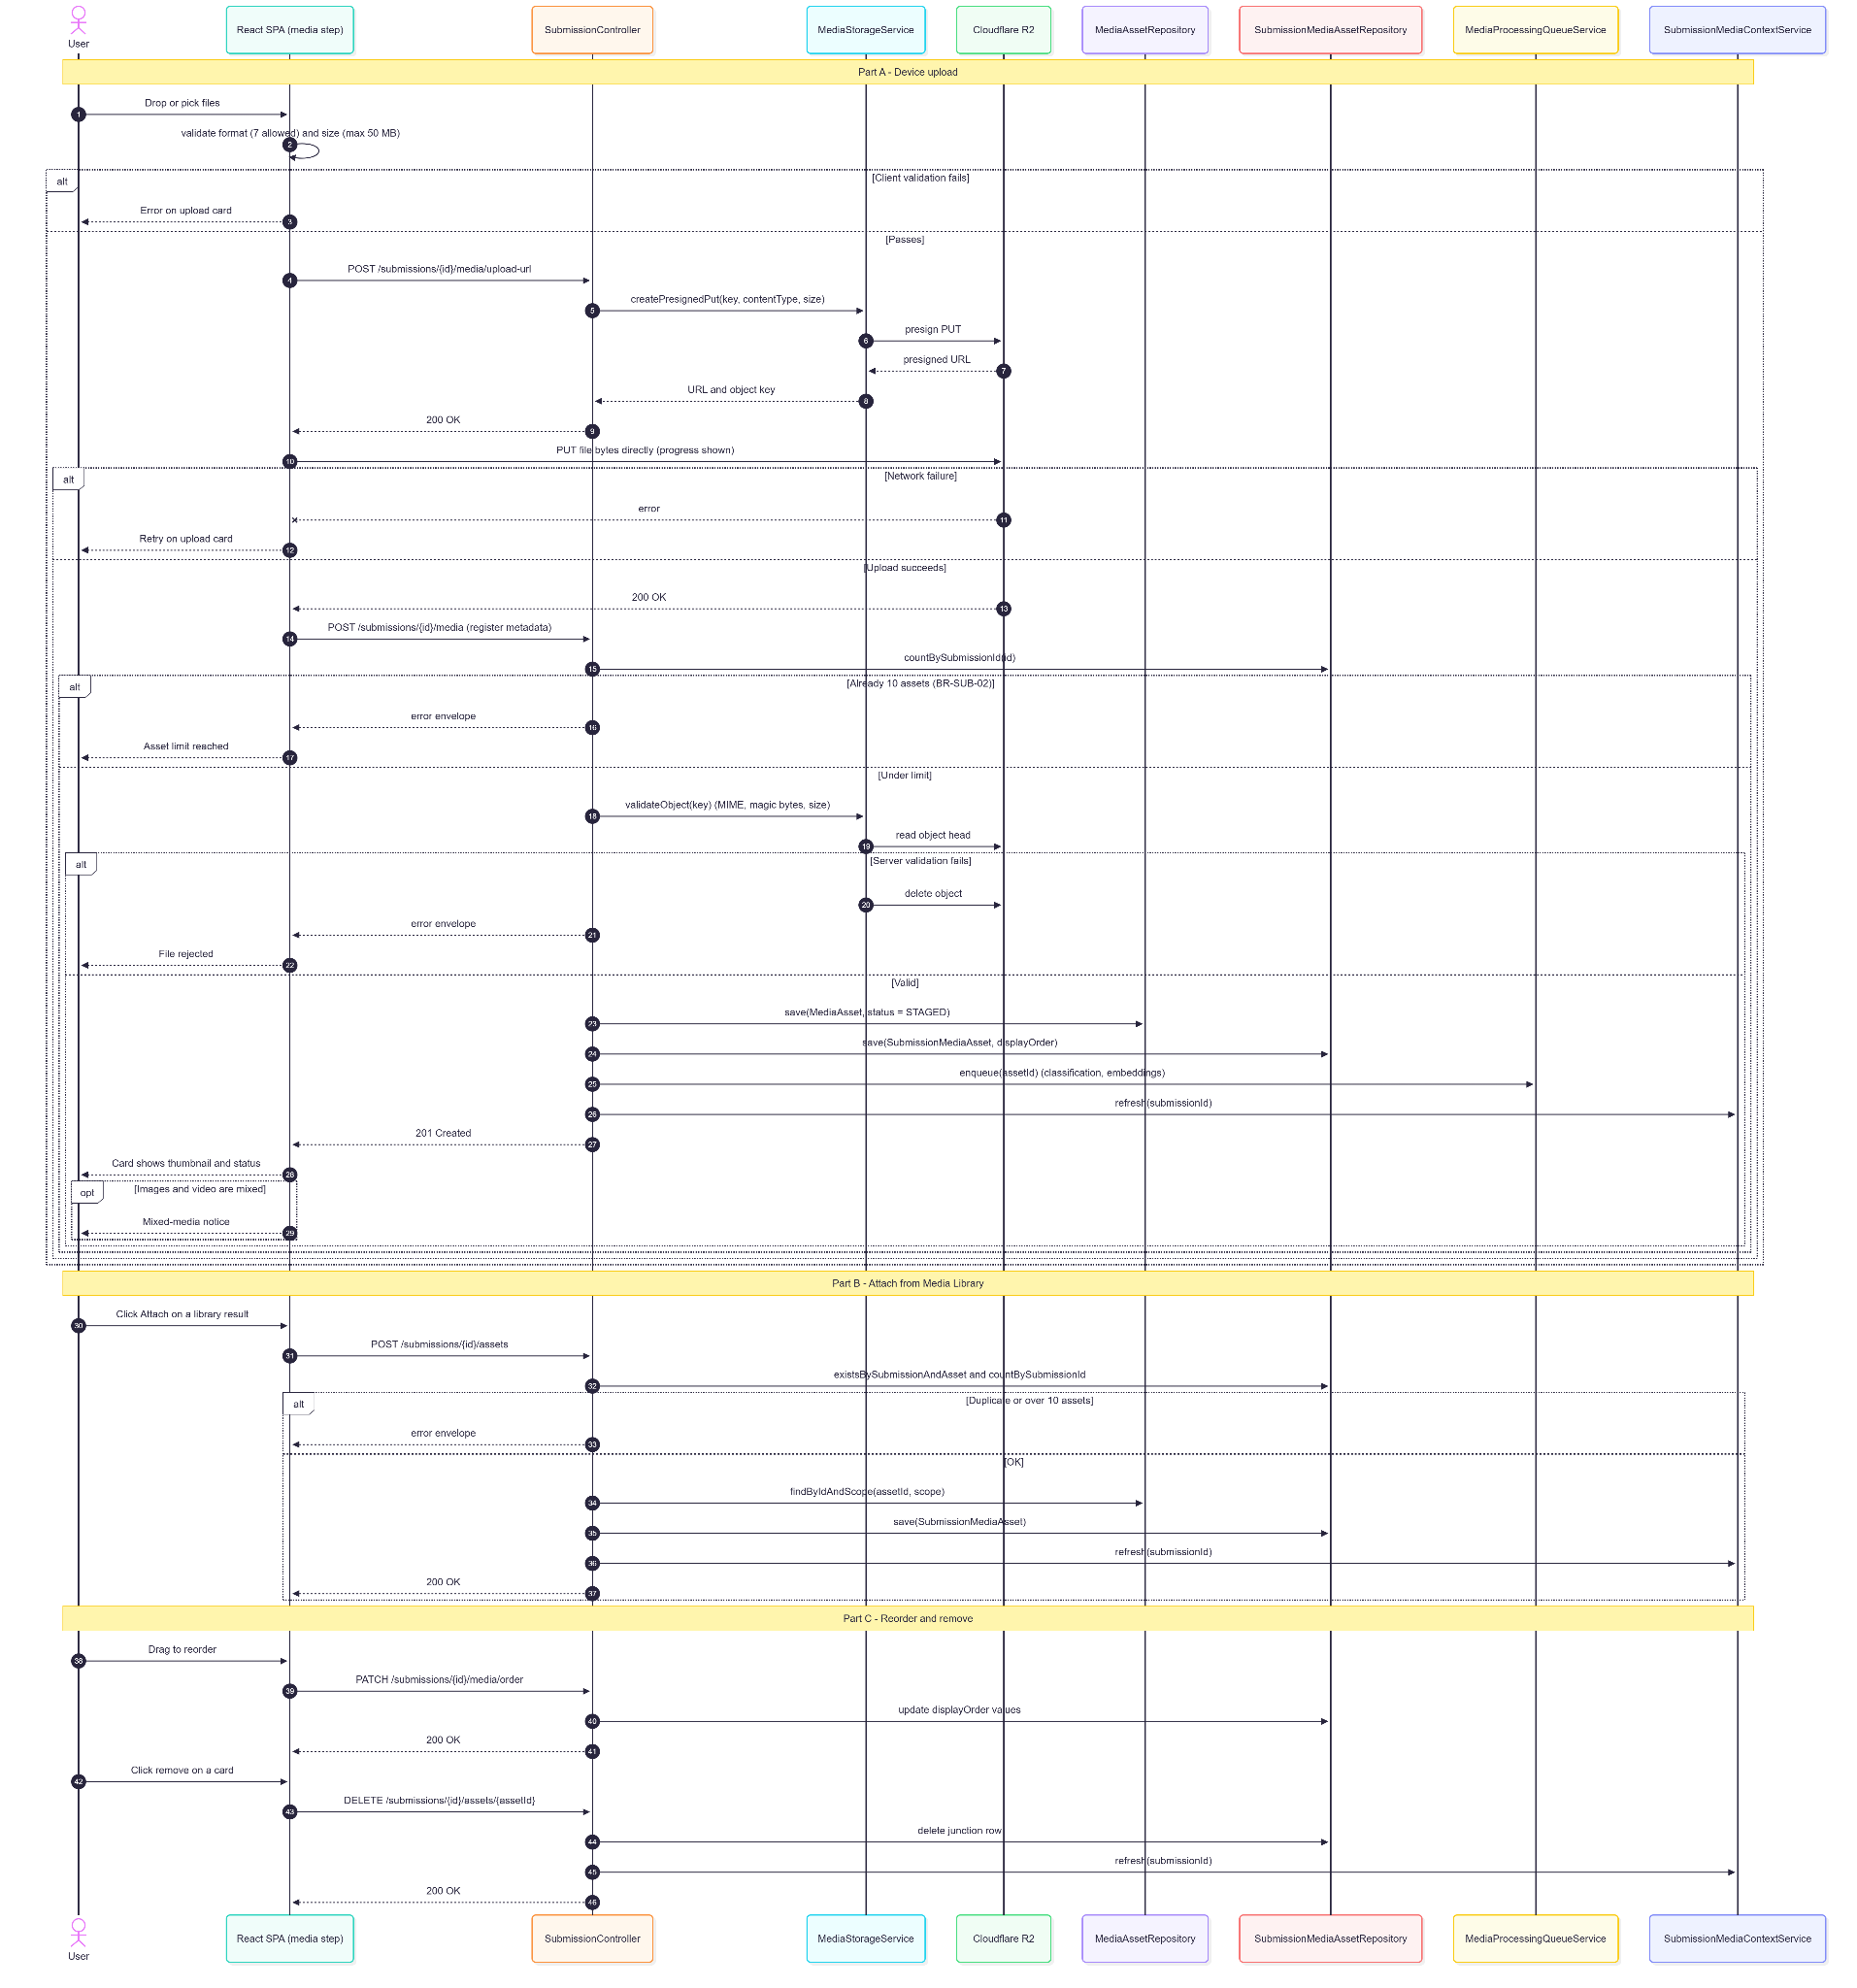
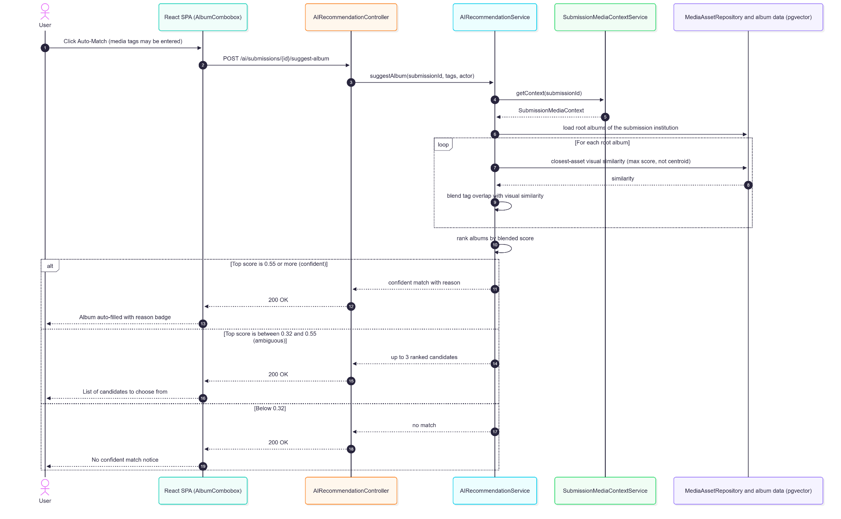

1.7.5. Data Design
- Entity Relationship Diagram
.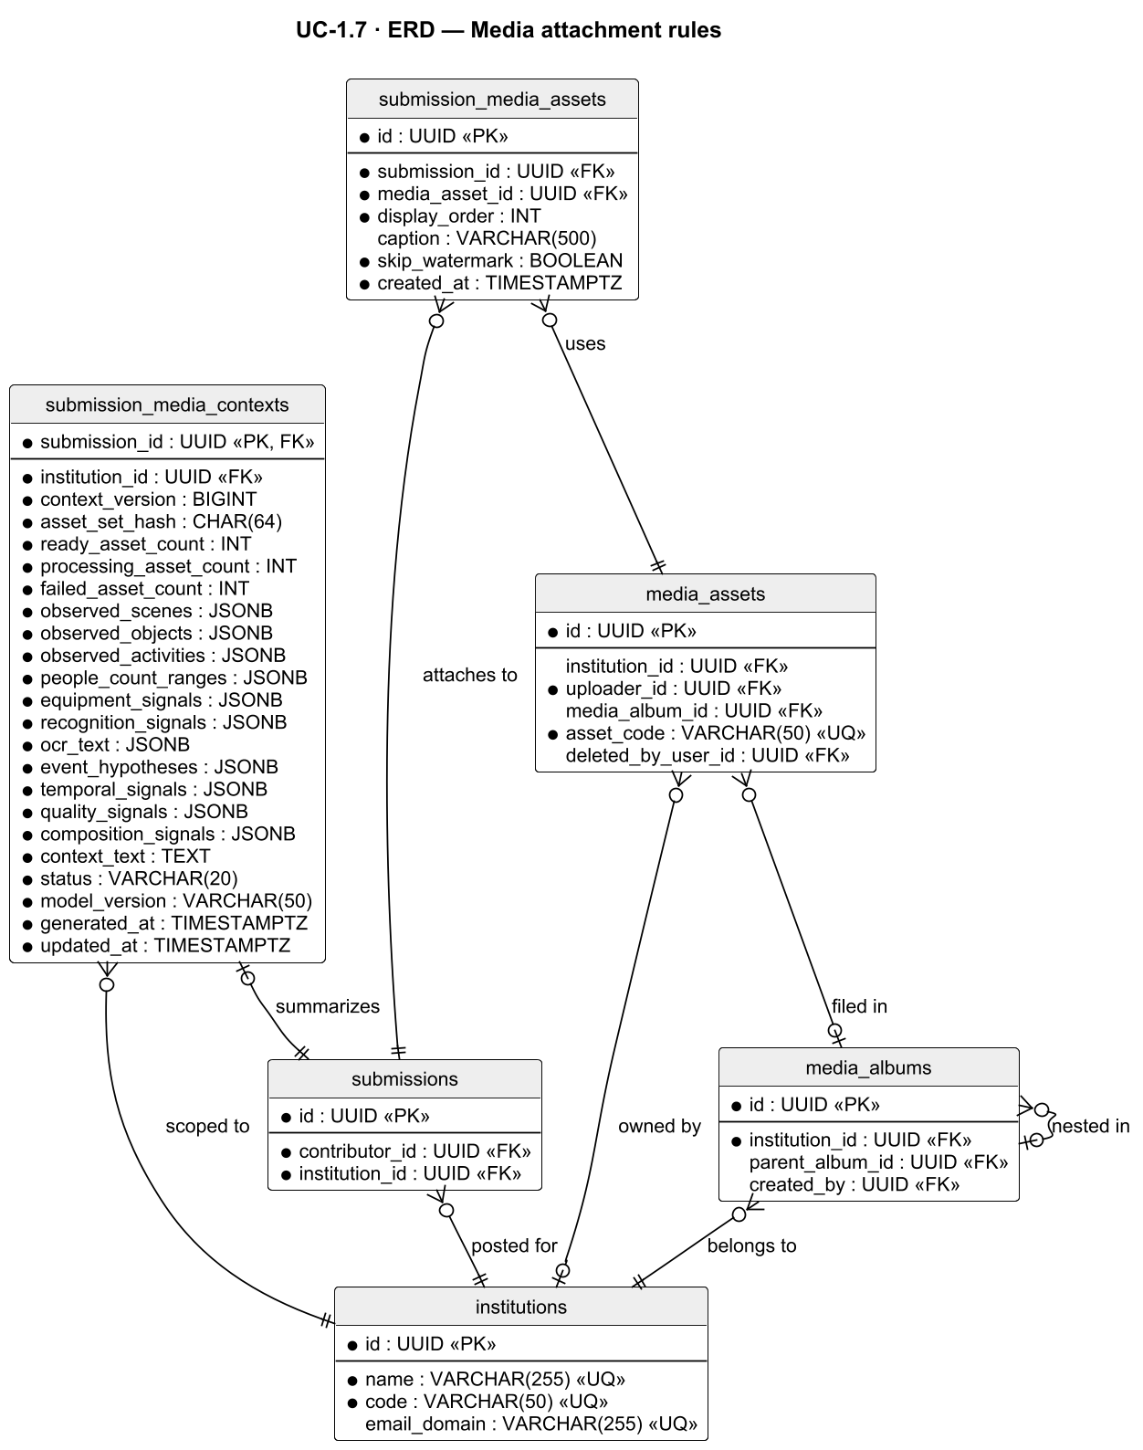
- Schema

CREATE TABLE submission_media_assets (
id UUID PRIMARY KEY DEFAULT gen_random_uuid(),
submission_id UUID NOT NULL REFERENCES submissions(id) ON DELETE CASCADE,
media_asset_id UUID NOT NULL REFERENCES media_assets(id),
display_order INT NOT NULL DEFAULT 0,
caption VARCHAR(500), -- per-asset caption (published per photo)
skip_watermark BOOLEAN NOT NULL DEFAULT FALSE, -- photo-only opt-out (UC-2.5 A5)
created_at TIMESTAMPTZ NOT NULL DEFAULT NOW(),
UNIQUE (submission_id, media_asset_id)
);

-- Aggregated AI context per submission used for suggestions
CREATE TABLE submission_media_contexts (
submission_id UUID PRIMARY KEY REFERENCES submissions(id) ON DELETE CASCADE,
institution_id UUID NOT NULL REFERENCES institutions(id),
context_version BIGINT NOT NULL DEFAULT 1,
asset_set_hash CHAR(64) NOT NULL, -- detects a changed set of attached assets
ready_asset_count INT NOT NULL DEFAULT 0,
processing_asset_count INT NOT NULL DEFAULT 0,
failed_asset_count INT NOT NULL DEFAULT 0,
observed_scenes JSONB NOT NULL DEFAULT '[]'::jsonb,
observed_objects JSONB NOT NULL DEFAULT '[]'::jsonb,
observed_activities JSONB NOT NULL DEFAULT '[]'::jsonb,
people_count_ranges JSONB NOT NULL DEFAULT '[]'::jsonb,
equipment_signals JSONB NOT NULL DEFAULT '[]'::jsonb,
recognition_signals JSONB NOT NULL DEFAULT '[]'::jsonb,
ocr_text JSONB NOT NULL DEFAULT '[]'::jsonb,
event_hypotheses JSONB NOT NULL DEFAULT '[]'::jsonb,
temporal_signals JSONB NOT NULL DEFAULT '{}'::jsonb,
quality_signals JSONB NOT NULL DEFAULT '[]'::jsonb,
composition_signals JSONB NOT NULL DEFAULT '[]'::jsonb,
context_text TEXT NOT NULL DEFAULT '', -- text used for suggestion queries
status VARCHAR(20) NOT NULL CHECK (status IN ('EMPTY', 'PARTIAL', 'READY')),
model_version VARCHAR(50) NOT NULL,
generated_at TIMESTAMPTZ NOT NULL DEFAULT NOW(),
updated_at TIMESTAMPTZ NOT NULL DEFAULT NOW()
);

1.8. Engagement Helpers

1.8.1. User Interface Design
Schedule Mode (Organize & Schedule step)
A toggle between Schedule (default) and Live Event (Fast-Track). Fast-Track hides all date/time and recommendation UI.
When to Post — Recommendation Tiles
A compact row of up to 3 calendar-style slot tiles under a "When to Post *" heading. The source explanation sits behind an ⓘ toggle; the "why" line shows only for the selected tile; a "Top pick" badge and engagement bars appear only when real Page history (HISTORICAL) separates the slots. With insufficient history the panel shows "Best-practice guidance" (Tue/Wed/Thu 6 PM). If the Facebook analytics call fails, the panel is hidden and the picker remains.
Date and Time Picker
Selecting a tile fills the fields; manual entry is always allowed. Validation is debounced; hard guard-rail blocks show as errors, and soft warnings (three-unpublished-post institution quota, six-post daily cap) show inline beneath the fields (.sub-inline-warning) only when guard rails are enforced.

1.8.2. Front-end Component(s)
EngagementRecommendationsPanel
- GET /engagement-recommendations for the selected institution; skipped for Fast-Track drafts and for Administrator composers without an institution scope.
- React functional component

CalendarDateField / TimePickerField
- Date/time inputs with debounced validation via POST /submissions/{id}/evaluate-slot (saved draft) or POST /guardrails/validate.
- React functional components

1.8.3. Back-end Component(s)
EngagementRecommendationController / EngagementRecommendationService
- Reads the Page's last 100 posts (reactions + comments + shares) from the Graph API, buckets by weekday and hour within 8 AM–8 PM Asia/Manila, keeps the top 5 buckets when ≥20 samples exist (else default Tue/Wed/Thu 6 PM), walks a 30-day lookahead for the first matching slots, drops hard-blocked candidates, and returns up to 3 slots with soft warnings and a score.
- Spring @RestController / @Service

GuardRailController / GuardRailService / GuardRailSettingsService
- POST /guardrails/validate. Hard rules: network-wide conflict buffer (GR-H1, default ±30 min), minimum lead time (GR-H2, default 2 h), maximum horizon (GR-H3, default 30 days), and posting window (GR-H4, default 8:00 AM–8:00 PM Asia/Manila). Soft: per-institution active quota (GR-S1, default 3 scheduled-but-unpublished posts) and daily volume cap (GR-S2, default 6 per day). Every threshold is Administrator-configurable in Page Settings (V116, V121, V122) and read through GuardRailSettingsService. The database exclusion constraint (UC-1.8 schema) stays fixed at 30 minutes regardless of the configured buffer. When the switch is off, a Contributor's slot only needs to be in the future; a schedule change made by a Moderator or Administrator is still validated, and only an Administrator may bypass a hard block with a reason (audited SCHEDULE_GUARDRAIL_OVERRIDE). Returns a structured GuardRailResult of violations and warnings.
- Spring @RestController / @Service

SubmissionController / SlotReservationService
- POST /submissions/{id}/evaluate-slot; holds a held reservation for Standard drafts (not Fast-Track).
- Spring @RestController / @Service

FacebookEngagementAnalyticsClient
- Graph API engagement reads using the active Page token.
- Spring @Component

1.8.4. Object-Oriented Component(s)
- Class Diagram
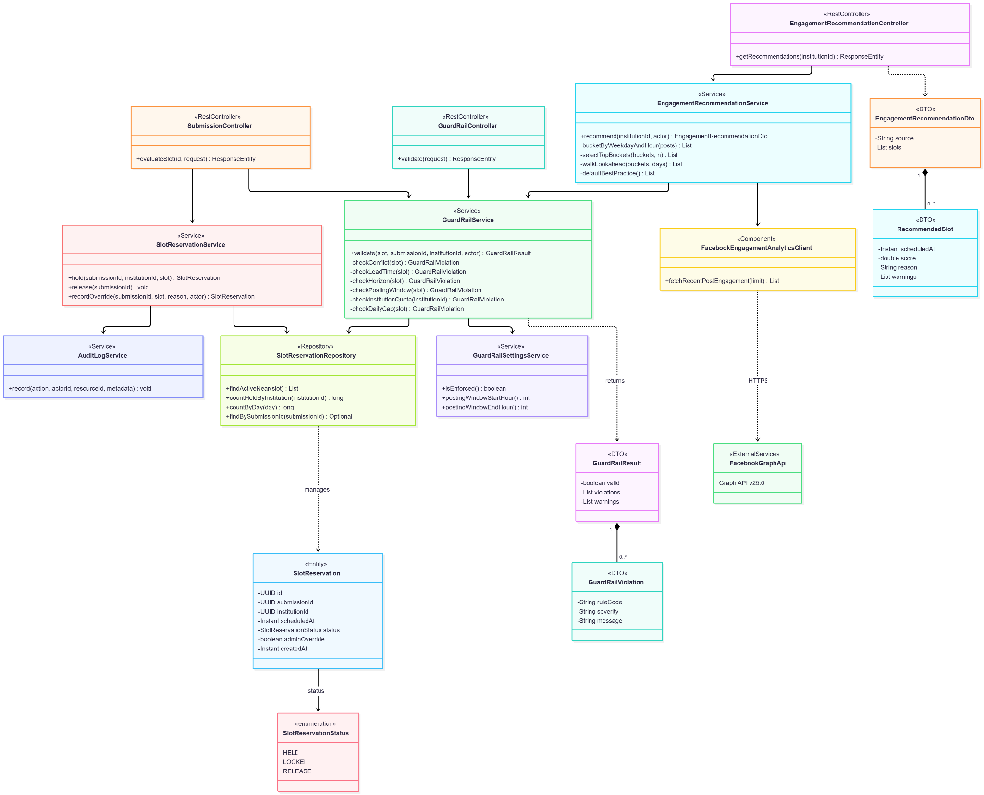
- Sequence Diagram
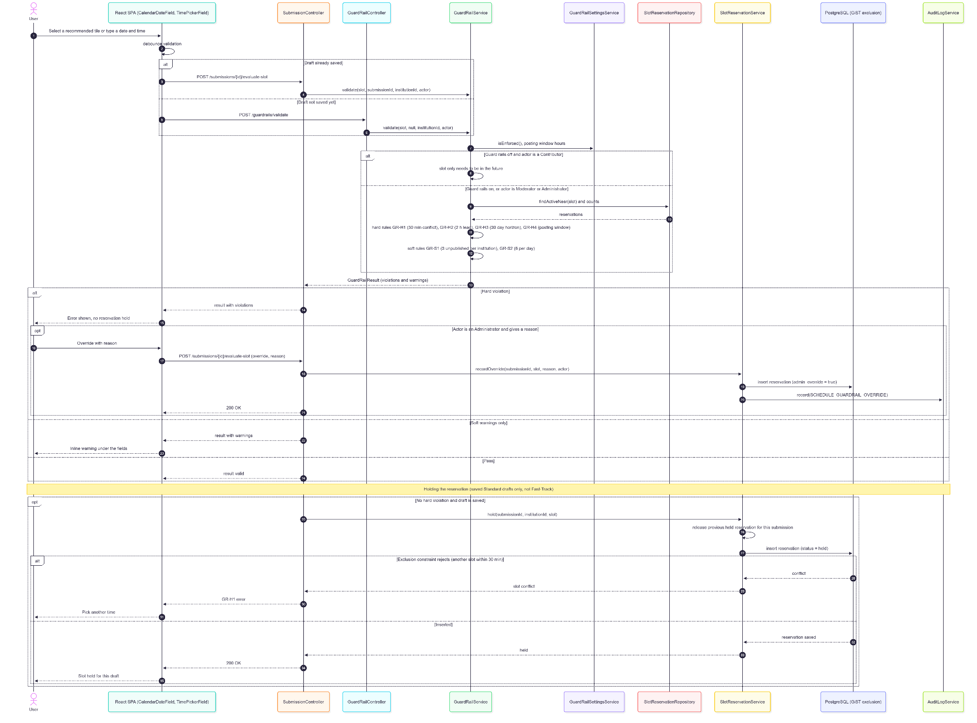

1.8.5. Data Design
- Entity Relationship Diagram
- Schema

CREATE TABLE slot_reservations (
id UUID PRIMARY KEY DEFAULT gen_random_uuid(),
submission_id UUID NOT NULL REFERENCES submissions(id),
institution_id UUID NOT NULL REFERENCES institutions(id),
scheduled_at TIMESTAMPTZ NOT NULL,
status VARCHAR(20) NOT NULL DEFAULT 'held'
CHECK (status IN ('held', 'locked', 'released')),
admin_override BOOLEAN NOT NULL DEFAULT FALSE, -- set only for an Admin hard-block override
created_at TIMESTAMPTZ NOT NULL DEFAULT NOW()
);

-- GR-H1 enforced by the database (V95/V96): no two active, non-override
-- reservations within ±30 minutes of each other, network-wide.
CREATE OR REPLACE FUNCTION epoch_seconds_immutable(ts timestamptz)
RETURNS bigint LANGUAGE sql IMMUTABLE PARALLEL SAFE
AS $$ $SELECT(EXTRACT(EPOCHFROMts))::bigint;$ $$;

ALTER TABLE slot_reservations ADD CONSTRAINT excl_slot_reservations_network_buffer
EXCLUDE USING gist (
int8range(epoch_seconds_immutable(scheduled_at),
epoch_seconds_immutable(scheduled_at) + 1800, '[]') WITH &&
) WHERE (status <> 'released' AND NOT admin_override);
-- Each reservation covers [t, t + 30 min]; two ranges overlap exactly when the
-- slots are within 30 minutes of each other.
Related tables used by this use case:
-- page_settings (defined in UC-1.4)
CREATE TABLE page_settings (
id UUID PRIMARY KEY DEFAULT gen_random_uuid(),
institution_id UUID REFERENCES institutions(id),
guardrails_enforced BOOLEAN NOT NULL DEFAULT TRUE,
posting_window_start_hour INT NOT NULL DEFAULT 8, -- GR-H4 window start (Asia/Manila, V116)
posting_window_end_hour INT NOT NULL DEFAULT 20, -- GR-H4 window end (exclusive)
conflict_buffer_minutes INT NOT NULL DEFAULT 30, -- GR-H1 (V121)
minimum_lead_time_hours INT NOT NULL DEFAULT 2, -- GR-H2 (V121)
maximum_lead_time_days INT NOT NULL DEFAULT 30, -- GR-H3 (V121)
per_institution_active_quota INT NOT NULL DEFAULT 3, -- GR-S1 (V122)
daily_volume_cap INT NOT NULL DEFAULT 6, -- GR-S2 (V122)
watermark_enabled BOOLEAN,
watermark_text VARCHAR(150),
facebook_page_id VARCHAR(255),
updated_by UUID REFERENCES users(id),
updated_at TIMESTAMPTZ NOT NULL DEFAULT NOW()
);

1.9. Draft Submission

1.9.1. User Interface Design
Submit for Approval
The final action in the composer. The frontend re-checks title, date, caption, media, album, and (Standard) schedule; anything missing jumps back to the relevant step with a toast. If only Recommended items remain, a non-blocking confirmation shows the readiness score ("Submit anyway / Go back").
Submission Success State
The composer closes and returns to the Submissions list with the item shown as Pending (or a "Live Event" badge for Fast-Track).
Slot Conflict at Submit
On a 409 slot conflict the confirmation closes and the composer returns to Organize & Schedule with a prompt to pick a new time.
Withdraw Submission
Available on pending items with no review lock; confirmation returns the item to Draft.

1.9.2. Front-end Component(s)
SubmissionScreen (submit flow)
- POST /submissions/{id}/submit; specific 409 handling redirects to the Schedule step.
- React functional component

SubmissionListScreen (withdraw)
- POST /submissions/{id}/withdraw with a confirmation prompt.
- React functional component

1.9.3. Back-end Component(s)
SubmissionController
- POST /submissions/{id}/submit (draft/needs_revision/rejected → pending), POST /submissions/{id}/withdraw (pending → draft, refused with 409 once a review lock exists).
- Spring @RestController

SubmissionService
- assertContentComplete (title, date, caption + length, media, album) runs before any state change or media reconciliation; Standard drafts are re-validated against the guard rails (409 on conflict); Fast-Track skips slot validation. On success: reconciles media (new uploads are bound to the institution, filed into the album resolved from album_name, marked PROCESSING; library picks keep their album; all receive the post's media tags), clears a prior rejection reason, sets submitted_at, and writes SUBMISSION_SUBMITTED. Notification failures are caught so they never roll back the transition.
- Spring @Service

NotificationService
- T-01 (standard): in-app + Messenger to every active Moderator and Administrator. T-11 (Fast-Track): in-app + email + Messenger, urgent, to every active Moderator and Administrator (NotificationEventListener.reviewers()).
- Spring @Service

SubmissionRepository
- findValidationQueue(priorityCutoff), behind GET /validation/queue, orders fast_track DESC, then submissions due within 30 minutes (GR-T1), then scheduled_at ASC NULLS LAST, submitted_at ASC. findValidationPage, behind the paginated GET /validation/queue/page that the Review Queue screen uses, orders fast_track DESC and then the selected sort, without the 30-minute term — there GR-T1 appears only as a badge. SubmissionSummaryDto.priorityFlag marks those due within 30 minutes in both.
- Spring @Repository

1.9.4. Object-Oriented Component(s)
- Class Diagram
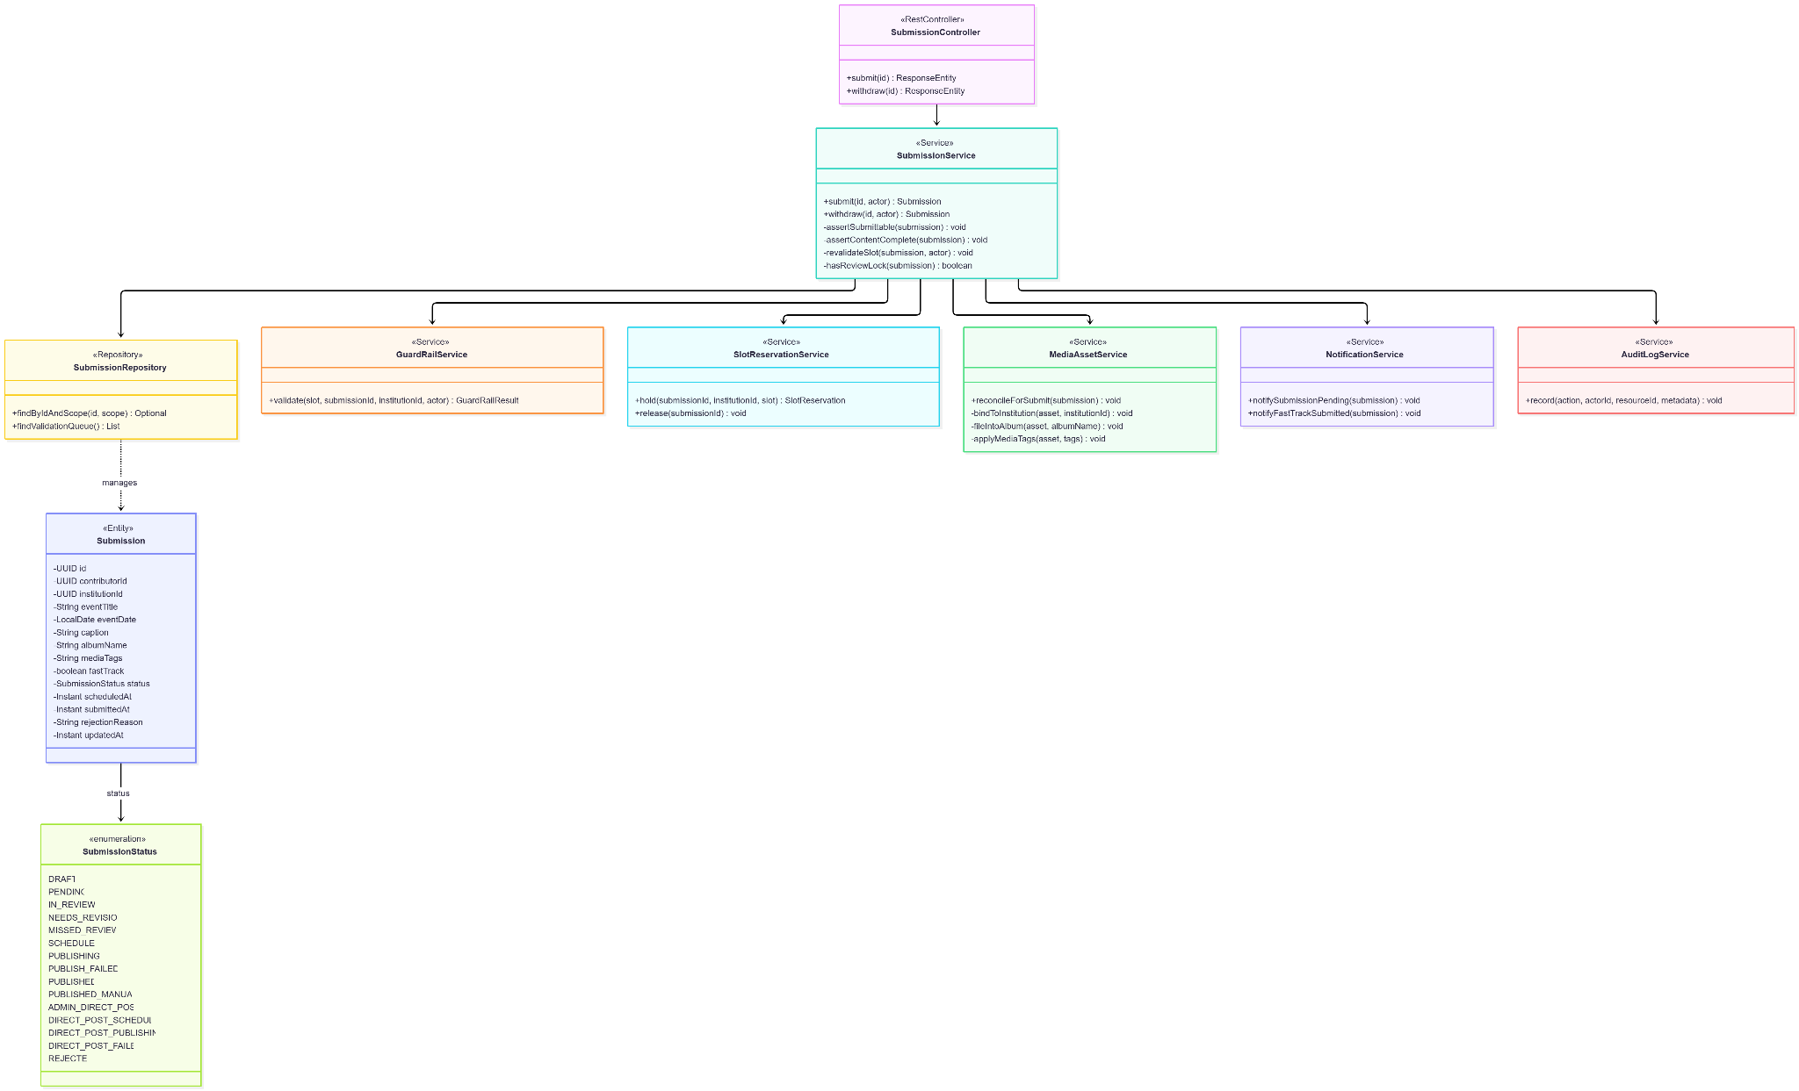
- Sequence Diagram

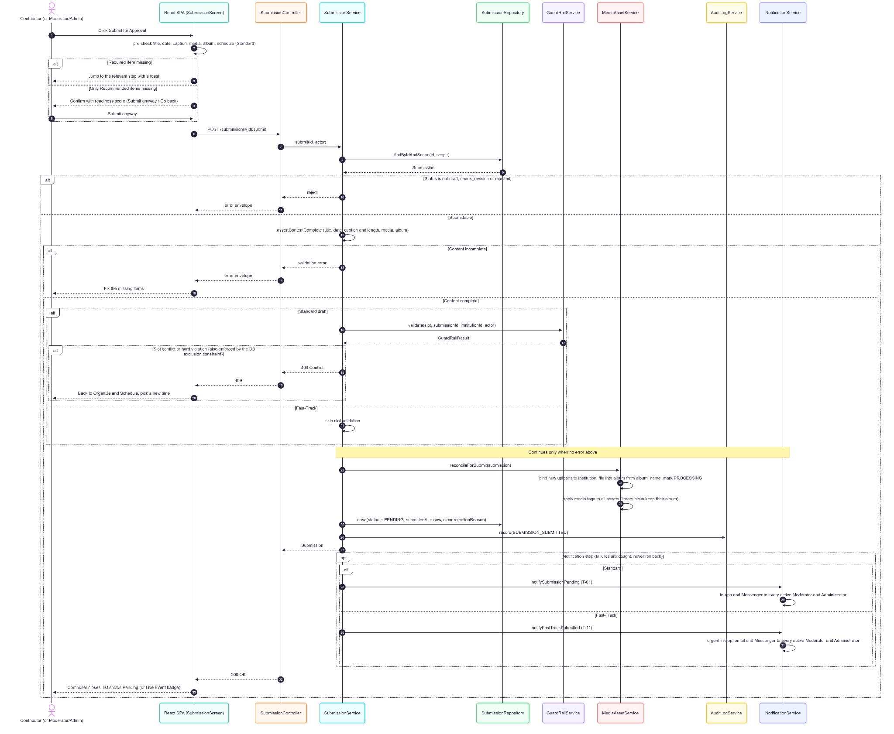

1.9.5. Data Design
- Entity Relationship Diagram
- Schema

-- UC-1.9 operates on submissions (defined in UC-1.5) and slot_reservations (UC-1.8);
-- no new tables. Columns used by draft submission and withdrawal:
CREATE TABLE submissions (
id UUID PRIMARY KEY DEFAULT gen_random_uuid(),
contributor_id UUID NOT NULL REFERENCES users(id),
institution_id UUID NOT NULL REFERENCES institutions(id),
event_title VARCHAR(255),
event_date DATE,
caption TEXT,
description TEXT,
tags TEXT,
media_tags TEXT,
album_name VARCHAR(255),
template_id VARCHAR(100),
fast_track BOOLEAN NOT NULL DEFAULT FALSE,
live_event_name VARCHAR(255),
status VARCHAR(30) NOT NULL DEFAULT 'draft'
CHECK (status IN ('draft', 'pending', 'in_review', 'needs_revision',
'missed_review', 'scheduled', 'publishing', 'publish_failed',
'published', 'published_manual', 'admin_direct_post',
'direct_post_scheduled', 'direct_post_publishing',
'direct_post_failed', 'rejected')),
scheduled_at TIMESTAMPTZ,
original_scheduled_at TIMESTAMPTZ,
moderator_reschedule_count INT NOT NULL DEFAULT 0,
submitted_at TIMESTAMPTZ,
published_at TIMESTAMPTZ,
platform_post_id VARCHAR(255),
validator_remarks TEXT,
rejection_reason TEXT,
review_snapshot JSONB,
retry_count INT NOT NULL DEFAULT 0,
requires_manual_publishing BOOLEAN NOT NULL DEFAULT FALSE,
manual_publish_started_at TIMESTAMPTZ,
last_manual_publish_abandoned_at TIMESTAMPTZ,
published_manual_url TEXT,
published_manual_notes TEXT,
token_blocked_at TIMESTAMPTZ,
token_escalated_24h_at TIMESTAMPTZ,
token_final_failed_at TIMESTAMPTZ,
created_at TIMESTAMPTZ NOT NULL DEFAULT NOW(),
updated_at TIMESTAMPTZ NOT NULL DEFAULT NOW()
);

CREATE TABLE slot_reservations (
id UUID PRIMARY KEY DEFAULT gen_random_uuid(),
submission_id UUID NOT NULL REFERENCES submissions(id),
institution_id UUID NOT NULL REFERENCES institutions(id),
scheduled_at TIMESTAMPTZ NOT NULL,
status VARCHAR(20) NOT NULL DEFAULT 'held'
CHECK (status IN ('held', 'locked', 'released')),
admin_override BOOLEAN NOT NULL DEFAULT FALSE,
created_at TIMESTAMPTZ NOT NULL DEFAULT NOW()
);
Indexes:
-- Indexes supporting submit-time slot re-validation and the approval queue
CREATE INDEX idx_submissions_status ON submissions(status);
CREATE INDEX idx_submissions_scheduled_at ON submissions(scheduled_at)
WHERE status IN ('scheduled', 'publishing', 'pending', 'in_review',
'direct_post_scheduled', 'direct_post_publishing');
CREATE INDEX idx_slot_reservations_slot ON slot_reservations(scheduled_at, institution_id)
WHERE status != 'released';
-- Concurrent slot conflicts at submit (A4) are also rejected by the slot_reservations
-- exclusion constraint defined in UC-1.8 (GR-H1, ±30 minutes). Queue order
-- (fast_track DESC, due-within-30-minutes first, scheduled_at, submitted_at) is applied by the repository query.

1.10. Moderator Account Management

1.10.1. User Interface Design
Moderator Management (User Management, /admin/user-management)
A Moderators card listing network-wide Moderator accounts (no institution) with status badges and pending Moderator invitations. Any active Administrator may Invite, Deactivate, Reactivate, Delete, Resend, and Cancel; Erase is Admin Owner only.
Change Role Dialog
Moves an active account between Contributor and Moderator. Contributor → Moderator clears the institution; Moderator → Contributor requires selecting an active institution. Either direction revokes sessions and releases any review locks the account holds.

1.10.2. Front-end Component(s)
UserManagementScreen / InvitationComposer / PendingInvitationsCard / ChangeRoleModal
- GET /users/moderators, GET /invitations/pending/network, POST /invitations (role = moderator), PATCH /users/{id}/status, DELETE /users/{id}, POST /users/{id}/erase, PATCH /users/{id}/role, POST /users/promotion/confirm|decline, DELETE /users/{id}/promotion (one unified promotion flow for both target roles).
- React functional components

1.10.3. Back-end Component(s)
InvitationController / InvitationService — network-scoped Moderator invitations (no institution), same token, reuse, and conflict rules as UC-1.1.
UserController / UserService
- Deactivate/reactivate/delete/erase as in UC-1.1/UC-1.3 (any active Admin; erase Admin Owner only). Role change between Contributor and Moderator: a Contributor → Moderator proposal is stored in the unified pending_promotion_role/requested_by/expires_at columns (72 hours) and applied on the target's confirmation; Moderator → Contributor is applied directly. On change: session_version++, review locks released via ReviewLockService, MODERATOR_PROMOTION_CONFIRMED (confirmed proposal) or USER_ROLE_CHANGED (direct change) written, affected user notified.
- Spring @RestController / @Service

ReviewLockService — releases locks held by a deactivated or role-changed Moderator.

1.10.4. Object-Oriented Component(s)
- Class Diagram
- Sequence Diagram
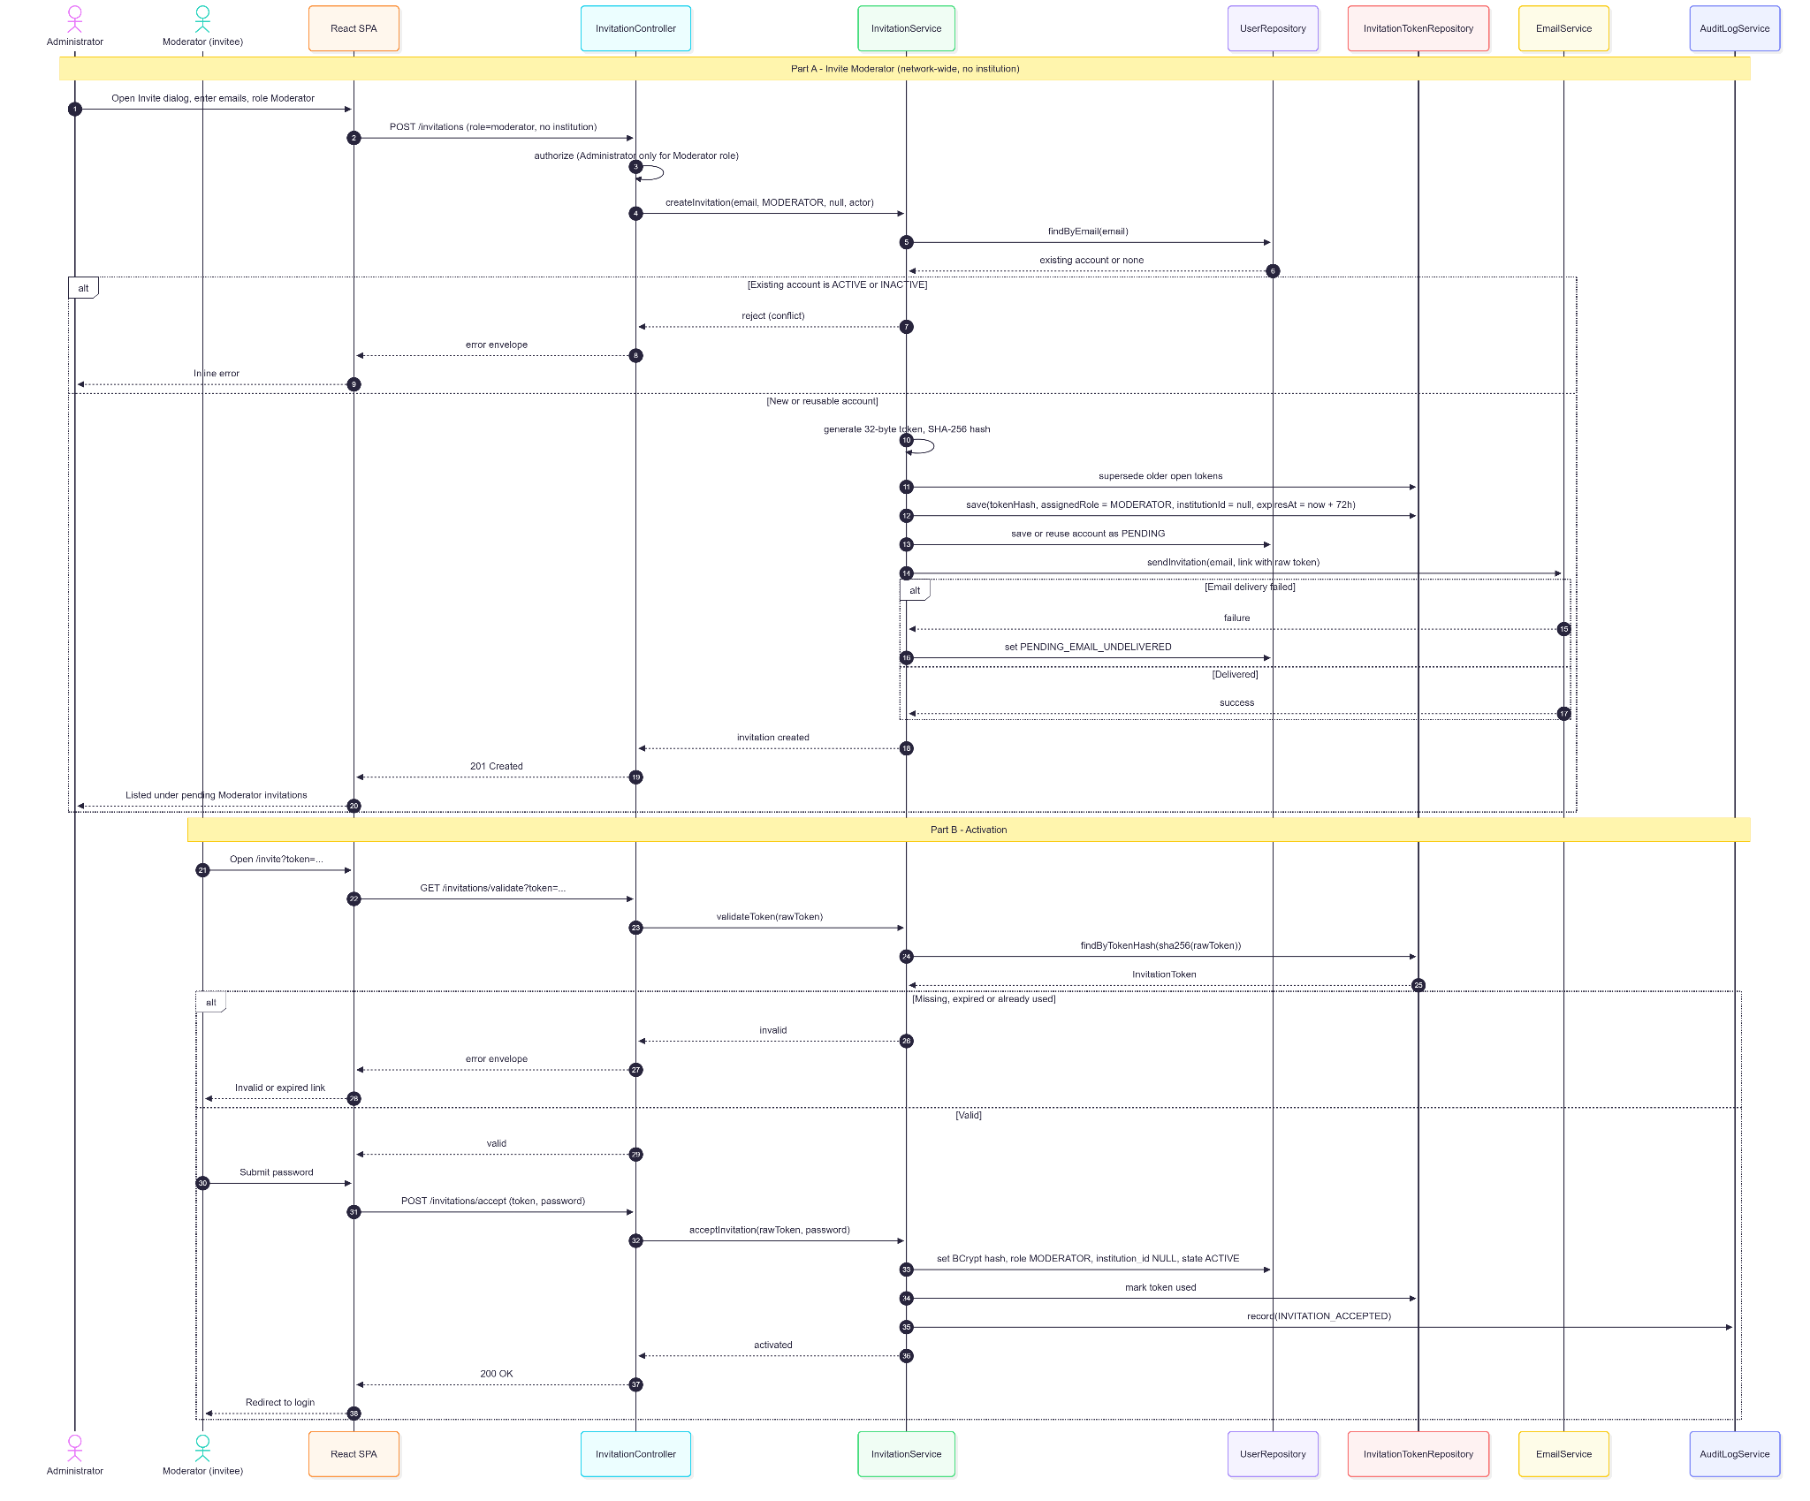

1.10.5. Data Design
- Entity Relationship Diagram
- Schema

-- UC-1.10 reuses users and invitation_tokens (UC-1.1) and review_locks (UC-2.4);
-- no new tables. Moderator accounts use role = 'moderator' with institution_id IS NULL
-- (network-wide).

-- users (columns used by Moderator account management)
CREATE TABLE users (
id UUID PRIMARY KEY DEFAULT gen_random_uuid(),
institution_id UUID REFERENCES institutions(id), -- NULL for moderators
email VARCHAR(255) UNIQUE NOT NULL,
password_hash VARCHAR(255),
display_name VARCHAR(150),
role VARCHAR(20) NOT NULL
CHECK (role IN ('contributor', 'moderator', 'admin')),
account_state VARCHAR(30) NOT NULL DEFAULT 'pending',
session_version BIGINT NOT NULL DEFAULT 0, -- incremented on deactivation / role change
pending_promotion_role VARCHAR(20) -- 'moderator' for Contributor → Moderator
CHECK (pending_promotion_role IN ('admin', 'moderator')),
pending_promotion_requested_by UUID REFERENCES users(id),
pending_promotion_expires_at TIMESTAMPTZ, -- 72-hour confirmation window
super_admin_transfer_requested_by UUID REFERENCES users(id), -- Moderator as Admin Owner transfer target
super_admin_transfer_expires_at TIMESTAMPTZ,
invited_by_user_id UUID REFERENCES users(id),
purged_at TIMESTAMPTZ,
purged_by_user_id UUID REFERENCES users(id),
created_at TIMESTAMPTZ NOT NULL DEFAULT NOW(),
updated_at TIMESTAMPTZ NOT NULL DEFAULT NOW()
);

-- Moderator invitations carry no institution
CREATE TABLE invitation_tokens (
id UUID PRIMARY KEY DEFAULT gen_random_uuid(),
token_hash VARCHAR(64) NOT NULL,
recipient_email VARCHAR(255) NOT NULL,
assigned_role VARCHAR(20) NOT NULL
CHECK (assigned_role IN ('contributor', 'moderator', 'admin')),
institution_id UUID REFERENCES institutions(id), -- NULL for moderator invitations
created_by_user_id UUID REFERENCES users(id), -- scopes "manage own invitations"
expires_at TIMESTAMPTZ NOT NULL,
used_at TIMESTAMPTZ,
created_at TIMESTAMPTZ NOT NULL DEFAULT NOW()
);

-- Review locks released when a Moderator is deactivated or changes role
CREATE TABLE review_locks (
id UUID PRIMARY KEY DEFAULT gen_random_uuid(),
submission_id UUID NOT NULL UNIQUE REFERENCES submissions(id),
locked_by UUID NOT NULL REFERENCES users(id),
acquired_at TIMESTAMPTZ NOT NULL DEFAULT NOW(),
expires_at TIMESTAMPTZ NOT NULL -- acquired_at + 15 minutes
);

CREATE INDEX idx_users_email ON users(email);
CREATE INDEX idx_invitation_tokens_created_by ON invitation_tokens(created_by_user_id);
CREATE INDEX idx_review_locks_expiry ON review_locks(expires_at);

2. Module 2
Module 2 delivers the institution-scoped media library (upload, nested albums, AI enrichment, semantic search, lifecycle and deletion), the network-wide Moderator/Administrator approval workflow with failed-publication recovery, and automated brand watermarking at publish time.

2.1. Library Uploads & Albums

2.1.1. User Interface Design
Upload Modal (Media Repository)
Multi-file drag-and-drop accepting JPEG, PNG, WebP, GIF, MP4, MOV, and WebM up to 50 MB each, with per-file progress and inline errors. Before confirming, the actor sets an album (existing, new, nested folder path, or Auto-Match) and at least one tag; a tooltip suggests the event name as a tag. Images show a "Processing…" badge until AI processing finishes; videos are READY immediately.
Album Auto-Match (library upload)
Text-based (tag and filename overlap): confident (≥0.6) auto-fills with a reasons badge, ambiguous (≥0.3) lists up to 3 candidates, otherwise manual entry with a notice.
Album Navigation
Folder-style nested albums (parent/child) with breadcrumbs, album cards (name, asset count), rename, create, move (re-parent, cycle-guarded), and delete. A shared default-institution library is visible to all Contributors.
Move to Album
From the asset menu; an asset always belongs to exactly one album (no "unfiled" option). Cross-institution moves follow role rules.

2.1.2. Front-end Component(s)
MediaRepositoryScreen / MediaToolbar / AlbumCard / AssetCard
- Grid/list browsing and album navigation; GET /media-assets/albums, POST /media-assets/albums, POST /media-assets/albums/{id} (rename), POST /media-assets/albums/ensure-path, PATCH /media-assets/albums/{id}/parent, DELETE /media-assets/albums/{id}.
- React functional components / Signed-in route

UploadModal
- POST /media-assets/upload-url → browser PUT to R2 → POST /media-assets/upload with album and tags.
- React modal component

AlbumCombobox — shared with UC-1.7 (suggestions prop for ranked candidates).

2.1.3. Back-end Component(s)
MediaAssetController
- Upload, album, move (POST /media-assets/{id}/album), and tag endpoints (POST /media-assets/{id}/tags, DELETE /media-assets/{id}/tags/{tagId}). isAuthenticated() — all three roles.
- Spring @RestController

MediaAssetService
- Validates format/size, requires ≥1 manual tag at upload and keeps ≥1 manual tag on removal (AI tags do not count), computes SHA-256 content_hash, generates asset_code, enforces album rules (no null album, cycle guard), and applies cross-institution move rules (Contributor: own uploads, own institution or shared library; Moderator/Admin: any institution). Queues image processing; videos are marked READY without classification.
- Spring @Service

MediaStorageService — R2 presign, upload verification, proxy URL resolution.
MediaProcessingQueueService / MediaProcessingWorker
- DB-backed job queue (media_processing_jobs) with leases, retries, max_attempts, and dead letters. Job types allowed by the database (V117): RETRIEVAL_EMBEDDINGS, CLASSIFY_AND_EMBED, EMBED_IMAGE_ONLY, BUILD_SUBMISSION_CONTEXT. Status values: PENDING, PROCESSING, RETRY, COMPLETED, DEAD (default 5 attempts, app.media-processing.max-attempts). Administrators list and retry dead letters through MediaProcessingAdminController (GET/system-health/media-processing/dead-letters, POST /system-health/media-processing/dead-letters/{jobId}/retry, audited MEDIA_PROCESSING_DEAD_LETTER_RETRIED).
- Spring @Service / @Scheduled worker

AIClassificationService
- Google Gemini classification (GeminiVisionClient, model gemini-3.8-flash by default) into the 14-category taxonomy and an asset type, with description, up to 30 AI tags, and enrichment for scenes, objects, activities, OCR, people-count range, and event hypotheses. For CLASSIFY_AND_EMBED jobs it sets READY once classification and both Voyage embeddings succeed and FAILED otherwise; for RETRIEVAL_EMBEDDINGS jobs Gemini enrichment is optional and does not change readiness.
- Spring @Service

MediaImageEmbeddingService / MediaSemanticEmbeddingService
- Voyage voyage-multimodal-3.5 image embeddings and voyage-4-lite semantic text embeddings (1024 dimensions) stored in media_asset_embeddings
- Spring @Service

MediaAlbumRepository / AssetTagRepository / MediaAssetRepository
- Spring @Repository. Native queries that hydrate MediaAsset list every mapped column explicitly.

2.1.4. Object-Oriented Component(s)
- Class Diagram
- Sequence Diagram

2.1.5. Data Design
- Entity Relationship Diagram
- Schema

CREATE TABLE media_albums (
id UUID PRIMARY KEY DEFAULT gen_random_uuid(),
institution_id UUID NOT NULL REFERENCES institutions(id),
parent_album_id UUID REFERENCES media_albums(id), -- nested folders
name VARCHAR(255) NOT NULL,
created_by UUID REFERENCES users(id),
created_at TIMESTAMPTZ NOT NULL DEFAULT NOW(),
updated_at TIMESTAMPTZ NOT NULL DEFAULT NOW()
);

CREATE TABLE media_assets (
id UUID PRIMARY KEY DEFAULT gen_random_uuid(),
institution_id UUID REFERENCES institutions(id), -- NULL while STAGED; bound on submit (V73)
uploader_id UUID NOT NULL REFERENCES users(id),
media_album_id UUID REFERENCES media_albums(id),
asset_code VARCHAR(50) UNIQUE NOT NULL, -- e.g. CITU-IMG-0042
storage_url TEXT NOT NULL, -- backend proxy URL
file_name VARCHAR(255) NOT NULL,
display_title VARCHAR(255), -- editable, display-only (V90)
content_hash VARCHAR(64), -- SHA-256 duplicate detection (V92)
file_type VARCHAR(10) NOT NULL
CHECK (file_type IN ('jpeg','png','webp','gif','mp4','mov','webm')),
asset_type TEXT, -- image | video
file_size_bytes BIGINT NOT NULL,
status TEXT NOT NULL, -- STAGED | PROCESSING | READY | FAILED | DELETED
ai_category VARCHAR(50),
ai_confidence NUMERIC(5,4),
ai_description TEXT,
ai_tags TEXT[],
ai_classified_at TIMESTAMPTZ,
ai_classification_model VARCHAR(100),
ai_processing_version VARCHAR(50),
observed_scenes TEXT[], -- Gemini enrichment fields
visible_objects TEXT[],
observed_activities TEXT[],
ocr_text TEXT[],
people_count_range VARCHAR(30),
event_hypotheses JSONB,
specific_subjects TEXT[],
visual_style TEXT[],
dominant_colors TEXT[],
possible_use_cases TEXT[],
excluded_categories TEXT[],
equipment_signals TEXT[],
recognition_signals TEXT[],
visible_dates TEXT[],
visual_quality_signals TEXT[],
composition_signals TEXT[],
temporal_classification VARCHAR(30),
possible_expiration VARCHAR(80),
reclassified_at TIMESTAMPTZ,
embedding VECTOR(1024), -- legacy; superseded by media_asset_embeddings
embedding_generated_at TIMESTAMPTZ,
embedding_model VARCHAR(100),
semantic_revision BIGINT NOT NULL DEFAULT 0,
deleted_at TIMESTAMPTZ, -- soft delete
deleted_by_user_id UUID REFERENCES users(id),
purged_at TIMESTAMPTZ,
created_at TIMESTAMPTZ NOT NULL DEFAULT NOW()
);

CREATE TABLE asset_tags (
id UUID PRIMARY KEY DEFAULT gen_random_uuid(),
media_asset_id UUID NOT NULL REFERENCES media_assets(id) ON DELETE CASCADE,
label VARCHAR(50) NOT NULL,
source VARCHAR(20) NOT NULL DEFAULT 'manual', -- manual | ai
created_at TIMESTAMPTZ NOT NULL DEFAULT NOW(),
UNIQUE (media_asset_id, label)
);

CREATE TABLE media_asset_embeddings (
id UUID PRIMARY KEY DEFAULT gen_random_uuid(),
asset_id UUID NOT NULL REFERENCES media_assets(id) ON DELETE CASCADE,
embedding_type TEXT NOT NULL CHECK (embedding_type IN ('image','semantic','keyframe')),
model TEXT NOT NULL,
source_input_hash CHAR(64),
source_revision BIGINT,
processing_version VARCHAR(50),
embedding VECTOR(1024) NOT NULL,
created_at TIMESTAMPTZ NOT NULL DEFAULT NOW(),
UNIQUE (asset_id, embedding_type)
);

CREATE TABLE media_processing_jobs (
id UUID PRIMARY KEY DEFAULT gen_random_uuid(),
asset_id UUID REFERENCES media_assets(id) ON DELETE CASCADE,
submission_id UUID REFERENCES submissions(id) ON DELETE CASCADE,
job_type VARCHAR(40) NOT NULL
CHECK (job_type IN ('RETRIEVAL_EMBEDDINGS', 'CLASSIFY_AND_EMBED',
'EMBED_IMAGE_ONLY', 'BUILD_SUBMISSION_CONTEXT')),
status VARCHAR(20) NOT NULL
CHECK (status IN ('PENDING','PROCESSING','RETRY','COMPLETED','DEAD')),
attempt_count INT NOT NULL DEFAULT 0,
max_attempts INT NOT NULL,
priority SMALLINT NOT NULL DEFAULT 10,
rerun_requested BOOLEAN NOT NULL DEFAULT FALSE,
next_attempt_at TIMESTAMPTZ,
lease_until TIMESTAMPTZ,
claimed_by VARCHAR(100),
processing_version VARCHAR(50),
last_error VARCHAR(500),
completed_at TIMESTAMPTZ,
created_at TIMESTAMPTZ NOT NULL DEFAULT NOW(),
updated_at TIMESTAMPTZ NOT NULL DEFAULT NOW()
);

CREATE INDEX idx_media_assets_institution ON media_assets(institution_id) WHERE deleted_at IS NULL;
CREATE INDEX idx_media_assets_media_album_id ON media_assets(media_album_id);
CREATE INDEX idx_media_asset_embeddings_vector ON media_asset_embeddings
USING hnsw (embedding vector_cosine_ops) WITH (m = 16, ef_construction = 64);

2.2. Semantic Search & Filtering

2.2.1. User Interface Design
Media Repository Screen (/media-repository)
A grid/list of assets scoped to the actor's visibility: Contributors see their institution and the shared network-default institution; Moderators and Administrators see the whole network (Network View is always on for them) with an institution filter and institution badges. Each card shows thumbnail or video poster, asset code, editable display title, upload date, size/type, and a Processing badge or AI category. Controls: keyword/semantic search, album filter, institution filter (Moderator/Admin), sort (Newest, Oldest, Name, Size), grid/list toggle, and a result strip with match count and clearable filter chips. An empty state appears when nothing matches.
Asset Detail Panel
Media preview (lightbox zoom or video player), read-only asset code, click-to-edit title (Enter/blur saves, Escape cancels), metadata grid (filename, uploader, institution, upload date, album, size, resolution/duration, type), AI Tags with confidence, "Your tags" with add/remove, Used In history (UC-2.3), and actions: Use in New Post, Add to Existing Draft (all roles), Download, Delete.

2.2.2. Front-end Component(s)
MediaRepositoryScreen / useMediaAssets
- GET /media-assets (keyword, album, institution, sort, pagination) and GET /media-assets/search (semantic).
- React functional component / hook

AssetDetailPanel / AssetLightbox
- GET /media-assets/{id}, POST /media-assets/{id}/title, tag endpoints, history (UC-2.3).
- React functional components

AddToDraftModal
- Lists the actor's drafts and attaches via POST /submissions/{id}/assets; with no drafts, offers a new post. Reports partial success at the 10-asset limit.
- React modal component

MediaLibraryTab (composer and review picker)
- Library picker with institution filter for Moderator/Admin (defaults to the submission's institution).
- React functional component

2.2.3. Back-end Component(s)
MediaAssetController
- GET /media-assets, GET /media-assets/search, GET /media-assets/{id}, POST /media-assets/{id}/title.
- Spring @RestController

MediaAssetService
- Visibility scoping via TenantScopeService; keyword matching across filename, display title, asset code, uploader email, AI metadata, and all tags (manual and AI, batch-loaded by loadAllTagLabels). A cross-institution request outside visibility returns 404.
- Spring @Service

MediaSemanticEmbeddingService / MediaSearchCacheService
- Voyage query embedding + pgvector ranking, with keyword fallback/supplement; short-lived search result caching. Embeddings are not recomputed on tag or title edits.
- Spring @Service

2.2.4. Object-Oriented Component(s)
- Class Diagram
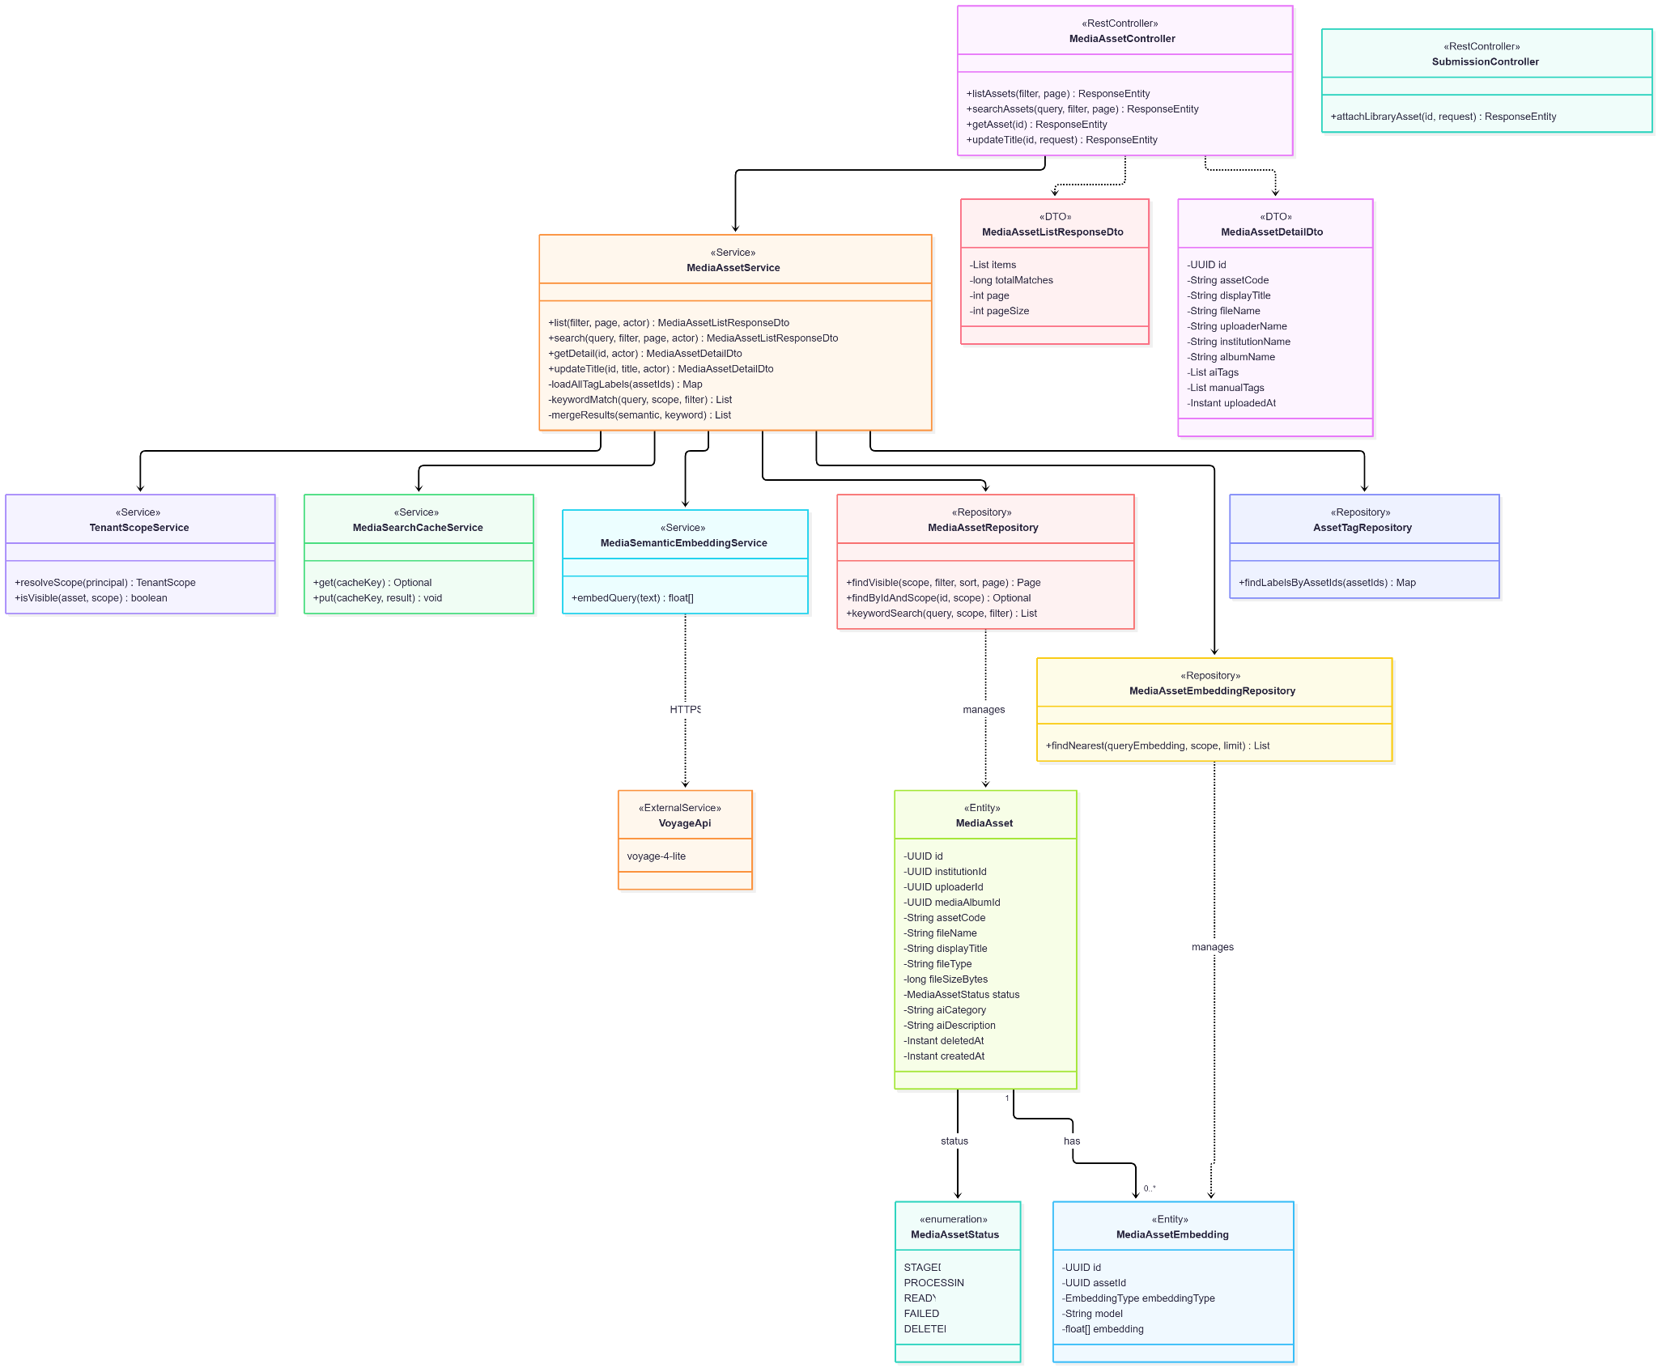
- Sequence Diagram
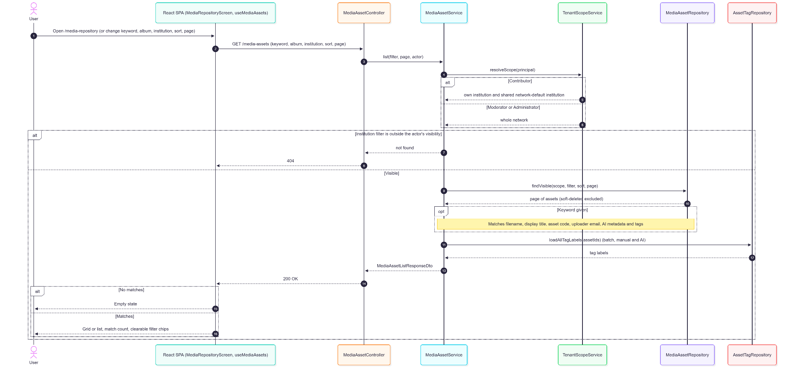
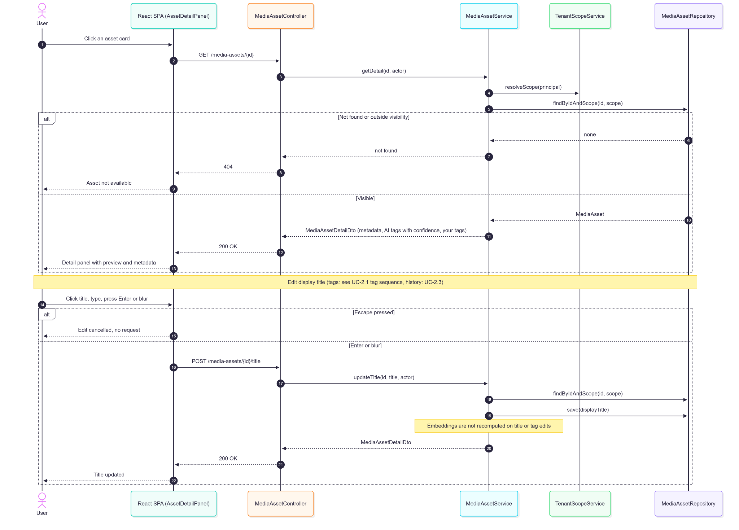
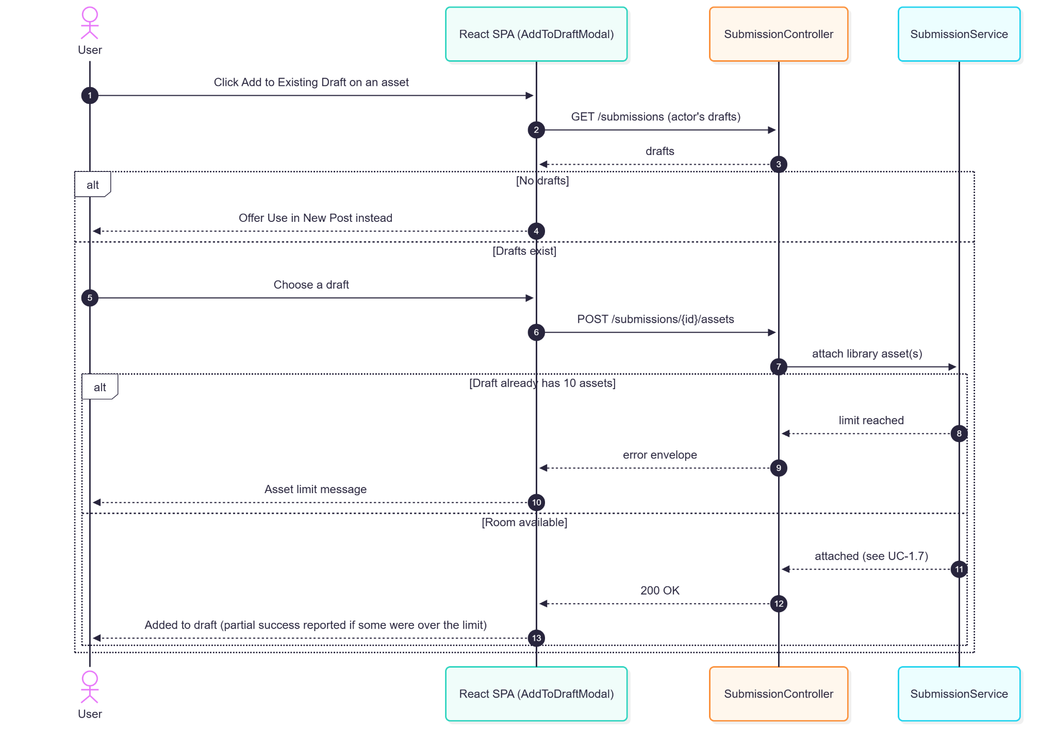

2.2.5. Data Design
- Entity Relationship Diagram
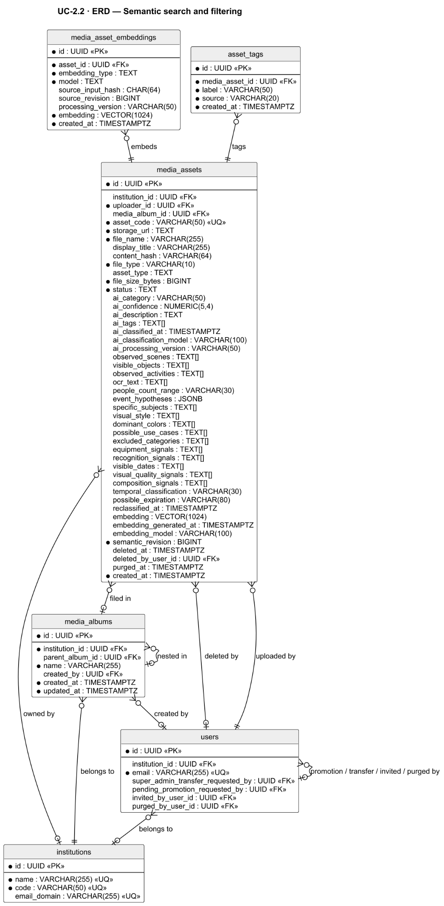
- Schema

CREATE EXTENSION IF NOT EXISTS vector; -- pgvector: semantic search
CREATE EXTENSION IF NOT EXISTS pg_trgm; -- trigram: ILIKE substring search

-- media_assets (columns searched, filtered, sorted, or shown in the detail panel)
CREATE TABLE media_assets (
id UUID PRIMARY KEY DEFAULT gen_random_uuid(),
institution_id UUID REFERENCES institutions(id), -- visibility scope / institution filter
uploader_id UUID NOT NULL REFERENCES users(id), -- uploader email is keyword-searchable
media_album_id UUID REFERENCES media_albums(id), -- album filter
asset_code VARCHAR(50) UNIQUE NOT NULL, -- keyword search
file_name VARCHAR(255) NOT NULL, -- keyword search, sort by name
display_title VARCHAR(255), -- editable title, keyword search
file_type VARCHAR(10) NOT NULL,
file_size_bytes BIGINT NOT NULL, -- sort by size
status TEXT NOT NULL, -- Processing badge until READY
ai_category VARCHAR(50), -- AI label shown on card
ai_description TEXT, -- keyword search
ai_tags TEXT[], -- AI tags with confidence in detail panel
deleted_at TIMESTAMPTZ, -- soft-deleted assets excluded
created_at TIMESTAMPTZ NOT NULL DEFAULT NOW() -- sort newest / oldest
);

-- Voyage embeddings used for meaning-based search (one row per asset per type)
CREATE TABLE media_asset_embeddings (
id UUID PRIMARY KEY DEFAULT gen_random_uuid(),
asset_id UUID NOT NULL REFERENCES media_assets(id) ON DELETE CASCADE,
embedding_type TEXT NOT NULL CHECK (embedding_type IN ('image', 'semantic', 'keyframe')),
embedding VECTOR(1024) NOT NULL,
model TEXT NOT NULL,
source_input_hash CHAR(64),
source_revision BIGINT,
processing_version VARCHAR(50),
created_at TIMESTAMPTZ NOT NULL DEFAULT NOW()
);

-- Manual and AI tags (all are keyword-searchable)
CREATE TABLE asset_tags (
id UUID PRIMARY KEY DEFAULT gen_random_uuid(),
media_asset_id UUID NOT NULL REFERENCES media_assets(id) ON DELETE CASCADE,
label VARCHAR(50) NOT NULL,
source VARCHAR(20) NOT NULL DEFAULT 'manual',
created_at TIMESTAMPTZ NOT NULL DEFAULT NOW(),
CONSTRAINT uq_asset_tags_media_asset_label UNIQUE (media_asset_id, label)
);

-- Albums (album filter and folder navigation)
CREATE TABLE media_albums (
id UUID PRIMARY KEY,
institution_id UUID NOT NULL REFERENCES institutions(id),
parent_album_id UUID REFERENCES media_albums(id),
name VARCHAR(255) NOT NULL,
created_by UUID REFERENCES users(id),
created_at TIMESTAMPTZ NOT NULL DEFAULT NOW(),
updated_at TIMESTAMPTZ NOT NULL DEFAULT NOW()
);

-- Indexes supporting search and filtering
CREATE INDEX idx_media_assets_institution ON media_assets(institution_id) WHERE deleted_at IS NULL;
CREATE INDEX idx_media_assets_status_ready ON media_assets(institution_id, status, created_at DESC)
WHERE deleted_at IS NULL;
CREATE INDEX idx_media_assets_ai_category ON media_assets(institution_id, ai_category)
WHERE deleted_at IS NULL;
CREATE INDEX idx_media_assets_media_album_id ON media_assets(media_album_id);
CREATE INDEX idx_media_assets_file_name_trgm ON media_assets USING GIN (file_name gin_trgm_ops)
WHERE deleted_at IS NULL;
CREATE INDEX idx_media_assets_asset_code_trgm ON media_assets USING GIN (asset_code gin_trgm_ops)
WHERE deleted_at IS NULL;
CREATE UNIQUE INDEX uq_media_asset_embedding_type ON media_asset_embeddings(asset_id, embedding_type);
CREATE INDEX idx_media_asset_embeddings_vector ON media_asset_embeddings
USING hnsw (embedding vector_cosine_ops) WITH (m = 16, ef_construction = 64);
CREATE INDEX idx_asset_tags_media_asset_id ON asset_tags(media_asset_id);
CREATE INDEX idx_asset_tags_source ON asset_tags(source);
CREATE INDEX idx_media_albums_parent ON media_albums(parent_album_id);
CREATE UNIQUE INDEX uq_media_albums_inst_parent_name ON media_albums (
institution_id,
COALESCE(parent_album_id, '00000000-0000-0000-0000-000000000000'::uuid),
LOWER(name)
);

2.3. Media History Tracking

2.3.1. User Interface Design
Used In Block (Asset Detail Panel)
Lists submissions referencing the asset (title, date, status badge, jump link subject to access), followed by historical reuse records for deleted submissions shown as "[Submission Deleted]". Assets removed from terminal submissions show "[Asset Deleted]".
Activity History
A per-asset, role-scoped slice of audit events (upload, title/album changes, reuse, deletion).
Delete Confirmation Modal (tiered)
- Blocked — referenced by a pending, in_review,scheduled,or publishing submission; shows the conflicting submissions with links.
- Warning — referenced only by draft/needs_revision submissions; lists affected drafts and requires "Delete Anyway" (force=true).
- Free — referenced only by terminal submissions or unreferenced; a simple confirmation.

Bulk delete applies the same tiers per asset.
Duplicate Detected
On upload, an exact SHA-256 match prompts the actor to use the existing asset or upload anyway.
Trash View (Administrator only)
Lists soft-deleted assets within the 30-day retention window with Restore, Bulk Restore, Purge, Bulk Purge, and Empty Trash.

2.3.2. Front-end Component(s)
AssetDetailPanel (Used In / history)
- GET /media-assets/{id} (usage) and GET /media-assets/{id}/history.

DeleteModal
- DELETE /media-assets/{id}?force=…, POST /media-assets/bulk-delete.
- React modal component

TrashView
- GET /media-assets/trash, POST /media-assets/trash/{id}/restore, POST /media-assets/trash/bulk-restore, DELETE /media-assets/trash/{id}, POST /media-assets/trash/bulk-purge, POST /media-assets/trash/empty.
- React functional component (Admin)

2.3.3. Back-end Component(s)
MediaAssetController — history, delete, bulk-delete, and trash endpoints (trash is hasRole('ADMIN')).
MediaAssetService
- Builds Used In (current relationships + historical MEDIA_ASSET_REUSED audit rows); tiered deletion authorization (Administrator any asset; Moderator and Contributor only assets they uploaded) and reference tiers; soft delete sets deleted_at, deleted_by_user_id, status deleted, and removes the asset's embeddings; duplicate detection by content_hash.
- Spring @Service

MediaAssetRetentionService / MediaAssetRetentionPurgeJob
- After app.media-assets.deleted-retention-days (default 30), purges R2 objects and embeddings and marks purged_at; restore is possible before purge.
- Spring @Service / @Scheduled

AuditLogService
- Media lifecycle events (MEDIA_ASSET_UPLOADED, MEDIA_ASSET_REUSED, album changes, MEDIA_ASSET_DELETED, restore/purge).

2.3.4. Object-Oriented Component(s)
- Class Diagram
- Sequence Diagram
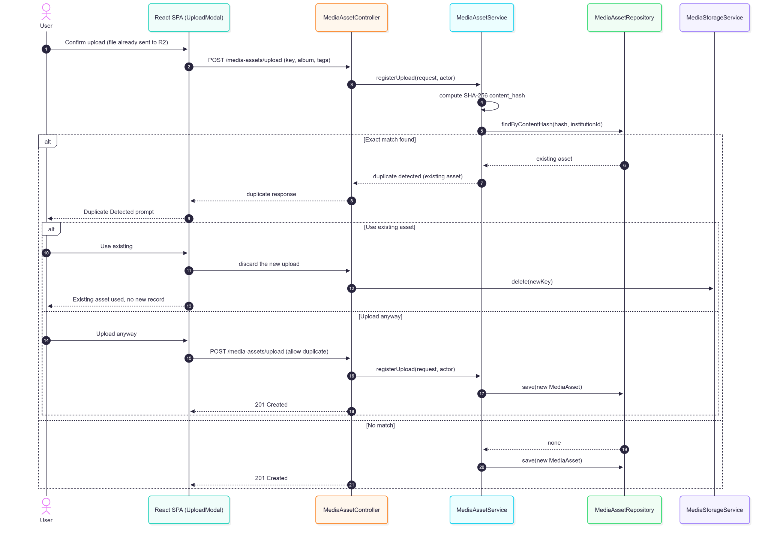

2.3.5. Data Design
- Entity Relationship Diagram
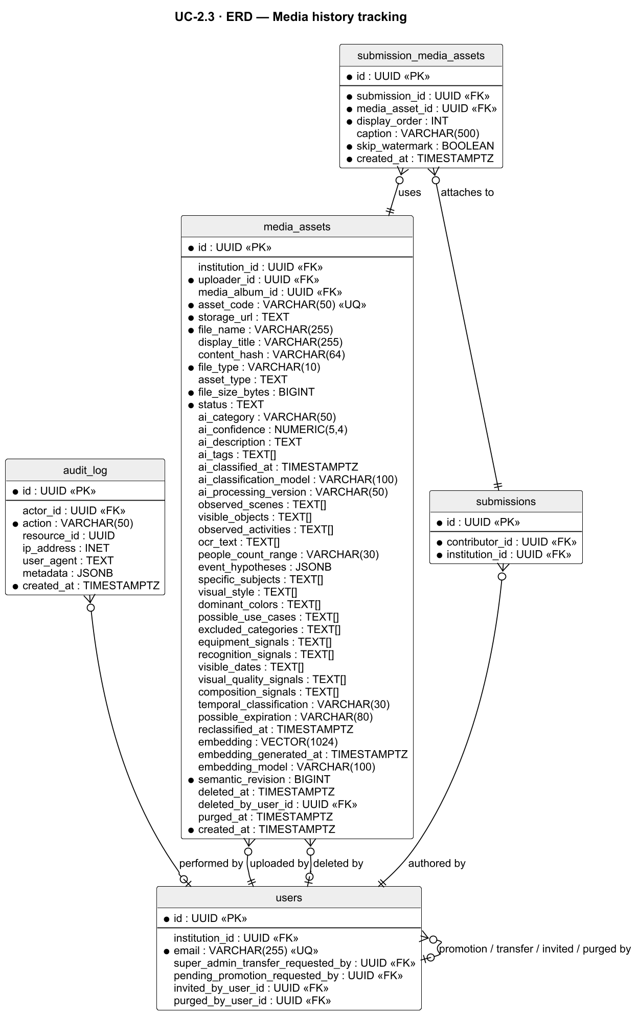
- Schema

-- media_assets (lifecycle and duplicate-detection columns)
CREATE TABLE media_assets (
id UUID PRIMARY KEY DEFAULT gen_random_uuid(),
institution_id UUID REFERENCES institutions(id), -- NULL while STAGED; bound on submit (V73)
uploader_id UUID NOT NULL REFERENCES users(id), -- Contributors may delete only their own uploads
asset_code VARCHAR(50) UNIQUE NOT NULL,
storage_url TEXT NOT NULL, -- R2 object removed at purge
file_name VARCHAR(255) NOT NULL,
status TEXT NOT NULL, -- DELETED once soft-deleted
content_hash VARCHAR(64), -- SHA-256 exact-duplicate detection
deleted_at TIMESTAMPTZ, -- soft delete; starts the 30-day window
deleted_by_user_id UUID REFERENCES users(id),
purged_at TIMESTAMPTZ, -- set when the retention job purges files
created_at TIMESTAMPTZ NOT NULL DEFAULT NOW()
);

-- Submission ↔ asset references (Used In block; determines blocked / warn / free deletion)
CREATE TABLE submission_media_assets (
id UUID PRIMARY KEY DEFAULT gen_random_uuid(),
submission_id UUID NOT NULL REFERENCES submissions(id) ON DELETE CASCADE,
media_asset_id UUID NOT NULL REFERENCES media_assets(id),
display_order INT NOT NULL DEFAULT 0,
caption VARCHAR(500),
skip_watermark BOOLEAN NOT NULL DEFAULT FALSE,
created_at TIMESTAMPTZ NOT NULL DEFAULT NOW(),
CONSTRAINT uq_submission_media_asset UNIQUE (submission_id, media_asset_id)
);

-- Media lifecycle events (upload, reuse, album change, delete, restore, purge)
CREATE TABLE audit_log (
id UUID PRIMARY KEY DEFAULT gen_random_uuid(),
actor_id UUID REFERENCES users(id),
action VARCHAR(50) NOT NULL, -- e.g. MEDIA_ASSET_REUSED, MEDIA_ASSET_DELETED
ip_address INET,
user_agent TEXT,
resource_id UUID, -- the media asset (or submission) affected
metadata JSONB, -- event details (before/after values, context)
created_at TIMESTAMPTZ NOT NULL DEFAULT NOW()
);

-- Indexes
CREATE INDEX idx_media_assets_institution_content_hash ON media_assets(institution_id, content_hash)
WHERE deleted_at IS NULL AND content_hash IS NOT NULL; -- duplicate lookup on upload
CREATE INDEX idx_media_assets_deleted_retention ON media_assets(deleted_at)
WHERE deleted_at IS NOT NULL AND purged_at IS NULL; -- trash view and retention purge
CREATE INDEX idx_submission_media_submission ON submission_media_assets(submission_id);
CREATE INDEX idx_submission_media_asset ON submission_media_assets(media_asset_id); -- Used In lookup
CREATE INDEX idx_audit_log_resource ON audit_log(resource_id, created_at DESC); -- asset history

2.4. Admin Approval Workflow

2.4.1. User Interface Design
Review Queue (/queue)
A network-wide, server-paginated queue shared by Moderators and Administrators with tabs All, Pending, In Review, Needs Revision, Scheduled, Published, Rejected, Failed. Fast-Track items sort to the top of the active tabs, then items follow the selected sort; items due within 30 minutes show a priority flag (GR-T1) but are not moved by the paginated queue. Counts appear on each tab.
Submission Details Panel
The single details surface: media (with a "failed to load" placeholder and Retry), AI tags, submitter, institution, event details, schedule, caption, and a Review History entry point. Clicking Review acquires a 15-minute lock (renewed while open); other reviewers see who holds it and a read-only view. Self-submissions cannot be reviewed. A 30-minute countdown / slot-passed banner appears for Scheduled posts nearing or past their slot.
Edit During Review
Edit caption, title, date, media (add from library, remove, reorder), tags, and schedule (Admin-only Schedule ↔ Live Event mode toggle; a static mode badge for Moderators). Review & Save shows every change with Undo before saving (with a Live Event warning); Restore original returns a field to the contributor's value; Check writing runs on demand and automatically after a caption edit.
Decisions
- Approve — scheduled, or immediate publish for Fast-Track. A passed slot requires a new slot, or an Administrator "Publish now" override.
- Request Revision — remarks of 10–1,000 characters.
- Reject — reason code (Inappropriate content, Out of scope, Duplicate event, No longer relevant, Rights or privacy, Wrong institution, Other — notes required for Other). Not final: the contributor may edit and resubmit.

Failed Tab
Lists publish_failed items with failure reason, unresolved staged photo IDs (copyable), and actions: Retry (same mode), Retry with new schedule (a missed_review item returns to pending for review), Retry as Live (Admin only), and Publish Manually — a 3-step workflow (Copy content → Open Facebook → Record details with optional URL/notes) with a 2-hour countdown and cancel confirmation.
Guides
Four view-only walkthroughs (queue, review/decision, failed publishing, moderator editing) that open what each step describes without mutating state.

2.4.2. Front-end Component(s)
ValidationQueueScreen / useValidationQueue
- GET /validation/queue/page, GET /validation/dashboard-summary, lock endpoints (GET/POST/DELETE /validation/{id}/lock), decisions (POST /validation/{id}/approve[?publishNow=true], /revise, /reject), edits (POST /validation/{id}/edit, /assets, DELETE /validation/{id}/assets/{assetId}, PATCH /validation/{id}/media/order), history (GET /validation/{id}/log).
- React functional component / Reviewer route

ReviewChangesDialog / WordDiffText
- Review & Save confirmation with per-change Undo and word-level diff.

ReviewLibraryPickerModal / ReviewAiSuggestionsModal
- Add library media and AI suggestions during review.

ResolutionRetryModal / ManualPublishWorkflowPanel
- GET /resolution/failures/page, GET /resolution/{id}, POST /resolution/{id}/retry, /retry-with-new-schedule, /retry-as-live, /manual-publish/start|complete|cancel.

SpotlightTour — review guides.

2.4.3. Back-end Component(s)
ValidationController
- Queue, lock, edit, media, decision, and log endpoints; hasAnyRole('MODERATOR','ADMIN').
- Spring @RestController

ValidationService
- Network-wide queue; unconditional self-review block; approve (snapshot original_scheduled_at, lock slot to locked, refuse a passed slot with 409 unless Admin publishNow → audited LATE_PUBLISH_OVERRIDE); request revision (remarks 10–1,000, slot released); reject (REJECTION_REASON_LABELS, revision-type reasons return 422, slot released). Edits validated against guard rails and the 10-media limit; a non-Admin changing fastTrack gets 403. Diffs are classified QUIET / FLAGGED / ADDED_MEDIA and accumulated over the whole review cycle (since the last terminal action). Contributors receive a separate edit notification (email only for FLAGGED/ADDED_MEDIA); FLAGGED/ADDED_MEDIA also notify other Administrators. Fires SubmissionApprovedEvent.
- Spring @Service

ReviewLockService / ReviewLockCleanupJob
- 15-minute lock (LOCK_DURATION_MINUTES = 15), renewal, release; expiry reverts in_review → pending.
- Spring @Service / @Scheduled

ValidationDeadlineNotificationJob / StaleSubmissionDetectorJob
- Approaching-deadline reviewer alerts (the GR-T1 flag itself is computed when the queue is read); unreviewed past slot → missed_review; the missed-review sweep skips locked submissions.

ProofreadService — advisory writing check (shared with UC-1.6).
ResolutionController / ResolutionService / ManualPublishingService / AbandonmentDetectorJob
- retry (replays the same mode; Fast-Track fires SubmissionFastTrackRetryEvent), retryWithNewSchedule (publish_failed → scheduled, resetting original_scheduled_at and moderator_reschedule_count; missed_review → pending with a new held slot; clears Fast-Track; Admin-gated when the item was Fast-Track; a hard guard-rail block needs an Administrator override reason), retryAsLiveOverride (Admin only), manual publish start/complete/cancel (published_manual, releases slot, notifies contributor), 2-hour abandonment.
- Spring @RestController / @Service / @Scheduled

AuditLogService / NotificationService — decision, edit, override, and manual-publish events; T-02, T-03, revision, edit, and T-05 notifications.

2.4.4. Object-Oriented Component(s)
- Class Diagram
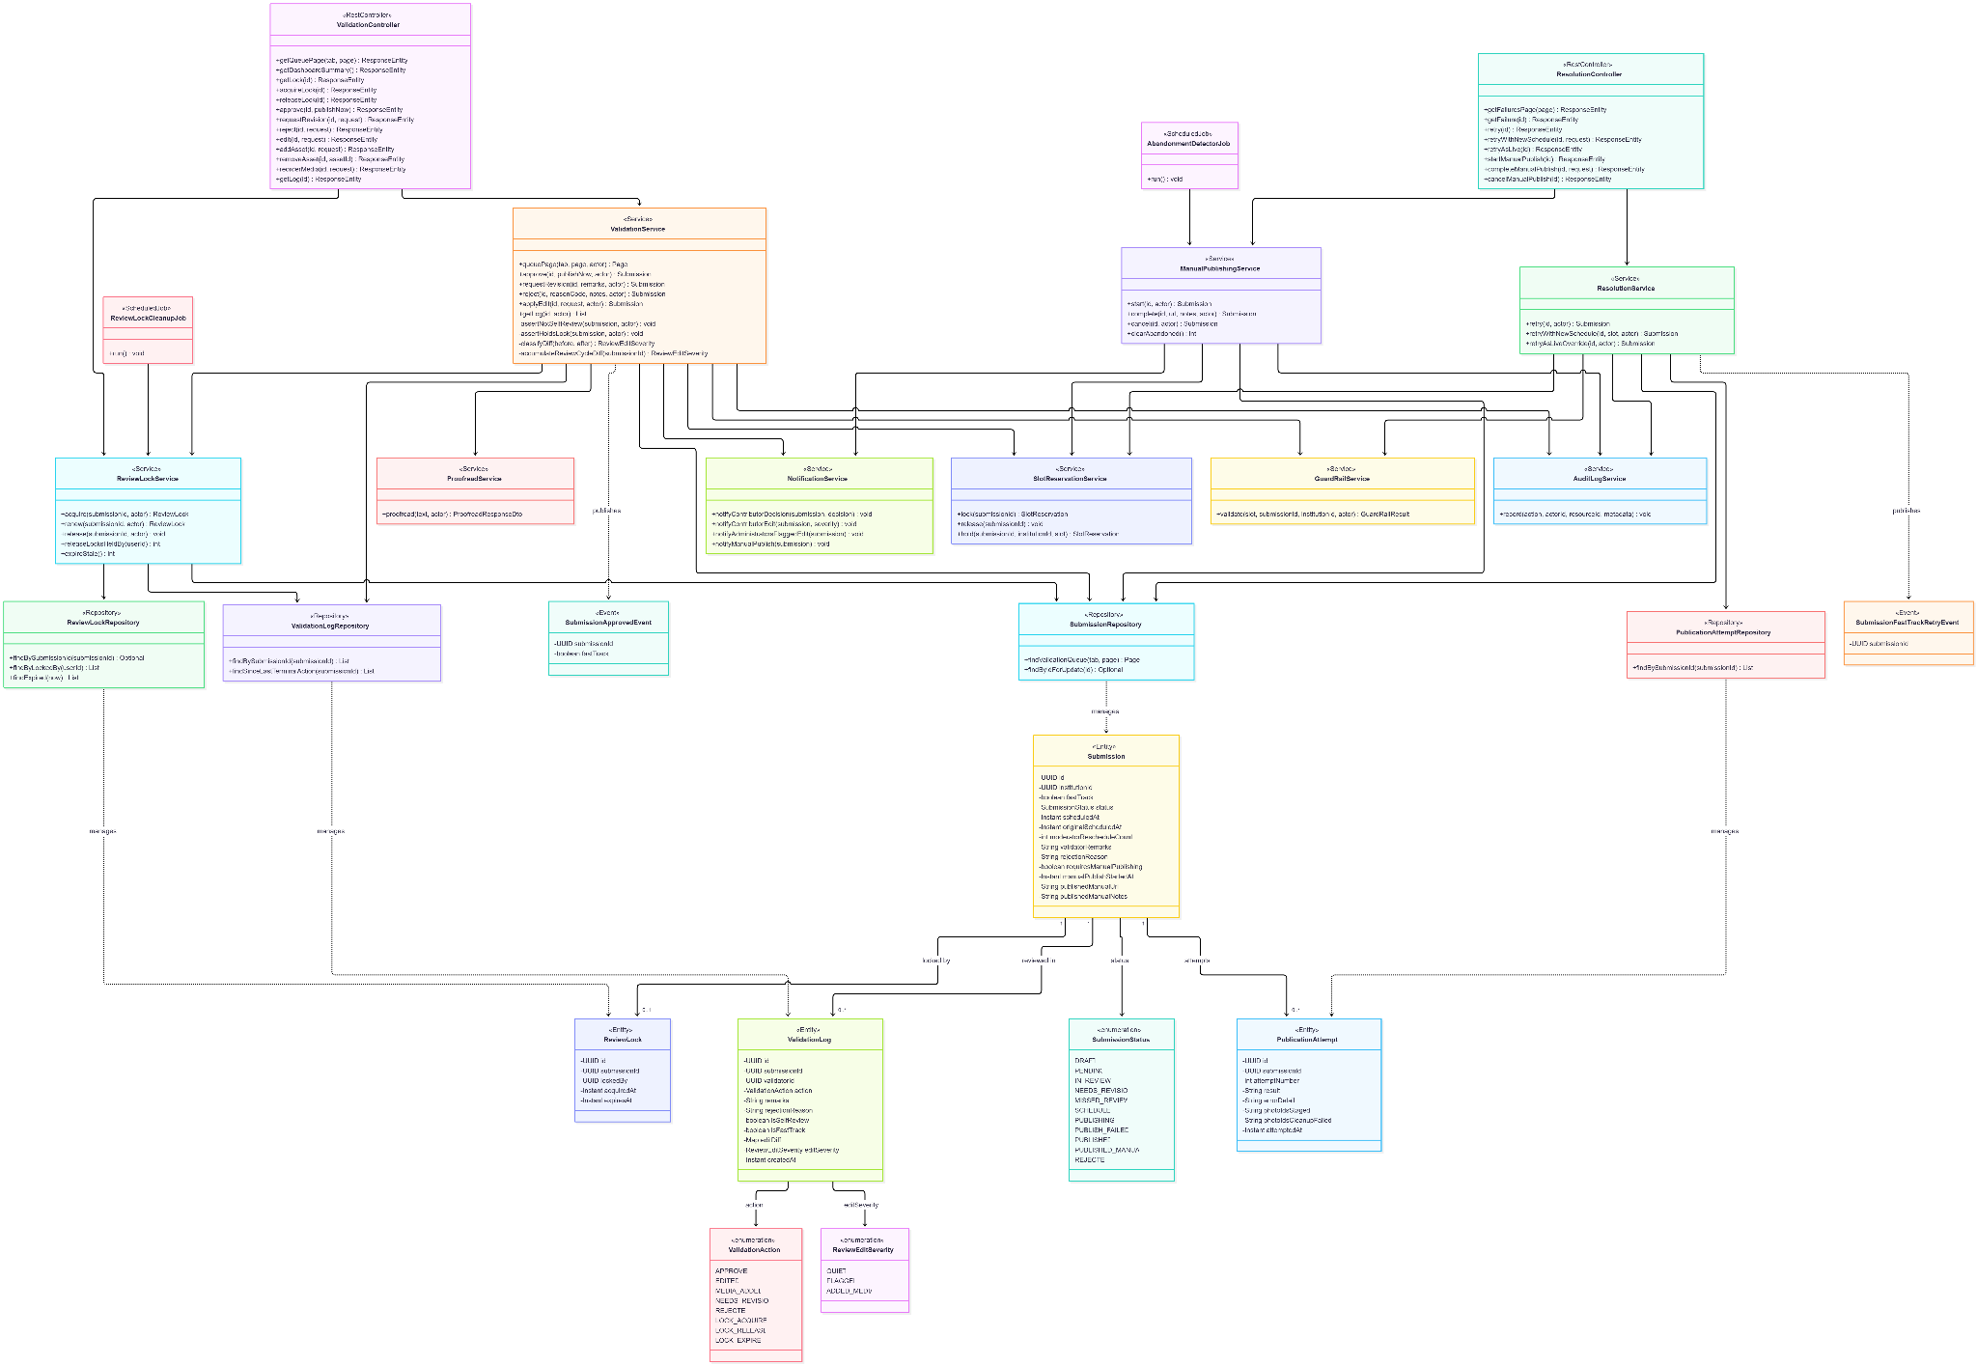
- Sequence Diagram
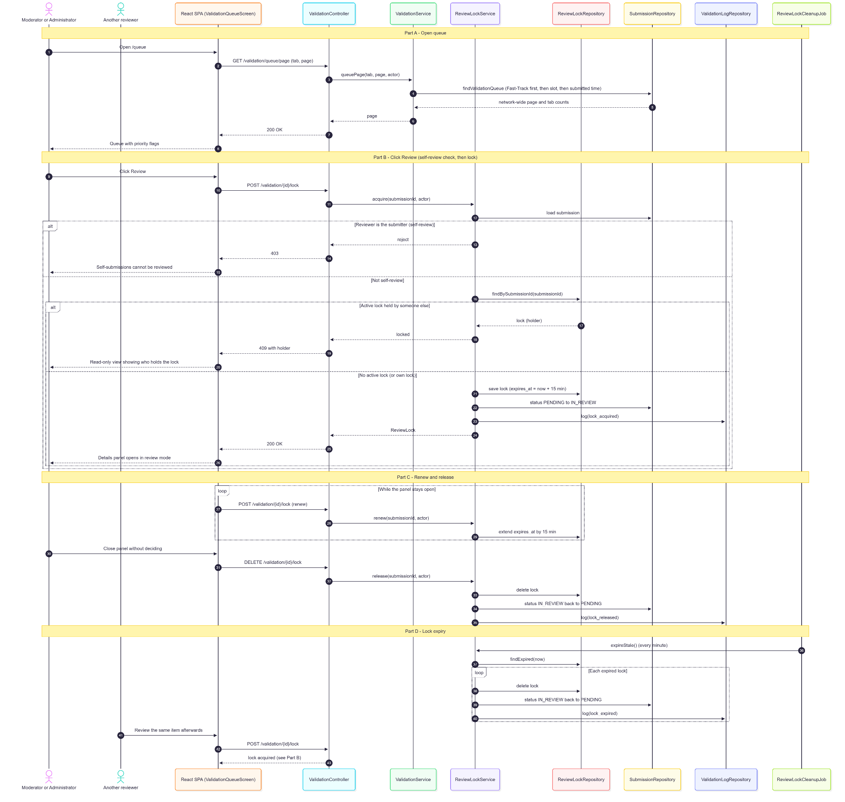
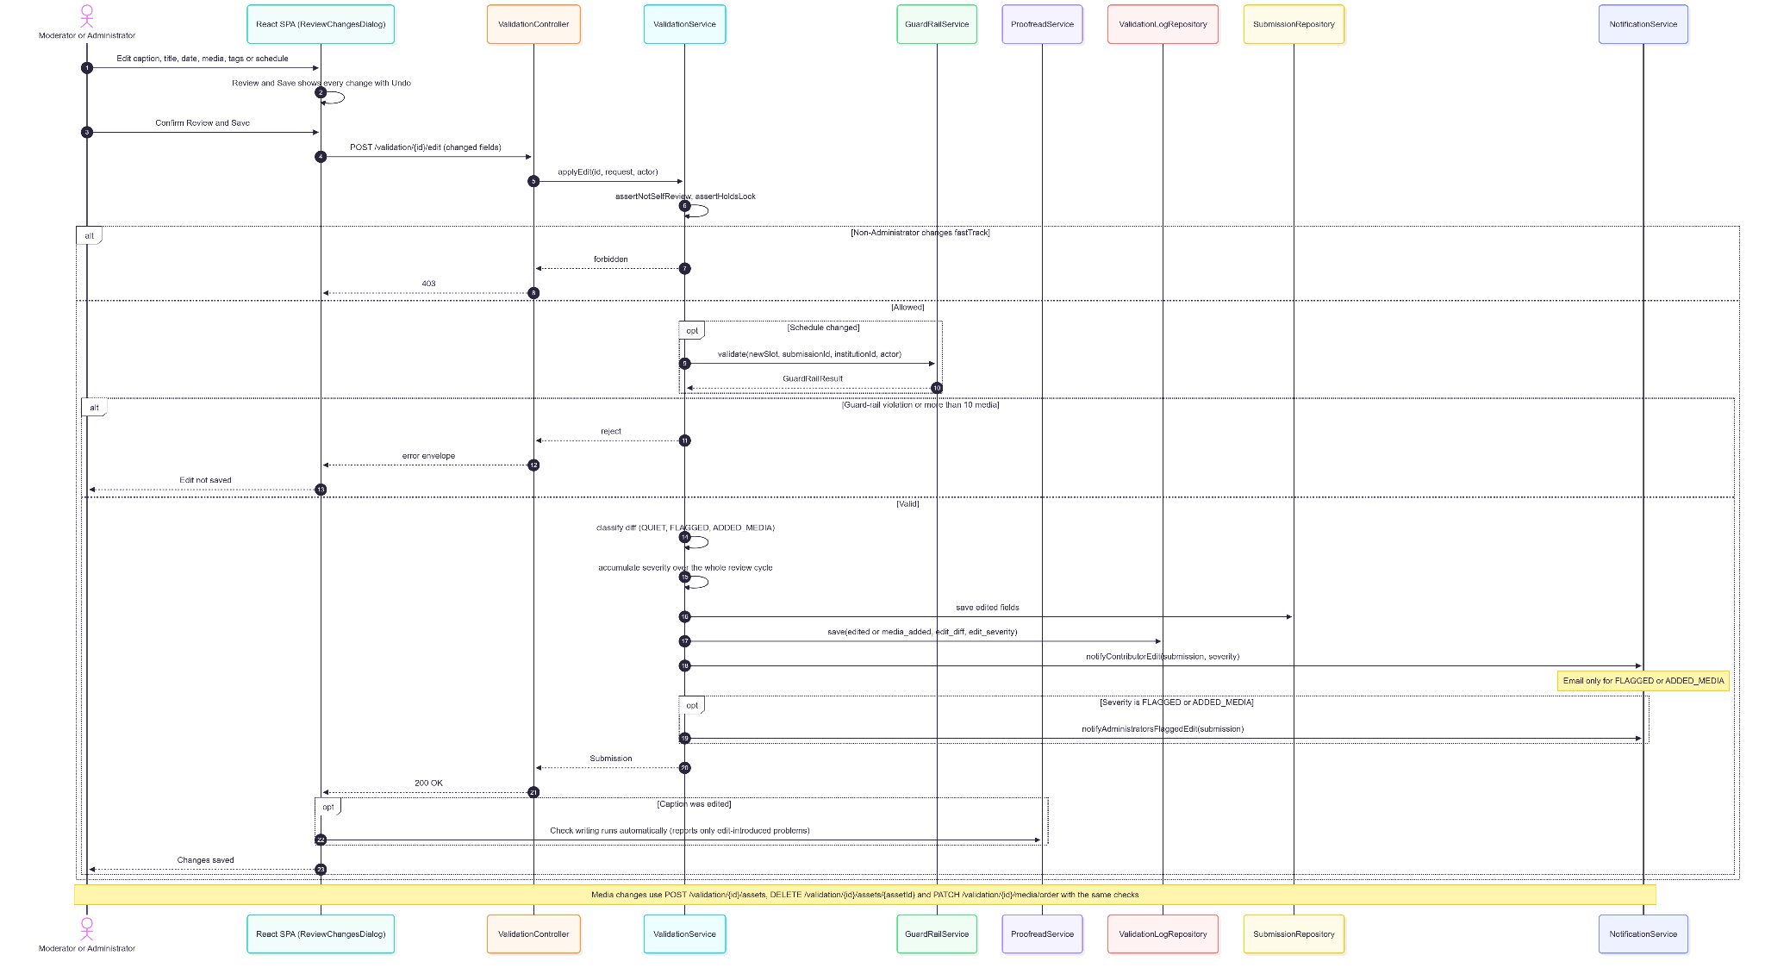
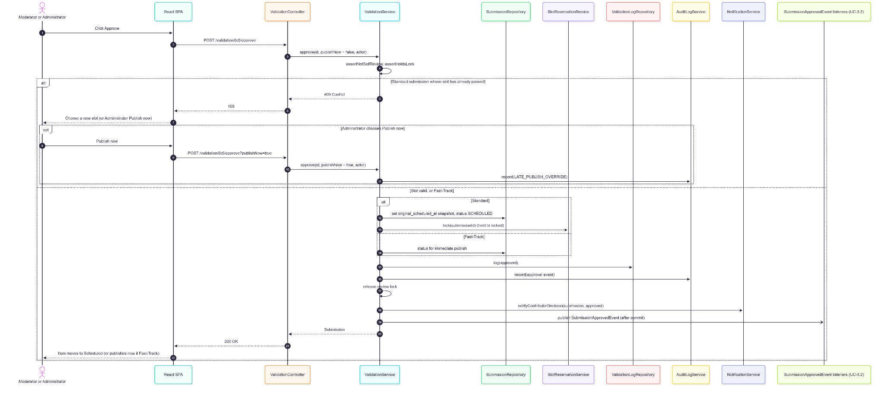
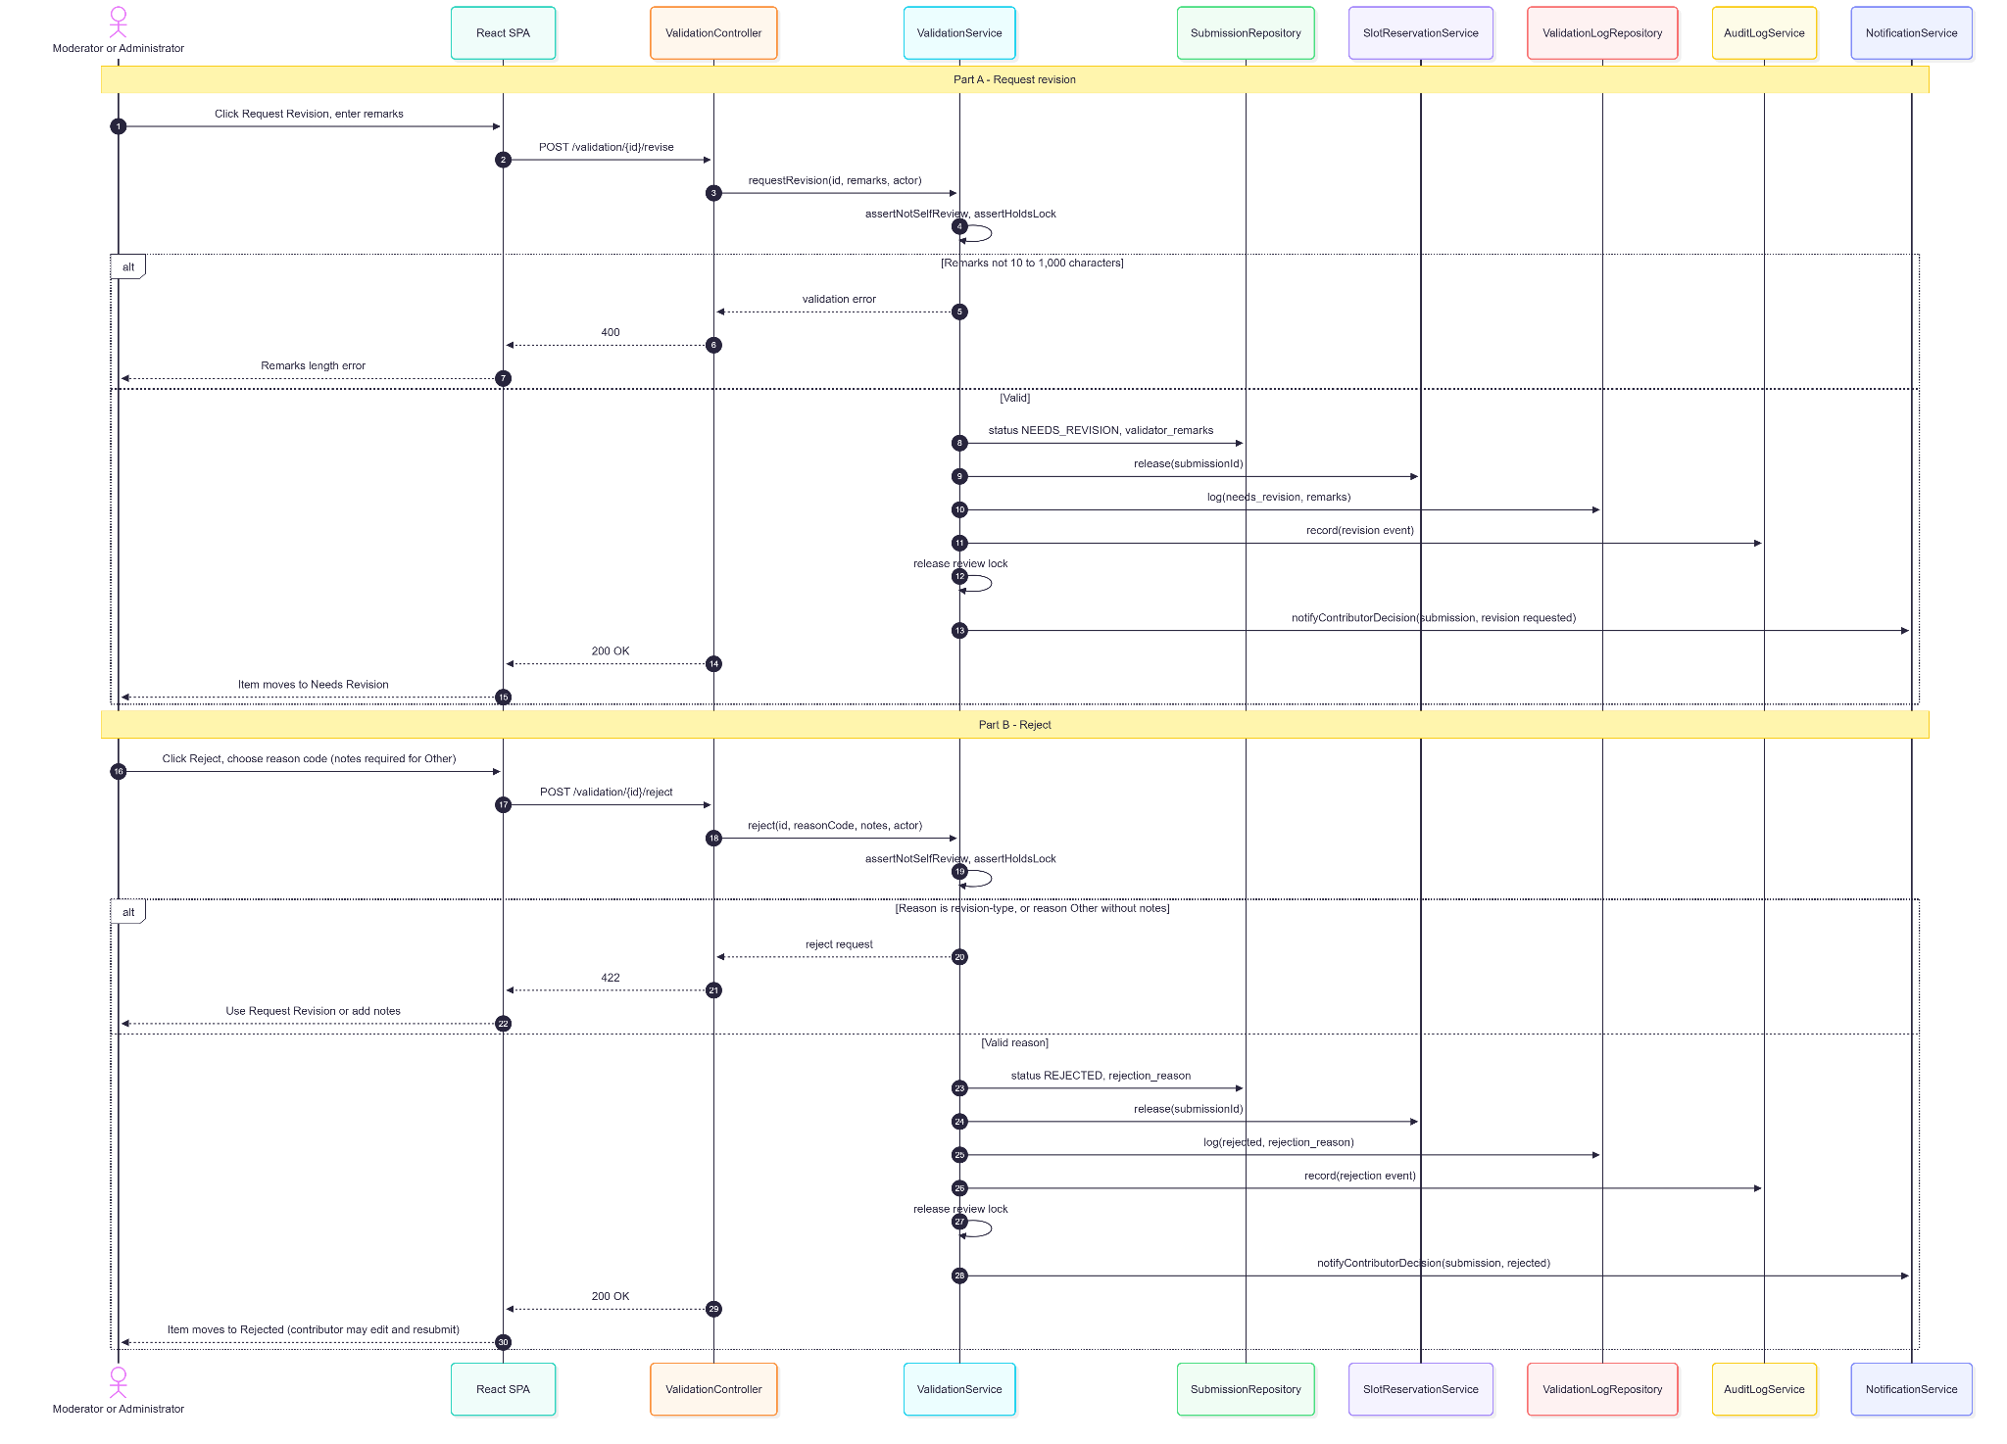
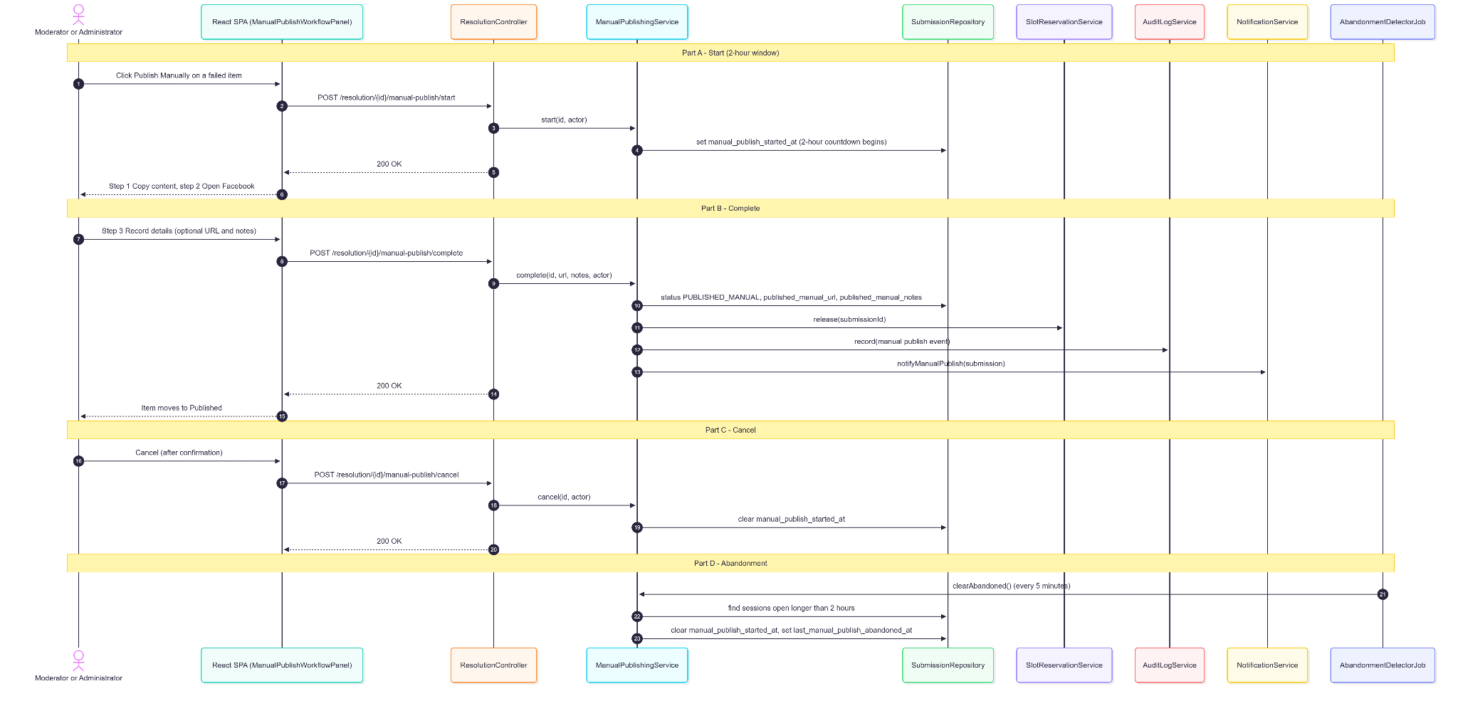

2.4.5. Data Design
- Entity Relationship Diagram
- Schema

CREATE TABLE review_locks (
id UUID PRIMARY KEY DEFAULT gen_random_uuid(),
submission_id UUID NOT NULL UNIQUE REFERENCES submissions(id) ON DELETE CASCADE,
locked_by UUID NOT NULL REFERENCES users(id),
acquired_at TIMESTAMPTZ NOT NULL DEFAULT NOW(),
expires_at TIMESTAMPTZ NOT NULL -- acquired_at + 15 minutes, renewed while open
);

CREATE TABLE validation_logs (
id UUID PRIMARY KEY DEFAULT gen_random_uuid(),
submission_id UUID NOT NULL REFERENCES submissions(id) ON DELETE CASCADE,
validator_id UUID NOT NULL REFERENCES users(id),
action VARCHAR(30) NOT NULL, -- approved | edited | media_added | needs_revision |
-- rejected | lock_acquired | lock_released | lock_expired ...
remarks TEXT,
rejection_reason VARCHAR(100),
is_self_review BOOLEAN NOT NULL DEFAULT FALSE,
is_fast_track BOOLEAN NOT NULL DEFAULT FALSE,
edit_diff JSONB, -- before/after field diff
edit_severity VARCHAR(20) CHECK (edit_severity IN ('QUIET','FLAGGED','ADDED_MEDIA')),
created_at TIMESTAMPTZ NOT NULL DEFAULT NOW()
);

CREATE INDEX idx_review_locks_expiry ON review_locks(expires_at);
CREATE INDEX idx_validation_logs_submission ON validation_logs(submission_id, created_at DESC);
Related tables used by this use case:
-- publication_attempts (defined in UC-3.2)
CREATE TABLE publication_attempts (
id UUID PRIMARY KEY DEFAULT gen_random_uuid(),
submission_id UUID NOT NULL REFERENCES submissions(id) ON DELETE CASCADE,
attempt_number INT NOT NULL,
result VARCHAR(10) NOT NULL,
error_detail TEXT,
photo_ids_staged TEXT,
photo_ids_cleanup_failed TEXT,
attempted_at TIMESTAMPTZ NOT NULL DEFAULT NOW(),
created_at TIMESTAMPTZ NOT NULL DEFAULT NOW()
);

2.5. Automated Watermarking

2.5.1. User Interface Design
Watermark Configuration (Settings → Page Settings, Administrator only)
A transparent canvas editor with 1:1, 4:5, and 16:9 preview toggles. The Administrator adds up to 3 elements — image, text, or shape (rectangle, divider line, or gradient scrim) — dragged and resized as percentage-based coordinates, with type-specific properties (image reference, text/font, shape/color). An Enabled switch and Save button persist the network-wide configuration.

2.5.2. Front-end Component(s)
WatermarkCanvasEditor
- GET /settings/watermark (any authenticated role — every role needs it to render post previews), PUT /settings/watermark (Admin). Element images uploaded through the media presign flow.
- React functional component

2.5.3. Back-end Component(s)
WatermarkConfigurationController / WatermarkConfigurationService
- Reads/writes the single network-wide configuration (institution overrides were removed).
- Spring @RestController / @Service

WatermarkApplicationService
- Called at publish time by FacebookPublisherService: honors per-asset skip_watermark first, reads the live configuration (a missing configuration falls back to a built-in default text watermark; a disabled one publishes unwatermarked), renders elements scaled to each photo (JPEG/PNG/GIF/WebP), and writes a derivative to generated/watermarked/ in R2. Videos are never watermarked. A rendering failure publishes the original image, writes PUBLISH_WATERMARK_FAILED, and fires WatermarkApplicationFailedEvent (in-app + email to every Administrator).
- Spring @Service

GeneratedWatermarkPurgeJob / MediaStorageService
- Daily purge of derivatives older than app.watermark.generated-retention-days (default 3).
- Spring @Scheduled / @Service

2.5.4. Object-Oriented Component(s)
- Class Diagram
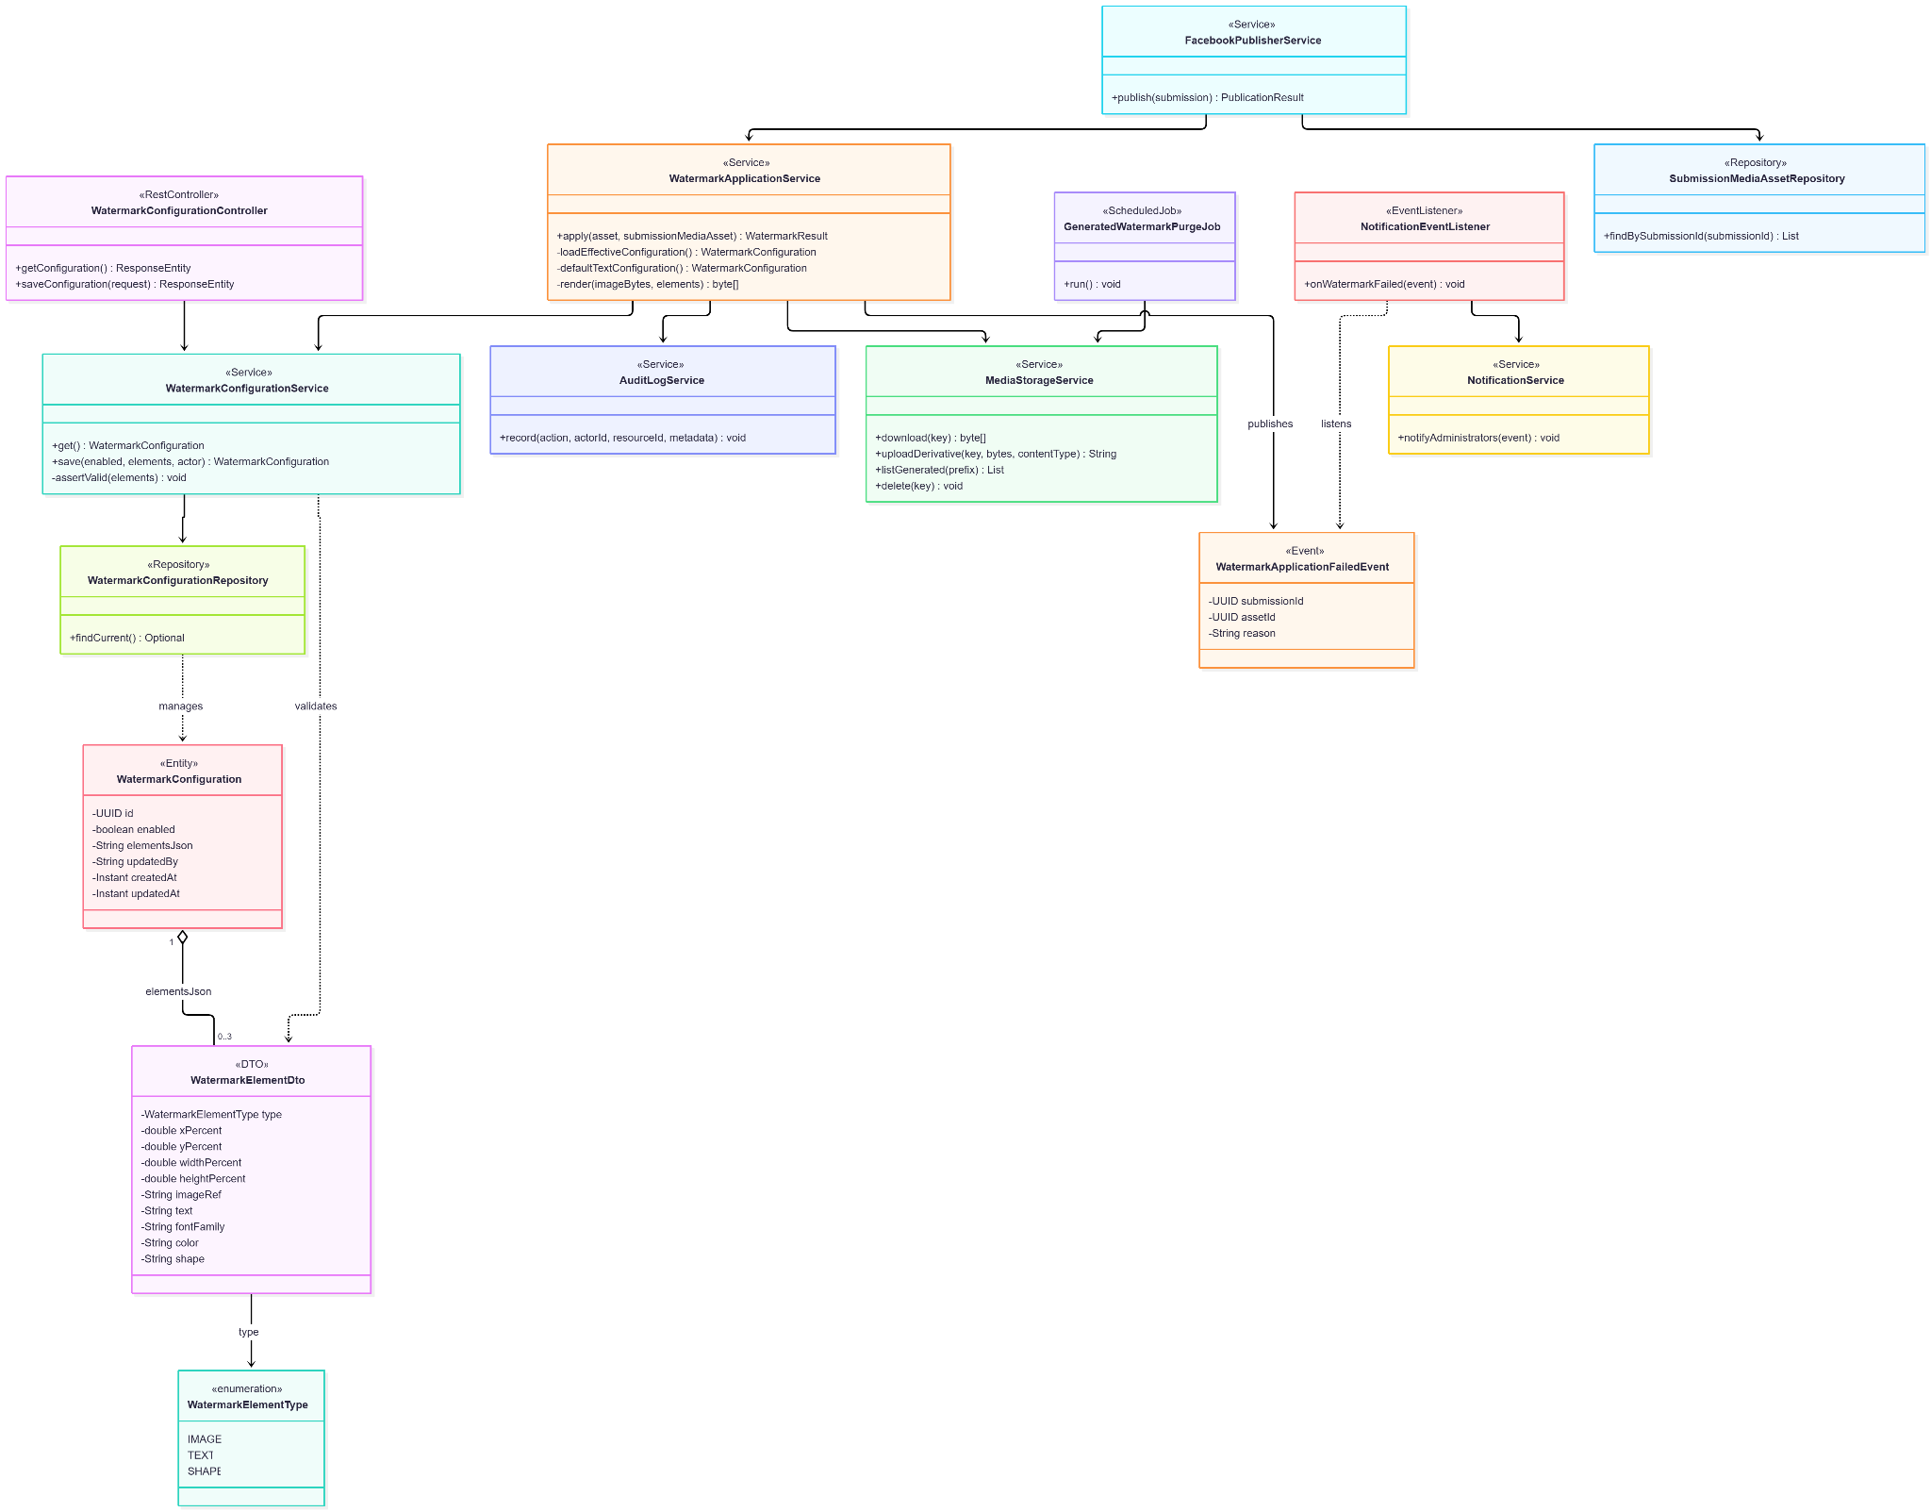
- Sequence Diagram

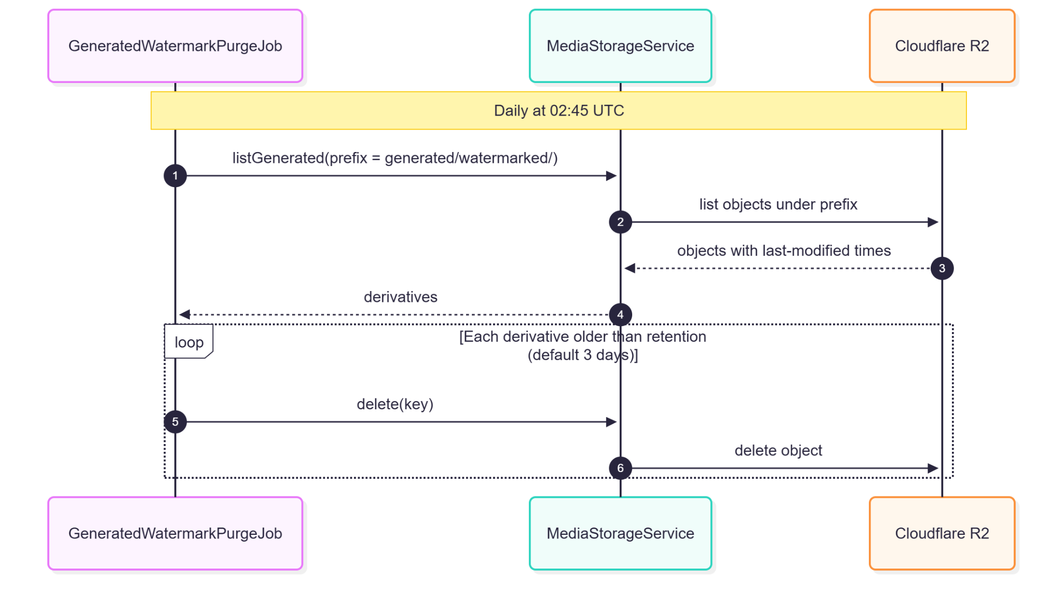

2.5.5. Data Design
- Entity Relationship Diagram
- Schema

CREATE TABLE watermark_configurations (
id UUID PRIMARY KEY DEFAULT gen_random_uuid(),
institution_id UUID REFERENCES institutions(id), -- unused; kept for FK cleanup on institution delete
enabled BOOLEAN NOT NULL DEFAULT TRUE,
elements_json TEXT NOT NULL, -- up to 3 elements, percentage geometry
updated_by VARCHAR(150),
created_at TIMESTAMPTZ NOT NULL DEFAULT NOW(),
updated_at TIMESTAMPTZ NOT NULL DEFAULT NOW()
);
Related tables used by this use case:
-- submission_media_assets (defined in UC-1.7)
CREATE TABLE submission_media_assets (
id UUID PRIMARY KEY DEFAULT gen_random_uuid(),
submission_id UUID NOT NULL REFERENCES submissions(id) ON DELETE CASCADE,
media_asset_id UUID NOT NULL REFERENCES media_assets(id),
display_order INT NOT NULL DEFAULT 0,
caption VARCHAR(500),
skip_watermark BOOLEAN NOT NULL DEFAULT FALSE,
created_at TIMESTAMPTZ NOT NULL DEFAULT NOW(),
UNIQUE (submission_id, media_asset_id)
);

3. Module 3
Module 3 delivers the role-scoped master calendar and rescheduling, the automated Facebook publishing pipeline, the notification system, social engagement analytics, the Administrator System Health dashboard, and the Audit Log.

3.1. Master Calendar Visibility

3.1.1. User Interface Design
Calendar Screen (/calendar)
FullCalendar month and week views with a toolbar and legend. Cards are color-coded by state (Pending, In Review, Scheduled, Publishing, Published, Published Manual, Publish Failed, Missed Review — each with its own color and a text label). Moderators and Administrators see every submission network-wide in full detail. Contributors see the network view with full detail for their own institution and DASIG Central Visayas, masked cards (time and institution badge only) for other institutions, and their own in-flight submissions marked as "yours".
Event Detail Modal
A read-only details drawer for the selected card (status, institution, schedule, caption with a Copy action, media). It has no reschedule action.
Reschedule Modal
Triggered only by dragging a scheduled card to a new slot (Moderator/Admin); there is currently no keyboard-accessible alternative. Shows the new slot, guard-rail result, and a mandatory justification for every reschedule. Moderators are pre-checked client-side against the 2-reschedule cap and ±1-day window (from the originally approved slot); a hard block tells a Moderator to ask an Administrator, while an Administrator may override with the stated reason.

3.1.2. Front-end Component(s)
CalendarScreen / CalendarView / CalendarToolbar / CalendarLegend / CalendarStates
- GET /calendar?from=&to=; editable only for Moderator/Admin on scheduled events; handleEventDrop pre-checks Moderator caps.
- React functional components / Signed-in route

CalendarEventDetailModal
- Event detail and actions.

CalendarRescheduleModal
- PATCH /submissions/{id}/reschedule with scheduledAt, reason, and override flag; surfaces backend messages from response.data.error.

3.1.3. Back-end Component(s)
CalendarController
- GET /calendar (isAuthenticated()), PATCH /submissions/{id}/reschedule (hasAnyRole('ADMIN','MODERATOR')).
- Spring @RestController

CalendarService
- Role projection: Moderator/Admin → full network calendar; Contributor → masked network view plus own in-flight submissions.
- Spring @Service

SubmissionService.reschedule / GuardRailService / SlotReservationService
- Server re-validation (must still be scheduled; Moderator cap and window; guard rails). Admin override reserves via reserveLockedSlot(..., adminOverride = true). The write is an atomic conditional update (claimModeratorReschedule / claimAdminReschedule); a claim that affects ≠ 1 row returns 409. Notifies the contributor (T-10) and audits the reschedule/override.
- Spring @Service

3.1.4. Object-Oriented Component(s)
- Class Diagram
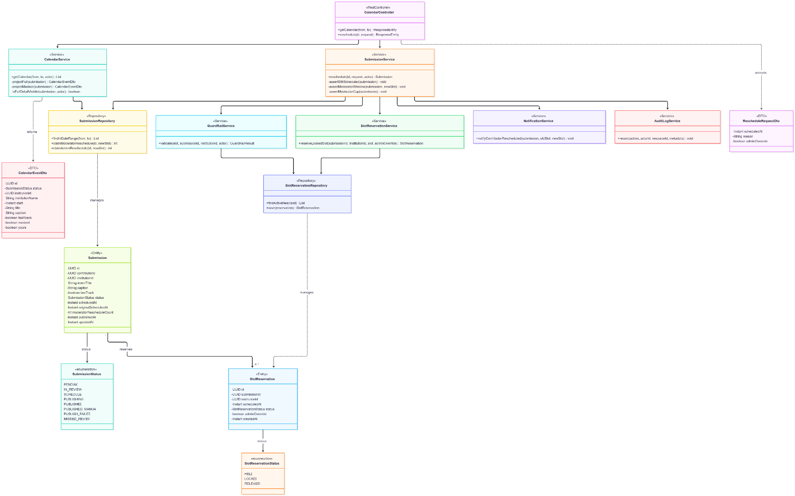
- Sequence Diagram

3.1.5. Data Design
- Entity Relationship Diagram
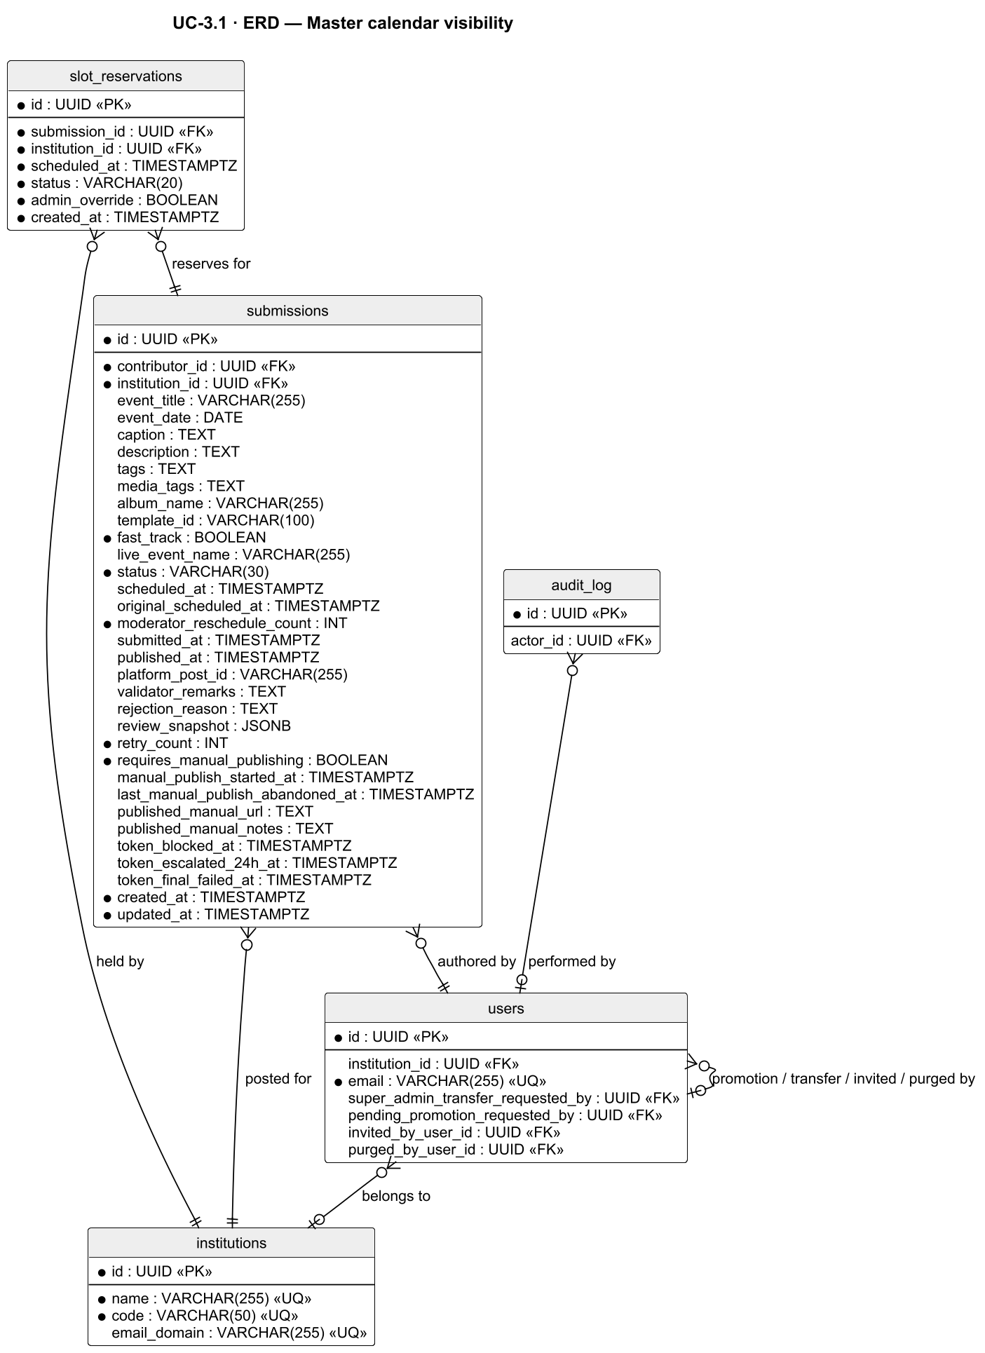

- Schema

-- submissions (columns used by calendar display and rescheduling)
CREATE TABLE submissions (
id UUID PRIMARY KEY DEFAULT gen_random_uuid(),
contributor_id UUID NOT NULL REFERENCES users(id), -- "your submission" marker; hidden on masked cards
institution_id UUID NOT NULL REFERENCES institutions(id), -- card color / masking scope
event_title VARCHAR(255), -- hidden on masked cards
caption TEXT, -- hidden on masked cards
fast_track BOOLEAN NOT NULL DEFAULT FALSE,
status VARCHAR(30) NOT NULL, -- card state; only 'scheduled' can be moved
scheduled_at TIMESTAMPTZ, -- calendar position
original_scheduled_at TIMESTAMPTZ, -- snapshot at approval; anchors the ±1-day window
moderator_reschedule_count INTEGER NOT NULL DEFAULT 0, -- Moderator cap: at most 2
published_at TIMESTAMPTZ, -- position for published cards
updated_at TIMESTAMPTZ NOT NULL DEFAULT NOW()
);

-- slot_reservations (the slot taken by a scheduled post)
CREATE TABLE slot_reservations (
id UUID PRIMARY KEY DEFAULT gen_random_uuid(),
submission_id UUID NOT NULL REFERENCES submissions(id),
institution_id UUID NOT NULL REFERENCES institutions(id),
scheduled_at TIMESTAMPTZ NOT NULL,
status VARCHAR(20) NOT NULL DEFAULT 'held'
CHECK (status IN ('held', 'locked', 'released')),
admin_override BOOLEAN NOT NULL DEFAULT FALSE, -- TRUE only for an Administrator hard-block override
created_at TIMESTAMPTZ NOT NULL DEFAULT NOW()
);

-- GR-H1: no two active reservations within 30 minutes, network-wide (V95/V96)
ALTER TABLE slot_reservations ADD CONSTRAINT excl_slot_reservations_network_buffer
EXCLUDE USING gist (
int8range(epoch_seconds_immutable(scheduled_at),
epoch_seconds_immutable(scheduled_at) + 1800, '[]') WITH &&
) WHERE (status <> 'released' AND NOT admin_override);

-- Indexes
CREATE INDEX idx_submissions_scheduled_at ON submissions(scheduled_at)
WHERE status IN ('scheduled', 'publishing', 'pending', 'in_review',
'direct_post_scheduled', 'direct_post_publishing'); -- calendar date-range query
CREATE INDEX idx_slot_reservations_slot ON slot_reservations(scheduled_at, institution_id)
WHERE status != 'released';
CREATE INDEX idx_audit_log_resource ON audit_log(resource_id, created_at DESC); -- reschedule history
The reschedule write is an atomic conditional UPDATE on submissions (claimModeratorReschedule / claimAdminReschedule) guarded on status = 'scheduled' and, for Moderators, moderator_reschedule_count < 2; the ±1-day window is checked in SubmissionService.reschedule() before the write. A result of zero rows returns 409.

3.2. Automated Facebook Post Publishing

3.2.1. User Interface Design
This use case is system-driven and has no dedicated screen. Its results are visible on the Calendar (state colors), the Submissions list, notifications, the Review Queue Failed tab (failure reason, unresolved photo IDs), and System Health (token status, job health, publish success rate).

3.2.2. Front-end Component(s)
No dedicated components. Outcomes are rendered by CalendarScreen, SubmissionListScreen, ValidationQueueScreen (Failed tab), NotificationsScreen, and SystemHealthScreen.

3.2.3. Back-end Component(s)
PublishingSchedulerJob
- Every minute: finds scheduled / direct_post_scheduled submissions due within a 5-minute lookback and claims each atomically (scheduled → publishing) via PublishingQueryService.claimForPublishing (conditional UPDATE that also bumps updated_at) before any Graph API call. No DB transaction is held open across the Graph API call.
- Spring @Scheduled

FastTrackPublishingListener
- @TransactionalEventListener(AFTER_COMMIT) on SubmissionApprovedEvent / SubmissionFastTrackRetryEvent; claims and publishes asynchronously without an enclosing transaction.
- Spring component

FacebookPublisherService
- Resolves the active Page token (findFirstByIsActiveTrue) and decrypts it; image-only posts stage each photo unpublished with its per-asset caption (watermark applied immediately before staging), then create one /feed post with attached_media; video-only posts use a single /videos call; mixed media fails immediately without retry. Up to 3 attempts with backoff. Tags already in the caption are not appended again. On success: published, platform_post_id, published_at, slot released, T-04. On failure: cleans up staged photos, records unresolved IDs in publication_attempts.photo_ids_cleanup_failed, publish_failed, T-06. Token failures suspend without consuming retries (token_blocked_at). One-time env bootstrap of the token row if the table is empty.
- Spring @Service

PublishingQueryService / PublishingStateService — short transactional reads, claims, and state writes around the publish call; PublishingStateService performs the stale-detector transitions in their own transactions.
StaleSubmissionDetectorJob
- Every 5 minutes: approved scheduled past the window → publish_failed; never-reviewed past slot → missed_review (slot released; listed in the Failed tab, where Retry with new schedule returns it to pending for review; Administrators and the Contributor are notified); stuck publishing recovery, including Fast-Track rows (scheduled_at IS NULL, updated_at older than 5 minutes); token-blocked rows excluded.
- Spring @Scheduled

TokenPublishingEscalationJob
- Every 5 minutes: retries token-blocked submissions once hasUsableActiveToken(); escalates at 24 hours and fails at 48 hours.
- Spring @Scheduled

TokenEncryptionService
- AES-256-GCM encryption of Page tokens; the key is the SHA-256 hash of FACEBOOK_APP_SECRET
- Spring @Service

PublicationAttemptRepository / SlotReservationService / NotificationService / AuditLogService

3.2.4. Object-Oriented Component(s)
- Class Diagram
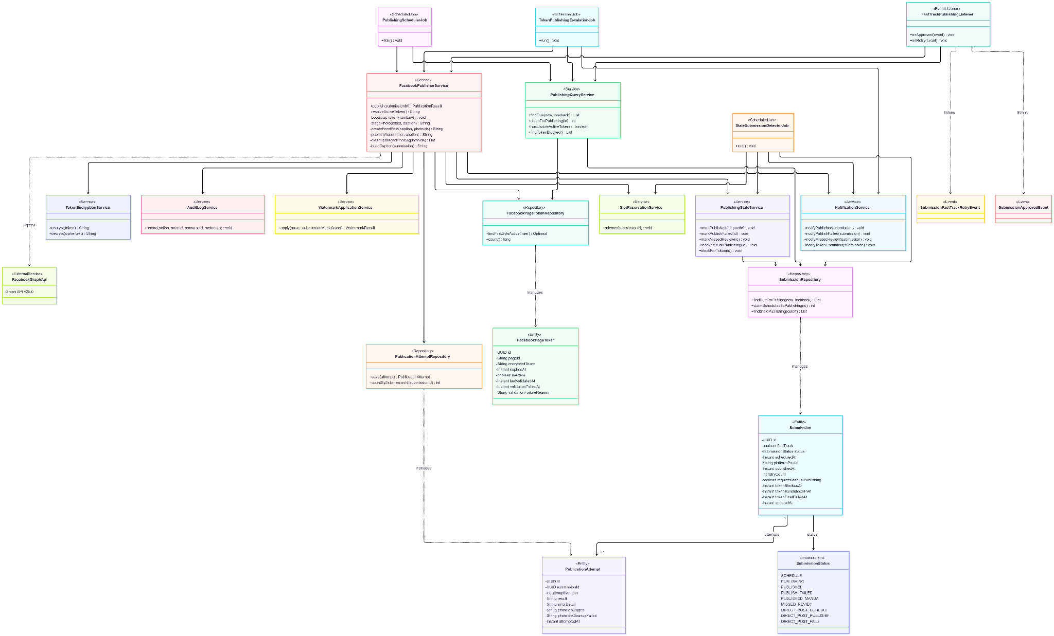
- Sequence Diagram
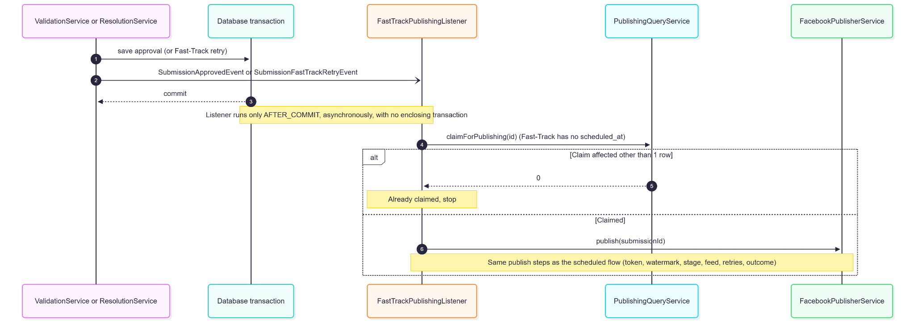
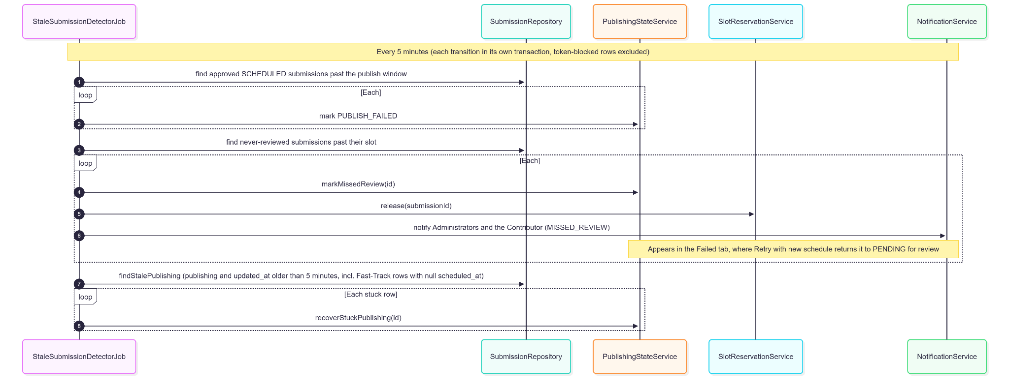

3.2.5. Data Design
- Entity Relationship Diagram
- Schema

-- Connected Facebook Page(s); exactly one row is active (DB-driven, not env-driven)
CREATE TABLE facebook_page_tokens (
id UUID PRIMARY KEY DEFAULT gen_random_uuid(),
page_id VARCHAR(50) UNIQUE NOT NULL,
encrypted_token TEXT NOT NULL, -- AES-256-GCM (IV + tag stored with ciphertext)
expires_at TIMESTAMPTZ,
is_active BOOLEAN NOT NULL DEFAULT FALSE,
last_validated_at TIMESTAMPTZ,
validation_failed_at TIMESTAMPTZ,
validation_failure_reason TEXT,
created_at TIMESTAMPTZ NOT NULL DEFAULT NOW(),
updated_at TIMESTAMPTZ NOT NULL DEFAULT NOW()
);

CREATE TABLE publication_attempts (
id UUID PRIMARY KEY DEFAULT gen_random_uuid(),
submission_id UUID NOT NULL REFERENCES submissions(id) ON DELETE CASCADE,
attempt_number INT NOT NULL,
result VARCHAR(10) NOT NULL, -- success | failed | retrying
error_detail TEXT,
photo_ids_staged TEXT,
photo_ids_cleanup_failed TEXT, -- surfaced in the Failed tab (V97)
attempted_at TIMESTAMPTZ NOT NULL DEFAULT NOW(),
created_at TIMESTAMPTZ NOT NULL DEFAULT NOW()
);

CREATE INDEX idx_submissions_due_for_publish ON submissions(scheduled_at) WHERE status = 'scheduled';
CREATE INDEX idx_pub_attempts_submission ON publication_attempts(submission_id, attempted_at DESC);
Related tables used by this use case:
-- submissions (defined in UC-1.5)
CREATE TABLE submissions (
id UUID PRIMARY KEY DEFAULT gen_random_uuid(),
contributor_id UUID NOT NULL REFERENCES users(id),
institution_id UUID NOT NULL REFERENCES institutions(id),
event_title VARCHAR(255),
event_date DATE,
caption TEXT,
description TEXT,
tags TEXT,
media_tags TEXT,
album_name VARCHAR(255),
template_id VARCHAR(100),
fast_track BOOLEAN NOT NULL DEFAULT FALSE,
live_event_name VARCHAR(255),
status VARCHAR(30) NOT NULL DEFAULT 'draft'
CHECK (status IN ('draft', 'pending', 'in_review', 'needs_revision',
'missed_review', 'scheduled', 'publishing', 'publish_failed',
'published', 'published_manual', 'admin_direct_post',
'direct_post_scheduled', 'direct_post_publishing',
'direct_post_failed', 'rejected')),
scheduled_at TIMESTAMPTZ,
original_scheduled_at TIMESTAMPTZ,
moderator_reschedule_count INT NOT NULL DEFAULT 0,
submitted_at TIMESTAMPTZ,
published_at TIMESTAMPTZ,
platform_post_id VARCHAR(255),
validator_remarks TEXT,
rejection_reason TEXT,
review_snapshot JSONB,
retry_count INT NOT NULL DEFAULT 0,
requires_manual_publishing BOOLEAN NOT NULL DEFAULT FALSE,
manual_publish_started_at TIMESTAMPTZ,
last_manual_publish_abandoned_at TIMESTAMPTZ,
published_manual_url TEXT,
published_manual_notes TEXT,
token_blocked_at TIMESTAMPTZ,
token_escalated_24h_at TIMESTAMPTZ,
token_final_failed_at TIMESTAMPTZ,
created_at TIMESTAMPTZ NOT NULL DEFAULT NOW(),
updated_at TIMESTAMPTZ NOT NULL DEFAULT NOW()
);

3.3. Automated Reminders & Alerts

3.3.1. User Interface Design
Notification Bell (global header)
An unread badge kept current through its own SSE subscription (refetches the true count on notification, read, and read-all events), with a 3-minute poll only as a dropped-connection fallback.
Notifications Screen (/notifications)
A paginated list (newest first) with event icon, message, relative time, and unread indicator; clicking navigates to the item's deep link and marks it read; "Mark All as Read" in the header; a history view for older items. Read-state changes are pushed to all of the user's open sessions.
Email Notification
A branded HTML email with a CTA deep link, sent for triggers configured with an email channel and respecting the user's channel preferences.
Messenger Notification
A Page message to Moderators/Administrators who linked Messenger (UC-1.4 A8), for T-01, T-06, and T-11.

3.3.2. Front-end Component(s)
NotificationsScreen / useNotifications
- GET /notifications, GET /notifications/history, PATCH /notifications/{id}/read, PATCH /notifications/read-all, GET /notifications/stream (SSE); applies read/read-all events idempotently.
- React functional component / hook

useNotificationUnreadCount (navbar bell)
- GET /notifications/unread-count + its own SSE subscription.
- React hook

3.3.3. Back-end Component(s)
NotificationController
- List, history, unread count, mark read, mark all read, and SSE stream.
- Spring @RestController

NotificationService / NotificationEventListener
- Resolves recipients by trigger category (review triggers → active Moderators and Administrators; content outcomes → the contributor; system/infrastructure → Administrators), persists notifications, pushes SSE to every live emitter of the recipient, dispatches email and Messenger per trigger configuration, and pushes read/read-all events after markRead/markAllRead. Each event creates its own notification, except publish failures: when more than 5 PUBLISH_FAILED audit entries occur within an hour, individual T-06 alerts are suppressed and Administrators receive one consolidated high-volume alert (GR-T6). Covers the 27 NotificationEventType values, including the named T-01–T-12 triggers. Both channels honour the recipient's in-app and email preferences (users.notify_in_app, users.notify_email).
- Spring @Service / event listener

EmailService / EmailDeliveryService
- Resend API dispatch, one attempt per email with no automatic retry; each attempt is recorded in email_delivery_log (queued, then sent or failed); email failure never blocks in-app delivery. Invitations and password resets go through EmailService and ignore the notification preference.
- Spring @Service

MessengerDeliveryService — Graph API Send API to linked recipients; unlinked recipients are silently skipped.
Scheduled triggers
- ValidationDeadlineNotificationJob (deadline alerts), TokenHealthCheckJob (T-08, T-09), EmptyScheduleWarningJob + ContentIdeaSuggestionService (T-07 with Claude-generated content ideas from cross-institution signals and the institution's 10 most recently published titles), EmbeddingFailureDigestJob (T-12).

3.3.4. Object-Oriented Component(s)
- Class Diagram
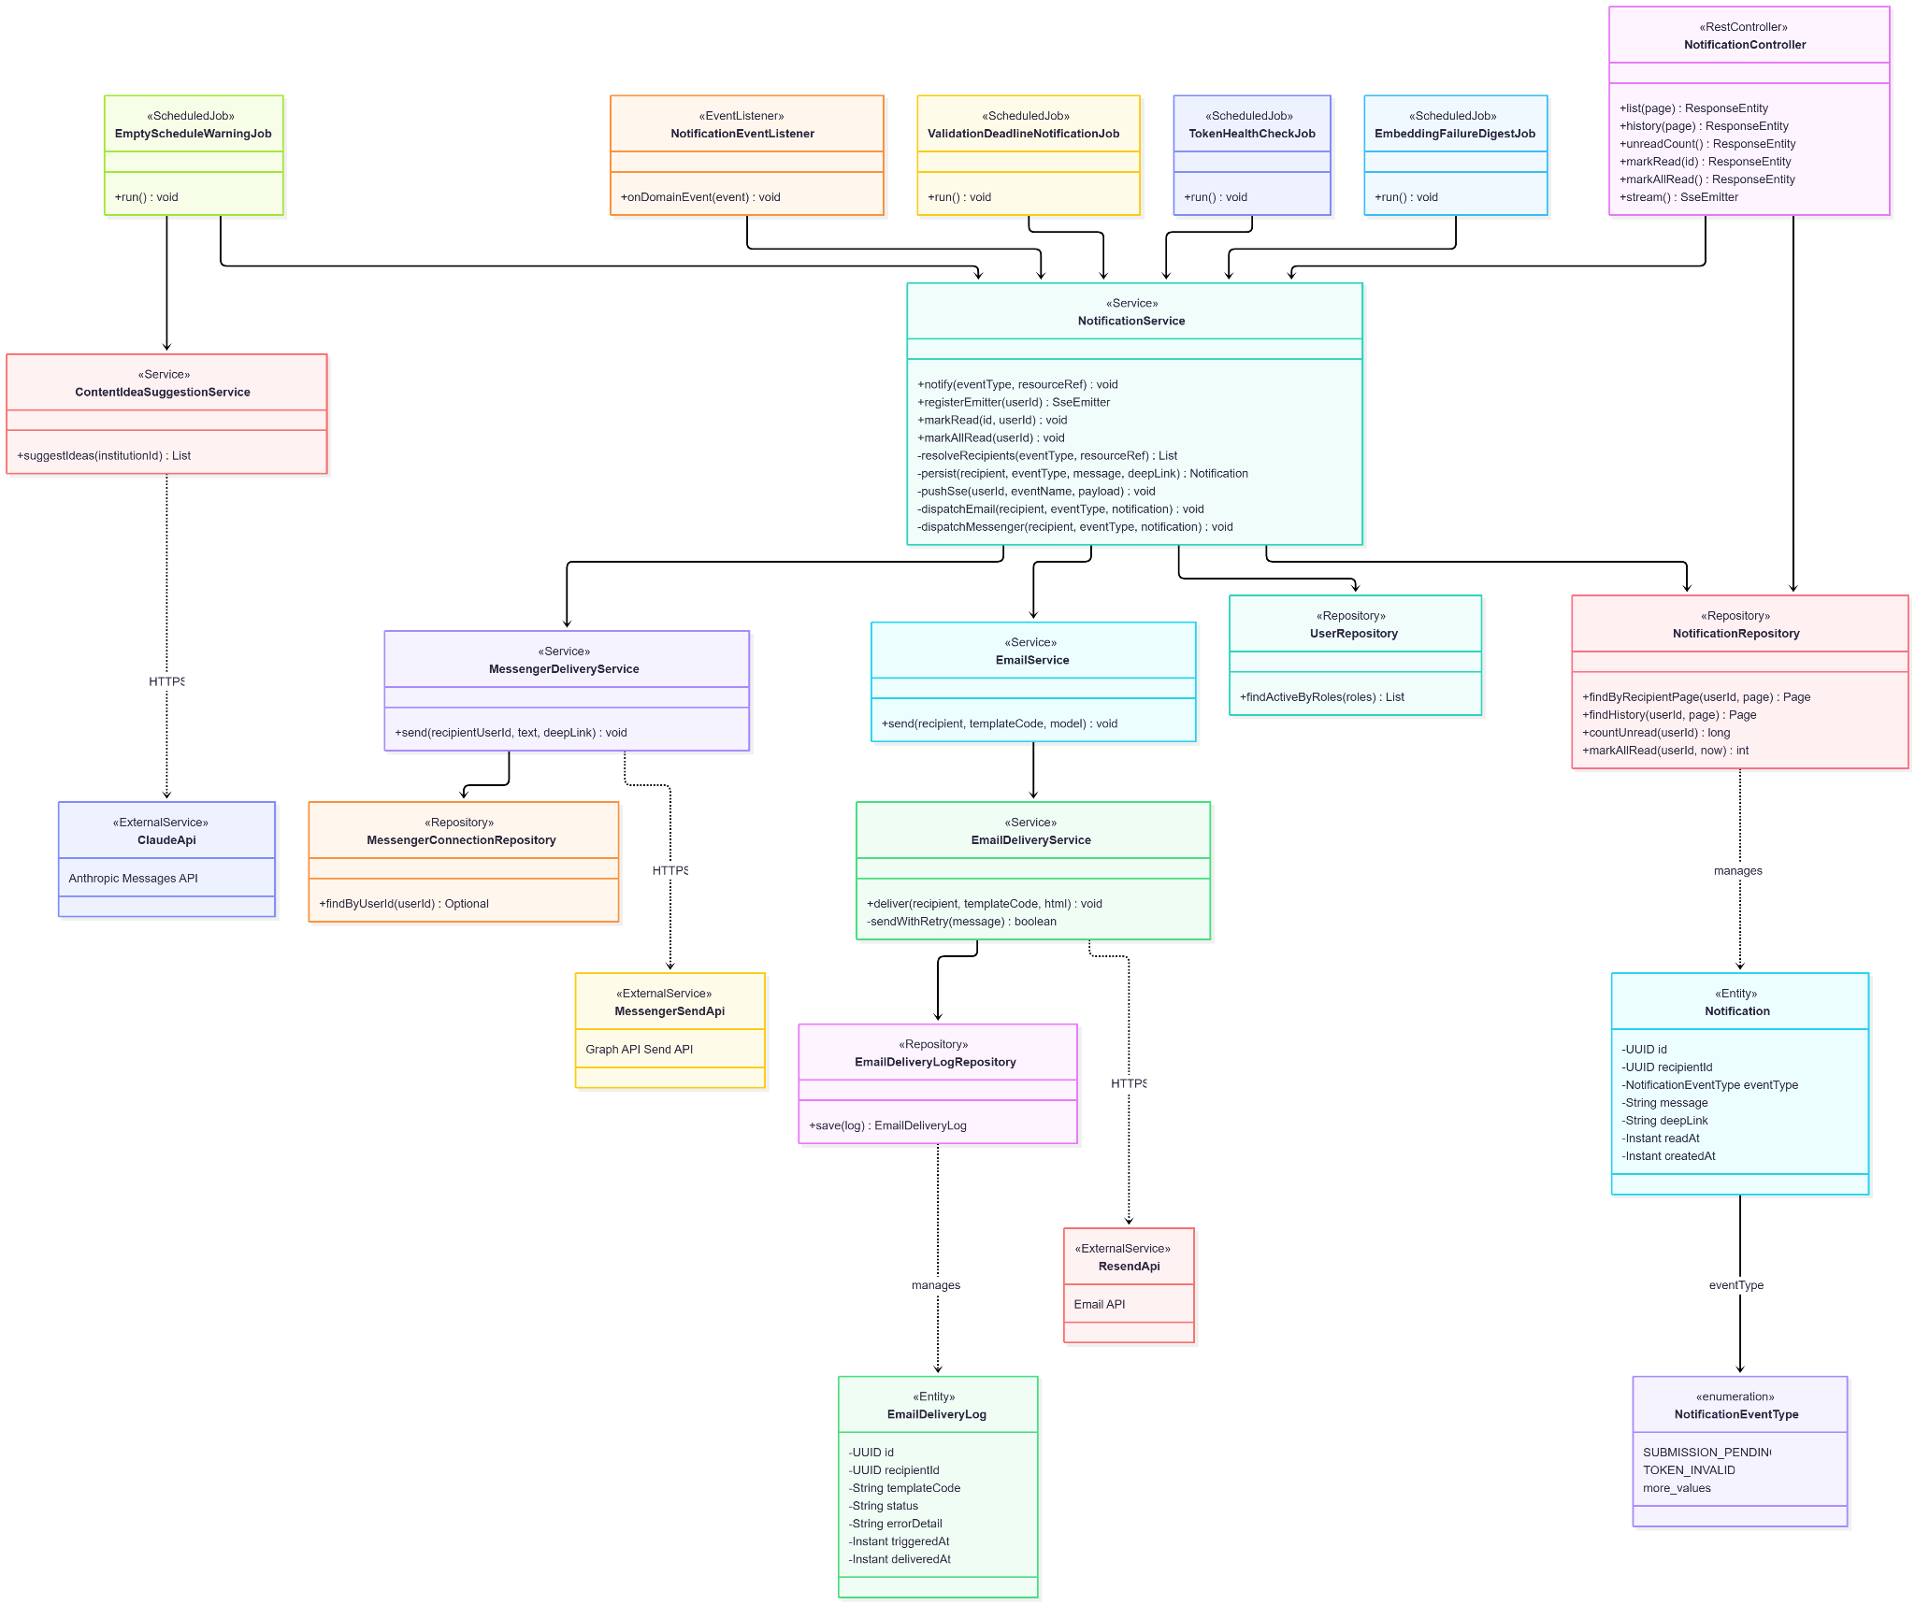
- Sequence Diagram
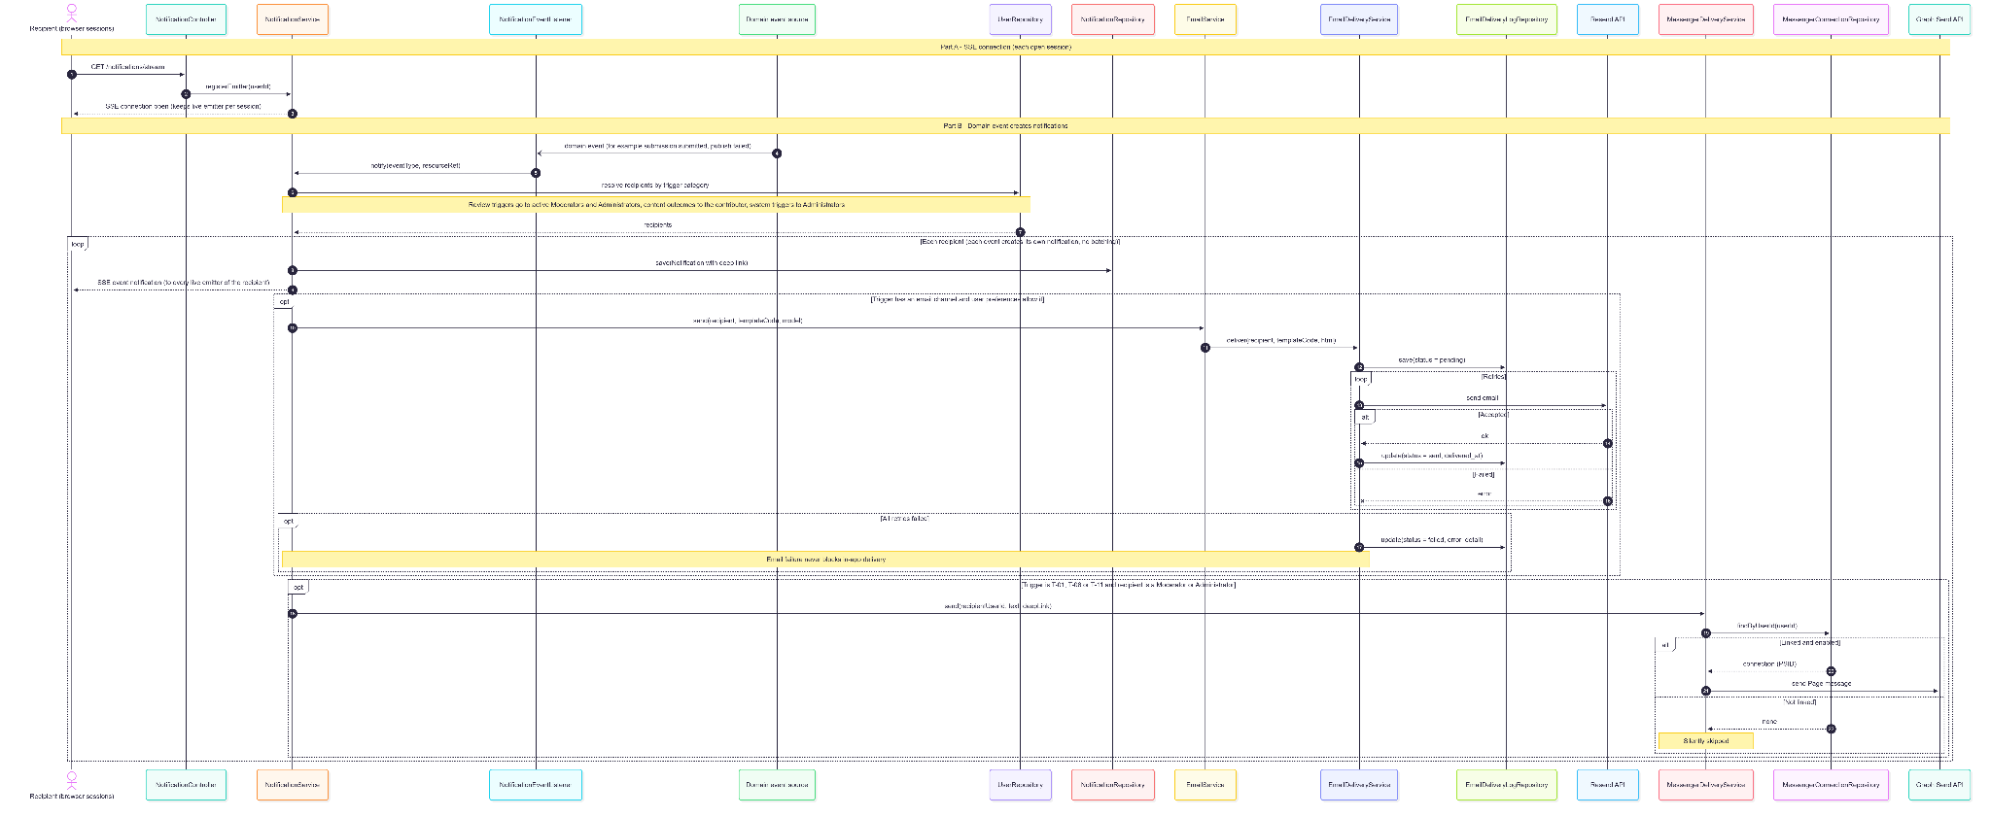
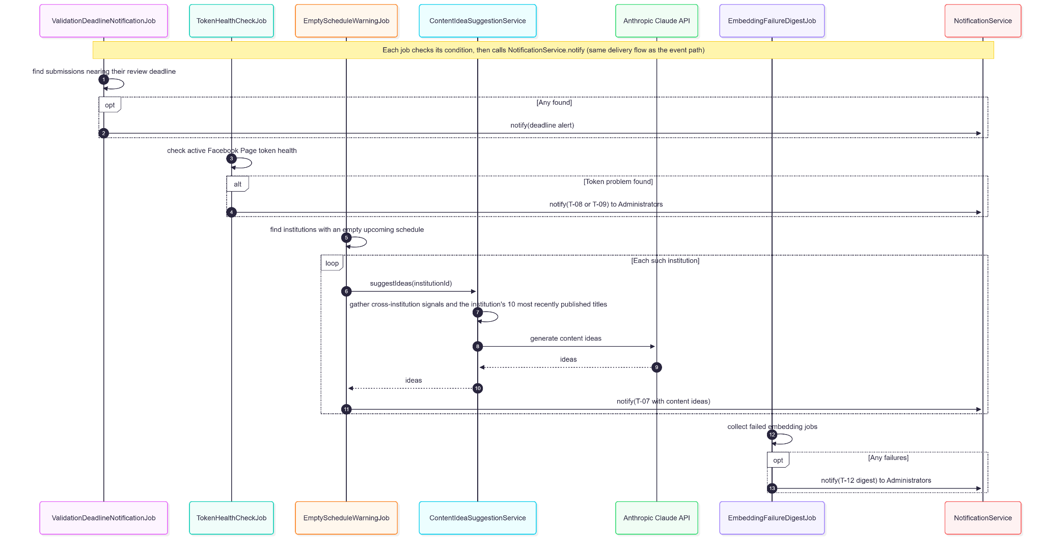

3.3.5. Data Design
- Entity Relationship Diagram
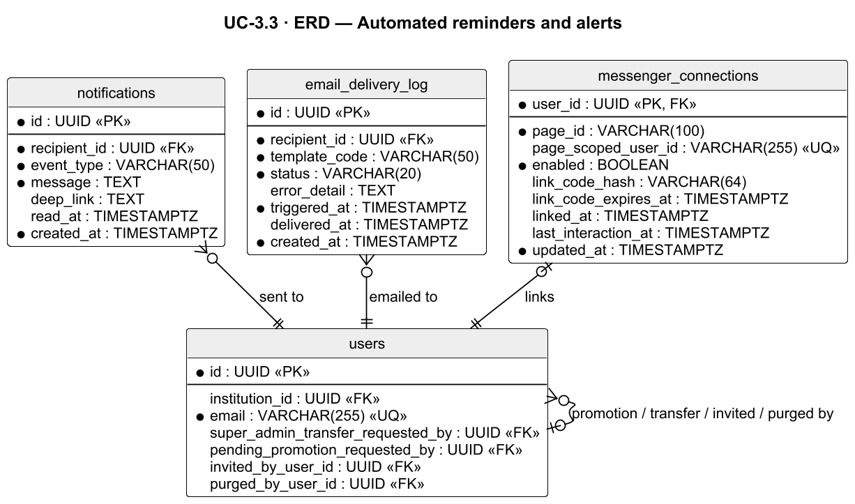
- Schema

CREATE TABLE notifications (
id UUID PRIMARY KEY DEFAULT gen_random_uuid(),
recipient_id UUID NOT NULL REFERENCES users(id),
event_type VARCHAR(50) NOT NULL, -- NotificationEventType (e.g. submission_pending, token_invalid)
message TEXT NOT NULL,
deep_link TEXT, -- in-app route of the affected resource
read_at TIMESTAMPTZ, -- NULL = unread
created_at TIMESTAMPTZ NOT NULL DEFAULT NOW()
);

CREATE TABLE email_delivery_log (
id UUID PRIMARY KEY DEFAULT gen_random_uuid(),
recipient_id UUID NOT NULL REFERENCES users(id),
template_code VARCHAR(50) NOT NULL,
status VARCHAR(20) NOT NULL, -- pending | sent | failed
error_detail TEXT,
triggered_at TIMESTAMPTZ NOT NULL,
delivered_at TIMESTAMPTZ,
created_at TIMESTAMPTZ NOT NULL DEFAULT NOW()
);

CREATE INDEX idx_notifications_recipient_created_at ON notifications(recipient_id, created_at DESC);
CREATE INDEX idx_notifications_recipient_read_at ON notifications(recipient_id, read_at);
Related tables used by this use case:
-- messenger_connections (defined in UC-1.4)
CREATE TABLE messenger_connections (
user_id UUID PRIMARY KEY REFERENCES users(id) ON DELETE CASCADE,
page_id VARCHAR(100) NOT NULL,
page_scoped_user_id VARCHAR(255) UNIQUE, -- Messenger PSID once linked
enabled BOOLEAN NOT NULL DEFAULT FALSE,
link_code_hash VARCHAR(64),
link_code_expires_at TIMESTAMPTZ, -- 10 minutes
linked_at TIMESTAMPTZ,
last_interaction_at TIMESTAMPTZ,
updated_at TIMESTAMPTZ NOT NULL DEFAULT NOW()
);

3.4. Social Engagement Analytics

3.4.1. User Interface Design
Analytics Dashboard (/analytics)
Available to all three roles with role-scoped data. A date-range picker (7d, 30d, 90d, YTD, custom) and, for Administrators only, a multi-select institution filter. The dashboard auto-refreshes every 5 minutes while visible and has a manual Refresh button.
- Executive summary and KPI tiles — Average Posting Delay, Content Completeness (95% target), Total Posts Published, each with a period-over-period delta and sparkline; clicking opens the Full Report.
- Publishing trend and status breakdown charts.
- Facebook Engagement — reach, reactions, comments, shares from the cached engagement sync, with a "pending updated figures" count and last-refresh time.
- Posts by Institution chart (Moderator/Admin, network-wide).
- Administrator only — Operational Health (including On-Time Publication with its 95% target badge), AI Feature Adoption (insufficient-data notice below 20 events), Page Performance (live Page insights, degrades gracefully), and — after drilling into one institution — Review Workload and Contributor Breakdown.

Full Report Modal
Daily-breakdown and detail-row tabs for a metric, with Export CSV; export failures show an inline error with "Retry Download".

3.4.2. Front-end Component(s)
AnalyticsDashboardPage
- GET /analytics/summary?from=&to=&institutionId=; role-aware panels.
- React functional component / Signed-in route

KpiTileGroup / ExecutiveSummaryStrip / PublishingTrendChart / StatusBreakdownPanel / StatusDonutChart / ContentIssuesPanel / RoleMetricPanel / ContributorAnalyticsView
- Shared dashboard panels.

FacebookEngagementPanel / SocialEngagementCard / PagePerformanceCard / PostsByInstitutionChart / OperationsAndEngagementCard
- Engagement and network panels.

AdminAnalyticsPanel / OperationalHealthPanel / ContributorBreakdownTable
- Administrator panels.

FullReportModal / AnalyticsDateRangePicker
- GET /analytics/report/{metric}, GET /analytics/export/{metric} (CSV).

3.4.3. Back-end Component(s)
AnalyticsController
- GET /analytics/summary, GET /analytics/report/{metric}, GET /analytics/export/{metric}; isAuthenticated().
- Spring @RestController

MetricsAggregatorService
- scopeFor(): Contributor → own institution (any institutionId param → 403); Moderator → whole network (institution filter → 403); Admin → network with multi-institution filter. summary is @Cacheable (60 s). operational-health and ai-performance metrics are Admin-only (403 otherwise); posting-delay, content-completeness, posts-by-institution, and facebook-engagement are open to all roles within scope. escapeCsv neutralizes leading = + - @, tab, and CR.
- Spring @Service

AnalyticsRepository / PublishSuccessRateRepository
- Native aggregation queries filtered by institution_id IN (:institutionIds); on-time publication computed as |published_at − scheduled_at| ≤ 300 s.
- Spring @Repository

SocialEngagementSyncService / SocialEngagementSyncJob / FacebookEngagementAnalyticsClient
- Every 15 minutes, refreshes per-post reach, reactions, comments, and shares into submission_engagement_metrics.
- Spring @Service / @Scheduled / @Component

3.4.4. Object-Oriented Component(s)
- Class Diagram
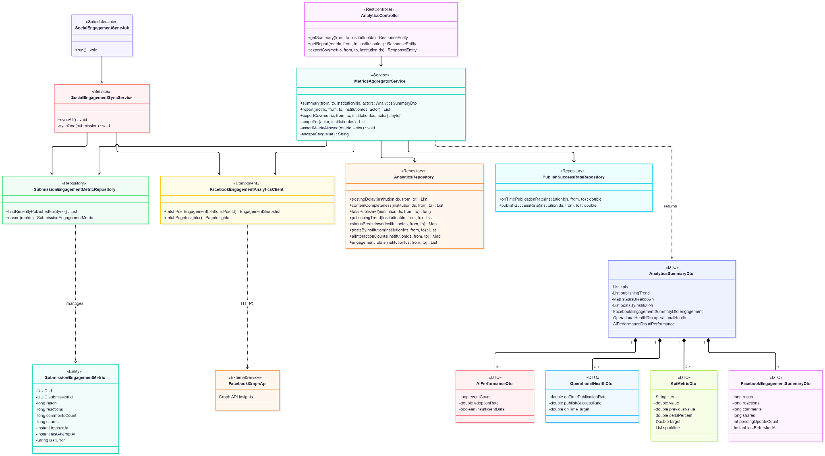
- Sequence Diagram
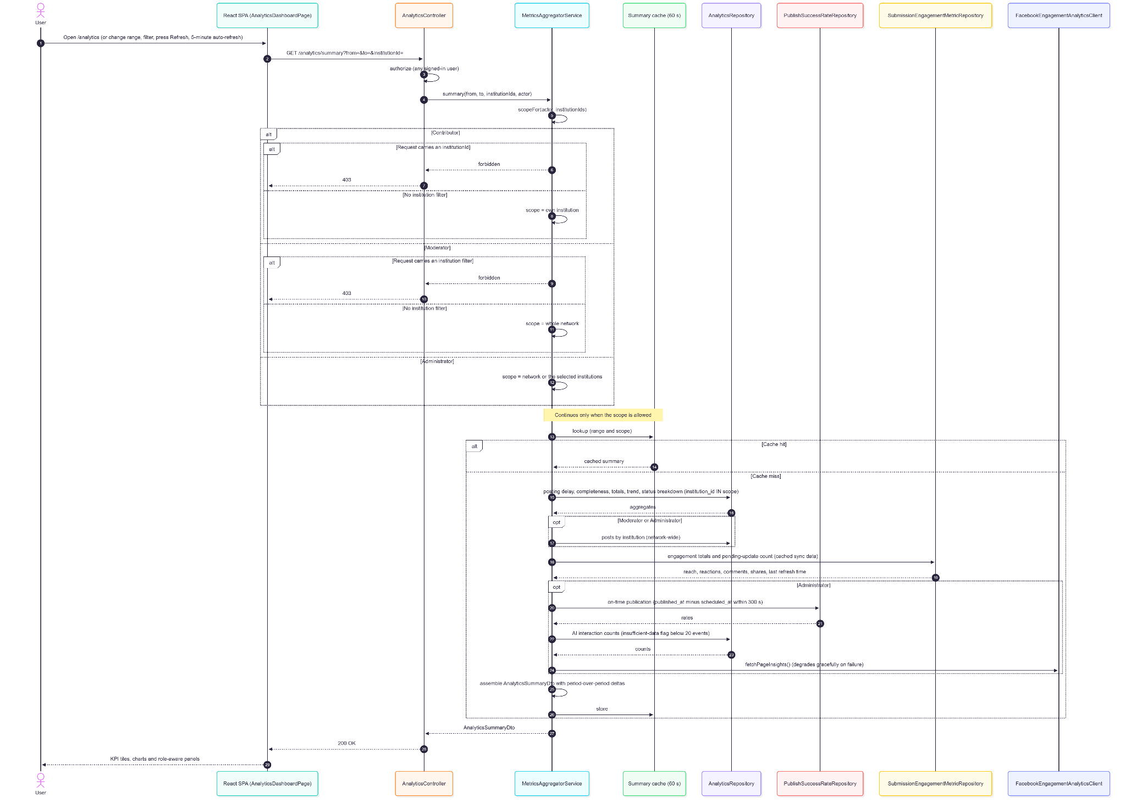
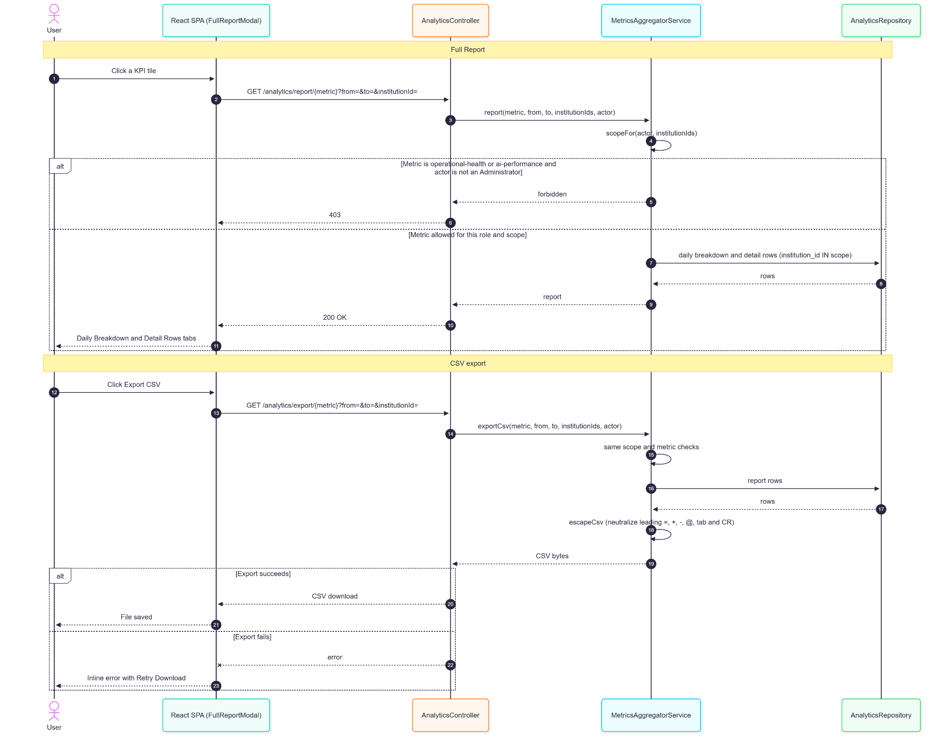

3.4.5. Data Design
- Entity Relationship Diagram
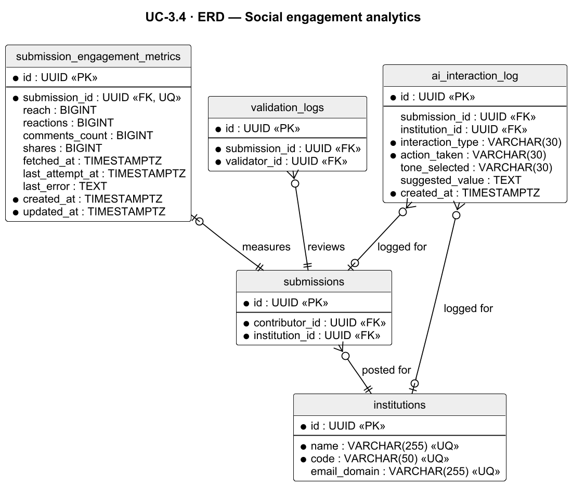
- Schema

CREATE TABLE submission_engagement_metrics (
id UUID PRIMARY KEY DEFAULT gen_random_uuid(),
submission_id UUID UNIQUE NOT NULL REFERENCES submissions(id) ON DELETE CASCADE,
reach BIGINT,
reactions BIGINT,
comments_count BIGINT,
shares BIGINT,
fetched_at TIMESTAMPTZ, -- last successful refresh
last_attempt_at TIMESTAMPTZ,
last_error TEXT,
created_at TIMESTAMPTZ NOT NULL DEFAULT NOW(),
updated_at TIMESTAMPTZ NOT NULL DEFAULT NOW()
);
-- Workflow KPIs are computed at query time from submissions, validation_logs,
-- publication_attempts, and ai_interaction_log; no KPI columns are stored.
Related tables used by this use case:
-- ai_interaction_log (defined in UC-1.6)
CREATE TABLE ai_interaction_log (
id UUID PRIMARY KEY DEFAULT gen_random_uuid(),
submission_id UUID REFERENCES submissions(id),
institution_id UUID REFERENCES institutions(id),
interaction_type VARCHAR(30) NOT NULL,
action_taken VARCHAR(30) NOT NULL,
tone_selected VARCHAR(30),
suggested_value TEXT,
created_at TIMESTAMPTZ NOT NULL DEFAULT NOW()
);

3.5. System Health Analytics

3.5.1. User Interface Design
System Health Screen (/admin/system-health, Administrator only)
An overall status (worst status across all rows with WARNING / UNHEALTHY / UNAVAILABLE counts) above four sections, each row carrying a HEALTHY, WARNING, UNHEALTHY, UNAVAILABLE, or SCHEDULED indicator:
- Storage — database size and R2 bucket usage against configurable tier limits (80% warning, 95% critical).
- External Services — Supabase PostgreSQL, Cloudflare R2, Facebook Graph API (token status and expiry countdown), Anthropic, Voyage AI, and the email provider. Google Gemini is not probed; its health shows through the Media AI metrics.
- Background Jobs — 16 tracked jobs with last run, duration, error, and a stale flag (last run > 2× expected interval), each with a Re-run action.
- Operational Metrics (rolling 30 days) — approval turnaround, Edit & Approve rate, manual fallback resolution rate, publish success rate (same calculation as Analytics), Fast-Track volume, and missed-review rate (WARNING above 10%).

Additional panels: Media AI metrics and embedding coverage, media-processing dead letters with Retry, Facebook token management (Reauthorize via OAuth, paste a token manually, re-check token, and — Admin Owner only — Connect a Different Page), and Export Snapshot (CSV).

3.5.2. Front-end Component(s)
SystemHealthScreen
- GET /system-health/summary, /storage, /external-services, /jobs, /operational-metrics, /media-ai-metrics, /media-ai-coverage, /tokens; POST /system-health/jobs/{jobKey}/run; POST /system-health/tokens/recheck; GET /system-health/tokens/{tokenId}/oauth-init; PUT /system-health/tokens/{tokenId}/manual; PUT /system-health/tokens/connect; GET /system-health/export; GET /system-health/media-processing/dead-letters, POST …/dead-letters/{jobId}/retry. Adjusts toast copy for the two asynchronous jobs.
- React functional component / Admin route

3.5.3. Back-end Component(s)
SystemHealthController / MediaProcessingAdminController
- Class-level hasRole('ADMIN').
- Spring @RestController

SystemHealthService
- Storage (pg_database_size + live R2 scan with DB-estimate fallback), external service probes, job health from scheduled_job_runs against EXPECTED_JOBS, operational metrics including missedReviewRate(), status roll-up, and snapshot CSV export (audit-logged; any cell beginning with = + - @, tab, or CR is prefixed with an apostrophe against formula injection — PR #409)..
- Spring @Service

ScheduledJobHealthService / ManualJobRunner
- Records job runs; on-demand re-runs (audit BACKGROUND_JOB_RUN); PublishingSchedulerJob and TokenPublishingEscalationJob run asynchronously (ASYNC_JOB_KEYS), the rest synchronously.
- Spring @Service / @Component

TokenManagementService / FacebookOAuthCallbackController
- initOAuth with an HMAC-signed stateless state (token ID + expiry + signature); GET /facebook/oauth-callback exchanges the code for a long-lived Page token, validates it against the Graph API, encrypts and stores it (TOKEN_REAUTHORIZED). Manual paste (TOKEN_MANUALLY_SET) is validated the same way. Connect a Different Page (FACEBOOK_PAGE_CONNECTED) is Admin Owner only and deactivates all other rows. Suspended publishing resumes when TokenPublishingEscalationJob next finds a usable token. Redirect URI defaults from BACKEND_PUBLIC_BASE_URL.
- Spring @Service / @RestController

TokenHealthCheckJob / MediaAiTelemetryService — daily token validation; media AI stage metrics.

3.5.4. Object-Oriented Component(s)
- Class Diagram
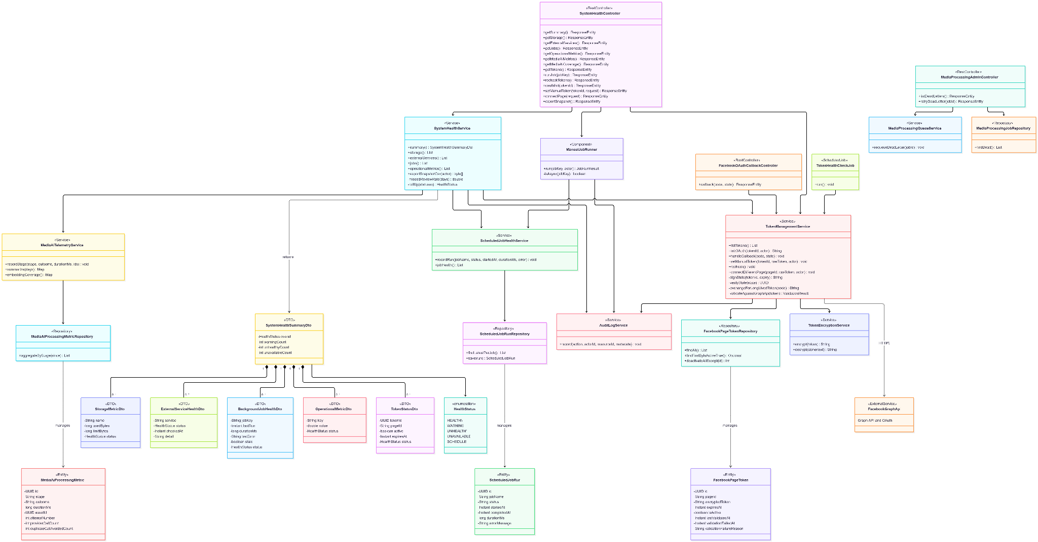
- Sequence Diagram
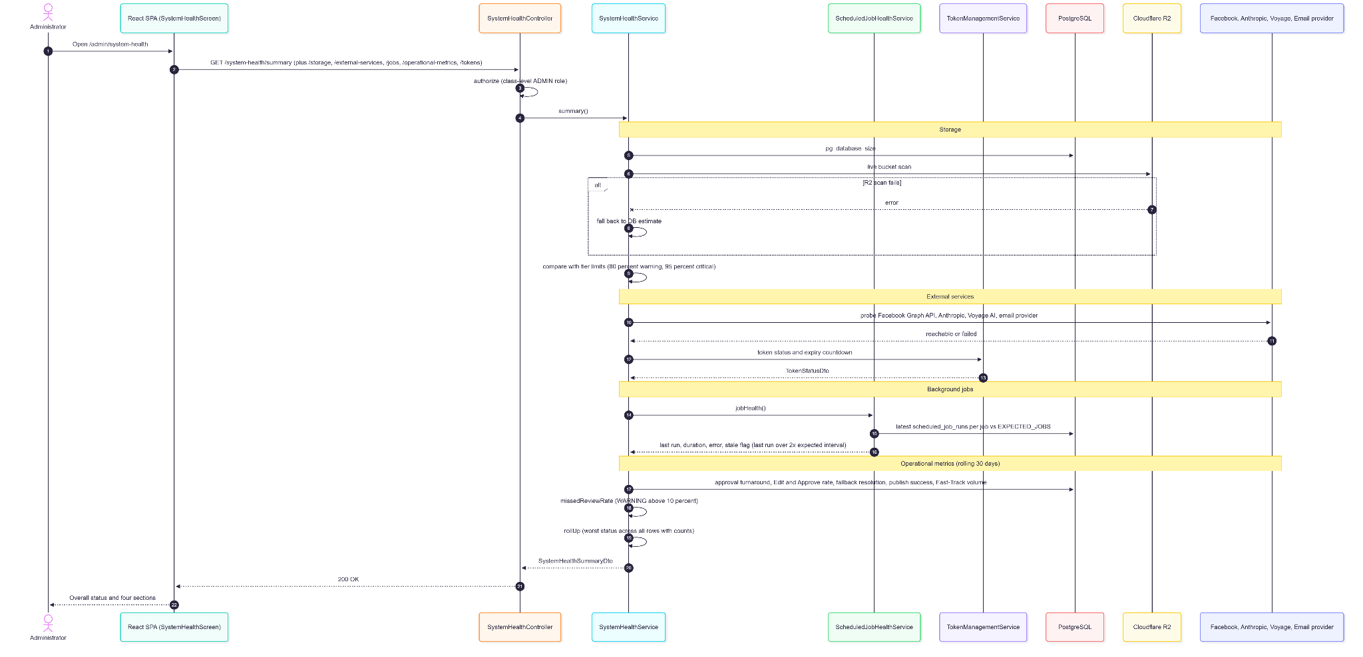
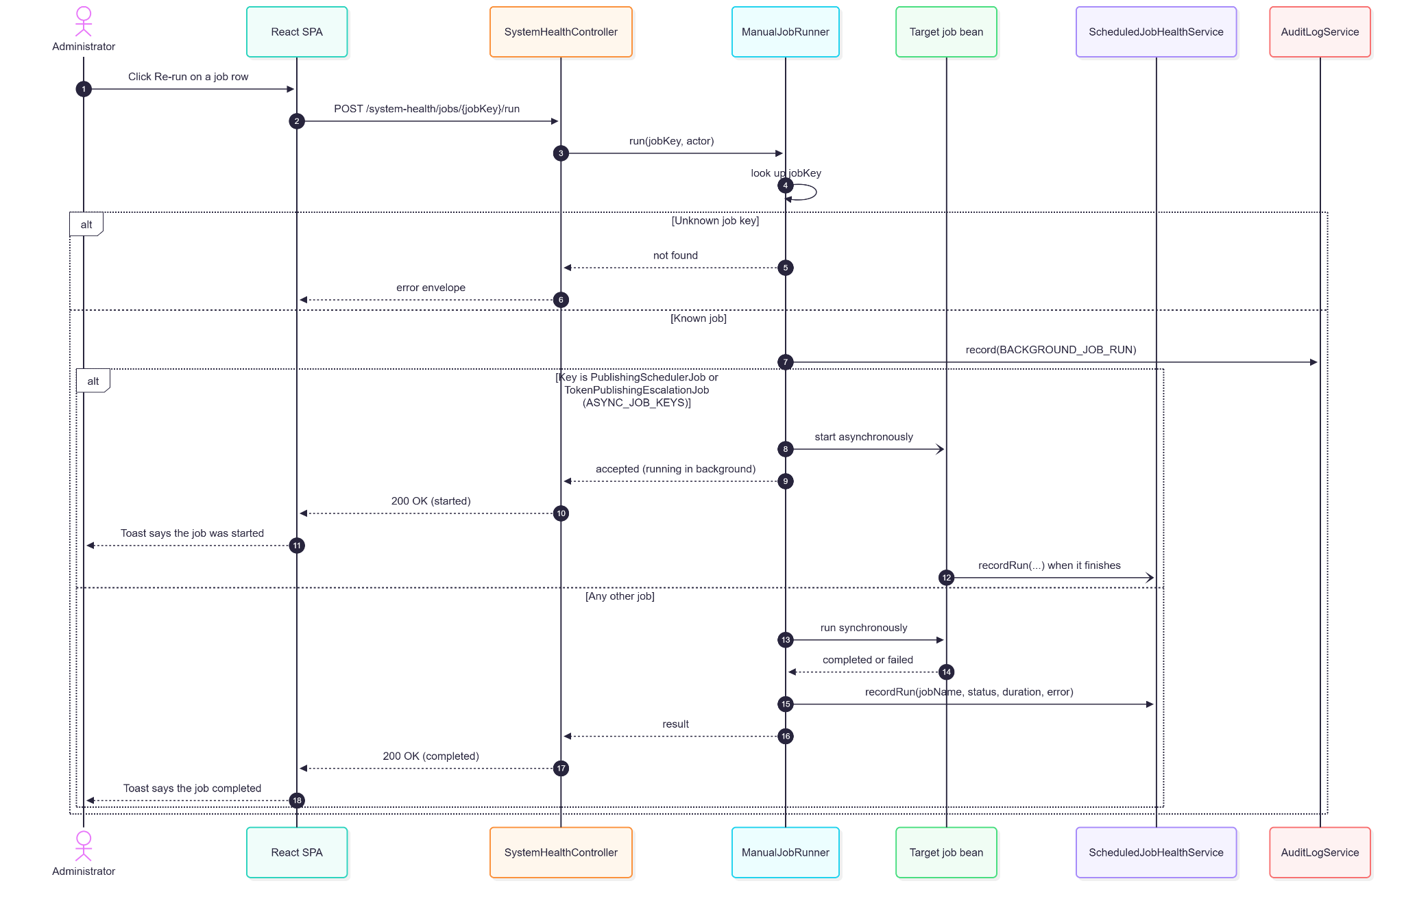
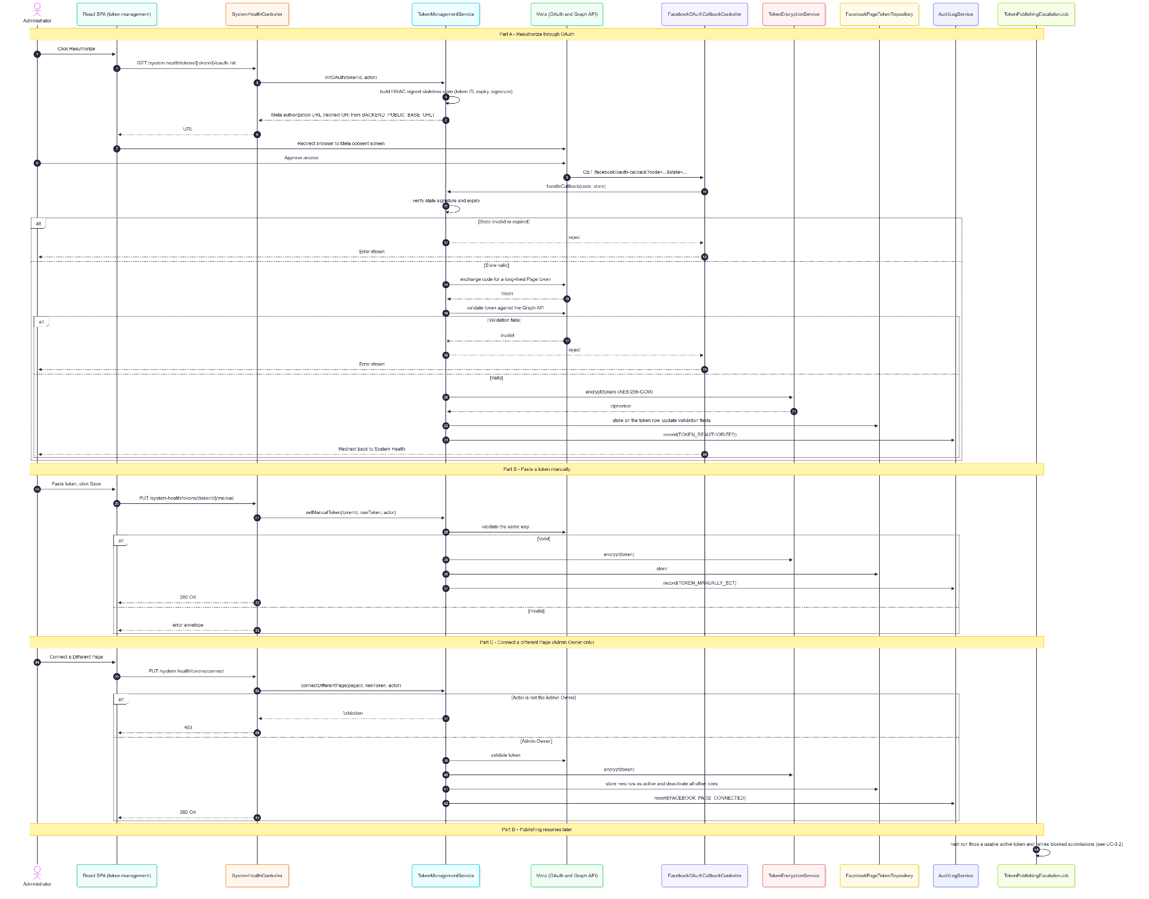

3.5.5. Data Design
- Entity Relationship Diagram
- Schema

CREATE TABLE scheduled_job_runs (
id UUID PRIMARY KEY DEFAULT gen_random_uuid(),
job_name VARCHAR(120) NOT NULL,
status VARCHAR(20) NOT NULL CHECK (status IN ('SUCCESS', 'FAILED')),
started_at TIMESTAMPTZ NOT NULL,
completed_at TIMESTAMPTZ,
duration_ms BIGINT,
error_message TEXT,
created_at TIMESTAMPTZ NOT NULL DEFAULT NOW()
);

-- Media AI telemetry (per-stage latency/outcome)
CREATE TABLE media_ai_processing_metrics (
id UUID PRIMARY KEY DEFAULT gen_random_uuid(),
stage VARCHAR(40) NOT NULL
CHECK (stage IN ('R2_UPLOAD','DB_REGISTRATION','QUEUE_DELAY',
'VOYAGE_IMAGE_EMBEDDING','CLAUDE_CLASSIFICATION',
'VOYAGE_SEMANTIC_EMBEDDING','READY_LATENCY','AI_SUGGESTION_QUERY')),
outcome VARCHAR(20) NOT NULL CHECK (outcome IN ('SUCCESS','FAILURE','REUSED')),
duration_ms BIGINT NOT NULL DEFAULT 0,
asset_id UUID REFERENCES media_assets(id) ON DELETE SET NULL,
submission_id UUID REFERENCES submissions(id) ON DELETE SET NULL,
attempt_number INT NOT NULL DEFAULT 1,
provider_call_count INT NOT NULL DEFAULT 0,
duplicate_call_avoided_count INT NOT NULL DEFAULT 0,
created_at TIMESTAMPTZ NOT NULL DEFAULT NOW()
);

CREATE INDEX idx_scheduled_job_runs_job ON scheduled_job_runs(job_name, started_at DESC);
Related tables used by this use case:
-- facebook_page_tokens (defined in UC-3.2)
CREATE TABLE facebook_page_tokens (
id UUID PRIMARY KEY DEFAULT gen_random_uuid(),
page_id VARCHAR(50) UNIQUE NOT NULL,
encrypted_token TEXT NOT NULL,
expires_at TIMESTAMPTZ,
is_active BOOLEAN NOT NULL DEFAULT FALSE,
last_validated_at TIMESTAMPTZ,
validation_failed_at TIMESTAMPTZ,
validation_failure_reason TEXT,
created_at TIMESTAMPTZ NOT NULL DEFAULT NOW(),
updated_at TIMESTAMPTZ NOT NULL DEFAULT NOW()
);

-- media_processing_jobs (defined in UC-2.1)
CREATE TABLE media_processing_jobs (
id UUID PRIMARY KEY DEFAULT gen_random_uuid(),
asset_id UUID REFERENCES media_assets(id) ON DELETE CASCADE,
submission_id UUID REFERENCES submissions(id) ON DELETE CASCADE,
job_type VARCHAR(40) NOT NULL
CHECK (job_type IN ('RETRIEVAL_EMBEDDINGS', 'CLASSIFY_AND_EMBED',
'EMBED_IMAGE_ONLY', 'BUILD_SUBMISSION_CONTEXT')),
status VARCHAR(20) NOT NULL
CHECK (status IN ('PENDING','PROCESSING','RETRY','COMPLETED','DEAD')),
attempt_count INT NOT NULL DEFAULT 0,
max_attempts INT NOT NULL,
priority SMALLINT NOT NULL DEFAULT 10,
rerun_requested BOOLEAN NOT NULL DEFAULT FALSE,
next_attempt_at TIMESTAMPTZ,
lease_until TIMESTAMPTZ,
claimed_by VARCHAR(100),
processing_version VARCHAR(50),
last_error VARCHAR(500),
completed_at TIMESTAMPTZ,
created_at TIMESTAMPTZ NOT NULL DEFAULT NOW(),
updated_at TIMESTAMPTZ NOT NULL DEFAULT NOW()
);

3.6. Audit Log Review

3.6.1. User Interface Design
Audit Log Screen (/admin/audit-log, Administrator only)
A server-paginated table, newest first, with Actor, Timestamp (Asia/Manila), Category/Action badge, Affected Entity, and a one-line Summary. Filters: date range, actor (ID or name/email), category (11), action code, entity type (8), resource ID, and free-text search — combinable. Export CSV downloads the filtered result (capped at 5,000 rows; failures surface as a toast with filters preserved).
Audit Detail Modal
Actor & Execution (name, email, role, institution, Admin Owner flag, action code, IP, user agent), Target Entity (type, jump link or "Deleted/Unavailable" badge, ID), generated summary including any override/justification reason, a structured Field / Previous / Updated diff for edits, schedule changes, status transitions, and role changes, and a raw-detail inspector.

3.6.2. Front-end Component(s)
AuditLogScreen
- GET /audit-log (filters + pagination), GET /audit-log/categories, GET /audit-log/export-csv.
- React functional component / Admin route

AuditDetailModal
- Structured diff and raw metadata view.
- React modal component

3.6.3. Back-end Component(s)
AuditLogController
- Class-level hasRole('ADMIN').
- Spring @RestController

AuditLogService
- Single write path for audit entries; derives category and entity type from the action code at read time (AuditLogCategory, AuditEntityType); server-side filtering; CSV export (itself audited) with formula-injection-safe escapeCsv. Routine page views and self-service preference changes are intentionally not audited.
- Spring @Service

AuditLogRetentionJob
- Scheduled retention purge — the only sanctioned deletion path besides the right-to-be-forgotten scrub of actor email fields.
- Spring @Scheduled

AuditLogRepository
- Spring @Repository extending JpaRepository<AuditLog, UUID> with specification-based filtering.

3.6.4. Object-Oriented Component(s)
- Class Diagram
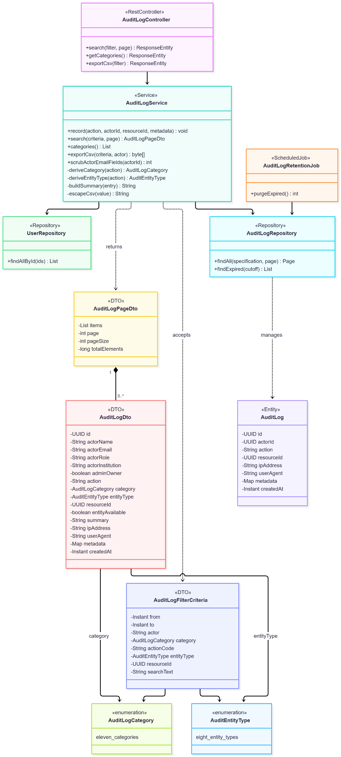
- Sequence Diagram
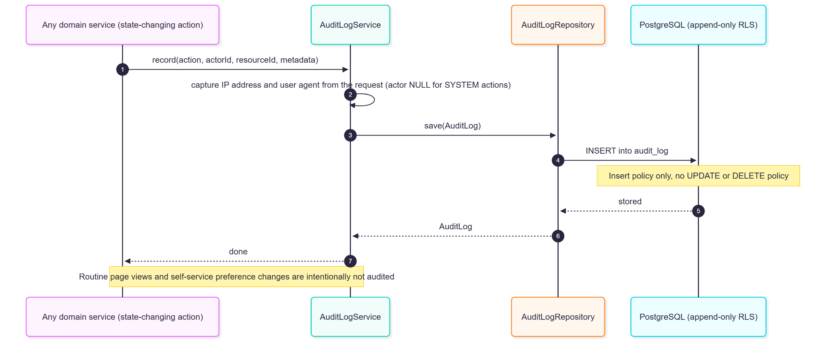
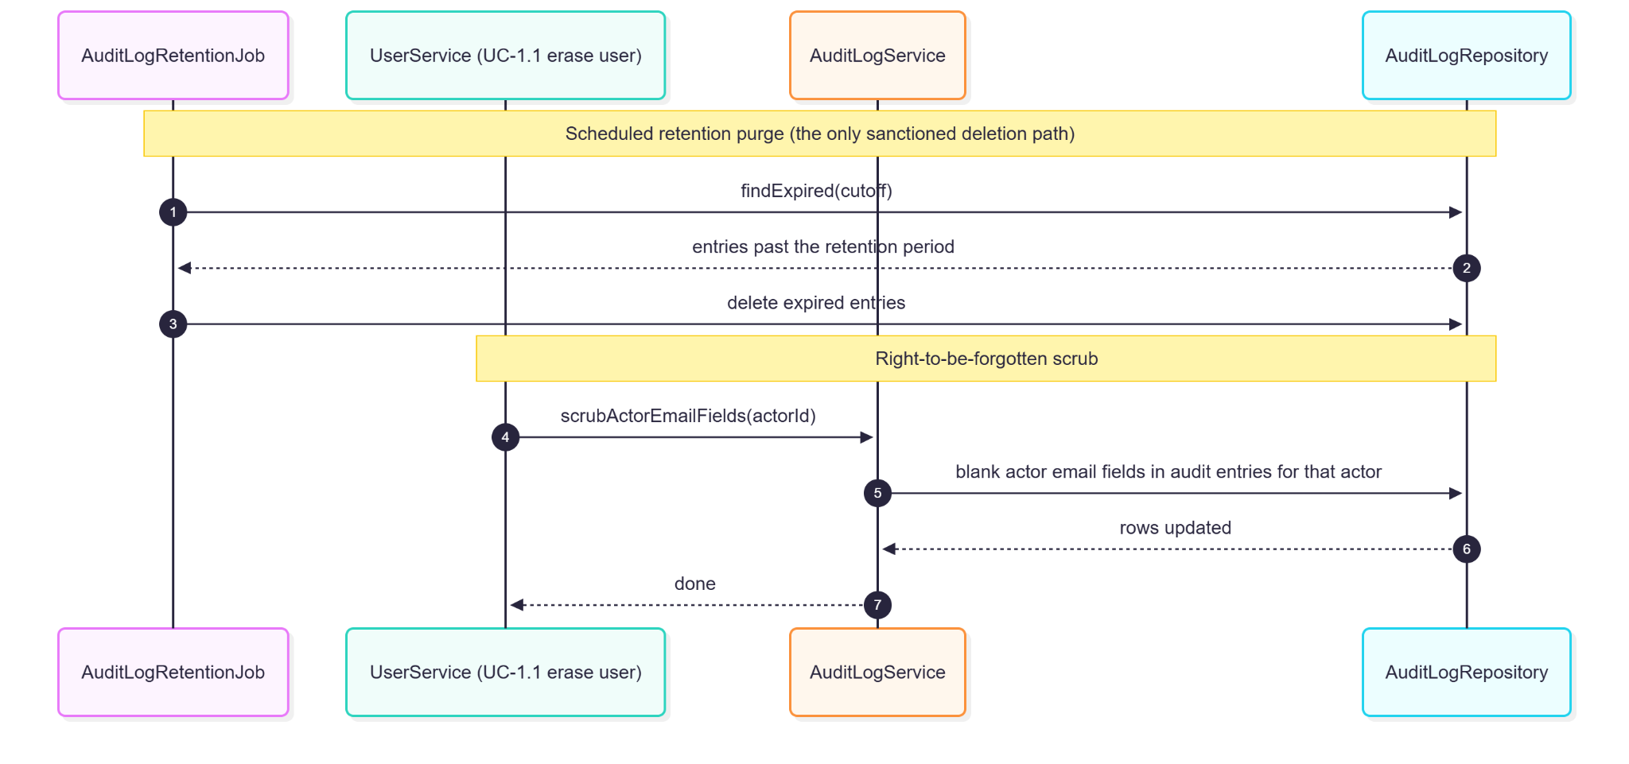

3.6.5. Data Design
- Entity Relationship Diagram
- Schema

CREATE TABLE audit_log (
id UUID PRIMARY KEY DEFAULT gen_random_uuid(),
actor_id UUID REFERENCES users(id), -- NULL for SYSTEM actions
action VARCHAR(50) NOT NULL,
resource_id UUID,
ip_address INET,
user_agent TEXT,
metadata JSONB, -- before/after diff, reasons, context
created_at TIMESTAMPTZ NOT NULL DEFAULT NOW()
);

CREATE INDEX idx_audit_log_actor ON audit_log(actor_id, created_at DESC);
CREATE INDEX idx_audit_log_resource ON audit_log(resource_id, created_at DESC);

-- Append-only guarantee (V78): insert/select policies only; no UPDATE/DELETE policy
ALTER TABLE audit_log ENABLE ROW LEVEL SECURITY;
CREATE POLICY audit_log_append ON audit_log FOR INSERT WITH CHECK (true);
CREATE POLICY audit_log_read ON audit_log FOR SELECT
USING (
current_setting('app.current_role', true) = 'administrator'
OR EXISTS (
SELECT 1 FROM users u
WHERE u.id = audit_log.actor_id
AND u.institution_id = nullif(current_setting('app.current_institution_id', true), '')::UUID
)
);

4. Planned Design for Validation-Driven Refactoring (RP-01–RP-05)
These items come from the MVP Validation Findings & Refactoring Priorities (12 Oct 2026, VF-01–VF-05) and implement SRS v7.0 Section 3.6.
Status: Planned — not implemented in release v3.0.2. Each item lists the components to add or change, the data and API design, and the STD acceptance test that will verify it. Scheduling is in SPMP v2.1 §5.2.5.

4.1. RP-01 — Submission gate separated from quality tips (VF-01; REQ-124)
- Current design: features/submission/utils.ts computes one score round(required/7 × 75 + recommended/5 × 25); readinessTone colours it.
- Target design: replace the score with two derived values computed in the same hook: gate = { passed, total: 7, nextMissing } and tips = { applied, total: 5 }. The readiness panel shows "Required: 7 of 7 — Ready to submit" or names nextMissing with a jump link; tips render separately as "Tips: 3 of 5 applied" with no percentage. Submit becomes the primary action whenever gate.passed === gate.total, on every screen size (shared with §3.4.4's mobile action bar). Server-side SubmissionService.assertContentComplete is unchanged (it already checks only the required items).
- Data: none. Optional metric: drafts whose gate passed but that were not submitted within 24 h (query over submissions and the task-event log of §4.2).
- Test: STD Case-30a. Status: Implemented (refactor/p1-submission-gate).

4.2. RP-02 — Next action, plain-language status, task-event log (VF-02; REQ-125, REQ-126)
- Next-action card: new GET /api/v1/me/next-action returning { kind, label, count, deepLink } computed per role — Contributor: oldest draft with nextMissing items or a needs_revision item; Moderator: count of pending (Fast-Track first) with link to the oldest; Administrator: count of publish_failed, else pending reviews. Rendered at the top of DashboardScreen.
- Status wording: one shared map statusCopy[status] = { label, meaning, whoActsNext } used by submission lists, the review queue, and notification templates (NotificationEventListener messages), so the same sentence appears everywhere.
- Task-event log: new table task_events (id, user_id, role, task_type, submission_id NULL, event ENUM('started','completed','abandoned'), occurred_at, client_session_id), written by a new POST /api/v1/task-events (signed in) and by server-side hooks for completion (submit, terminal review action, invitation sent). Used to compute first-attempt completion and Time-on-Task per role. No free text is stored.
- Test: STD Case-30b; re-validation.

4.3. RP-03 — Caption on upload, media-first picker, log-based GO3 (VF-03; REQ-320, REQ-321)
- Background caption: after the first image is attached to a saved draft that has an event title, the composer calls a new POST /api/v1/ai/caption/background (same 30/h limit and 30 s timeout as POST /ai/caption); CaptionGenerationService stores the result in a new ai_caption_suggestions (id, submission_id, user_id, tone, caption, model, status ENUM('generated','used','used_edited','dismissed','failed'), rating SMALLINT NULL, generated_at, decided_at). The caption field shows "AI draft ready — Use / Edit / Dismiss"; it is never inserted automatically. Failure falls back silently to manual entry.
- Measurement: coverage = suggestions generated ÷ submissions with images; acceptance = (used + used_edited) ÷ generated; quality = mean rating (one-click 1–5 at decision); drafting time = time from opening Post Details to first caption save, recorded as a task event (§4.2).
- Media-first: MediaAssetsPicker initial tab becomes suggestions when AIRecommendationService reports enough context (≥ 10 characters or a selected image); otherwise upload.
- Test: STD Case-30c.

4.4. RP-04 — Mobile operability (VF-04; REQ-218)
- Persistent primary-action bar: a shared MobileActionBar component (fixed bottom, ≤ 900 px) on the composer (Submit / Save Draft), review screen (Approve / Request Revision / Reject), Failed tab (Retry / Manual publish), calendar detail (Reschedule), and invite acceptance.
- Deep links: notification links include the target state, e.g. /queue?submission={id}&mode=review, which opens the submission and acquires the review lock on load; Messenger and email templates use the same links.
- Tests: a Playwright project with a 360×800 viewport covering the five actions (STD Case-29).

4.5. RP-05 — Bulk invitations with preview and batch audit (VF-05; REQ-127)
- API: POST /api/v1/invitations/batch/preview (Moderator, Administrator) accepts [{ email, role, institutionId }] (≤ 200 rows, from CSV or paste) and returns a per-row status: valid, duplicate_in_batch, invalid_email, inactive_institution, active_account_exists, deactivated_use_reactivation, pending_will_be_superseded, admin_cap_exceeded, role_not_permitted. POST /api/v1/invitations/batch re-validates server-side, creates invitations for valid rows only through the existing InvitationService.create path, and returns per-row results.
- Audit: new invitation_batches (id, created_by, row_count, sent_count, rejected_count, created_at); each invitation's audit metadata carries batchId; one INVITATION_BATCH_SENT summary row is written.
- Rules: Moderators may batch-invite Contributors only; the 3-Admin cap is checked across the whole batch; self-registration remains out of scope (SO 1.4).
- Test: STD Case-30d.

Appendix

Overview
DASIGConnect uses a single PostgreSQL relational database hosted on Supabase. The schema is owned by Flyway and built from versioned migrations V1–V122 (backend/src/main/resources/db/migration); Hibernate DDL generation is not used. It consists of 31 tables introduced progressively across the three development modules. All tables use UUID primary keys generated by gen_random_uuid(). Tenant isolation is enforced through Row-Level Security (RLS) policies scoped to institution_id. Media assets use soft deletes (deleted_at) with a 30-day retention window before purge. The pgvector extension provides VECTOR(1024) columns (media_asset_embeddings.embedding and the legacy media_assets.embedding) for cosine similarity search. Media files themselves are stored in Cloudflare R2, not in the database. Enum values are stored in lowercase.

Table Inventory
# | Table | Introduced By | Purpose
1 | institutions | UC-1.2 | Institution workspace records, status, protection flag, logo
2 | users | UC-1.1 | All accounts (Contributor, Moderator, Administrator), Admin Owner flag, session version, pending promotions/transfers, preferences
3 | invitation_tokens | UC-1.1 | One-time activation tokens for all roles
4 | password_reset_tokens | UC-1.4 | One-hour password reset tokens
5 | account_lockouts | UC-1.4 | Failed-login tracking and lockout
6 | revoked_tokens | UC-1.4 | Single-token logout revocation
7 | messenger_connections | UC-1.4 | Messenger link codes and linked Page-scoped IDs
8 | page_settings | UC-1.4 | Network-wide guard-rail switch and thresholds (plus legacy columns)
9 | audit_log | UC-3.6 | Append-only record of state-changing, destructive, and security actions
10 | submissions | UC-1.5 | Content submissions across all workflow states
11 | post_templates | UC-1.5 | Personal post templates
12 | ai_interaction_log | UC-1.6 | AI caption, proofreading, and recommendation interaction events
13 | submission_media_assets | UC-1.7 | Submission ↔ media junction with order, per-asset caption, skip-watermark
14 | submission_media_contexts | UC-1.7 | Aggregated AI media context per submission
15 | slot_reservations | UC-1.8 | Slot hold/lock/release with DB-level conflict exclusion
16 | media_albums | UC-2.1 | Nested, institution-scoped albums
17 | media_assets | UC-2.1 | Media metadata, AI classification/enrichment, hash, lifecycle
18 | asset_tags | UC-2.1 | Manual and AI tags per asset
19 | media_asset_embeddings | UC-2.1 | Image and semantic Voyage embeddings
20 | media_processing_jobs | UC-2.1 | DB-backed AI processing queue with retries and dead letters
21 | review_locks | UC-2.4 | 15-minute concurrent review locks
22 | validation_logs | UC-2.4 | Review actions with edit diff and severity
23 | watermark_configurations | UC-2.5 | Network-wide watermark design
24 | facebook_page_tokens | UC-3.2 | Encrypted Page tokens; one active page
25 | publication_attempts | UC-3.2 | Per-attempt publishing trail and staged/unresolved photo IDs
26 | notifications | UC-3.3 | In-app notifications
27 | email_delivery_log | UC-3.3 | Email delivery tracking
28 | submission_engagement_metrics | UC-3.4 | Cached Facebook engagement per published post
29 | scheduled_job_runs | UC-3.5 | Background job run history
30 | media_ai_processing_metrics | UC-3.5 | Media AI stage telemetry
31 | media_ai_ranking_shadow_metrics | UC-3.5 | Shadow-mode hybrid ranking evaluation

Removed in later migrations and not part of the current schema: override_requests (Contributor override requests were descoped) and media_asset_search_documents.

Master Entity Relationship Diagram
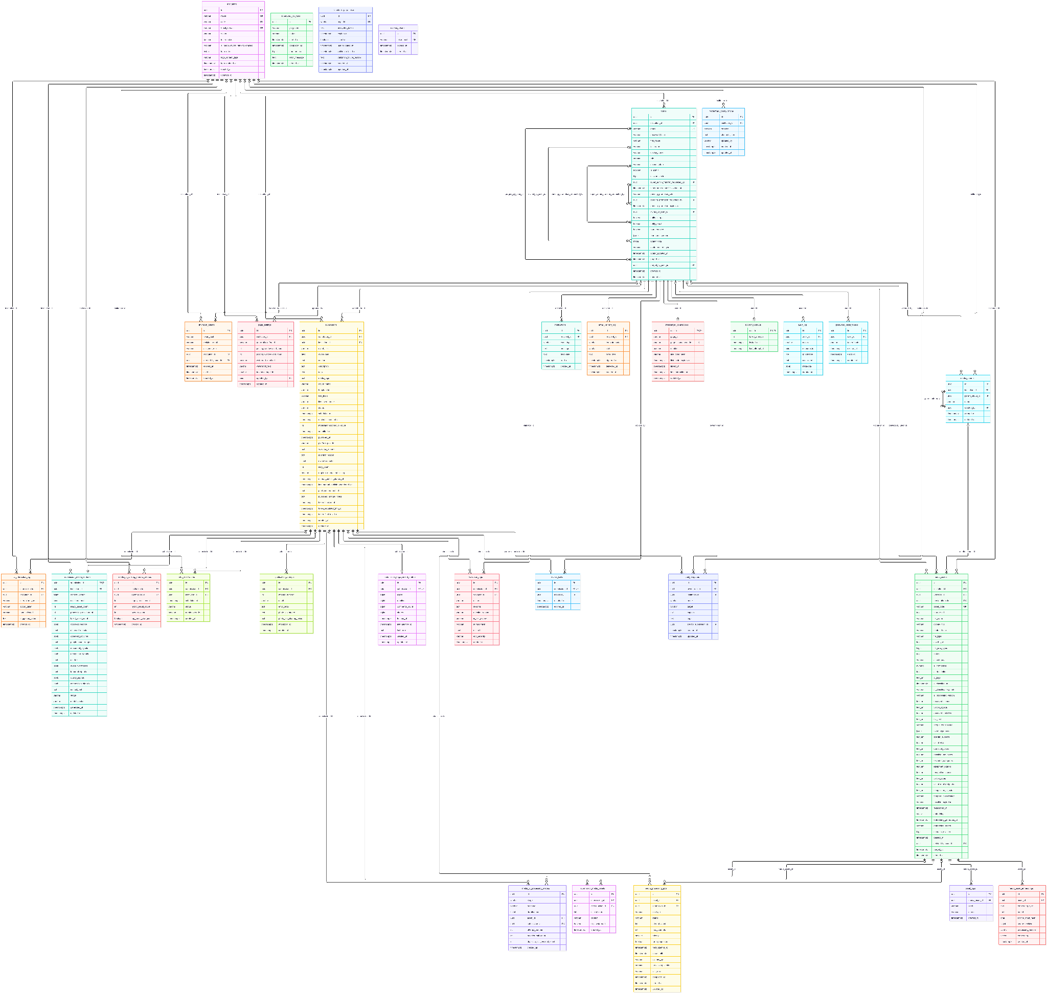
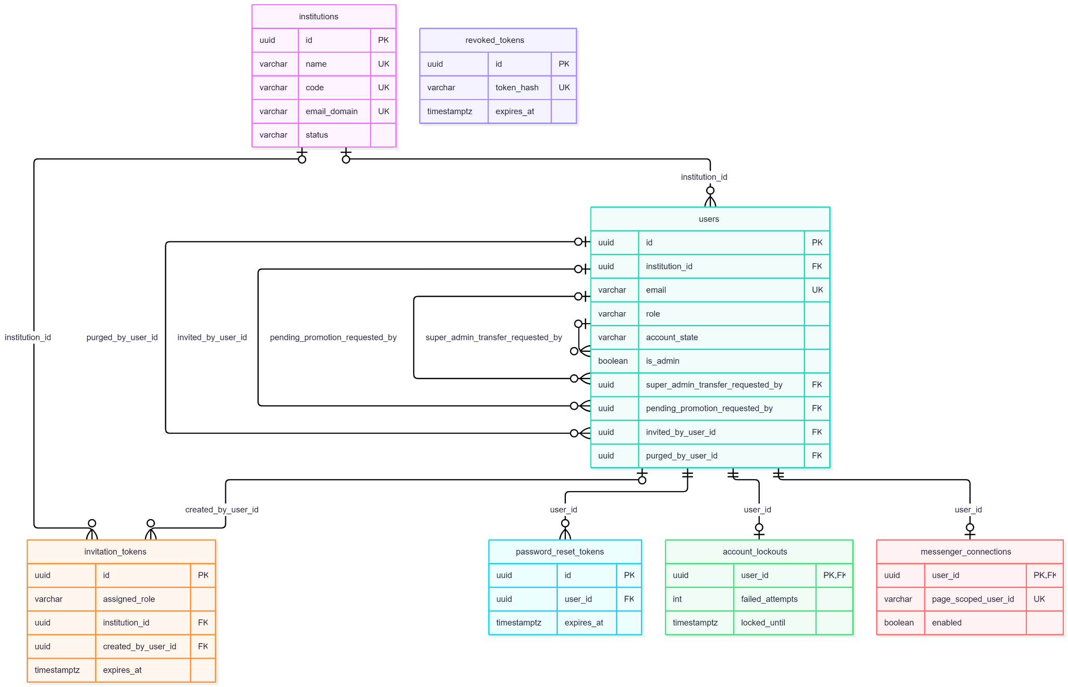
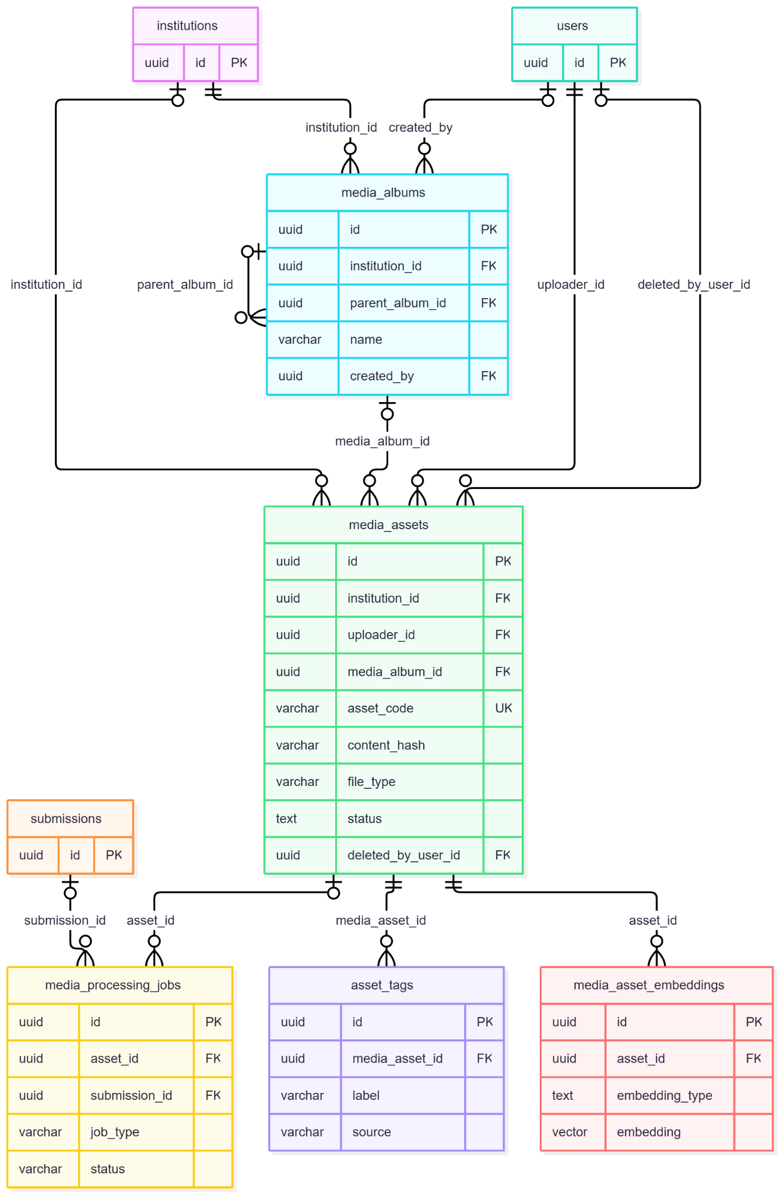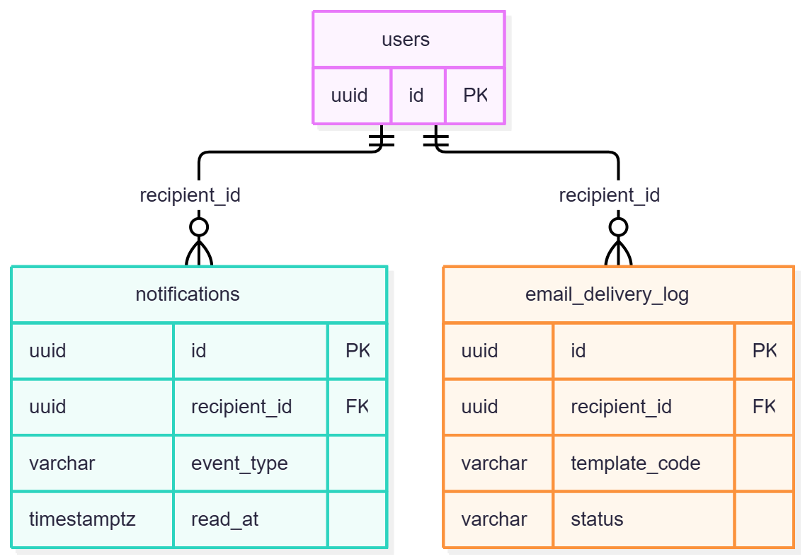

Complete SQL DDL
The authoritative DDL is the ordered set of Flyway migrations V1–V122. The consolidated listing below reflects the resulting schema; column types are simplified where migrations use equivalent forms.
-- ═══════════════════════════════════════════
-- EXTENSIONS
-- ═══════════════════════════════════════════
CREATE EXTENSION IF NOT EXISTS vector;
CREATE EXTENSION IF NOT EXISTS btree_gist;

-- ═══════════════════════════════════════════
-- 1. INSTITUTIONS
-- ═══════════════════════════════════════════
CREATE TABLE institutions (
id UUID PRIMARY KEY DEFAULT gen_random_uuid(),
name VARCHAR(255) UNIQUE NOT NULL,
code VARCHAR(50) UNIQUE NOT NULL,
email_domain VARCHAR(255) UNIQUE,
status VARCHAR(30) NOT NULL DEFAULT 'active'
CHECK (status IN ('pending', 'active', 'inactive')),
is_protected BOOLEAN NOT NULL DEFAULT FALSE,
ai_media_hybrid_ranking_enabled BOOLEAN NOT NULL DEFAULT FALSE,
logo_data BYTEA,
logo_content_type VARCHAR(40),
logo_updated_at TIMESTAMPTZ,
created_at TIMESTAMPTZ NOT NULL DEFAULT NOW(),
updated_at TIMESTAMPTZ NOT NULL DEFAULT NOW()
);

-- ═══════════════════════════════════════════
-- 2. USERS
-- ═══════════════════════════════════════════
CREATE TABLE users (
id UUID PRIMARY KEY DEFAULT gen_random_uuid(),
institution_id UUID REFERENCES institutions(id),
email VARCHAR(255) UNIQUE NOT NULL,
password_hash VARCHAR(255),
first_name VARCHAR(100),
last_name VARCHAR(100),
display_name VARCHAR(150),
role VARCHAR(20) NOT NULL
CHECK (role IN ('contributor', 'moderator', 'admin')),
account_state VARCHAR(30) NOT NULL DEFAULT 'pending'
CHECK (account_state IN ('pending', 'pending_email_undelivered',
'active', 'expired', 'inactive', 'cancelled')),
is_admin BOOLEAN NOT NULL DEFAULT FALSE,
session_version BIGINT NOT NULL DEFAULT 0,
super_admin_transfer_requested_by UUID REFERENCES users(id),
super_admin_transfer_expires_at TIMESTAMPTZ,
pending_promotion_role VARCHAR(20) -- 'admin' | 'moderator' (V118/V119)
CHECK (pending_promotion_role IN ('admin', 'moderator')),
pending_promotion_requested_by UUID REFERENCES users(id), -- proposing Administrator
pending_promotion_expires_at TIMESTAMPTZ, -- 72-hour confirmation window
invited_by_user_id UUID REFERENCES users(id),
notify_in_app BOOLEAN NOT NULL DEFAULT TRUE,
notify_email BOOLEAN NOT NULL DEFAULT TRUE,
tours_enabled BOOLEAN NOT NULL DEFAULT TRUE,
tour_seen_screens JSONB,
avatar_data BYTEA,
avatar_content_type VARCHAR(40),
avatar_updated_at TIMESTAMPTZ,
purged_at TIMESTAMPTZ,
purged_by_user_id UUID REFERENCES users(id),
created_at TIMESTAMPTZ NOT NULL DEFAULT NOW(),
updated_at TIMESTAMPTZ NOT NULL DEFAULT NOW()
);
CREATE INDEX idx_users_institution ON users(institution_id);
CREATE UNIQUE INDEX idx_users_single_active_admin_owner ON users ((role))
WHERE role = 'admin' AND account_state = 'active' AND is_admin = TRUE; -- exactly one active Admin Owner

-- ═══════════════════════════════════════════
-- 3. INVITATION TOKENS
-- ═══════════════════════════════════════════
CREATE TABLE invitation_tokens (
id UUID PRIMARY KEY DEFAULT gen_random_uuid(),
token_hash VARCHAR(64) NOT NULL,
recipient_email VARCHAR(255) NOT NULL,
assigned_role VARCHAR(20) NOT NULL
CHECK (assigned_role IN ('contributor', 'moderator', 'admin')),
institution_id UUID REFERENCES institutions(id),
created_by_user_id UUID REFERENCES users(id),
expires_at TIMESTAMPTZ NOT NULL,
used_at TIMESTAMPTZ,
created_at TIMESTAMPTZ NOT NULL DEFAULT NOW()
);
CREATE INDEX idx_invitation_tokens_hash ON invitation_tokens(token_hash);

-- ═══════════════════════════════════════════
-- 4–7. AUTH SUPPORT
-- ═══════════════════════════════════════════
CREATE TABLE password_reset_tokens (
id UUID PRIMARY KEY DEFAULT gen_random_uuid(),
user_id UUID NOT NULL REFERENCES users(id),
token_hash VARCHAR(64) NOT NULL,
expires_at TIMESTAMPTZ NOT NULL,
used_at TIMESTAMPTZ,
created_at TIMESTAMPTZ NOT NULL DEFAULT NOW()
);

CREATE TABLE account_lockouts (
user_id UUID PRIMARY KEY REFERENCES users(id),
failed_attempts INT NOT NULL DEFAULT 0,
locked_until TIMESTAMPTZ,
last_attempt_at TIMESTAMPTZ
);

CREATE TABLE revoked_tokens (
id UUID PRIMARY KEY DEFAULT gen_random_uuid(),
token_hash VARCHAR(64) UNIQUE NOT NULL,
expires_at TIMESTAMPTZ NOT NULL,
created_at TIMESTAMPTZ NOT NULL DEFAULT NOW()
);

CREATE TABLE messenger_connections (
user_id UUID PRIMARY KEY REFERENCES users(id) ON DELETE CASCADE,
page_id VARCHAR(100) NOT NULL,
page_scoped_user_id VARCHAR(255) UNIQUE, -- Messenger PSID once linked
enabled BOOLEAN NOT NULL DEFAULT FALSE,
link_code_hash VARCHAR(64),
link_code_expires_at TIMESTAMPTZ, -- 10 minutes
linked_at TIMESTAMPTZ,
last_interaction_at TIMESTAMPTZ,
updated_at TIMESTAMPTZ NOT NULL DEFAULT NOW()
);

-- ═══════════════════════════════════════════
-- 8. PAGE SETTINGS
-- ═══════════════════════════════════════════
CREATE TABLE page_settings (
id UUID PRIMARY KEY DEFAULT gen_random_uuid(),
institution_id UUID REFERENCES institutions(id),
guardrails_enforced BOOLEAN NOT NULL DEFAULT TRUE,
posting_window_start_hour INT NOT NULL DEFAULT 8, -- GR-H4 window start (Asia/Manila, V116)
posting_window_end_hour INT NOT NULL DEFAULT 20, -- GR-H4 window end (exclusive)
conflict_buffer_minutes INT NOT NULL DEFAULT 30, -- GR-H1 (V121)
minimum_lead_time_hours INT NOT NULL DEFAULT 2, -- GR-H2 (V121)
maximum_lead_time_days INT NOT NULL DEFAULT 30, -- GR-H3 (V121)
per_institution_active_quota INT NOT NULL DEFAULT 3, -- GR-S1 (V122)
daily_volume_cap INT NOT NULL DEFAULT 6, -- GR-S2 (V122)
watermark_enabled BOOLEAN,
watermark_text VARCHAR(150),
facebook_page_id VARCHAR(255),
updated_by UUID REFERENCES users(id),
updated_at TIMESTAMPTZ NOT NULL DEFAULT NOW()
);

-- ═══════════════════════════════════════════
-- 9. AUDIT LOG
-- ═══════════════════════════════════════════
CREATE TABLE audit_log (
id UUID PRIMARY KEY DEFAULT gen_random_uuid(),
actor_id UUID REFERENCES users(id),
action VARCHAR(50) NOT NULL,
resource_id UUID,
ip_address INET,
user_agent TEXT,
metadata JSONB,
created_at TIMESTAMPTZ NOT NULL DEFAULT NOW()
);
CREATE INDEX idx_audit_log_actor ON audit_log(actor_id, created_at DESC);
CREATE INDEX idx_audit_log_resource ON audit_log(resource_id, created_at DESC);

-- ═══════════════════════════════════════════
-- 10. SUBMISSIONS
-- ═══════════════════════════════════════════
CREATE TABLE submissions (
id UUID PRIMARY KEY DEFAULT gen_random_uuid(),
contributor_id UUID NOT NULL REFERENCES users(id),
institution_id UUID NOT NULL REFERENCES institutions(id),
event_title VARCHAR(255),
event_date DATE,
caption TEXT,
description TEXT,
tags TEXT,
media_tags TEXT,
album_name VARCHAR(255),
template_id VARCHAR(100),
fast_track BOOLEAN NOT NULL DEFAULT FALSE,
live_event_name VARCHAR(255),
status VARCHAR(30) NOT NULL DEFAULT 'draft'
CHECK (status IN ('draft', 'pending', 'in_review', 'needs_revision',
'missed_review', 'scheduled', 'publishing', 'publish_failed',
'published', 'published_manual', 'admin_direct_post',
'direct_post_scheduled', 'direct_post_publishing',
'direct_post_failed', 'rejected')),
scheduled_at TIMESTAMPTZ,
original_scheduled_at TIMESTAMPTZ,
moderator_reschedule_count INT NOT NULL DEFAULT 0,
submitted_at TIMESTAMPTZ,
published_at TIMESTAMPTZ,
platform_post_id VARCHAR(255),
validator_remarks TEXT,
rejection_reason TEXT,
review_snapshot JSONB,
retry_count INT NOT NULL DEFAULT 0,
requires_manual_publishing BOOLEAN NOT NULL DEFAULT FALSE,
manual_publish_started_at TIMESTAMPTZ,
last_manual_publish_abandoned_at TIMESTAMPTZ,
published_manual_url TEXT,
published_manual_notes TEXT,
token_blocked_at TIMESTAMPTZ,
token_escalated_24h_at TIMESTAMPTZ,
token_final_failed_at TIMESTAMPTZ,
created_at TIMESTAMPTZ NOT NULL DEFAULT NOW(),
updated_at TIMESTAMPTZ NOT NULL DEFAULT NOW()
);
CREATE INDEX idx_submissions_contributor ON submissions(contributor_id);
CREATE INDEX idx_submissions_institution ON submissions(institution_id);
CREATE INDEX idx_submissions_status ON submissions(status);
CREATE INDEX idx_submissions_due_for_publish ON submissions(scheduled_at) WHERE status = 'scheduled';

-- ═══════════════════════════════════════════
-- 11–12. TEMPLATES & AI INTERACTIONS
-- ═══════════════════════════════════════════
CREATE TABLE post_templates (
id UUID PRIMARY KEY DEFAULT gen_random_uuid(),
owner_user_id UUID NOT NULL REFERENCES users(id),
institution_id UUID REFERENCES institutions(id),
name VARCHAR(100) NOT NULL,
target VARCHAR(255),
caption TEXT NOT NULL,
tags TEXT,
source_submission_id UUID REFERENCES submissions(id),
created_at TIMESTAMPTZ NOT NULL DEFAULT NOW(),
updated_at TIMESTAMPTZ NOT NULL DEFAULT NOW()
);

CREATE TABLE ai_interaction_log (
id UUID PRIMARY KEY DEFAULT gen_random_uuid(),
submission_id UUID REFERENCES submissions(id),
institution_id UUID REFERENCES institutions(id),
interaction_type VARCHAR(30) NOT NULL,
action_taken VARCHAR(30) NOT NULL,
tone_selected VARCHAR(30),
suggested_value TEXT,
created_at TIMESTAMPTZ NOT NULL DEFAULT NOW()
);
CREATE INDEX idx_ai_interaction_institution ON ai_interaction_log(institution_id, created_at DESC);

-- ═══════════════════════════════════════════
-- 13–20. MEDIA
-- ═══════════════════════════════════════════
CREATE TABLE media_albums (
id UUID PRIMARY KEY DEFAULT gen_random_uuid(),
institution_id UUID NOT NULL REFERENCES institutions(id),
parent_album_id UUID REFERENCES media_albums(id),
name VARCHAR(255) NOT NULL,
created_by UUID REFERENCES users(id),
created_at TIMESTAMPTZ NOT NULL DEFAULT NOW(),
updated_at TIMESTAMPTZ NOT NULL DEFAULT NOW()
);

CREATE TABLE media_assets (
id UUID PRIMARY KEY DEFAULT gen_random_uuid(),
institution_id UUID REFERENCES institutions(id), -- NULL while STAGED; bound on submit (V73)
uploader_id UUID NOT NULL REFERENCES users(id),
media_album_id UUID REFERENCES media_albums(id),
asset_code VARCHAR(50) UNIQUE NOT NULL,
storage_url TEXT NOT NULL,
file_name VARCHAR(255) NOT NULL,
display_title VARCHAR(255),
content_hash VARCHAR(64),
file_type VARCHAR(10) NOT NULL
CHECK (file_type IN ('jpeg','png','webp','gif','mp4','mov','webm')),
asset_type TEXT,
file_size_bytes BIGINT NOT NULL,
status TEXT NOT NULL, -- STAGED | PROCESSING | READY | FAILED | DELETED
ai_category VARCHAR(50),
ai_confidence NUMERIC(5,4),
ai_description TEXT,
ai_tags TEXT[],
ai_classified_at TIMESTAMPTZ,
ai_classification_model VARCHAR(100),
ai_processing_version VARCHAR(50),
observed_scenes TEXT[],
visible_objects TEXT[],
observed_activities TEXT[],
ocr_text TEXT[],
people_count_range VARCHAR(30),
event_hypotheses JSONB,
specific_subjects TEXT[],
visual_style TEXT[],
dominant_colors TEXT[],
possible_use_cases TEXT[],
excluded_categories TEXT[],
equipment_signals TEXT[],
recognition_signals TEXT[],
visible_dates TEXT[],
visual_quality_signals TEXT[],
composition_signals TEXT[],
temporal_classification VARCHAR(30),
possible_expiration VARCHAR(80),
reclassified_at TIMESTAMPTZ,
embedding VECTOR(1024),
embedding_generated_at TIMESTAMPTZ,
embedding_model VARCHAR(100),
semantic_revision BIGINT NOT NULL DEFAULT 0,
deleted_at TIMESTAMPTZ,
deleted_by_user_id UUID REFERENCES users(id),
purged_at TIMESTAMPTZ,
created_at TIMESTAMPTZ NOT NULL DEFAULT NOW()
);
CREATE INDEX idx_media_assets_institution ON media_assets(institution_id) WHERE deleted_at IS NULL;
CREATE INDEX idx_media_assets_media_album_id ON media_assets(media_album_id);

CREATE TABLE asset_tags (
id UUID PRIMARY KEY DEFAULT gen_random_uuid(),
media_asset_id UUID NOT NULL REFERENCES media_assets(id) ON DELETE CASCADE,
label VARCHAR(50) NOT NULL,
source VARCHAR(20) NOT NULL DEFAULT 'manual',
created_at TIMESTAMPTZ NOT NULL DEFAULT NOW(),
UNIQUE (media_asset_id, label)
);

CREATE TABLE media_asset_embeddings (
id UUID PRIMARY KEY DEFAULT gen_random_uuid(),
asset_id UUID NOT NULL REFERENCES media_assets(id) ON DELETE CASCADE,
embedding_type TEXT NOT NULL CHECK (embedding_type IN ('image','semantic','keyframe')),
model TEXT NOT NULL,
source_input_hash CHAR(64),
source_revision BIGINT,
processing_version VARCHAR(50),
embedding VECTOR(1024) NOT NULL,
created_at TIMESTAMPTZ NOT NULL DEFAULT NOW(),
UNIQUE (asset_id, embedding_type)
);
CREATE INDEX idx_media_asset_embeddings_vector ON media_asset_embeddings
USING hnsw (embedding vector_cosine_ops) WITH (m = 16, ef_construction = 64);

CREATE TABLE media_processing_jobs (
id UUID PRIMARY KEY DEFAULT gen_random_uuid(),
asset_id UUID REFERENCES media_assets(id) ON DELETE CASCADE,
submission_id UUID REFERENCES submissions(id) ON DELETE CASCADE,
job_type VARCHAR(40) NOT NULL
CHECK (job_type IN ('RETRIEVAL_EMBEDDINGS', 'CLASSIFY_AND_EMBED',
'EMBED_IMAGE_ONLY', 'BUILD_SUBMISSION_CONTEXT')),
status VARCHAR(20) NOT NULL
CHECK (status IN ('PENDING','PROCESSING','RETRY','COMPLETED','DEAD')),
attempt_count INT NOT NULL DEFAULT 0,
max_attempts INT NOT NULL,
priority SMALLINT NOT NULL DEFAULT 10,
rerun_requested BOOLEAN NOT NULL DEFAULT FALSE,
next_attempt_at TIMESTAMPTZ,
lease_until TIMESTAMPTZ,
claimed_by VARCHAR(100),
processing_version VARCHAR(50),
last_error VARCHAR(500),
completed_at TIMESTAMPTZ,
created_at TIMESTAMPTZ NOT NULL DEFAULT NOW(),
updated_at TIMESTAMPTZ NOT NULL DEFAULT NOW()
);

CREATE TABLE submission_media_assets (
id UUID PRIMARY KEY DEFAULT gen_random_uuid(),
submission_id UUID NOT NULL REFERENCES submissions(id) ON DELETE CASCADE,
media_asset_id UUID NOT NULL REFERENCES media_assets(id),
display_order INT NOT NULL DEFAULT 0,
caption VARCHAR(500),
skip_watermark BOOLEAN NOT NULL DEFAULT FALSE,
created_at TIMESTAMPTZ NOT NULL DEFAULT NOW(),
UNIQUE (submission_id, media_asset_id)
);

CREATE TABLE submission_media_contexts (
submission_id UUID PRIMARY KEY REFERENCES submissions(id) ON DELETE CASCADE,
institution_id UUID NOT NULL REFERENCES institutions(id),
context_version BIGINT NOT NULL DEFAULT 1,
asset_set_hash CHAR(64) NOT NULL, -- detects a changed set of attached assets
ready_asset_count INT NOT NULL DEFAULT 0,
processing_asset_count INT NOT NULL DEFAULT 0,
failed_asset_count INT NOT NULL DEFAULT 0,
observed_scenes JSONB NOT NULL DEFAULT '[]'::jsonb,
observed_objects JSONB NOT NULL DEFAULT '[]'::jsonb,
observed_activities JSONB NOT NULL DEFAULT '[]'::jsonb,
people_count_ranges JSONB NOT NULL DEFAULT '[]'::jsonb,
equipment_signals JSONB NOT NULL DEFAULT '[]'::jsonb,
recognition_signals JSONB NOT NULL DEFAULT '[]'::jsonb,
ocr_text JSONB NOT NULL DEFAULT '[]'::jsonb,
event_hypotheses JSONB NOT NULL DEFAULT '[]'::jsonb,
temporal_signals JSONB NOT NULL DEFAULT '{}'::jsonb,
quality_signals JSONB NOT NULL DEFAULT '[]'::jsonb,
composition_signals JSONB NOT NULL DEFAULT '[]'::jsonb,
context_text TEXT NOT NULL DEFAULT '', -- text used for suggestion queries
status VARCHAR(20) NOT NULL CHECK (status IN ('EMPTY', 'PARTIAL', 'READY')),
model_version VARCHAR(50) NOT NULL,
generated_at TIMESTAMPTZ NOT NULL DEFAULT NOW(),
updated_at TIMESTAMPTZ NOT NULL DEFAULT NOW()
);

-- ═══════════════════════════════════════════
-- 21. SLOT RESERVATIONS (GR-H1 enforced in DB)
-- ═══════════════════════════════════════════
CREATE TABLE slot_reservations (
id UUID PRIMARY KEY DEFAULT gen_random_uuid(),
submission_id UUID NOT NULL REFERENCES submissions(id),
institution_id UUID NOT NULL REFERENCES institutions(id),
scheduled_at TIMESTAMPTZ NOT NULL,
status VARCHAR(20) NOT NULL DEFAULT 'held'
CHECK (status IN ('held', 'locked', 'released')),
admin_override BOOLEAN NOT NULL DEFAULT FALSE,
created_at TIMESTAMPTZ NOT NULL DEFAULT NOW()
);
CREATE OR REPLACE FUNCTION epoch_seconds_immutable(ts timestamptz)
RETURNS bigint LANGUAGE sql IMMUTABLE PARALLEL SAFE
AS $$ $SELECT(EXTRACT(EPOCHFROMts))::bigint;$ $$;
ALTER TABLE slot_reservations ADD CONSTRAINT excl_slot_reservations_network_buffer
EXCLUDE USING gist (
int8range(epoch_seconds_immutable(scheduled_at),
epoch_seconds_immutable(scheduled_at) + 1800, '[]') WITH &&
) WHERE (status <> 'released' AND NOT admin_override);
-- Each reservation covers [t, t + 30 min]; two ranges overlap exactly when the
-- slots are within 30 minutes of each other.

-- ═══════════════════════════════════════════
-- 22–23. REVIEW
-- ═══════════════════════════════════════════
CREATE TABLE review_locks (
id UUID PRIMARY KEY DEFAULT gen_random_uuid(),
submission_id UUID NOT NULL UNIQUE REFERENCES submissions(id) ON DELETE CASCADE,
locked_by UUID NOT NULL REFERENCES users(id),
acquired_at TIMESTAMPTZ NOT NULL DEFAULT NOW(),
expires_at TIMESTAMPTZ NOT NULL
);

CREATE TABLE validation_logs (
id UUID PRIMARY KEY DEFAULT gen_random_uuid(),
submission_id UUID NOT NULL REFERENCES submissions(id) ON DELETE CASCADE,
validator_id UUID NOT NULL REFERENCES users(id),
action VARCHAR(30) NOT NULL,
remarks TEXT,
rejection_reason VARCHAR(100),
is_self_review BOOLEAN NOT NULL DEFAULT FALSE,
is_fast_track BOOLEAN NOT NULL DEFAULT FALSE,
edit_diff JSONB,
edit_severity VARCHAR(20) CHECK (edit_severity IN ('QUIET','FLAGGED','ADDED_MEDIA')),
created_at TIMESTAMPTZ NOT NULL DEFAULT NOW()
);
CREATE INDEX idx_validation_logs_submission ON validation_logs(submission_id, created_at DESC);

-- ═══════════════════════════════════════════
-- 24–27. PUBLISHING
-- ═══════════════════════════════════════════
CREATE TABLE watermark_configurations (
id UUID PRIMARY KEY DEFAULT gen_random_uuid(),
institution_id UUID REFERENCES institutions(id),
enabled BOOLEAN NOT NULL DEFAULT TRUE,
elements_json TEXT NOT NULL,
updated_by VARCHAR(150),
created_at TIMESTAMPTZ NOT NULL DEFAULT NOW(),
updated_at TIMESTAMPTZ NOT NULL DEFAULT NOW()
);

CREATE TABLE facebook_page_tokens (
id UUID PRIMARY KEY DEFAULT gen_random_uuid(),
page_id VARCHAR(50) UNIQUE NOT NULL,
encrypted_token TEXT NOT NULL,
expires_at TIMESTAMPTZ,
is_active BOOLEAN NOT NULL DEFAULT FALSE,
last_validated_at TIMESTAMPTZ,
validation_failed_at TIMESTAMPTZ,
validation_failure_reason TEXT,
created_at TIMESTAMPTZ NOT NULL DEFAULT NOW(),
updated_at TIMESTAMPTZ NOT NULL DEFAULT NOW()
);

CREATE TABLE publication_attempts (
id UUID PRIMARY KEY DEFAULT gen_random_uuid(),
submission_id UUID NOT NULL REFERENCES submissions(id) ON DELETE CASCADE,
attempt_number INT NOT NULL,
result VARCHAR(10) NOT NULL,
error_detail TEXT,
photo_ids_staged TEXT,
photo_ids_cleanup_failed TEXT,
attempted_at TIMESTAMPTZ NOT NULL DEFAULT NOW(),
created_at TIMESTAMPTZ NOT NULL DEFAULT NOW()
);

CREATE TABLE submission_engagement_metrics (
id UUID PRIMARY KEY DEFAULT gen_random_uuid(),
submission_id UUID UNIQUE NOT NULL REFERENCES submissions(id) ON DELETE CASCADE,
reach BIGINT,
reactions BIGINT,
comments_count BIGINT,
shares BIGINT,
fetched_at TIMESTAMPTZ,
last_attempt_at TIMESTAMPTZ,
last_error TEXT,
created_at TIMESTAMPTZ NOT NULL DEFAULT NOW(),
updated_at TIMESTAMPTZ NOT NULL DEFAULT NOW()
);

-- ═══════════════════════════════════════════
-- 28–29. NOTIFICATIONS
-- ═══════════════════════════════════════════
CREATE TABLE notifications (
id UUID PRIMARY KEY DEFAULT gen_random_uuid(),
recipient_id UUID NOT NULL REFERENCES users(id),
event_type VARCHAR(50) NOT NULL,
message TEXT NOT NULL,
deep_link TEXT,
read_at TIMESTAMPTZ,
created_at TIMESTAMPTZ NOT NULL DEFAULT NOW()
);
CREATE INDEX idx_notifications_recipient_created_at ON notifications(recipient_id, created_at DESC);
CREATE INDEX idx_notifications_recipient_read_at ON notifications(recipient_id, read_at);

CREATE TABLE email_delivery_log (
id UUID PRIMARY KEY DEFAULT gen_random_uuid(),
recipient_id UUID NOT NULL REFERENCES users(id),
template_code VARCHAR(50) NOT NULL,
status VARCHAR(20) NOT NULL,
error_detail TEXT,
triggered_at TIMESTAMPTZ NOT NULL,
delivered_at TIMESTAMPTZ,
created_at TIMESTAMPTZ NOT NULL DEFAULT NOW()
);

-- ═══════════════════════════════════════════
-- 30–31. OPERATIONS
-- ═══════════════════════════════════════════
CREATE TABLE scheduled_job_runs (
id UUID PRIMARY KEY DEFAULT gen_random_uuid(),
job_name VARCHAR(120) NOT NULL,
status VARCHAR(20) NOT NULL CHECK (status IN ('SUCCESS', 'FAILED')),
started_at TIMESTAMPTZ NOT NULL,
completed_at TIMESTAMPTZ,
duration_ms BIGINT,
error_message TEXT,
created_at TIMESTAMPTZ NOT NULL DEFAULT NOW()
);
CREATE INDEX idx_scheduled_job_runs_job ON scheduled_job_runs(job_name, started_at DESC);

CREATE TABLE media_ai_processing_metrics (
id UUID PRIMARY KEY DEFAULT gen_random_uuid(),
stage VARCHAR(40) NOT NULL
CHECK (stage IN ('R2_UPLOAD','DB_REGISTRATION','QUEUE_DELAY',
'VOYAGE_IMAGE_EMBEDDING','CLAUDE_CLASSIFICATION',
'VOYAGE_SEMANTIC_EMBEDDING','READY_LATENCY','AI_SUGGESTION_QUERY')),
outcome VARCHAR(20) NOT NULL CHECK (outcome IN ('SUCCESS','FAILURE','REUSED')),
duration_ms BIGINT NOT NULL DEFAULT 0,
asset_id UUID REFERENCES media_assets(id) ON DELETE SET NULL,
submission_id UUID REFERENCES submissions(id) ON DELETE SET NULL,
attempt_number INT NOT NULL DEFAULT 1,
provider_call_count INT NOT NULL DEFAULT 0,
duplicate_call_avoided_count INT NOT NULL DEFAULT 0,
created_at TIMESTAMPTZ NOT NULL DEFAULT NOW()
);

CREATE TABLE media_ai_ranking_shadow_metrics (
id UUID PRIMARY KEY DEFAULT gen_random_uuid(),
institution_id UUID NOT NULL REFERENCES institutions(id) ON DELETE CASCADE,
submission_id UUID REFERENCES submissions(id) ON DELETE SET NULL,
legacy_result_count INT NOT NULL,
hybrid_result_count INT NOT NULL,
overlap_count INT NOT NULL,
top_result_changed BOOLEAN NOT NULL,
created_at TIMESTAMPTZ NOT NULL DEFAULT NOW()
);

-- ═══════════════════════════════════════════
-- ROW-LEVEL SECURITY
-- ═══════════════════════════════════════════
-- Enabled in Flyway on institution-scoped tables (submissions, slot_reservations,
-- media_assets, media_albums, asset_tags, submission_media_assets, review_locks,
-- validation_logs, ai_interaction_log, ...). Pattern:
ALTER TABLE submissions ENABLE ROW LEVEL SECURITY;
CREATE POLICY institution_isolation ON submissions
USING (
institution_id = current_setting('app.current_institution_id', true)::UUID
OR current_setting('app.current_role', true) IN ('moderator', 'admin')
);

-- audit_log is append-only (V78): INSERT and SELECT policies only.
ALTER TABLE audit_log ENABLE ROW LEVEL SECURITY;
CREATE POLICY audit_log_append ON audit_log FOR INSERT WITH CHECK (true);
CREATE POLICY audit_log_read ON audit_log FOR SELECT
USING (
current_setting('app.current_role', true) = 'administrator'
OR EXISTS (
SELECT 1 FROM users u
WHERE u.id = audit_log.actor_id
AND u.institution_id = nullif(current_setting('app.current_institution_id', true), '')::UUID
)
);

Appendix — REST API Endpoint Table
All 168 endpoints exposed by the backend controllers in release v3.0.2, listed by controller. "Access" is the effective rule from the controller's @PreAuthorize annotations and SecurityConfig: Public needs no token; Any signed-in needs a valid JWT; All roles means Contributor, Moderator, and Administrator; Moderator, Admin means either reviewer role. Role checks inside a service (for example Admin Owner–only actions or Moderator limits) are described in the use-case sections above.
Controller | Method | Path | Handler | Access
AIRecommendation | GET | /api/v1/ai/submissions/{id}/similar-media | getSimilarMedia | All roles
AIRecommendation | POST | /api/v1/ai/submissions/{id}/suggest-media | suggestMedia | All roles
AIRecommendation | POST | /api/v1/ai/submissions/{id}/suggest-media-status | getSuggestMediaStatus | All roles
AIRecommendation | POST | /api/v1/ai/submissions/{id}/suggest-album | suggestAlbum | All roles
AIRecommendation | POST | /api/v1/ai/submissions/{id}/log-interaction | logInteraction | All roles
AiTemplate | POST | /api/v1/ai/templates/from-top-posts | fromTopPosts | All roles
Analytics | GET | /api/v1/analytics/summary | summary | Any signed-in
Analytics | GET | /api/v1/analytics/export/{metric} | export | Any signed-in
Analytics | GET | /api/v1/analytics/report/{metric} | report | Any signed-in
AuditLog | GET | /api/v1/audit-log | getAuditLogs | Admin
AuditLog | GET | /api/v1/audit-log/categories | getCategories | Admin
AuditLog | GET | /api/v1/audit-log/export-csv | exportCsv | Admin
Auth | POST | /api/v1/auth/login | login | Public
Auth | POST | /api/v1/auth/logout | logout | Public
Auth | POST | /api/v1/auth/refresh | refresh | Any signed-in
Calendar | GET | /api/v1/calendar | getCalendar | Any signed-in
Calendar | PATCH | /api/v1/submissions/{id}/reschedule | reschedule | Moderator, Admin
Caption | POST | /api/v1/ai/caption | generateCaption | All roles
Caption | POST | /api/v1/ai/caption/log | logCaptionInteraction | All roles
EngagementRecommendation | GET | /api/v1/engagement-recommendations | recommendations | All roles
FacebookOAuthCallback | GET | /api/v1/facebook/oauth-callback | oauthCallback | Public
GuardRail | POST | /api/v1/guardrails/validate | validate | All roles
Health | GET | /health | health | Public
Institution | POST | /api/v1/institutions | createInstitution | Admin
Institution | GET | /api/v1/institutions/{institutionId} | getInstitution | Moderator, Admin
Institution | GET | /api/v1/institutions | listInstitutions | Moderator, Admin
Institution | GET | /api/v1/institutions/summary-counts | listSummaryCounts | Moderator, Admin
Institution | GET | /api/v1/institutions/public | listPublicInstitutions | Public
Institution | PUT | /api/v1/institutions/{institutionId}/logo | updateLogo | Admin
Institution | GET | /api/v1/institutions/{institutionId}/logo | getLogo | Public
Institution | PUT | /api/v1/institutions/{institutionId} | updateInstitution | Admin
Institution | PATCH | /api/v1/institutions/{institutionId}/ai-media-hybrid-ranking | setAiMediaHybridRankingEnabled | Admin
Institution | PATCH | /api/v1/institutions/{institutionId}/deactivate | deactivateInstitution | Admin
Institution | PATCH | /api/v1/institutions/{institutionId}/reactivate | reactivateInstitution | Admin
Institution | DELETE | /api/v1/institutions/{institutionId} | deleteInstitution | Admin
Invitation | POST | /api/v1/invitations | create | Moderator, Admin
Invitation | GET | /api/v1/invitations/validate | validate | Public
Invitation | POST | /api/v1/invitations/accept | accept | Public
Invitation | POST | /api/v1/invitations/{id}/resend | resend | Moderator, Admin
Invitation | DELETE | /api/v1/invitations/{id} | cancel | Moderator, Admin
Invitation | DELETE | /api/v1/invitations/by-user/{userId} | cancelByUser | Admin
Invitation | GET | /api/v1/invitations/pending | pending | Moderator, Admin
Invitation | GET | /api/v1/invitations/pending/admins | pendingAdmins | Admin
Invitation | GET | /api/v1/invitations/pending/network | pendingNetwork | Admin
Invitation | GET | /api/v1/invitations/pending/count | pendingCount | Moderator, Admin
MediaAsset | GET | /api/v1/media-assets | list | Any signed-in
MediaAsset | GET | /api/v1/media-assets/search | semanticSearch | Any signed-in
MediaAsset | GET | /api/v1/media-assets/{id} | get | Any signed-in
MediaAsset | GET | /api/v1/media-assets/{id}/history | history | Any signed-in
MediaAsset | POST | /api/v1/media-assets/upload-url | getUploadUrl | Any signed-in
MediaAsset | POST | /api/v1/media-assets/upload | upload | Any signed-in
MediaAsset | GET | /api/v1/media-assets/albums | listAlbums | Any signed-in
MediaAsset | POST | /api/v1/media-assets/albums | createAlbum | Any signed-in
MediaAsset | POST | /api/v1/media-assets/albums/{id} | renameAlbum | Any signed-in
MediaAsset | POST | /api/v1/media-assets/albums/ensure-path | ensureAlbumPath | Any signed-in
MediaAsset | PATCH | /api/v1/media-assets/albums/{id}/parent | moveAlbum | Any signed-in
MediaAsset | DELETE | /api/v1/media-assets/albums/{id} | deleteAlbum | Any signed-in
MediaAsset | POST | /api/v1/media-assets/{id}/album | updateAlbum | Any signed-in
MediaAsset | POST | /api/v1/media-assets/{id}/title | renameAsset | Any signed-in
MediaAsset | POST | /api/v1/media-assets/{id}/tags | addTag | Any signed-in
MediaAsset | DELETE | /api/v1/media-assets/{id}/tags/{tagId} | removeTag | Any signed-in
MediaAsset | DELETE | /api/v1/media-assets/{id} | delete | Any signed-in
MediaAsset | POST | /api/v1/media-assets/bulk-delete | bulkDelete | Any signed-in
MediaAsset | GET | /api/v1/media-assets/trash | listTrash | Admin
MediaAsset | POST | /api/v1/media-assets/trash/{id}/restore | restore | Admin
MediaAsset | POST | /api/v1/media-assets/trash/bulk-restore | bulkRestore | Admin
MediaAsset | DELETE | /api/v1/media-assets/trash/{id} | purgeTrash | Admin
MediaAsset | POST | /api/v1/media-assets/trash/bulk-purge | bulkPurgeTrash | Admin
MediaAsset | POST | /api/v1/media-assets/trash/empty | emptyTrash | Admin
MediaProcessingAdmin | GET | /api/v1/system-health/media-processing/dead-letters | deadLetters | Admin
MediaProcessingAdmin | POST | /api/v1/system-health/media-processing/dead-letters/{jobId}/retry | retryDeadLetter | Admin
MediaProxy | GET | /api/v1/media-files/{*objectPath} | serve | Public
MessengerConnection | GET | /api/v1/integrations/messenger/connection | status | Any signed-in
MessengerConnection | POST | /api/v1/integrations/messenger/connection/link-code | createCode | Any signed-in
MessengerConnection | DELETE | /api/v1/integrations/messenger/connection | disconnect | Any signed-in
MessengerWebhook | GET | /api/v1/integrations/messenger/webhook | verify | Public
MessengerWebhook | POST | /api/v1/integrations/messenger/webhook | receive | Public
Notification | GET | /api/v1/notifications | list | Any signed-in
Notification | GET | /api/v1/notifications/unread-count | unreadCount | Any signed-in
Notification | PATCH | /api/v1/notifications/{id}/read | markRead | Any signed-in
Notification | PATCH | /api/v1/notifications/read-all | markAllRead | Any signed-in
Notification | GET | /api/v1/notifications/history | history | Any signed-in
Notification | GET | /api/v1/notifications/stream | stream | Any signed-in
PageSettings | GET | /api/v1/settings/page | get | Admin
PageSettings | PUT | /api/v1/settings/page | update | Admin
Password | POST | /api/v1/auth/forgot-password | forgotPassword | Public
Password | POST | /api/v1/auth/reset-password | resetPassword | Public
Password | POST | /api/v1/auth/change-password | changePassword | Any signed-in
PostTemplate | GET | /api/v1/post-templates | list | Any signed-in
PostTemplate | POST | /api/v1/post-templates | create | Any signed-in
PostTemplate | DELETE | /api/v1/post-templates/{id} | delete | Any signed-in
Proofread | POST | /api/v1/ai/proofread | proofread | All roles
Proofread | POST | /api/v1/ai/proofread/applied | fixApplied | All roles
Resolution | GET | /api/v1/resolution/failures | listFailures | Moderator, Admin
Resolution | GET | /api/v1/resolution/failures/page | listFailurePage | Moderator, Admin
Resolution | GET | /api/v1/resolution/{id} | getDetail | Moderator, Admin
Resolution | POST | /api/v1/resolution/{id}/retry | retry | Moderator, Admin
Resolution | POST | /api/v1/resolution/{id}/retry-with-new-schedule | retryWithNewSchedule | Moderator, Admin
Resolution | POST | /api/v1/resolution/{id}/retry-as-live | retryAsLive | Moderator, Admin
Resolution | POST | /api/v1/resolution/{id}/manual-publish/start | startManualPublish | Moderator, Admin
Resolution | POST | /api/v1/resolution/{id}/manual-publish/complete | completeManualPublish | Moderator, Admin
Resolution | POST | /api/v1/resolution/{id}/manual-publish/cancel | cancelManualPublish | Moderator, Admin
Submission | GET | /api/v1/submissions/lookups | lookups | Any signed-in
Submission | GET | /api/v1/submissions | list | Any signed-in
Submission | GET | /api/v1/submissions/page | listPage | Any signed-in
Submission | POST | /api/v1/submissions | create | All roles
Submission | GET | /api/v1/submissions/{id} | get | Any signed-in
Submission | PATCH | /api/v1/submissions/{id} | update | All roles
Submission | DELETE | /api/v1/submissions/{id} | delete | All roles
Submission | POST | /api/v1/submissions/{id}/submit | submit | All roles
Submission | POST | /api/v1/submissions/{id}/withdraw | withdraw | All roles
Submission | POST | /api/v1/submissions/{id}/evaluate-slot | evaluateSlot | All roles
Submission | POST | /api/v1/submissions/{id}/media/upload-url | getSignedUploadUrl | All roles
Submission | POST | /api/v1/submissions/{id}/media | attachMedia | All roles
Submission | PATCH | /api/v1/submissions/{id}/media/order | reorderMedia | All roles
Submission | POST | /api/v1/submissions/{id}/assets | attachAsset | All roles
Submission | DELETE | /api/v1/submissions/{id}/assets/{assetId} | detachAsset | All roles
SystemHealth | GET | /api/v1/system-health/summary | summary | Admin
SystemHealth | GET | /api/v1/system-health/storage | storage | Admin
SystemHealth | GET | /api/v1/system-health/external-services | externalServices | Admin
SystemHealth | GET | /api/v1/system-health/jobs | jobs | Admin
SystemHealth | GET | /api/v1/system-health/operational-metrics | operationalMetrics | Admin
SystemHealth | GET | /api/v1/system-health/media-ai-metrics | mediaAiMetrics | Admin
SystemHealth | GET | /api/v1/system-health/media-ai-coverage | mediaAiCoverage | Admin
SystemHealth | GET | /api/v1/system-health/tokens | tokens | Admin
SystemHealth | GET | /api/v1/system-health/tokens/{tokenId}/oauth-init | oauthInit | Admin
SystemHealth | PUT | /api/v1/system-health/tokens/{tokenId}/manual | setManualToken | Admin
SystemHealth | PUT | /api/v1/system-health/tokens/connect | connectPage | Admin
SystemHealth | POST | /api/v1/system-health/jobs/{jobKey}/run | runJob | Admin
SystemHealth | POST | /api/v1/system-health/tokens/recheck | recheckTokenHealth | Admin
SystemHealth | GET | /api/v1/system-health/export | exportSnapshot | Admin
User | GET | /api/v1/me | me | Any signed-in
User | PATCH | /api/v1/me/settings | updateMySettings | Any signed-in
User | PATCH | /api/v1/me/tour-preferences | updateMyTourPreferences | Any signed-in
User | GET | /api/v1/users | listUsers | Moderator, Admin
User | GET | /api/v1/users/admins | listAdmins | Admin
User | GET | /api/v1/users/moderators | listModerators | Admin
User | GET | /api/v1/users/network | listNetworkUsers | Admin
User | GET | /api/v1/users/{id} | getUser | Moderator, Admin
User | PATCH | /api/v1/users/{id}/status | updateStatus | Admin
User | PATCH | /api/v1/users/{id}/role | changeRole | Admin
User | PATCH | /api/v1/users/{id}/institution | reassignInstitution | Admin
User | PUT | /api/v1/users/{id}/avatar | updateAvatar | Any signed-in
User | GET | /api/v1/users/{id}/avatar | getAvatar | Public
User | DELETE | /api/v1/users/{id} | removeUser | Moderator, Admin
User | POST | /api/v1/users/{id}/erase | erasePersonalData | Admin
User | POST | /api/v1/users/{id}/admin-transfer | requestAdminTransfer | Admin
User | POST | /api/v1/users/admin-transfer/confirm | confirmAdminTransfer | Admin
User | POST | /api/v1/users/promotion/confirm | confirmPromotion | Any signed-in
User | DELETE | /api/v1/users/{id}/promotion | cancelPromotion | Admin
User | POST | /api/v1/users/promotion/decline | declinePromotion | Any signed-in
User | GET | /api/v1/users/counts | userCounts | Moderator, Admin
Validation | GET | /api/v1/validation/queue | getQueue | Moderator, Admin
Validation | GET | /api/v1/validation/queue/page | getQueuePage | Moderator, Admin
Validation | GET | /api/v1/validation/dashboard-summary | getDashboardSummary | Moderator, Admin
Validation | GET | /api/v1/validation/{id}/lock | getLockStatus | Moderator, Admin
Validation | POST | /api/v1/validation/{id}/lock | acquireLock | Moderator, Admin
Validation | DELETE | /api/v1/validation/{id}/lock | releaseLock | Moderator, Admin
Validation | POST | /api/v1/validation/{id}/approve | approve | Moderator, Admin
Validation | POST | /api/v1/validation/{id}/edit | edit | Moderator, Admin
Validation | POST | /api/v1/validation/{id}/assets | attachReviewLibraryAsset | Moderator, Admin
Validation | DELETE | /api/v1/validation/{id}/assets/{assetId} | detachReviewMedia | Moderator, Admin
Validation | PATCH | /api/v1/validation/{id}/media/order | reorderReviewMedia | Moderator, Admin
Validation | POST | /api/v1/validation/{id}/revise | requestRevision | Moderator, Admin
Validation | POST | /api/v1/validation/{id}/reject | reject | Moderator, Admin
Validation | GET | /api/v1/validation/{id}/log | getLog | Moderator, Admin
WatermarkConfiguration | GET | /api/v1/settings/watermark | get | Any signed-in
WatermarkConfiguration | PUT | /api/v1/settings/watermark | save | Admin

