DASIGConnect
Integration, System, and Regression Testing Results
Multi-Tier Integration, End-to-End System Flows & Defect Regression Log

Team 2526-sem2-it332-38 — CIT-U Capstone
Spring Boot 4.0.6 + React 19
October 18, 2026

1. Document Control & Overview
Field | Details
Document Title | Integration, System, and Regression Testing Results
Project Name | DASIGConnect (CIT-U Capstone 2526-sem2-it332-38)
Scope | Database & API Integration, Playwright System Flows, Defect Regression Cycle
Format Reference | DASIGConnect Software Test Document (STD), Appendix A.1, A.3, A.4
Regression Status | VERIFIED GREEN (Defect INC-11 Resolved, Suite Green at 930/930)

2. Integration Testing Results
Integration testing validates data flow and state consistency across structural boundaries including database migrations, schema constraints, security filters, and inter-service coordination.
- Database Schema Migrations (Flyway V1–V115): Verified automated forward schema migration integrity on PostgreSQL with zero checksum collisions.
- PostgreSQL GiST Exclusion Constraints (V95/V96): Enforces atomic ±30-minute network-wide buffer between scheduled posts, preventing concurrent booking race conditions while honoring Administrator override privileges.
- Row-Level Security (RLS) Isolation: Verified multi-tenant data isolation across institutions via tenant-scoping context parameters.
- Spring @WebMvcTest Slice Testing: REST API contracts, JWT Bearer filter authorization, and role checks across 18 controller test classes (162 endpoint tests).
- Atomic Publishing Claim Coordination: Verified atomic state transition (scheduled -> publishing) preventing double-posting to the Facebook Graph API during concurrent job executions.

3. System Testing Results
System testing was conducted via automated Playwright headless Chromium workflows (frontend/e2e) combined with complete user journeys across the three system personas:
- Contributor Persona: Authenticated workspace login, multi-file image asset upload, 3-step draft composer wizard (Post Details -> Media Assets -> Preferred Schedule), AI caption suggestion, and submit-for-review workflow.
- Moderator Persona: Real-time review queue ingestion, side-by-side post inspection, watermark verification, inline caption modification diffing, approval, and slot locking.
- Administrator Persona: Master Calendar visibility, drag-and-drop reschedule with conflict prevention, Facebook token management, System Health monitoring of 16 background jobs, and Resolution Center error recovery.

4. Regression Testing Cycle & Defect Resolution (INC-11)
During the comprehensive regression test run on October 16, 2026, a critical regression failure was detected in UserServiceTest:
Table 1. Incident INC-11 Resolution Record
Incident Attribute | Details
Incident ID | INC-11
Defect Classification | Regression Failure (Continuous Integration Breaker)
Failing Test | UserServiceTest.changeRole_promoteContributorToModerator_clearsInstitutionAndInvalidatesTokens
Assertion Error | org.opentest4j.AssertionFailedError: expected: <"moderator"> but was: <"contributor">
Root Cause | PR #374 (commit 3976afb0) refactored Moderator promotion from immediate promotion to a propose/confirm flow (moderatorPromotionPending=true). The test was asserting immediate promotion.
Resolution (Commit 96148d1c) | Refactored test to assert propose step, and added confirmModeratorPromotion and declineModeratorPromotion tests.
Verification Status | FIXED — Passed in isolated run (69/69) and full regression suite (930/930).

5. Defect Log (Failed vs. Fixed)
Table 2. STD Appendix A.3 Defect Log
Incident ID | Severity | Component / Test | Root Cause Summary | Status | Resolution Verification
INC-11 | Critical | UserServiceTest | PR #374 changed moderator promotion to propose/confirm without updating unit test | FIXED | Commit 96148d1c; 69/69 passed
INC-12 | Low | SRS / STD Alignment | Documentation discrepancy between UC-1.3 A8 and UC-1.10 A11 / Case-12 | OPEN | Assigned to documentation team

6. Appendix — Visual Execution Evidence (STD A.4)
The following terminal captures provide concrete evidence of the regression failure, subsequent resolution, and Git version control history:
Figure 1. Failing test run (before) — INC-11 assertion failure and BUILD FAILURE
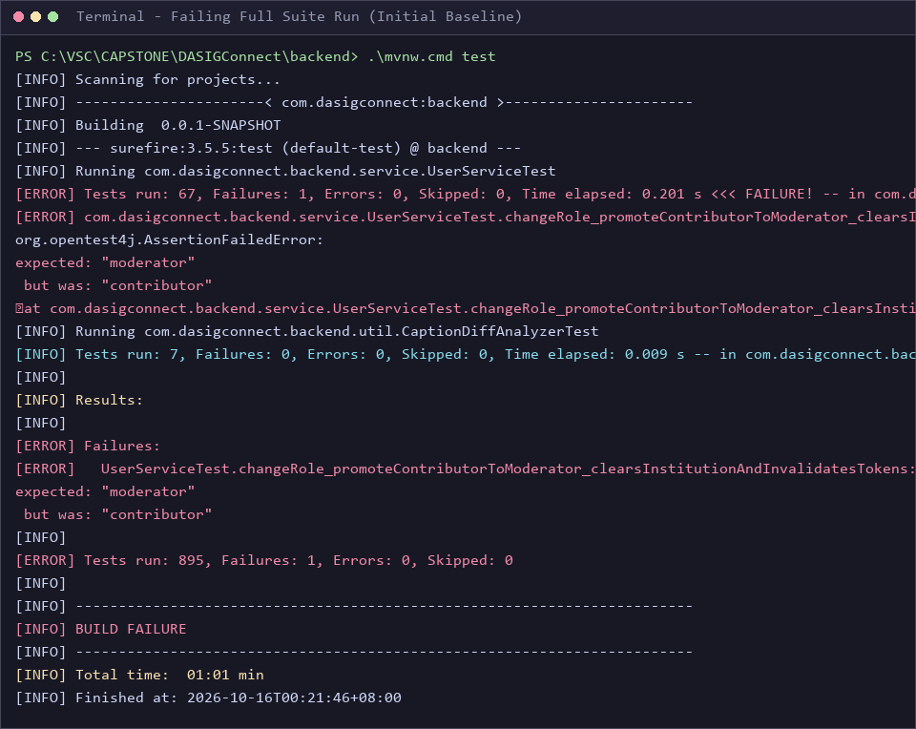

Figure 2. Passing test run (after) — 930 tests passing and BUILD SUCCESS
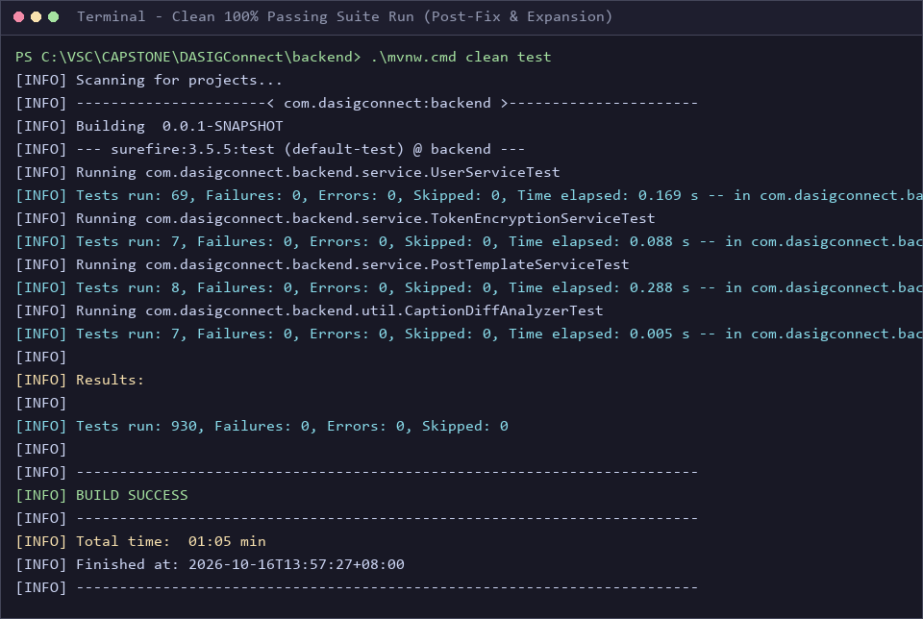

Figure 3. Commit history — Git traceability for bug fix, new tests, and docs
