DASIGConnect
Folder 03 — Testing Evidence
Bug Fixing, Test Coverage, Test Execution Logs and Defect Log

Prepared by: Member 2 (Bug Fixing & Test Coverage)
Team 2526-sem2-it332-38 — Cebu Institute of Technology – University
October 16, 2026

Document Information
Field | Value
Document | Member 2 — Folder 03 Testing Evidence Report
Project | DASIGConnect (Spring Boot 4.0.6 + React 19)
Prepared by | Member 2 — Bug Fixing & Test Coverage
Test cycle | Regression cycle, 2026-10-16
Repository / Branch | github.com/dasigconnect-dev/DASIGConnect — branch test/std
Format reference | DASIGConnect Software Test Document (STD), Appendix A.1–A.4
Version | 1.0

Contents
1. Introduction
2. Test Environment
3. Task 1A — Fixing Failing Test Cases
4. Task 1B — New Test Functions Written
5. Task 2A — Test Execution Logs (STD A.1)
6. Test Results (STD A.2)
7. Task 2B — Defect Log: Failed vs. Fixed (STD A.3)
8. Summary and Hand-off
Appendix A — Git Commit Evidence
Appendix B — Screenshot Evidence (STD A.4)
Appendix C — Per-Class Test Results
Appendix D — Evidence File Locations

1. Introduction

1.1 Purpose
This document records the bug-fixing and test-coverage work done by Member 2 in the 2026-10-16 regression cycle. It provides the evidence for Folder 03: what failed, why it failed, how it was fixed, what new tests were written, and the raw test execution logs that prove the results.

1.2 Assigned Tasks
Table 1. Assigned tasks and where each is answered
# | Assigned task (Member 2) | Where it is answered
1 | Fix failing test cases and write new test functions (for code that had none). | Section 3 and Section 4
2 | Save test execution logs and fill out the Defect Log (failed vs. fixed) for Folder 03. | Section 5, Section 6 and Section 7

1.3 Scope
- In scope: the automated backend test suite (backend/, JUnit 5 + Mockito + Spring MockMvc) — 99 test classes.
- Out of scope for this cycle: the frontend Playwright E2E suite and the manual UI procedures for Case-1 to Case-25 (the STD A.1 manual logs still apply).

1.4 Result at a Glance
Table 2. Result at a glance
Metric | Before | After
Tests executed | 895 | 930
Failed | 1 | 0
Pass rate | 99.89% | 100.00%
Build | BUILD FAILURE | BUILD SUCCESS

1.5 References
- DASIGConnect Software Test Document (docs/pdf/DASIGConnect_Software Test Document.pdf)
- SRS and use cases: UC-1.3 A8 (docs/md/UC-1.3-contributor-account-management.md), UC-1.10 A11 (docs/md/UC-1.10-moderator-account-management.md)
- Pull request #374, commit 3976afb0 — "Fix: admin/moderator transfer confirmation"

2. Test Environment
Table 3. Test environment
Item | Value
Operating system | Microsoft Windows 11 Home Single Language
JDK | Java 21.0.9 LTS (HotSpot 64-Bit)
Build tool | Apache Maven 3.9.15 via Maven Wrapper (mvnw.cmd)
Framework | Spring Boot 4.0.6
Test tools | JUnit 5 (Maven Surefire 3.5.5), Mockito (inline mock maker), AssertJ, Spring @WebMvcTest / MockMvc
Test database | H2 in-memory for Spring context tests; repositories are mocked in unit tests
External services | Facebook Graph API, Voyage, Claude/Gemini, storage and SMTP are all mocked (no network calls)
Command used | .\mvnw.cmd clean test (run from the backend folder)

3. Task 1A — Fixing Failing Test Cases

3.1 Failure Detected
The full backend suite was run at the start of the cycle. One test failed, which made the whole build fail.
Table 4. INC-11 failure details
Item | Detail
Incident ID | INC-11 (continues the STD numbering, which ends at INC-10)
Failing test | UserServiceTest.changeRole_promoteContributorToModerator_clearsInstitutionAndInvalidatesTokens
Error | AssertionFailedError at UserServiceTest.java:522 — expected: "moderator" but was: "contributor"
Detected | 2026-10-16 00:21 PHT, full suite run (log 01)
Suite result | 895 tests run, 1 failure — BUILD FAILURE
Related STD cases | Case-12 (UC-1.10), Case-4 (UC-1.3 A8)

Code 1. Log excerpt — failure in logs/01_BEFORE_full-suite_895-tests_1-FAILED.log
2268| [ERROR] Tests run: 67, Failures: 1, Errors: 0, Skipped: 0, Time elapsed: 0.201 s <<< FAILURE! -- in com.dasigconnect.backend.service.UserServiceTest
2269| [ERROR] com.dasigconnect.backend.service.UserServiceTest.changeRole_promoteContributorToModerator_clearsInstitutionAndInvalidatesTokens -- Time elapsed: 0.018 s <<< FAILURE!
2270| org.opentest4j.AssertionFailedError:
2271|
2272| expected: "moderator"
2273| but was: "contributor"
2274| at com.dasigconnect.backend.service.UserServiceTest.changeRole_promoteContributorToModerator_clearsInstitutionAndInvalidatesTokens(UserServiceTest.java:522)

Code 2. Log excerpt — suite summary before the fix
2313| [ERROR] Tests run: 895, Failures: 1, Errors: 0, Skipped: 0
2314| [INFO]
2315| [INFO] ------------------------------------------------------------------------
2316| [INFO] BUILD FAILURE
2317| [INFO] ------------------------------------------------------------------------

3.2 Root Cause
The test was outdated; the application code was correct.
- Commit 3976afb0 (PR #374, 2026-10-04) changed Contributor → Moderator promotion into a propose/confirm flow. changeRole() now only records a pending proposal; the role stays "contributor" until the user confirms through the new confirmModeratorPromotion() method.
- The same PR updated UC-1.3 A8, which says: "The proposal does not immediately change the Contributor's role, institution assignment, or active sessions. The Contributor must confirm the proposal before the change takes effect."
- The PR did not update UserServiceTest, so the old test still expected the role to change immediately.

3.3 Fix Applied
Only the test file was changed (UserServiceTest.java, +41 / −1 lines). No production code was changed.
Code 3. BEFORE — outdated test (expects an immediate role change)
@Test
void changeRole_promoteContributorToModerator_clearsInstitutionAndInvalidatesTokens() {
...
UserDto result = userService.changeRole(target.getId(), UserRole.moderator, null,
principal(peerAdmin.getId(), "admin", null));
assertThat(result.getRole()).isEqualTo("moderator"); // fails: role is still "contributor"
assertThat(target.getInstitution()).isNull();
verify(jwtService).invalidateUserTokens(target.getId());
verify(eventPublisher).publishEvent(any(UserRoleChangedEvent.class));
}

Code 4. AFTER — three tests that match the propose / confirm / decline flow
@Test
void changeRole_proposeModeratorPromotion_setsPendingWithoutChangingRoleYet() {
...
assertThat(result.getRole()).isEqualTo("contributor"); // not changed yet
assertThat(result.isModeratorPromotionPending()).isTrue();
verify(jwtService, never()).invalidateUserTokens(any()); // sessions kept until confirm
verify(eventPublisher).publishEvent(any(ModeratorPromotionRequestedEvent.class));
}
@Test
void confirmModeratorPromotion_clearsInstitutionAndInvalidatesTokens() {
...
assertThat(result.getRole()).isEqualTo("moderator");
assertThat(target.getInstitution()).isNull();
verify(jwtService).invalidateUserTokens(target.getId());
verify(eventPublisher).publishEvent(any(UserRoleChangedEvent.class));
}
@Test
void declineModeratorPromotion_clearsPromotionFieldsWithoutChangingRole() {
...
assertThat(result.getRole()).isEqualTo("contributor");
assertThat(target.getModeratorPromotionRequestedBy()).isNull();
}

3.4 Verification
Table 5. INC-11 verification
Check | Result | Evidence
UserServiceTest run on its own | 69 tests, 0 failures | logs/02_FIX_UserServiceTest_69-tests_PASSED.log
Full suite after all changes | 930 tests, 0 failures, BUILD SUCCESS | logs/04_AFTER_full-suite_FINAL.log
Fix commit | 96148d1c | Appendix A

Code 5. Log excerpt — UserServiceTest passing in the final run (logs/04_AFTER_full-suite_FINAL.log)
2287| [INFO] Tests run: 69, Failures: 0, Errors: 0, Skipped: 0, Time elapsed: 0.169 s -- in com.dasigconnect.backend.service.UserServiceTest

4. Task 1B — New Test Functions Written

4.1 Coverage Gaps Identified
Each service class in backend/src/main/java/.../service/ was compared with the test folder. The 7 services below had no test class at all. A new test class was written for each one (commit e2ad438e).
Table 6. Services that had no tests, and the new test classes
ID | New test class | Service under test | What the service does | STD Case / UC | Tests
CG-01 | TokenEncryptionServiceTest | TokenEncryptionService | Encrypts the stored Facebook Page token (AES-256-GCM) | Case-20 (UC-3.2), Case-24 (UC-3.5) | 7
CG-02 | PostTemplateServiceTest | PostTemplateService | Saved post templates | Case-6 (UC-1.5) | 8
CG-03 | ScheduledJobHealthServiceTest | ScheduledJobHealthService | Records background job runs for System Health | Case-24 (UC-3.5) | 4
CG-04 | WorkspaceProvisionerServiceTest | WorkspaceProvisionerService | Binds tenant scope when an institution is onboarded | Case-3 (UC-1.2), Case-25 | 1
CG-05 | MediaRetrievalEmbeddingServiceTest | MediaRetrievalEmbeddingService | Runs image and semantic embedding stages | Case-14 (UC-2.2), Case-9 (UC-1.7) | 4
CG-06 | MediaSearchCacheServiceTest | MediaSearchCacheService | 30-second media search cache | Case-14 (UC-2.2) | 4
CG-07 | SocialEngagementSyncServiceTest | SocialEngagementSyncService | Syncs Facebook engagement metrics | Case-23 (UC-3.4) | 5
 |  |  |  | Total | 33

4.2 Test Functions per Class
Table 7. CG-01 TokenEncryptionServiceTest
# | Test function | What it verifies | Result
1 | isConfigured_withSecret_returnsTrue | Reports configured when an app secret is set | PASS
2 | isConfigured_withNullOrBlank_returnsFalse | A null or blank secret means not configured | PASS
3 | encryptAndDecryptToken_roundTrip_matchesOriginal | Encrypt then decrypt returns the original token | PASS
4 | encryptToken_producesDifferentIVEachTime | Same token encrypts differently each time (random IV) | PASS
5 | decryptToken_invalidFormat_throwsException | A malformed stored value fails safely | PASS
6 | decryptToken_tamperedCiphertext_throwsException | Tampered data is rejected by the GCM tag | PASS
7 | encryptToken_withBlankSecret_throwsException | Encryption fails safely when the secret is blank | PASS

Table 8. CG-02 PostTemplateServiceTest
# | Test function | What it verifies | Result
1 | list_returnsOrderedTemplatesForUser | Lists only the user's templates, newest first | PASS
2 | create_withValidData_normalizesAndSavesTemplate | Trims text, falls back to the user's institution, cleans tags (max 8) | PASS
3 | create_duplicateName_throwsConflict409 | Duplicate template name returns 409 | PASS
4 | create_missingName_throwsIllegalArgumentException | Name is required | PASS
5 | create_missingCaption_throwsIllegalArgumentException | Caption is required | PASS
6 | create_withNullOptionalFields_appliesFallbacks | Default target and category are applied | PASS
7 | delete_existingTemplate_deletesSuccessfully | Owner can delete their template | PASS
8 | delete_nonExistentTemplate_throwsNotFound404 | Missing or other user's template returns 404 | PASS

Table 9. CG-03 ScheduledJobHealthServiceTest
# | Test function | What it verifies | Result
1 | recordSuccess_savesSuccessRunWithoutError | Stores a SUCCESS run with start, end and duration | PASS
2 | recordFailure_withException_savesFailedRunAndTruncatesLongError | Stores a FAILED run; error text capped at 1,000 characters | PASS
3 | recordFailure_withNullException_savesUnknownFailure | Null exception stored as "Unknown failure" | PASS
4 | recordFailure_withExceptionWithoutMessage_summarizesClassSimpleName | No message: stores the exception class name | PASS

Table 10. CG-04 WorkspaceProvisionerServiceTest
# | Test function | What it verifies | Result
1 | provision_bindsTenantScopeForAdmin | Onboarding binds the tenant scope for the institution | PASS

Table 11. CG-05 MediaRetrievalEmbeddingServiceTest
# | Test function | What it verifies | Result
1 | generateOrReuse_imageTypeSuccess_runsBothEmbeddingStages | Images run the image stage, then the semantic stage | PASS
2 | generateOrReuse_imageTypeImageStageFails_shortCircuitsAndReturnsFalse | If the image stage fails, the semantic stage is skipped | PASS
3 | generateOrReuse_nonImage_skipsImageStageAndRunsSemanticStage | Videos skip the image stage | PASS
4 | generateOrReuse_nonImageSemanticFails_returnsFalse | A semantic-stage failure is reported | PASS

Table 12. CG-06 MediaSearchCacheServiceTest
# | Test function | What it verifies | Result
1 | get_nonExistentKey_returnsNull | A cache miss returns nothing | PASS
2 | putAndGet_validKey_returnsCachedResponse | A cached result is returned | PASS
3 | invalidateAll_clearsAllEntries | Invalidation empties the cache | PASS
4 | put_exceedsMaxEntries_clearsAndAcceptsNew | The 500-entry memory guard clears the cache and still stores the new entry | PASS

Table 13. CG-07 SocialEngagementSyncServiceTest
# | Test function | What it verifies | Result
1 | syncPending_withMissingEngagement_processesBatchAndReturnsCount | Only posts with a Facebook post ID are counted as synced | PASS
2 | syncOne_successfulFetch_savesUpdatedMetrics | Saves reach, reactions, comments and shares | PASS
3 | syncOne_apiThrowsException_recordsLastErrorAndReturnsFalse | A Graph API error is recorded without crashing | PASS
4 | syncOne_missingSubmission_returnsFalse | A missing submission is skipped safely | PASS
5 | constructor_clampsBatchSizeBetween1And100 | Batch size config is kept between 1 and 100 | PASS

4.3 Tests Added During the INC-11 Fix
Table 14. UserServiceTest — tests added or rewritten for INC-11
# | Test function | What it verifies | Result
1 | changeRole_proposeModeratorPromotion_setsPendingWithoutChangingRoleYet | Proposal keeps the role, marks it pending, keeps sessions | PASS
2 | confirmModeratorPromotion_clearsInstitutionAndInvalidatesTokens | Confirmation applies Moderator, clears institution, revokes sessions | PASS
3 | declineModeratorPromotion_clearsPromotionFieldsWithoutChangingRole | Declining clears the proposal; role unchanged | PASS

Test count check: 33 new tests (Section 4.1) + 2 net new tests in UserServiceTest (67 → 69) = 35, which matches the suite growing from 895 to 930.

5. Task 2A — Test Execution Logs (STD A.1)
Each log is the unedited console output of Maven. They are numbered in the order they were run and saved in docs/03-testing/logs/.
Table 15. Test execution logs
Log | File | Command | Date / time (PHT) | Result
Log 1 | 01_BEFORE_full-suite_895-tests_1-FAILED.log | .\mvnw.cmd test | 2026-10-16 00:20–00:21 | 895 run, 1 failure — BUILD FAILURE
Log 2 | 02_FIX_UserServiceTest_69-tests_PASSED.log | .\mvnw.cmd test -Dtest=UserServiceTest | 2026-10-16 00:29 | 69 run, 0 failures
Log 3 | 03_NEW-TESTS_7-classes_33-tests_PASSED.log | .\mvnw.cmd test -Dtest=<7 new classes> | 2026-10-16 00:33 | 33 run, 0 failures
Log 4 | 04_AFTER_full-suite_FINAL.log | .\mvnw.cmd clean test | 2026-10-16 13:56–13:57 | 930 run, 0 failures — BUILD SUCCESS

How to read a log: search for "Tests run:" to see each test class, and "Results:" for the summary at the end. In Log 1, search for "FAILURE" to find the failing test.
Code 6. Log excerpt — final summary (logs/04_AFTER_full-suite_FINAL.log)
2322| [INFO] Results:
2323| [INFO]
2324| [INFO] Tests run: 930, Failures: 0, Errors: 0, Skipped: 0
2325| [INFO]
2326| [INFO] ------------------------------------------------------------------------
2327| [INFO] BUILD SUCCESS
2328| [INFO] ------------------------------------------------------------------------
2329| [INFO] Total time: 01:05 min

6. Test Results (STD A.2)

6.1 Summary of Test Execution Metrics
Table 16. Before vs. after metrics
Metric | Before (00:21) | After (13:57) | Change
Test classes | 92 | 99 | +7
Tests executed | 895 | 930 | +35
Passed | 894 | 930 | +36
Failed | 1 | 0 | −1
Errors / Skipped | 0 / 0 | 0 / 0 | —
Pass rate | 99.89% | 100.00%
Build | BUILD FAILURE | BUILD SUCCESS
Duration | 1 min 01 s | 1 min 05 s

6.2 Results by Package (final run)
Table 17. Final results by package (from Surefire XML reports)
Package | Test classes | Tests | Failed
backend | 1 | 1 | 0
backend.controller | 18 | 162 | 0
backend.event | 1 | 12 | 0
backend.exception | 1 | 4 | 0
backend.external | 2 | 8 | 0
backend.model.dto.* | 3 | 21 | 0
backend.repository | 1 | 1 | 0
backend.schedule | 11 | 48 | 0
backend.service | 60 | 666 | 0
backend.util | 1 | 7 | 0
Total | 99 | 930 | 0

6.3 Note for the STD
STD Appendix A.2 currently lists "17 Test Classes (273+ JUnit 5 / MockMvc tests)". The measured figure is now 99 test classes and 930 tests. The documentation team should update that row.

7. Task 2B — Defect Log: Failed vs. Fixed (STD A.3)

7.1 Failed vs. Fixed (Resolved Incidents Verified During Regression Testing)
Table 18. Defect Log — failed vs. fixed
Incident ID | Related Test / UC | Severity | Defect summary | Date failed | Status before | Fix / commit | Date fixed | Status after
INC-11 | Case-12 (UC-1.10), Case-4 (UC-1.3 A8) | Medium | Moderator-promotion unit test expected an immediate role change; PR #374 had made it propose/confirm | 2026-10-16 00:21 | FAILED | Test rewritten + 2 tests added — 96148d1c | 2026-10-16 00:29 | FIXED

Table 19. INC-11 resolution details
Field | Detail
Root cause | Outdated test. Commit 3976afb0 (PR #374) changed changeRole() to a propose/confirm flow and did not update UserServiceTest.
Production code changed | No — test file only
Evidence (before) | logs/01_BEFORE_full-suite_895-tests_1-FAILED.log — 895 run, 1 failure
Evidence (after) | logs/02_FIX… (69/69) and logs/04_AFTER_full-suite_FINAL.log (930/930)
Verified by / date | Member 2 — 2026-10-16 13:57 PHT (clean run)

7.2 Open Incidents & Known Discrepancies (new this cycle)
Table 20. Open incidents
Incident ID | Related Test / UC | Severity | Description & root cause | Status & resolution plan
INC-12 | Case-12 (UC-1.10 A11), Case-4 (UC-1.3 A8) | Low (documentation) | The specs disagree. UC-1.3 A8 and the code say Contributor → Moderator needs confirmation. UC-1.10 A11 and SRS UC-1.10 A11 still say "no confirmation step". STD Case-12 follows the old wording. | OPEN — handed to the documentation team to update UC-1.10 A11, SRS and STD Case-12. If the team decides promotion should be immediate, the code must change back and INC-11 is reopened.

7.3 Notes on Existing STD Incidents
Table 21. Existing incidents affected by this cycle
Incident | Observation | Recommendation
INC-01 (Admin Owner transfer to an existing Admin) | PR #374 ("Fix: admin/moderator transfer confirmation") came after the STD logs. Unit test confirmAdminTransfer_toExistingAdmin_keepsOutgoingAsAdmin passes. | Re-run the Case-2 procedure through the app before marking it Resolved; the unit test does not cover the endpoint's role check.

8. Summary and Hand-off
Table 22. Task completion
Assigned task | Status | Evidence
Fix failing test cases | Done — 1 of 1 fixed (INC-11) | Section 3, Log 1 → Log 2 → Log 4
Write new test functions | Done — 7 new classes / 33 tests, plus 2 in UserServiceTest | Section 4, Log 3, Log 4
Save test execution logs | Done — 4 logs | Section 5, docs/03-testing/logs/
Fill out the Defect Log (failed vs. fixed) | Done — INC-11 fixed, INC-12 open | Section 7, 01_Defect_Log_Failed_vs_Fixed.csv

The backend suite is green (930/930) at commit e2ad438e on branch test/std and is ready to pass to Member 1 for code freeze.

Appendix A — Git Commit Evidence
Table 23. Commits
Commit | Author | Date | Message | Role in this report
3976afb0 | Teammate (PR #374) | 2026-10-04 | Fix: admin/moderator transfer confirmation (#374) | Root cause of INC-11
96148d1c | Member 2 | 2026-10-16 | test(user): align moderator promotion tests with propose/confirm flow (INC-11) | Fix for INC-11
e2ad438e | Member 2 | 2026-10-16 | test: add unit tests for 7 previously untested services (33 tests) | New test functions
07910352 | Member 2 | 2026-10-16 | docs(testing): add Folder 03 defect log, test execution report, and logs | Folder 03 evidence

GitHub link format (after pushing): https://github.com/dasigconnect-dev/DASIGConnect/commit/<commit>

Appendix B — Screenshot Evidence (STD A.4)
The terminal execution screenshots below provide visual verification of the testing cycle and defect resolution.
Figure 1. Failing test run (before) — INC-11 assertion failure and BUILD FAILURE
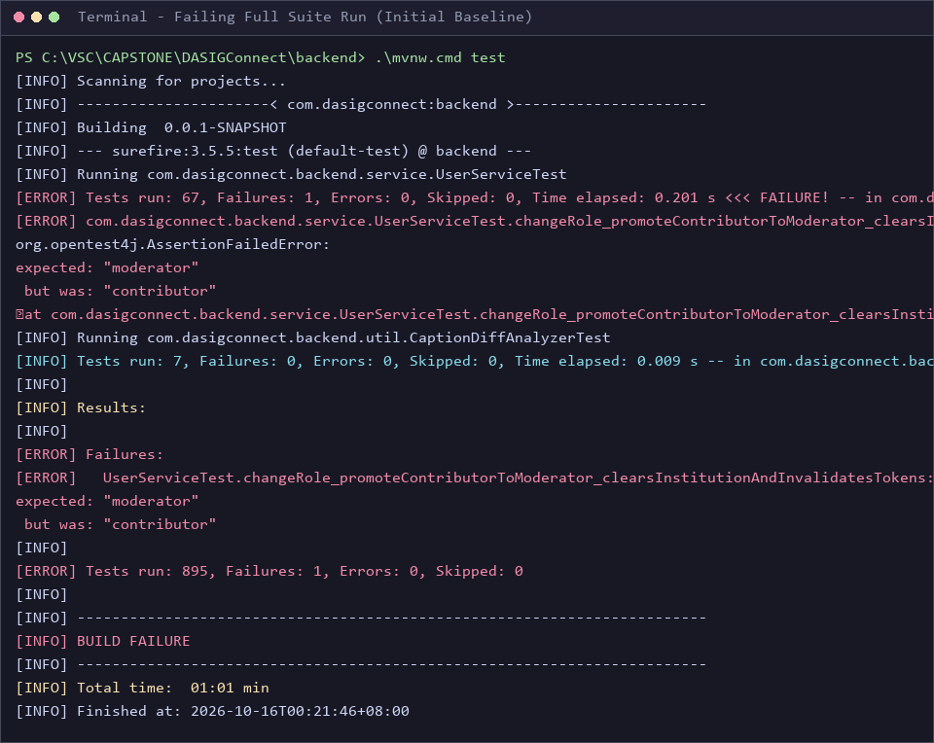

Figure 2. Passing test run (after) — 930 tests passing and BUILD SUCCESS
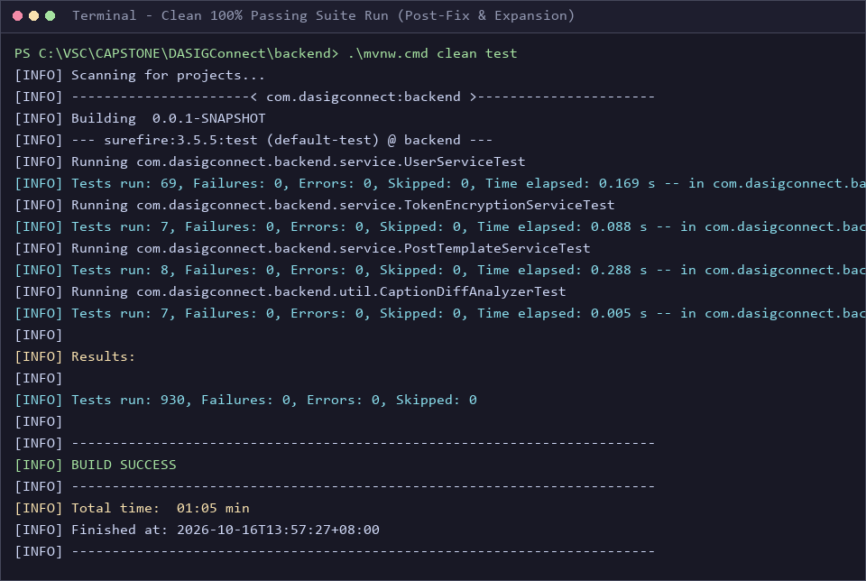

Figure 3. Commit history — Git traceability for bug fix, new tests, and docs
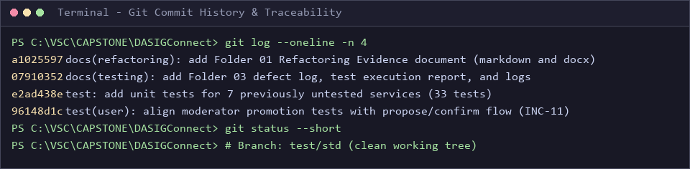

Appendix C — Per-Class Test Results (final run)
Table 24. All 99 test classes
# | Test class | Package | Tests | Failed | Time (s) | Result
1 | BackendApplicationTests | backend | 1 | 0 | 16.531 | PASS
2 | AIRecommendationControllerUnitTest | backend.controller | 3 | 0 | 0.381 | PASS
3 | AnalyticsControllerTest | backend.controller | 5 | 0 | 2.093 | PASS
4 | AuditLogControllerTest | backend.controller | 4 | 0 | 0.892 | PASS
5 | AuthControllerTest | backend.controller | 9 | 0 | 0.937 | PASS
6 | CalendarControllerTest | backend.controller | 4 | 0 | 0.951 | PASS
7 | CaptionControllerTest | backend.controller | 9 | 0 | 0.885 | PASS
8 | InstitutionControllerAuthTest | backend.controller | 7 | 0 | 0.902 | PASS
9 | InvitationControllerTest | backend.controller | 15 | 0 | 1.008 | PASS
10 | MediaAssetControllerTest | backend.controller | 14 | 0 | 1.157 | PASS
11 | MediaProxyControllerTest | backend.controller | 2 | 0 | 0.704 | PASS
12 | MessengerWebhookControllerTest | backend.controller | 4 | 0 | 0.615 | PASS
13 | NotificationControllerTest | backend.controller | 6 | 0 | 0.686 | PASS
14 | PasswordControllerTest | backend.controller | 9 | 0 | 0.868 | PASS
15 | ResolutionControllerTest | backend.controller | 15 | 0 | 1.041 | PASS
16 | SubmissionControllerTest | backend.controller | 16 | 0 | 0.937 | PASS
17 | SystemHealthControllerTest | backend.controller | 8 | 0 | 0.858 | PASS
18 | UserControllerTest | backend.controller | 27 | 0 | 0.982 | PASS
19 | ValidationControllerTest | backend.controller | 5 | 0 | 0.700 | PASS
20 | NotificationEventListenerTest | backend.event | 12 | 0 | 0.243 | PASS
21 | AccessDeniedAuditRecorderTest | backend.exception | 4 | 0 | 0.123 | PASS
22 | ClaudeVisionClientTest | backend.external | 6 | 0 | 0.012 | PASS
23 | GeminiVisionClientTest | backend.external | 2 | 0 | 0.173 | PASS
24 | TokenStatusDtoTest | backend.model.dto.exception | 6 | 0 | 0.006 | PASS
25 | GuardRailDtoTest | backend.model.dto.guardrail | 10 | 0 | 0.015 | PASS
26 | InstitutionDtoTest | backend.model.dto.institution | 5 | 0 | 0.004 | PASS
27 | AnalyticsRepositoryTest | backend.repository | 1 | 0 | 0.190 | PASS
28 | EmbeddingFailureDigestJobTest | backend.schedule | 3 | 0 | 0.229 | PASS
29 | EmbeddingReconciliationJobTest | backend.schedule | 9 | 0 | 0.157 | PASS
30 | EmptyScheduleWarningJobTest | backend.schedule | 2 | 0 | 0.138 | PASS
31 | MediaProcessingWorkerTest | backend.schedule | 12 | 0 | 0.385 | PASS
32 | PublishingSchedulerJobTest | backend.schedule | 2 | 0 | 0.135 | PASS
33 | ReviewLockCleanupJobTest | backend.schedule | 2 | 0 | 0.022 | PASS
34 | ScheduledJobRunRetentionJobTest | backend.schedule | 2 | 0 | 0.080 | PASS
35 | StaleSubmissionDetectorJobTest | backend.schedule | 4 | 0 | 0.082 | PASS
36 | TokenHealthCheckJobTest | backend.schedule | 7 | 0 | 0.019 | PASS
37 | TokenPublishingEscalationJobTest | backend.schedule | 3 | 0 | 0.012 | PASS
38 | ValidationDeadlineNotificationJobTest | backend.schedule | 2 | 0 | 0.080 | PASS
39 | AIClassificationServiceTest | backend.service | 12 | 0 | 0.267 | PASS
40 | AIRecommendationServiceTest | backend.service | 25 | 0 | 0.247 | PASS
41 | AccountLockoutServiceTest | backend.service | 7 | 0 | 0.094 | PASS
42 | AdminCapPolicyTest | backend.service | 6 | 0 | 0.109 | PASS
43 | AiAdoptionTrackingServiceTest | backend.service | 7 | 0 | 0.086 | PASS
44 | AuditLogServiceTest | backend.service | 3 | 0 | 0.228 | PASS
45 | AuthServiceTest | backend.service | 8 | 0 | 0.140 | PASS
46 | CalendarServiceTest | backend.service | 5 | 0 | 0.093 | PASS
47 | CaptionGenerationServiceTest | backend.service | 10 | 0 | 0.035 | PASS
48 | ContentIdeaSuggestionServiceTest | backend.service | 2 | 0 | 0.005 | PASS
49 | EmailDeliveryServiceTest | backend.service | 2 | 0 | 0.147 | PASS
50 | EmailServiceTest | backend.service | 3 | 0 | 0.030 | PASS
51 | EngagementRecommendationServiceTest | backend.service | 4 | 0 | 0.146 | PASS
52 | FacebookPublisherServiceTest | backend.service | 10 | 0 | 0.248 | PASS
53 | GuardRailServiceTest | backend.service | 19 | 0 | 0.087 | PASS
54 | GuardRailSettingsServiceTest | backend.service | 2 | 0 | 0.091 | PASS
55 | InstitutionServiceTest | backend.service | 26 | 0 | 0.267 | PASS
56 | InvitationServiceTest | backend.service | 45 | 0 | 0.296 | PASS
57 | JWTServiceTest | backend.service | 13 | 0 | 0.290 | PASS
58 | ManualJobRunnerTest | backend.service | 4 | 0 | 0.918 | PASS
59 | ManualPublishingServiceTest | backend.service | 28 | 0 | 0.085 | PASS
60 | MediaAiTelemetryServiceTest | backend.service | 5 | 0 | 0.158 | PASS
61 | MediaAssetRetentionServiceTest | backend.service | 1 | 0 | 0.135 | PASS
62 | MediaAssetServiceTest | backend.service | 45 | 0 | 0.218 | PASS
63 | MediaImageEmbeddingServiceTest | backend.service | 5 | 0 | 0.019 | PASS
64 | MediaProcessingQueueServiceTest | backend.service | 15 | 0 | 0.111 | PASS
65 | MediaRetrievalEmbeddingServiceTest | backend.service | 4 | 0 | 0.020 | PASS
66 | MediaSearchCacheServiceTest | backend.service | 4 | 0 | 0.007 | PASS
67 | MediaSemanticEmbeddingServiceTest | backend.service | 5 | 0 | 0.017 | PASS
68 | MediaStorageServiceTest | backend.service | 10 | 0 | 0.945 | PASS
69 | MediaSuggestionEvaluationServiceTest | backend.service | 4 | 0 | 0.012 | PASS
70 | MessengerConnectionServiceTest | backend.service | 3 | 0 | 0.149 | PASS
71 | MessengerDeliveryServiceTest | backend.service | 6 | 0 | 0.092 | PASS
72 | MessengerWebhookServiceTest | backend.service | 3 | 0 | 0.005 | PASS
73 | MetricsAggregatorServiceTest | backend.service | 17 | 0 | 0.125 | PASS
74 | NotificationServiceTest | backend.service | 9 | 0 | 0.028 | PASS
75 | PageSettingsServiceTest | backend.service | 5 | 0 | 0.013 | PASS
76 | PasswordPolicyTest | backend.service | 3 | 0 | 0.005 | PASS
77 | PasswordServiceTest | backend.service | 10 | 0 | 0.098 | PASS
78 | PostTemplateServiceTest | backend.service | 8 | 0 | 0.110 | PASS
79 | ProofreadServiceTest | backend.service | 5 | 0 | 0.012 | PASS
80 | PublishingQueryServiceTest | backend.service | 2 | 0 | 0.006 | PASS
81 | ResolutionServiceTest | backend.service | 2 | 0 | 0.006 | PASS
82 | ReviewLockServiceTest | backend.service | 4 | 0 | 0.127 | PASS
83 | ScheduledJobHealthServiceTest | backend.service | 4 | 0 | 0.011 | PASS
84 | SlotReservationServiceTest | backend.service | 14 | 0 | 0.075 | PASS
85 | SocialEngagementSyncServiceTest | backend.service | 5 | 0 | 0.115 | PASS
86 | SubmissionMediaContextServiceTest | backend.service | 1 | 0 | 0.022 | PASS
87 | SubmissionServiceTest | backend.service | 67 | 0 | 0.298 | PASS
88 | SystemHealthServiceTest | backend.service | 13 | 0 | 0.074 | PASS
89 | TenantScopeServiceTest | backend.service | 3 | 0 | 0.077 | PASS
90 | TokenEncryptionServiceTest | backend.service | 7 | 0 | 0.017 | PASS
91 | TokenManagementServiceTest | backend.service | 13 | 0 | 0.140 | PASS
92 | TopPostTemplateServiceTest | backend.service | 5 | 0 | 0.019 | PASS
93 | UserServiceTest | backend.service | 69 | 0 | 0.169 | PASS
94 | ValidationRejectionReasonTest | backend.service | 4 | 0 | 0.004 | PASS
95 | ValidationServiceTest | backend.service | 32 | 0 | 0.240 | PASS
96 | WatermarkApplicationServiceTest | backend.service | 5 | 0 | 0.379 | PASS
97 | WatermarkConfigurationServiceTest | backend.service | 7 | 0 | 0.019 | PASS
98 | WorkspaceProvisionerServiceTest | backend.service | 1 | 0 | 0.002 | PASS
99 | CaptionDiffAnalyzerTest | backend.util | 7 | 0 | 0.005 | PASS

Appendix D — Evidence File Locations
Table 25. Where each evidence file is
File | Location | Used in
Defect Log (document) | docs/03-testing/01_Defect_Log_Failed_vs_Fixed.md | Section 7
Defect Log (spreadsheet) | docs/03-testing/01_Defect_Log_Failed_vs_Fixed.csv | Section 7
Test execution report (source) | docs/03-testing/02_Test_Execution_Report.md | Sections 2, 4–6
Logs 1–4 | docs/03-testing/logs/ | Section 5
Per-class results | docs/03-testing/reports/per-class-test-results.csv | Section 6, Appendix C
Fixed test | backend/src/test/java/com/dasigconnect/backend/service/UserServiceTest.java | Section 3
New tests (7 files) | backend/src/test/java/com/dasigconnect/backend/service/*Test.java (see Section 4.1) | Section 4

