
How to access SQL Server reports

Project Name: WA Oracle Report convention
Department: Hunting & Fishing
Product/Process: WA Oracle Report
Prepared By:
Document Owner(s) | Project/Organization Role
Ivy | Developer

Project Status Report Version Control
Version | Date | Author | Change Description
1.0 | 09/12/2009 | Ivy | Document created

TABLE OF CONTENTS

1. Access report via report server 3

1.1 Deployment 3
1.2 Access 3
2. URL Access 4

2.1 URL Access Syntax 4
2.2 Form a report URL 7
3. How to integrate with Perl web application 8

1. Access report via report server

1.1 Deployment
In order to access report, you should deploy the reports to the report server first. In SQL Server Business Intelligence Development Studio, right click the project and choose properties, configure it as follow:
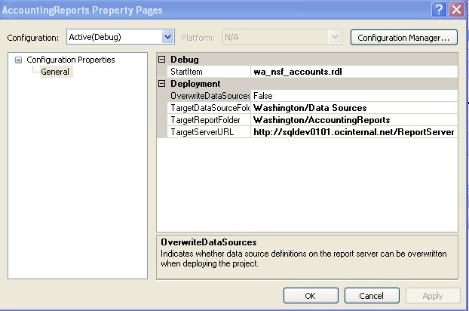
Then right click the report you want to deploy, click Deploy.

1.2 Access

After that you can run the report on the report server via http://sqldev0101.ocinternal.net/Reports under folder “Washingtion/AccountingReports”.
You also can access these reports via http://sqldev0101.ocinternal.net/ReportServer, you can see the whole file hierarchy over there.

2. URL Access

2.1 URL Access Syntax
You can access the report server by using a URL. URL requests can contain multiple parameters that are listed in any order. Parameters are separated by an ampersand (&) and name/value pairs are separated by an equal sign (=):

protocol://server/virtualroot?[/pathinfo]&prefix:param=value[&prefix:param=value]...n]
- Protocol:
The protocol of the URL. For example, http:// or https://.
- Server:
The name of the computer on which the report server is running. This can include a fully qualified domain name, for us it’s sqldev0101.ocinternal.net.
- Vitualroot :
The name of the virtual root of the report server. (“ReportServer” in most case)
- ?
The item path and parameter portion of the URL.
- [/ pathinfo ] :
The full path name of the item being accessed in the report server database.
- &
Used to separate name and value pairs of parameters.
- Prefix:
Optional, a parameter prefix (for example, rs: or rc :) that accesses a specific process running within the report server. If a parameter prefix for a parameter is not included, the parameter is processed by the report server as a report parameter. Following are the most useful prefixes and their parameters:
- HTML Viewer Commands
The following table describes the URL access parameters that are prefixed with rc: and are used to target the HTML Viewer.
Parameter | Action
Toolbar | Shows or hides the toolbar. If the value of this parameter is false, all remaining options are ignored. If you omit this parameter, the toolbar is automatically displayed for rendering formats that support it. The default of this parameter is true.
Parameters | Shows or hides the parameters area of the toolbar. If you set this parameter to true, the parameters area of the toolbar is displayed. If you set this parameter to false, the parameters area is not displayed and cannot be displayed by the user. If you set this parameter to a value of Collapsed, the parameters area will not be displayed, but can be toggled by the end user. The default value of this parameter is true.
Zoom | Sets the report zoom value as an integer percentage or a string constant. Standard string values include Page Width and Whole Page. This parameter is ignored by versions of Microsoft Internet Explorer earlier than Internet Explorer 5.0 and all non-Microsoft browsers. The default value of this parameter is 100.
Section | Sets which page in the report to display. Any value that is greater than the number of pages in the report displays the last page. Any value that is less than 0 displays page 1 of the report. The default value of this parameter is 1.

- Report Server Commands
The following table describes the URL access parameters that are prefixed with rs: and are used to target the report server.
Parameter | Action
Command | Specifies the last section to search. The default value of this parameter is the last page of the report.
Format | Specifies the format in which to render a report. Common values include HTML3.2, HTML4.0, MHTML, IMAGE, EXCEL, WORD, CSV, PDF, XML, and NULL.
ParameterLanguage | Provides a language for parameters passed in a URL that is independent of the browser language. The default value is the browser language. The value can be a culture value, such as en-us or de-de.
Snapshot | enders a report based on a report history snapshot..

- Report Viewer Web Part Commands
The following table describes the new SQL Server 2008 reserved report parameter names that are used to target the Report Viewer Web Part when Reporting Services is integrated with Windows SharePoint Services (WSS) 3.0 or Microsoft Office SharePoint Server (MOSS) 2007. These parameter names are prefixed with rv:. The Report Viewer Web Part also accepts the rs: ParameterLanguage parameter.
Parameter | Action
Toolbar | Controls the toolbar display for the Report Viewer Web Part. The default value is Full. Values can be:  - Full: display the complete toolbar.  - Navigation: display only pagination in the toolbar.  - None: do not display the toolbar.
HeaderArea | Controls the header display for the Report Viewer Web Part. The default value is Full. Values can be:  - Full: display the complete header.  - BreadCrumbsOnly: display only the bread-crumb navigation in the header to inform the user where they are in the application.  - None: do not display the header.
DocMapAreaWidth | Controls the display width, in pixels, of the parameter area in the Report Viewer Web Part. The default value is the same as the Report Viewer Web Part default. The value must be a non-negative integer.
AsyncRender | Controls whether a report is rendered asynchronously. The default value is true, which specifies that a report be rendered asynchronously. The value must be a Boolean value of true or false.

2.2 Form a report URL
Use report “wa_tag_exchange” as an example, it has several parameters like: P_BNG_DT, P_END_DT, P_DEALER_ID, P_CORP_ID, P_AG_REP_SF_ID, and P_STATUS_IND. P_DEALER_ID should accept multiple values. So the URL should like this:
http://sqldev0101.ocinternal.net /ReportServer?/Washington/AccountingReports/wa_tag_exchange&rc:Parameters=false&rc:Toolbar=false&rs:Format=HTML4.0&P_BEG_DT=XXX&P_END_DT=XXX
2009&P_STATUS_IND=A&P_DEALER_ID=XXX&P_DEALER_ID=XXX&P_AG_REP_SF_ID=&P_CORP_ID=
In the above URL
- “rc: Parameter=false” means hide the parameter area
- “rc: Toolbar=false” means hide the toolbar
- “rs: Format=HTML4.0” means display it as HTML format
- Parameters with multiple values are specified by repeating the parameter name,
and if there is no input for this parameter just use” Parameter Name=” (must list all the parameters that the report has even there is no input).

The report we get through that URL will like this:

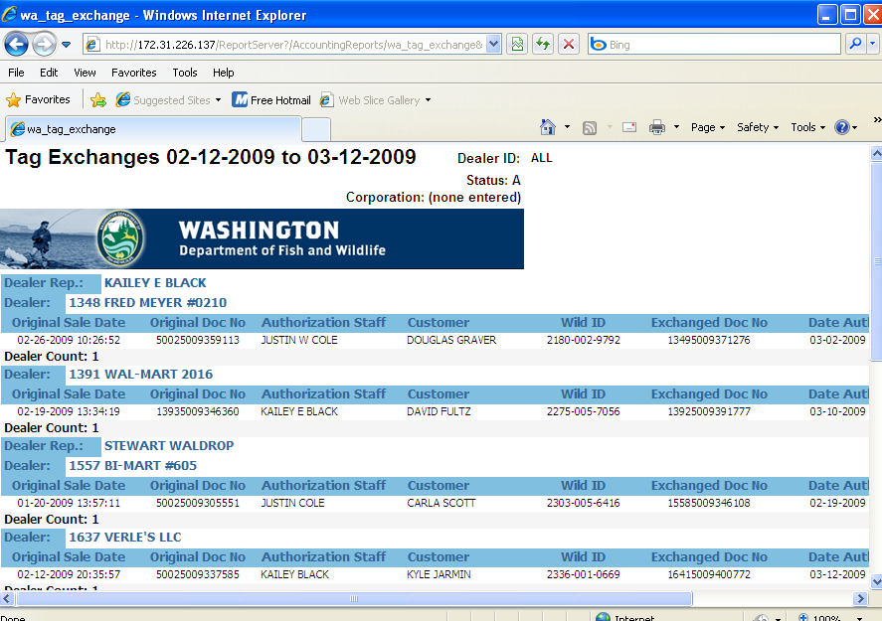

3. How to integrate with Perl web application
In order to access these new reports, we need modify the Perl code. In wa/modperl/Control/Utilities/Form.pm, it forms the report URL in a JavaScript function (validateReportServerReports) and it invokes a Perl function (Control::Utilities::Queries::getReportURL) to use a database function (GET_REPORTS_URL_F) to get the server URL from the database as follow:

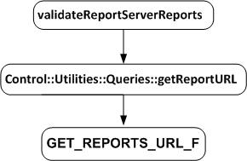

So we have two options to integrate the report URL into our application:
- Create a new DB function or modify the former one, and insert the SSRS server information into table (REPORT_SERVERS)
- Write the report server information into a new Perl function.
Then change the code in function (validateReportServerReports) to follow the SSRS rules.
After that we can access these new reports though web application.

