**Introduction**

One of the key challenges for IoT and wireless sensor networks is the limited lifetime due to massive devices being powered with batteries. The low-power and low-complexity backscatter communication has emerged as a promising technology to overcome this limitation. The backscatter communication consists in reflecting and modulating an incident radio signal.

…

In most RFID systems, the modulation in the communication between the tag and reader is an ASK or PSK that modulates either the amplitude, or both the amplitude and phase of the transmitted CW.

Nevertheless, there are some works that explore high order modulation schemes to be applied in semi-passive and passive sensor networks. In [1] the authors shown a 4-QAM scheme in backscatter communication. With this scheme the sensor can transmit 2 bits per symbol instead of 1 bit per symbol with ASK, increasing the data rate and leading to a reduced on-chip power consumption. The work presented in [1, 2] refers to a 4-QAM backscatter in semipassive systems, by using an approach with a four lumped impedances connected to a RF switch that is controlled by a microcontroller. The same authors developed a 16-QAM modulator for UHF backscatter communication with 5 switches with lumped terminations as a 16-to-1 multiplexer to modulate the load between 16 different states [3].

…

**Design of 4-PAM modulator**

The RF front-end consists of an RF transistor ATF52189 that is responsible for the modulation over the backscattered FM signals with the main challenge being the appropriate change of the drain impedance by varying the voltage at the gate only between 0 to 0.6 V. The RF front-end circuit was optimized using the Advanced Design System (ADS) from Keysight and the simulations performed consisted in the variation of the gate voltage at the transistor from 0 to 0.6 V with a sweep of 0.01 V from 87.5 MHz to 108 MHz. The results from this simulation with an input power of -30 dBm can be observed in Fig. 1.

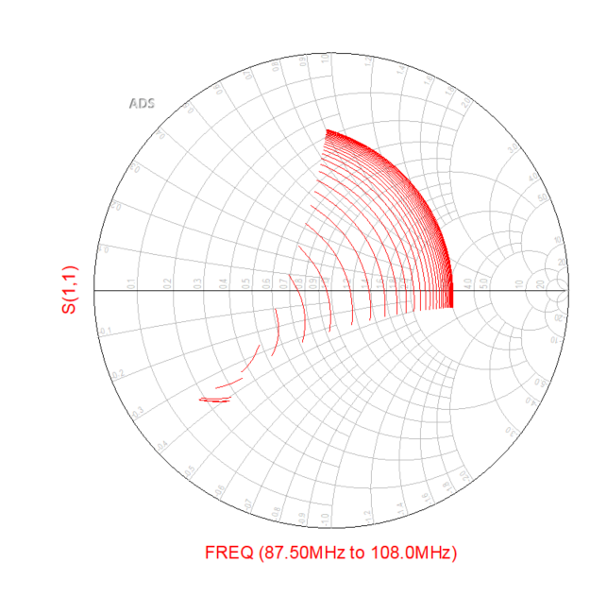

Moreover, another simulation was performed to evaluate the performance of the modulator with variation of the gate voltage at the transistor from 0 to 0.6 V with a sweep of 0.01 V for different input power levels, from -70 dBm to 0 dBm, for a fixed frequency of 95.8 MHz. Figure 2 shows the results obtained from the simulation.

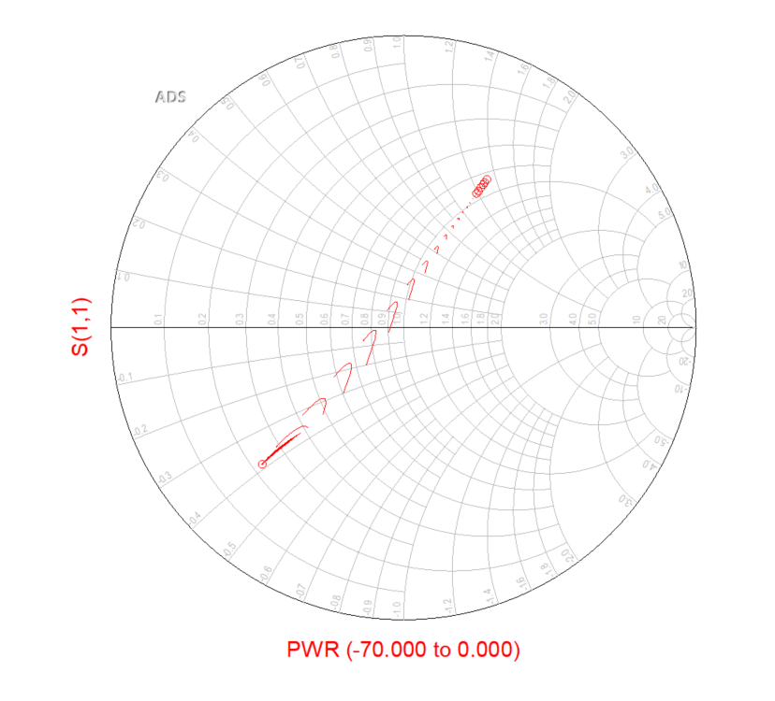

Both simulations validate the performance of the modulator in all FM bands and with variations of the input power.

**References**

[1] S. J. Thomas, E. Wheeler, J. Teizer, and M. S. Reynolds, “Quadrature amplitude modulated backscatter in passive and semipassive UHF RFID systems,” IEEE Transactions on Microwave Theory and Techniques., vol. 60, no. 4, pp. 1175–1182, 2012.

[2] S. Thomas and M. S. Reynolds, “QAM backscatter for passive UHF RFID tags,” in 2010 IEEE Int. Conf. RFID (IEEE RFID 2010). IEEE, Apr 2010, pp. 210–214.

[3] S. J. Thomas and M. S. Reynolds, “A 96 Mbit/sec, 15.5 pJ/bit 16-QAM modulator for UHF backscatter communication,” in 2012 IEEE Int. Conf. RFID. IEEE, Apr 2012, pp. 185–190.