- Explain Bug(Defect) life cycle.
The Defect Life Cycle is the life cycle of a defect or bug that it goes through covering a specific set of states in its entire life. Mainly bug life cycle refers to its entire state starting from a new defect detected to the closing off of that defect by the tester. Alternatively, it is also called a Bug Life Cycle.
The objective of the defect lifecycle is to easily coordinate and communicate the defect's current status and thus help make the defect-fixing process efficient.
Defect Status
Defect status or Bug status is the current state from which the defect is currently going through. The number of states the defect goes through varies from project to project. The below diagram illustrates all the possible states of the defect:
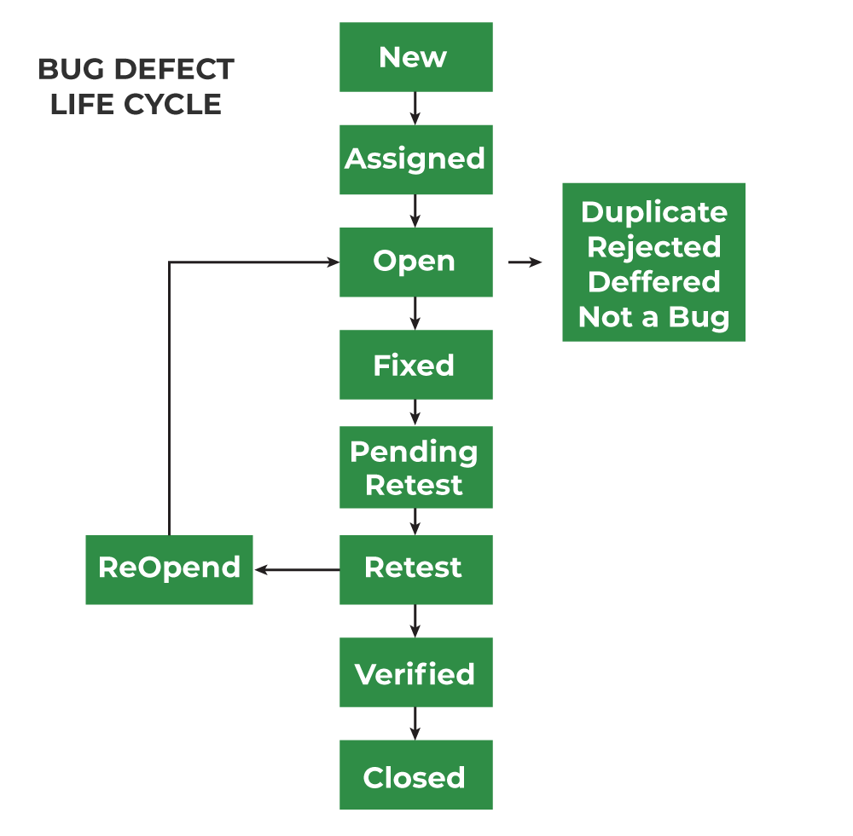
1. New: When any new defect is identified by the tester, it falls in the ‘New’ state. It is the first state of the Bug Life Cycle. The tester provides a proper Defect document to the Development team so that the development team can refer to Defect Document and can fix the bug accordingly.

2. Assigned: Defects that are in the status of ‘New’ will be approved and that newly identified defect is assigned to the development team for working on the defect and to resolve that. When the defect is assigned to the developer team the status of the bug changes to the ‘Assigned’ state.

3. Open: In this ‘Open’ state the defect is being addressed by the developer team and the developer team works on the defect for fixing the bug. Based on some specific reason if the developer team feels that the defect is not appropriate then it is transferred to either the ‘Rejected’ or ‘Deferred’ state.

4. Fixed: After necessary changes of codes or after fixing identified bug developer team marks the state as ‘Fixed’.

5. Pending Request: During the fixing of the defect is completed, the developer team passes the new code to the testing team for retesting. And the code/application is pending for retesting on the Tester side so the status is assigned as ‘Pending Retest’.

6. Retest: At this stage, the tester starts work of retesting the defect to check whether the defect is fixed by the developer or not, and the status is marked as ‘Retesting’.

7. Reopen: After ‘Retesting’ if the tester team found that the bug continues like previously even after the developer team has fixed the bug, then the status of the bug is again changed to ‘Reopened’. Once again bug goes to the ‘Open’ state and goes through the life cycle again. This means it goes for Re-fixing by the developer team.

8. Verified: The tester re-tests the bug after it got fixed by the developer team and if the tester does not find any kind of defect/bug then the bug is fixed and the status assigned is ‘Verified’.

9. Closed: It is the final state of the Defect Cycle, after fixing the defect by the developer team when testing found that the bug has been resolved and it does not persist then they mark the defect as a ‘Closed’ state.

- Explain unit, integration, system and user acceptance testing.
Unit Testing:- Unit Testing is the first level of testing usually performed by the developers.
In unit testing, a module or component is tested in isolation.
As the testing is limited to a particular module or component, exhaustive testing is possible.
Advantage – Error can be detected at an early stage saving time and money to fix it.
Limitation – Integration issues are not detected in this stage, modules may work perfectly on isolation but can have issues in interfacing between the modules.

Integration Testing:- Integration testing is the second level of testing in which we test a group of related modules.
It aims at finding interfacing issues b/w the modules i.e. if the individual units can be integrated into a sub-system correctly.
It is of four types – Big-bang, top-down, bottom-up, and Hybrid.

System Testing:- System Testing is the third level of testing.
It is the level of testing where the complete integrated application is tested as a whole.
It aims at determining if the application conforms to its business requirements.
System testing is carried out in an environment that is very similar to the production environment.

User Acceptance Testing:- Acceptance testing is the final and one of the most important levels of testing on successful completion of which the application is released to production.
It aims at ensuring that the product meets the specified business requirements within the defined standard of quality.
There are two kinds of acceptance testing- alpha testing and beta testing.
When acceptance testing is carried out by testers or some other internal employees of the organization at the developer’s site it is known as alpha testing.
User acceptance testing done by end-users at the end-user’s site is called beta testing.

- Briefly explain STLC models.
The Software Testing Life Cycle (STLC) is a systematic approach to testing a software application to ensure that it meets the requirements and is free of defects. It follows a series of steps or phases, each with specific objectives and deliverables. The STLC ensures that the software is high-quality, reliable, and meets the needs of the end users.
1. Requirement Analysis: Requirement Analysis is the first step of the Software Testing Life Cycle (STLC). In this phase quality assurance team understands the requirements like what is to be tested. If anything is missing or not understandable then the quality assurance team meets with the stakeholders to better understand the detailed knowledge of requirements.

2. Test Planning: Test Planning is the most efficient phase of the software testing life cycle where all testing plans are defined. In this phase manager of the testing, team calculates the estimated effort and cost for the testing work. This phase gets started once the requirement-gathering phase is completed.

3. Test Case Development: The test case development phase gets started once the test planning phase is completed. In this phase testing team notes down the detailed test cases. The testing team also prepares the required test data for the testing. When the test cases are prepared then they are reviewed by the quality assurance team.

4. Test Environment Setup: Test environment setup is a vital part of the STLC. Basically, the test environment decides the conditions on which software is tested. This is independent activity and can be started along with test case development. In this process, the testing team is not involved. either the developer or the customer creates the testing environment.

5. Test Execution: After the test case development and test environment setup test execution phase gets started. In this phase testing team starts executing test cases based on prepared test cases in the earlier step.

- Why is String immutable in Java?
Immutable means which cannot be changed. When a reference variable to a particular string value gets changed,the value still exists in String Constant Pool or String Literal Pool. That’s why string is immutable in Java.

String Constant Pool is a private area of string where string type data gets stored. SCP contains only unique values. Whenever we declare a value using
String s1= “Moumita”; only one object with Moumita will be created and that value will gets stored in String Constant Pool.

5. WAP to print fibonacci series upto n. (Take n from user)
package assignment7;

import java.util.Scanner;

public class Fibonacci {

public static void main(String[] args) {
// TODO Auto-generated method stub
Scanner sc=new Scanner(System.in);
System.out.println("Enter the number of terms: ");
int n=sc.nextInt();
Fibonacci fb=new Fibonacci();
int n1=0,n2=1;
fb.fibo(n,n1,n2);
sc.close();

}
public void fibo(int n,int n1,int n2)
{
for (int i=0;i<n;i++)
{
System.out.print(n1+" ");
int n3=n1+n2;
n1=n2;
n2=n3;

}
}

}
Output:
Enter the number of terms:
10
0 1 1 2 3 5 8 13 21 34

6. WAP to print the only even number from 10 t0 1 without using any loop.

public class WithOutLoop {

public static void main(String[] args) {
// TODO Auto-generated method stub
/*package whatever //do not write package name here */

printNos(1, 10);
}
public static void printNos(int initial, int last)
{
if(initial <= last) {

if(initial%2==0) {
System.out.print(initial + " ");
printNos(initial + 2, last);
}
else {
printNos(initial + 1, last);
}
}
}

}
Output:
2 4 6 8 10

7. Define final keyword.
The final Keyword in Java is used as a non-access modifier applicable only to a variable, a method, or a class. It is used to restrict a user in Java, final keyword is used to indicate that a variable, method, or class cannot be modified or extended.
The following are different contexts where the final is used:
Final variables: When a variable is declared as final, its value cannot be changed once it has been initialized. This is useful for declaring constants or other values that should not be modified.
package assignment12;
//Main class
public class FinalClass {
// Java Program to Demonstrate Re-assigning
// Final Variable will throw Compile-time Error
// Declaring and customly initializing

// static final variable
static final int CAPACITY = 4;

// Main driver method
public static void main(String args[])
{

// Re-assigning final variable
// will throw compile-time error
CAPACITY = 5;
}
}

If the final variable is a reference, this means that the variable cannot be re-bound to reference another object, but the internal state of the object pointed by that reference variable can be changed i.e. you can add or remove elements.
When a final variable is a reference to an object, then this final variable is called the reference final variable. For example, a final StringBuffer variable looks defined below as follows:
final StringBuffer sb;
As we all know a final variable cannot be re-assign. But in the case of a reference final variable, the internal state of the object pointed by that reference variable can be changed. Note that this is not re-assigning.
This property of the final is called non-transitivity. ToThe final Keyword in Java is used as a non-access modifier applicable only to a variable, a method, or a class. It is used to restrict a user in Java, final keyword is used to indicate that a variable, method, or class cannot be modified or extended.
The following are different contexts where the final is used:
Final variables: When a variable is declared as final, its value cannot be changed once it has been initialized. This is useful for declaring constants or other values that should not be modified.
package assignment12;
//Main class
public class FinalClass {

// Java Program to Demonstrate Re-assigning
// Final Variable will throw Compile-time Error
// Declaring and customly initializing
understand what is meant by the internal state of the object as shown in the below example as follows
// Java Program to demonstrate
// Reference of Final Variable

// Main class
class GFG {

// Main driver method
public static void main(String[] args)
{
// Creating an object of StringBuilder class
// Final reference variable
final StringBuilder sb = new StringBuilder("Geeks");

// Printing the element in StringBuilder object
System.out.println(sb);

// changing internal state of object reference by
// final reference variable sb
sb.append("ForGeeks");

// Again printing the element in StringBuilder
// object after appending above element in it
System.out.println(sb);
}
}
Output
Geeks
GeeksForGeeks
Final methods: When a method is declared as final, it cannot be overridden by a subclass. This is useful for methods that are part of a class’s public API and should not be modified by subclasses.
Final classes: When a class is declared as final, it cannot be extended by a subclass. This is useful for classes that are intended to be used as is and should not be modified or extended.

8. What do you understand by JIT.
The JIT or Just-In-Time compiler is an essential part of the JRE (Java Runtime Environment), that is responsible for performance optimization of java based applications during run time. The compiler is one of the key aspects in deciding the performance of an application for both parties i.e. the end-user and the application developer.

9. What is Selenium?
Selenium is an open-source, automated testing tool used to test web applications across various browsers. Selenium can only test web applications, unfortunately, so desktop and mobile apps can't be tested. However, other tools like Appium and HP's QTP can be used to test software and mobile applications.

10. Tell some advantages and some disadvantages of using Selenium.

1. Free and Open Source
Selenium's popularity stems largely from its free and open-source nature.
It allows companies of every type to use it for automated testing, and the community is constantly adding new functionality.
This highlights its potential for automated testing and makes it available to a wide range of businesses, regardless of size or sector.
Selenium has made a name for itself as the platform of choice for businesses looking for affordable and effective automated testing solutions because it is free and open source.

2. Supports a Wide Number of Systems, Languages, and Browsers
no better tool than Selenium can automate testing across most major operating systems and browsers.
The robust automation tool Selenium demonstrates remarkable adaptability by interacting with a wide variety of systems, browsers, and computer languages with ease.
This feature allows QA specialists, developers, and testers to do thorough tests on several platforms with greater freedom.
As it is cross-compatible, switching between separate tools for each platform is avoided, which saves a significant amount of time.
Automating testing processes for popular operating systems and browsers is a simple way to increase productivity and accelerate the software development lifecycle. Within a quickly changing technological environment, selenium's flexibility plays a major role in upholding high levels of dependability and quality.

3. Integrated with CI/CD
Another significant advantage is that Selenium is completely integrated with CI/CD—continuous integration /continuous deployment—platforms like Jenkins, Azure DevOps, Bamboo, Travis CI, Circle CI, GitLab, and many others.
The exceptional interoperability of Selenium with numerous CI/CD platforms is one of the main advantages of using it for automated testing.
Selenium's smooth interface with these systems facilitates automated deployments and continuous monitoring, which speeds up the testing process and increases the development team's productivity.

4. Run Tests Concurrently
Selenium Grid allows you to run tests concurrently and manage execution from a single location. Web tests are known to take longer to run over time, and parallel execution provides significant benefits as your test suite grows.
Selenium Grid, a powerful tool in the realm of automated testing, empowers users to execute test cases simultaneously while efficiently controlling the process from a centralized hub.
In the landscape of web testing, where the duration of tests tends to increase as test suites evolve, utilizing parallel execution brings forth notable advantages. By harnessing Selenium Grid's capabilities to run tests concurrently, users can optimize test suite performance as it scales, enhancing productivity and reducing overall testing time.

Cons of the Selenium Automation Testing Tool
1. Supports Web Applications Only
Selenium is only useful for web test automation.
Although Selenium can only automate interactions within web browsers, it is unable to automate processes outside of the browser, such as desktop applications.

2. Not Having an Image Comparison
Selenium does not have built-in image comparison functionality, so it is important to ensure that all images you display in your application are present and displayed correctly.
A third-party library is required to achieve this.
This restriction emphasizes how crucial it is to carefully verify that every image in the user interface of your application exists and is accurate. It becomes imperative to incorporate a third-party image comparison library into your testing suite to close this gap.

3. Selenium cannot Create Reports
Selenium does not have a basic functionality called reports. To communicate test automation results to management, contractors, customers, and stakeholders, testers, and developers must generate all reports.
Although Selenium lacks native reporting features, it offers integration support for several reporting frameworks and libraries.
Test automation engineers can use Selenium WebDriver to create thorough test reports by utilizing third-party reporting technologies like TestNG, ExtentReports, Allure, or custom reporting solutions.

4. No Technical Support will be Provided
Renowned for its powerful automated testing features, Selenium has a large community of seasoned specialists willing to share their vast experience and knowledge. Nevertheless, even with a large number of specialists, users who are just learning about Selenium's capabilities may find it difficult to navigate among the array of solutions accessible.
One major challenge that many new users have is the lack of readily available Selenium-focused businesses or service providers.
Lack of professional support can be quite difficult because it can be difficult to troubleshoot problems or seek advice when there aren't easily available resources.
Due to this, learning Selenium and realizing its full potential for effective testing procedures may seem like a difficult and lonely road for individuals who choose to take it.

11. Write down about the Selenium components.
Selenium Suite has 4 components namely:

- Selenium IDE
- Selenium RC
- Selenium WebDriver
- Selenium Grid

- Selenium IDE
Selenium IDE is a Chrome and Firefox plugin. The primary use of a Selenium IDE is to record user interactions such as clicks, selections etc in the browser and play them back as automated tests .
It then generates the test script (of the automated tests) in programming languages like C#, Java, Python, and Ruby and Selenese (Selenium’s own scripting language).

Selenium IDE helps in:
Creating automated test scripts and validating them at speed
Identifying and highlighting errors during the replay of interactions
Cross Browser Testing

- Selenium RC
Selenium RC was built to automate the testing of web applications by simulating user interactions across different browsers and platforms. It provided a way to browser automation remotely and execute test scripts written in various programming languages.

Limitations of Selenium RC:

Browser Limitations: Selenium RC had to work with browsers using a JavaScript-based “proxy” mechanism, which introduced potential instability and limitations, especially when working with modern web applications.
Speed and Performance: The use of a JavaScript proxy added overhead and affected the speed and performance of test execution.
Maintenance and Compatibility: Selenium RC required separate “drivers” for each browser, making maintenance and compatibility challenging as browsers continued to update and evolve.
Synchronization Issues: Selenium RC often faced synchronization problems, where test scripts had to wait for the browser to respond before proceeding to the next step.
Complex Setup: Setting up Selenium RC involved multiple components, which could be complex and difficult to configure correctly.

3.Selenium WebDriver
Selenium WebDriver is a powerful and enhanced version of Selenium RC which was developed to overcome the limitations of Selenium RC. WebDriver communicates with browsers directly with the help of browser-specific native methods, thereby completely eliminating the need for Selenium RC.
WebDriver works closely with Selenium IDE and Selenium Grid resulting in reliable test execution at speed and scale.

4.Selenium Grid
Selenium Grid is a smart proxy server that allows QAs to run tests in parallel on multiple machines. This is done by routing commands to remote web browser instances, where one server acts as the hub. This hub routes test commands that are in JSON format to multiple registered Grid nodes.

12. What is Selenium WebDriver?
Selenium WebDriver is a web framework that permits you to execute cross-browser tests. This tool is used for automating web-based application testing to verify that it performs expectedly. Selenium WebDriver allows you to choose a programming language to create test scripts.

13.WAP to open browser using Selenium script.
import org.openqa.selenium.WebDriver;
import org.openqa.selenium.chrome.ChromeDriver;

public class Open_Chrome {

public static void main(String args[])
{
System.setProperty("webdriver.chrome.driver",”C:\\Users\\ADMIN\\Documents\\chromedriver.exe");
// Instantiate a ChromeDriver class.
WebDriver driver = new ChromeDriver();

// Maximize the browser
driver.manage().window().maximize();

// Launch Website
driver.get("https://www.google.com/");
}
}

14. Tell the differences between
1. driver.quit() and driver.close()
driver. quit() : The quit() method quits the driver, closing every associated window.
driver. close() : The close() method closes the currently focused window, quitting the driver if the current window is the only open window.
2. driver.get() and driver.navigate().to()
The get function waits until the webpage is loaded properly and available to return control.
The navigate function does not wait for the webpage to be loaded properly.

15.What are the different navigate methods available in Selenium and how they are used demonstrate that using Selenium scripts.
In Selenium WebDriver, the navigate() method is part of the WebDriver. Navigation interface and provides more advanced capabilities for navigating through the browser history compared to the get() method. It allows you to move forward and backward in the browser's history, refresh the current page, and navigate to a specific URL.
The purpose of navigate() Method is to navigate() method is used for more granular control over browser navigation. It includes functionalities for navigating to a URL, moving back and forth in the browser's history, and refreshing the page.

In this example, we have opened the Geeks For Geeks website (link) using navigate().to() function. Then, we have refreshed the browser using navigate().refresh(), click on the element having the text 'Trending Now'. Moreover, we will now go back to the previous page using navigate().back() function and to next page using navigate().forward() function.
// Using implicit wait
package selenium1;

//Importing selenium libraries
import java.util.concurrent.TimeUnit;

import org.openqa.selenium.By;
import org.openqa.selenium.WebDriver;
import org.openqa.selenium.chrome.ChromeDriver;

public class selenium6 {
public static void main(String[] args) throws InterruptedException {

// State the chromedriver URL
System.setProperty(“webdriver.chrome.driver”,
"C:\\Users\\Vinayak Rai\\Downloads\\chromedriver-win64\\chromedriver-win64\\chromedriver.exe");

// Define and initiate the chrome driver
WebDriver driver = new ChromeDriver();

// Open google
driver.navigate().to("https://www.google.com/");

// refresh the current browser
driver.navigate().refresh();

// Clicking of element having text Trending Now
driver.findElement(By.linkText("Trending Now")).click(

// Go to previous web page
driver.navigate().back();

// Go to next web page
driver.navigate().forward();
}
}

