- What is a Wrapper class? Explain autoboxing and unboxing.
The wrapper class is a class that converts primitive data types to objects and vice versa.
Ways for converting primitive datatypes to objects and vice versa are autoboxing and unboxing respectively.
Autoboxing/Boxing - Conversion of primitive datatype to objects. It is done automatically.
Unboxing- Conversion of objects to primitive datatypes.

public class AutoBoxing {

public static void main(String[] args) {
// TODO Auto-generated method stub
// Creating an Integer Object
// with custom value say it be 10
Integer i = new Integer(10);

// Unboxing the Object
int i1 = i;

// Print statements
System.out.println("Value of i:" + i);
System.out.println("Value of i1: " + i1);

// Autoboxing of character
Character g = 'a';

// Auto-unboxing of Character
char ch = g;

// Print statements
System.out.println("Value of ch: " + ch);
System.out.println(" Value of g: " + g);

}

}
Output:
Value of i:10
Value of i1: 10
Value of ch: a
Value of g: a

- WAp to sort ArrayList in descending order and print its value using for each loop.
//import java.util.Collections;
import java.util.*;

public class SortArrayList {

public static void main(String[] args) {
// TODO Auto-generated method stub
// Define an objects of ArrayList class
ArrayList<String> list = new ArrayList<String>();

// Adding elements to the ArrayList
list.add("India");
list.add("Pakistan");
list.add("Srilanka");
list.add("USA");
list.add("Australia");
list.add("Japan");

// Printing the unsorted ArrayList
System.out.println("Before Sorting : " + list);

// Sorting ArrayList in ascending Order
// Collections.sort(list);

Collections.sort(list, Collections.reverseOrder());

// printing the sorted ArrayList
System.out.println("After Sorting : " + list);

}

}
Output:
Before Sorting : [India, Pakistan, Srilanka, USA, Australia, Japan]
After Sorting : [USA, Srilanka, Pakistan, Japan, India, Australia]

- Write the difference between array and arraylist.
In Java, an Array is a fixed-sized, homogenous data structure that stores elements of the same type whereas, ArrayList is a dynamic-size, part of the Java Collections Framework and is used for storing objects with built-in methods for manipulation. The main difference between array and ArrayList is:
Array: Arrays have a fixed size and provide fast performance.
ArrayList: ArrayList is dynamic in size and provides more flexibility and built-in methods.

Difference Between Array and ArrayList
The difference between Array and ArrayList is listed below

Aspect | Array | ArrayList
Dimensionality | An array can be single-dimensional or multi-dimensional | ArrayList can be only a single-dimensional
Traversing Elements | Uses for and for-each loop for iteration | uses for-each, Iteraor or ListIterator
Length/Size | The length keyword gives the total size of the array | size() method returns the number of elements in the ArrayList
Size | Array size is static | ArrayList size is dynamic.
Speed | Array speed is fast due to the fixed size | ArrayList speed is relatively slower due to resizing and dynamic behavior
Generics | Not supported, making arrays type-unsafe | Supports generics, making ArrayList type-safe
Adding Elements | Uses assignment (arr[0] = value) | Uses add() method

- What is a Thread? Mention the different thread life cycle.
In the context of Java, a thread is the path followed when executing a program. All java programs have at least one thread, known as the main thread, created by the JVM at the program’s start when the main()method is invoked with the main thread.
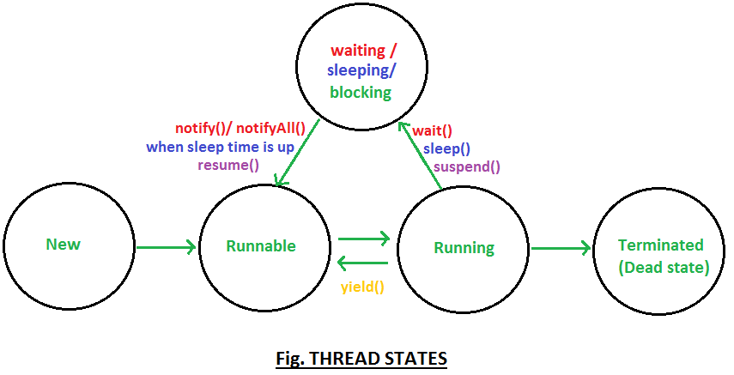

Thread states in detail >

New: When instance of thread is created using new operator it is in new state, but the start() method has not been invoked on the thread yet, thread is not eligible to run yet.
>Thread object is considered alive but thread is not alive yet.

Runnable: When start() method is called on thread it enters runnable state.
>As soon as Thread enters runnable state it is eligible to run, but not running. (Thread scheduler has not scheduled the Thread execution yet, Thread has not entered in run() method yet)
>A thread first enters the runnable state when the start() method is invoked, but a thread can also return to the runnable state after either running or coming back from a
blocked, waiting, or sleeping state.
>Thread is considered alive in a runnable state.
>Thread is in the Runnable pool.

Running: The thread scheduler selects a thread to go from runnable to running state. In the running state, Thread starts executing by entering run() method.
>Thread scheduler selects a thread from the runnable pool on the basis of priority, if the priority of two threads is the same, threads are scheduled in unpredictable manner. Thread scheduler behavior is completely unpredictable.
>When threads are running, the yield() method can make the thread go into a Runnable state.

Waiting/blocked/sleeping: In this state, a thread is not eligible to run.
>Thread is still alive, but currently, it’s not eligible to run. In other words.
> How can Thread go from running to waiting state ?
By calling wait() method thread go from running to a waiting state. In waiting state it will wait for other threads to release object monitor/lock.
> How can Thread return from waiting to runnable state ?
Once notify() or notifyAll() method is called object monitor/lock becomes available and thread can again return to runnable state.
> How can Thread go from running to sleeping state ?
By calling sleep() method thread go from running to sleeping state. In sleeping state it will wait for sleep time to get over.
> How can Thread return from sleeping to runnable state ?
Once specified sleep time is up thread can again return to runnable state.

Suspend() method can be used to put thread in waiting state and resume() method is the only way which could put thread in runnable state.

Thread also may go from running to waiting state if it is waiting for some I/O operation to take place. Once input is available thread may return to running state.

Terminated (Dead) : A thread is considered dead when its run() method completes.
>Once thread is dead it cannot be started again doing so will throw runtimeException i.e. IllegalThreadStateException.
destroy() method puts thread directly into dead state.

- WAP to check whether a date is palindrome or not.

public class DatePalindrome {

public static void main(String[] args) {
// TODO Auto-generated method stub
String str="22/02/2022";
String num="";
for (int i=0;i<str.length();i++)
{
char ch=str.charAt(i);
if(Character.isDigit(ch))
{
num=num+ch;
}
}
int date=Integer.parseInt(num);
int temp=date;
int last,rev=0;
while(date!=0) {
last=date%10;
rev=(rev*10)+last;
date=date/10;
}
if(temp==rev)
{
System.out.println("Date is palindrome");
}
else
System.out.println("Date is not palindrome");
}

}
Output:
Date is palindrome

6. When do we need isDisplayed(), isEnabled() and isSelected()?

When we want to check whether a page is completely loaded or not we will apply any of the isDisplayed(), isEnabled() and isSelected() methods on any of the webelements on the page.

7. WAP to program to separate special symbols, numbers and alphabets from a string and print them separately.
package assignment8;

import java.util.Scanner;

public class AlphaDigit {

public static void main(String[] args) {
// TODO Auto-generated method stub
Scanner sc=new Scanner(System.in);
System.out.println("Enter a sentence");
String sen=sc.nextLine();
checking(sen);
sc.close();
}
public static void checking(String sen)
{
String digit="";
String alpha="";
String sch="";
for(int i=0;i<sen.length();i++)
{
char c=sen.charAt(i);
if(Character.isDigit(c))
{
digit=digit+c+" ";
}
else if(Character.isAlphabetic(c))
{
alpha=alpha+c+" ";
}
else
{
sch=sch+c+" ";
}

}
System.out.println("Numbers are: "+digit);
System.out.println("Alphabets are: "+alpha);
System.out.println("Special characters are: "+sch.replaceAll("\\s", ""));

}

}
Output:
Enter a sentence
My dob is 11/10/1990
Numbers are: 1 1 1 0 1 9 9 0
Alphabets are: M y d o b i s
Special characters are: //

8. Difference between findElement and findElements.

 | findElement | findElements
Exception Handling | Throws a NoSuchElementException when no matching element is found. | Returns an empty list (not null) when no matching elements are found.
Purpose | Find the first matching element based on the locator you specify. | Finds all matching elements based on the locator.
Return Type | A single WebElement object. | A List of WebElements. If no elements match, it returns an empty list.
Use Case | When interacting with a single element | When working with multiple elements or checking if elements exist

9. WAP to open facebook, locate and fill email box using By.name() and locate and fill password box using By.id() and then click on login button using By.xpath(

package FirstProgram.FirstProgramSelenium;
import org.openqa.selenium.*;
import org.openqa.selenium.chrome.ChromeDriver;
public class OpenFacebook {

public static void main(String[] args) throws InterruptedException {
// TODO Auto-generated method stub
WebDriver driver=new ChromeDriver();
driver.get("https://www.facebook.com/");
Thread.sleep(1000);
driver.findElement(By.name("email")).sendKeys("dasmoumita64@gmail.com");;
Thread.sleep(1000);
driver.findElement(By.id("pass")).sendKeys("123456789");
Thread.sleep(1000);
driver.findElement(By.xpath("//*[@name='login']")).click();
Thread.sleep(2000);
//driver.close();

}

}
Output:
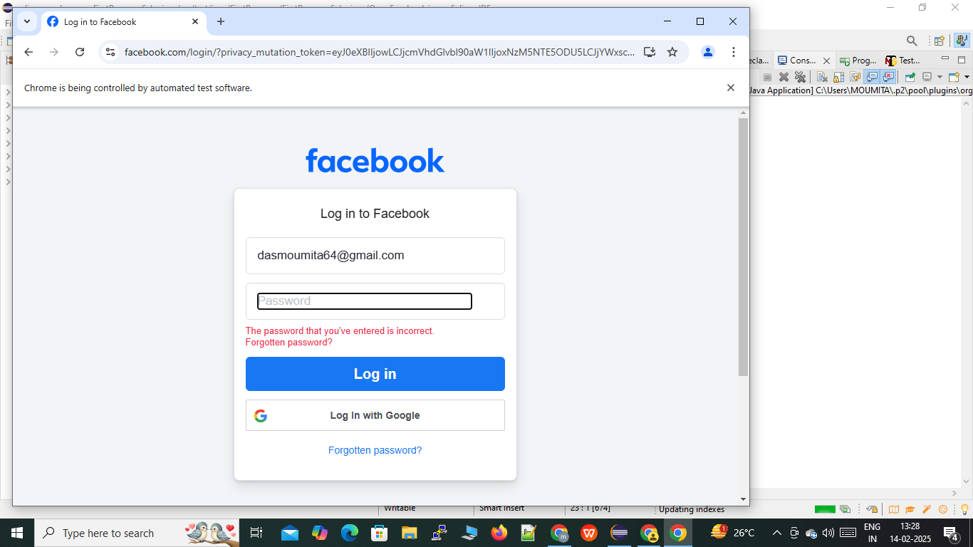

10.Explain Sanity testing , Smoke Testing, Regression testing and Retesting.

Re-Testing:
In Software Testing, Re-Testing refers to the testing again of a module to ensure that the bug is fixed. This means it confirms the test cases that failed in the final execution are passing after the errors/defects are fixed. The process of Re-Testing is as follows –
At first an error is detected in any module of the application.
Then it undergoes correction/modification by the developer.
After the developer has solved and tested the issue again, it is called Re-Testing.
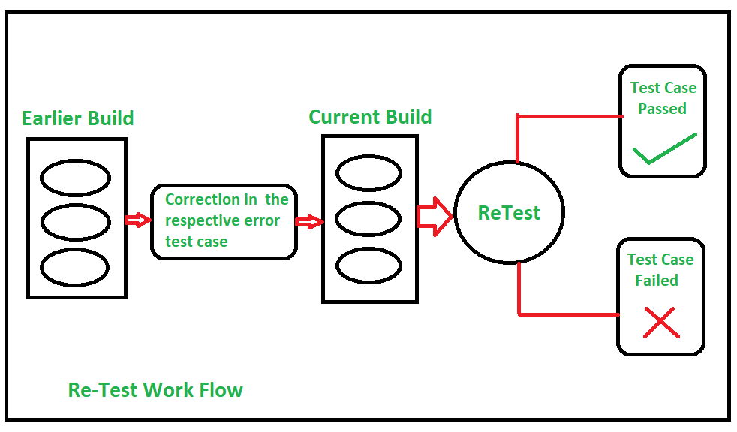

Sanity Testing:
In Software Testing, Sanity Testing refers to the testing performed after receiving a software build, with minor changes in code, or functionality, to ascertain that the bugs/errors have been fixed and no further issues are introduced due to these changes. The process of Sanity Testing is as follows –
A software build is received first.
Determine that the proposed functionality works roughly as expected after changes.
If the sanity test fails, the build is rejected.
If the sanity test passes, it is passed for further testing.
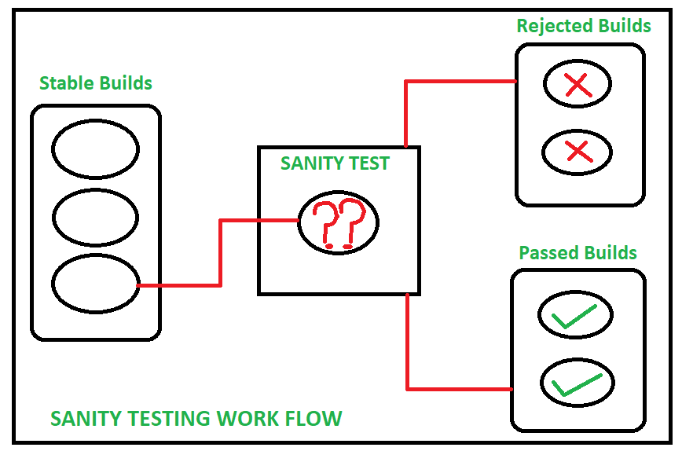

Smoke Testing
Commonly known as build verification testing, smoke testing is a functional testing type that determines whether the deployed build is stable or not. If the build is stable, the QA team can continue with other types of testing. Smoke testing identifies issues in the early stages before testing starts and saves a lot of time and effort.
When should you run smoke tests?
Smoke tests are run when new features are added to the build. If the new build passes these tests, the testing process can continue.

Regression Testing
Regression testing is a type of functional testing that takes place when changes are introduced in code, to ensure nothing has broken in other parts of the product.

Let’s discuss various types of regression testing techniques:
Retest all - In this technique, all the tests are executed multiple times to ensure that the system is bug-free. This technique is not used often as it’s time-consuming and needs more resources. In terms of cost, it’s an expensive method.
Regression test selection - As the name suggests only a few tests are selected for regression testing. The selection of test cases is based on the module in which changes are made.
Regression test prioritization - In this technique, the tester identifies primary or most commonly used features and secondary or less used features in the product. Then, all the test cases are prioritized and test cases with high priority are taken up for regression testing. This saves time and human resources.
When should you run regression tests?
Regression tests are run when development is frozen and new improvements or changes are introduced in code.

11. What are these maven commands used for:
i. mvn clean
This command cleans the Maven project by deleting the target directory:
ii. mvn package
This command builds the Maven project and packages it into a JAR, WAR, etc.:
iii. mvn install
This command builds the Maven project and installs the project files (JAR, WAR, pom.xml, etc.) to the local repository:
iv. mvn clean package
The mvn clean package command clears the target directory. It builds the project and packages in the resulting JAR file into the target directory without running unit tests during the build.
v. mvn clean install
mvn clean install tells Maven to do the clean phase in each module before running the install phase for each module.

12. What is the folder name where our jars get stored when we add dependencies in the Maven project.
Maven Dependencies

