St. George Crash Analysis
Summary of Findings and Recommended Actions
Data: 9,728 crashes inside St. George, June 2021 – May 2026 (Utah crash portal), plus 299,407 statewide crashes, UDOT 2021–2024 traffic counts (AADT), UGRC road network data, and Open-Meteo weather.

1. Findings and conclusions

Serious and fatal (KA) crashes are too rare to model, but some risk factors are clear
Only 254 crashes (2.6%) were KA. Decision tree, SVM, and neural network models could not reliably predict them. But there were realiable factors in KA accidents:
Factor | KA rate with factor | KA rate without
Motorcycle involved | 25.4% | 2.0%
Pedestrian or bicyclist involved | 17.2%
Head-on collision | 12.8%
Unrestrained occupant | 11.5% | 2.4%

St. George is not more dangerous than other Utah cities, but more of its crashes happen at intersections
Its KA share (2.61%) matches other Utah cities (2.50%, p = 0.52). However, 34% of its crashes are at 4-leg intersections (29% statewide), and 17% at T-intersections (9% statewide). Roundabouts had 209 crashes and none were serious or fatal, compared with 1.6% statewide.

After adjusting for traffic volume, 55 of 138 road segments are significantly more dangerous than similar roads

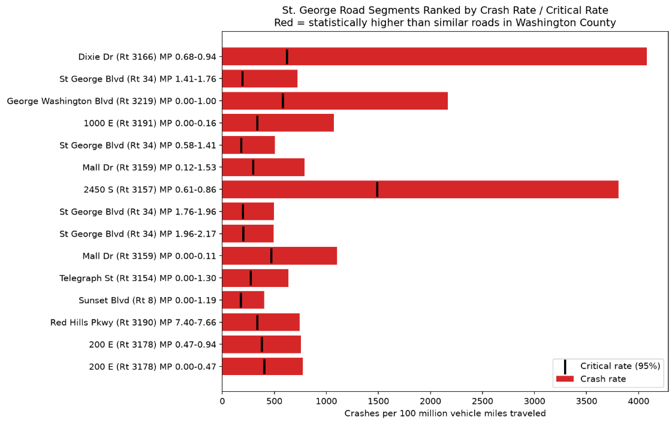
This uses the Highway Safety Manual's critical crash rate method at 95% confidence. The highest, all based on reliable traffic counts:
- St. George Blvd, Main St to I-15 (2.5–3.8× its critical rate)
- 1000 E (3.2×)
- Mall Dr (2.7×)
- Sunset Blvd, Dixie Downs to Valley View (2.3×, with the most serious and fatal crashes: 12)
- River Rd, 700 S to St. George Blvd (1.9×)

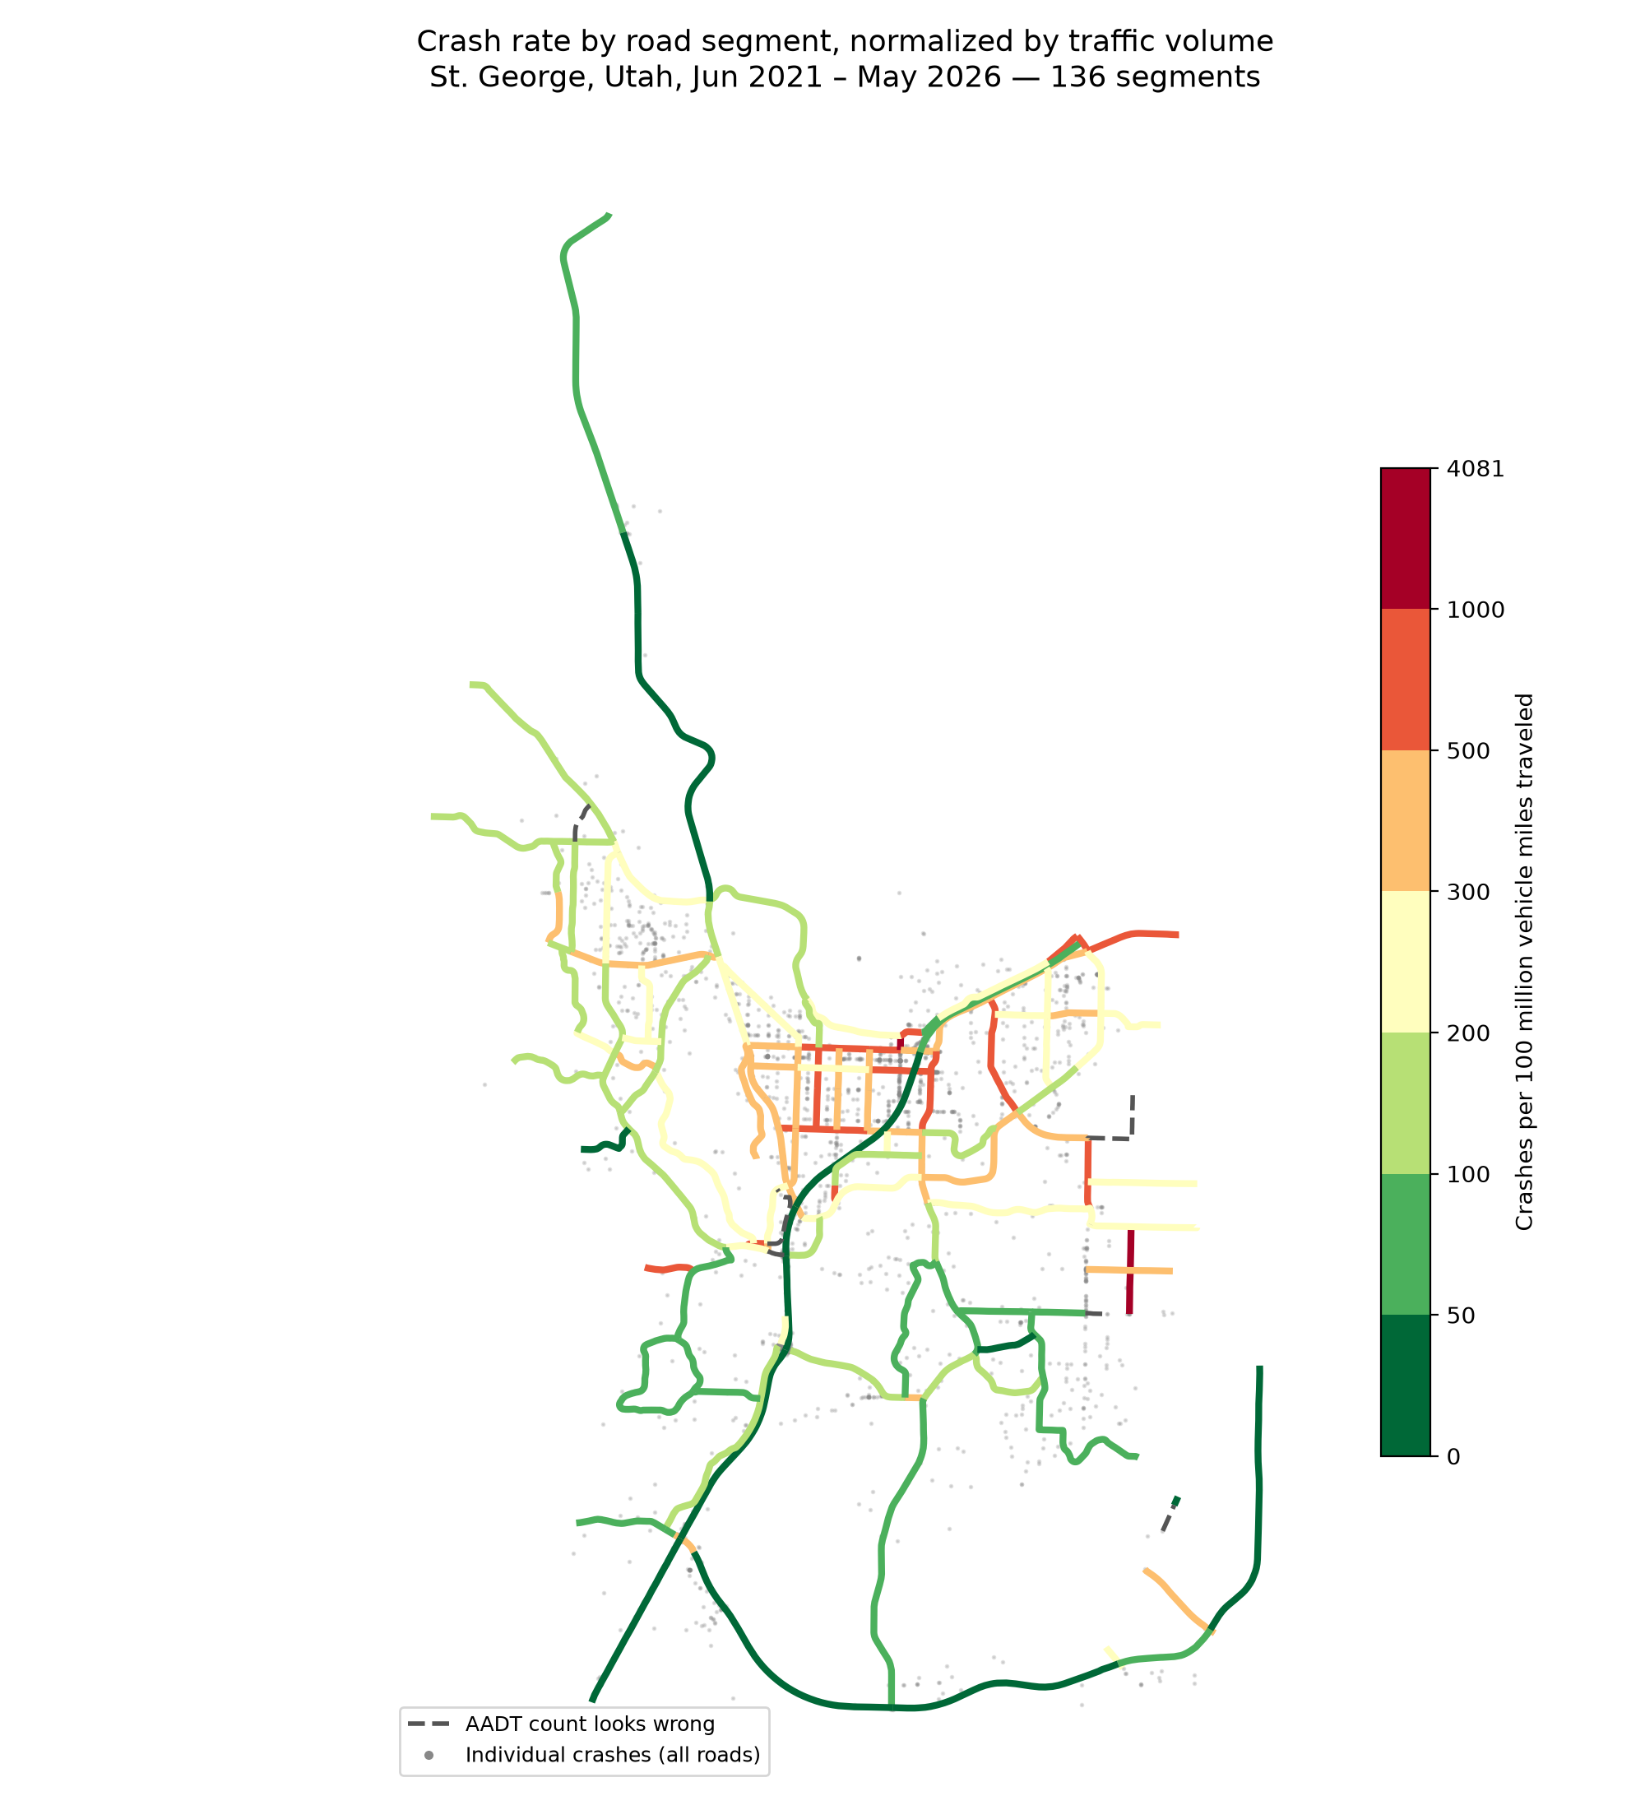
Figure 1. Crash rate per 100 million vehicle miles traveled by road segment. Dashed segments have suspect traffic counts.

Intersection density is the strongest road-design predictor of crash rate
Going from 5 to 13 intersections per mile raises the crash rate by 65% (95% CI +39% to +97%, p < 0.001), with traffic held constant.
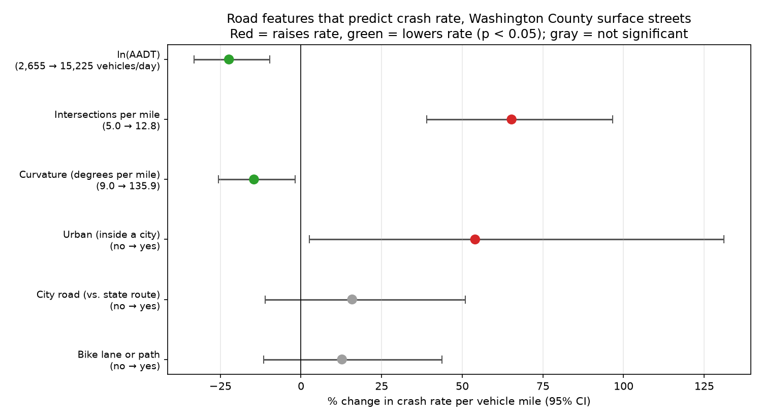
Figure 2. Effect of road features on crash rate per vehicle mile (negative binomial safety performance function, 224 segments).

Highest-rate intersections
In crashes per million entering vehicles: Red Cliffs Dr & Mall Dr (1.68), Sunset Blvd & Dixie Dr/Dixie Downs Rd (1.52, and the most crashes: 128), Riverside Dr & Mall Dr (1.07), River Rd & Riverside Dr (1.04).

Timing
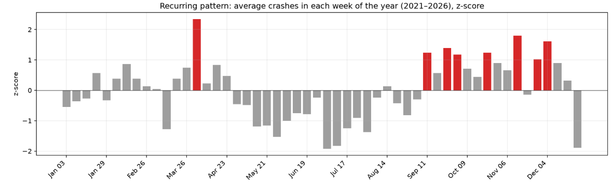

- Recurring peaks. The first week of April was elevated in 4 of 5 years, and September–December runs high every year. Summer is lowest.
- Storms cause the biggest single-day spikes.
- Problems are steady, not episodic. Unusual weeks at individual intersections and roads occurred about as often as chance predicts, so problem locations are consistently bad rather than bad in particular weeks.

2. Recommended actions based on FHWA Proven Safety Countermeasures
Location | Crash pattern | Countermeasure | FHWA expected effect
St. George Blvd, 700 E – 1000 E | 48% angle crashes, 38% left/U-turn | Reduced left-turn conflict design (median U-turn) or no-U-Turn signs | 62–66% fewer total crashes; 30% lower injury crash rate (median U-turn)
St. George Blvd, Main – 700 E and 1000 E – River Rd | 56–62% rear-end | Review yellow change intervals; backplates with retroreflective borders | 8–14% and 15% fewer total crashes
Mall Dr, Red Cliffs – Riverside | 63% angle, 55% left/U-turn, many crashes at business driveways | Corridor access management (consolidate driveways, raised medians) | 25–31% fewer fatal and injury crashes on urban arterials
200 E, 300 S – St. George Blvd | Running signals or signs 4.7× and pedestrians 4.8× the city rate, 29% at night | Crosswalk visibility enhancements, leading pedestrian interval, lighting | Up to 40% fewer pedestrian injury crashes (crosswalks), 13% (leading interval), 42% at night (lighting)
Sunset Blvd & Dixie Downs; Red Cliffs & Mall Dr | Highest intersection crash rates | Road safety audit; evaluate a roundabout | 10–60% fewer total crashes (audit); 78% fewer fatal and injury crashes (signal to roundabout)
Citywide arterials | Intersection density is the top predictor | Systemic access management on new and redesigned corridors | As above

Example estimate: the three rear-end segments of St. George Blvd average about 80 crashes a year. An 8–14% reduction from retimed yellow intervals would prevent roughly 6–11 crashes per year at very low cost.
Operational actions:
- Schedule enforcement and message boards for early April and September–December.
- Issue wet-weather warnings when storms are forecast.
- Target motorcycle and pedestrian safety campaigns, since those crashes are 6–12× more likely to be serious or fatal.

3. Limitations
- Traffic coverage: traffic-normalized results cover the 78% of crashes on roads with UDOT counts. Local streets aren't included because they could not be normalized based on average daily traffic counts.
- Suspect counts: a few traffic volume segments have counts that look wrong (e.g., Dixie Dr at I-15). They were left out until they can be verified.
- Missing features: speed limits, lane counts, and driveway locations weren't available reliably, so their effects aren't in the model.
- Expected effects are estimates: FHWA figures are averages from other locations, not guarantees for St. George.

Data helpful for future studies
Future work
-examining intersection features

