<https://blog.51cto.com/liqingbiao/2417010>

wget <https://github.com/yahoo/kafka-manager/archive/2.0.0.2.tar.gz>

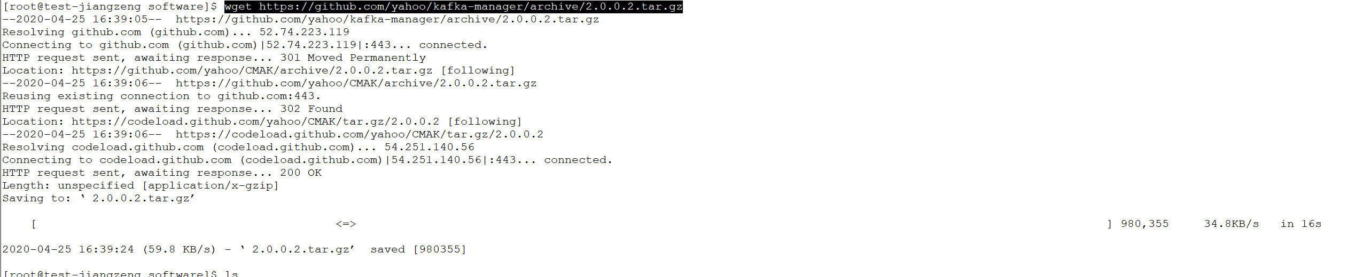

tar -zxvf 2.0.0.2.tar.gz

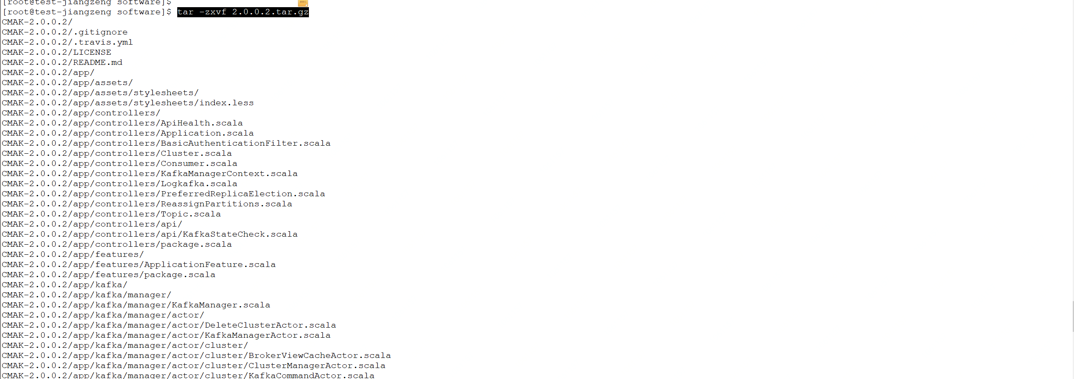

cd CMAK-2.0.0.2/

curl https://bintray.com/sbt/rpm/rpm > bintray-sbt-rpm.repo

mv bintray-sbt-rpm.repo /etc/yum.repos.d/

yum install -y sbt

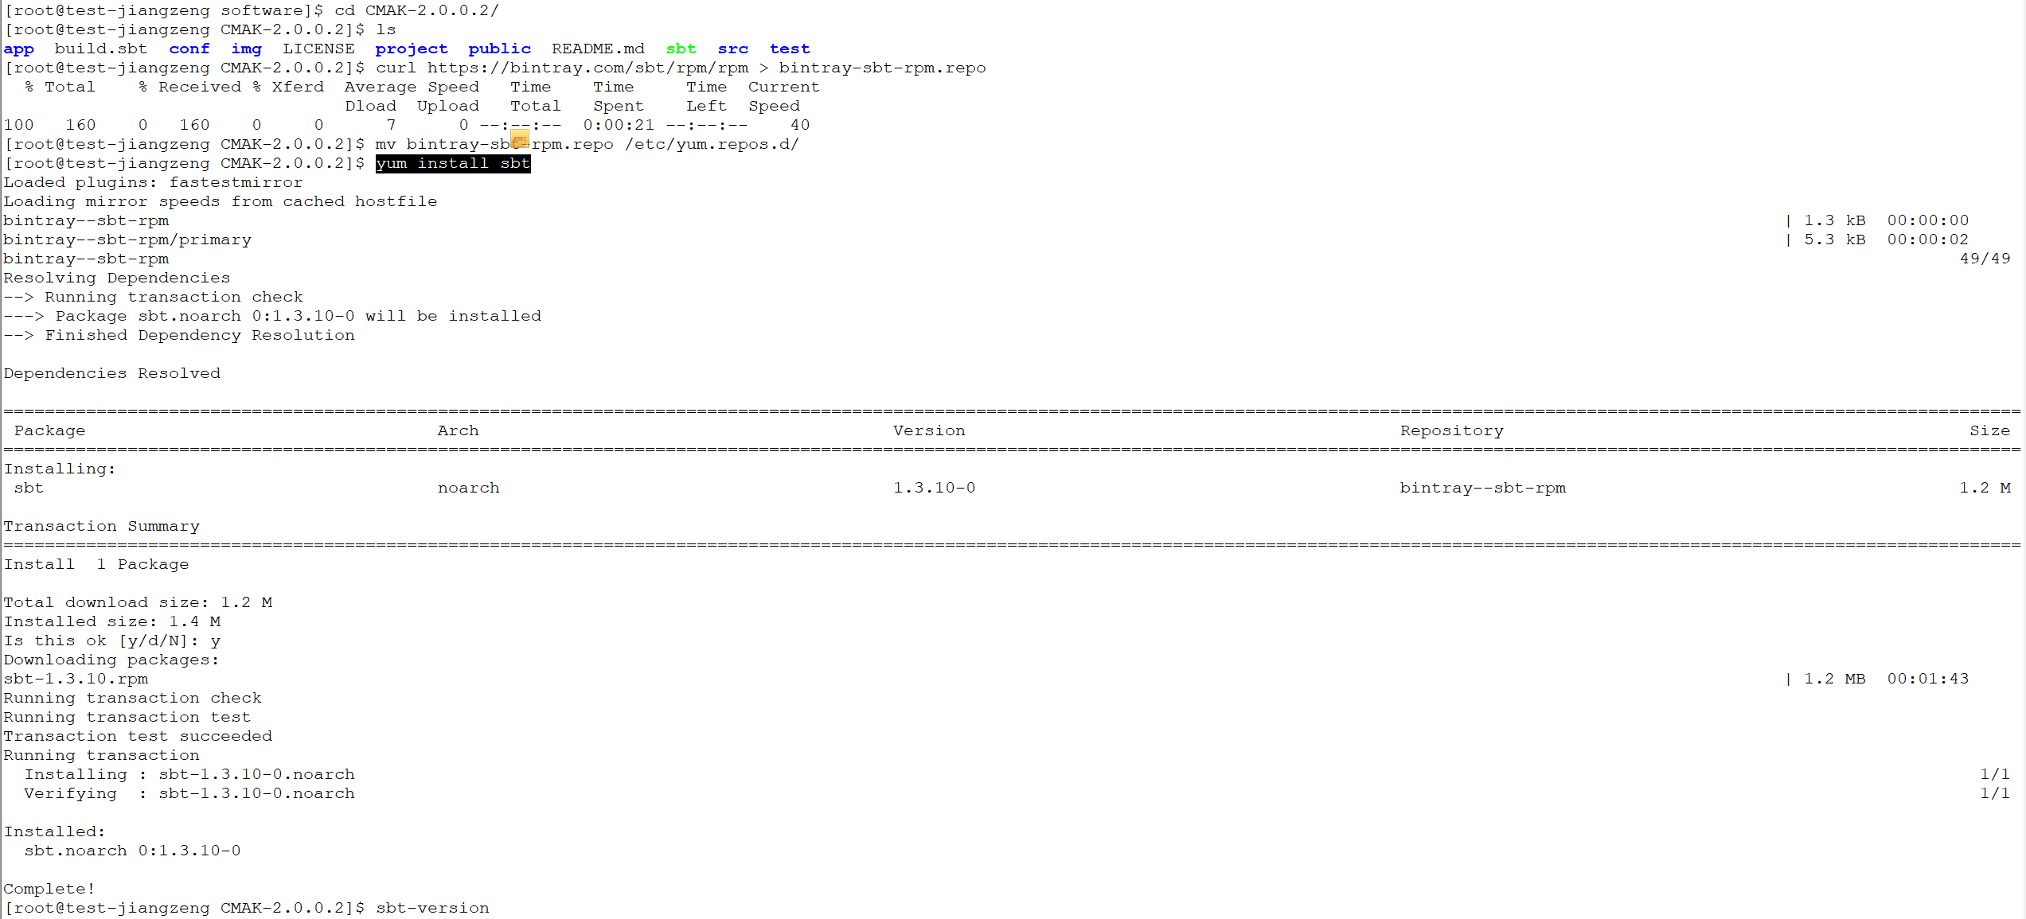

sbt –version

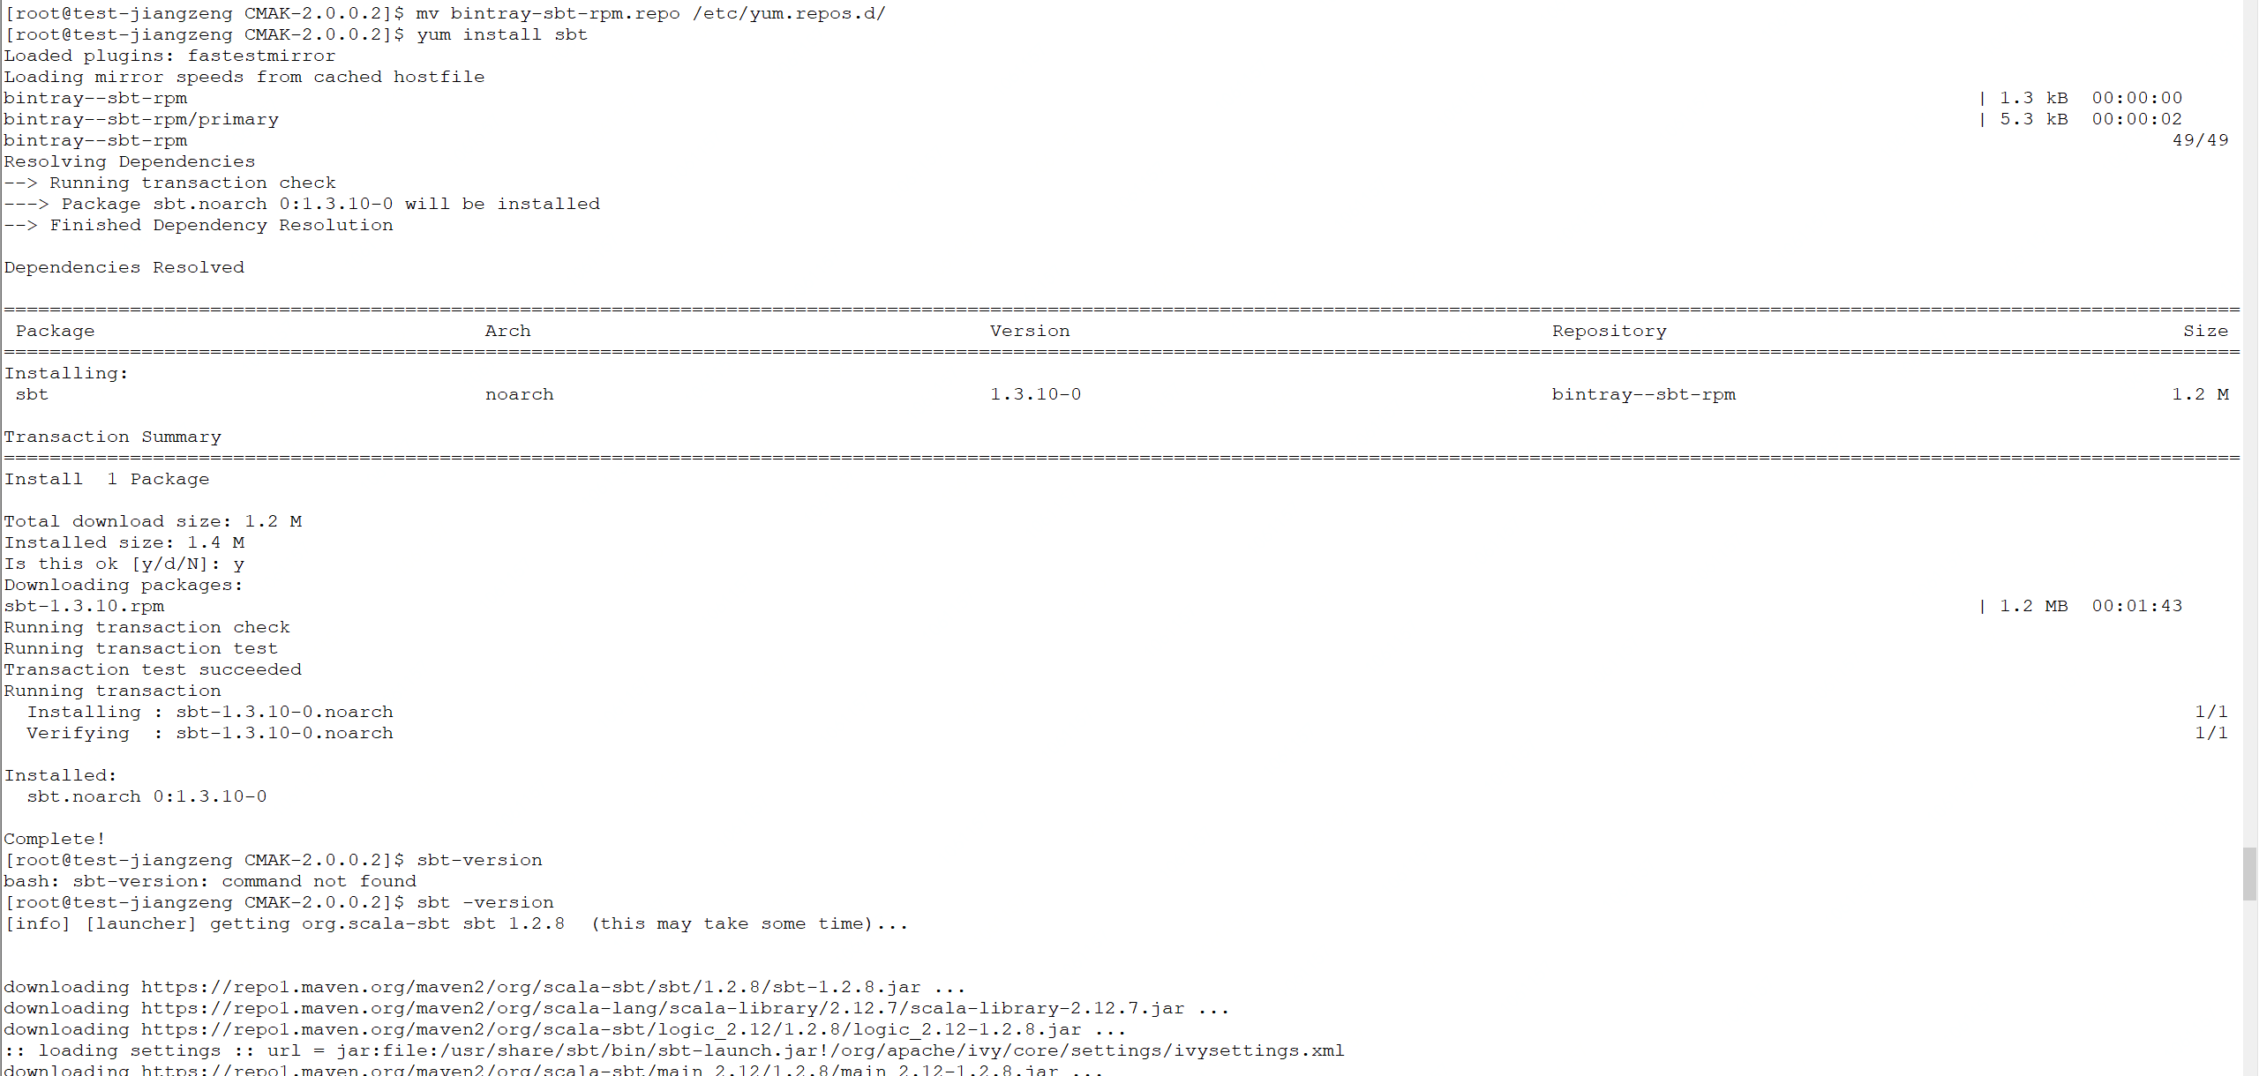

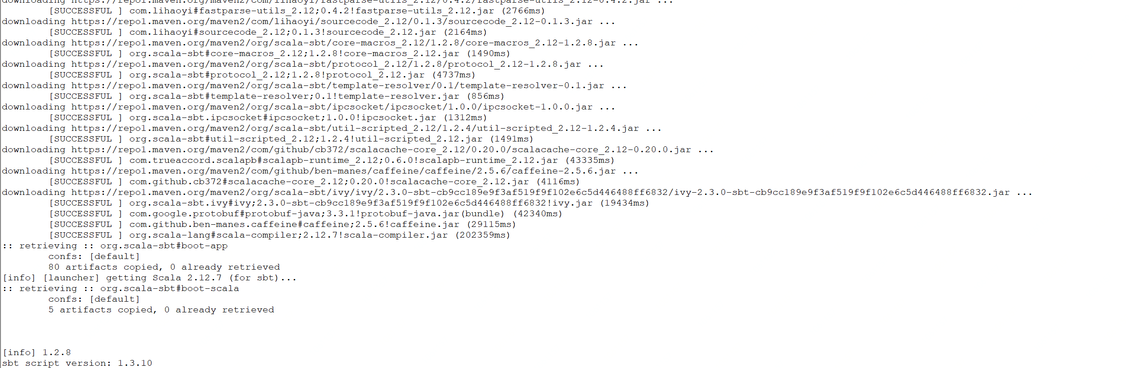

./sbt clean dist

