

International Competition: "SMART CITY 2030: Sustainable Urban Development Management in BRICS Countries"
Article Type: ARTICLE

Ward-Level Urban Heat-Vulnerability Mapping for Nagpur, India: Transferring the Ahmedabad Heat-Action Benchmark to a BRICS City
Rajvardhan Singh¹, Orpita Das ^{2,} Dr Shilpa sharma ^{3*}
¹ Computer Science and Engineering, LPU, Phagwara, Punjab 144411, India
² Computer Science and Engineering, LPU, Phagwara, Punjab 144411, India
³ School of AI and Emerging Technologies, LPU, Phagwara, Punjab 144411, India

KEYWORDS |  | ABSTRACT
Urban heat island  Heat vulnerability index  Land surface temperature  Ward-level mapping |  | Extreme heat kills more people in Indian cities than any other climate hazard, and most municipal heat action plans do not say where the risk is worst. Nagpur, ranked among the ten most heat-exposed cities in the world, began implementing a heat action plan only in 2025–26 and still has no map of which wards carry the greatest burden. This study builds a ward-level Heat Vulnerability Index (HVI) for the 38 wards of the Nagpur Municipal Corporation (NMC). We use eleven years (2015–2025) of Landsat summer land surface temperature (LST), NDVI and NDBI, together with ESA WorldCover land cover, SRTM elevation, WorldPop population, and NMC 2025 ward demographics. Six indicators (mean LST, NDBI, impervious fraction, population density, SC/ST share, and vegetation deficit) were normalised and combined with principal-component (PCA) weights, then tested against equal, entropy and IPCC-framework weighting. The first principal component explained 44.7% of the variance and was led by impervious fraction (0.27), population density (0.27) and vegetation deficit (0.24). Vulnerability concentrates in the dense central and south-central wards: Ward 20 (HVI 0.81), Ward 8 (0.75), and Wards 19 and 21 (0.74). The green western wards score lowest, with Ward 14 at 0.07. Ten wards hold 27% of the city's 2.45 million residents, and the High and Very-High quintiles hold 40%. Daytime LST runs against population vulnerability (Spearman ρ = −0.18), because dry peripheral cropland is hotter than the dense built-up core; an LST-only map would send resources to the hot but sparsely populated edge of the city. The ranking held across all four weighting schemes (top-10 overlap 10/10). If Nagpur reproduces the Ahmedabad benchmark of roughly 23% fewer heat excess deaths, a targeted plan would reach about 987,000 residents, rising to about 1.10 million by 2036 under SSP2-4.5 warming (+0.35 °C). The result is a reproducible targeting layer for Nagpur's heat action plan and a template other BRICS cities can reuse.

1. Introduction
1.1 The urban problem and its relevance
Extreme heat is the leading climate-related cause of death in India, and cities absorb most of that toll. The IPCC treats urban heat as a key climate risk for Asia and notes that adaptation is spread unevenly, often missing the districts that need it most [1]. The Indian numbers are stark. A 2025 post-AR6 assessment found that India's mean surface temperature rose about 0.89 °C between 2015–2024 relative to 1901–1930, that warm days and nights increased by 5 to 15 days per decade since 1951, and that another 1.2 to 1.3 °C of warming is projected by mid-century under SSP2-4.5 [24]. Worldwide, more than 95% of the highest heat-risk cities sit in South and South-East Asia and Sub-Saharan Africa [21], and Asian cities face a projected rise of about 3.8 °C under high-emission pathways [23].
Nagpur, a city of roughly 2.45 million people in the Vidarbha region of central India, sits squarely in that trend. A 2026 University of Oxford assessment placed Nagpur among the ten most heat-exposed cities in the world [19]. In May 2026 the India Meteorological Department issued a red-alert heatwave for the city, with maximum temperatures of 45.7 °C and Vidarbha stations above 46 °C. Nagpur also has deep social inequality and a large share of residents in dense, low-vegetation neighbourhoods, which raises the health risk further. Until recently, the city had no operational heat action plan.
This project tackles a concrete urban problem. Nagpur has started planning for heat, but it cannot see where heat risk actually concentrates. A plan without a spatial vulnerability map is a blunt tool: cooling centres, water points and outreach may end up where heat is physically highest rather than where vulnerable people are most exposed and least able to cope. We supply the missing evidence, a ward-level, reproducible Heat Vulnerability Index for all 38 NMC wards, benchmarked against the documented Ahmedabad Heat Action Plan and projected to the competition's ten-year horizon.
1.2 Literature review
Heat-vulnerability methods. Composite indices dominate this field. Reid et al. [7] set the template, using principal-component analysis (PCA) to collapse social and demographic variables into a single census-tract heat-vulnerability score. Inostroza et al. [8] reorganised the method around the IPCC's three components of exposure, sensitivity and adaptive capacity, standardising variables before combining them. Municipal indices have largely followed that design. The Philadelphia HVI combines remotely sensed LST, NDVI, NDWI and NDBI with a PCA social-sensitivity layer [9]. The New York State HVI groups 14 indicators into heat exposure, sociodemographic and health factors and scales the result to a 0–100 percentile [11]. Bradford et al. [10] showed that factor-analysis HVIs travel across locations and time. Open toolkits now make the method reproducible [12]. In India, IIT Delhi [15] built a Delhi ward-level HVI from an unweighted overlay of LST, land cover, population density and income, and found heat stress concentrated in central-western and eastern wards. Mandvikar et al. [13] ranked 37 million-plus Indian cities with a hazard-exposure-vulnerability Heat Health Risk Index, and the National Disaster Management Authority [14] built a household vulnerability index across four Indian cities. The message is consistent: heat risk depends on physical exposure and social vulnerability together, and both have to be mapped.
India-specific heat studies and the Nagpur evidence base. Indian studies repeatedly find that impervious surfaces drive surface heat while vegetation moderates it. NDBI-LST correlations are strongly positive and NDVI-LST correlations strongly negative in Delhi and Mumbai [25], and the Mumbai Climate Action Plan reports that over 60% of the built-up area sees summer LST of 35 to 42 °C, with compact mid-rise morphology the hottest form [26]. Nagpur's evidence base is much thinner and purely descriptive. Early work used Landsat ETM+ to show a Nagpur urban heat island [17]. A 2017 study linked LST to land-use and land-cover change [18], and the most recent assessment, from 2025, described seasonal UHI with 2023–24 Landsat 8/9 imagery [16]. None of these studies includes a social-vulnerability layer, a composite index, or a ward-level map. That is the central gap.
The Ahmedabad benchmark. Ahmedabad's May 2010 heat wave peaked at 46.8 °C and coincided with 4,462 all-cause deaths, of which an estimated 1,344 were excess, a 43.1% rise over a matched reference period [2]. The Ahmedabad Municipal Corporation and its partners responded with South Asia's first Heat Action Plan in 2013, built around an early-warning system triggered by forecast temperature thresholds (alerts above 41 °C), public awareness, health-worker training and cooling measures [3]. Independent evaluations have since reported results: a pilot evaluation using daily maximum-temperature-mortality models linked the post-HAP period to a 23% reduction in heat-related excess mortality, with the largest declines at the highest temperatures [4]; an earlier coalition evaluation found roughly a 25% reduction in May excess mortality [5]; and a later policy brief estimated about 1,190 deaths averted each year [31]. The World Bank's review of heat-health warning systems across Asia, North America and Europe reports excess-mortality reductions of 30% or more, and frames 20% and 40% as medium- and high-ambition targets [6]. Ahmedabad is the best-documented Global-South heat intervention, which makes it the natural yardstick for a city that is only starting to plan.
BRICS transferability. BRICS cities share both the problem and the tools. Johannesburg's 135-ward HVI, the closest methodological analogue to this work, found five vulnerability clusters and a north-south divide that tracks historical inequity, with mortality rising about 0.9% per 1 °C above a city-specific threshold and 2.1% for those aged 65 and over [20]. A globally comparable INFORM-style assessment found that exposure alone cannot predict risk, and that vulnerability and coping capacity do most of the work [21]. Brazilian cities recorded roughly 50,000 heat deaths in metropolitan areas between 2000 and 2020, yet most surveyed municipalities are still at early planning stages with real data and governance gaps [22]. For BRICS cities, a low-cost, open-method vulnerability index can be the difference between a plan on paper and a plan that reaches people.
1.3 Research gap
Three gaps frame this project. First, no composite, ward-level heat-vulnerability index exists for Nagpur; the city's literature stops at descriptive UHI and LST studies. Second, Nagpur's new heat action plan has no spatial targeting evidence. The NMC and UNDP have named ten heatwave-prone localities, but there is no quantitative, replicable map of which wards and how many people carry the greatest burden. Third, the Ahmedabad benchmark has never been adapted to Nagpur's size, climate and social geography. Ward-level heat-health data are missing as well: Maharashtra's heatstroke surveillance is state-aggregated and under-records heat deaths, which means any Nagpur index has to be validated against physical and administrative signals rather than health outcomes.
1.4 Aim and objectives
Aim. To develop and validate a ward-level Heat Vulnerability Index for Nagpur, and to use it to turn the Ahmedabad heat-action benchmark into a prioritised, ten-year adaptation pathway.
Objectives. (1) Quantify multi-year summer heat exposure, greenness and built-up intensity for all 38 NMC wards from satellite data. (2) Combine these with population and social data into a weighted composite HVI and identify priority wards. (3) Validate the index through internal consistency, weighting robustness and agreement with the municipality's own hotspot list. (4) Compare Nagpur's condition and method with the Ahmedabad benchmark. (5) Project heat exposure and the exposed population to 2036 under transparent scenarios. (6) Propose a monitoring mechanism and a stakeholder and risk framework for implementation.
1.5 Measurable tasks
• Extract per-ward LST, NDVI and NDBI for 2015–2025, plus per-ward elevation and land-cover fractions.
• Assemble per-ward population, density and SC/ST shares from the 2025 NMC delimitation.
• Build a six-indicator HVI with PCA weights and three robustness variants, and rank all 38 wards.
• Quantify the exposed population in priority wards and check the result against the NMC/UNDP hotspot list.
• Produce a ward vulnerability map, a ranking chart and an indicator atlas.
• Produce a 2036 scenario projection and a monitoring plan.
- 2. Materials and Methods
2.1 Study area
Nagpur (21.15° N, 79.09° E, about 310 m elevation) is the winter capital of Maharashtra and the largest city in Vidarbha. Under the 2025 delimitation the NMC area holds 38 wards across 234.0 km², with a population of 2,447,494 and an average density of 10,460 people per km². Summers are hot and semi-arid, and maximum temperatures in March to June routinely pass 42 °C. Wards range from 1.12 km² (Ward 8) to roughly 32 km², and population density ranges from 2,658 to 62,744 people per km². Both exposure and sensitivity vary sharply within the city.
2.2 Data sources
Every input is free and open. Landsat summer composites supplied 30 m LST, NDVI and NDBI for 2015–2025. Land cover is ESA WorldCover 10 m (2021), elevation is SRTM 30 m, population is WorldPop 2020 at 1 km, ward boundaries are the NMC 2025 delimitation GeoJSON, and ward demographics are the NMC 2025 ward-wise populations (total, SC, ST). The Census of India 2011 Primary Census Abstract supplies city-level socioeconomic context. Table 1 lists the sources, and the full data dictionary accompanies the submission.
Table 1. Data sources.
Data | Source | Resolution / year | Use
Land surface temperature | Landsat summer composites | 30 m, 2015–2025 | Heat exposure
NDVI, NDBI | Landsat summer composites | 30 m, 2015–2025 | Greenness, built-up intensity
Land cover | ESA WorldCover v200 | 10 m, 2021 | Impervious / green fraction
Elevation | SRTM GL1 | 30 m | Terrain context
Population grid | WorldPop (UN-adjusted) | 1 km, 2020 | Density cross-check
Ward boundaries | NMC 2025 delimitation | vector, 2025 | Analysis units
Ward demographics | NMC 2025 ward list | ward, 2025 | Population, SC/ST
Census context | Census of India PCA | city, 2011 | Socioeconomic framing
Heatstroke deaths | NCBDC/IDSP | state, 2016–2021 | Validation limitation
2.3 Indicator framework
Following the IPCC-consistent HVI framework [8,11], we chose six indicators, each oriented so that a higher value means greater vulnerability:
• Heat exposure: mean summer LST (°C), built-up intensity (NDBI), and impervious land-cover fraction.
• Sensitivity: population density (people per km²) and SC/ST population share.
• Adaptive-capacity deficit: vegetation deficit, defined as 1 − NDVI.
Per-ward LST, NDVI and NDBI came from zonal means of each annual composite, averaged over 2015–2025. All raster layers were aligned to the ward boundaries (WGS84, with metric work in UTM 44N) using zonal statistics, and indicators were min-max normalised to the range 0 to 1 across the 38 wards.
2.4 Index construction and weighting
We derived the weights from the data rather than assuming them. A PCA was fitted to the standardised indicators, the first principal component (PC1) was sign-aligned with LST, and weights were set to the normalised absolute PC1 loadings. PC1 explained 44.7% of the variance and was dominated by impervious fraction (0.27), population density (0.27) and vegetation deficit (0.24), followed by LST (0.15) and NDBI (0.07). SC/ST share loaded near zero. The composite HVI is the weighted sum of the normalised indicators. For robustness we also computed equal-weight, entropy-weight and an IPCC-framework composite (0.40 exposure, 0.35 sensitivity, 0.25 adaptive-capacity deficit). Section 3.5 reports how closely the schemes agree. Everything runs in Python (GeoPandas, Rasterio, Rasterstats, scikit-learn) and can be reproduced from the supplied scripts.
Table 2. Indicators, weights and PC1 loadings.
Indicator | Dimension | PCA weight | PC1 loading
Mean summer LST | Exposure | 0.147 | 0.305
NDBI | Exposure | 0.067 | −0.140
Impervious fraction | Exposure | 0.274 | −0.570
Population density | Sensitivity | 0.267 | −0.557
SC/ST share | Sensitivity | 0.004 | −0.007
Vegetation deficit (1 − NDVI) | Adaptive deficit | 0.241 | −0.502
2.5 Validation approach
No ward-level heat morbidity or mortality data are publicly available for Nagpur, so validation rests on three strands. The first is internal consistency: Spearman correlations between the HVI and its physical components. The second is weighting robustness: agreement between the PCA, equal, entropy and framework composites. The third is external plausibility: geocoding the ten NMC/UNDP heatwave-prone localities and checking the HVI rank of the wards that contain them. Section 4.4 sets out what this approach cannot show.
2.6 Forecast and scenario method
The competition asks for a ten-year projection. We computed per-ward ordinary-least-squares LST slopes for 2015–2025 but do not use them for forecasting. Annual city-mean LST swings between 42.3 °C in 2022 and 52.5 °C in 2019, which shows that inter-annual variation is driven by the Landsat acquisition date within the April to June window, not by climate. Instead we use a scenario projection that adds a spatially uniform regional warming increment to each ward's baseline, anchored to the post-AR6 India assessment of about 0.25 to 0.35 °C per decade under SSP2-4.5 [24]: low +0.20 °C, mid +0.35 °C, high +0.55 °C by 2036. Population is projected at 0.5, 1.0 and 1.5% per year for the three scenarios. This keeps the observed spatial pattern intact and measures growth in the exposed population rather than a change in which wards are vulnerable.
2.7 Stakeholders, implementation and risk
Implementation is conceived as a municipal programme led by the NMC Health and Disaster Management cells, with the Nagpur Smart and Sustainable City Development Corporation, IMD Nagpur and civil-society partners. Table 7 maps stakeholders to roles and Table 6 sets out the risk assessment. The core stages are: adopt the HVI as the targeting layer for the existing heat action plan; pilot cooling and greening in the top five wards; institutionalise seasonal monitoring; and scale across the city.
2.8 Public opinion approach
We did not administer a primary household survey. Following the NDMA household-vulnerability precedent [14] and the IRADe approach [31], we analyse public opinion from two secondary streams: documented resident complaints and municipal responses reported in local media [27,28], and comparable household heat-perception findings from Indian cities [14,31]. We also specify a standardised questionnaire for the monitoring phase (Appendix A). This is a deliberate choice. Presenting an unadministered survey as primary data would be dishonest, and the secondary evidence is enough to ground the intervention in residents' lived experience.
- 3. Results
3.1 Ward vulnerability map and ranking
The composite HVI runs from 0.069 in Ward 14 to 0.806 in Ward 20, and vulnerability is tightly concentrated in the dense central and south-central core (Figure 1). Table 3 lists the ten most vulnerable wards. Ward 20, which contains the Itwari and Ganeshpeth market district, combines the highest population density (57,636 per km²), a very high impervious fraction (0.93) and an above-average SC/ST share (0.55), which puts it first. Ward 8 and Wards 19 and 21 follow, all in the old city core. At the other end, the green, low-density western wards rank lowest: Ward 14 (Seminary Hills area, HVI 0.07), Ward 13 and Ward 11. Figure 3 shows the ranking and Figure 2 the full indicator atlas.
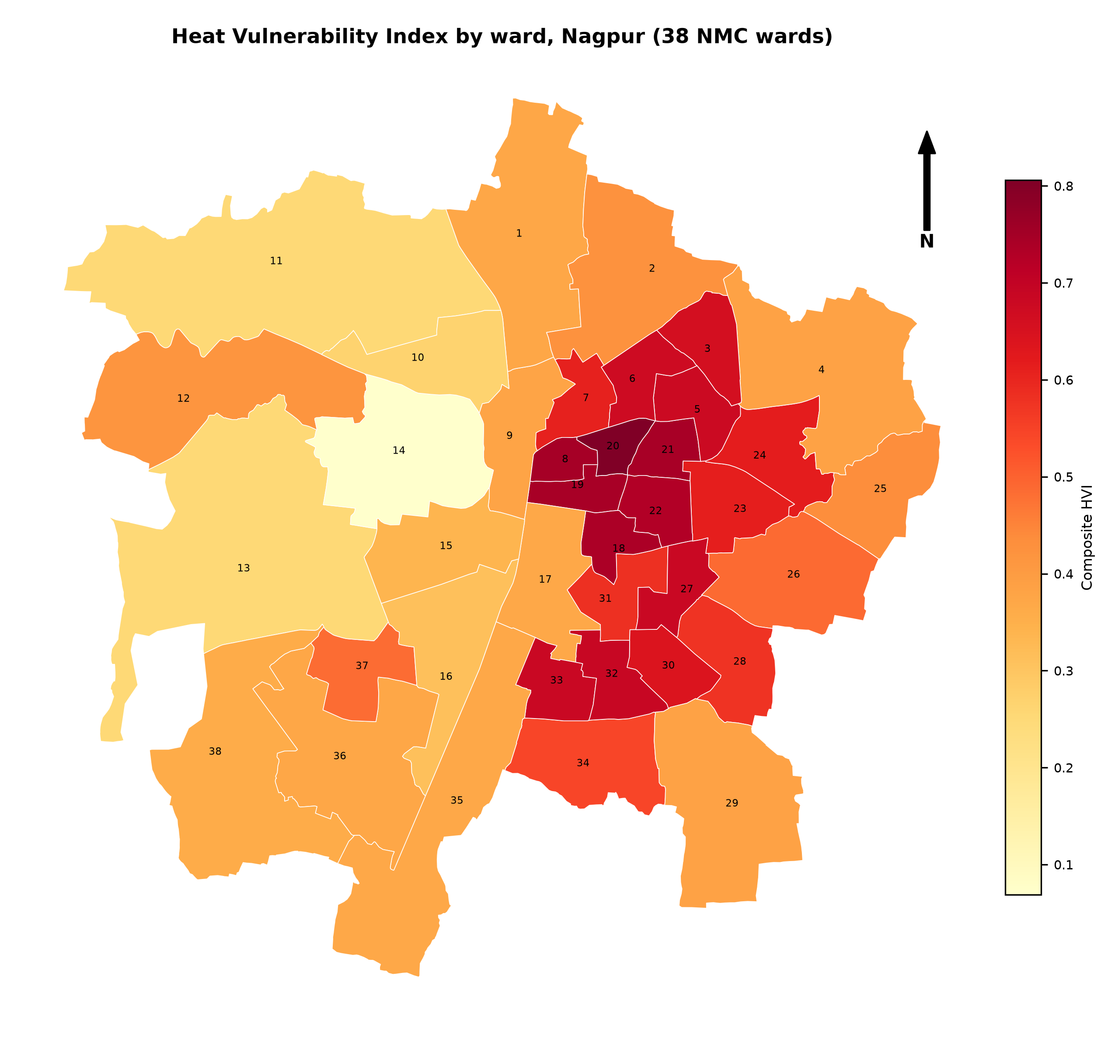
Figure 1. Composite Heat Vulnerability Index by ward, Nagpur (38 NMC wards). Darker red indicates higher vulnerability; ward numbers are labelled at ward centroids.
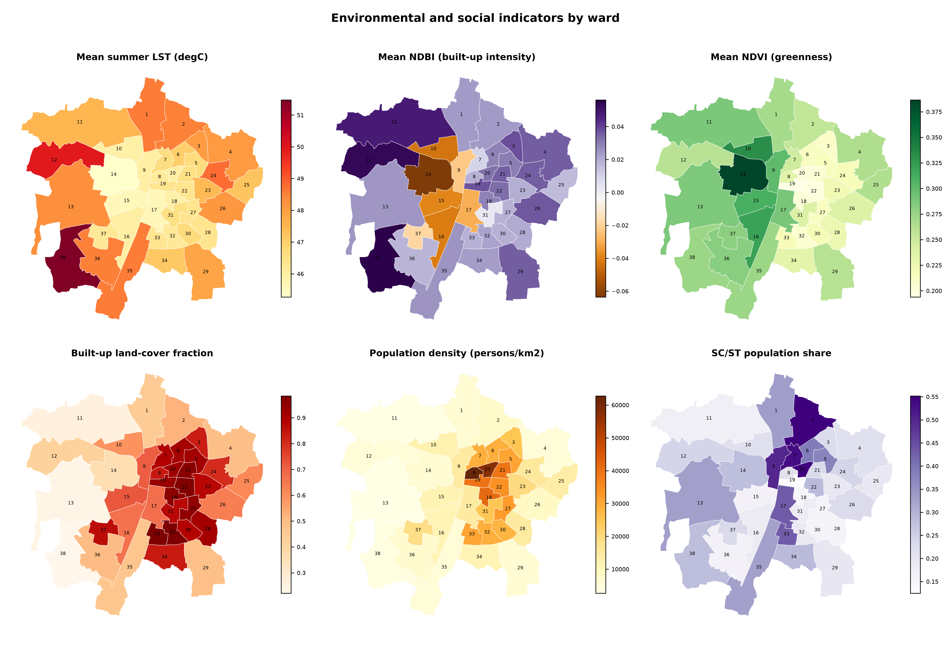
Figure 2. Environmental and social indicators by ward: mean summer LST, NDBI, NDVI, impervious fraction, population density and SC/ST share.
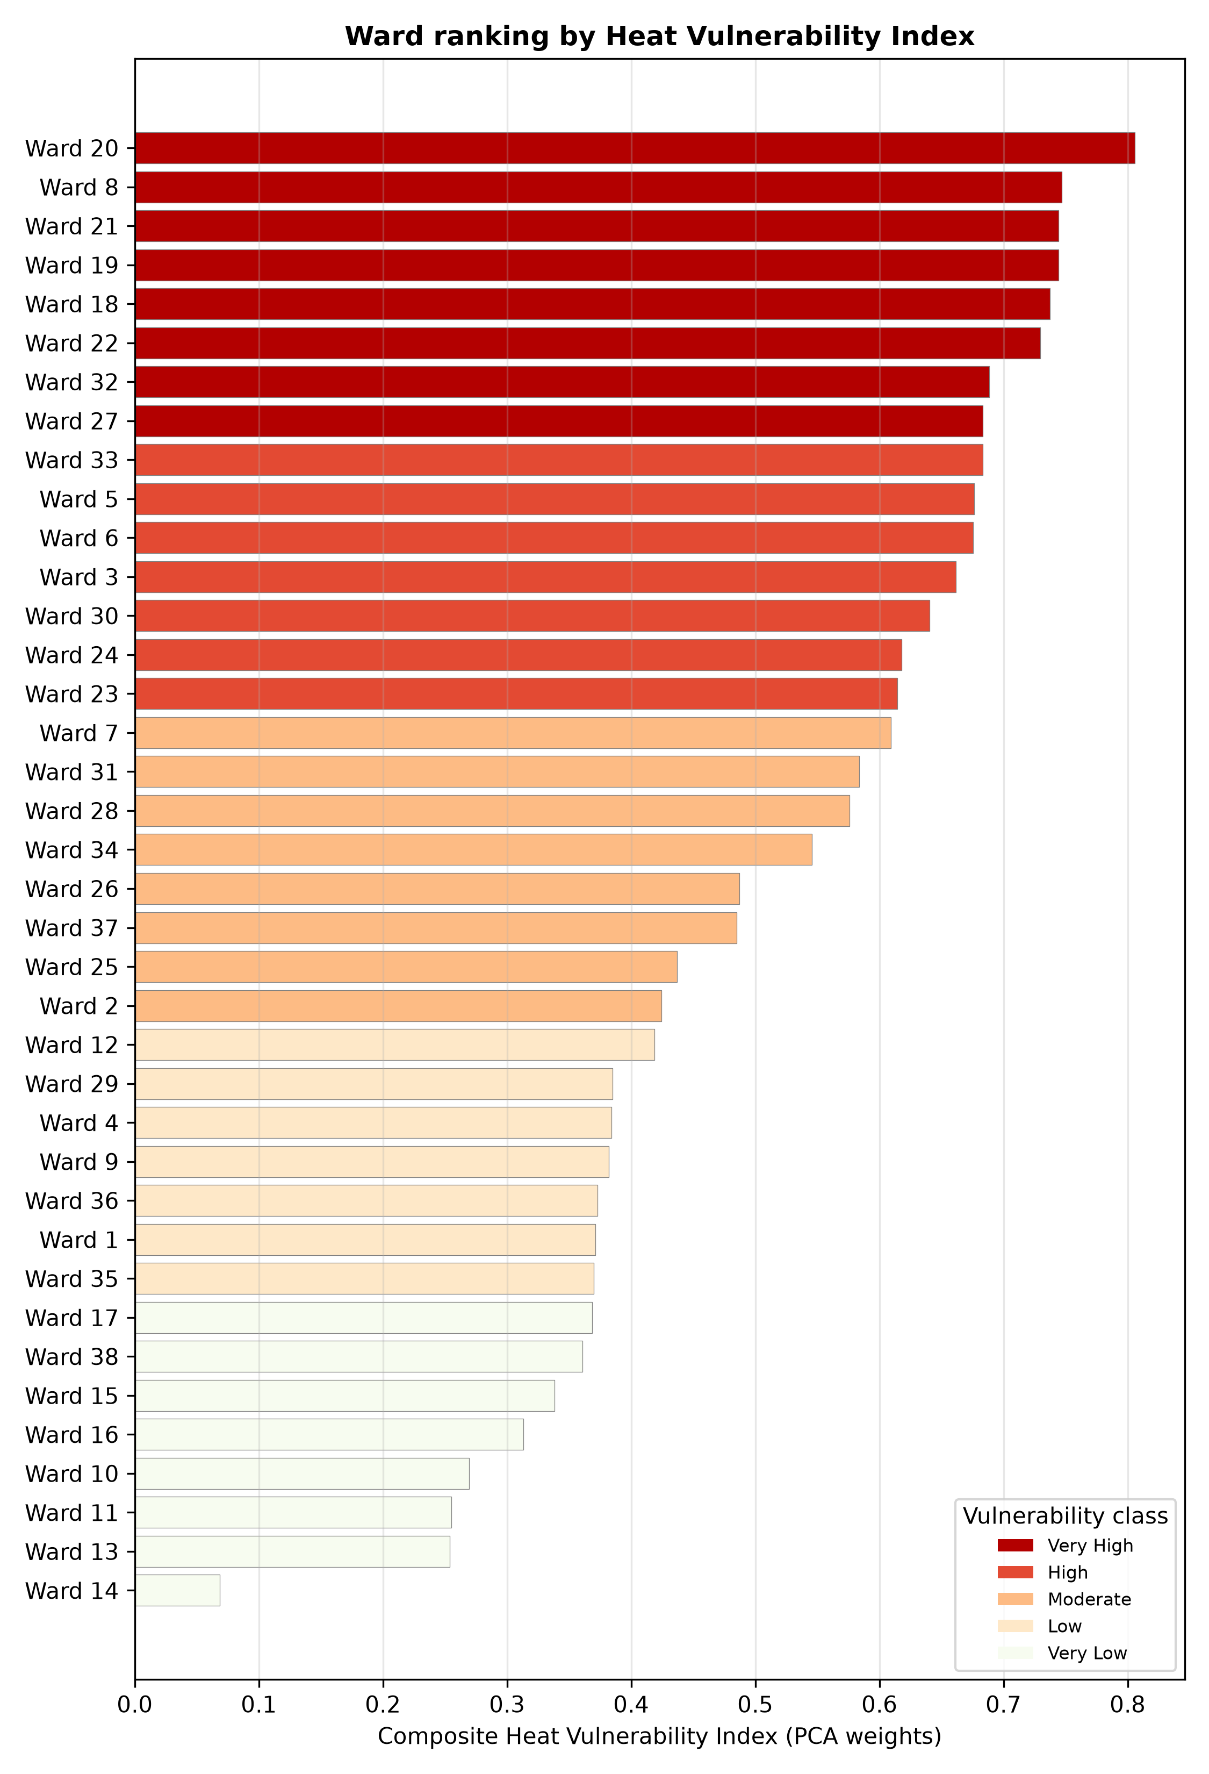
Figure 3. Ward ranking by composite HVI, coloured by vulnerability class (quintiles).
Table 3. Ten most vulnerable wards.
Rank | Ward | HVI | Mean LST (°C) | Density (/km²) | SC/ST share | NDVI | Impervious
1 | 20 | 0.806 | 45.96 | 57,636 | 0.55 | 0.20 | 0.93
2 | 8 | 0.747 | 46.19 | 62,744 | 0.21 | 0.23 | 0.84
3 | 19 | 0.744 | 46.36 | 39,550 | 0.12 | 0.19 | 0.94
3 | 21 | 0.744 | 46.54 | 39,402 | 0.23 | 0.20 | 0.96
5 | 18 | 0.738 | 45.93 | 41,551 | 0.15 | 0.20 | 0.96
6 | 22 | 0.730 | 46.36 | 34,255 | 0.29 | 0.20 | 0.98
7 | 32 | 0.689 | 46.20 | 28,993 | 0.19 | 0.21 | 0.98
8 | 27 | 0.683 | 46.38 | 32,264 | 0.16 | 0.21 | 0.95
9 | 33 | 0.683 | 46.37 | 30,609 | 0.43 | 0.22 | 0.98
10 | 5 | 0.677 | 46.69 | 30,717 | 0.38 | 0.22 | 0.92
3.2 Socioeconomic analysis
Nagpur's 2025 population of 2,447,494 includes 480,759 Scheduled Caste residents (19.6%) and 188,444 Scheduled Tribe residents (7.7%), together 27.3%. Those shares closely match the 2011 census (19.8% and 7.7%). City-level 2011 indicators fill in the picture: literacy 82.5%, female literacy 80.3%, work participation 35.1%, female work participation only 15.6%, and non-workers 64.9%. These numbers point to large daytime populations who are either outside formal work or exposed through outdoor and informal work, which is a well-documented heat-risk multiplier [3,14].
The spatial pattern matters most. The priority HVI wards are the densest in the city, and several also carry above-average SC/ST shares, with Wards 20, 33 and 5 above 37% combined. The High and Very-High vulnerability quintiles contain 986,625 residents, or 40% of the city, and the top ten wards alone contain 669,528, or 27%. Vulnerability is not a fringe issue in Nagpur: close to half the city lives in the wards where heat risk is highest. One further result is worth noting. The PCA placed SC/ST share almost exactly on the physical heat axis's zero point, which means social disadvantage and physical heat do not automatically coincide. That is an argument for a composite index rather than a heat-only map.
3.3 Public opinion and community perception
The secondary evidence suggests heat is a first-hand concern for Nagpur residents. Local reporting describes people in dense commercial districts struggling daily with tightly packed shops, concrete surfaces and heavy foot traffic, and the NMC's work with UNDP identified ten heatwave-prone localities: Sitabuldi Market, Kalamna Market, Reshimbag Ground, Ganeshpeth Bus Stand, Dhairyasheel Colony, Cotton Market, Itwari and Boriapura, Harpur Stadium, Jumairan Bazaar Mela, and Bhandewadi Dumping Yard [28]. Almost all are market, transit or dense-habitation places where people are present during the day, which fits the logic of the index. Household surveys in comparable Indian cities find that most households sit in moderate-to-high heat vulnerability, and that household characteristics such as housing material, occupation and access to cooling matter more than outdoor temperature alone [14,31]. In the 2026 season the NMC reported 38 heat-related illnesses and opened cold wards in 11 health facilities [27], so heat morbidity is already reaching the health system. To move from perception to measurement, Appendix A sets out a 15-item ward-level heat-perception questionnaire for the monitoring phase.
3.4 Development constraints
Two constraints shape where interventions can physically go. First, space is scarce in exactly the wards that need cooling most: the top ten wards average a 0.95 impervious fraction and densities of 29,000 to 63,000 people per km², so large new parks are not realistic. Interventions have to be small-scale, such as street trees, cool roofs, shade structures, water points and reflective pavements. Second, the hottest surfaces are not the most vulnerable places. Mean LST is highest in the low-density, cropland and bare periphery (Ward 38 at 51.5 °C and Ward 12 at 50.0 °C) and is negatively correlated with density (ρ = −0.53) and impervious fraction (ρ = −0.48), while correlating positively with cropland fraction (ρ = +0.73) (Figure 4). Elevation barely constrains anything, since mean ward elevation spans only 295 to 342 m. The practical consequence is that a greening programme should be prioritised by population vulnerability, not surface temperature, and that the hot agricultural periphery is a lower priority for human heat-health intervention.
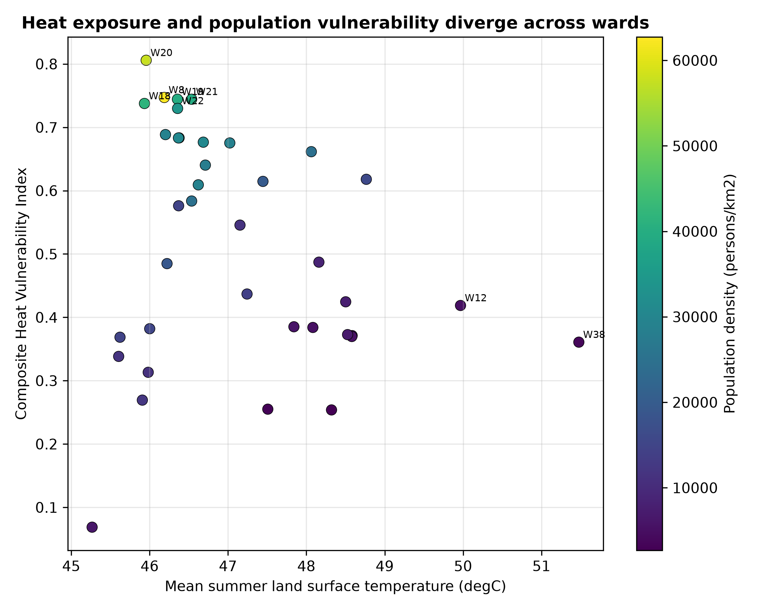
Figure 4. Heat exposure (daytime LST) and composite vulnerability diverge across wards; point colour shows population density.
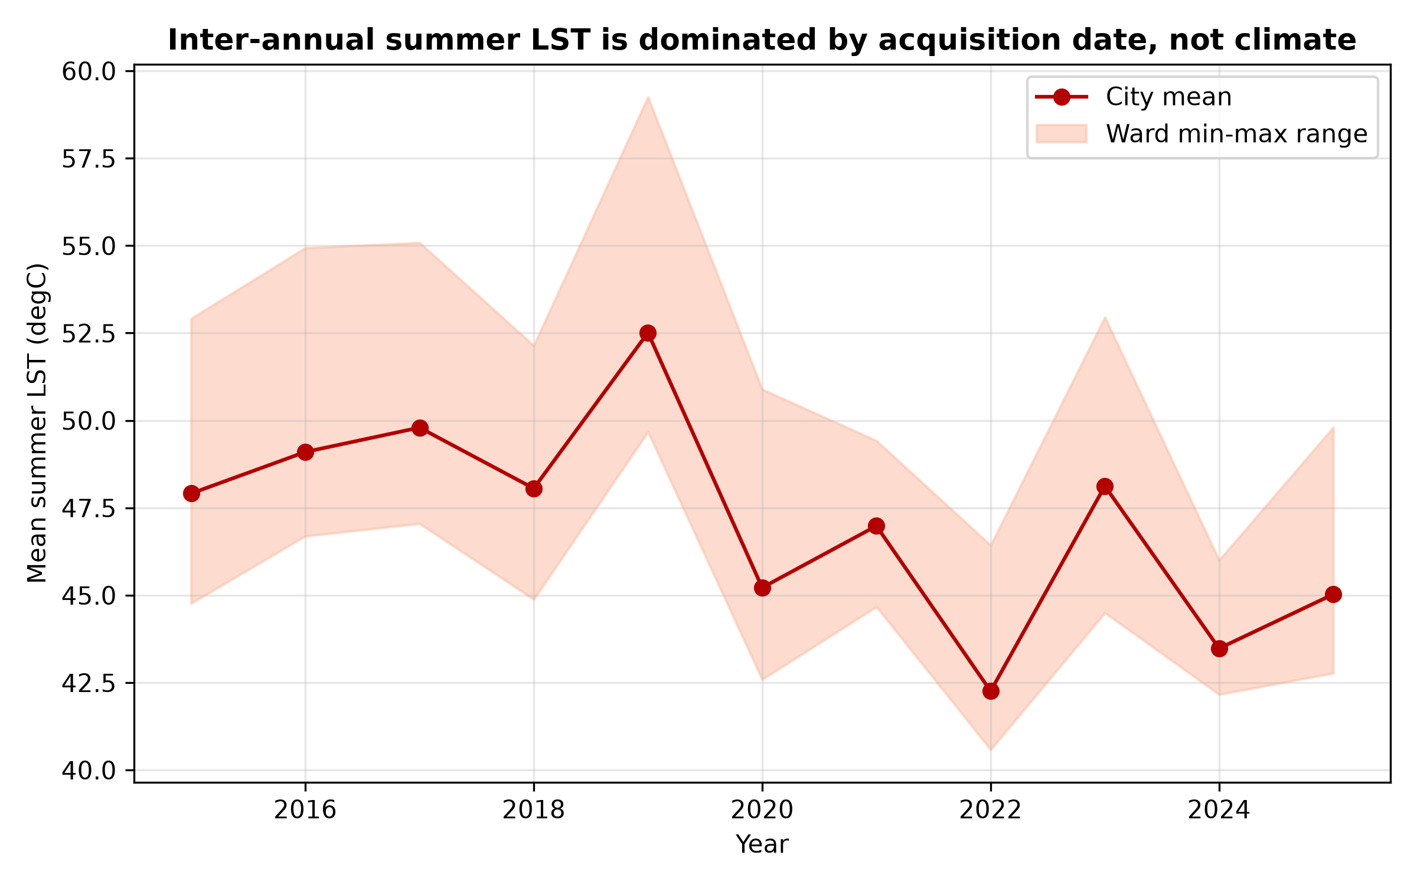
Figure 5. Inter-annual city-mean summer LST (2015–2025) with ward min-max range, showing acquisition-date dominance.
3.5 Validation
Internal consistency. The HVI tracks its components in the expected directions and strongly: impervious fraction (ρ = 0.86), population density (ρ = 0.89), vegetation deficit (ρ = 0.94, so NDVI ρ = −0.94), exposure index (ρ = 0.91) and sensitivity index (ρ = 0.89). It correlates only weakly with mean LST alone (ρ = −0.18), which is exactly why the composite, and not LST on its own, is the right targeting layer.
Weighting robustness. The PCA and IPCC-framework composites are rank-equivalent (Spearman ρ = 1.0) and share all ten top wards. Pearson correlations with the equal-weight and entropy-weight composites are 0.90 and 0.81. The identity of the priority wards holds across four different weighting philosophies.
External plausibility. Geocoding resolved 3 of 11 NMC/UNDP localities to wards. The best-resolved, Itwari, falls in Ward 20, the top-ranked ward, and Reshimbag Ground falls in Ward 31 (rank 17). Several unresolved localities, including Sitabuldi, Cotton Market, Gandhibagh and Ganeshpeth, are well-known central market districts inside the dense core wards that top the HVI. This is consistent with the index, though it does not prove it. The full validation log accompanies the submission.
3.6 Forecast to 2036
Under the mid SSP2-4.5 scenario (+0.35 °C by 2036) the same ten wards stay at the top, but the exposed population in the High and Very-High quintiles rises from 986,625 to 1,100,746, and in the top ten wards from 669,528 to roughly 747,000, assuming 1.0% annual population growth (Table 4). Because the warming increment is spatially uniform, the ranking does not change. The forecast therefore measures a growing human and thermal burden on wards already identified, not a shift in where vulnerability lies. Figure 5 shows why a data-driven LST trend was rejected as the forecast basis.
Table 4. Exposure and population under 2036 scenarios.
Scenario | Warming by 2036 | LST (priority-ward mean) | Population in High/Very-High wards
Baseline (2025) | — | ~46.4 °C | 986,625
Low | +0.20 °C | ~46.6 °C | 1,086,000
Mid (SSP2-4.5) | +0.35 °C | ~46.8 °C | 1,100,746
High | +0.55 °C | ~47.0 °C | 1,115,000
- 4. Discussion
4.1 Comparison with the Ahmedabad benchmark
Table 5 places Nagpur's current condition and method beside Ahmedabad's pre-HAP situation. Ahmedabad's response followed a quantified mortality shock (43.1% excess deaths in May 2010 [2]) and was built on household vulnerability surveys and epidemiological analysis [3]. Nagpur's trigger differs but is no less urgent. It is a top-10 global heat-exposed city [19] that already records heat illness (38 cases in 2026 [27]) and has just started a heat action plan, without spatial targeting evidence. The Ahmedabad experience supplies both the mechanism (early warning, cooling, outreach) and the expected effect size, with about a 23% reduction in heat excess mortality [4], roughly 1,190 deaths averted per year [31], and 20 to 40% envelopes [6].
Table 5. Ahmedabad benchmark versus Nagpur current condition.
Aspect | Ahmedabad (pre-HAP) | Nagpur (2025–26)
Population | ~5.8–7.6 million (metro) | 2,447,494 (NMC area)
Heat shock | May 2010: 46.8 °C, 43.1% excess deaths | IMD red alert May 2026, 45.7 °C; 38 heat illnesses
Plan status | No HAP before 2013 | Emerging HAP 2025–26
Targeting evidence | Household surveys + epidemiology | None published; qualitative hotspot list only
Spatial unit | City + vulnerable sub-populations | 38 NMC wards
Method | Tmax-mortality epidemiology | Ward composite HVI (PCA/framework)
Documented outcome | ~23% excess-mortality reduction | Not yet measured
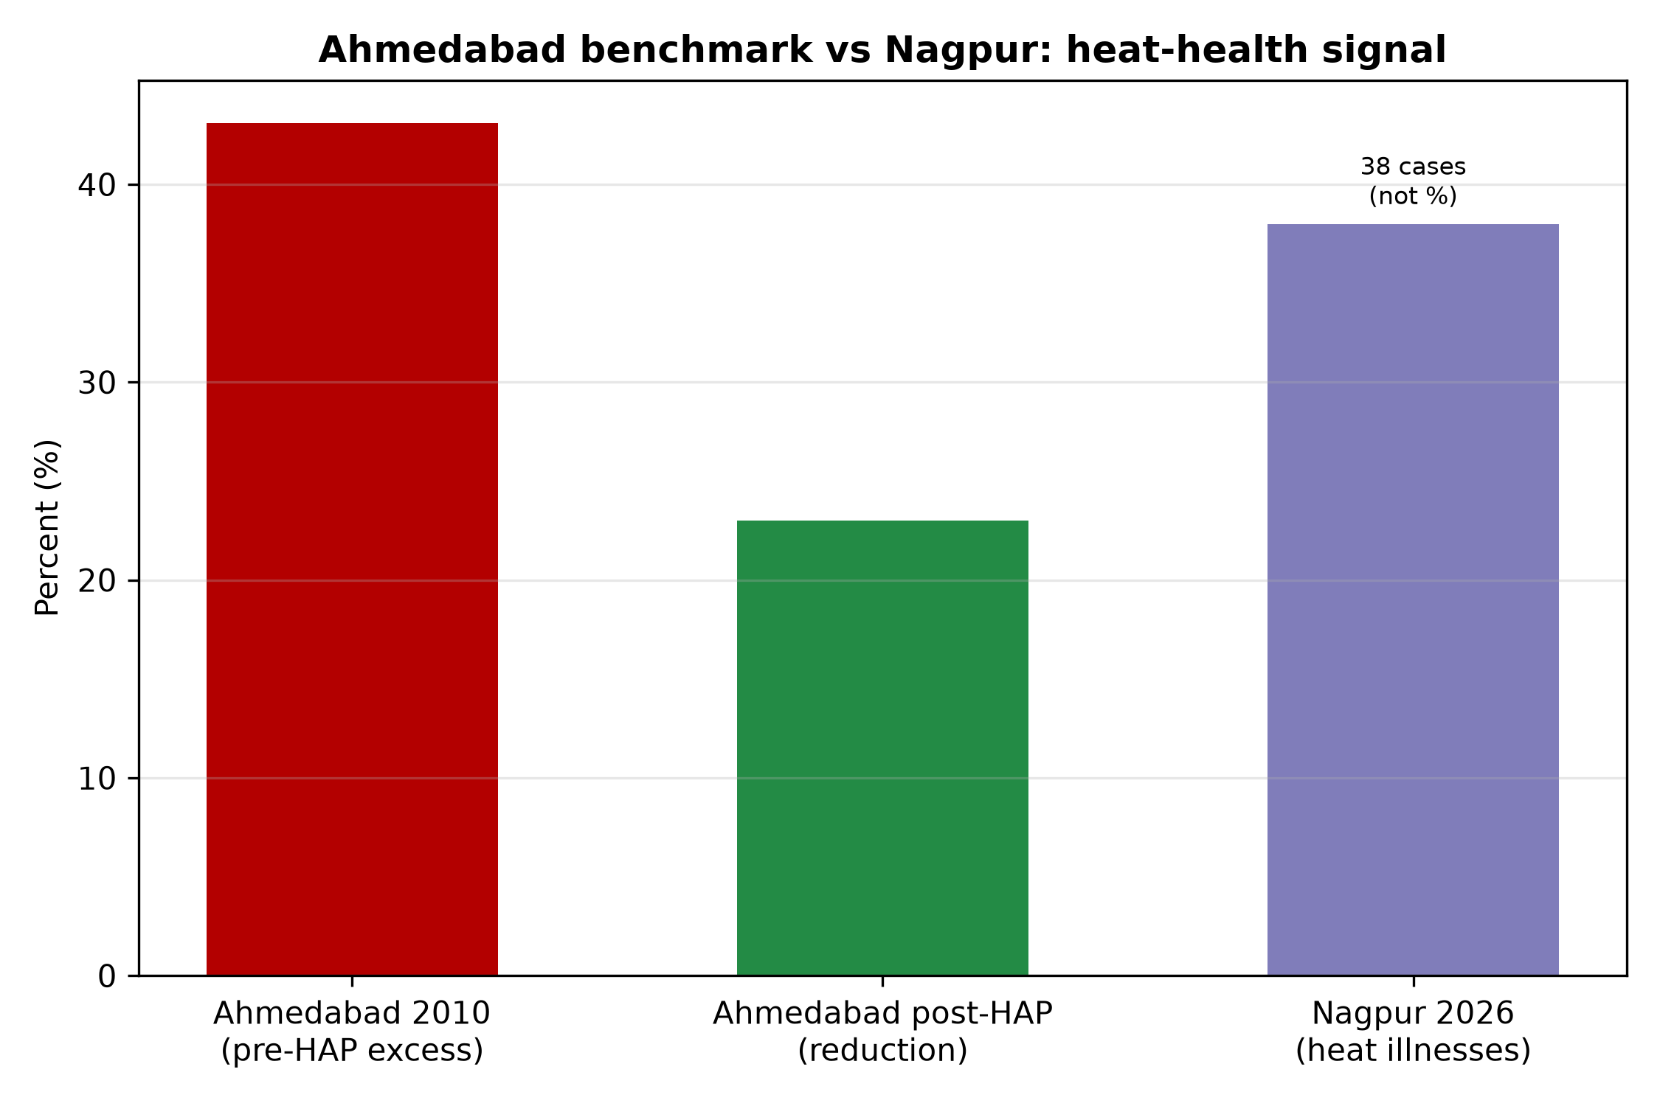
Figure 6. Ahmedabad's documented heat-health benchmark (43.1% excess mortality pre-HAP; about 23% reduction post-HAP) against Nagpur's current heat-illness signal.
The transferable lesson is that Ahmedabad's success came from reaching the right people, not from warnings alone. Nagpur's HVI puts that targeting logic to work: 40% of residents live in High or Very-High vulnerability wards, and the top ten wards hold 27% of the population. Applied at the Ahmedabad effect size, a well-targeted plan would reach the very wards where the municipality has already identified hotspots.
4.2 Ten-year outlook
The 2036 scenario shows that even moderate warming adds more than 100,000 residents to Nagpur's high-vulnerability wards and raises their thermal load by about 0.35 °C. Because vulnerability is spatially stable, the city has an unusual planning advantage: the target list will not move. Investments made now in the top wards will stay correctly sited through the plan horizon. The forecast also makes clear that adaptation has to be paired with mitigation, since a uniform warming increment compounds an already-high baseline of about 46 °C surface temperature in the priority wards.
4.3 Transferability across BRICS cities
The method used here is deliberately cheap and reproducible: open satellite composites, open population and land-cover layers, and authoritative municipal ward demographics combined through a transparent composite index. It mirrors the Johannesburg ward-level HVI [20] and the globally comparable INFORM approach [21], both of which show that exposure alone misleads and that vulnerability and coping capacity drive risk. Any BRICS city with a ward boundary file and Landsat coverage can run the same workflow, which makes the Nagpur case a template rather than a one-off. This matters because most Global-South cities are still at early planning stages and lack the data to target adaptation [22].
4.4 Limitations
1. No ward-level heat health data exist, so validation cannot use mortality or morbidity. It rests on physical consistency, weighting robustness and partial agreement with the municipality's hotspot list.
2. The LST data are daytime, single-sensor snapshots. Night-time UHI, a strong driver of heat mortality, is not captured, which partly explains the exposure-vulnerability divergence.
3. Inter-annual LST is acquisition-confounded. Annual means swing by about 10 °C, so no climate trend is inferred and the forecast uses literature-anchored scenarios.
4. The current 38 wards differ from the 136 census-2011 wards, and no open 2011 ward geometry exists. City-level census context and current NMC ward SC/ST data stand in, which means age structure (elderly and children) is not spatially resolved.
5. The WorldPop grid is coarse. At 1 km it diverges from NMC ward totals in most wards, so NMC totals are used as the primary density measure.
6. Geocoding uncertainty affects the external hotspot check.
7. The forecast uses a uniform increment, not a downscaled climate model, and ignores demographic ageing.
- 5. Conclusions and Recommendations
Main conclusions. Heat vulnerability in Nagpur is highly concentrated. Ward 20, Ward 8, and Wards 19 and 21 top a robust composite index, and 40% of residents live in High or Very-High vulnerability wards. Vulnerability is a built-environment and social phenomenon rather than a simple temperature one, and daytime LST runs against population vulnerability, so an LST-only map would send resources to the hot but sparsely populated periphery. The priority ranking is invariant across four weighting schemes, which gives policy users a stable target. Nagpur's emerging heat action plan can use this ward-level layer immediately, transferring the Ahmedabad benchmark to where it is needed most.
Recommendations. (a) Adopt the HVI as the targeting layer of the NMC heat action plan and prioritise the top ten wards for cooling centres, water points, shade and outreach. (b) Use small-scale cooling where space is tight: cool and reflective roofs on municipal and residential buildings, street-tree planting, and shaded market and transit nodes. (c) Prioritise by vulnerability, not surface temperature. (d) Formalise seasonal monitoring (Section 5.1). (e) Re-run the index every two to three years as wards, land cover and population change.
5.1 Monitoring mechanism and feasibility
Monitoring. We propose a light Heat Vulnerability Monitoring Cycle: update the LST, NDVI and NDBI composites and NMC ward demographics each year; report heat-illness presentations from NMC cold wards and hospitals every season, disaggregated to ward; administer the Appendix A perception questionnaire in the top ten wards; and publish a public HVI dashboard. Ward-level heat-illness counts would let the index be formally validated within two to three seasons and recalibrated over time.
Feasibility. The method uses only free data and open-source software, so the marginal cost is staff time for the annual update. It fits the NMC's existing 2025–26 heat action plan and UNDP collaboration, and Maharashtra's state heat-wave action plan [29]. The main requirement is institutional ownership of the monitoring cycle, not new technology.
Expected outcomes. A defensible, annually updatable vulnerability map; a prioritised investment list; a measurable fall in heat-illness presentations in the target wards; and a BRICS template other cities can reuse.
5.2 Risk assessment
Table 6. Implementation risks and mitigations.
Risk | Likelihood | Impact | Mitigation
Data updates lapse | Medium | Medium | Embed the update in the NMC annual budget; use open data
Interventions sited by temperature rather than vulnerability | Medium | High | Mandate HVI-based siting
Space constraints in dense wards | High | Medium | Small-scale interventions: roofs, shade, trees
No ward health data to prove effect | High | Medium | Start ward-level recording through the cold wards
Low community uptake | Medium | Medium | Outreach in local language; engage ward committees
Political or administrative turnover | Medium | Medium | Institutionalise through the NMC/UNDP programme
5.3 Stakeholders
Table 7. Stakeholders and roles.
Stakeholder | Role
NMC Health and Disaster Management cells | Lead; cold wards; seasonal monitoring
Nagpur Smart and Sustainable City Corp. | Data platform; dashboard; cool-roof pilots
IMD Nagpur | Heat warnings; threshold calibration
State SDMA, Maharashtra | Alignment with the state HAP; funding
Ward committees and resident groups | Outreach; questionnaire administration
Local NGOs and community health workers | Last-mile engagement
Academic partners | Method audit; index recalibration
- Author Contributions
Conceptualization, team; methodology, team; software, team; validation, team; formal analysis, team; data curation, team; writing, original draft, team; writing, review and editing, team; visualization, team. All authors have read and agreed to the published version of the manuscript.
- Funding
This work received no external funding.
- Institutional Review Board Statement
Not applicable. The study did not involve human or animal subjects. The proposed questionnaire (Appendix A) will need ethics review before it is administered.
- Informed Consent Statement
Not applicable.
- Data Availability Statement
All datasets used are free and open: Landsat summer composites, ESA WorldCover 2021, SRTM GL1, WorldPop 2020, NMC 2025 ward boundaries and ward demographics, and the Census of India 2011 Primary Census Abstract. Processed tables, figures and analysis code accompany this submission.
- Acknowledgments
The team thanks the NMC and UNDP for publishing ward-level delimitation and hotspot information, and the providers of the open Earth-observation datasets.
- Conflicts of Interest
The authors declare no conflict of interest.
- Appendix A. Participant's questionnaire
Proposed 15-item heat-perception and vulnerability questionnaire for the ten highest-HVI wards. To be translated into Marathi and Hindi before use.
1. In which ward do you live? (Ward number)
2. How many years have you lived in this ward?
3. On the hottest days, how would you rate the heat in your home? (1 very mild to 5 unbearable)
4. Which room or space is hottest, and at what time of day?
5. What is the main roof material of your home? (concrete, tin, asbestos, tiles, other)
6. Does your home have a working fan, cooler or air-conditioner? (yes or no, and which)
7. On the hottest days, how many hours a day is your home uncomfortably hot?
8. How often do you or your family drink water outside the home on hot days? (never, sometimes, daily)
9. Is there a public drinking-water point or shaded space within a five-minute walk? (yes or no)
10. Have you or a household member felt dizzy, nauseous or faint from heat in the last 12 months? (yes or no)
11. Did anyone in your household need medical help for heat in the last 12 months? (yes or no)
12. What is your main occupation and typical working hours? (outdoor, indoor or mixed)
13. How do you usually avoid the heat? (stay indoors, use water, use fan or cooler, go to shade, other)
14. Do you receive heat warnings or advice from the municipality? (never, rarely, sometimes, often)
15. What single change would most reduce heat risk in your neighbourhood? (open text)
- References
- [1] IPCC, 2022. Climate Change 2022: Impacts, Adaptation and Vulnerability. Working Group II Contribution to the Sixth Assessment Report, Chapter 10 (Asia). Cambridge University Press: Cambridge, UK.
- [2] Azhar, G.S.; Mavalankar, D.; Nori-Sarma, A.; Rajiva, A.; Dutta, P.; Jaiswal, A.; Sheffield, P.; Knowlton, K.; Hess, J.J., 2014. Heat-Related Mortality in India: Excess All-Cause Mortality Associated with the 2010 Ahmedabad Heat Wave. PLOS ONE 9(3), e91831. DOI: https://doi.org/10.1371/journal.pone.0091831.
- [3] Knowlton, K.; Kulkarni, S.P.; Azhar, G.S.; Mavalankar, D.; Jaiswal, A.; Connolly, M.; Nori-Sarma, A.; Rajiva, A.; Dutta, P.; Deol, B.; et al., 2014. Development and Implementation of South Asia's First Heat-Health Action Plan in Ahmedabad (Gujarat, India). Int. J. Environ. Res. Public Health 11(4), 3473–3492. DOI: https://doi.org/10.3390/ijerph110403473.
- [4] Hess, J.J.; Sathish, L.M.; Knowlton, K.; Saha, S.; Dutta, P.; Ganguly, P.; Tiwari, A.; Jaiswal, A.; Sheffield, P.; Sarkar, J.; et al., 2018. Building Resilience to Climate Change: Pilot Evaluation of the Impact of India's First Heat Action Plan on All-Cause Mortality. BioMed Res. Int. 2018, 7973519. DOI: https://doi.org/10.1155/2018/7973519.
- [5] NRDC, 2015. Evaluation of Ahmedabad's Heat Action Plan. Natural Resources Defense Council: New York, NY, USA.
- [6] World Bank, 2023. Prioritizing Heat Mitigation Actions in Indian Cities. World Bank Group: Washington, DC, USA.
- [7] Reid, C.E.; O'Neill, M.S.; Gronlund, C.J.; Brines, S.J.; Brown, D.G.; Diez-Roux, A.V.; Schwartz, J., 2009. Mapping Community Determinants of Heat Vulnerability. Environ. Health Perspect. 117(11), 1730–1736. DOI: https://doi.org/10.1289/ehp.0900683.
- [8] Inostroza, L.; Palme, M.; de la Barrera, F., 2016. A Heat Vulnerability Index: Spatial Patterns of Exposure, Sensitivity and Adaptive Capacity for Santiago de Chile. PLOS ONE 11(9), e0162340. DOI: https://doi.org/10.1371/journal.pone.0162340.
- [9] NASA DEVELOP National Program, 2020. Philadelphia Heat Vulnerability Index. NASA: Tempe, AZ, USA.
- [10] Bradford, K.; Abrahams, L.; Hegglin, M.; Klima, K., 2015. A Heat Vulnerability Index and Adaptation Solutions for Pittsburgh, Pennsylvania. Environ. Sci. Technol. 49(19), 11303–11311. DOI: https://doi.org/10.1021/acs.est.5b03127.
- [11] New York State Department of Health, 2026. Heat Vulnerability Index Methodology. NYS DOH: Albany, NY, USA.
- [12] iHVI: An Open-Source Toolkit for Constructing an Integrated Heat Vulnerability Index. ISPRS Archives XLVIII-4/W5-2022, 175–182. DOI: https://doi.org/10.5194/isprs-archives-XLVIII-4-W5-2022-175-2022.
- [13] Mandvikar, K.; et al., 2024. Evaluating Heat Health Risk in Indian Cities: Geospatial and Socio-economic Analysis. Urban Climate (Elsevier). DOI: https://doi.org/10.1016/j.uclim.2024.
- [14] National Disaster Management Authority (NDMA), 2022. Heat Wave Vulnerability and Threshold Assessment Report. NDMA: New Delhi, India.
- [15] IIT Delhi, 2023. Identifying the High Urban Heat Vulnerability Zones of a City: The Case of Delhi. Energise Conference Proceedings, New Delhi, India.
- [16] Shinde, H.; Balamwar, S., 2025. Seasonal and Spatial Assessment of the Urban Heat Island Effect and Land Surface Temperature in Nagpur Using Landsat Remote Sensing Data. EarthArXiv preprint.
- [17] Heat Island Analysis of Nagpur and Surrounding Area using Geomatics Techniques. Int. J. Eng. Res. Technol. (IJERT) 3(6), 2014.
- [18] Assessment of Urban Heat Island through Remote Sensing in Nagpur Urban Area Using Landsat 7 ETM+ Satellite Images, 2017. Zenodo. DOI: https://doi.org/10.5281/zenodo.1131073.
- [19] University of Oxford heat-risk assessment, 2026. Reported in New Indian Express, 4 June 2026.
- [20] Quantifying Intra-Urban Socio-economic and Environmental Vulnerability to Extreme Heat Events in Johannesburg, South Africa, 2025. (PMC12540561).
- [21] Moving Beyond Exposure: A Globally Comparable Framework for Heat Risk Assessment in Cities, 2026. Sustainable Cities and Society (Elsevier).
- [22] Beat the Heat / COP30, 2025. Assessment of Brazilian Cities' Preparedness for Extreme Heat.
- [23] The World's Largest Cities under Climate Change and their Adaptive Capacity to Rising Heat, 2025. Scientific Reports 15. DOI: https://doi.org/10.1038/s41598-025-19954-z.
- [24] A Post-AR6 Update on Observed and Projected Climate Change in India, 2025. PLOS Climate 4(11), e0000724. DOI: https://doi.org/10.1371/journal.pclm.0000724.
- [25] Modelling Urban Heat Island (UHI) and Thermal Field Variation and their Relationship with Land Use Indices over Delhi and Mumbai Metro Cities, 2021. Springer (Environmental Monitoring and Assessment).
- [26] Municipal Corporation of Greater Mumbai (MCGM), 2022. Mumbai Heat Risk Summary, Mumbai Climate Action Plan.
- [27] Chakraborty, P., 2026. NMC Rolls Out Heat Action Plan. The Times of India, Nagpur, 25 April 2026.
- [28] Nagpur Today / The Live Nagpur, 2026. NMC and UNDP Identify Ten Heatwave-Prone Areas in Nagpur.
- [29] Maharashtra State Disaster Management Authority (SDMA), 2025. Heat Wave Action Plan. Government of Maharashtra: Mumbai, India.
- [30] National Centre for Disease Control (NCDC)/IDSP, 2016–2021. Heatstroke Deaths Surveillance Data, India.
- [31] NRDC, 2022. Expanding Heat Resilience Across India. Natural Resources Defense Council: New York, NY, USA.
- [32] BRICS Cities: Facts and Analysis, 2016. South African Cities Network (SACN).

