Assignment 4  
201001001013 LAB EXP 4

1. Truncate data from all the five tables: Student, Department, Course, Batch, StudentStatus.

TRUNCATE table STUDENT

TRUNCATE table DEPARTMENT

TRUNCATE table COURSE

TRUNCATE table BATCH

TRUNCATE table StudentStatus

2. Create foreign key constraints on the following columns of Student table:

a. DeptId -- references to DeptId of Department with ON DELETE CASCADE

option

ALTER TABLE STUDENT

ADD CONSTRAINT FK1

FOREIGN KEY (DeptId)

REFERENCES DEPARTMENT(DeptId)

ON DELETE CASCADE

b. CourseId -- references to CourseId of Course with ON UPDATE SET NULL

option

ALTER TABLE STUDENT

ADD CONSTRAINT FK2

FOREIGN KEY (CourseId)

REFERENCES COURSE(CourseId)

ON UPDATE SET NULL

c. BatchId -- references to BatchId of Batch

ALTER TABLE STUDENT

ADD CONSTRAINT FK3

FOREIGN KEY (BatchId)

REFERENCES BATCH(BatchId)

d. StatusId -- references to StatusId of Status

ALTER TABLE STUDENT

ADD CONSTRAINT FK4

FOREIGN KEY (StatusId)

REFERENCES StudentStatus(StatusId)

3. Insert 4 records in each of the four tables.  
a. DeptId values: 101,102,103,104

INSERT INTO DEPARTMENT

VALUES('101', 'CSE');

INSERT INTO DEPARTMENT

VALUES('102', 'CSBS');

INSERT INTO DEPARTMENT

VALUES('103', 'ECE');

INSERT INTO DEPARTMENT

VALUES('104', 'BPHARM');

b. CourseId values: 201,202,203,204

INSERT INTO COURSE

VALUES('201', 'COMPUTERSCENGG');

INSERT INTO COURSE

VALUES('202', 'ELECTRICALENGG');

INSERT INTO COURSE

VALUES('203', 'CIVILENGG');

INSERT INTO COURSE

VALUES('204', 'MECHANICALENGG');

c. BatchId values: 301,302,303,304

INSERT INTO BATCH

VALUES('301', 'BCS3B');

INSERT INTO BATCH

VALUES('302', 'BCE3');

INSERT INTO BATCH

VALUES('303', 'CSBS2');

INSERT INTO BATCH

VALUES('304', 'BEE3');

d. StatusId values: 401,402,403,404

INSERT INTO StudentStatus

VALUES('401', 'Not Present');

INSERT INTO StudentStatus

VALUES('402', 'Completed');

INSERT INTO StudentStatus

VALUES('403', 'Present');

INSERT INTO StudentStatus

VALUES('404', 'Not Completed');

4. Insert 10 records in Student table.

INSERT INTO STUDENT

VALUES('210', 'Shivam', 'Kolkata', '9900990099', 'shivam@gmail.com', '2001-06-13', '2020-07-21', '2024-06-20', 'Kolkata', '101', '201', '301', '401');

INSERT INTO STUDENT

VALUES('102', 'Rishav', 'Gaya', '9900990099', 'rishav@gmail.com', '2002-03-11', '2020-07-21', '2024-06-20', 'Kolkata', '102', '202', '302', '402');

INSERT INTO STUDENT

VALUES('103', 'Satyam', 'Newtown', '9900990099', 'satyam@gmail.com', '2002-06-19', '2020-07-21', '2024-06-20', 'Kolkata', '101', '201', '301', '401');

INSERT INTO STUDENT

VALUES('104', 'Sameer', 'Kolkata', '9900990099', 'sameer@gmail.com', '2001-09-03', '2020-07-21', '2024-06-20', 'Kolkata', '103', '203', '303', '403');

INSERT INTO STUDENT

VALUES('121', 'Rahul', 'Kolkata', '9900990099', 'rahul@gmail.com', '2002-11-16', '2020-07-21', '2024-06-20', 'Kolkata', '101', '201', '301', '401');

INSERT INTO STUDENT

VALUES('124', 'Raunak', 'Patna', '9900990099', 'raunak@gmail.com', '2001-05-23', '2020-07-21', '2024-06-20', 'Kolkata', '102', '202', '302', '402');

INSERT INTO STUDENT

VALUES('132', 'Rajeev', 'DumDum', '9900990099', 'rajeev@gmail.com', '2002-07-29', '2020-07-21', '2024-06-20', 'Kolkata', '101', '201', '301', '401');

INSERT INTO STUDENT

VALUES('139', 'Shorab', 'Park Street', '9900990099', 'shorab@gmail.com', '2002-10-09', '2020-07-21', '2024-06-20', 'Kolkata', '101', '201', '301', '401');

INSERT INTO STUDENT

VALUES('153', 'Aditya', 'Kolkata', '9900990099', 'aditya@gmail.com', '2001-06-20', '2020-07-21', '2024-06-20', 'Kolkata', '103', '203', '303', '403');

INSERT INTO STUDENT

VALUES('158', 'Ayush', 'Howrah', '9900990099', 'ayush@gmail.com', '2001-12-07', '2020-07-21', '2024-06-20', 'Kolkata', '101', '201', '301', '401');

5. Select records from Department and Student where DeptId = 101

SELECT \* FROM STUDENT

INNER JOIN DEPARTMENT

ON STUDENT.DEPTID = DEPARTMENT.DEPTID

WHERE STUDENT.DEPTID = 101

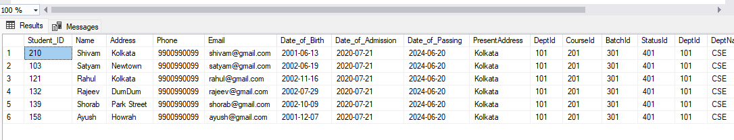

6. Delete records from Department where DeptId = 101 and execute Select from Q.5

DELETE FROM DEPARTMENT

WHERE DEPTID = 101

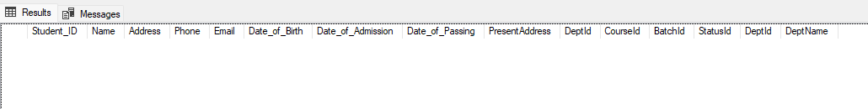

7. Select records from Course and Student where CourseId = 201

SELECT \* FROM STUDENT

INNER JOIN COURSE

ON STUDENT.COURSEID = COURSE.COURSEID

WHERE STUDENT.COURSEID = 201

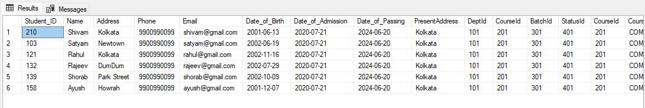

8. Update CourseId from 201 to 210 in Course table and execute Select from Q.7

UPDATE COURSE

SET COURSEID = '210'

WHERE COURSEID = '201'



9. Select records from Batch and Student where BatchId = 301

SELECT \* FROM STUDENT

INNER JOIN BATCH

ON BATCH.BATCHID = STUDENT.BATCHID

WHERE STUDENT.BATCHID = 301

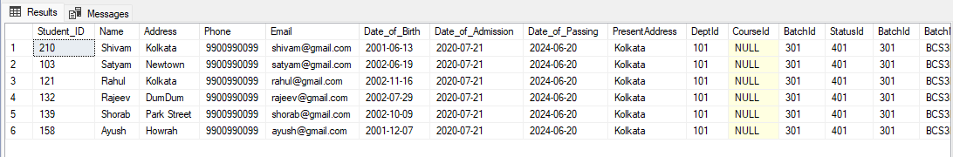

10. Delete records from Batch where BatchId = 301 and execute Select from Q.9

DELETE FROM BATCH

WHERE BATCHID = 301

