

**General Sir John Kotelawala Defence University**

Faculty of Computing

Department of Information Technology

**Virtual Environment control system through Sensor network**

**For greenhouse**

**Literature Review**

By

GHMDD Lakshan(IT/13/241)

Under the Supervision of

Mr. B. Hettige

Mr. D Maithri Ranga Kulasekara

**1.1 Introduction**

Greenhouse is a building or place where plants are grown. Greenhouses form an important part of the agriculture and horticulture sectors of a country. Greenhouses are used for Grow flowers, vegetables, fruits, and tobacco plant. It create the best condition for the plant growth and eliminate the impact on plant growth due to some outside environment behaviors changes .Basic factors that affect for plant growth are sunlight, humidity temperature etc. The most important factors for the quality and productivity of plant growth are temperature, humidity, light. The optimal greenhouse environment adjustment can enable us to improve productivity and to enhance the cultivation when environment parameters change rapidly. This system is used to monitor and control the essential greenhouse parameters, such as, Temperature, humidity and light intensity. Automated greenhouse involves the automatic monitoring and controlling of climatic parameters which directly or indirectly govern the plant growth and their production. In order to control the climate factors and environment autonomously, it is required a computer/software equipment. The system has advantages of low power consumption, low cost, good robustness, and extended flexibility. Environment factors like temperature, humidity and light are hard to control manually inside a Greenhouse and there is a need for automated system to do that task. When Environment behaviors change rapidly, immediately response must be activated. It can’t be done by the manual system. As well as manual system’s price is very expensive and maintenance isn’t convenient.[1]

**1.2 A Wireless Sensors Network for Monitoring Environmental Variables in a Tomato Greenhouse**

M. Mancuso and F. Bustaffa have done research work in Wireless Sensors Network for Monitoring Environmental Variables in a Tomato Greenhouse. The Rinnovando group (Rgroup) is working with agricultural experts on a short-term deployment of a wireless sensors network in a tomato greenhouse in the South of Italy. In this project, Sensicast devices are used in order to apply of Wireless Sensor Networks (WSN) in agriculture and particularly that of microclimate monitoring within a greenhouse incorporating sensor nodes in an agricultural ICT infrastructure. They have used sensor node for the air temperature, humidity and soil temperature measurements light with wireless sensor network. They have also developed a Web-based application to monitor the plant. Sensor node can read the measurements over the Internet, and notification will be sent to his mobile phone by SMS or GPRS if some measurement variable changes rapidly. Liu et al. They have developed and tested a WSN prototype for environmental monitoring inside the greenhouse. They are using a star topology network of Crossbow MICAz motes. The motes measure temperature, humidity and soil moisture, and send their measurements to the sink node in five minutes intervals. Sink node is a combination of MICAz mote and MIB510 board with data terminal. The terminal with ARM processor module shows the latest measurements in LCD-screen inside the greenhouse and delivers the data to the main PC by using GSM module. The central PC located further apart from the network takes care of data logging and processing. [2]

**1.3 Greenhouse Monitoring with Wireless Sensor Network**

Teemu Ahonen, Reino Virrankoski and Mohammed Elmusrati have done research in green house monitoring at the University of Vaasa in Finland. They made their experiments in Martens Greenhouse. They have developed wireless sensor node for greenhouse monitoring by integrating a sensor platform to control the temperature humidity and CO2vof the environment. With three commercial sensors capable to measure four climate variables. The feasibility of the developed node was tested by deploying a simple sensor network into Martens Greenhouse Research Foundation’s greenhouse in Närpiö town in Western Finland. During a one day experiment, they collected data to evaluate the network reliability and its ability to detect the microclimate layers, which typically exist in the greenhouse between lower and upper flora. They were also able to show that the network can detect the local differences in the greenhouse climate caused by various disturbances, such as direct sunshine near the greenhouse walls. This project can set the reference values to certain environmental variables, and then the greenhouse automation system targets to keep the variables in these values. The optimal levels of water and fertilizer can also be defined [3]

Green hose environment

We made our experiments in Martens Greenhouse Research Center’s greenhouse in the Närpiö town in Western Finland .The size of the greenhouse was 18 x 80 meters and in its traditional control system it has only one cabled measurement unit in the middle. Greenhouse’s moist climate and dense flora are similar to the surroundings of a jungle. This kind of environment is challenging both for the sensor node electronics and for the short-range IEEE 802.15.4 wireless network, which communication range is much longer in open areas. Therefore, we limited the distances between communicating nodes to 15 meters in our deployment.

Sensor Node

The wireless sensor node we used was Sensinode’s Micro.2420 U100 . It operated as a basic measuring node with a CC2420 802.15.4 RF-transceiver and a MSP430 Microcontroller. The gateway node was a combination of U100 node and USB serial adapter board (Micro.USB U600). Sensors were soldered to a board equipped with the needed components (resistors, capacitorsand operation amplifier). Then the sensor board fas plugged in to the U100 node through its I/O pins. The node and two 1,5V AA-batteries acting as power source were sheltered by a plastic box (80*55*33mm) to prevent them from the humidity. Sensor board was placed on the top of the box and sensitive electrical components were protected from the moisture by a plastic coating spray. Whole board was enveloped by ESD plastic sachet leaving only the heads of the sensors outside.

Sensor node’s devices are based on 6LoWPAN protocol, which enables transmission of compressed Internet Protocol version 6 (IPv6) packets over IEEE 802.15.4 networks .Sensinode’s Nanostack protocol provides the use of 6LoWPAN and a standard Socket API for accessing the network. It works in 2,4GHz ISM band and offers 250 kbps data rate .

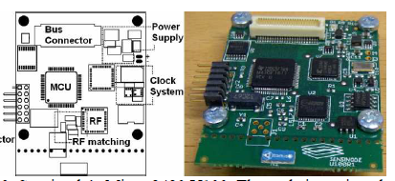

Figure 1: Sensor node’s Micro.2420 U100.

Sensors

Fast response time, low power consumption and tolerance against moisture climate made SHT75 relative humidity and temperature sensor a perfect solution for the greenhouse environment. Temperature accuracy of the sensor is ±0.3 °C and the accuracy of the relative humidity under ±2 %. Communication between SHT75 sensor and node is similar to IIC interface developed by Philips. Data and clock line are the same in both cases, but SHT75 has only one pull-up resistor between data and power supply line. Luminosity was measured by TAOS TSL262R which converts light intensity to voltage. Unstable output signal is handled by low-pass filter to get correct luminosity values. We mounted irradiance, temperature and humidity sensors into four nodes, but Carbon dioxide sensor was tricky because it sets special requirements for the input voltage and the response time. Figaro’s TGS4161 carbon dioxide sensor was the alternative, which was the most compatible with low voltage sensor node.

In this project four nodes were deployed to one greenhouse block to gather information about the differences in climate variables between lower and upper flora. Each node red temperature, humidity and irradiance values once in four minute intervals over three hours. During the experiment, the coordinator sent 200 data requests, and each sensor node responded 50 times. Ten packets with readings were either lost or received incorrectly. That indicated 5% data loss rate in terms of packets. The maximal communication range, 15 meters was figured out in individual test where the distance between the coordinator and the sensor node inside the greenhouse dense flora was increased until the connection was lost. We also observed that the reliable range in terms of tolerable packet loss was approximately 10 meters. Compared to our previous experiment in an open parking lot, the reliable communication range fell to one third in the greenhouse’s dense flora.

**1.4 The Use of ZigBee Wireless Network for Monitoring and Controlling Greenhouse Climate**

Ibrahim Al-Adwan, Munaf S. N. Al-D have done research in The Use of ZigBee Wireless Network for Monitoring and Controlling Greenhouse Climate. The aim of this paper is to present a novel wireless sensor network based ZigBee technology for monitoring and controlling greenhouse climate. The system consists of a number of local stations and a central station. The local stations are used to measure the environmental parameters and to control the operation of controlled actuators to maintain climate parameters at predefined set points. For each local station a PIC Microcontroller is used to store the instant values of the environmental parameters, send them to the central station and receive the control signals that are required for the operation of the actuators. The communication between the local stations and the central station is achieved via ZigBee wireless modules[4]

This control system for the greenhouse includes the following components.

Data acquisition of the environmental parameters through sensors. The processing of data, comparing it with desired states, and finally deciding what must be done to change the state of the system. The actuation component carrying the necessary actions. The control of the greenhouse investigated in this paper consists of several distributed local stations and one central station. Each local station is responsible for obtaining the greenhouse climate parameters by three sensors for the temperature, humidity and light. These sensors are connected to a PIC16F877A microcontroller which consists of embedded ADCs. A ZigBee transceiver is directly connected to the microcontroller to provide a wireless connection with a central station. A PC was used to implement the central station at which the set value for each parameter is declared and compared to those received from each local station. Based on the measure and set values of the parameters the central station provides the required control action at each location. These control actions are sent back to the local stations via ZigBee module. Finally, when the control actions received by the local station, the microcontroller will provide the necessary control signals to the actuators and coordinate their operation. Figure 2, shows the schematic diagram of a local station, and figure 3 shows a block diagram for the system architecture.



Figure2: Local wireless station

Sensor System

Sensors provide input information for the automation system by measuring the climate variables of the greenhouse. Sensor-generated signals are acquired and conditioned by a PIC16F877A microcontroller. Three parameters are monitored in this study namely temperature, humidity and light or solar radiation

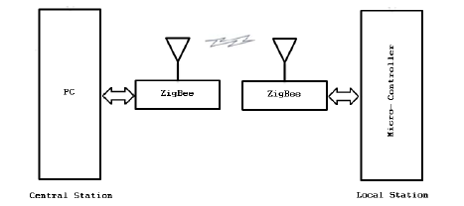

Figure 3:System architecture

In this project, thermistors are used to measure the temperature in the greenhouse. Thermistors are temperature dependent resistor devices, they are easier to wire, cost less and almost all automation panels accept them directly. Thermistors are made of semiconductor materials with a resistivity that is especially sensitive to temperature. When it comes to humidity sensing technology, there are three types of humidity sensors they are capacitive, resistive and thermal conductivity humidity sensors. They used Capacitive Humidity Sensors (CHSs) which are widely used in industrial, commercial, and weather telemetry applications. CHSs consist of a substrate on which a thin film of polymer or metal oxide is deposited between two conductive electrodes. The sensing surface is coated with a porous metal electrode to protect it from contamination and exposure to condensation. The substrate is typically glass, ceramic, or silicon. The changes in the dielectric constant of a CHS are nearly directly proportional to the relative humidity of the surrounding environment. CHS are able to function in high temperature environments (up to 200°C), near linear voltage output, wide RH (Relative Humidity) range, high condensation tolerance, reasonable resistance to chemical vapors and contaminants, minimal long-term drift, high accuracy, small size and low cost.

This project present some of the popular light sensors on the market that can be used for environmental monitoring applications. Here, Light Dependent Resistor (LDR) Similar to photometric sensors, LDRs measure visible light as seen by the human eye. A LDR is basically a resistor the internal resistance increases or decreases dependent on the level of light intensity impinging on the surface of the sensor.

Finally, a greenhouse sensor station has been designed and fabricated which is part of a complete greenhouse management system. The local station takes charge of collecting climate measurements data in a greenhouse (temperature, humidity and light) and transmits the data to the central station. Figure 3, shows the practical local station.

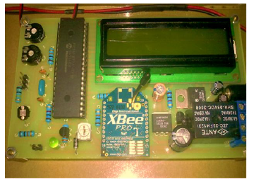

Figure 4: ZigBee based wireless local station

**1.5 Wireless Monitor and Control System for Greenhouse**

Rana H. Hussain, Dr. Ali F. Marhoona and Dr. Mofeed T. Rashid have done research on Wireless Monitor and Control System for Greenhouse This paper involve a design and implementation of an XBee based Wireless Sensor Network (WSN) that is used to monitor and control the essential greenhouse parameters, such as, temperature, humidity and light intensity. This implementation supports the farmers to increase the crop production. The standalone XBee module, i.e., without microcontroller, is integrated with specific small size sensors. All monitored parameters are transmitted through a wireless link to computer via coordinator to be analyzed, and then initiate suitable commands to the specific devices to overcome the drifts in an environmental parameters inside greenhouse.[5]

System architecture

When considering the architecture of this system is shown in Fig.1 which composed of two types of physical units: three remote sensor nodes, and a central control station. The remote sensor nodes are implemented with an XBee radio and analog sensors. These radios support ZigBee topologies which are configured to read analog signals directly from sensors to be transmitted with in a data packet. Each node is enabled to read temperature, humidity, and light levels. The measured data are sent periodically to the central computer. The central control unit consists of XBee radio kit which connected to personal computer through USB. [6]

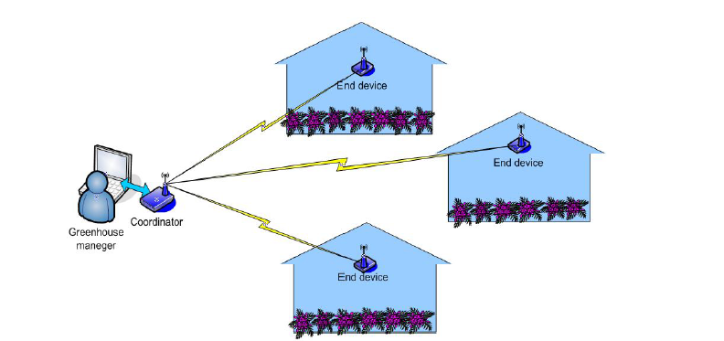

Figure 5: System Architecture

XBee is a device used to send and receive data wirelessly base on ZigBee/IEEE 802.15.4 network standard.XBee could be configuring to operate in different function including the Coordinator, Router and End Device.There are several types of XBee module, the very popular XBee is Series 1 (802.15.4), and series 2 that operate on ZigBee protocol. Each XBee radio has the capability to directly gather and transmit sensor data if it is configured as end device. In this work, XBee s2 is selected to be used as standalone device for gathering analog signals from three different sensors. In addition to the ability of this XBees2 to initiate the control signals though it's digital output bits. Hence, there is no need to use any microcontroller to do (I/O) operation.Eliminating the external microcontroller means saving money for sensor networks with hundreds of nodes, also the power consumption and node size will be reduced.

System hardware description

ZigBee standard

There are many types of wireless communication technologies such as ZigBee, Wi-Fi and Bluetooth. All these types are work at similar RF frequencies, and their application sometimes overlap for example can be used in greenhouse. In this project, ZigBee technology has been used because of the mainly advantages of this technology over the others technologies and most suitable to this application exactly following aspects of it:Reliable and self-configuration, Supports large number of nodes, easy to deploy, very long battery life, Secure and Low cost. Table 1 represents a comparison between these standards

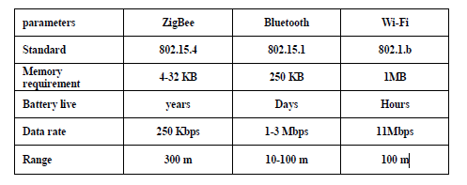

Table 1: Comparison between Wireless Technologies

XBee Modules

XBee is the brand name from Digi International for a family of form factor compatible radio modules. The first XBee radios were introduced under the MaxStream and were based on the 802.15.4 standard designed for point-to-point and point-to-multipoint communications at over-the-air baud rates of 250 Kbps. Two models were initially introduced a lower cost 1 mW XBee (S1 and S2) and the higher power 100 mW XBee-PRO.

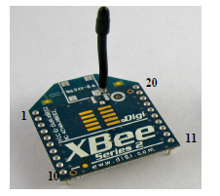

Figure 6: XBee Series 2 Radio

**1.6 A Wireless Sensor Network for Environmental Monitoring of Greenhouse Gases**

Ashenafi Lambebo and Sasan Haghani have done research on A Wireless Sensor Network for Environmental Monitoring of Greenhouse Gases. This project provides a detailed study and implementation of a WSN for real time and continuous environmental monitoring of greenhouse gases. A tree-topology WSN consisting of two sensor nodes and a base station was successfully built and tested using open source and inexpensive hardware to measure the concentration level of several greenhouse gases. The sensor nodes consisted of carbon monoxide sensor, a carbon dioxide sensor, a methane sensor, a temperature sensor, a GPS module and a ZigBee wireless transmitter packaged together. The GPS module was added to give information about the location of the sensors. The base stations consisted of an Arduino Uno micro-controller and a ZigBee receiver that can collect data from the various sensors and submit to a sink base station where data can be stored and processed. A website was developed where the captured data can be continuously monitored and displayed in real time. [6]

When taking about the network architecture The Wireless Sensor Network (WSN) was implemented using a tree topology in beacon mode where sensors collect data and send it to the base station which is the task manager of the network. The proposed WSN architecture is shown in Fig. 7.Two individual environmental sensor nodes serving as transmitters have been designed to collect, process, and transmit the gas concentration levels, temperature, and the sensor’s location signals in real time. The system operates within a range of 100m from the base station and is suitable for monitoring the concentration of greenhouse gases inside industrial buildings and warehouses. The base station, which is the network coordinator, manages the activities of individual nodes by periodically requesting data. In addition to data integration and analysis, the

Base station also relays processed data to display devices and,PDAs. The base station is equipped with an Arduino Uno Microcontroller for system coordination, a receiving ZigBee module and a Wi-Fi_33 module for wireless communication and data transmission over the 802.11b/g wireless networks, which make it possible to access the collected data via the Internet. In addition, the captured data is inserted into a MySQL database where a webpage with a graphing application

Programming interface (API) is used to display the data.[7]

## **Summery**

In this literature review, virtual environment control system have been discussed. What technology that was used to develop the system, type of input devices and output devices. As well as software that used to build the system. Sensor network is the main network architecture of this project .That point have been discussed in depth.

**References**

[1]I. F. Akyildiz, W. Su, Y. Sankarasubramaniam, and E. Cayirci, “Wireless sensor networks: a survey,” Comput. Netw., vol. 38, no. 4, pp. 393–422, 2002.

[2]Y. Song, C. Gong, Y. Feng, J. Ma, and X. Zhang, “Design of greenhouse control system based on wireless sensor networks and AVR microcontroller,” J. Netw., vol. 6, no. 12, pp. 1668–1674, 2011.

[3]R. H. Hussain, A. F. Marhoon, and M. T. Rashid, “Wireless Monitor and Control System for Greenhouse,” Int. J. Comput. Sci. Mob. Comput., vol. 2, no. 12, pp. 69–87, 2013.

[4]T. Ahonen, R. Virrankoski, and M. Elmusrati, “Greenhouse monitoring with wireless sensor network,” in Mechtronic and Embedded Systems and Applications, 2008. MESA 2008. IEEE/ASME International Conference on, 2008, pp. 403–408.

[5]C. Yawut and S. Kilaso, “A wireless sensor network for weather and disaster alarm systems,” in Proc. International Conference on Information and Electronics Engineering, IPCSIT, 2011, vol. 6.

[6]M. A. Perillo and W. B. Heinzelman, “Wireless sensor network protocols,” Algorithms Protoc. Wirel. Mob. Netw. Eds Boukerche Al CRC Hall Publ., 2004.

[7]M. Nakamura, A. Sakurai, and J. Nakamura, “Distributed Environment Control Using Wireless Sensor/Actuator Networks for Lighting Applications,” Sensors, vol. 9, no. 11, pp. 8593–8609, Oct. 2009.