Sources: [Visual](https://code.visualstudio.com/docs) [Visual](https://code.visualstudio.com/docs) [Studio](https://code.visualstudio.com/docs) [Code](https://code.visualstudio.com/docs) [Documentation](https://code.visualstudio.com/docs)

Sources: [Visual](https://code.visualstudio.com/download) [Studio](https://code.visualstudio.com/download) [Code](https://code.visualstudio.com/download) [Download](https://code.visualstudio.com/download)

**1. Installation of VS Code**

# Steps to Download and Install VS Code on Windows

1. **Download VS Code:**

○ Visit the official website of Visual Studio Code: [Visual](https://code.visualstudio.com/) [Studio](https://code.visualstudio.com/) [Code Download](https://code.visualstudio.com/).

○ Look for the “Download for Windows” button and click on it.

○ This will start the download of the VS Code installer (VSCodeUserSetup-x64-1.X64-1.XX.X.exe).

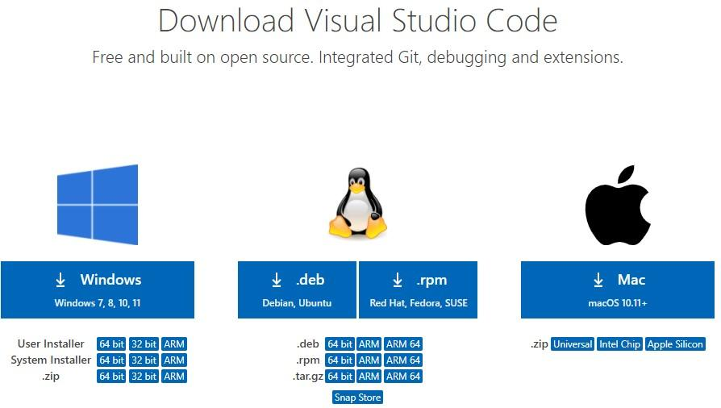

1. **Run the Installer:**

○ Once the download is complete, locate it in the file explorer.

○ Double-click on the installer file.

* 1. The installer wizard will appear.

1. **Installation Prompt:**
   1. Accept the license agreement and click next.

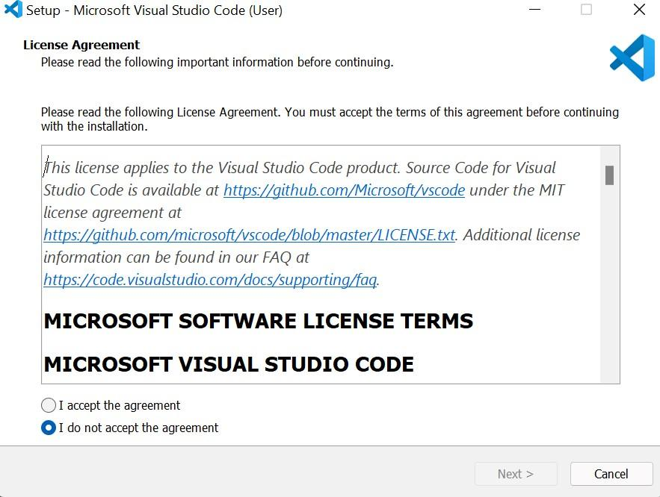

○ Choose the location where you want the VS Code installation to be kept.

Accept the default location and click next.

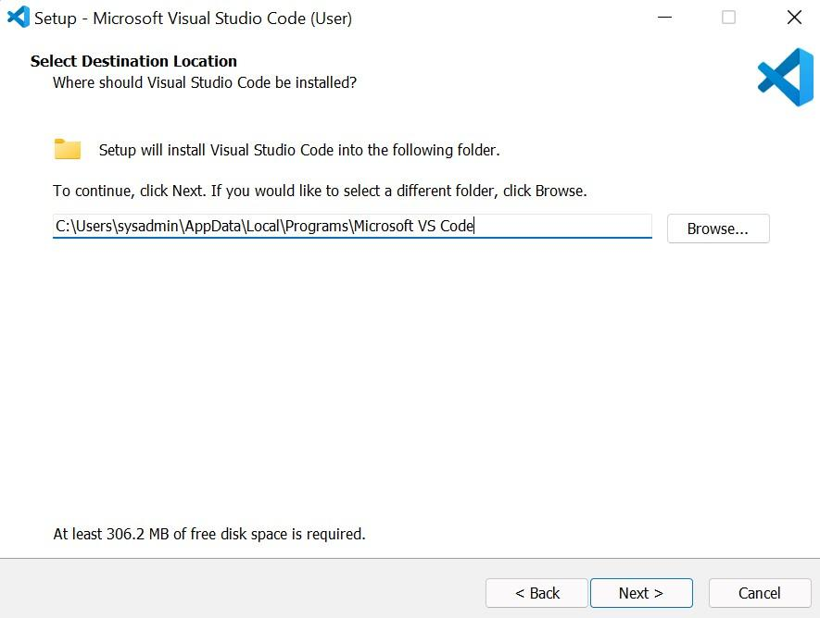

○ Accept the default Start Menu Folder and click Next.

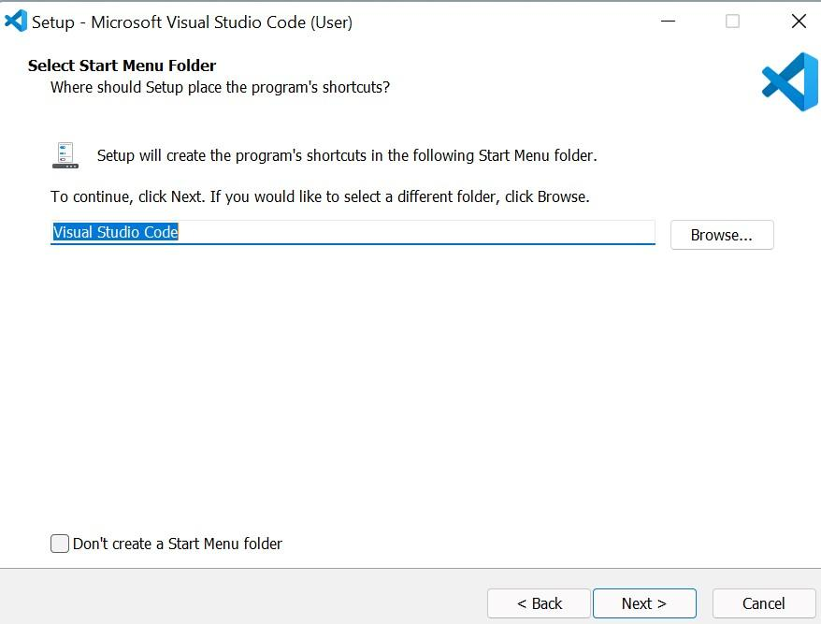

○ Select additional tasks (optional but recommended):

■ Click on Create a Desktop icon.

■ Click on Add to path (important to use the command line).

■ Click register code as an Editor for supported files.

■ Adding “Open with Code” action to the Windows Explorer context menu.

■ Adding “Open with Code” to the directory context menu.

○ Click next.

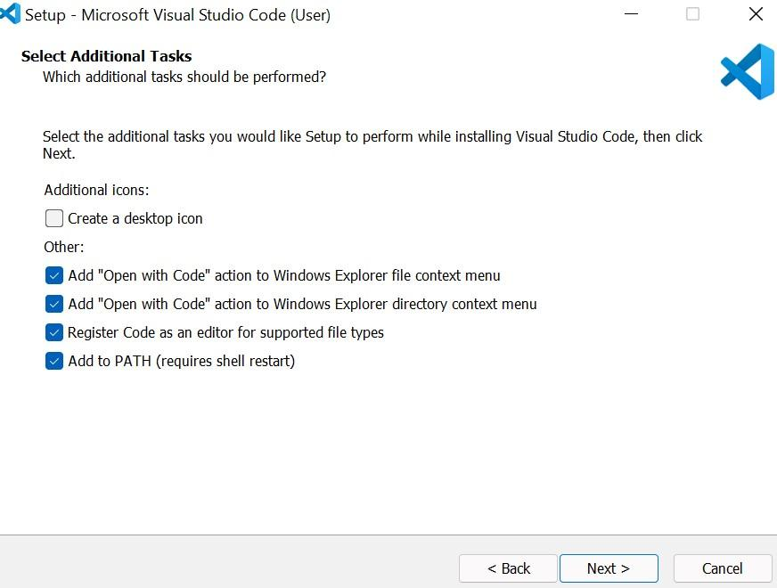

○ The installation will begin. Click on the install button.

○ After clicking install, it should take about one minute to install VS Code on your device.

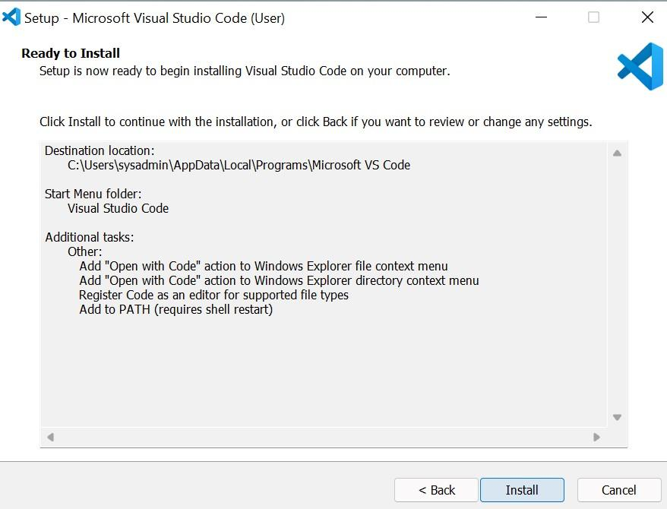

4. **Finish Installation:**

○ After installation, a setup window will appear. Tick on Launch VS Code and click Finish.

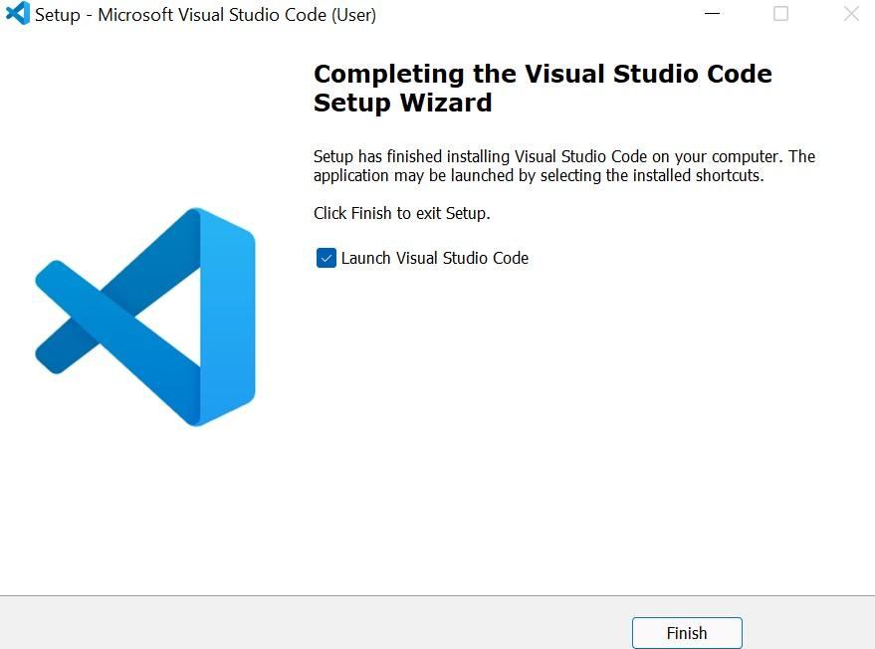

**Prerequisites**

* Windows 10 or 11 (64-bit).
* Internet connection to download the installer.
* 1.6 GHz or faster processor.
* 1 GB RAM.



# 2. First-Time Setup

## Initial Configurations and Settings for Optimal Coding Environment

1. **Theme Selection:**

○ Go to File > Preferences > Color Theme and choose a theme that suits your preferences (e.g., Dark+, Light+).

○ Install an icon pack like "Material Icon Theme" for better file navigation.

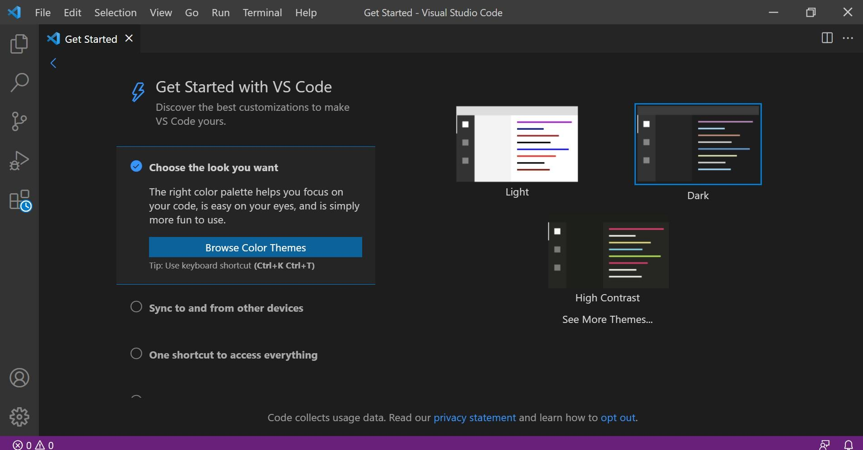

1. **Font Size and Family:**
   1. Open File > Preferences > Settings.

○ In the search bar, type "Font Size" and adjust it (e.g., 14).

○ Type "Font Family" to change the font (e.g., Fira Code, Consolas).

1. **Extensions:**
   1. Install essential extensions by clicking the Extensions icon in the Activity Bar.

○ Common extensions include:

■ Prettier (Code formatter).

■ ESLint (JavaScript and TypeScript linting).

■ Live Server (Local server for HTML/JavaScript development).

■ Python (Python language support).

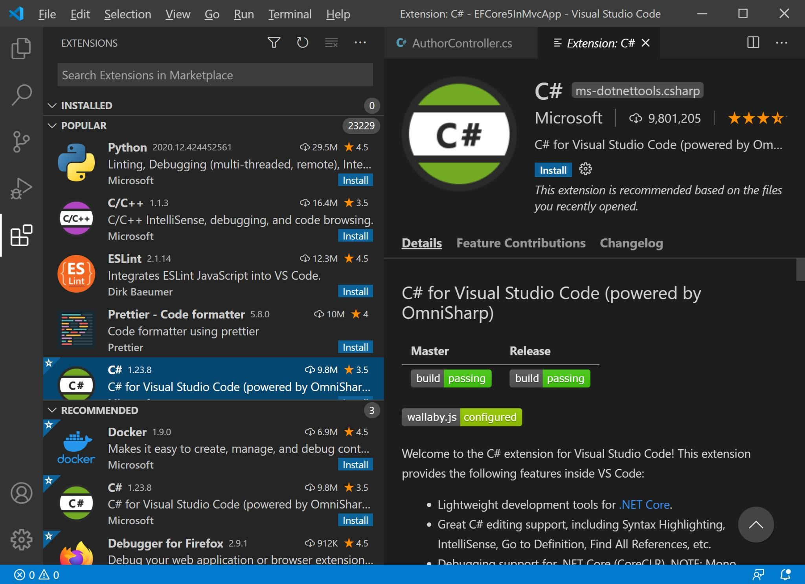

1. **Editor Configuration:**
   1. Adjust editor settings like tab size, auto-save, and word wrap via File > Preferences > Settings.

○ Access settings via File > Preferences > Settings or Ctrl+,.

1. **Version Control Setup:**
   1. If using Git, ensure it is installed and configure VS Code to use Git:

■ File > Preferences > Settings, search for "Git Path" and set the path if needed.

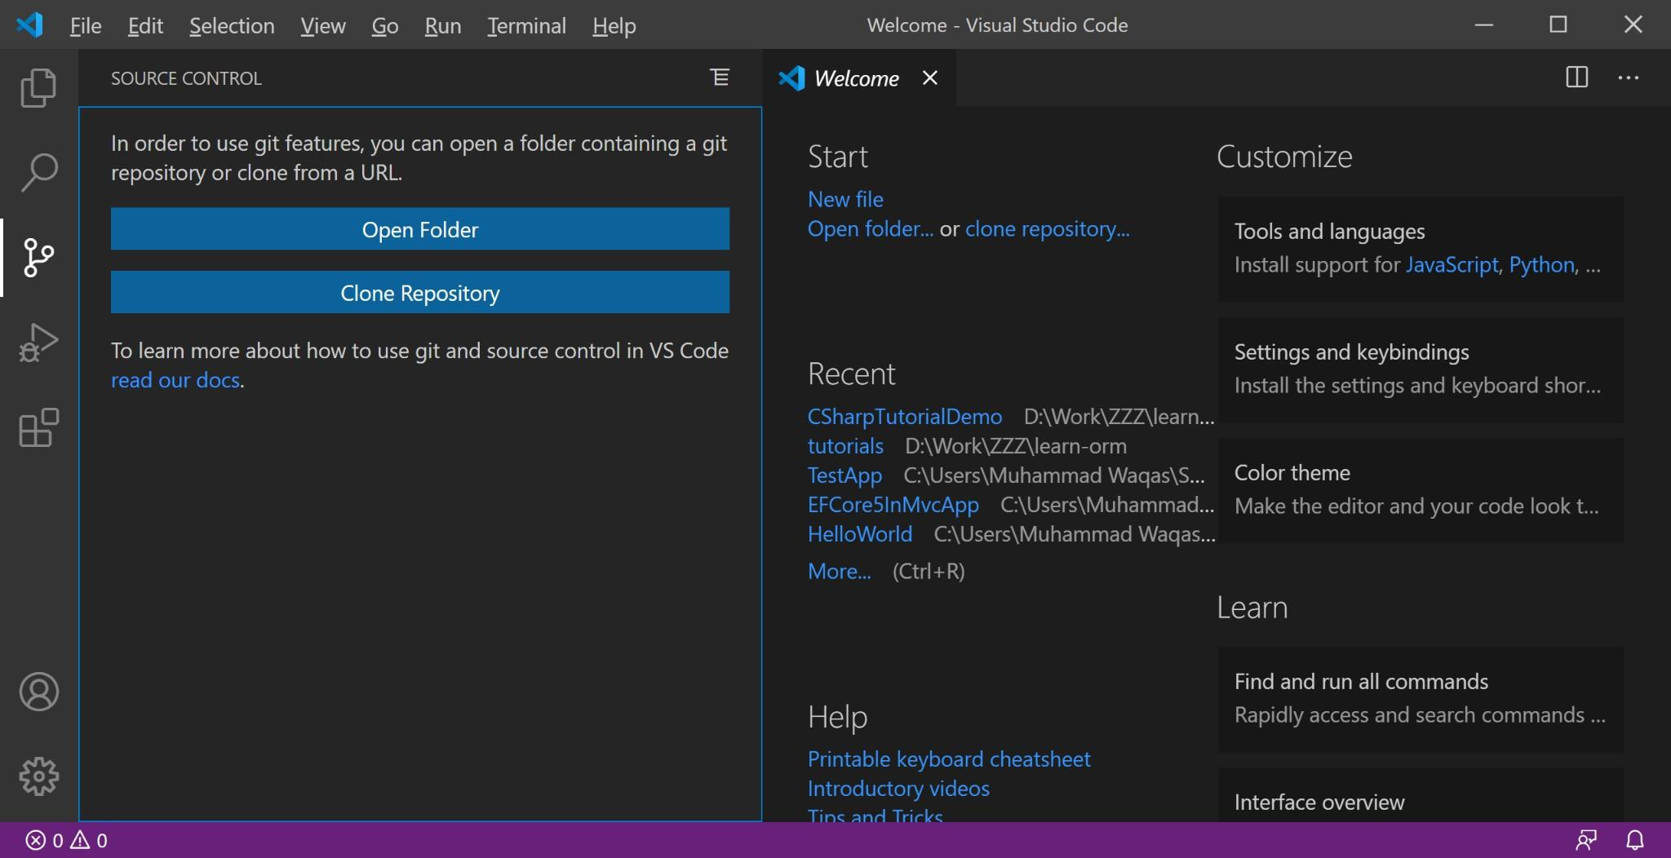



# 3. User Interface Overview

**Main Components of the VS Code User Interface**

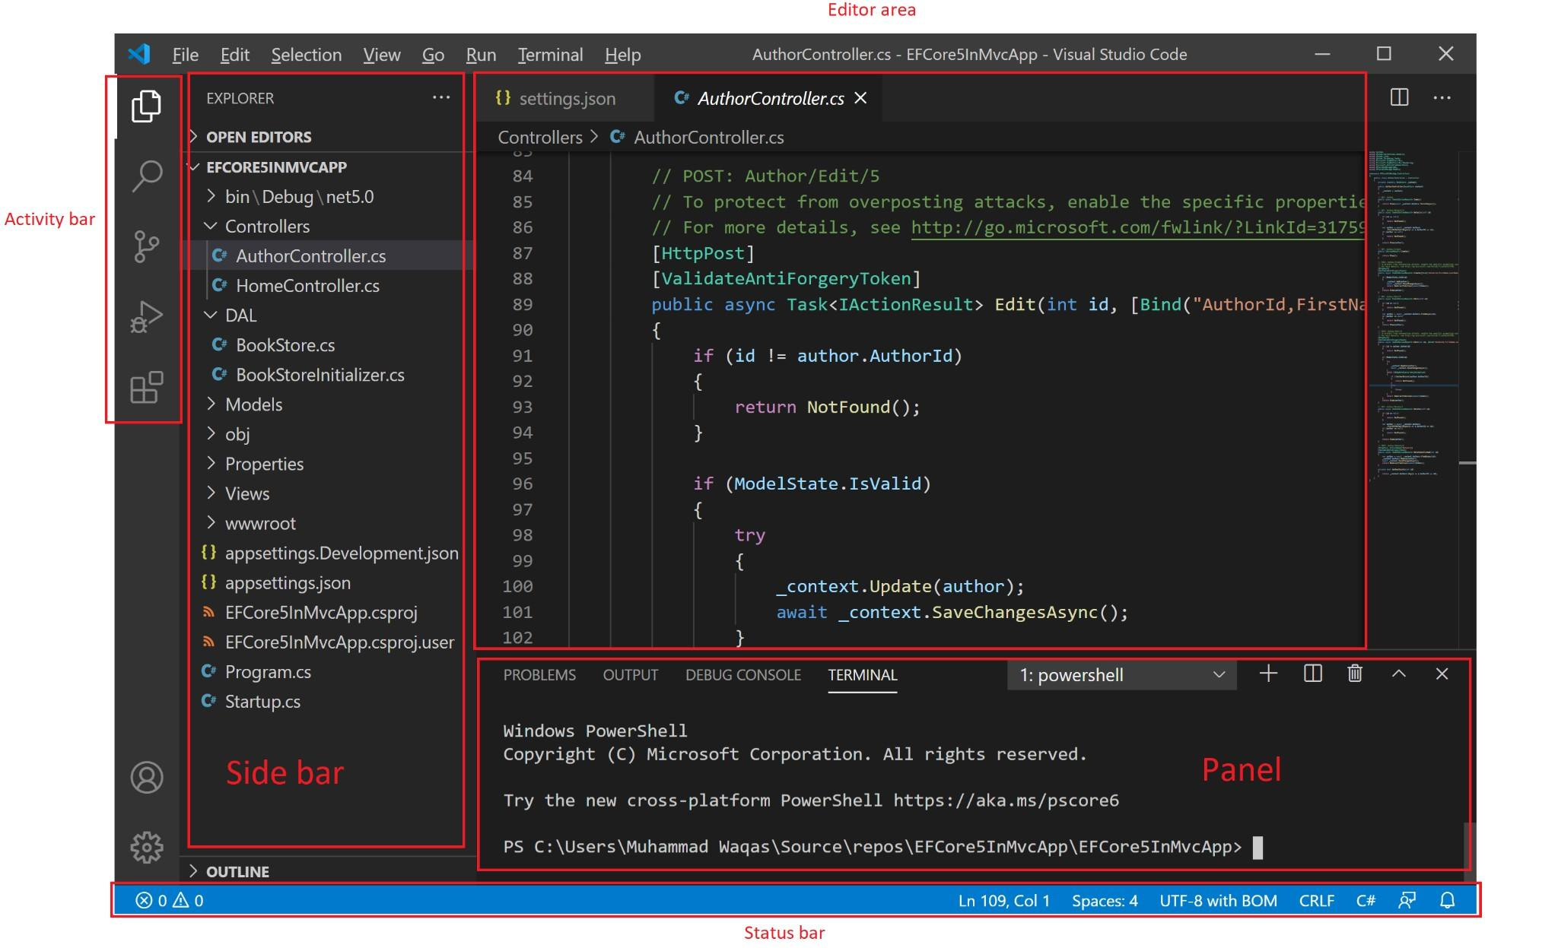

1. **Activity Bar:**
   1. Located on the far left, it provides access to different views like Explorer, Search, Source Control, Run and Debug, and Extensions.
2. **Side Bar:**
   1. Displays different panels based on the selected activity (e.g., file explorer, search results, source control changes).
3. **Editor Area:**
   1. The main area where files are opened and edited. You can have multiple editor groups to view files side-by-side.
4. **Status Bar:**
   1. Located at the bottom, it shows information about the current file and project, such as line number, Git branch, errors and warnings, and programming language.



# 4. Command Palette

**What is the Command Palette?**

The Command Palette is a powerful tool in VS Code that allows you to access and execute various commands quickly.

**Accessing the Command Palette**

* Press Ctrl + Shift + P (or F1).

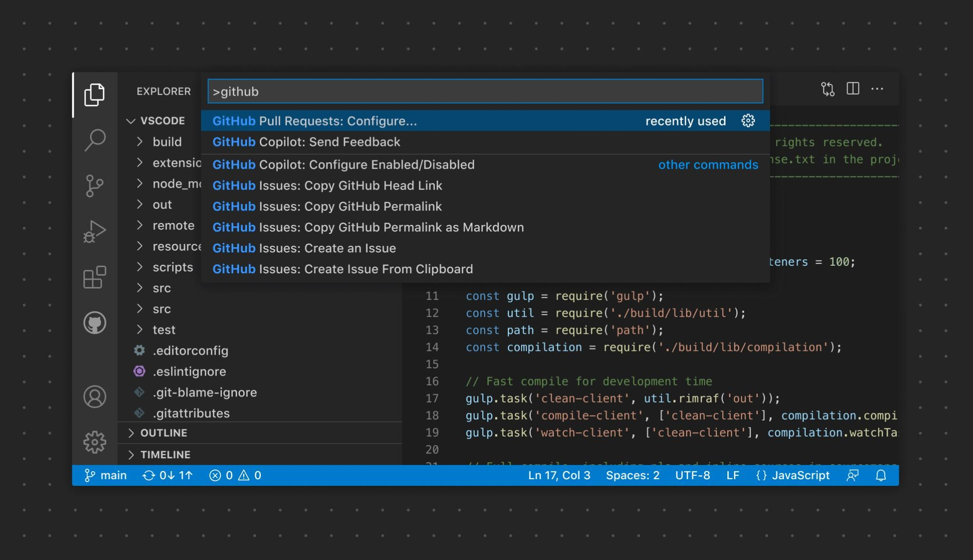

**Common Tasks Using the Command Palette**

* Opening files: File: Open File....
* Installing extensions: Extensions: Install Extensions.
* Running tasks: Tasks: Run Task.
* Formatting code: Format Document.
* Changing color theme: Preferences: Color Theme.



# 5. Extensions in VS Code

## Role of Extensions

Extensions enhance the functionality of VS Code by adding support for new languages, themes, debuggers, and tools.

**Finding, Installing, and Managing Extensions**

1. **Finding Extensions:**
   1. Click the Extensions icon in the Activity Bar or press Ctrl + Shift +

X.

○ Search for the desired extension and click "Install".

1. **Installing Extensions:**
   1. Search for the desired extension in the Extensions view. ○ Click the "Install" button next to the extension.
2. **Managing Extensions:**
   1. View installed extensions in the Extensions view.

○ Disable or uninstall extensions by clicking the gear icon next to each extension.



**Essential Extensions for Web Development**

* Prettier: Code formatter.
* ESLint: JavaScript and TypeScript linting.
* Live Server: Local server for HTML/JavaScript development.
* Debugger for Chrome: Debugging JavaScript code in Chrome.
* HTML Snippets: Code snippets for HTML.



# 6. Integrated Terminal

**Opening and Using the Integrated Terminal**

1. **Opening the Terminal:**
   1. To open the integrated terminal, go to View > Terminal or press Ctrl+ (backtick).

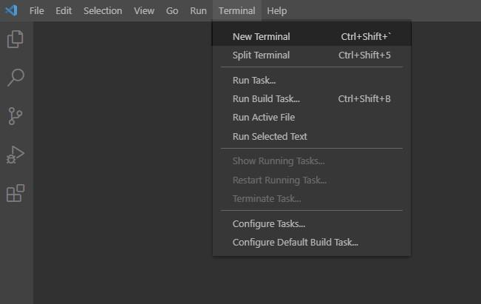

1. **Using the Terminal:**
   1. Execute commands as you would in any terminal.

○ Create multiple terminals and switch between them.

**Advantages of Using the Integrated Terminal**

* Directly interacts with the project files.
* Supports multiple terminal sessions.
* Consistent environment within the editor.
* Integrated with VS Code features (e.g., debugging, source control).



# 7. File and Folder Management

**Creating, Opening, and Managing Files and Folders**

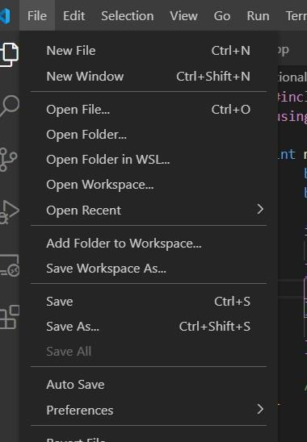

1. **Creating Files/Folders:**
   1. Right-click in the Explorer view and select "New File" or "New Folder."

○ Or use the Command Palette (Ctrl+Shift+P) and type New File or New Folder.

1. **Opening Files:**
   1. Double-click a file in the Explorer view to open it in the Editor.

○ Use the File > Open File or File > Open Folder menu options.

1. **Managing Files:**
   1. Use the context menu in the Explorer view to rename, delete, or move files and folders.

**Navigating Between Files and Directories Efficiently**

* Use the Explorer view to browse directories.
* Use Ctrl + P to quickly open a file by name.
* Use the breadcrumbs feature at the top of the editor to navigate the file structure.
* Use Ctrl + Tab to switch between open files.



## 8. Settings and Preferences Finding and Customizing Settings

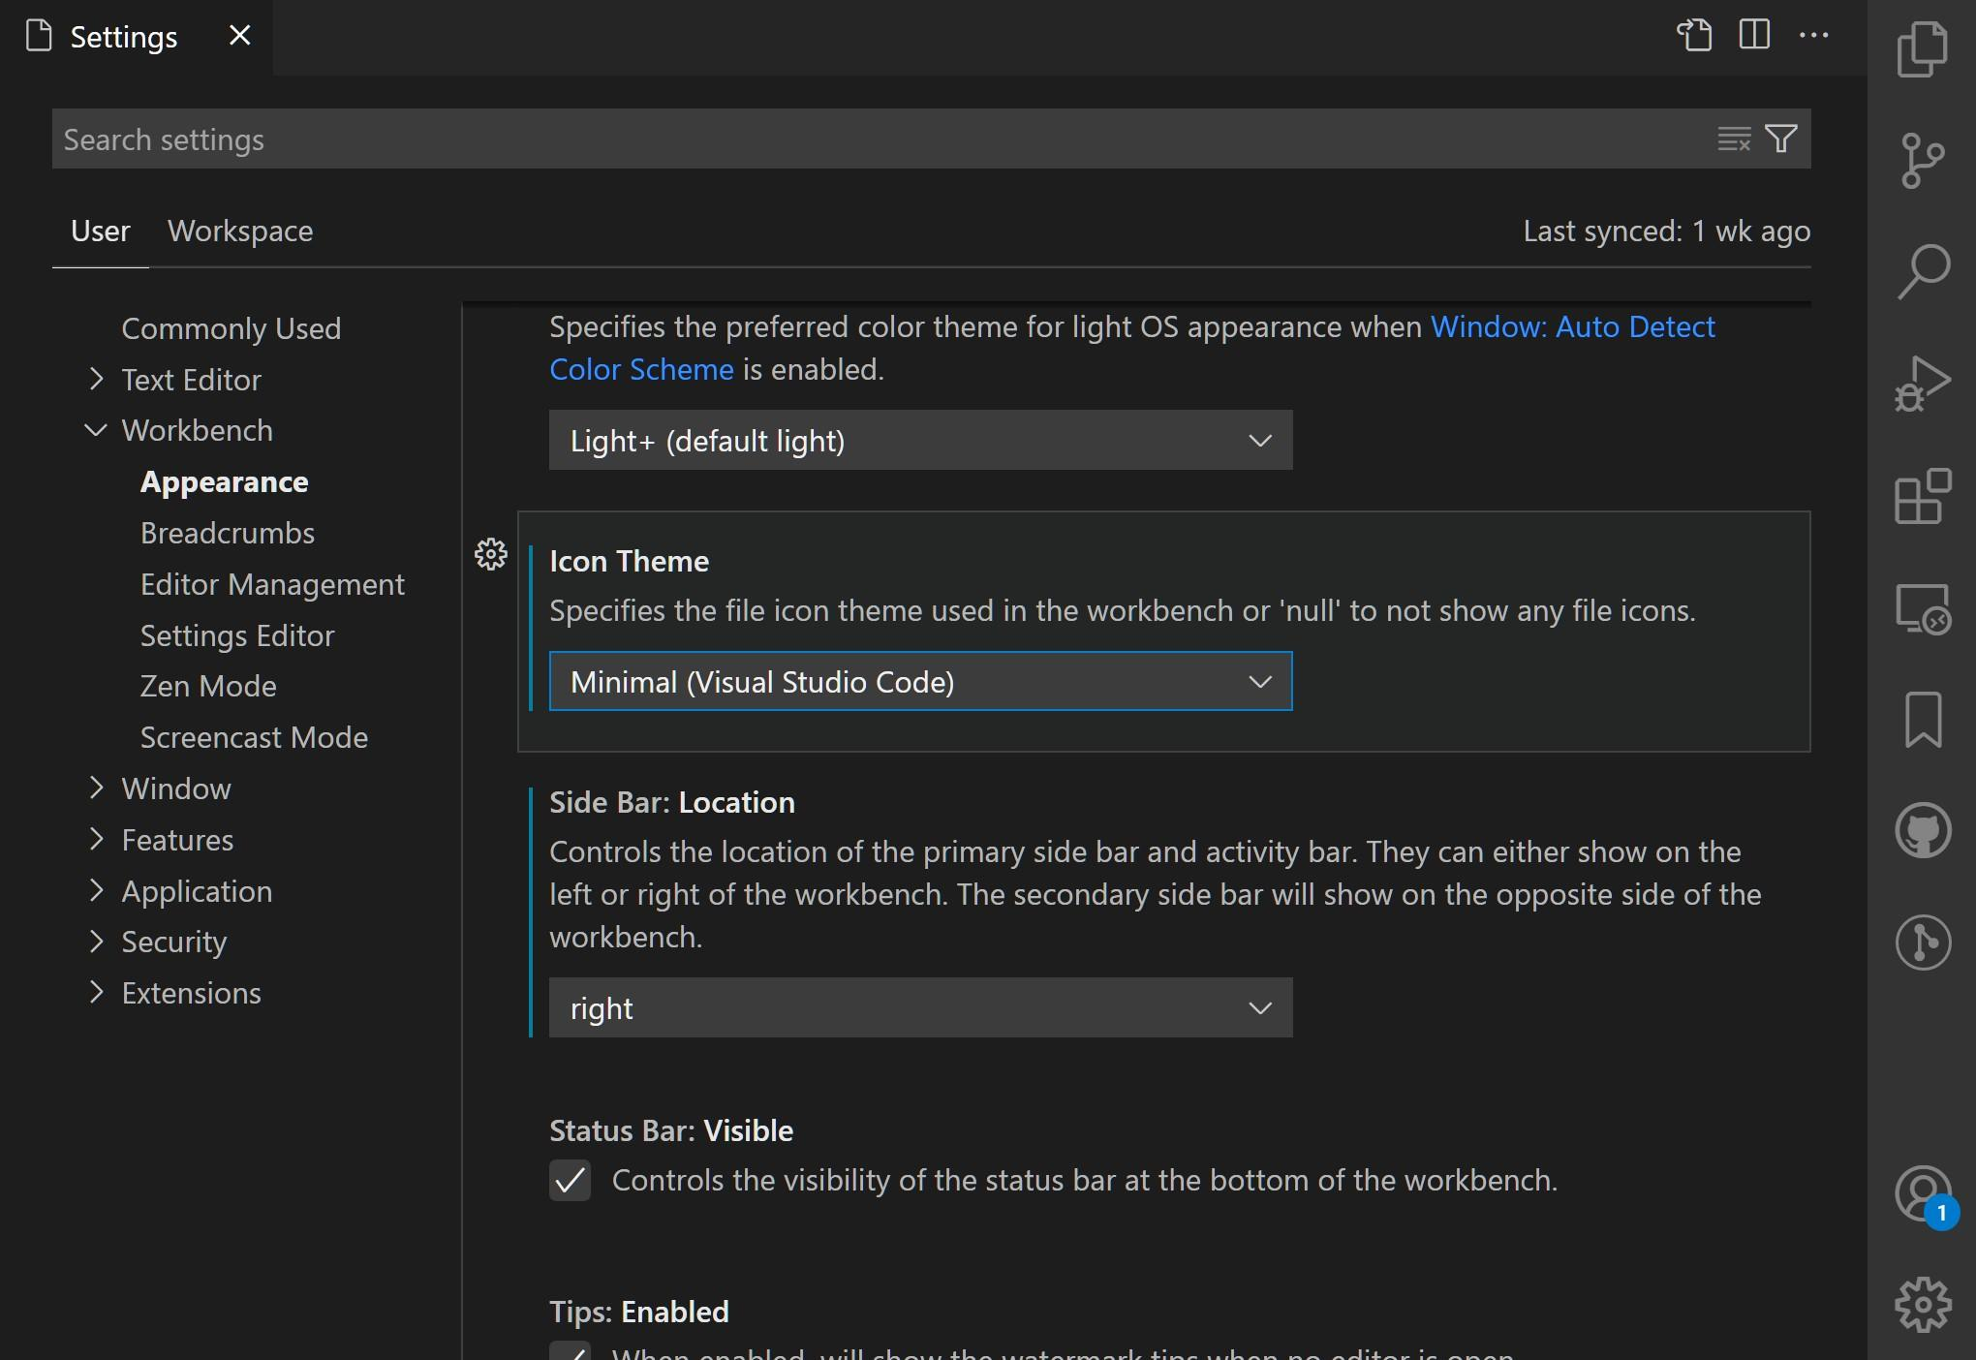

1. **Accessing Settings:**
   1. Go to File > Preferences > Settings (or press Ctrl+,).
2. **Changing Theme:**
   1. Search for "Color Theme" and select the preferred theme.
3. **Adjusting Font Size:**
   1. Search for "Font Size" and set the desired size.
4. **Modifying Keybindings:**
   1. Go to File > Preferences > Keyboard Shortcuts or press Ctrl + K Ctrl + S.

○ Search for the command and set new keybindings.



# 9. Debugging in VS Code

## Setting Up and Starting Debugging

**Open the Debug View:**

* Click on the Debug icon in the Activity Bar or press Ctrl+Shift+D.

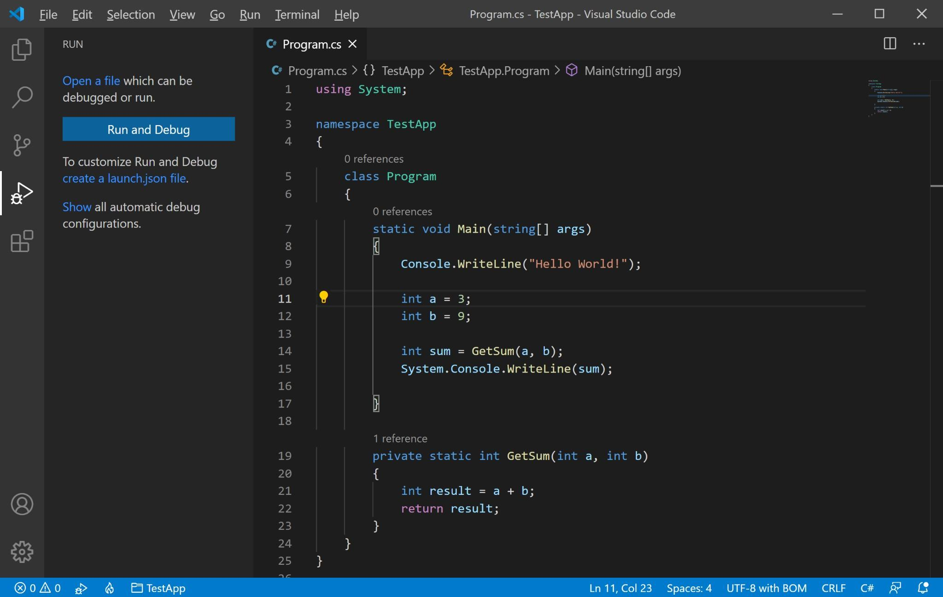

**Configure Debugging:**

* Click on the gear icon to create a launch.json file with debugging configurations.

**Set Breakpoints:**

* Click in the gutter next to the line number where you want to add a breakpoint.

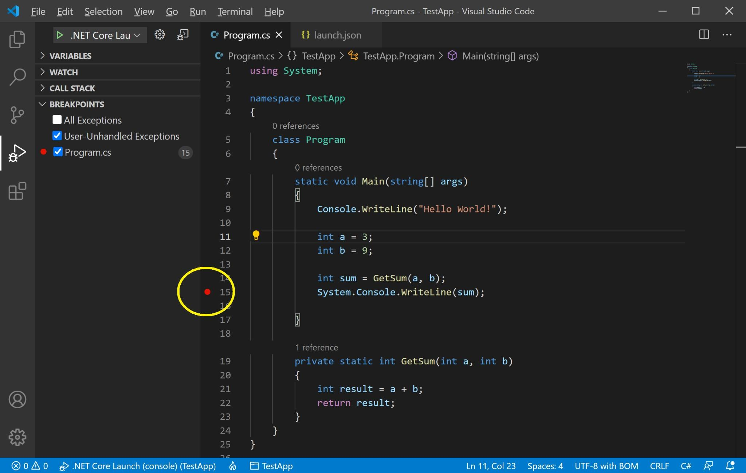

**Start Debugging:**

* Click the green play button in the Debug view or press F5.

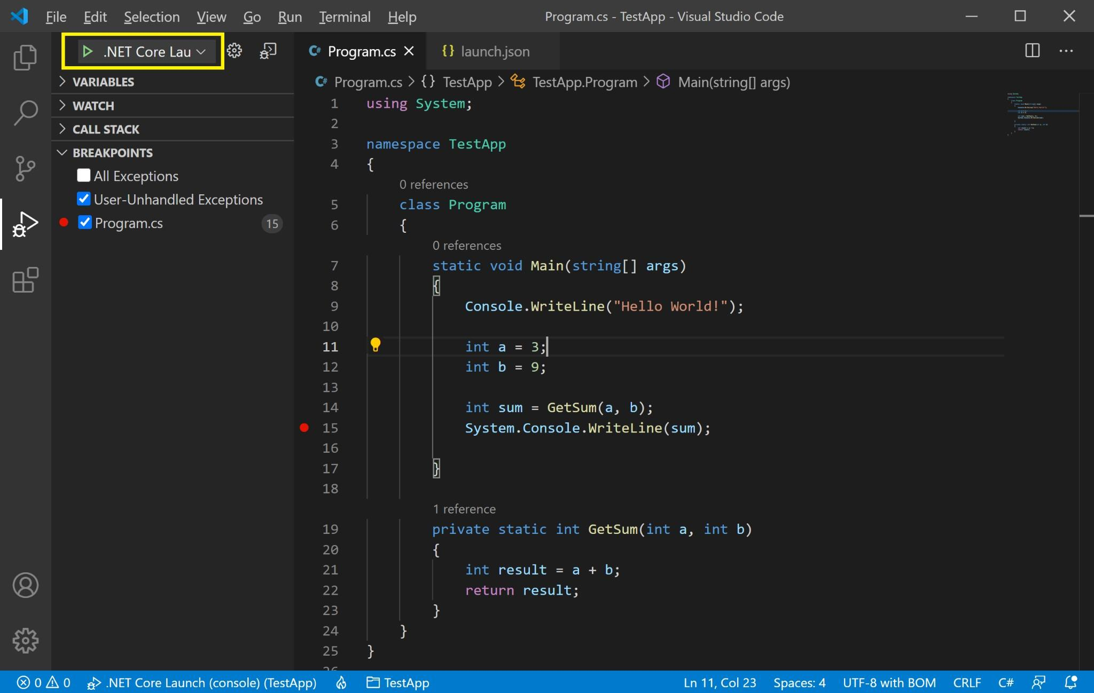

## Key Debugging Features

* **Breakpoints:** Pause execution at specific lines.
* **Watch:** Monitor variables and expressions.
* **Call Stack:** View the call stack and navigate through function calls.
* **Variables:** Inspect the current state of variables.
* **Debug Console:** Execute commands and evaluate expressions during debugging.



# 10. Using Source Control

## Integrating Git with VS Code

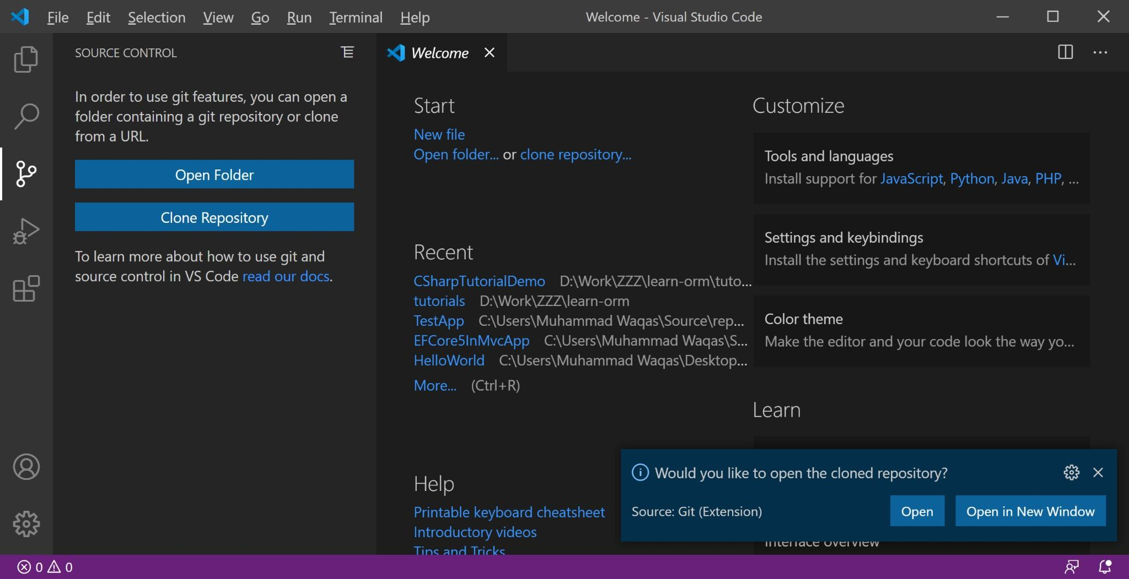

1. **Initializing a Repository:**
   1. Open the Source Control view by clicking the Source Control icon in the

Activity Bar.

○ Click "Initialize Repository" to create a new Git repository.

○ Alternatively Open the terminal and run git init in your project directory.

1. **Making Commits:**
   1. Stage changes using the Source Control view or terminal (git add .).

○ Commit changes using the Source Control view or terminal (git commit -m "commit message").

1. **Pushing Changes to GitHub:**
   1. Add a remote repository: git remote add origin <repository-URL>.

○ Push changes: git push -u origin main.

