https://www.udemy.com/course/zero-to-hero-in-selenium-webdriver-java-basics-to-advance/learn/lecture/40011186#overview

Orange-hrm new - https://opensource-demo.orangehrmlive.com/web/index.php/auth/login
Orange hrm old - https://opensource-demo.orangehrmlive.com/web/index.php/auth/login

*********. Section 1. ***********
1. Must Watch - About this Course. => Pending

*********. Section 2. ************
10. Install Java on Mac Machine
https://www.oracle.com/in/java/technologies/downloads/#jdk21-mac
- Java –version
- Need to set JAVA_HOME
- Run this command - /usr/libexec/java_home
Output: /Library/Java/JavaVirtualMachines/jdk-21.jdk/Contents/Home
As in my macbook terminal is .zsh, so I need to open .zshenv
touch ~/.zshenv
open ~/.zshenv
Specify java env file path
Write this export JAVA_HOME=$(/usr/libexec/java_home)
source ~/.zshenv
echo $JAVA_HOME

===========. Section 5. ============
45. Must Read - Preferred versions configuration
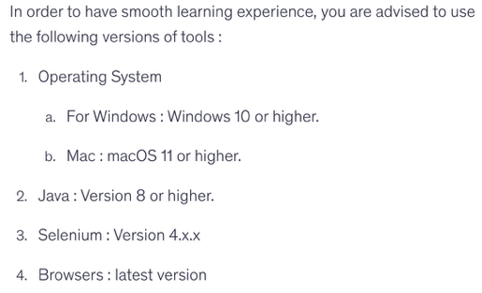
46. Must Read - Selenium Library Version Updates
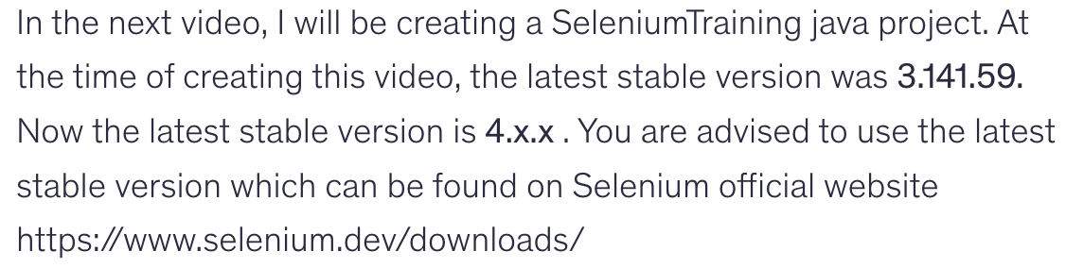
47. Understanding Selenium WebDriver Architecture.
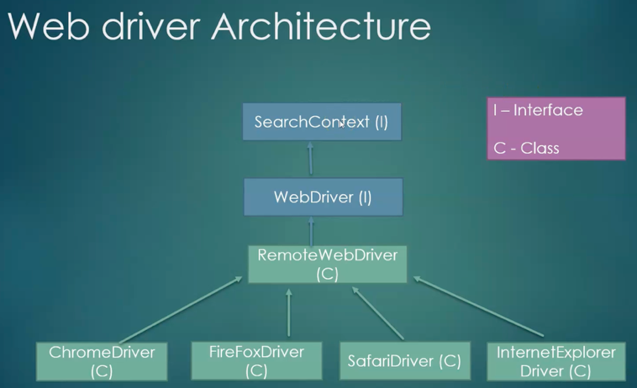
To download selenium package manually
https://www.selenium.dev/

48. Must Read- Fix chromedriver-is-not-accessible error.
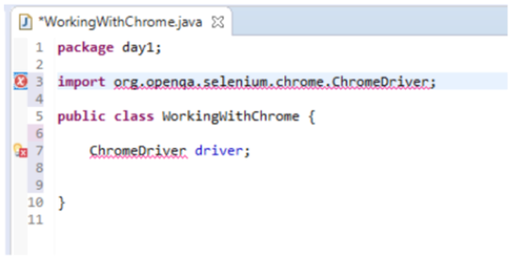
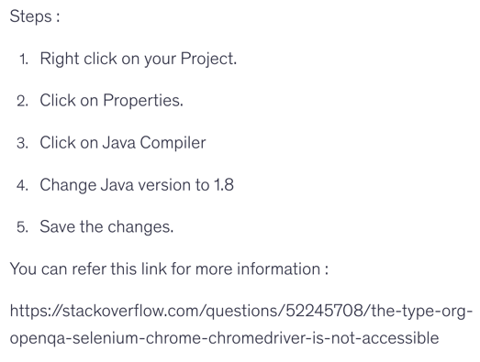

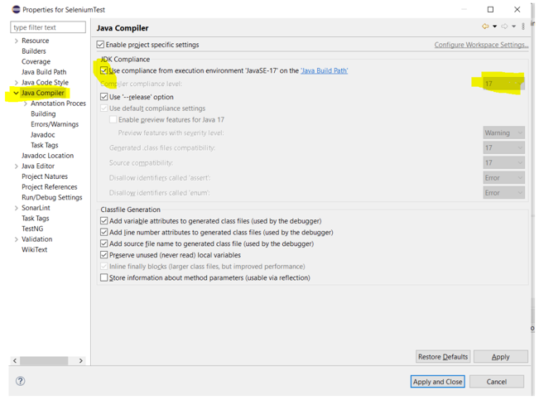

49. Must Read - Driver updates in Selenium 4

50. Launch Google Chrome via Selenium WebDriver Script.
https://developer.chrome.com/docs/chromedriver/downloads
https://googlechromelabs.github.io/chrome-for-testing/

51. Launch Firefox browser via Selenium WebDriver Script.

52. Launch Internet Explorer browser via Selenium WebDriver Script.

==================. Section 6. ===================

53. Introduction of Selenium Locators and types.
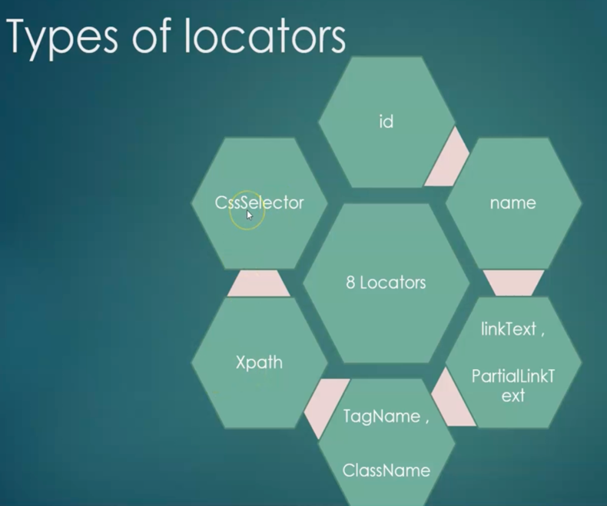

54. Finding the elements by Id and name locators.

55. Finding Web link element by using Link Text and Partial Link Text locators

56. Understanding the Xpath and it's types.

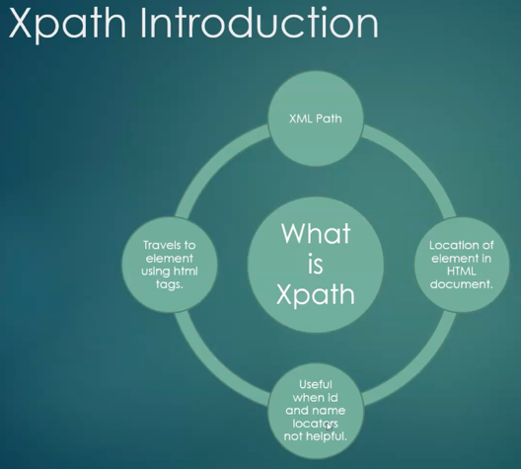

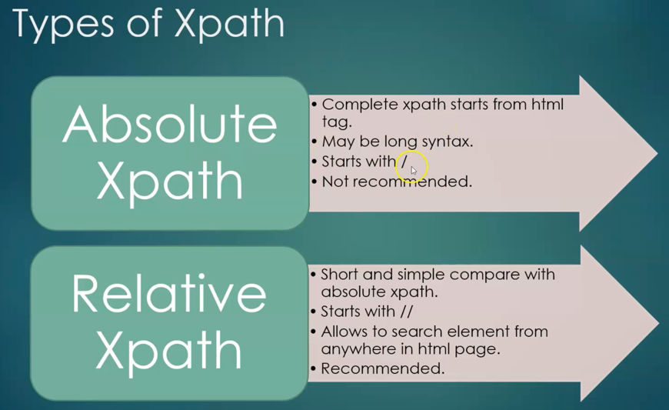

57. Solving the real time elements issues by Xpath methods - Part 1

58. Solving the real time elements issues by Xpath methods - Part 12
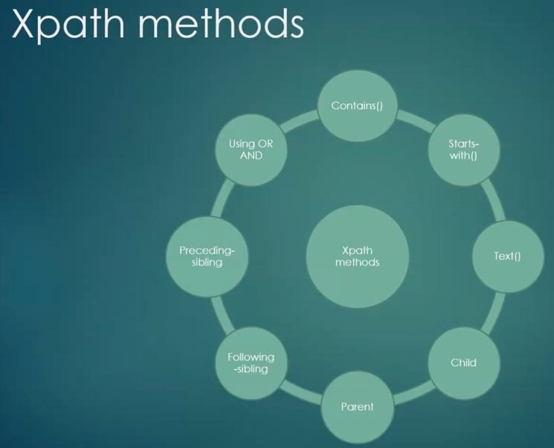

59. Must Watch : Practice Application - OrangeHRM Minor Updates.

60. Understanding Css Selector locators

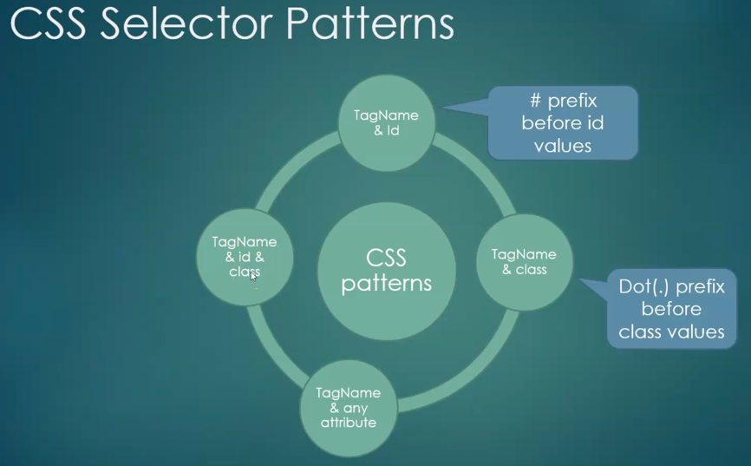

61. Solving the real time elements issues by Css Selector locator

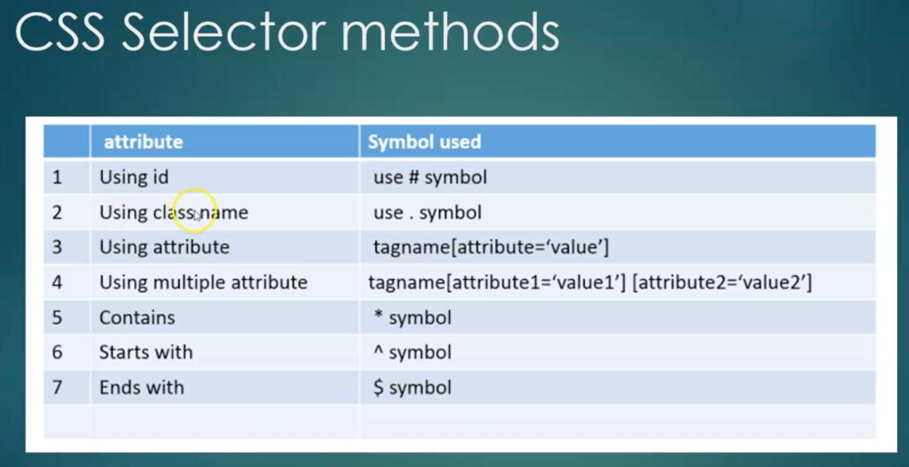

62. Understanding Class name locator.

63. Understanding TagName locator.

64. Understanding the difference between findElement() and findElements()

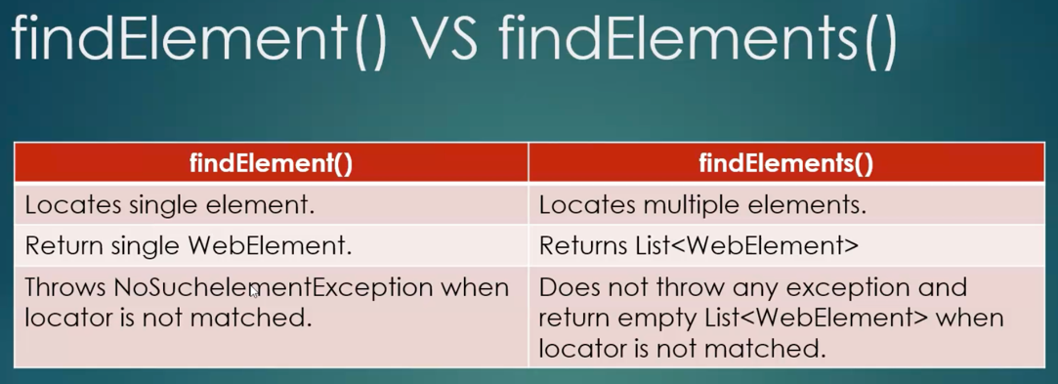

Quiz 5: Quiz

==================. Section 7. ===================

65. Text box operations handling

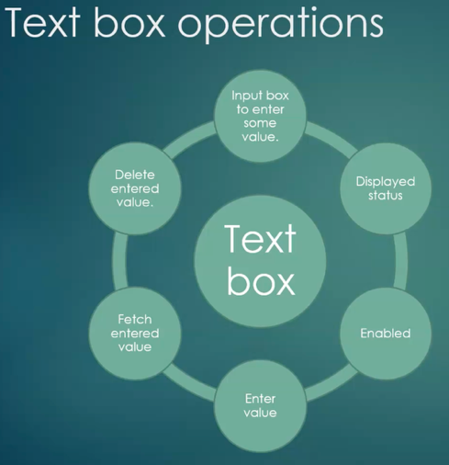

66. Checkbox operations handling

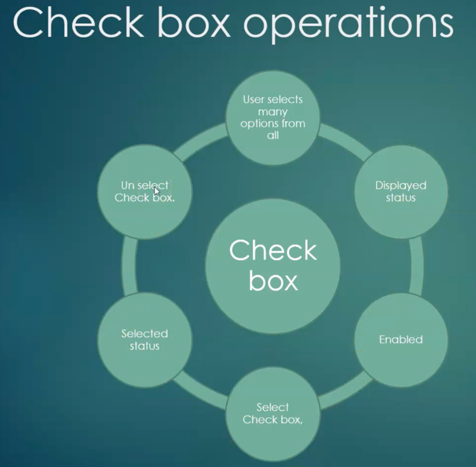

67. Must Read - Website to Practice Radio button and drop down demos

68. Radio button operations handling

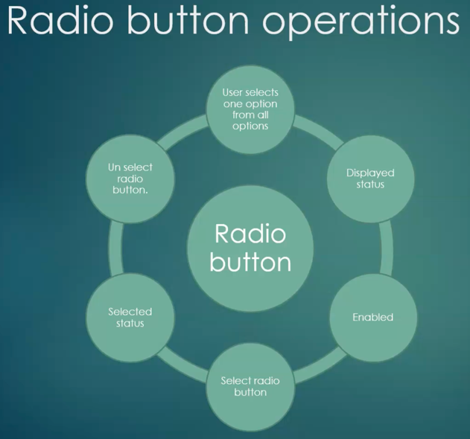

69. Dropdown operations handling

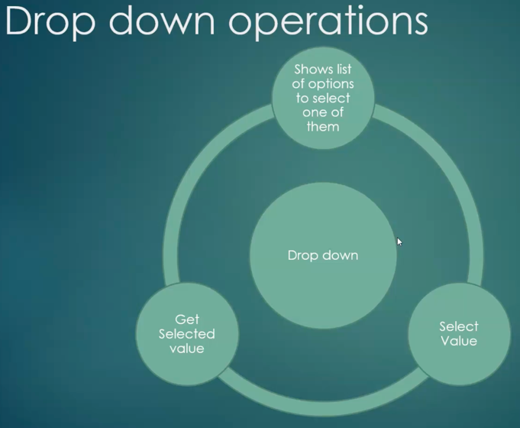

70. Links operations handling.

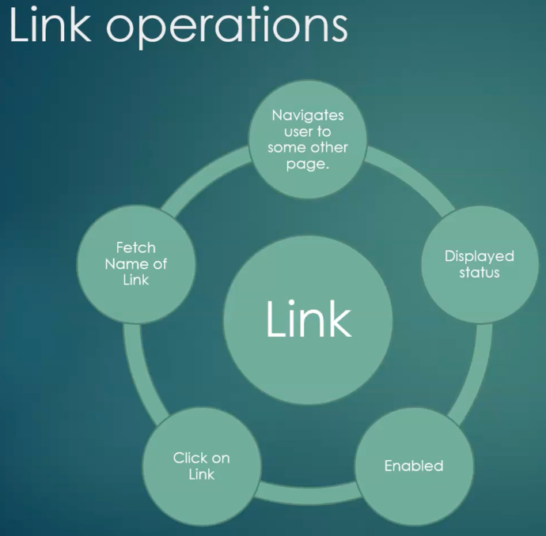

71. Must Read - Calendar Operations handling Test Website

72. Calendar operations handling

