https://www.udemy.com/course/playwright-cucumber-typescript-automation/learn/lecture/50167179?start=0#overview
subhenduda8014@gmail.com

========= Section 1 (Introduction) =========

1. Introduction: Done
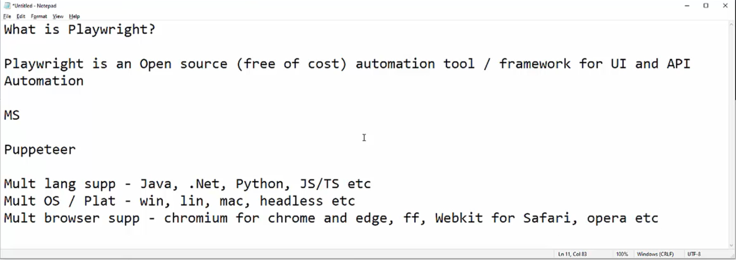
https://playwright.dev/

2. What is Playwright?: Done

3. Comparison between Playwright, Selenium and Cypress: Done
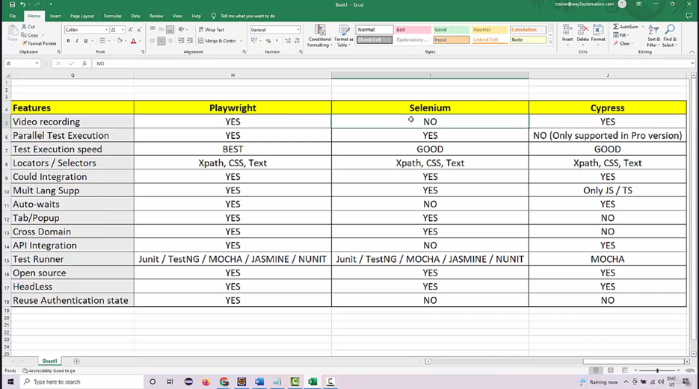

4. Playwright Architecture: https://medium.com/version-1/playwright-vs-selenium-which-is-faster-and-more-stable-c41ba1a89c0a
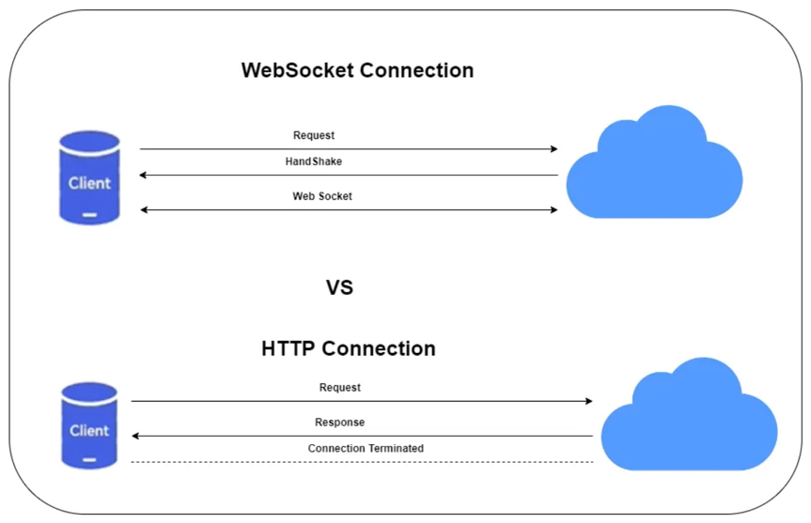

=========== Section 2 (TypeScript fundamentals) ============

6. Introduction to Typescript:
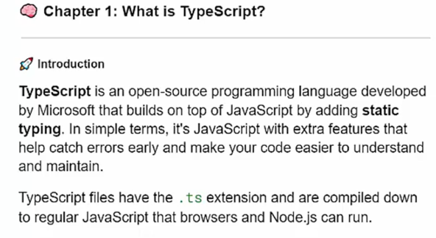
7. Pre-requisite:
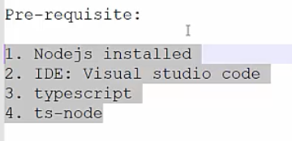
- https://nodejs.org/en [For mac - brew install node]
- https://code.visualstudio.com/
- Go to vscode terminal and install typescript – npm install -g typescript
- Npm init -y [It creates package.json file]
- Tsc –init [A typescript config file]
- {
- "compilerOptions": {
- "rootDir": "./src",
- "outDir": "./dist",
- "module": "nodenext",
- "target": "esnext",
- "types": [],
- "strict": true
- },
- "include": ["src"]
- }

- How to run
- npx tsc (It will compile all typescript files and will create .js files)
- node ./dist/intro.js (Now we need to run the javascript file)
- Code-Runner Installing code runner in vscode which will directly make the .ts file executable. (I don’t need to compile and run)
- Need to install - npm install -g ts-node as Code-Runner will use <ts-node>
- So when we will be using Jenkins or pipeline then we will be using ts-node, and here as well we can use ts-node for directly compilation and running .ts file – <npx ts-node TypeScriptTutorials/src/intro.ts>

8. Naming Conventions, Variables and Datatypes
/*
Naming Conventions:
- kebab-case: Used for file names (e.g., my-file.ts).
- camelCase: Used for variables and functions (e.g., myVariable, calculateSum).
- PascalCase: Used for classes and interfaces (e.g., MyClass, IUser).
- snake_case: Sometimes used for constants (e.g., MAX_VALUE).
*/

9. More Types
Object types, enum etc

10. Operators
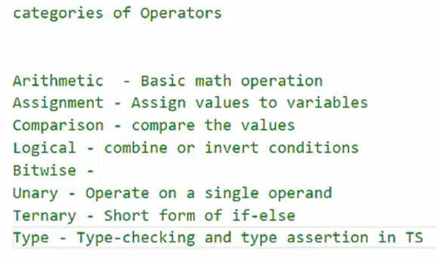
2:58

