https://www.udemy.com/course/playwright-cucumber-typescript-automation/learn/lecture/50167179?start=0#overview
subhenduda8014@gmail.com

========= Section 1 (Introduction) =========

1. Introduction: Done
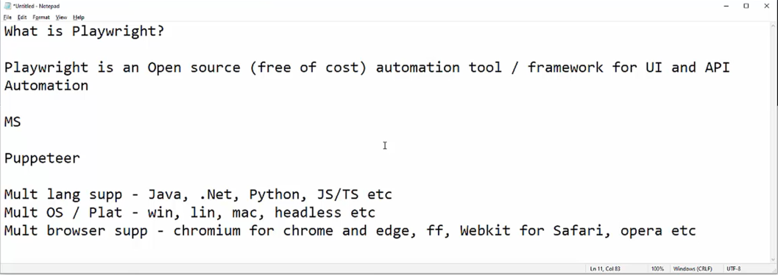
https://playwright.dev/

2. What is Playwright?: Done

3. Comparison between Playwright, Selenium and Cypress: Done
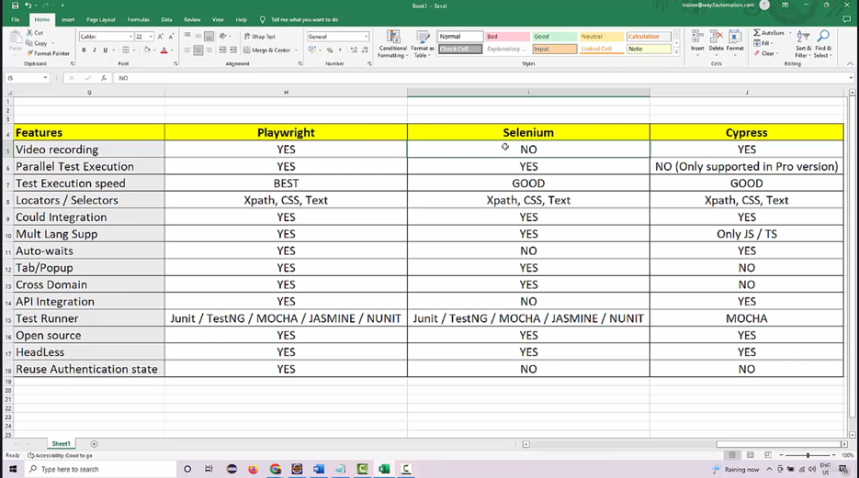

4. Playwright Architecture: https://medium.com/version-1/playwright-vs-selenium-which-is-faster-and-more-stable-c41ba1a89c0a
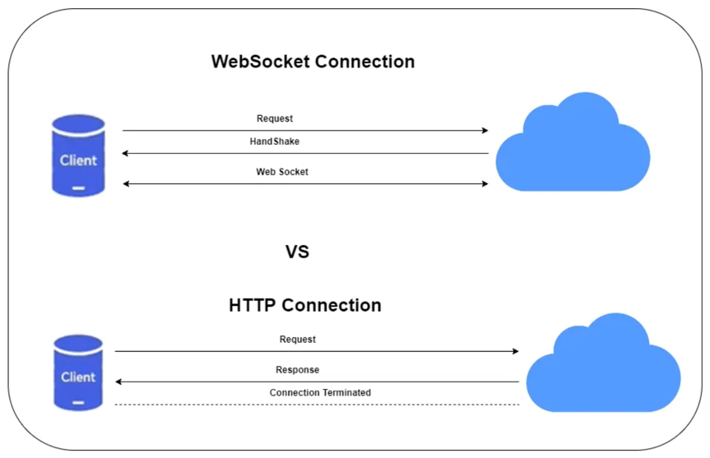

=========== Section 2 (TypeScript fundamentals) ============

6. Introduction to Typescript:
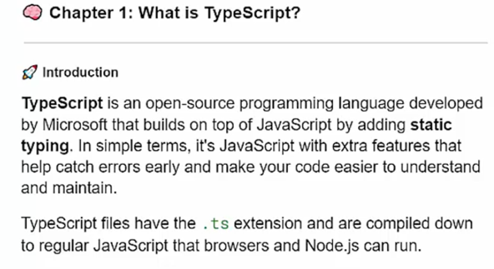
7. Pre-requisite:
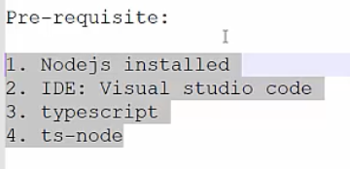
- https://nodejs.org/en [For mac - brew install node]
- https://code.visualstudio.com/
- Go to vscode terminal and install typescript – npm install -g typescript
- Npm init -y [It creates package.json file]
- Tsc –init [A typescript config file]
- {
- "compilerOptions": {
- "rootDir": "./src",
- "outDir": "./dist",
- "module": "nodenext",
- "target": "esnext",
- "types": [],
- "strict": true
- },
- "include": ["src"]
- }

- How to run
- npx tsc (It will compile all typescript files and will create .js files)
- node ./dist/intro.js (Now we need to run the javascript file)
- Code-Runner Installing code runner in vscode which will directly make the .ts file executable. (I don’t need to compile and run)
- Need to install - npm install -g ts-node as Code-Runner will use <ts-node>
- So when we will be using Jenkins or pipeline then we will be using ts-node, and here as well we can use ts-node for directly compilation and running .ts file – <npx ts-node TypeScriptTutorials/src/intro.ts>

8. Naming Conventions, Variables and Datatypes
/*
Naming Conventions:
- kebab-case: Used for file names (e.g., my-file.ts).
- camelCase: Used for variables and functions (e.g., myVariable, calculateSum).
- PascalCase: Used for classes and interfaces (e.g., MyClass, IUser).
- snake_case: Sometimes used for constants (e.g., MAX_VALUE).
*/

9. More Types
Object types, enum etc

10. Operators
Please go through this video over and over again as this is conceptual based.
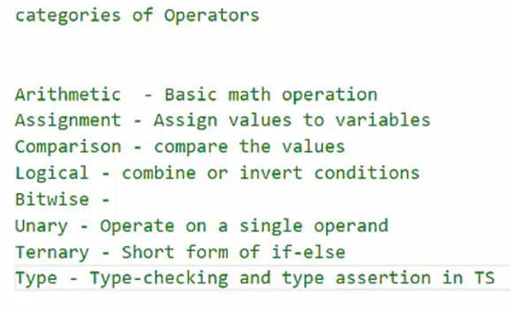

11. Concatenation Operators

12. Functions

13. Arrow Functions and Function Overloading

14. Control Flow statements - IfElse, SwitchCase

15. Loops

16. Arrays.
17. 2D Arrays

18. Tuples

19. Objects Pending

