https://www.udemy.com/course/zero-to-hero-in-selenium-webdriver-java-basics-to-advance/learn/lecture/40011186#overview

Orange-hrm new - https://opensource-demo.orangehrmlive.com/web/index.php/auth/login
Orange hrm old - https://opensource-demo.orangehrmlive.com/web/index.php/auth/login

*********. Section 1. ***********
1. Must Watch - About this Course. => Pending

*********. Section 2. ************
10. Install Java on Mac Machine
https://www.oracle.com/in/java/technologies/downloads/#jdk21-mac
- Java –version
- Need to set JAVA_HOME
- Run this command - /usr/libexec/java_home
Output: /Library/Java/JavaVirtualMachines/jdk-21.jdk/Contents/Home
As in my macbook terminal is .zsh, so I need to open .zshenv
touch ~/.zshenv
open ~/.zshenv
Specify java env file path
Write this export JAVA_HOME=$(/usr/libexec/java_home)
source ~/.zshenv
echo $JAVA_HOME

=============. Section – 3 ===============
18. What is an Operator and it's different types. Pending

===========. Section 5. ============
45. Must Read - Preferred versions configuration
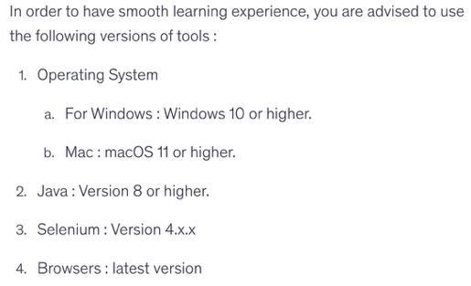
46. Must Read - Selenium Library Version Updates
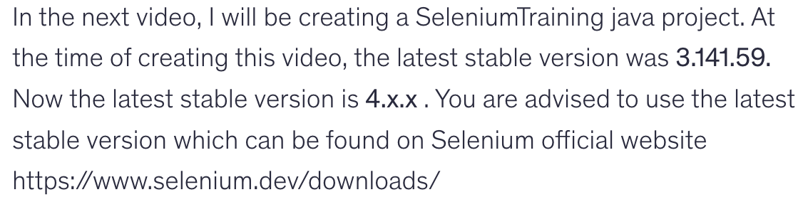
47. Understanding Selenium WebDriver Architecture.
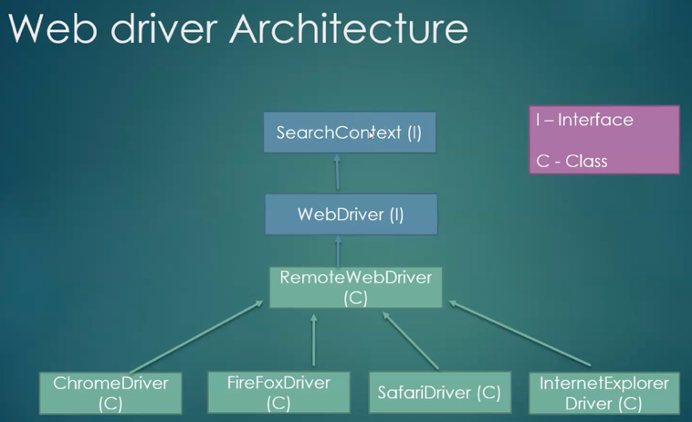
To download selenium package manually
https://www.selenium.dev/

48. Must Read- Fix chromedriver-is-not-accessible error.
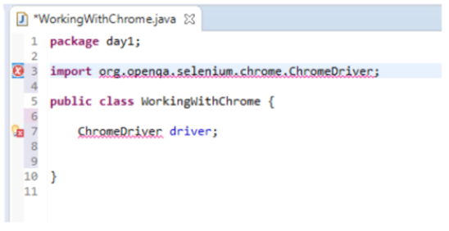
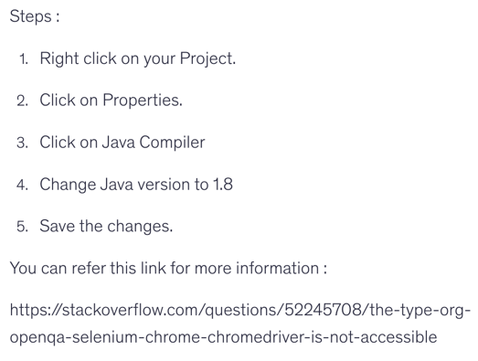

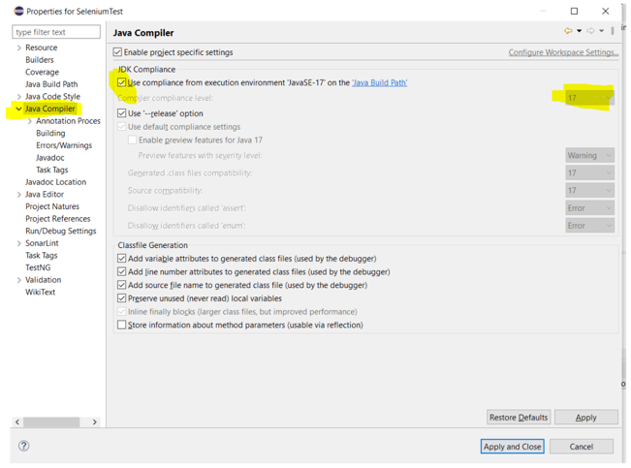

49. Must Read - Driver updates in Selenium 4

50. Launch Google Chrome via Selenium WebDriver Script.
https://developer.chrome.com/docs/chromedriver/downloads
https://googlechromelabs.github.io/chrome-for-testing/

51. Launch Firefox browser via Selenium WebDriver Script.

52. Launch Internet Explorer browser via Selenium WebDriver Script.

==================. Section 6. ===================

53. Introduction of Selenium Locators and types.
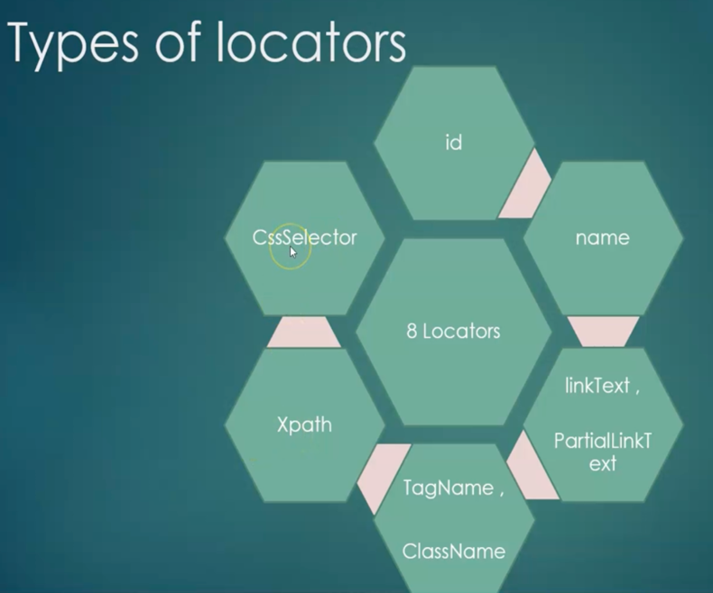

54. Finding the elements by Id and name locators.

55. Finding Web link element by using Link Text and Partial Link Text locators

56. Understanding the Xpath and it's types.

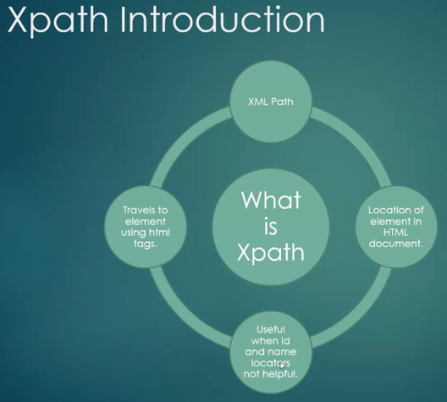

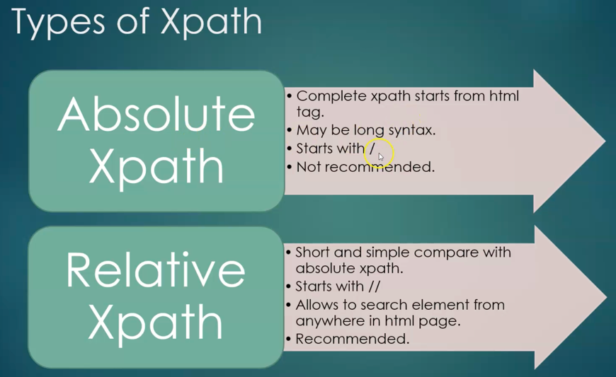

57. Solving the real time elements issues by Xpath methods - Part 1

58. Solving the real time elements issues by Xpath methods - Part 12
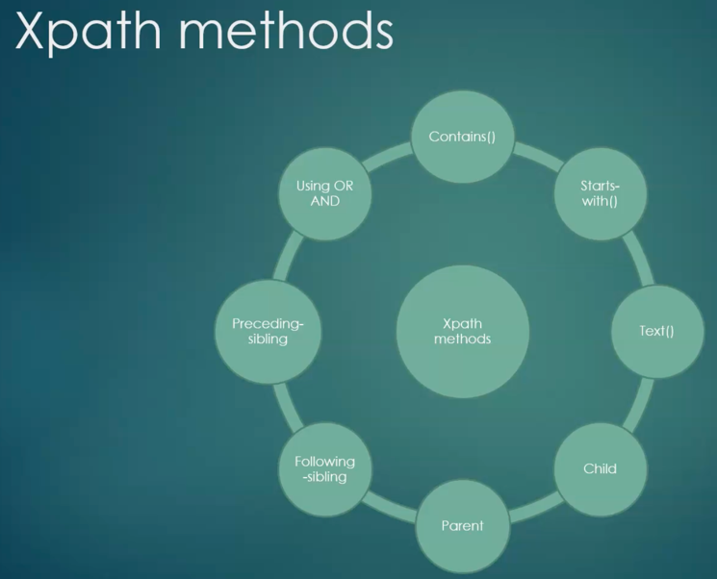

59. Must Watch : Practice Application - OrangeHRM Minor Updates.

60. Understanding Css Selector locators

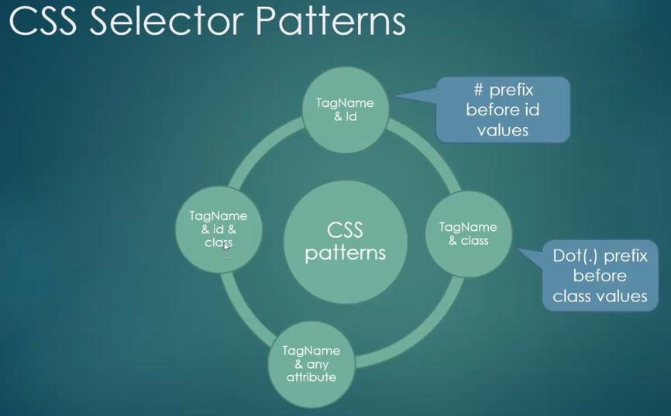

61. Solving the real time elements issues by Css Selector locator

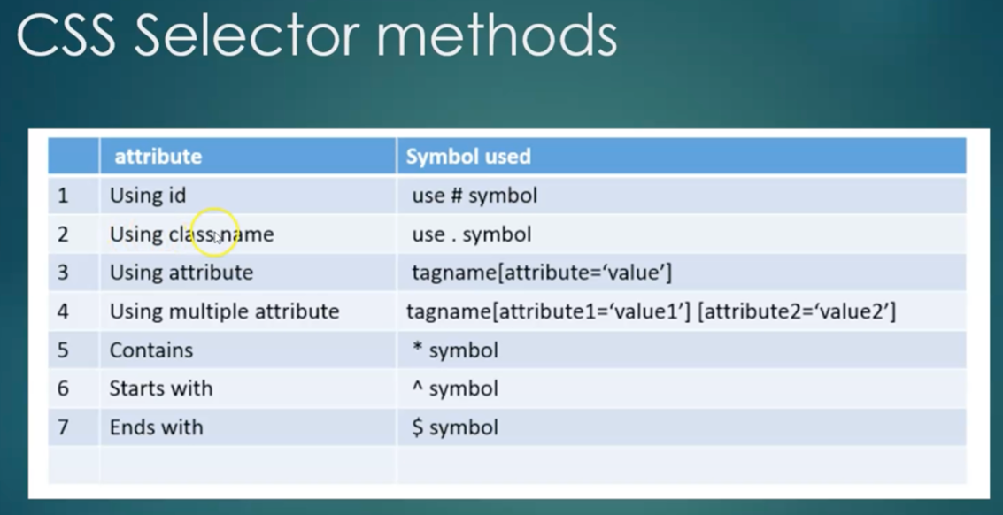

62. Understanding Class name locator.

63. Understanding TagName locator.

64. Understanding the difference between findElement() and findElements()

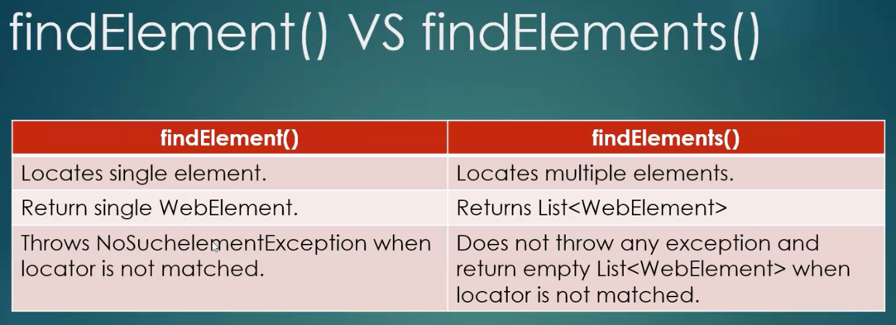

Quiz 5: Quiz

==================. Section 7. ===================

65. Text box operations handling

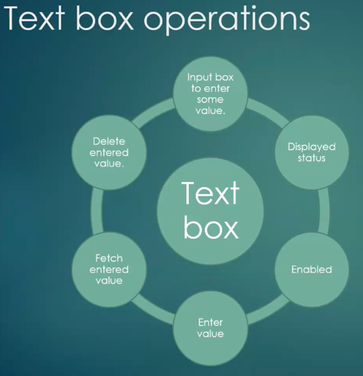

66. Checkbox operations handling

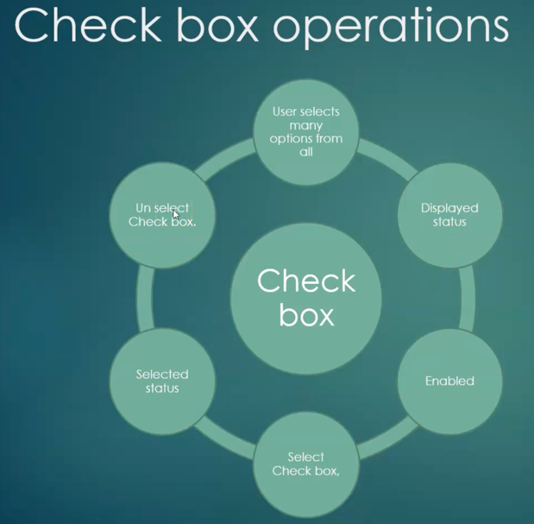

67. Must Read - Website to Practice Radio button and drop down demos

68. Radio button operations handling

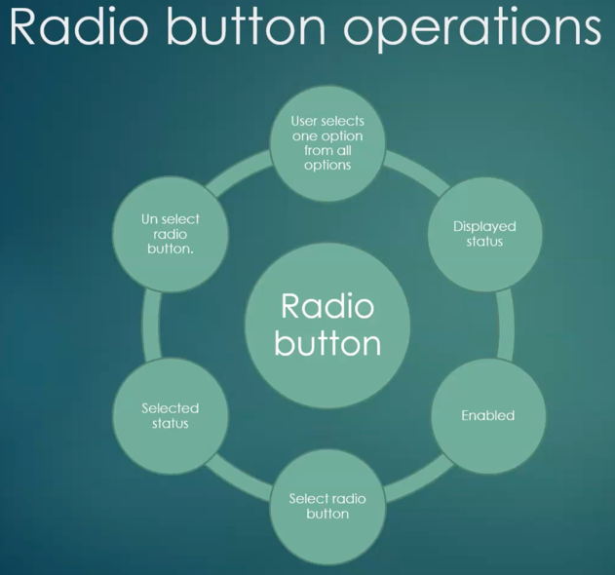

69. Dropdown operations handling

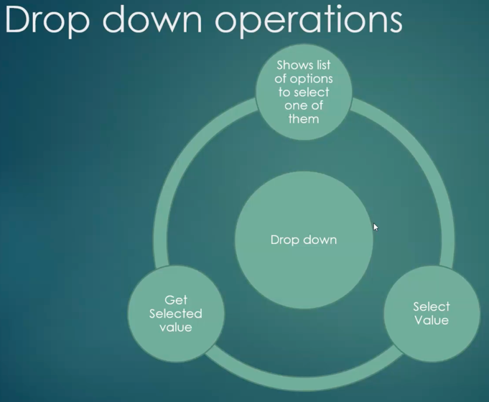

70. Links operations handling.

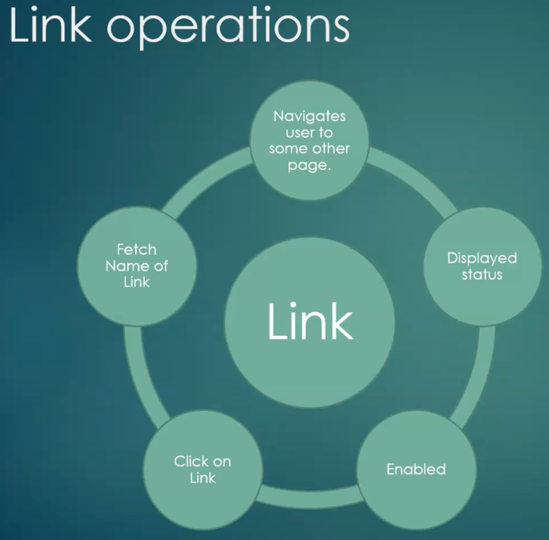

71. Must Read - Calendar Operations handling Test Website

72. Calendar operations handling

=============. Section – 9 ===============
78. Automate Javascript alert with real time example.

79. Understanding the Iframe and it's handling.

80. Nested Iframe handling.

81. Handling the Multiple windows of a browser.

=============. Section – 10 ===============
82. Understanding the JavaScript usage for Selenium

83. Must Read - OrangeHRM Application recent updates

84. Execute JavaScript via Selenium to enter value in Text box and click on button.

85. Execute JavaScript via Selenium to get title and url of web page.

86. Execute JavaScript via Selenium to Scroll down.
87. Execute JavaScript via Selenium for Horizontal Scrolling

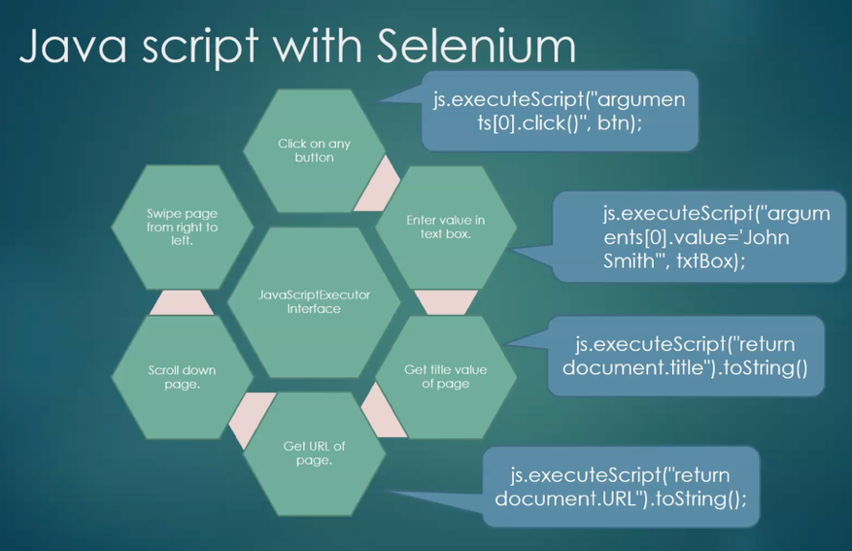

=============. Section – 11 ===============
88. Understanding the need to keyboard and mouse handling.

89. How to automate double click action.

90. How to automate right click action.
91. How to automate drag and drop action.
92. How to automate Move mouse on any element and perform click, and enter value.

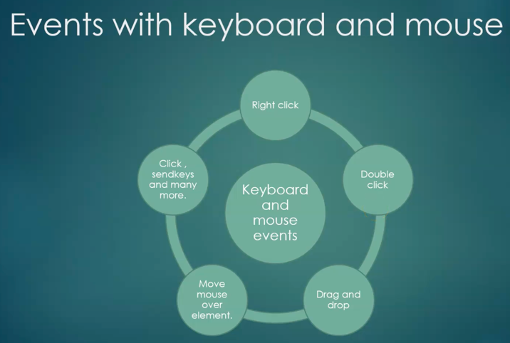

=============. Section – 12 ===============

93. Understanding the Synchronization Usage in Selenium.

94. Must Read - Implicit wait line of code

95. Understanding the Implicit wait with real time example.

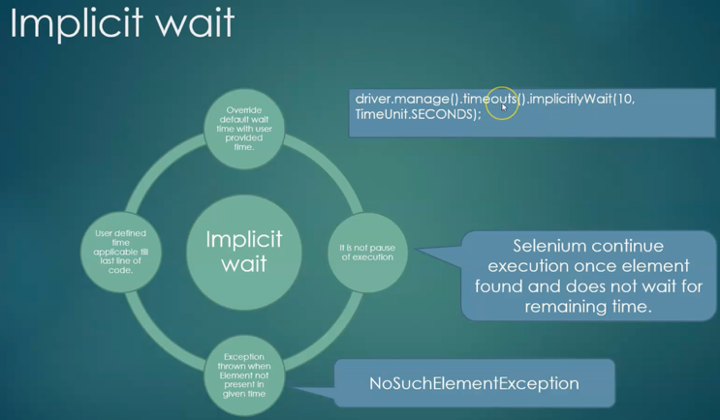

96. Understanding the need to Explicit wait.

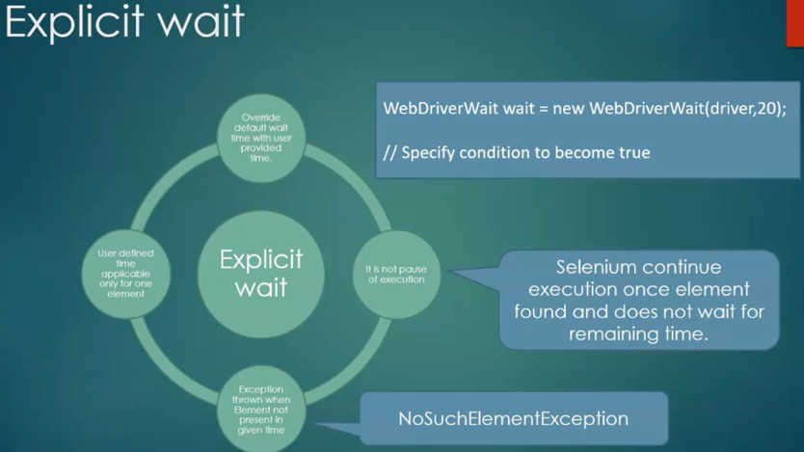

97. Understanding the Explicit wait with real time example.

98. Understanding the need to Fluent wait.

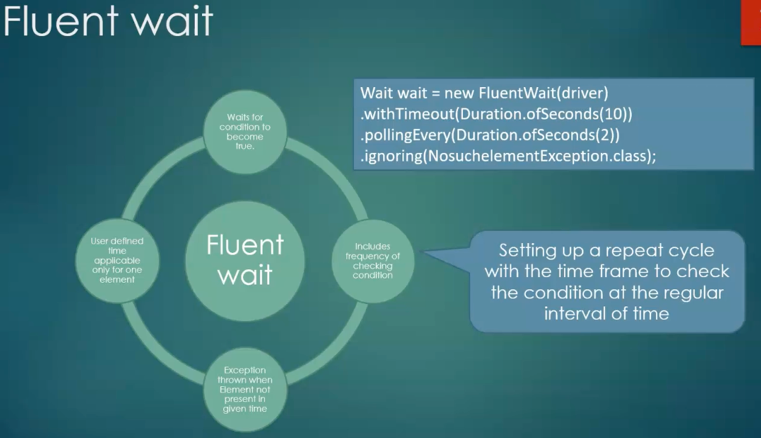

99. Understanding the Fluent wait with real time example.

100. Difference between Implicit VS Explicit VS Fluent waits.

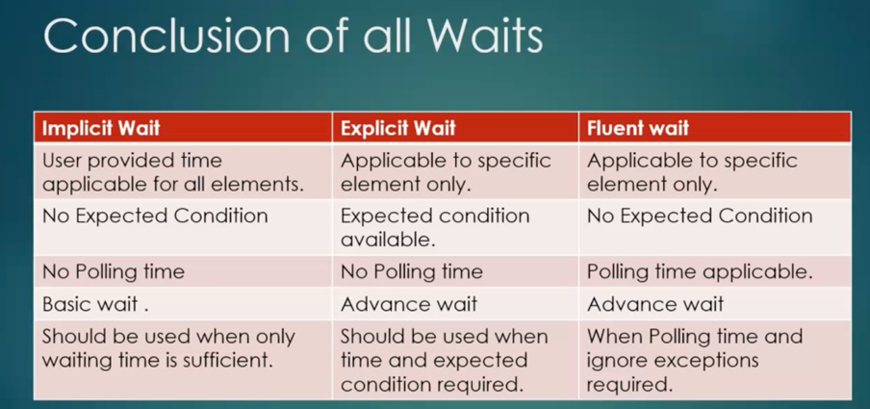

=============. Section – 13 ===============

101. Understanding the need to customizing the browser settings.

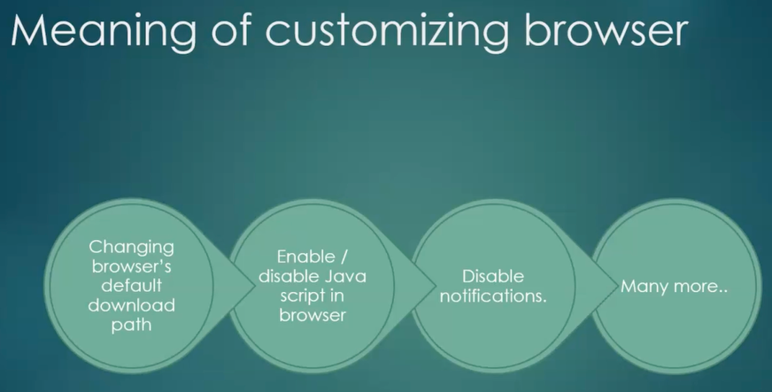

102. Customized the Chrome browser to change default download path.

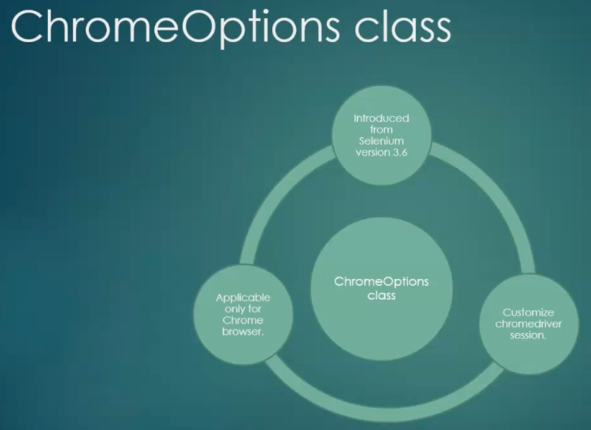

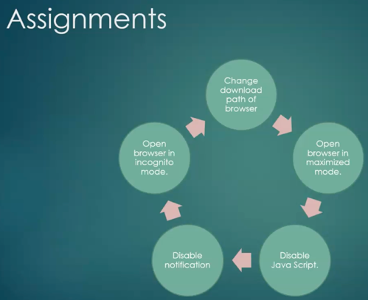

103. Customized the Chrome browser to launch with Maximized mode.

104. Customized the Chrome browser to disable JavaScript and notification.

105. Customized the Chrome browser to run automation with Incognito mode.

106. Customized the Firefox browser to change default download path.

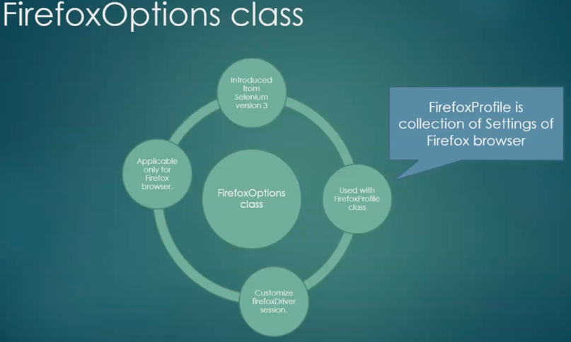

107. Customized the Firefox browser to run automation with Private Mode.

108. Customized the Firefox browser to launch existing profile.

109. Customized the IE browser to ignore zoom level.

110. Customized the IE browser to set initial url.

111. Understanding the need to run automation in Headless mode.

112. Execute test script in Chrome headless mode.

113. Execute test script in Firefox headless mode.

=============. Section – 14 ===============

114. What is SSL Certificate.

115. Handle SSL certificate in Chrome browser.

116. Handle SSL certificate in Chrome browser.

117. Handle SSL certificate in Firefox browser.

=============. Section – 15 ===============
118. Cookies Introduction.

119. How to get cookies at run time.

120. How to add cookies at run time.
121. How to delete cookies at run time.

=============. Section – 16 ===============
122. Understanding the TakeScreenshot Interface of Selenium.

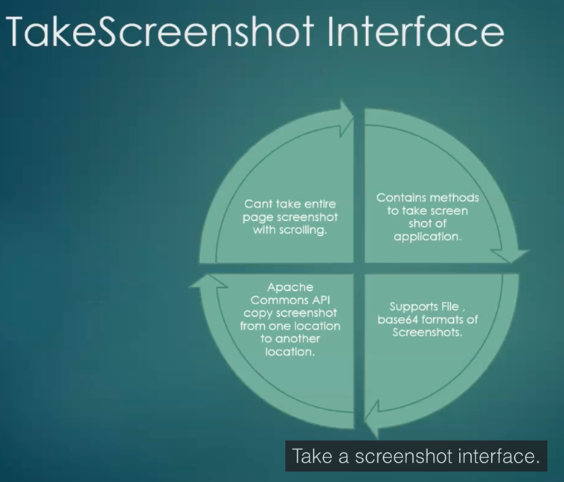

123. Understanding the TakeScreenshot Interface of Selenium.

124. Capture Application Screenshot Using TakeScreenShot Interface

125. Design Reusable method to capture multiple screenshots

126. Limitations of TakeScreenShot Interface.

127. Understanding the AShot API to capture screenshot.

128. Ashot API to to take screenshot of screen
129. Ashot API to tale Full Page Screenshot

=============. Section – 18 ===============

130. TestNG Framework Introduction.

131. Install TestNG Plugin Using Eclipse Market Place.

132. Creating first test case using TestNG framework

133. Understanding TestNG Assertions.

134. Understanding Assert Equals assertion.

135. Understanding Assert Not Equals assertion.

136. Understanding Assert True assertion.
137. Understanding Assert False assertion.

138. Creating multiple assertions in single test case.

139. Understanding Assertion types and Hard Assertions.

140. SoftAssertion Introduction With demonstration

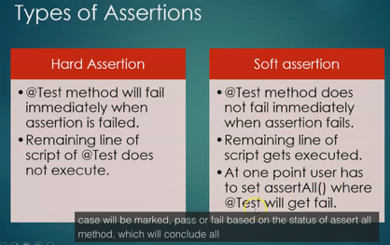
141. Understanding TestNG priority with dummy test

142. Implementing TestNG priority with real time example.

143. Understanding TestNG priority with duplicate priority values.

144. Understanding TestNG priority with negative priority values.

145. TestNG priority - partial priority for Test cases

146. Understanding the different ways to exclude test case from execution.

147. Exclude test case using enabled attribute and @Ignore Annotation.
148. Exclude test case for Orange HRM Application.

149. Invocation Count - Execute @Test multiple times

150. Understanding the TestNG.XML file.

151. First TestNG.xml file to execute test cases of class

152. TestNG.xml file to include specific test cases to execute (Pending)

153. Exclude Test case using exclude tag in testng.xml
154. TestNG.xml file to execute multiple classes - Part 1
155. TestNG.xml file to execute multiple classes - Part 2
156. Understanding Parameters annotation.
157. Implementing Parameters annotation for Orange HRM login test case.
158. Parameters annotation with @Optional annotation
159. Understanding the Data Provider annotation.
160. Data Provider to execute OrangeHRM Login test case with different data.
161. Understanding the Groups.
162. Execute test case based on Group name.
163. Assign multiple groups to single @Test and run @Tests from multiple classes.
164. DependsOnMethods attribute Introduction
165. Understan DependsOnMethods with Apply Leave and Approve Leave test cases
166. Understanding DependsOnMethods with OrangeHRM test cases
167. Understanding @Test Annotation
168. Understanding BeforeMethod and AfterMethod Annotations
169. Understanding BeforeTest and AfterTest Annotations
170. Understanding BeforeSuite And AfterSuite Annotation [Pending - Need to implement]
171. Understanding BeforeClass And AfterClass
172. Understanding Before Groups And After Groups [Pending - Need to implement]

173. Understanding the TestNG Listeners. [Pending - WIP]

============= Syllabus – Students ===============

- Setup and configuration
- Browser Launch and Locators, Basic xpath
- Advanced xpath
- CSS selector and Advanced CSS selector
- Alert handling and class concept
- Iframe and Multiple window

