Training Neural Networks with ADMM on Apache Spark

Signal Processing for Big Data
Sergio Barbarossa and Paolo Di Lorenzo
Student: Dastagiri Dudekula 1826239
Sapienza University of Rome
M.Sc. in Data Science

Abstract:
Many problems of recent interest in statistics and machine learning can be posed in the framework of convex optimization. Due to the explosion in size and complexity of modern datasets, ‘Big Data’ become increasingly necessary for data handling and neural networks become important to train large network models.
By the reference(3), this project experimented an unconventional training method that uses alternating direction methods and Bregman iteration to train networks without gradient descent steps, on top of Apache Spark. The results are compared by the loss and accuracy plots of train, validation and test model performances.

1. Introduction:
In most of the applied fields, it is now common place to attack problems through data analysis, particularly through the use of statistical and machine learning algorithms on what are often large datasets. As hardware and algorithms advance, neural network performance is constantly improving for many machine learning tasks to model. (3) introduced the new method for training the parameters of neural nets using the Alternating Direction Method of Multipliers (ADMM) and Bregman iteration. To implement this into big data, I have extended data handling part with Apache Spark RDD implementation.
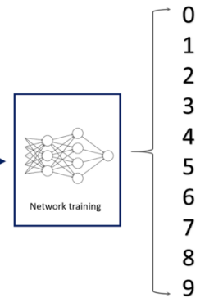
2. Architecture:

Model & Evaluate

Apache Spark
Train(X,Y)_RDD
Valid(X,Y)_RDD
Test(X,Y)_RDD

Apache Spark 3.0 installed into my Ubuntu 18.04(16G-RAM, 12Core).
SparkContext.parallelize(RDD, Partitions) uses to partition the RDD to number of block specified and improve availability by parallelizing.

3. Modeling:
Though there are many variations, a typical neural network consists of L layers which includes input, hidden and output layers.
Training the network is the task of tuning the weight matrices W to match the output activations to the targets y, given the inputs a₀. Using a loss function l, the training problem can be posed as;
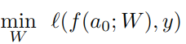

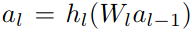
Where W = {W}, weight matrices and a single layer computes and outputs the non-linear function;

Alternating minimization for neural networks:
Instead of feeding the output of the linear operator W_{l} directly into the activation function h_{l} , we store the output of layer l in a new variable as;
and the output representation of the activation function as

Now try to solve the following problem ; (A)
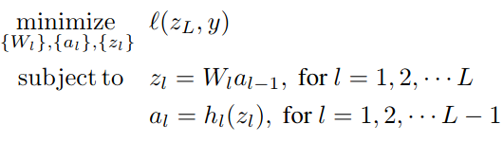

To the problems (A), relax the constraints by adding the l₂ penalty function to the objective and attack the unconstrained problem; (B)
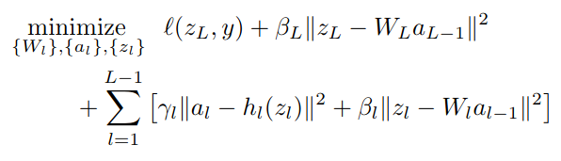

* where β_{l} and γ_{l} are weight controllers of contraints.
To obtain exact enforcement of the constraints, we add a Lagrange multiplier term to above equation, and obtains (C)
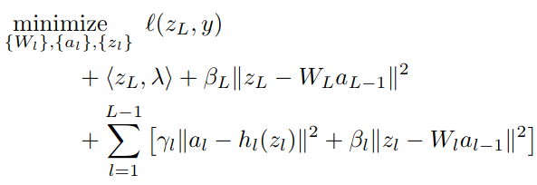

* where the λ is a vector of Lagrange multipliers with the same dimensions as z_{L}.
In the above equations, instead of conventional ADMM, implemented by using the Bregman formulation. This I have exampled from the reference
paper.
Minimization:
1. w.r.to Weight: minimize {W_{l}} for equation (4); for each layer optimal solution argmin
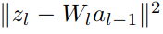
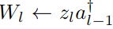
which is simply least squares problem, and the solution is
# pseudo-inverse of input activation
p_inv = np.linalg.pinv(activation_input)
return tf.matmul(tf.cast(layer_output, tf.float32), tf.cast(p_inv, tf.float32))

2. w.r.to Activation: Minimization for {a_{l}} is a simple least squares problem similar to the weight update. However, in this case the matrix appears in two penalty terms in the problem, and so we must minimize:
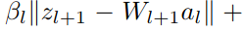
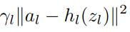

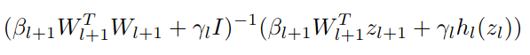
The new value is
# Calculate ReLU/Sigmoid
layer_nl_output = self.h_function(layer_nl_output, h_func)
# Activation inverse
m1 = beta * tf.matmul(tf.matrix_transpose(next_weight), next_weight)
m2 = tf.scalar_mul(gamma, tf.eye(tf.cast(m1.get_shape()[0], tf.int32)))
# Activation formulate
m3 = beta * tf.matmul(tf.matrix_transpose(next_weight), next_layer_output)
m4 = gamma * layer_nl_output
# Output
updated_activation_matrix = tf.matmul(tf.matrix_inverse(tf.cast(m1, tf.float32) + tf.cast(m2, tf.float32)), tf.cast(m3, tf.float32) + tf.cast(m4, tf.float32))
return updated_activation_matrix
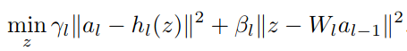
3. w.r.to Output:

Because of the non-linear function h_{l}, this becomes non-convex and non-quadratic problem. Hence solving h by sub-terms as linearly, it can be solved closed form. So h includes ReLU (h_{relu}) and non-differentiable sigmoid functions (h_{Sig}). I have implemented both and can be choosen by external parameter setting.
w_mul_a = tf.matmul(tf.cast(w, tf.float32), tf.cast(a_in, tf.float32))
m1 = np.array(gamma * a + beta * w_mul_a) / (gamma + beta)
m2 = np.array(w_mul_a)
z1 = np.zeros_like(a)
z2 = np.zeros_like(a)
z_output = np.zeros_like(a)
z1[m1 >= 0.] = m1[m1 >= 0.]
z2[m2 <= 0.] = m2[m2 <= 0.]
fz_1 = gamma * tf.square(a - self.h_function(z1, h_func)) + beta * (tf.square(z1 - w_mul_a))
fz_2 = gamma * tf.square(a - self.h_function(z2, h_func)) + beta * (tf.square(z2 - w_mul_a))
fz_1 = np.array(fz_1)
fz_2 = np.array(fz_2)
index_z1 = fz_1 <= fz_2
index_z2 = fz_2 < fz_1
z_output[index_z1] = z1[index_z1]
z_output[index_z2] = z2[index_z2]
return z_output
And the last layer output matrix Z is updated as;
m = tf.matmul(tf.cast(w, tf.float32), tf.cast(a_in, tf.float32))
z = (targets - lambd + beta * m) / (1 + beta)
return z
Where h_function() is ReLU or non-differential Sigmoid function;
if choice == 1:
# Relu activation function
return tf.maximum(0.,x)
else:
# non-differential Sigmoid function
return tf.nn.sigmoid(x)
Note: From the experimental results on the MNIST datasets, ReLU gives more accuracies than Sigmoid.
4. w.r.to Lagrange multipler: The λ update is simply by;
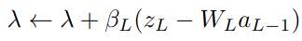
w_mul_a = tf.matmul(tf.cast(w, tf.float32), tf.cast(a_in, tf.float32))
update_lambda = beta * (last_layer_output_ZL – w_mul_a)

return update_lambda

For all updations,

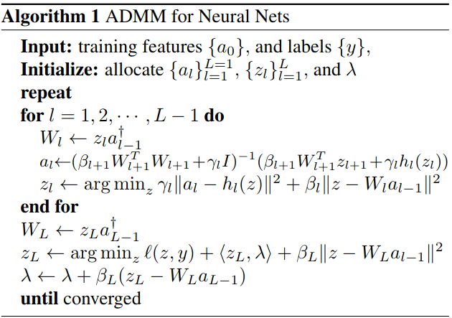

Result: The experiment was done on MNIST data. The MNIST dataset is split into three parts, 55,000 data points of training data (mnist.train), 10,000 points of test data (mnist.test), and 5,000 points of validation data (mnist.validation). Every MNIST data point has two parts: an image of a handwritten digit and a corresponding label.
The results are illustrated based on loss and accuracy of model training, validation and testing performances accordingly.
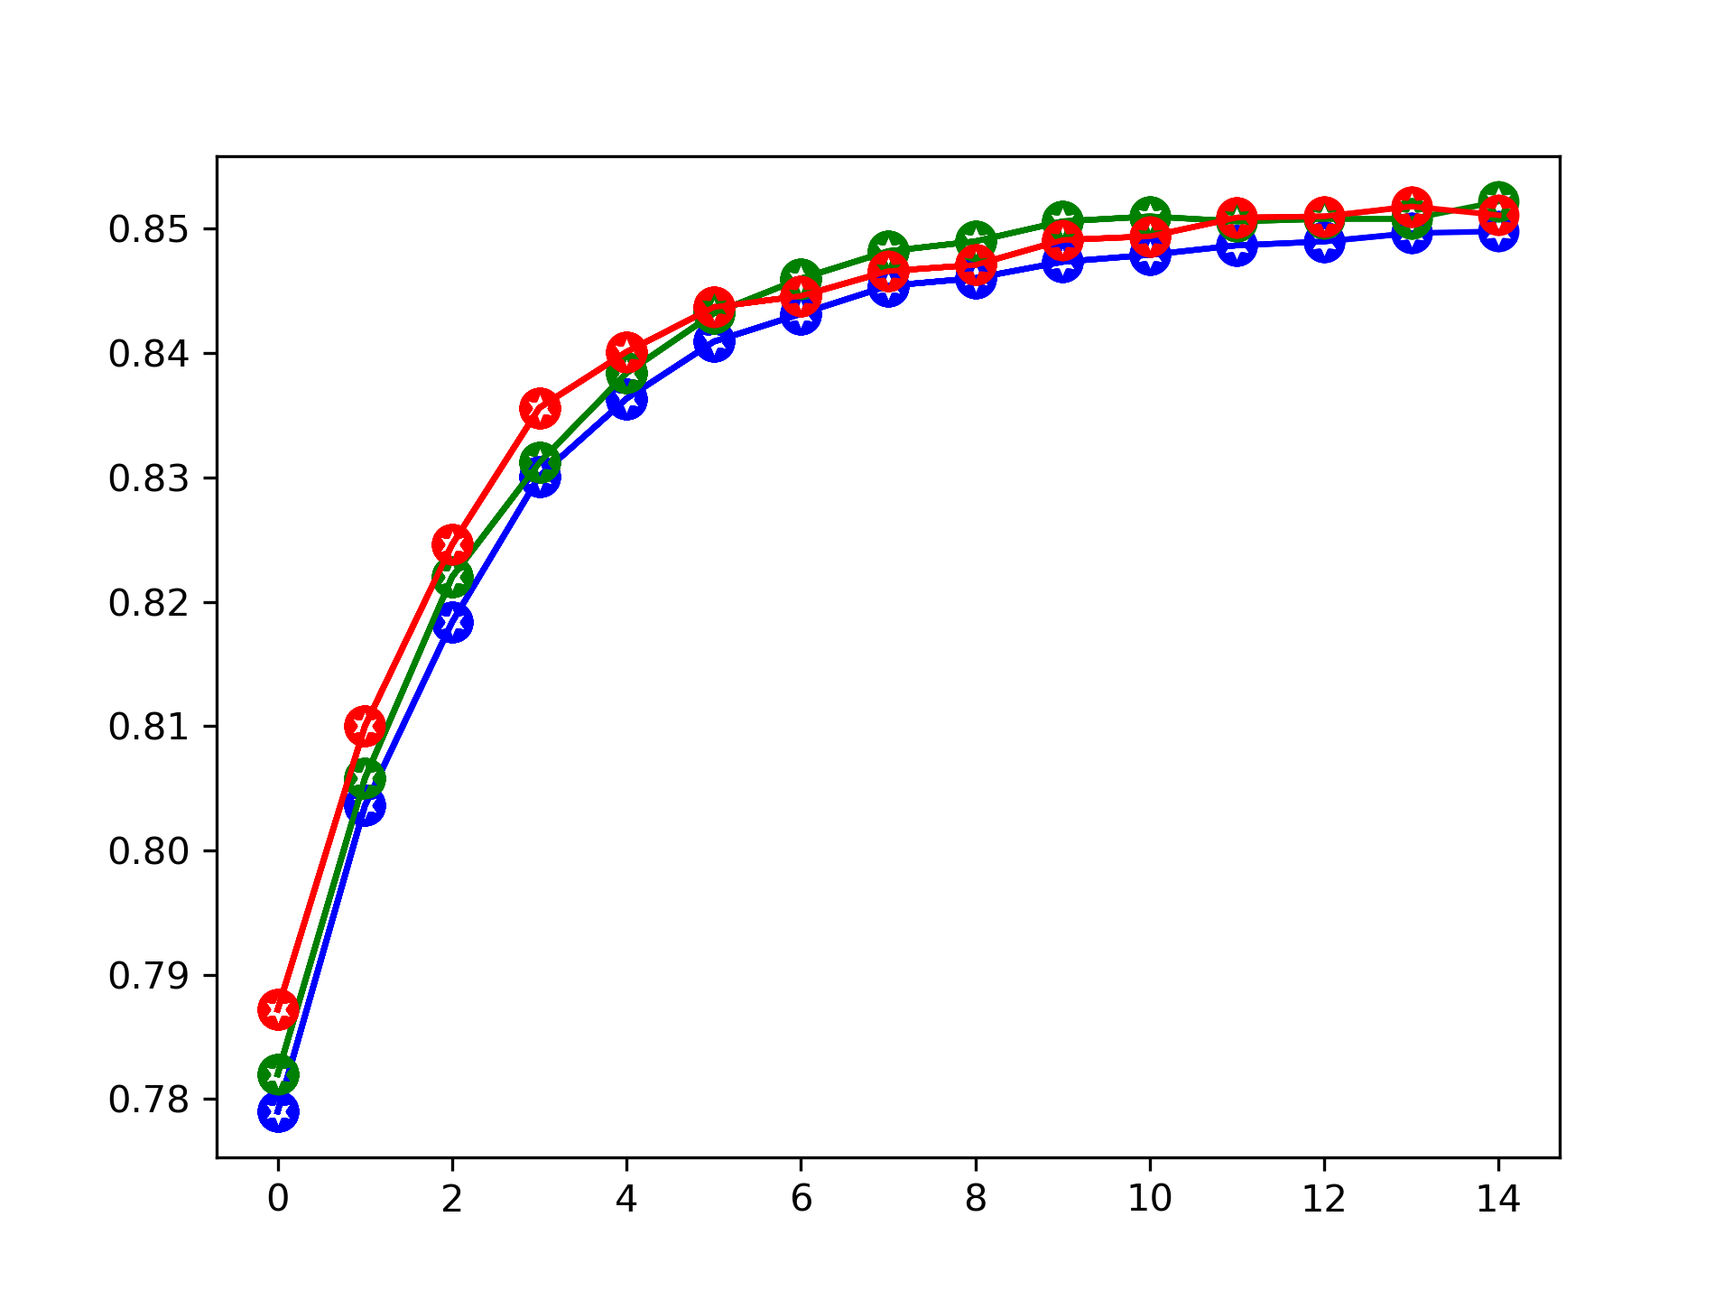

Figure 1. Ilustrates the training(blue), validation(green) and testing(red) Accuracies with the respect number of epochs traversal.
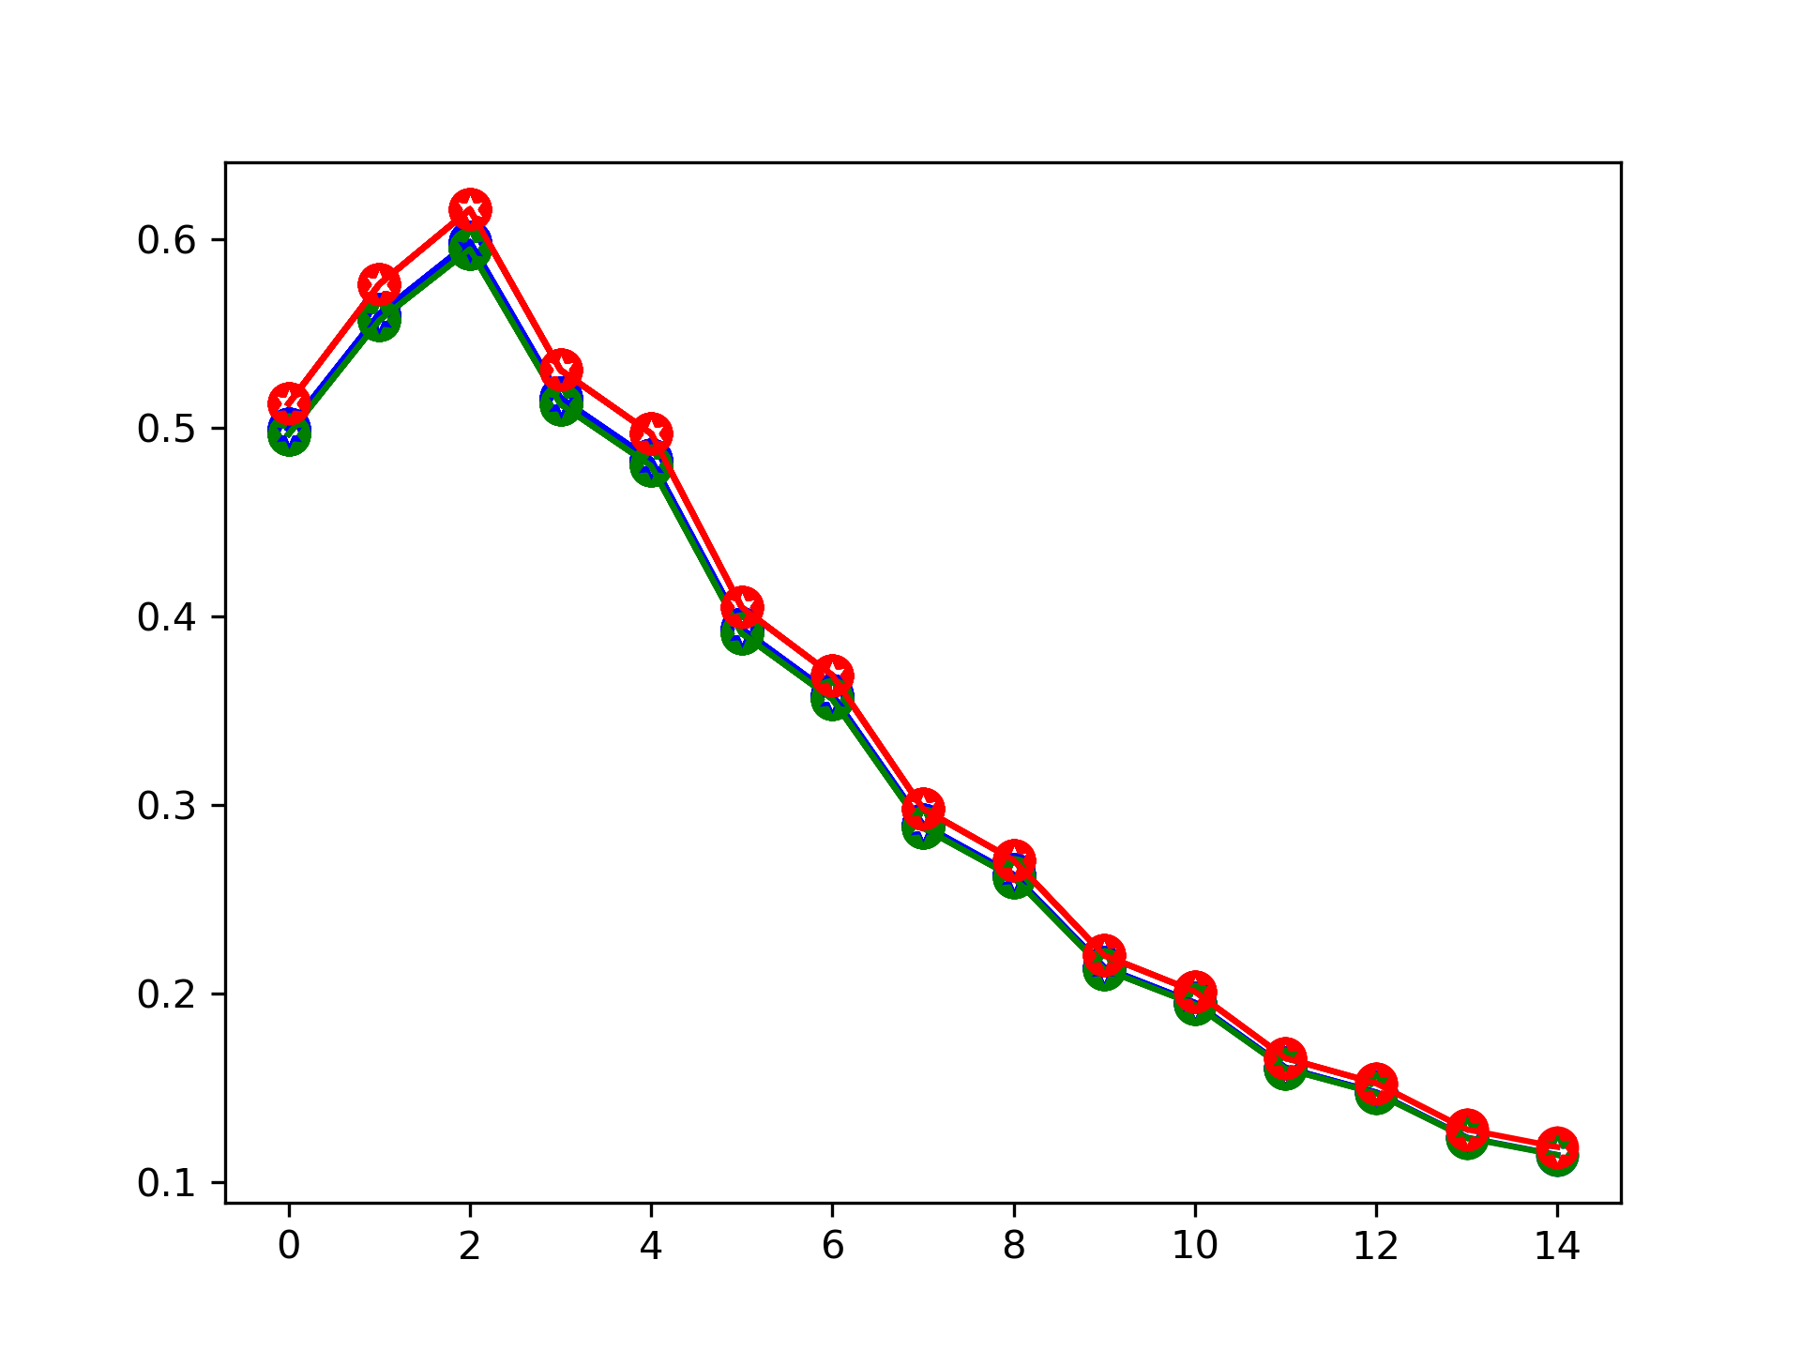

Figure 2. Ilustrates the training(blue), validation(green) and testing(red) Losses with the respect number of epochs traversal.
The 85 percent of testing accuracy reached at the 10th epoch from the Figure1.

Overall Work:
Initially I thought of developing the ADMM implementation on top of Hadoop distributed file system(HDFS) and MapRed. Since, Hadoop-ecosystem allows the large data replications in multiple machines and MapRed allows to train neural network modelling in distributed way. But, because of iterative functionality of ADMM, I thought its not possible to aggregate the results using Reducer’s (not experimented).
The Apache Spark, which is another big data open source framework, allows to play with huge datasets, and parallelized as block partitions in-memory. In this empirical project, the most of the time was allocated to research work related to ADMM(equations) and Spark optimization. The final results came pretty satisfied.
In the future works, continue this work in graph neural networks to scale ADMM optimization. And, experiment once, the distributed ADMM mechanism on Hadoop-ecosystem.

References:
1º. Classroom materials
1¹. Distributed Optimization and Statistical Learning via the Alternating Direction Method of Multipliers
2. ADMM based Scalable Machine Learning on Spark
3. Training Neural Networks Without Gradients:A Scalable ADMM Approach
4. https://spark.apache.org/docs/latest/
5. https://www.tensorflow.org/tutorials/images/cnn
6. Stackoverflow

