**Laboratory work 5**

*Solve following problems by HTML, JavaScript. Your web page should looks like an image below:*

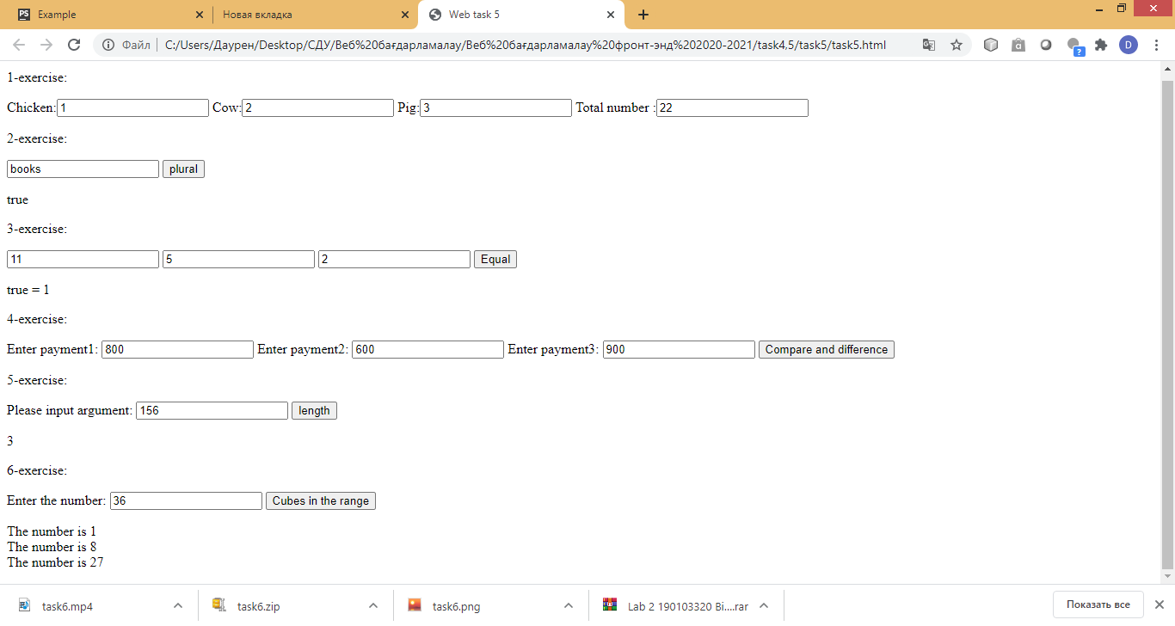

*Hint:*

*To get 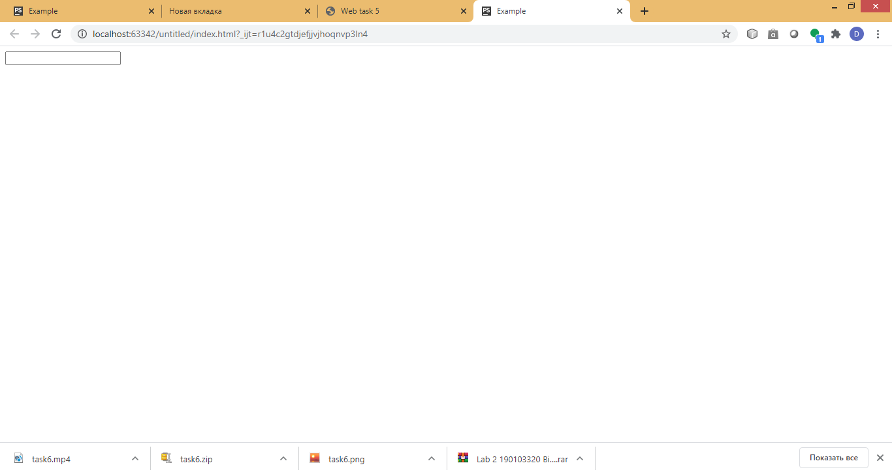 element, you should write* <**input type="text" id="input_id"**> .

To get entered text in your input, you should write:

document.getElementById("input_id").value;

To write some value in your input you should write:

document.getElementById("input_id").innerHTML ="some value";

**1.The Farm Problem**

You've got chickens (2 legs), cows (4 legs) and pigs (4 legs) on your farm. Return the total number of legs on your farm.

**Examples**

animals(2, 3, 5) ➞ 36

animals(1, 2, 3) ➞ 22

animals(5, 2, 8) ➞ 50

**2. Is the Word Singular or Plural?**

Write a function that takes in a word and determines whether or not it is plural.

**Examples**

isPlural("changes") ➞ true

isPlural("change") ➞ false

isPlural("magic") ➞ false

**3. Slice of Pie**

Write a function that determines whether or not it's possible to split a pie fairly giving these three parameters:

* Total number of slices.
* Number of recipients.
* How many slices each person gets.

The function will be in this form:

equalSlices(total slices, no. recipients, slices each)

**Examples**

equalSlices(11, 5, 2) ➞ true

// 5 people x 2 slices each = 10 slices < 11 slices

equalSlices(11, 5, 3) ➞ false

// 5 people x 3 slices each = 15 slices > 11 slices

equalSlices(8, 3, 2) ➞ true

equalSlices(8, 3, 3) ➞ false

equalSlices(24, 12, 2) ➞ true

**Notes**

* Return (trivially) true if there are zero people.
* It's fine not to use the entire pie.
* All test parameters are integers.

**4. The 3 Programmers Problem**

There are three programmers. Write a function that takes three numbers (the hourly wage of each programmer) and returns the difference between the highest paid programmer and the lowest paid .

**Examples**

programmers(147, 33, 526) ➞ 493

programmers(33, 72, 74) ➞ 41

programmers(1, 5, 9) ➞ 8

**5. Find the Total Number of Digits the Given Number Has**

Write a function that takes a number as an argument and returns the amount of digits it has.

Examples

findDigitAmount(123) ➞ 3

findDigitAmount(56) ➞ 2

findDigitAmount(7154) ➞ 4

findDigitAmount(61217311514) ➞ 11

findDigitAmount(0) ➞ 1

**6.**Write a function, which prints cubes of integer numbers until cube exceed entered number. For instance, if user enters 126, your program should print 1, 8, 27, 64,125. If user enters 44, your program should enter 1,8,27.