Report

|  |  |
| --- | --- |
| Student name: | Muratov Dastan, Yesbosym Aiym |
| Group: | SE-2116 |
| Teacher name: | Beisembiyev Bakhytzhan |
| Project name: | Music-shop Web Site |
| Project type: | Group |
| Analogies: | 1. <https://www.soundbarmusic.com/soundtrack-music> 2. <https://www.vinyl.com.au> |
| User roles: | Administrator, Customer |
| Functions: | Database function; Search and Retrieve; Log in and Sign Up functions; Sort by filters |

**INTRODUCTION PART**

Our team decided to create a website related to music, or rather the sale of vinyl records. Our goal is to enable our customers and music lovers to buy discs, provide the best service using information technology. The audience of our website: people for all increase, because both children and adults can get carried away and order vinyl. Fill up your music collection with records. Whether you are re a long-time vinyl purist or have just discovered the wonders of the format. We have you covered with a selection of records from artists of all genres and eras.

**MAIN PART**

The online store will be made by us to enable customers to buy music-related products from home and make it accessible to all music lovers. For example, you want to buy a vinyl record, but finding them in your country is very difficult, and looking for the problem is very difficult and takes a lot of time. Customers acquire one click on our website. We create a website with a huge interface and features. It will be enough to open our site in any case to make a purchase. First, we will choose the ways in which we will create our website. We believe that the most correct and suitable option for us to write codes backend is Node JS. And we will also use the programming languages HTML, CSS and JavaScript to write the frontend. Bootstrap will be the basis for the above. Most importantly Node JS will be responsible for the main part and functionality of our site. We will use MySQL to work with queries and database. HTML and CSS were used to create the interface of the website. JavaScript, Node JS were used to write the main part of the website and were responsible for their functionality. The main reason of choosing those programming languages was that they are easy to learn compared to other alternatives. Also, we used MySQL and Bootstrap. MySQL was used in order to work with queries and databases. While Bootstrap was the framework for HTML, CSS and JavaScript.

*Web Site will be used by:*

1. Administrator
2. Users

*Web Site should be:*

* Easy to use
* Functional
* Responsive Design
* Well Dessigned
* Have contact information
* FAQs Section
* Useful for Clients

*For admin website should include next opportunities:*

1) Shopping cart. The administrator can view the customer’s shopping cart and has the right to reject the customer’s request or accept it due to the availability of goods.

2) Find the order. In this section, the administrator sees the customer’s order and its details, with which he can contact him.

*Site functions:*

The client can enter his personal account or register. When entering a personal account, he has access to a shopping cart, a list of favorites, as well as he can save some goods in the Wishing List. The site will run a search engine, as well as sorting by filters and different categories. Background of some vinyl records will play music from this album.

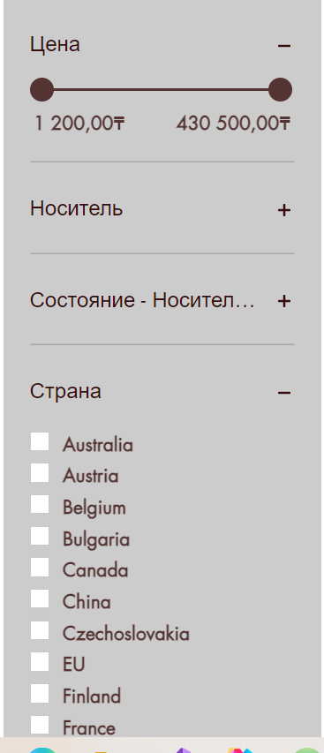 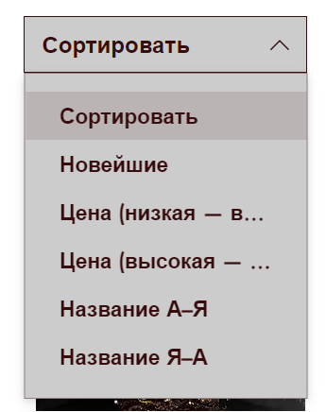

*Screens for analogies (similar websites) across the internet corresponding to our topic:*

1. 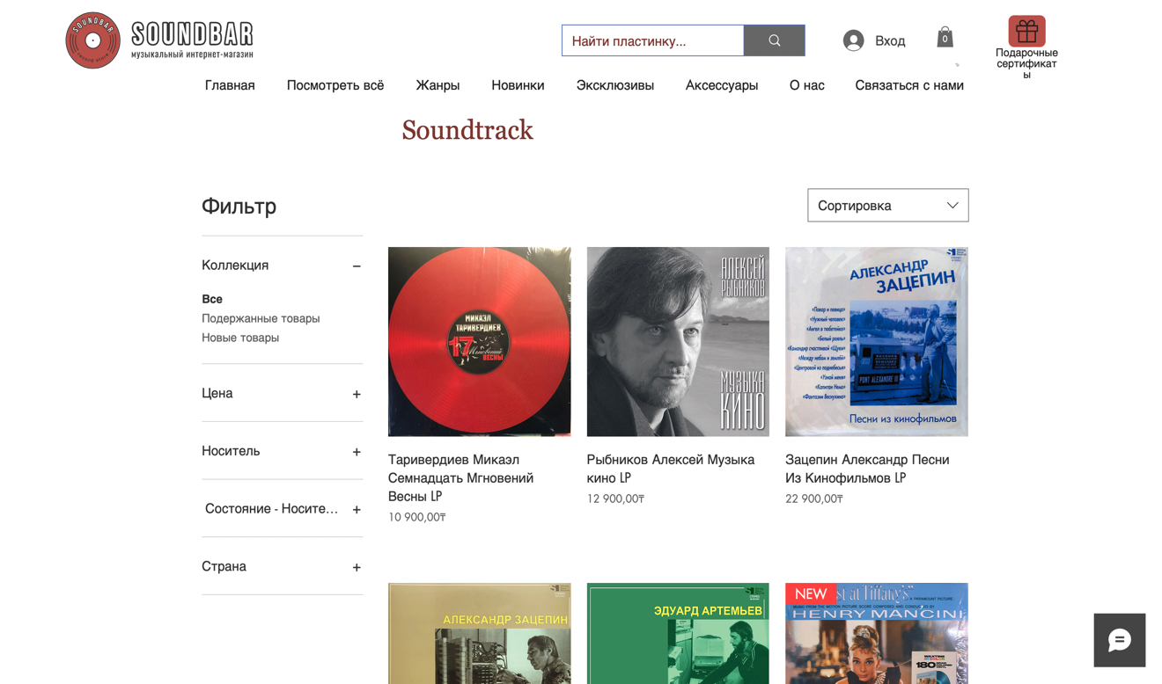 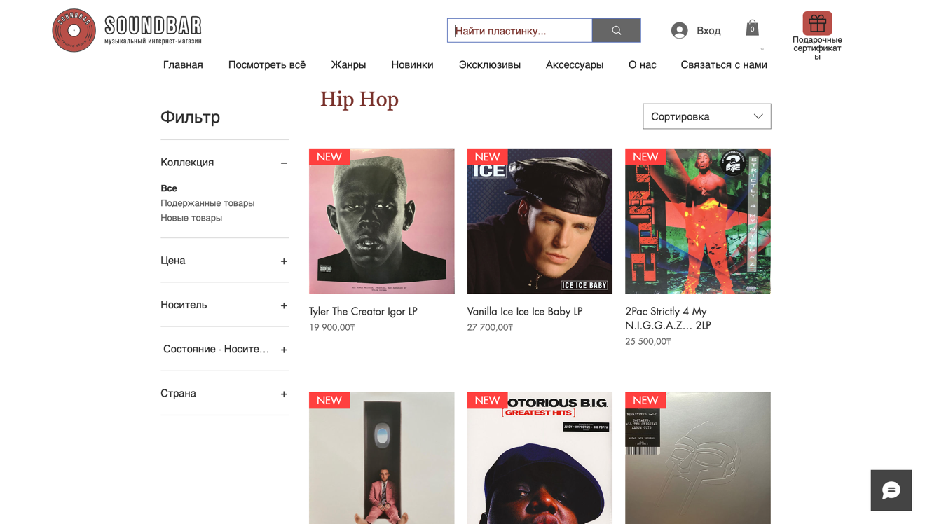
2. Изображение выглядит как текст, другой, снимок экрана

   Автоматически созданное описание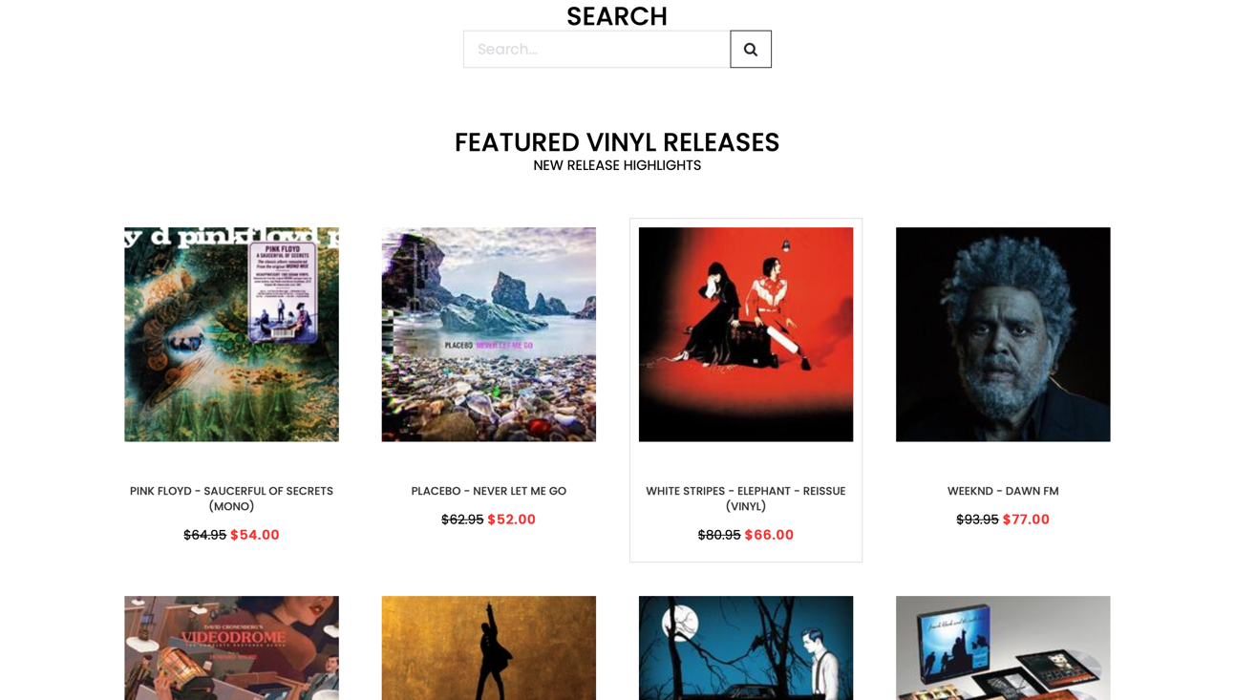

Sitemap: 