ELEC 5614

Christopher Rosiak

Han Lin

Kelvin D'Amore - 430515051

Stephen Tridgell

**Hydroelectric Dam System Simulation**

Real Time Computing

May 7, 214

Table of Contents

Introduction 1

Project Description 1

Deliverable 1 2

Use Case Diagram 2

Deliverable 2 3

Functional Requirements 3

Non-functional Requirements 3

Deliverable 3 4

State Diagram 4

Sequence Diagram 4

Diagram 3 4

Diagram 4 4

Deliverable 4 5

Real Time System Code 5

Deliverable 5 6

Test Cases 6

# Introduction

Power and water consumption are integral parts of any type of community to provide the basic necessities available for people to use. This makes the use of a hydroelectric dam system to be hugely important to be able to extract both appropriate power and water needs for a community while calculating important water capacity constraints between dams and ensuring appropriate flow. This makes the use of real time computing widely important as data such as dam capacity, power usage, water usage, river flow and upstream pumping are highly competing factors that have large impacts on the system all of which must be done at real time to ensure appropriate calculations are carried out and constraints are being adhered to so that the functional and non-functional requirements of the system is met.

# Project Description

As a hydroelectric dam system designed to provide adequate water and electricity to a typical community has such a large reliance on real time systems a simulation was designed for this project to analyse appropriate real time calculations and provide an advanced overview of expected outcomes of the system dependent on many different constraints including electricity usage, water usage and water availability. The simulation in particular that will be tested within the project will include 4 main dams as seen below with an interconnecting river and piping system to allow for water flow to either go down through generators to obtain electricity or up through pipes to bank water into dams or resend extra water for power availability at a later use.

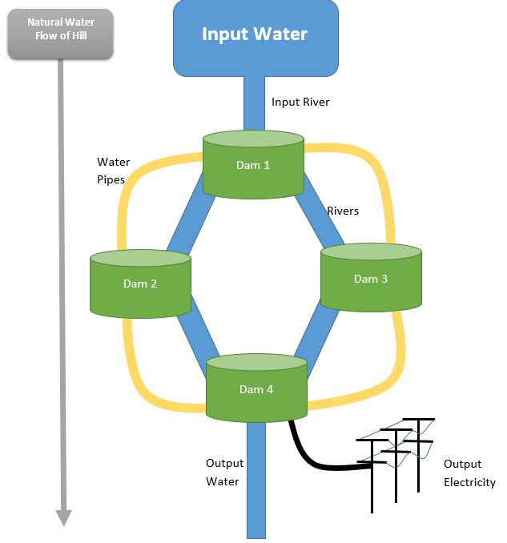

# Deliverable 1

## Use Case Diagram

Actor 1 – Electricity Usage

Actor 2 – Water Usage

Include Use Case Description???

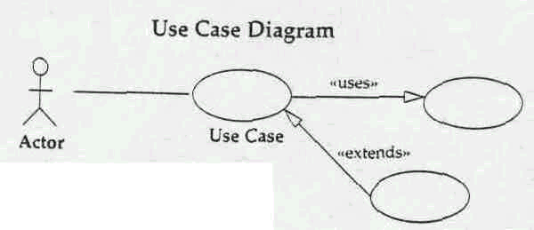

|  |  |
| --- | --- |
| **Name** |  |
| **Id Number** |  |
| **Goal** |  |
| **Scope & Level** |  |
| **Pre-Condition** |  |
| **Success end condition** |  |
| **Failed end condition** |  |
| **Actor(s)** |  |
| **Brief Description** |  |
| **Frequency of use case** |  |
| **Level of Risk** |  |
| **Priority** |  |
| **Stakeholder(s)** |  |
| **Trigger(s)** |  |
| **Normal Flow** |  |
| **Include** |  |
| **Extends** |  |

# Deliverable 2

## Functional Requirements

* Provide Appropriate Electricity
* Provide Appropriate Water
* Pump Water upstream to a dam
* Flow water downstream for power and movement

## Non-functional Requirements

Should be defined in terms of metrics (Actual value).

* Compliance
* Disaster recovery
* Efficiency (resource consumption for given load)
* Failure management
* Maintainability
* Performance / response time (performance engineering)
* Quality (e.g. faults discovered, faults delivered, fault removal efficacy)
* Recovery / recoverability (e.g. mean time to recovery – MTTR downtime?)
* Reliability (e.g. mean time between failures - MTBF)
* Safety or Factor of safety
* Stability

Keep river above X amount or percent capacity

Keep dam above X amount of capacity

Ensure dam is below Y amount capacity

# Deliverable 3

## State Diagram

## Sequence Diagram

## Diagram 3

## Diagram 4

# Deliverable 4

## Real Time System Code

# Deliverable 5

## Test Cases

Possible example test case from SQE

Test Case

|  |  |
| --- | --- |
| **Title**: |  |
| **Type of test**: |  |
| **Purpose**: |  |
| **Prerequisite**: |  |
| **Input data/Entry criteria**: |  |
| **Steps**: |  |
| **Output**: |  |
| **Exit criteria**: |  |
| **Recommendations**: |  |
| **Note**: |  |

Test Case

|  |  |
| --- | --- |
| **Title**: |  |
| **Type of test**: |  |
| **Purpose**: |  |
| **Prerequisite**: |  |
| **Input data/Entry criteria**: |  |
| **Steps**: |  |
| **Output**: |  |
| **Exit criteria**: |  |
| **Recommendations**: |  |
| **Note**: |  |