ELEC 5614

Christopher Rosiak

Han Lin

Kelvin D'Amore - 430515051

Stephen Tridgell

**Snowy Hydro Scheme Simulation**

Real Time Computing

June 7, 214

Table of Contents

Introduction 1

Project Description 1

Snowy Hydro Map Scheme 2

Deliverable 1 5

Use Case Diagram 5

Deliverable 2 6

Functional Requirements 6

Non-functional Requirements 6

Deliverable 3 7

State Diagram 7

Sequence Diagram 7

Diagram 3 7

Diagram 4 7

Deliverable 4 8

Real Time System Code 8

Deliverable 5 9

Test Cases 9

# Introduction

Power and water consumption are integral parts of any type of community to provide the basic necessities available for people to use. This makes the use of a hydroelectric dam system to be largely important to be able to extract both appropriate power and water needs for a community while calculating important water capacity constraints between dams and ensuring appropriate flow. This makes the use of real time computing widely important as data such as dam capacity, power usage, water usage, river flow and upstream pumping are highly competing factors that have large impacts on the system all of which must be done at real time to ensure appropriate calculations are carried out and constraints are being adhered to so that the functional and non-functional requirements of the system is met.

# Project Description

As a hydroelectric dam system designed to provide adequate water and electricity to a typical community has such a large reliance on real time systems a simulation was designed for this project to analyse appropriate real time calculations and provide an advanced overview of expected outcomes of the system dependent on many different constraints including electricity usage, water usage and water availability. The simulation in particular tested the Snowy Mountains Scheme in New South Wales, Australia. The scheme consists of a major network of hydroelectric and normal dams spanning through the system utilising 15 major dams and 7 power stations. The scheme itself is seen to be one of the largest engineering projects seen in Australia and provides water and electricity to surrounding communities

To start development on the scheme appropriate information needed to be researched about the system first of which was how each dam connected with each other. Unfortunately as no adequate map is available that shows the complete damn and hydroelectric system utilised by snowy hydro. An original map had to be created to develop appropriate connections between rivers, pipes, outflow, dams and hydropower stations. This map was simplified and utilised for the programming part of the project to design an adequate and real time system of the snowy hydro scheme. The map in particular manipulated variables such as rivers being seen as a huge dam and the simplification of connections between dams, pipes and rivers as well as some minor rivers being removed. The complete mapping system for the project can be seen below:

## Snowy Hydro Map Scheme

**Key:**



Dams

Rivers

Lakes

Pipes

Outflow

Blowering

Jounama

Talbingo

Tumut 2

Tumut 1

Tooma

Happy Jacks

Tangara

Eucumbene

Jindabyne

Geehi

Murray 1

Murray 2

Khanconban

Outflow

Outflow

Outflow

Island Bend

Guthega

Information provided by Snowy Hydro for the Dam and hydroelectric system made the following quantifiable variables:

|  |  |  |
| --- | --- | --- |
| Dam Name | Capacity (ML) | Max Power (MW) |
| Blowering | 1628000 | 80 |
| Talbingo | 921400 | 1500 |
| Tumut 2 | 2677 | 286 |
| Tumut 1 | 52793 | 330 |
| Guthega | 1604 | 60 |
| Murray | 2344 | 1500 |
| Jounama | 43542 | 0 |
| Tooma | 28124 | 0 |
| Happy Jacks | 271 | 0 |
| Tangara | 254099 | 0 |
| Eucumbene | 4798400 | 0 |
| Jindabyne | 688287 | 0 |
| Island Bend | 3084 | 0 |
| Geehi | 21093 | 0 |
| Khancoban | 26643 | 0 |

Rivers and piping system also had to be analysed throughout the snowy hydro scheme. Unfortunately very limited information is given about these integral variables for the system and thus a lot of information needed to be obtained in approximate amounts. The lengths were developed by analysing river maps of the scheme system and measuring the lengths seen between these dams and scaling them appropriately. This made it possible to obtain much higher accuracy type estimations as it is based on the actual mapping of the snowy mountains. The maximum values were then worked out to be approximately the Mega Litres of 3 times the length of the river. The minimum capacity value was then viewed as 10 percent of this value providing an adequate estimation of the complete snowy scheme. The importance of a maximum value for a river was used as any water capacity above this point would be found to flood the river and cause damage to the system. Alternatively a minimum capacity was needed as if the river flow is too low, it can highly effect the ecological life of the river themselves also causing damage.

|  |  |  |  |  |  |
| --- | --- | --- | --- | --- | --- |
| Name | Type | Max Cap (ML) | Min Cap (ML) | Length (m) | End Point |
| Blowering to Ocean | River | 1000 | 100 | 10 | Ocean |
| Junama To Blowering | River | 54 | 5 | 17857 | Blowering |
| Talbingo to Jumama | River | 27 | 3 | 8923 | Jounama |
| Tumut to Talbingo | River | 89 | 9 | 29762 | Talbingo |
| Tumut 1 to Tumut 2 | River | 27 | 3 | 8929 | Tumut 2 |
| Happy Jacks to Tumut 1 | River | 45 | 5 | 14881 | Tumut 1 |
| Eucumbene to Happy Jacks | Pipe |  |  |  |  |
| Tangara to Eucumbene | River | 107 | 10 | 35714 | Eucumbene |
| Eucumbene to Jinabyne | River | 928 | 93 | 327382 | Jindabyne |
| Snow River | River | 100 | 0 | 100 | Ocean |
| JindaBune to Island Bend | Pipe |  |  |  |  |
| Eucumbene to Island | Pipe |  |  |  |  |
| Guthega to Island Bend | River | 54 | 5 | 17857 | Island Bend Dam |
| Island Bend to Geehi | River | 48 | 5 | 16071 | Geehi |
| Geehi to Murray | River | 45 | 5 | 14881 | Murray |
| Murray to Khancoban | River | 31 | 3 | 10119 | Khancoban |
| Khancoban to Ocean | River | 100 | 0 | 100 | Ocean |

Data of the flow of the snowy scheme needed to be analysed so that appropriate simulation could be undertaken in a close to accurate test of the system. Research online showed that from the year of 2012 to 2013 the water inflow through snowy hydro was about 2,188GL of water. This value could thus be utilised as appropriate water inflow for about a year and could be shared among the dams to provide adequate use for electricity and water. Research for power itself found that about 260 litres of water is used to obtain 1000 KWh of power. Utilising this data would show that 3.8462 KWh of electricity is provided by the hydroelectric dams if converted to a typical litre. Outflow of the water was also found to be <><><> Add out flow <><><>

<http://spectrum.ieee.org/energy/environment/how-much-water-does-it-take-to-make-electricity>

http://www.snowyhydro.com.au/

# Deliverable 1

## Use Case Diagram

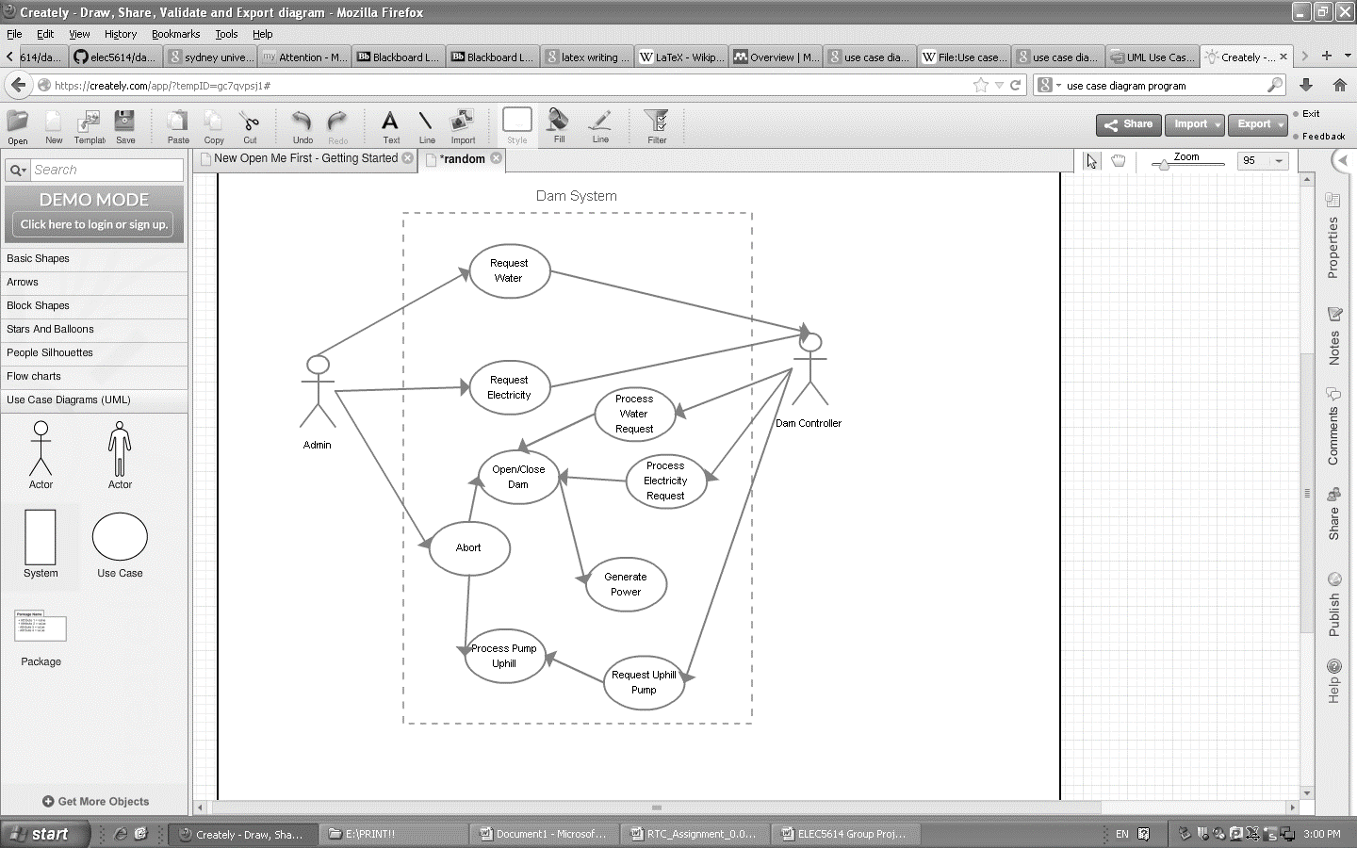

# Deliverable 2

## Functional and Non-functional Requirements

1. **Functional Requirements**
   1. System Functions
      1. The System shall automatically provide appropriate electricity based on demand
      2. The System shall automatically provide appropriate water output based on demand
      3. The appropriate abort request will automatically halt the system
      4. Pipes can send water both up and down to dams utilising power from the snowy hydro scheme.
      5. Dams will provide adequate storage for water loading to be used for demand periods of water and power.
2. **Non Functional Requirements**
   1. Safety
      1. Dam failure will have a maximum of three days for recovery.
      2. The Scheme will adhere to all compliance as stated by typical international standards
      3. Rivers will ensure a maximum value of three times the length of the river to halt overflow and damaging the system.
      4. Rivers will have a minimum of 10 percent capacity at all times to ensure drought times does not affect the river structure or ecology.
   2. Maintenance
      1. Each dam will have monthly maintenance to adhere to applicable preventative maintenance structure.
      2. Non-critical scheme faults will be addressed within 48 hours.
   3. Performance
      1. The Hydro Snowy Scheme will have less than 5 percent down time a year
      2. Water based demand will be adhered to within 24 hours
      3. Electricity based demand will be adhered to within 5 hours

# Deliverable 3

## State Diagram

## Sequence Diagram

## Diagram 3

## Diagram 4

# Deliverable 4

## Real Time System Code

# Deliverable 5

## Test Cases

Possible example test case from SQE

Test Case

|  |  |
| --- | --- |
| Title: |  |
| Type of test: |  |
| Purpose: |  |
| Prerequisite: |  |
| Input data/Entry criteria: |  |
| Steps: |  |
| Output: |  |
| Exit criteria: |  |
| Recommendations: |  |
| Note: |  |

Test Case

|  |  |
| --- | --- |
| Title: |  |
| Type of test: |  |
| Purpose: |  |
| Prerequisite: |  |
| Input data/Entry criteria: |  |
| Steps: |  |
| Output: |  |
| Exit criteria: |  |
| Recommendations: |  |
| Note: |  |