ELEC 5614

Christopher Rosiak

Han Lin

Kelvin D'Amore - 430515051

Stephen Tridgell

**Snowy Hydro Scheme Simulation**

Real Time Computing

June 7, 214

Table of Contents

Introduction 1

Project Description 1

Snowy Hydro Map Scheme 2

Snowy Scheme Information 3

Deliverable 1 5

Use Case Diagram 5

Deliverable 2 6

Functional and Non-functional Requirements 6

1. Functional Requirements 6

2. Non-Functional Requirements 7

Deliverable 3 9

State Diagram 9

Sequence Diagram 9

Diagram 3 9

Diagram 4 9

Deliverable 4 10

Real Time System Code 10

Deliverable 5 11

Test Case 1 11

Test Case 2 12

Test Case 3 13

# Introduction

Power and water consumption are integral parts of any type of community to provide the basic necessities available for people to use. This makes the use of a hydroelectric dam system to be largely important to be able to extract both appropriate power and water needs for a community while calculating important water capacity constraints between dams and ensuring appropriate flow. This makes the use of real time computing widely important as data such as dam capacity, power usage, water usage, river flow and upstream pumping are highly competing factors that have large impacts on the system all of which must be done at real time to ensure appropriate calculations are carried out and constraints are being adhered to so that the functional and non-functional requirements of the system is met.

# Project Description

As a hydroelectric dam system designed to provide adequate water and electricity to a typical community has such a large reliance on real time systems a simulation was designed for this project to analyse appropriate real time calculations and provide an advanced overview of expected outcomes of the system dependent on many different constraints including electricity usage, water usage and water availability. The simulation in particular tested the Snowy Mountains Scheme in New South Wales, Australia. The scheme consists of a major network of hydroelectric and normal dams spanning through the system utilising 15 major dams and 7 power stations. The scheme itself is seen to be one of the largest engineering projects seen in Australia and provides water and electricity to surrounding communities

To start development on the scheme appropriate information needed to be researched about the system first of which was how each dam connected with each other. Unfortunately as no adequate map is available that shows the complete damn and hydroelectric system utilised by snowy hydro. An original map had to be created to develop appropriate connections between rivers, pipes, outflow, dams and hydropower stations. This map was simplified and utilised for the programming part of the project to design an adequate and real time system of the snowy hydro scheme. The map in particular manipulated variables such as rivers being seen as a huge dam and the simplification of connections between dams, pipes and rivers as well as some minor rivers being removed. The complete mapping system for the project can be seen below:

## Snowy Hydro Map Scheme

**Key:**



Dams

Rivers

Lakes

Pipes

Outflow

Blowering

Jounama

Talbingo

Tumut 2

Tumut 1

Tooma

Happy Jacks

Tangara

Eucumbene

Jindabyne

Geehi

Murray 1

Murray 2

Khanconban

Outflow

Outflow

Outflow

Island Bend

Guthega

## Snowy Scheme Information

Information provided by Snowy Hydro for the Dam and hydroelectric system made the following quantifiable variables:

|  |  |  |
| --- | --- | --- |
| Dam Name | Capacity (ML) | Max Power (MW) |
| Blowering | 1628000 | 80 |
| Talbingo | 921400 | 1500 |
| Tumut 2 | 2677 | 286 |
| Tumut 1 | 52793 | 330 |
| Guthega | 1604 | 60 |
| Murray | 2344 | 1500 |
| Jounama | 43542 | 0 |
| Tooma | 28124 | 0 |
| Happy Jacks | 271 | 0 |
| Tangara | 254099 | 0 |
| Eucumbene | 4798400 | 0 |
| Jindabyne | 688287 | 0 |
| Island Bend | 3084 | 0 |
| Geehi | 21093 | 0 |
| Khancoban | 26643 | 0 |

Rivers and piping system also had to be analysed throughout the snowy hydro scheme. Unfortunately very limited information is given about these integral variables for the system and thus a lot of information needed to be obtained in approximate amounts. The lengths were developed by analysing river maps of the scheme system and measuring the lengths seen between these dams and scaling them appropriately. This made it possible to obtain much higher accuracy type estimations as it is based on the actual mapping of the snowy mountains. The maximum values were then worked out to be approximately the Mega Litres of 3 times the length of the river. The minimum capacity value was then viewed as 10 percent of this value providing an adequate estimation of the complete snowy scheme. The importance of a maximum value for a river was used as any water capacity above this point would be found to flood the river and cause damage to the system. Alternatively a minimum capacity was needed as if the river flow is too low, it can highly effect the ecological life of the river themselves also causing damage.

|  |  |  |  |  |  |
| --- | --- | --- | --- | --- | --- |
| Name | Type | Max Cap (ML) | Min Cap (ML) | Length (m) | End Point |
| Blowering to Ocean | River | 1000 | 100 | 10 | Ocean |
| Junama To Blowering | River | 54 | 5 | 17857 | Blowering |
| Talbingo to Jumama | River | 27 | 3 | 8923 | Jounama |
| Tumut to Talbingo | River | 89 | 9 | 29762 | Talbingo |
| Tumut 1 to Tumut 2 | River | 27 | 3 | 8929 | Tumut 2 |
| Happy Jacks to Tumut 1 | River | 45 | 5 | 14881 | Tumut 1 |
| Eucumbene to Happy Jacks | Pipe |  |  |  |  |
| Tangara to Eucumbene | River | 107 | 10 | 35714 | Eucumbene |
| Eucumbene to Jinabyne | River | 928 | 93 | 327382 | Jindabyne |
| Snow River | River | 100 | 0 | 100 | Ocean |
| JindaBune to Island Bend | Pipe |  |  |  |  |
| Eucumbene to Island | Pipe |  |  |  |  |
| Guthega to Island Bend | River | 54 | 5 | 17857 | Island Bend Dam |
| Island Bend to Geehi | River | 48 | 5 | 16071 | Geehi |
| Geehi to Murray | River | 45 | 5 | 14881 | Murray |
| Murray to Khancoban | River | 31 | 3 | 10119 | Khancoban |
| Khancoban to Ocean | River | 100 | 0 | 100 | Ocean |

Data of the flow of the snowy scheme needed to be analysed so that appropriate simulation could be undertaken in a close to accurate test of the system. Research online showed that from the year of 2012 to 2013 the water inflow through snowy hydro was about 2,188GL of water. This value could thus be utilised as appropriate water inflow for about a year and could be shared among the dams to provide adequate use for electricity and water. Research for power itself found that about 260 litres of water is used to obtain 1000 KWh of power. Utilising this data would show that 3.8462 KWh of electricity is provided by the hydroelectric dams if converted to a typical litre. Outflow of the water was also found to be about 2,100 GL each year to the Murray Darling Basin, and about 4500 Gigawatt hours of energy is outputted by the scheme to meet the yearly demand.

<http://spectrum.ieee.org/energy/environment/how-much-water-does-it-take-to-make-electricity>

<http://www.snowyhydro.com.au/>

http://www.smec.com/our-business/divisions/australia/new-south-wales

# Deliverable 1

## Use Case Diagram

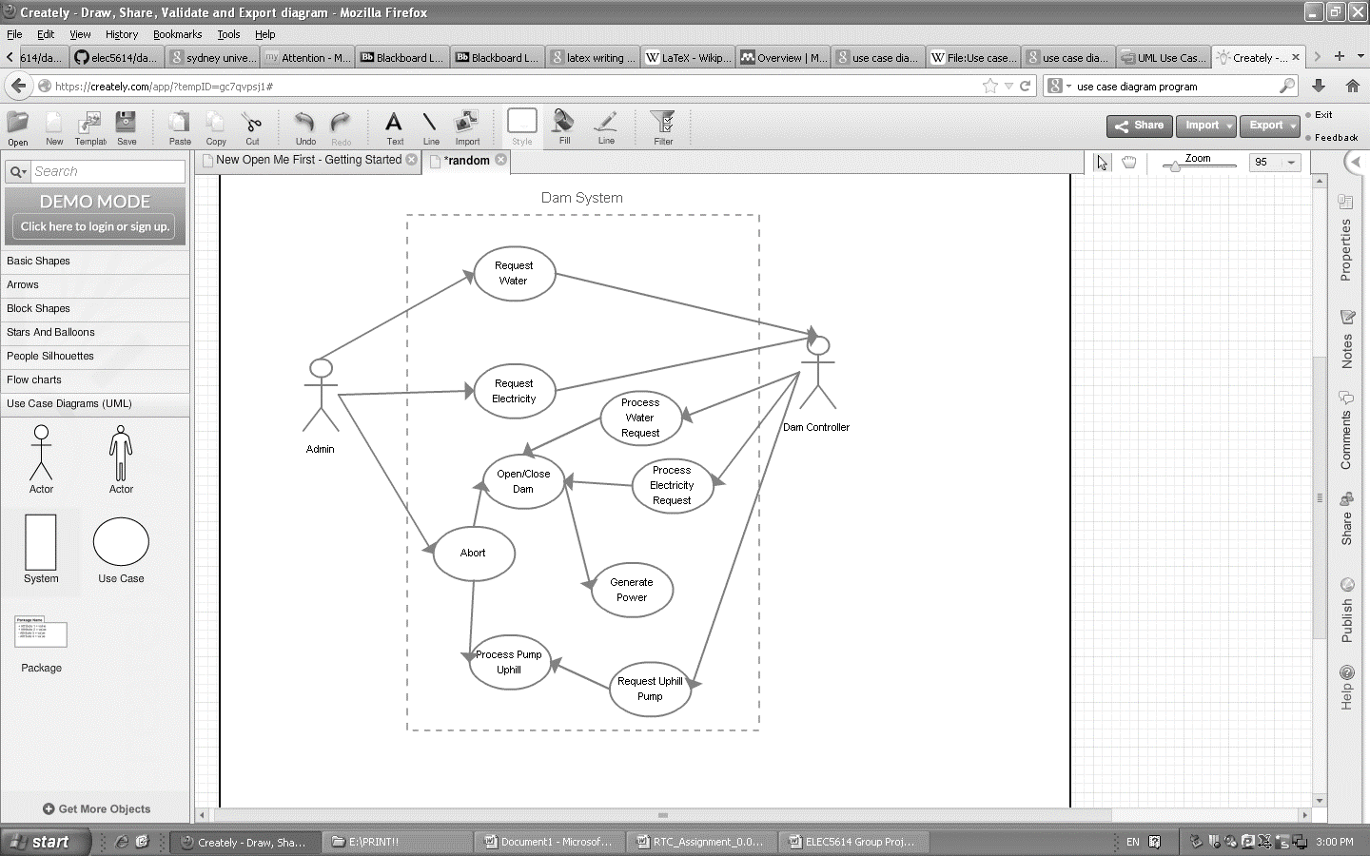

# Deliverable 2

## Functional and Non-functional Requirements

1. Functional Requirements
   1. **System Functions**
      1. The System shall automatically provide appropriate electricity based on demand
         1. The appropriate electricity output will calculate dam consumption and send the request
         2. The system will automatically open the correct dam depending on request to allow flow for power generation
         3. All dams through the system will be utilised for appropriate water flow although only the dams with hydroelectric plants will provide power
      2. The System shall automatically provide appropriate water output based on demand
         1. The appropriate water output will be calculated automatically and then the dam request will be sent
         2. The system will automatically open the appropriate dams to ensure water flow to the correct dam, this includes the dams with hydroelectric plants.
      3. Pipes can send water both up and down streams to dams utilising power from the snowy hydro scheme.
         1. The pipe system will utilise power while flowing water up stream only.
         2. Flowing water downstream should not use any power.
      4. Dams will provide adequate storage for water loading to be used for demand periods of water and power.
         1. During times of high rain or snow, water will be stored among the dam systems
         2. During times of low rain or snow the water will be released as part of the water outflow request.
      5. The system will automatically return information for appropriate dam usage.
         1. Specific dam level will be returned by the system.
         2. Overflow values of each dam will be returned by the system.
   2. **User Interface**
      1. The interface will provide all water data in terms of mega litres (ML) to ensure appropriate estimation and use within the scheme.
      2. All power values will utilise a megawatt (MW) or megawatt per hour (MWh) value for decisive calculation and estimation of the scheme.
      3. Overflow values will be shown in Boolean of either “true” if overflowed or “false” if it hasn’t.
      4. All dams as part of the interface will show its name, capacity, level and overflow value.
      5. The abort button will always be shown as part of the user interface
   3. **Design Constraints** 
      1. The snowy scheme will be designed utilising the Java programming language.
      2. The scheme will have support on both PC and UNIX or Linux platforms.
      3. Dynamic data will be utilised to ensure appropriate storing and utilisation of values.
   4. **Abort Function**
      1. The appropriate abort request will automatically halt the system
         1. The user can initiate the abort request basing off of information of the dam level and overflow values.
         2. The abort request can be applied at all times while the scheme is functioning
         3. Abort function will take precedence over all other function requests on the system
2. Non-Functional Requirements
   1. **Safety**
      1. The Scheme will adhere to all compliance standards
         1. Typical international standards for software development will be utilised as part of the scheme
         2. All units as part of the scheme will ensure to keep within units of the metric system.
      2. Rivers will be periodically tested to ensure it doesn’t go above or below approved flow.
         1. Rivers will ensure a maximum value of 3 times the length of the river to halt overflow and damaging the system.
         2. Rivers will have a minimum of 10 percent capacity at all times to ensure drought times does not affect the river structure or ecology.
      3. The snowy scheme will ensure that dams will not go above its specific maximum capacity value
         1. Return values of dam level capacity must be sent to the user interface periodically to ensure this doesn’t happen.
   2. **Maintenance**
      1. The MTBF should be 96 percent of the total running time of the scheme per annum.
      2. Non-critical scheme faults will be addressed within 48 hours.
   3. **Reliability**
      1. Error Handling
         1. Errors will ensure to save current
      2. Ease of Recovery
   4. **Performance**
      1. The Hydro Snowy Scheme will have less than 5 percent down time a year
      2. Water based demand will be requested and processed within seconds.
      3. Electricity based demand will be requested and process within seconds.
      4. Degradation of system performance during peak load of power and water should still output at least 90 percent of both water and power demand.
      5. Response Time
      6. Resource Usage
         1. Computing resource should utilise the minimum amount needed to ensure that appropriate calculations are
      7. User interface will update itself automatically every.
   5. **Accuracy and Precision**
      1. Electricity precision needs to be at least 5 percent within the required demand value.
      2. Dam level values need to be adequately accurate and precise to ensure appropriate user view.
         1. The maximum dam capacity will be accurate to a single decimal place of its specified unit.
         2. The current water level of a dam will be accurate to a single decimal place of the specified unit.
      3. Water and power demand needs to be accurately represented to ensure that the correct amount is supplied to the scheme
         1. Water demands should be given as a single float value with a maximum of 32 bits.
         2. Electricity demand should be given as a float value of a maximum of 32 bits

# Deliverable 3

## State Diagram

## Sequence Diagram

## Diagram 3

## Diagram 4

# Deliverable 4

## Real Time System Code

# Deliverable 5

## Test Case 1

**Test Case ID:** 1.1.1 – Typical usage

**Type of test:** Functional Testing

**Purpose:** Ensure that under typical stress and load that the snowy scheme correctly meets both water and power demands

**Prerequisite:**

* The dam should be in its typical running state
* No previous errors have occurred on the dam scheme
* No overflow is apparent on the dam scheme
* Initial capacity values are set to half the dam capacity
* All 15 dams including ones with power generation are operating normally
* The abort button has not been pressed

**Test data / Input data / Entry criteria:**

* Water inflow should be 2,188 GL per annum or 145,867 ML for each dam per annum.
* Power demand is set to 4500 GW-h per annum.
* Water demand should be 2100 GL per annum.
* Current dam level is set to half the dam capacity.

**Steps:**

1. Assuming a balanced water inflow over the snowy scheme, type down the value of 145,867 ML for each dam for water under the simulation window and then click on “Set Rain Level”
2. [Check] to ensure that no errors have occurred in implementing the expected rain level.
3. Type down 2100000 ML in the simulation window under the float value labelled area and click on change water demand.
4. Type down 4500 GW under the float value label area and click on change power demand.
5. [Check] the RTC Snowy Hydro window to see if any overflow, or over levelled values have occurred.
6. [Check] The console to make sure both water and electricity demand is correctly met.

|  |  |
| --- | --- |
| Expected | Actual |
| The model is valid  Controller initialized  Good  Good  Good  Good  Good  rainForDams List size:15  Dams List size:15 |  |

**Output:**

**Exit criteria:**

Pass:

* Overflow did not occur
* Water level was kept under capacity
* All inflow water was added to the scheme without error
* Power demand was met by the scheme
* Water demand is met appropriately by the scheme

Fail:

* Errors occurred of the water inflow
* Overflow occurred
* Water level went above capacity
* Power demand or water demand is not met

**Recommendations:**

**Notes, Issues and Questions:**

## Test Case 2

**Test Case ID:** 1.1.2 – Overflow of dam level

**Type of test:** Scenario Testing

**Purpose:** This test will check to make sure that if excess rain or snow flows into a particular dam then the overflow flag will sign “true”.

**Prerequisite:**

* The dam should be in its typical running state
* No previous errors have occurred on the dam scheme
* Initial capacity values are set to half the dam capacity
* All 15 dams including ones with power generation are operating normally
* The abort button has not been pressed

**Test data / Input data / Entry criteria:**

* Guthega dam water inflow is: 900 ML
* Power demand is set to 1000 GW-h per annum.
* Water demand should be 1000 GL per annum.
* Current dam level is set to half the dam capacity.

**Steps:**

1. Type in the value box the water demand of 100000 ML and click on the “change water demand” button.
2. Type in the box 100000 GW in the and click on “change power demand” button
3. Type a water inflow of 500 ML in every dam inflow except for the one titled “Guthega”.
4. Under the Guthega dam type and inflow of 1000ML.
5. Click on the “Set Rain Level” button.
6. [Check] that all rain levels were inputted correctly.
7. [Check] the RTC Snowy Hydro window to ensure that the Guthega overflow has turned its Boolean to true.

|  |  |
| --- | --- |
| Expected | Actual |
|  |  |

**Output:**

**Exit criteria:**

Pass:

* Power demand should be met by the snowy system
* Water demand should be met by the snowy system
* Guthega should show that it has gone to overflow in the RTC Snowy Hydro Window

Fail:

* No overflow Boolean change is seen in RTC Snowy Hydro window.
* Power demand is not met
* Water demand is not met

**Recommendations:**

**Notes, Issues and Questions:**

## Test Case 3

**Test Case ID:** 1.1.3 – Too high electricity demand

**Type of test:** Black Box Testing

**Purpose:** The main purpose of this test case is to ensure that during a time of electricity demand being above possible outputs, the appropriate error will return.

**Prerequisite:**

* The dam should be in its typical running state
* No previous errors have occurred on the dam scheme
* Initial capacity values are set to half the dam capacity
* All 15 dams including ones with power generation are operating normally
* The abort button has not been pressed

**Test data / Input data / Entry criteria:**

* Power demand is set to 1000 GW-h per annum.
* Water demand should be 1000 GL per annum.
* Current dam level is set to half the dam capacity.

**Steps:**

1. Under the simulation window add 0ML to every dam inflow value.
2. Enter a Power demand of 1000 GW and click on the “Change Power Demand” button.
3. Enter a water demand of 1000 GL and then press the “Change Water Demand” button.
4. Click on the “Set Rain Level” button.
5. [Check] the console and ensure that an error occurs which states that the power demand cannot be met.

|  |  |
| --- | --- |
| Expected | Actual |
|  |  |

**Output:**

**Exit criteria:**

Pass:

* No dam went over capacity
* Rain and snow inflow levels were added without errors
* A “Power demand not met:” error is shown followed by a “Needed 1234.0+/-5.0% and got 162.0” output.

Fail:

* Adding rain and snow levels achieved an error
* Any dam went over its capacity
* The “Power demand not met” error didn’t appear.

**Recommendations:**

**Notes, Issues and Questions:**