1. What are the Boolean data type's two values? How do you go about writing them?

A. Boolean datatype only take the values True or False. Values True=1 and False=0.

Type(True)

2. What are the three different types of Boolean operators?

A. Three types of Boolean operators AND ,OR and NOT.

3. Make a list of each Boolean operator's truth tables (i.e. every possible combination of Boolean values for the operator and what it evaluate ).

A.

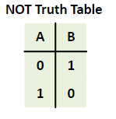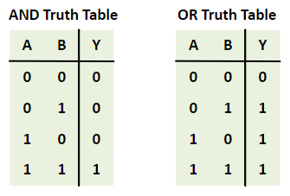

4. What are the values of the following expressions?

(5 > 4) and (3 == 5)

not (5 > 4)

(5 > 4) or (3 == 5)

not ((5 > 4) or (3 == 5))

(True and True) and (True == False)

(not False) or (not True)

A . (5 > 4) and (3 == 5) =False

not (5 > 4)= False

(5 > 4) or (3 == 5)= True

not ((5 > 4) or (3 == 5)) = False

(True and True) and (True == False)= False

(not False) or (not True)= True

5. What are the six different types of reference operators?

* Python Assignment Operators.
* Python Arithmetic Operators.
* Python Comparison Operators.
* Python Bitwise Operators.
* Python Logical Operators.
* Python Operator Precedence.

6. How do you tell the difference between the equal to and assignment operators?

A. = is a assignment operator which is used to assign value to right and to the variable to left.

== operator checks whether the two given operands are equal or not.

7. Describe a condition and when you would use one.

A. a=10,b=20 a output is 10

5==5 output is True

8. Recognize the following three blocks in this code:

spam = 0 # Block 1

if spam == 10: # Block2

print('eggs')

if spam > 5: # Block3

print('bacon')

else:

print('ham')

print('spam')

print('spam')

9. Create a programme that prints. If 1 is stored in spam, prints Hello; if 2 is stored in spam, prints Howdy; and if 3 is stored in spam, prints Salutations! if there's something else in spam.

spam=int(input(“Enter a number”))

if spam==1:

print(“Hello”)

elif spam==2:

print(“Howdy”)

elif spam==3:

print(“Salutations”)

else:

print(“something in spam”)

10.If your programme is stuck in an endless loop, what keys can you press?

A. CTRL+C

11. How can you tell the difference between break and continue?

A. Break statements exist in Python to exit or “break” a for or while conditional loop.

continue statement is used to skip code within a loop for certain iterations of the loop.

After the code is skipped

12. In a for loop, what is the difference between range(10), range(0, 10), and range(0, 10, 1)?

A. 1. Range(10) prints range(0,10) 2. Range(0,10) prints 0 to 9 numbers 3. Range of 0 to 9 with

1 stepwise

13. Using a for loop, write a short programme that prints the numbers 1 to 10 Then, using a while loop, create an identical programme that prints the numbers 1 to 10.

**## For Loop**

a=[1,2,3,4]

Sum=0

For i in a:

Sum=Sum+i

Print(“sum is”, sum)

## **While Loop**

i=2

j=6

while i<j:

i=i+1

print(i)

14. If you had a bacon() function within a spam module, how would you call it after importing spam?

## Bacon function

Def bacon():

Print(“Spam”)

bacon()