TOP-1
Sadullayev Jaxongir

Root CA uchun maxfiy kalit yaratish
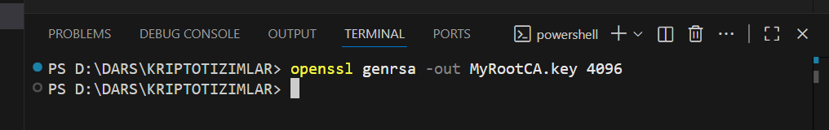
openssl genrsa -out MyRootCA.key 4096

Root sertifikatini yaratish
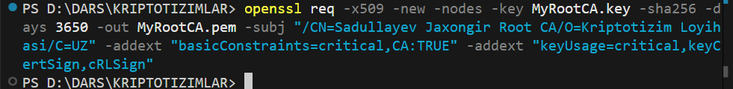
openssl req -x509 -new -nodes -key MyRootCA.key -sha256 -days 3650 -out MyRootCA.pem -subj "/CN=Sadullayev Jaxongir Root CA/O=Kriptotizim Loyih
asi/C=UZ" -addext "basicConstraints=critical,CA:TRUE" -addext "keyUsage=critical,keyC
ertSign,cRLSign"
Sertifikat ma'lumotlarini tekshirish
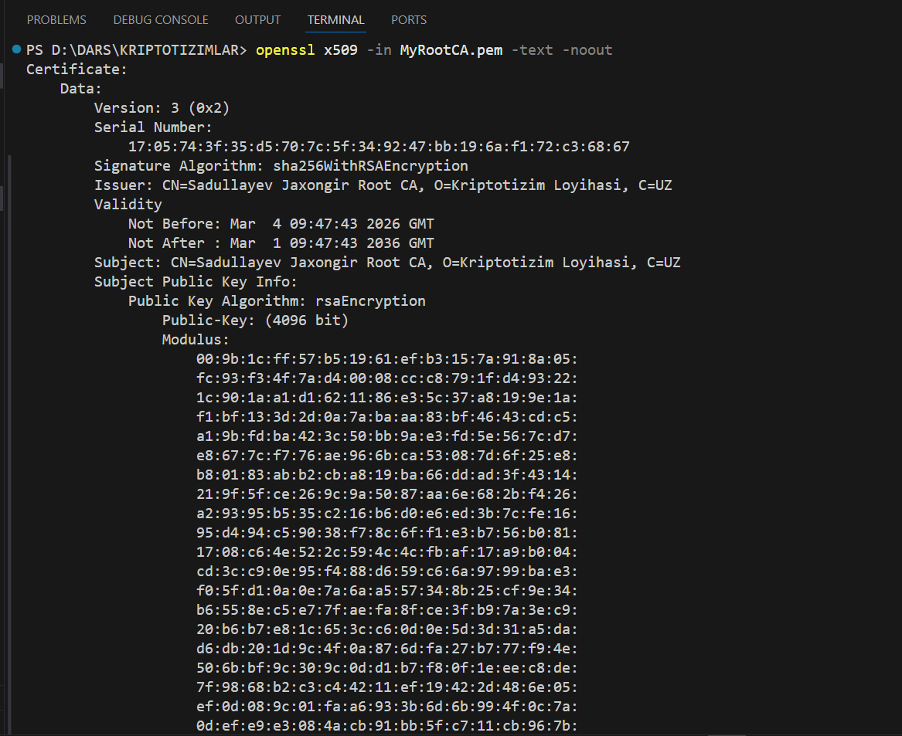 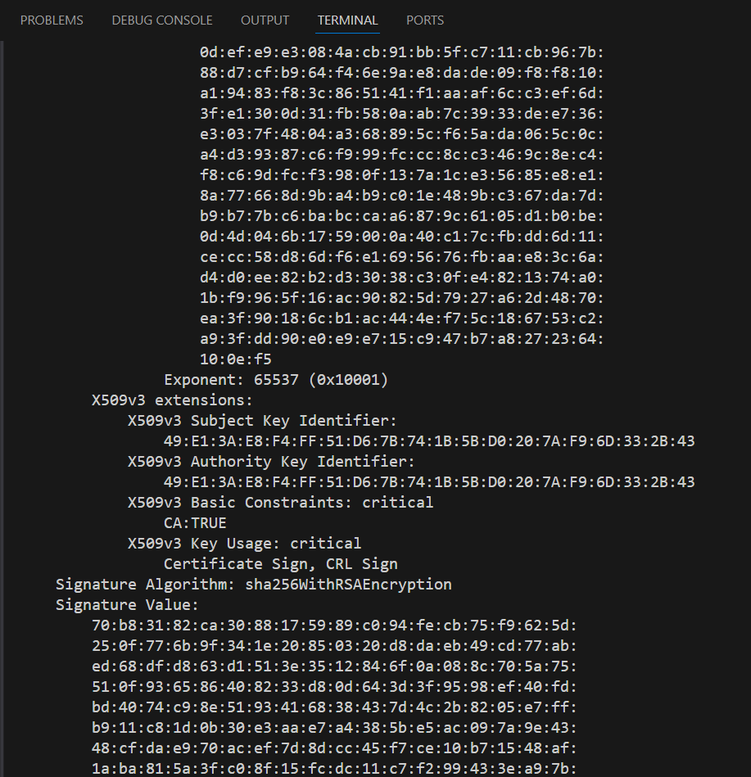 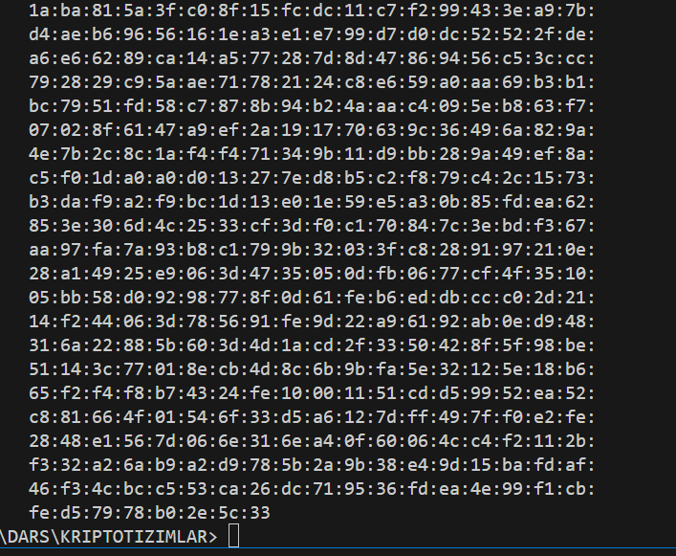
qisqacha:
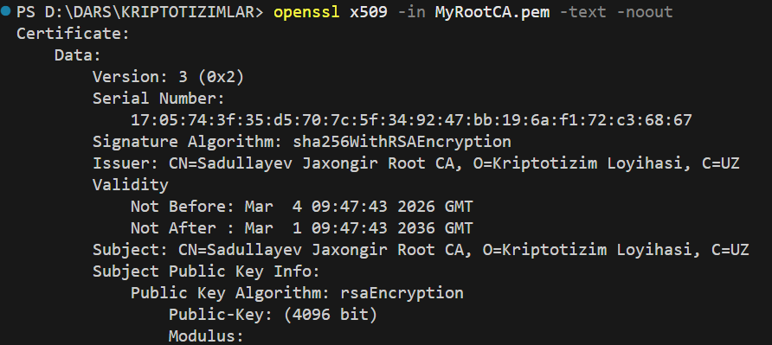
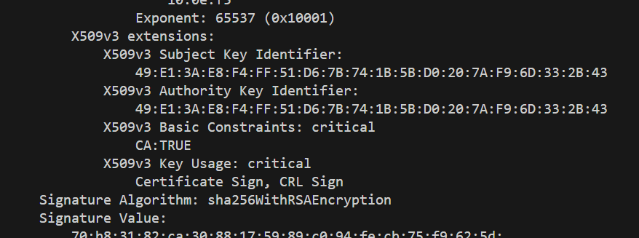
openssl x509 -in MyRootCA.pem -text –noout
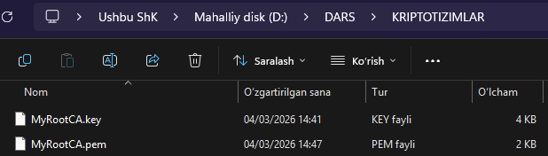

Sertifikatlash markazi tayyor!
- MyRootCA.key: muhri
- MyRootCA.pem: ochiq sertifika

Server uchun maxfiy kalit yaratish
openssl genrsa -out server.key 2048

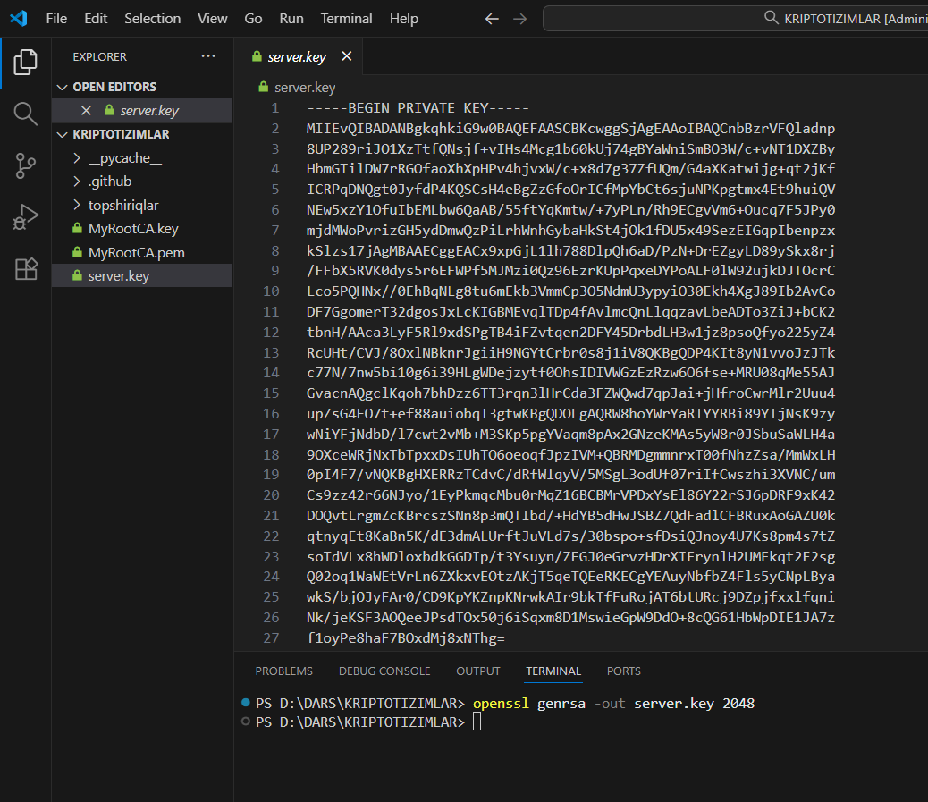

IP manzilingizni aniqlash
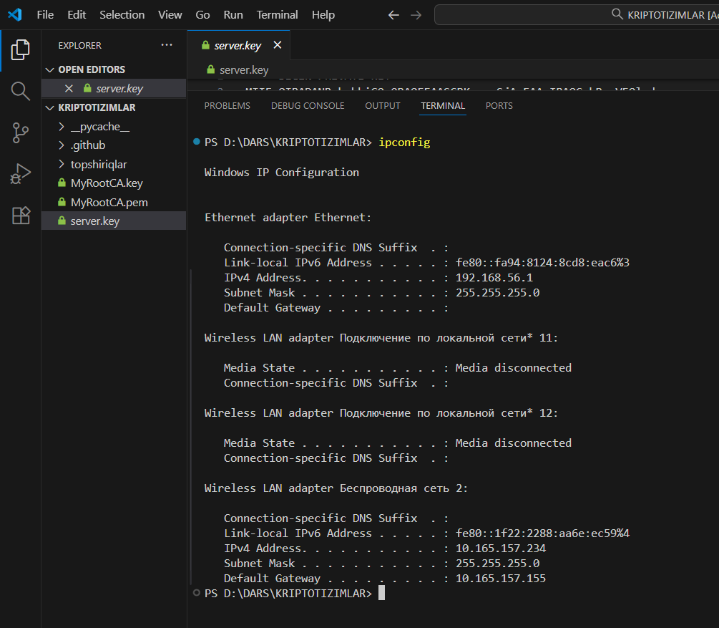
IPv4 Address. . . . . . . . . . . : 192.168.56.1

Sertifikat so'rovi (CSR) yaratish

openssl req -new -key server.key -out server.csr -subj "/CN=MeningLokalServerim/O=Loyiham/C=UZ"

Sertifikatni Root CA bilan imzolash
openssl x509 -req -in server.csr -CA MyRootCA.pem -CAkey MyRootCA.key -CAcreateserial -out server.crt -days 825 -sha256 -extfile server.ext
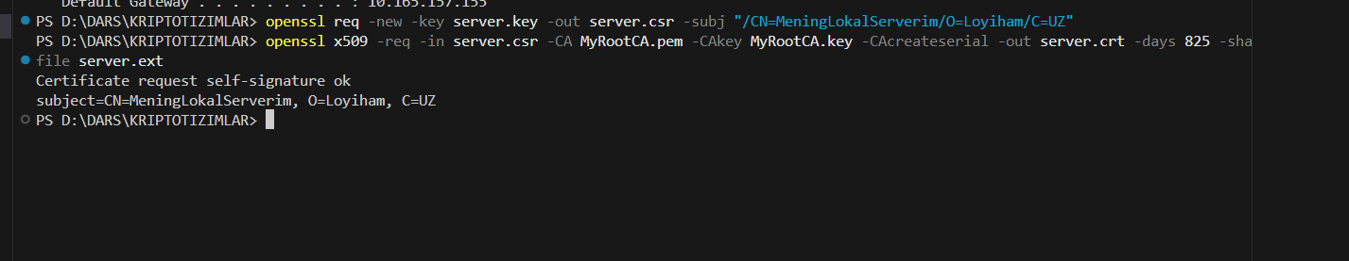
Tekshirish
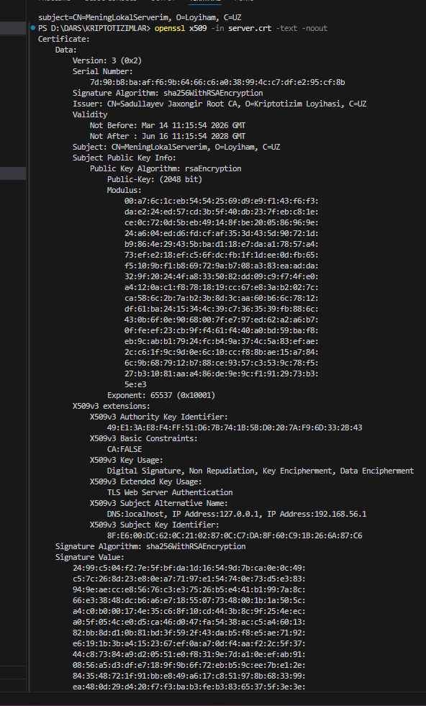
3-vazifa: Foydalanuvchi (Mijoz) sertifikatini yaratish

Foydalanuvchi uchun maxfiy kalit yaratish
openssl genrsa -out client.key 2048
Foydalanuvchi uchun sertifikat so'rovi (CSR)
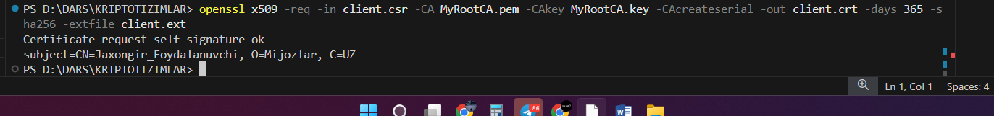

PKCS12 faylini yaratish

openssl pkcs12 -export -out client.p12 -inkey client.key -in client.crt -certfile MyRootCA.pem
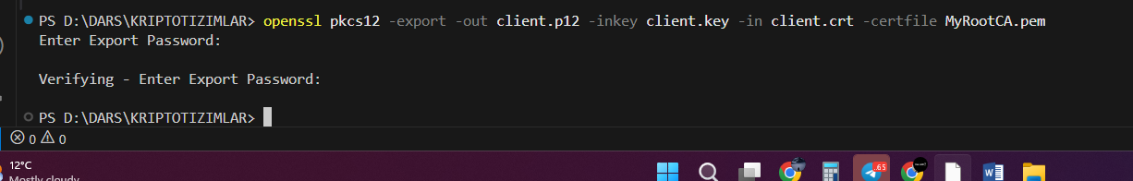

Joriy parol: 12345

Mijoz (Client) sertifikatini o'rnatish
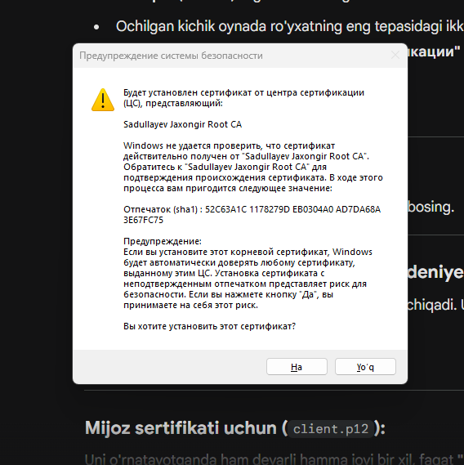
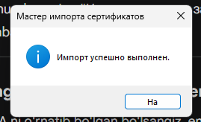
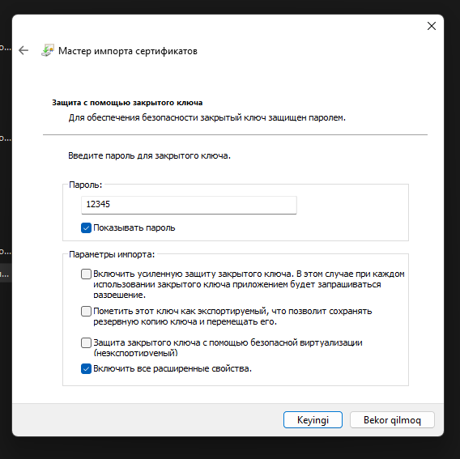
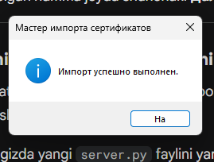

Python Serverni ishga tushirish
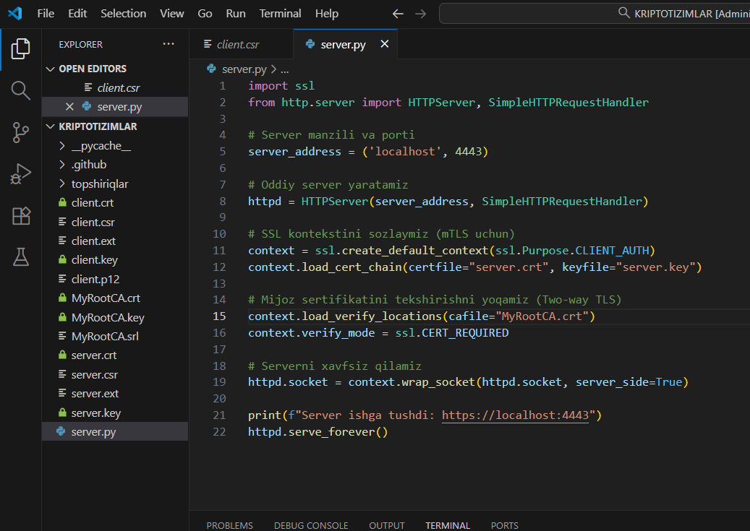
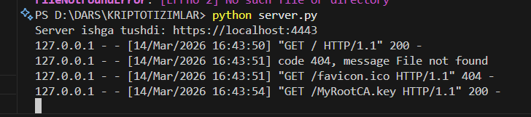
Server ishga tushdi: https://localhost:4443
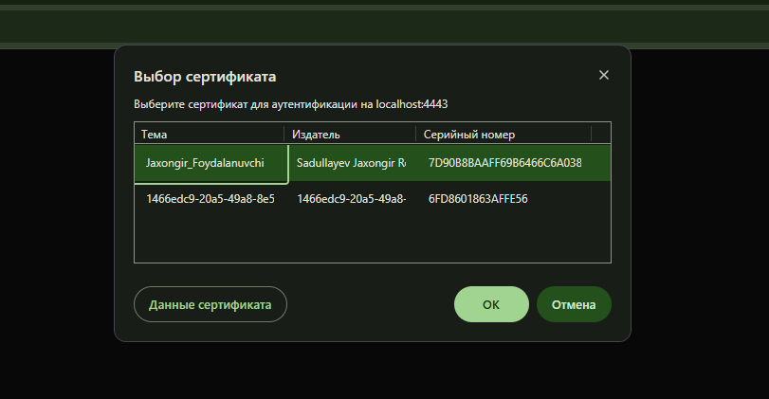

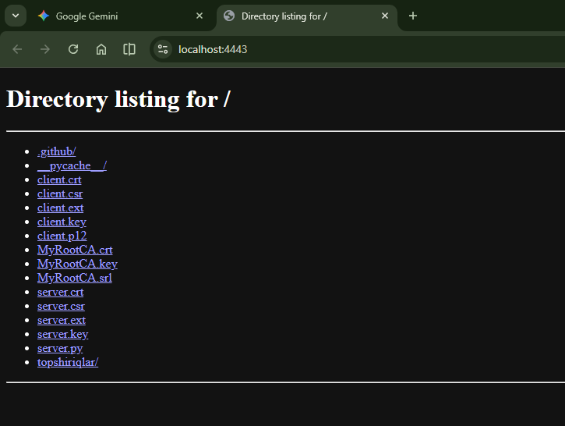
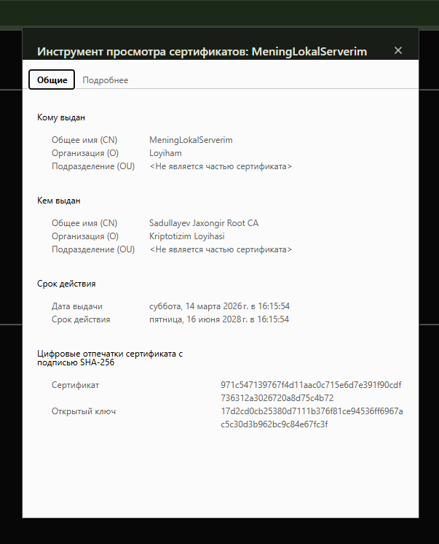
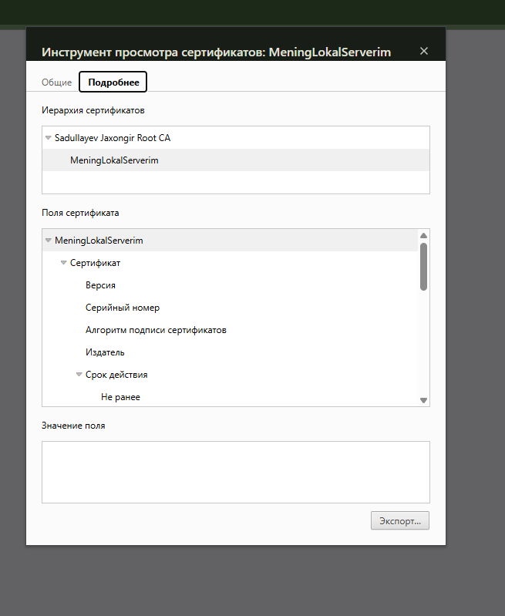
Dizayn yangilandi
