Growth of Online Gaming with Data Analytics

**Dasun Wellawalage**

[wdbandara@my365.bellevue.edu](mailto:wdbandara@my365.bellevue.edu)

**Kayla Thompson**

[kthompson@my365.bellevue.edu](mailto:kthompson@my365.bellevue.edu)

**Jason Corbaley**

[jcorbaley@my365.bellevue.edu](mailto:jcorbaley@my365.bellevue.edu)

**Abstract**

The rapid growth of data analytics has resulted in a convergence between big data and the gaming industry which is currently a $20 billion market in the United States alone with over 2 billion players around the world. Data Science has already made its way into various aspects of the gaming industry such as game development, monetization, game design, object identification, visual effects, personalized marketing, fraud detection, customer analysis etc. Artificial intelligence and machine learning, which were only important to a few strategic board games like chess, are now being used in open world games like Grand Theft Auto and Assassin’s Creed as well as in simple mobile games. We believe those companies who use data analytics will have a significant competitive advantage over the others who don't. Through this research we try to shed some light into how some of the largest gaming studios use data science methodologies internally.

**Keywords**

Analytics; Game Design; Game Development; Artificial Intelligence; Machine Learning

**Introduction**

Video Gaming has evolved from the days of PAC-MAN and arcades. The world of computer games is now a powerful and profitable business (Teradata, 2017). Games have started to become more and more complex in terms of design. Player economy ecosystems need to be maintained, and we no longer create games from a fire-and-forget point of view (Solarwinds Loggly, 2016). Big Data has already made its way into every single aspect of the gaming industry. Whether it's collecting data from the users, targeted marketing, better user experience, or even customer focus, Big Data has got you covered. Analytics is not about trend analysis anymore, it is driving the product development for gaming companies. In this paper we will focus on the common use cases of data analytics in the gaming industry.

**Why Big Data and Why Now?**

Mobile games and online multi-player games have changed the gaming industry completely over the last decade. Gaming analytics has steadily been rising in popularity over the last two decades, but it has really exploded in the last few years. For example, even the simplest game like “Candy Crush” utilizes Data Science techniques to improve their user experience. In fact, according to a study conducted by Toby Walsh, a professor at University of NSW, Australia, showed that this game is classified as a ‘NP-hard problem’ evident in computational complexity theory.

**Game Design & Development**

Game design is a complex process requiring various programming, visualization, and animation skills. Gaming data insights along with the developers’ creativity help create interesting scenarios for the games. The insights from the gaming analytics are used to obtain the specific knowledge of what the player wants, to predict the gaming bottlenecks, reasoning, and timing. New game concepts, storylines, and mechanics are designed using the data gained previously (Medium, 2019).

Image recognition is another area where Data Science techniques are used in gaming. object detection models are used by developers to create natural change of scenes and movement in the game space. Motion capture in games, real-time rendering, and photogrammetry are some of the advanced use cases of visual effects in gaming. This lets them create more human-like characters in their games. Advanced machine learning algorithms help developers achieve this.

**User Experience & Monetization**

Insights from gaming analytics can also be used to improve the user experience. For example, analyzing a lot of user records can lead us towards a point where most of the users quit playing or completely gave up on the game. Identifying these gaming bottlenecks is critical to understanding the reasoning & timing behind a game’s churn rate (Data iku, 2019).

Analyzing the devices used by players also helps developers to create gaming experiences that work effectively for their user base. Different objects and their sizes used in the game might be effective or counter effective depending on the size of the device used. Object size ratios used for the laptop should be different from that is used for the mobile or the tablet device. Data analytics makes all this information readily available in bulk so developers can leverage them in their design.

In free-to-play business model users can play the game freely but at some point, they will have to pay for advanced features or premium services. This has to be designed in a subtle manner, so users won’t feel discouraged to pay. By the time this option is presented users should already be heavily engaged in the game. Using big data in the freemium stage allows game developers to accurately measure, predict, and track player behavior to optimize the experience, increasing the likelihood users converting to a paid model.

However, sometimes companies prefer long term strategy over immediate profits. For example, When Microsoft acquired Minecraft, it seemed like an odd fit (CIO, 2018). Many Minecraft lovers were sure of the game’s doom, or limitations to only Microsoft’s own platforms, like Xbox. However, this year Minecraft sales hit 122 million copies sold with 55 million people playing each month. Surpassing Microsoft’s goal of 100 million copies.

**Player Analysis**

Analyzing the players and their behavior is quite important in the gaming industry. Identifying these personal traits and designing the game around it helps build a loyal customer base and will retain players in the long run.

According to two researchers Caillois in *Man, Play and Games* and Brown in *Play,* there are certain properties of play that is important to a game designer. Identifying these and using them in their games is up to the developers and designers.

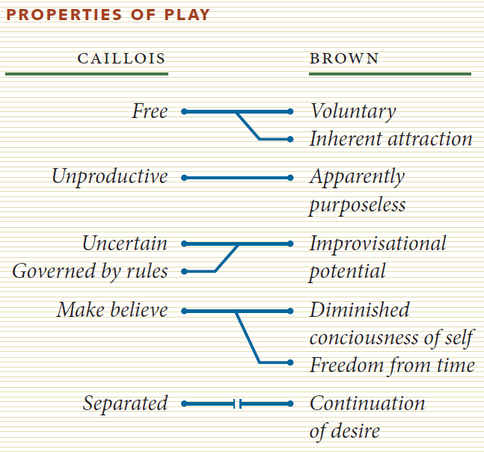

Figure 1. A comparison of Caillois’ and Brown’s properties of play

Caillois classifies games based on what exists in the market. He divides them into four separate groups: chance, competition, simulation, and vertigo. Each category also has an axis that spans from unstructured to structured play, as can be seen in the figure below

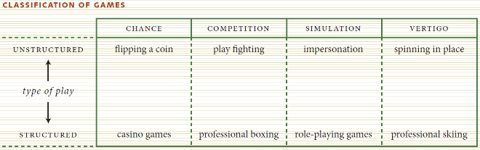

Figure 2. Caillois’ classification of games

Brown goes on to explain the types of players and categorize them based on different characteristics. It differentiates between players who are playing just to get a new experience, competitive players, excitement seekers and so on. Below figure summarizes his classification.

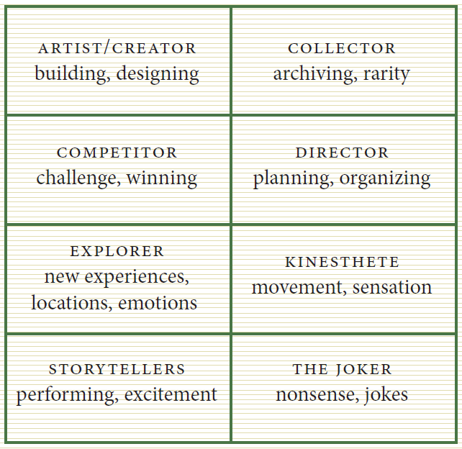

Figure 3. Brown's classification of players

Based on the player type there are certain techniques that can be effective on them. For example, Map making really helps catching the attention of exploratory users and motivate them to move forward.

Massively multiplayer online role-playing games with large 3D game worlds are examples where the in-game mapping system provides less information than players determine as valuable for play. For example, fighting monsters is one geographically determined activity found in MMORPGs such as the World of Warcraft, but the in-game maps do not display the various monsters that exist in an area (Melder, 2011).

Competition is another factor that is being used by analytics tools. Most players love the fact that they can compete against real human beings in online multiplayer games. Based on game results and other data we can predict which two players can be a good match for each other.

Player dossier is a record of player progress and statistics over time. Third party services help visualize each player’s dossier reports and prompt players to explore other’s data.

**Predictive Analysis**

Many industries use predictive analysis to improve their sales revenue. Media industry for example, uses it for their advertisements. AT&T, one of the world’s biggest telecom operators, uses predictive analytics to increase the hit rate of TV Ads. Based on the data they collected, they built a predictive model for their TV advertisements which resulted in more than $50 million (Game Refinery, 2019) in sales which was the most successful in their history.

This same technique is now being used in the gaming industry. So, instead of developing many different games to reach the revenue targets, companies can develop a few targeted games to achieve their sales goals.

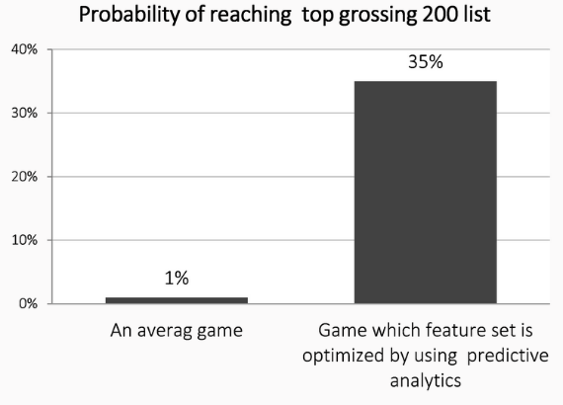

Figure 4. Based on GameRefinery’s database games which feature set has been optimized using predictive analytics engine have 10-40% probability of reaching the top 200 list.

**Intelligent Agents**

A few years ago, using AI in gaming was only restricted to a few board games like chess, and Go. Thanks to the advancements in Data Science we now have intelligent bots that play complex strategy games like “Dota”.

Fundamentally, video games offer challenges that board games like Go just doesn’t. Since in video games most of the information is hidden from the players, this leads to the fact that AI cannot perceive the whole picture and make the best move. There’s also more information to process and a huge number of possible moves (Kadyrov, 2019).

These AI bots have evolved so much over the years they can now play against humans, and even beat champions in some cases.

**Marketing**

Just like every other industry, gaming industry also uses personalized 1 to 1 marketing strategies based on user data. It helps retain existing players as well as attract new users. Analytics help identify Ad responsive users from those who are not and tailor their messages based on that.

One of the biggest portions of the gaming industry to use data in their marketing is the online casino industry. Online casinos have come to realize that a personalized experience results in a greater customer loyalty. To give each customer this experience they look at what games, promotions and bonuses draw people to their sites as well as what time they should be pushing these offers to their customers to entice them the most (Smart Data Collective, 2018).

Outside of the casino industry, online games are using data to provide messaging more personalized than ever before. Historically segmentation was used to send targeting marketing messages. Now, each digital user logs in to a game expecting a completely personalized message. The personalization is important because it drives the level of esteem associated with your brand in the eyes of the consumer (CIO, 2018).

**Success Stories**

A classic example of a successful data-driven game is Candy Crush Saga, which is made almost $2 billion dollars in 2013 from in-game purchases. The game launched in 2012 but it’s still appearing in the top 10 grossing mobile games across the Google Play Store and the App Store (Shane Lynn, 2019).

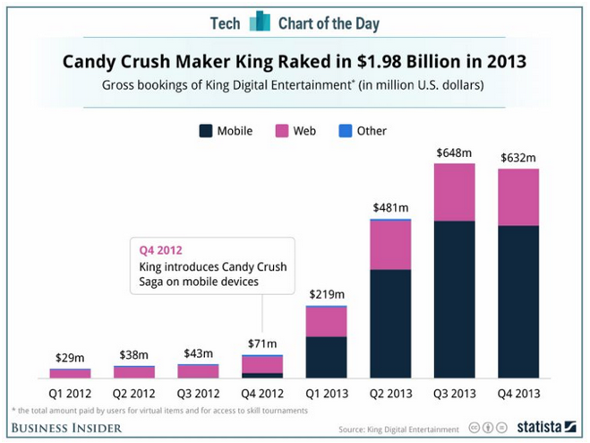

Figure 5. Candy Crush Revenue in 2012 & 2013

Another example of a success story is Clash of Clans. When first starting out the developer

Another game that optimized data driven decisions is Pokémon GO. This game used user data to decide where to spawn the Pokémon for the users. Niantic, who owns the game, has profited $600 million from it. The game came out in 2016 and there is still a big following with the game today. Below graph shows how well Pokémon was doing compared to some other popular games in the market.

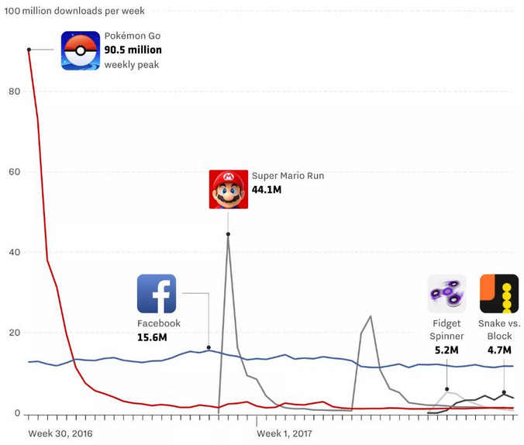

Figure 6. Pokémon Go early download peak versus other apps

Clash of Clans is another good example. When first starting out, the developers wanted the game to be a game people will play for years. Clash of Clans used data driven decisions to optimize the addictiveness of their game. With games like this the creator, Supercell, is now worth over $2 billion as well.

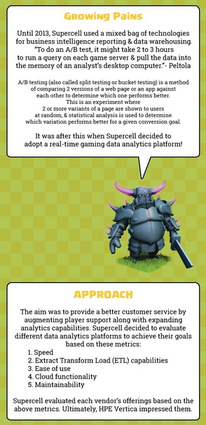

Figure 7. Clash of Clans Analytics Approach

**Acknowledgements**

Thank you to our instructors of DSC 500 at Bellevue University for allowing us to explore such an interesting topic. The lessons we have learned are invaluable and will most definitely apply to our professional and personal lives.

**Conclusion**

We can conclude data science is important in the development of video games. Data science helps developers create better AI for the games being produced. Smarter and more intuitive AI creates a better experience for the user because of the increased unpredictability in the game. Data science is very important to game monetization because this is ultimately where the company's profit lies. It is important to know who your top players are and collect data on their preferences to improve your game. Data science in games is only going to become better over the years creating more profits and better user experiences.

**References**

1. Analytics India (Oct 2018). How The Gaming Industry Uses Data & Analytics To Up Game Development & Drive User Base? Retrieved June 17, 2019, from <https://www.analyticsindiamag.com/how-the-gaming-industry-uses-data-analytics-to-up-game-development-drive-user-base/>
2. Andrade, G., Ramalho, G., Santana, H., & Corruble, V. (Jul 2005). Extending Reinforcement Learning to Provide Dynamic Game Balancing. ResearchGate.
3. CIO (Jan 2018). How big data is disrupting the gaming industry. Retrieved June 17, 2019, from <https://www.cio.com/article/3251172/how-big-data-is-disrupting-the-gaming-industry.html>
4. Data Iku (2019). Gaming Industry. Retrieved June 17, 2019, from <https://www.dataiku.com/solutions/industries/gaming/>
5. Freire, M., Serrano-Laguna, Á, Manero Iglesias, B., Martínez-Ortiz, I., O Moreno-Ger, P., & R Fernández-Manjón, B. (2016). Game Learning Analytics: Learning Analytics for Serious Games. 1-29. Retrieved June 21, 2019, from <https://link.springer.com/content/pdf/10.1007/978-3-319-17727-4_21-1.pdf>
6. Game Refinery (2019). 3 Ways Predictive Analytics Will Change Mobile Games. Retrieved June 17, 2019, from <https://www.gamerefinery.com/3-ways-predictive-analytics-will-change-mobile-games-part-i/>
7. Kadyrov, I. (2019, April 25). OpenAI Bot Crushes Dota 2 Champions And This is Just the Beginning. Retrieved July 4, 2019, from <https://towardsdatascience.com/openai-bot-crushes-dota-2-champions-and-this-is-just-the-beginning-63622134e4df>
8. Lent, M. V., Laird, J., Buckman, J., Hartford, J., Houchard, S., Steinkrau, K., & Tedrake, R. (1999). Intelligent Agents in Computer Games. AAAI.
9. Medium (Mar 2019). Top 8 Data Science Use Cases in Gaming. Retrieved June 17, 2019, from <https://medium.com/activewizards-machine-learning-company/top-8-data-science-use-cases-in-gaming-de1f429ae651>
10. Medium (Nov 2018). How to teach AI to play Games: Deep Reinforcement Learning. Retrieved June 21, 2019, from <https://towardsdatascience.com/how-to-teach-an-ai-to-play-games-deep-reinforcement-learning-28f9b920440a>
11. Melder, B. (n.d.). Game Studies. Retrieved from <http://gamestudies.org/1101/articles/medler>
12. Melder, B. (2011). Analytics of Play: Using Information Visualization and Gameplay Practices for Visualizing Video Game Data. 3(1), 1-12. Retrieved June 21, 2019, from <http://adamlab.gatech.edu/wp-content/uploads/2011/07/medler_pjim11.pdf>
13. NYC Data Science Academy (Feb 2018). Analyzing trends in the video Gaming Industry. Retrieved June 17, 2019, from <https://nycdatascience.com/blog/student-works/analyzing-trends-in-the-video-gaming-industry/>
14. Otokiti, E. (2018, March 28). How Analytics Are Changing The Game: Articles: Big Data. Retrieved July 4, 2019, from <https://channels.theinnovationenterprise.com/articles/how-analytics-are-changing-the-game>
15. Schoenbaum, D. (2018, January 13). Why Data Unification is Critical for Gaming Companies to Understand Their Customers and Overall... Retrieved July 4, 2019, from <https://towardsdatascience.com/why-data-unification-is-critical-for-gaming-companies-to-understand-their-customers-and-their-afdf861f94d0>
16. Shane Lynn (2019). Using big data to create better mobile video games. Retrieved June 17, 2019, from <https://www.shanelynn.ie/using-big-data-to-create-better-mobile-video-games/>
17. Smart Data Collective (June 2018). How The Online Gaming Industry Uses Big Data Analytics To Grow. Retrieved June 17, 2019, from <https://www.smartdatacollective.com/online-gaming-industry-uses-big-data-analytics-grow/>
18. Solarwinds Loggly (2016). Analytics in Game Development: Data-Driven What?. Retrieved June 17, 2019, from <https://www.loggly.com/blog/data-driven-game-development-analytics/>
19. SpringPeople (Dec 2017). Data Science and Analytics in the Gaming Industry. Retrieved June 17, 2019, from <https://www.springpeople.com/blog/data-science-and-analytics-in-the-gaming-industry/>
20. Teradata (2017). Gaming Companies Use Data Analytics to Score Points with Players. Retrieved June 17, 2019, from <https://www.teradata.com/Resources/Case-Studies/Gaming-Companies-Use-Data-Analytics>