React Native Introduction:

Build native mobile apps using JavaScript and React

React Native app is a real mobile app which is build using JavaScript.

React Native app is about hot reloading.

* Cross platform, Native IOS and Andriod apps without web views
* Mainly focused in the frontend
* Uses React JavaScript
* 100% access to native API via JavaScript and reuse of packages from NPM
* Backed by FaceBook

How React Native Works

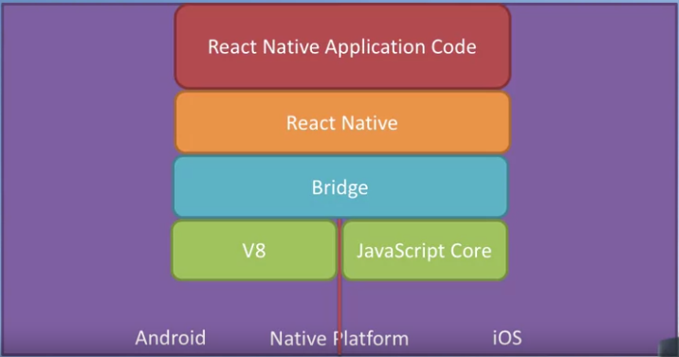

|  |  |
| --- | --- |
|  | How do we target native platform (camera/ect)? Hybrid development using JavaScript. |
|  | Android has V8 JavaScript engine and IOS has JavaScript Core engine which are used by browsers. |
|  | The bridge to connect with native environment through JavaScript engine. |
|  | On top of it React Native Framework is built. |
|  | We access framework by writing React Native Application code using JavaScript. |

[Iornic or React Native or NativeScript](https://www.monterail.com/blog/react-native-vs-nativescript-2019)

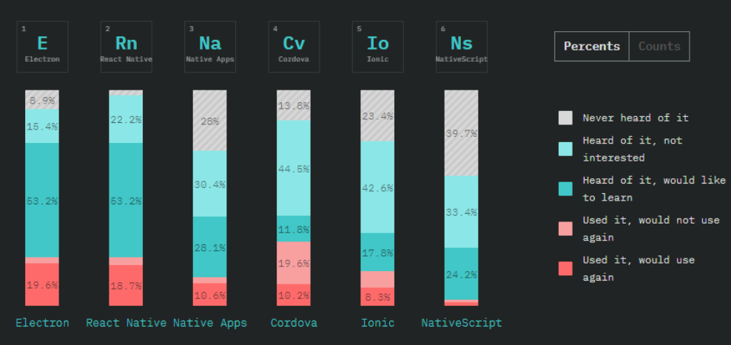

[Comparison Table](https://blog.jscrambler.com/react-native-vs-ionic-vs-nativescript-a-practical-guide/)

|  |  |  |  |
| --- | --- | --- | --- |
|  | Ionic | React Native | Native Script |
| created by | Drifty Co | Facebook | Progress |
| Development | Easiest to learn  Default JS framework  Web is ok | React’s jsx syntax  Web may not working | xml based language |
| UI component | Just like web | maintain by Facebook  Some may work only one platform | widgets are in default style  professional graded ui like graph, calendars ,charts |
| debugging | like usual web  can use Android or ionic | chrome developer tools  react native debugger | chrome developer tools  vs code native script extension |
| native device features: camera, location, Bluetooth | ionic native wrapper | api developed by react native community  small collection | all platform’s apis by plugging |
| performance | worst performs |  |  |
| usage | great when using existing web knowledge | huge community support  still evolving technology | when performance impact  more matured technology  open source framework but paid support |

React native components

* State
* Props
* JSX

React native components

* All in UI kit