CreditSource AI Engineer: Agentic Data Extraction from Financial Documents

Overview
Annual reports convey how an organisation is operating financially to other interested parties. In most countries, the law requires lodgement of financial reports with the relevant authorities.
You have been given a sample of four annual reports of Australian public companies. Analyse these documents. You will observe that areas in financial statements such as the Statement of Profit and Loss and the Consolidated Statement of Financial Income have notes that provide detailed information. Names used by companies vary; some have a Profit and Loss statement, and others have a Consolidated Statement of Financial Income. There are scenarios where a single item in a financial statement refers to multiple notes, usually separated by a comma.
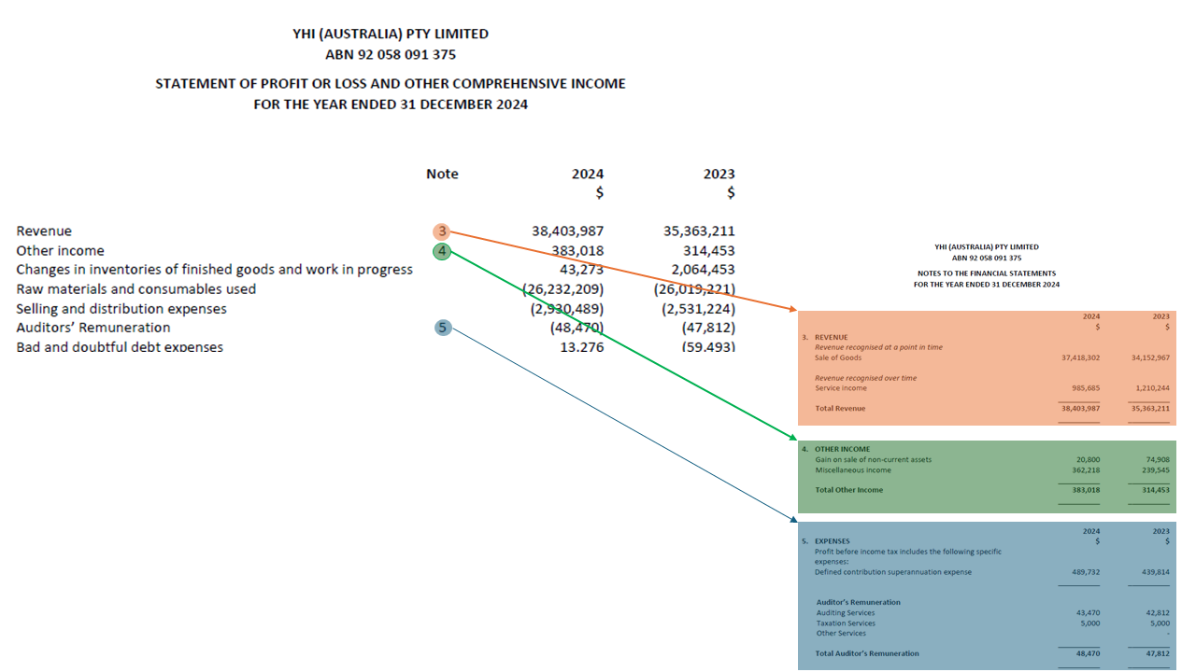
Figure 1: Example of P&L and linked notes
The tasks involve designing and implementing an agentic workflow that orchestrates multiple specialised agents to analyse financial documents, extract relevant data, and represent it in a machine-readable format for further processing. There are three tasks, which are described below.

Task 1
You are required to design an agentic workflow to extract the P&L or Consolidated Statement of Financial Income, including all associated notes, and to score each company based on key financial indicators derived from the extracted data. The workflow should be composed of specialised agents that collaborate to accomplish this end-to-end, covering both extraction and scoring.
In this extracted format, it should be able to identify:
- Links to notes for the individual item
- The financial year individual item references
- The currency and rounding used; for instance, whether financials are in millions of dollars($M)
- Key financial ratios and indicators computed from the extracted data, including profitability (e.g. net profit margin), liquidity (e.g. current ratio), leverage (e.g. debt-to-equity), and coverage (e.g. interest coverage ratio)
- A composite credit risk score per company, derived from the above indicators, with a clear scoring methodology and thresholds
Provide a detailed technical design document for the agentic workflow. In this design document specify;
- Agent roles, stages, and components; indicate inputs, outputs, and inter-agent communication.
- Assumptions and perceived challenges.
- Scoring model design; specify the financial indicators used, the scoring methodology (rules-based, statistical, or ML), how scores are aggregated into a composite risk score, and how the scoring agent integrates with the extraction agents.
- Technology stack, which you may use in this design, includes relevant libraries, tools, ML models, and agentic frameworks (e.g. LangGraph, LlamaIndex Workflows, or similar).
You are required to use Python to implement the agentic solution. You can use any open-source models, agentic frameworks, and tools that can be executed without accessing the Internet. However, you are not allowed to use third-party hosted services such as Google Vertex AI and ChatGPT.
You may add written descriptions where necessary to better describe the solution.
This solution document should be in PDF format and must be submitted within seven calendar days of receiving the material.

Task 2 (Optional)
You are encouraged to implement your agentic design (partially or fully). During the technical interview, you will have the opportunity to showcase/demo the agentic workflow in action. If you have implemented the solution (partially) along with Task 1 (i.e. within seven days of receiving the material), please send the implementation clearly indicating how to execute in a local environment (using poetry is preferable).

Task 3 (Optional)
Using the structured financial data extracted by the agentic workflow in Task 1, design a risk model that assesses the financial health and creditworthiness of the companies in the sample.
The risk model should:
- Score each company based on key financial indicators (e.g. profitability, liquidity, leverage, and coverage ratios) derived from the extracted P&L and associated notes.
- Identify material risks or anomalies in the financial statements, such as significant year-on-year deterioration, unusual note disclosures, or off-balance-sheet exposures.
- Output a structured risk report per company, suitable for consumption by a credit analyst.
In your design document, specify how the risk model integrates with the extraction workflow from Task 1, the features used, the modelling approach (rules-based, ML, or hybrid), and how model outputs are validated.

