Ex1:

Kết quả:

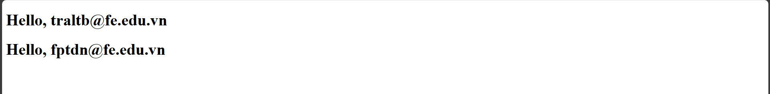

Code:

const Welcome = ({ name }) => <h1>Hello, {name}</h1>;

export default Welcome;

App.js:

import Welcome from "./components/Welcome";

function App() {

  return (

    <>

      <Welcome name="traltb@fe.edu.vn" />

      <Welcome name="fptdn@fe.edu.vn" />

    </>

  );

}

export default App;

Ex2:  
Kết quả:

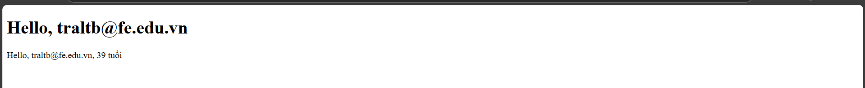

Code:

const UserProfile = ({ user }) => (

  <div>

    <p>Hello, {user.name}, {user.age} tuổi</p>

  </div>

);

export default UserProfile;

App.js:

// src/App.js

import UserProfile from "./components/UserProfile";

import Welcome from "./components/Welcome";

function App() {

  const userData = { name: "traltb@fe.edu.vn", age: 39 };

  return (

    <>

      <Welcome name="traltb@fe.edu.vn" />

      <UserProfile user={userData} />

    </>

  );

}

export default App;

Ex3:

Kết quả:

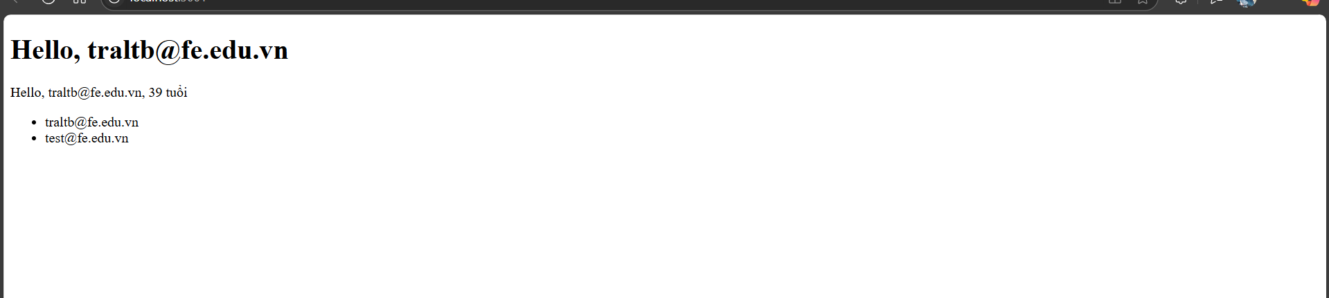

Code:

const NameList = ({ names }) => (

  <div>

    <ul>

      {names.map((name, index) => (

        <li key={index}>{name}</li>

      ))}

    </ul>

  </div>

);

export default NameList;

App.js:

// src/App.js

import NameList from "./components/NameList";

import UserProfile from "./components/UserProfile";

import Welcome from "./components/Welcome";

function App() {

  const userData = { name: "traltb@fe.edu.vn", age: 39 };

  const namesList = ["traltb@fe.edu.vn", "test@fe.edu.vn"];

  return (

    <>

      <Welcome name="traltb@fe.edu.vn" />

      <UserProfile user={userData} />

      <NameList names={namesList} />

    </>

  );

}

export default App;

Ex4:

Kết quả:

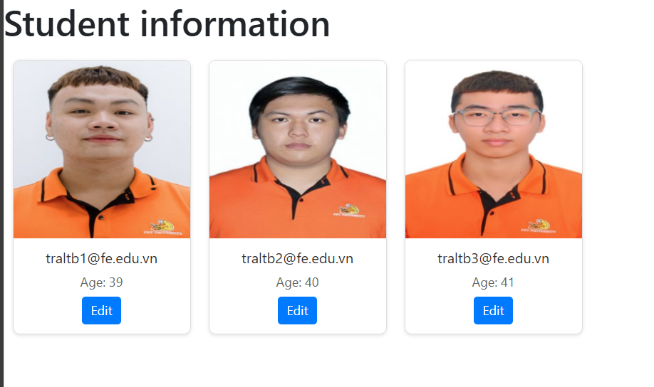

Code:

// src/components/StudentCard.js

const StudentCard = ({ student }) => {

  return (

    <div className="student-card">

      <img

        src={student.avatar || "/images/fallback.jpg"}

        alt={`${student.name}'s avatar`}

        className="card-img"

      />

      <div className="card-content">

        <p className="card-name">{student.name}</p>

        <p className="card-age">Age: {student.age}</p>

        <button className="edit-btn">Edit</button>

      </div>

    </div>

  );

};

export default StudentCard;

App.js:

import NameList from "./components/NameList";

import UserProfile from "./components/UserProfile";

import Welcome from "./components/Welcome";

import StudentCard from "./components/StudentCard";

import "./App.css";

import img1 from "./image1.png";

import img2 from "./image2.png";

import img3 from "./image3.png";

function App() {

  const userData = { name: "traltb@fe.edu.vn", age: 39 };

  const namesList = ["traltb@fe.edu.vn", "test@fe.edu.vn"];

  const students = [

    { name: "traltb1@fe.edu.vn", age: 39, avatar: img1 },

    { name: "traltb2@fe.edu.vn", age: 40, avatar: img2 },

    { name: "traltb3@fe.edu.vn", age: 41, avatar: img3 },

  ];

  return (

    <>

      <Welcome name="traltb@fe.edu.vn" />

      <UserProfile user={userData} />

      <NameList names={namesList} />

      <div className="app-container">

        <h1 className="title">Student information</h1>

        <div className="cards-container">

          {students.map((student, index) => (

            <StudentCard key={index} student={student} />

          ))}

        </div>

      </div>

    </>

  );

}

export default App;