Kết quả và code:  
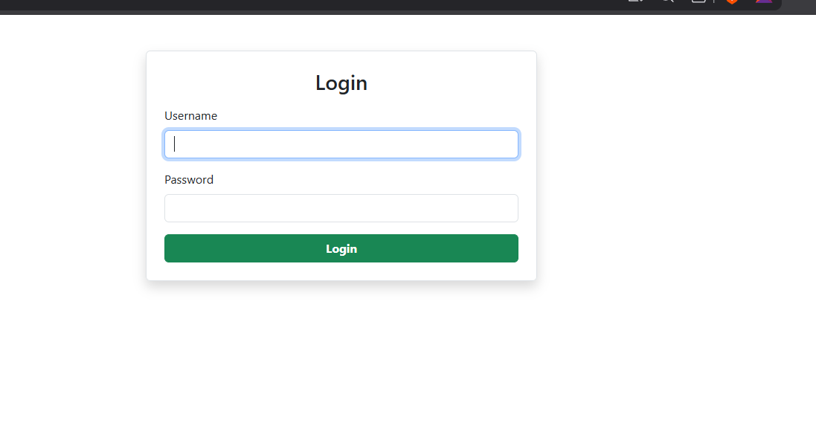

import React, { useState } from "react";

import PropTypes from "prop-types";

import axios from "axios";

import { Modal, Button, Form, Container, Row, Col } from "react-bootstrap";

function Login({ setUser }) {

  const [username, setUsername] = useState("");

  const [password, setPassword] = useState("");

  const [show, setShow] = useState(false);

  const handleLogin = (e) => {

    e.preventDefault();

    axios

      .get(

        `http://localhost:3001/UserAccounts?username=${username}&password=${password}`

      )

      .then((res) => {

        if (res.data.length > 0) {

          setShow(true);

          setUser(res.data[0]);

        } else {

          alert("Invalid username or password!");

        }

      });

  };

  return (

    <Container className="mt-5">

      <Row className="justify-content-center">

        <Col xs={12} sm={8} md={5}>

          <Form onSubmit={handleLogin} className="p-4 border rounded shadow">

            <h3 className="mb-3 text-center">Login</h3>

            <Form.Group className="mb-3">

              <Form.Label>Username</Form.Label>

              <Form.Control

                type="text"

                value={username}

                required

                onChange={(e) => setUsername(e.target.value)}

            />

            </Form.Group>

            <Form.Group className="mb-3">

              <Form.Label>Password</Form.Label>

              <Form.Control

                type="password"

                value={password}

                required

                onChange={(e) => setPassword(e.target.value)}

              />

            </Form.Group>

            <Button variant="success" type="submit" className="w-100 fw-bold">

              Login

            </Button>

          </Form>

        </Col>

      </Row>

      <Modal show={show} onHide={() => setShow(false)} centered>

        <Modal.Header closeButton>

          <Modal.Title>Welcome</Modal.Title>

        </Modal.Header>

        <Modal.Body>

          Welcome, <b>{username}</b> login Successful!

        </Modal.Body>

        <Modal.Footer>

          <Button variant="success" onClick={() => setShow(false)}>

            OK

          </Button>

        </Modal.Footer>

      </Modal>

    </Container>

  );

}

Login.propTypes = {

  setUser: PropTypes.func.isRequired,

};

export default Login;

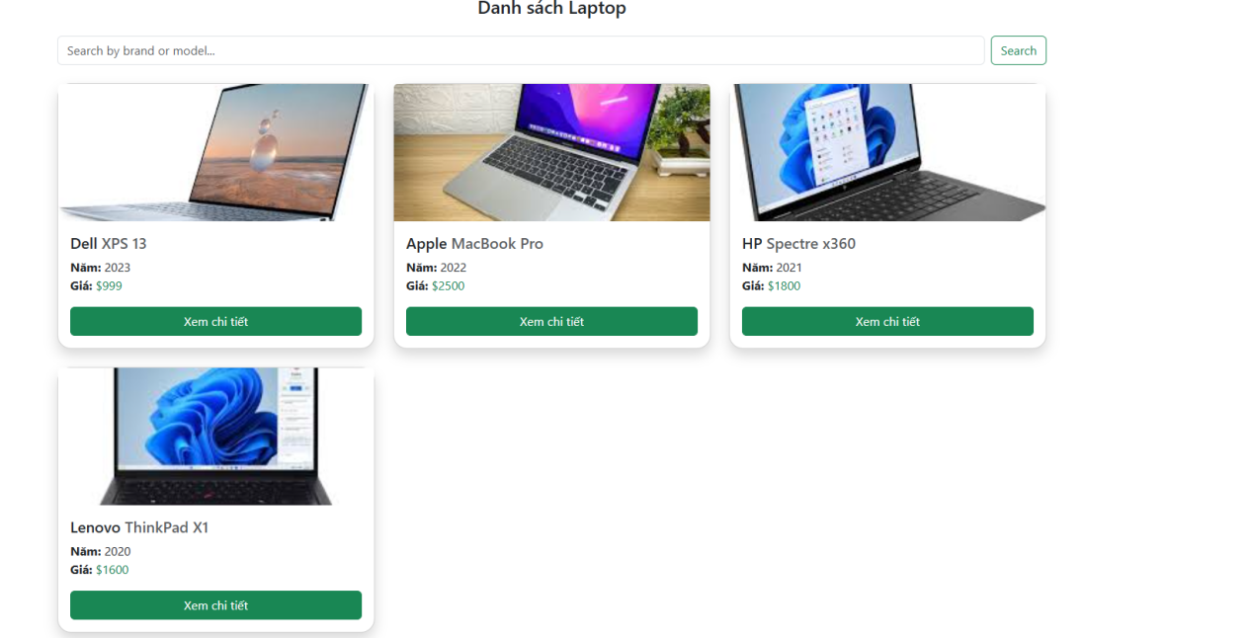

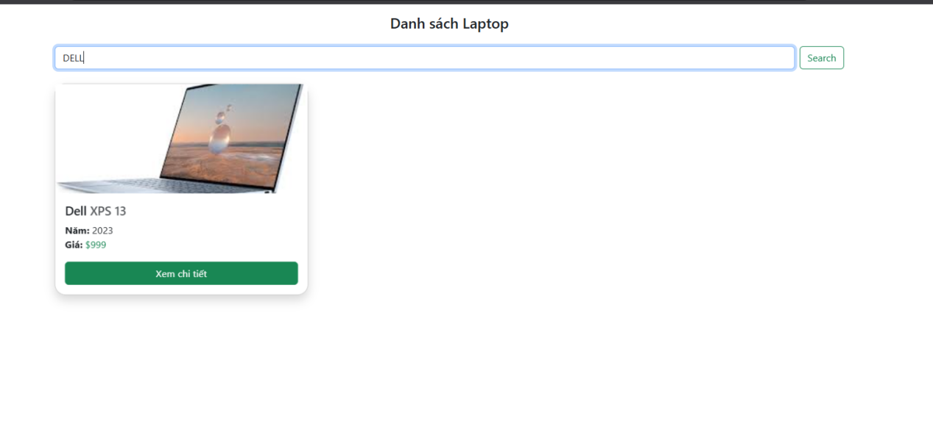

import React, { useEffect, useState } from "react";

import PropTypes from "prop-types";

import axios from "axios";

import Button from "react-bootstrap/Button";

import Card from "react-bootstrap/Card";

import { useNavigate } from "react-router-dom";

import { Container, Row, Col, Form } from "react-bootstrap";

function LaptopList({ user }) {

  const [laptops, setLaptops] = useState([]);

  const [loading, setLoading] = useState(true);

  const [search, setSearch] = useState("");

  const [filtered, setFiltered] = useState([]);

  const navigate = useNavigate();

  useEffect(() => {

    axios.get("http://localhost:3001/Laptops").then((res) => {

      setLaptops(res.data);

      setFiltered(res.data);

      setLoading(false);

    });

  }, []);

  const handleSearch = (e) => {

    e.preventDefault();

    if (!search.trim()) {

      setFiltered(laptops);

      return;

    }

    setFiltered(

      laptops.filter(

        (lap) =>

          lap.brand.toLowerCase().includes(search.toLowerCase()) ||

          lap.model.toLowerCase().includes(search.toLowerCase())

      )

    );

  };

  if (loading) return <div>Đang tải...</div>;

  return (

    <Container className="mt-3">

      <h4 className="mb-4 text-center">Danh sách Laptop</h4>

      <Form className="mb-4 d-flex" onSubmit={handleSearch}>

        <Form.Control

          placeholder="Search by brand or model..."

          value={search}

          onChange={(e) => setSearch(e.target.value)}

        />

        <Button type="submit" variant="outline-success" className="ms-2">

          Search

        </Button>

      </Form>

      <Row>

        {filtered.length === 0 ? (

          <div className="text-center">No laptops found.</div>

        ) : (

          filtered.map((lap) => (

            <Col xs={12} md={6} lg={4} className="mb-4" key={lap.id}>

              <Card className="shadow laptop-card">

                <Card.Img

                  variant="top"

                  src={lap.image}

                  alt={lap.model}

                  style={{ height: 180, objectFit: "cover" }}

                />

                <Card.Body>

                  <Card.Title>

                    {lap.brand} <span className="text-muted">{lap.model}</span>

                  </Card.Title>

                  <Card.Text>

                    <b>Năm:</b> {lap.year}

                    <br />

                    <b>Giá:</b>{" "}

                    <span className="text-success">{lap.price}</span>

                  </Card.Text>

                  <Button

                    variant="success"

                    className="w-100"

                    onClick={() => navigate(`/laptops/${lap.id}`)}

                  >

                    Xem chi tiết

                  </Button>

                </Card.Body>

              </Card>

            </Col>

          ))

        )}

      </Row>

      <style>{`

        .laptop-card {

          border-radius: 18px;

          transition: box-shadow 0.25s, transform 0.25s;

        }

        .laptop-card:hover {

          box-shadow: 0 10px 28px 0 rgba(60,133,104,0.25), 0 2px 6px 0 rgba(60,133,104,0.14);

          transform: translateY(-8px) scale(1.025);

          border: 2px solid #198754;

        }

      `}</style>

    </Container>

  );

}

LaptopList.propTypes = {

  user: PropTypes.object.isRequired,

};

export default LaptopList;

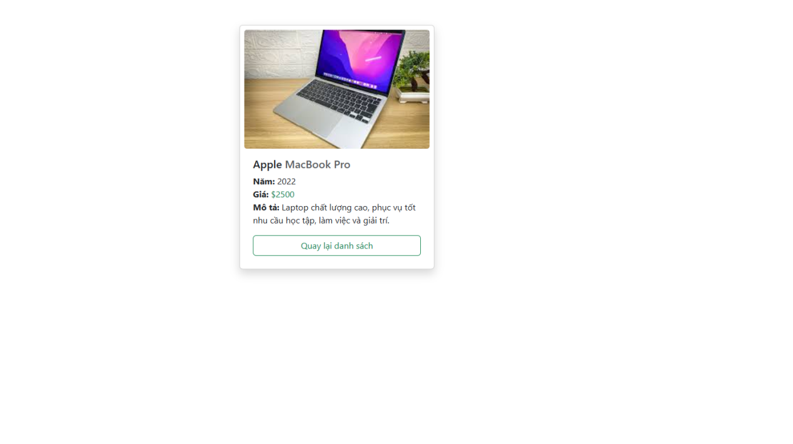import React, { useEffect, useState } from "react";

import axios from "axios";

import { useParams, Link } from "react-router-dom";

import { Card, Button, Container } from "react-bootstrap";

function LaptopDetail() {

  const { id } = useParams();

  const [laptop, setLaptop] = useState(null);

  const [loading, setLoading] = useState(true);

  useEffect(() => {

    axios

      .get(`http://localhost:3001/Laptops/${id}`)

      .then((res) => {

        setLaptop(res.data);

        setLoading(false);

      })

      .catch(() => setLoading(false));

  }, [id]);

  if (loading) return <div>Đang tải...</div>;

  if (!laptop || !laptop.id)

    return (

      <Container className="text-center mt-5">

        <h2>404 Not Found</h2>

        <Link to="/laptops">

          <Button variant="success" className="mt-3">

            Quay lại danh sách

          </Button>

        </Link>

      </Container>

    );

  return (

    <Container className="mt-5 d-flex justify-content-center">

      <Card style={{ width: 360 }} className="shadow p-2">

        <Card.Img

          src={laptop.image}

          alt={laptop.model}

          style={{ height: 220, objectFit: "cover" }}

        />

        <Card.Body>

          <Card.Title>

            {laptop.brand} <span className="text-muted">{laptop.model}</span>

          </Card.Title>

          <Card.Text>

            <b>Năm:</b> {laptop.year} <br />

            <b>Giá:</b> <span className="text-success">{laptop.price}</span>{" "}

            <br />

            <b>Mô tả:</b> Laptop chất lượng cao, phục vụ tốt nhu cầu học tập,

            làm việc và giải trí.

          </Card.Text>

          <Link to="/laptops">

            <Button variant="outline-success" className="w-100">

              Quay lại danh sách

            </Button>

          </Link>

        </Card.Body>

      </Card>

    </Container>

  );

}

export default LaptopDetail;